PUBLIC NOTICE
Notice of Intent to Adopt a Negative Declaration and Opportunity for a Public Hearing
(Study Results Available)
Mariposa 41 Culvert Replacement
Do you want a public hearing on changes proposed for State Route 41 in Mariposa County?
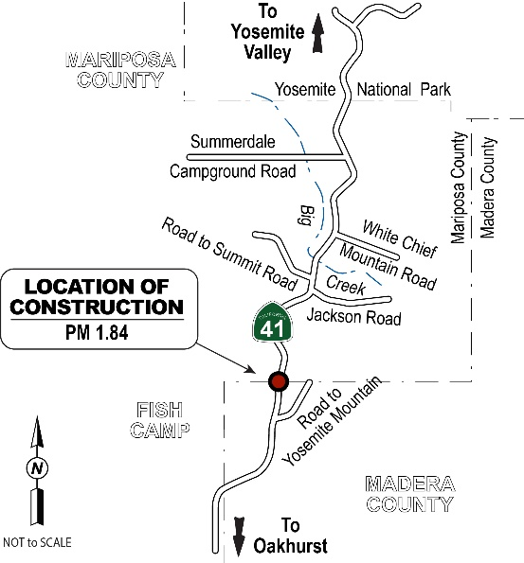
PUBLIC COMMENT PERIOD
Comments will be accepted from May 17, 2023, to June 16, 2023. If there are no major comments or requests for a public hearing, Caltrans will proceed with the project’s design.
WHAT’S BEING PLANNED?
The California Department of Transportation (Caltrans) proposes to remove an existing 18-inch corrugated steel culvert at post mile D1.84 on State Route 41 in Mariposa County near Fish Camp and replace it with a larger 24-inch corrugated steel culvert.
WHY THIS PUBLIC NOTICE?
Caltrans has studied the effects this project may have on the environment. Our studies show the project will not significantly affect the quality of the environment. The report that explains why is called an Initial Study with Proposed Negative Declaration. This notice is to inform you of the preparation of the Initial Study with Proposed Negative Declaration and of its availability for you to read and comment on. This notice also offers you an opportunity to request a public hearing.
WHAT’S AVAILABLE
The Initial Study with Proposed Negative Declaration and other project information are available for review and copying at the following locations:
- Caltrans District 6 Office at 1352 West Olive Avenue, Fresno, California 93728, Monday through Friday, from 8:00 a.m. to 5:00 p.m.
- Bassett Memorial Library at 7971 Chilnualna Falls Road, Wawona, California 95389, Monday and Wednesday, from 12:00 p.m. to 5:00 p.m., and Saturday, from 10:00 a.m. to 3:00 p.m.
- Online at https://dot.ca.gov/caltrans-near-me/district-6/district-6-projects/06-1C260
WHERE YOU COME IN?
Do you have any comments about processing the project with an Initial Study with Proposed Negative Declaration? Do you disagree with the findings of our study as set forth in the Proposed Negative Declaration? Would you care to make any other comments on the project? Would you like a public hearing? Please submit your comments or requests for a public hearing in writing by U.S. Mail or email no later than June 16, 2023, to Caltrans, Attention: Javier Almaguer, Senior Environmental Scientist, District 6 Environmental Division, 2015 East Shields Avenue, Suite 100, Fresno, California 93726, or by email to javier.almaguer@dot.ca.gov. The date Caltrans will begin accepting comments is May 17, 2023. If there are no major comments or requests for a public hearing, Caltrans will proceed with the project’s design.
CONTACT
For more information about this project, please contact Rene Sanchez, Project Manager, by phone at 559-488-4225 or by email at rene.sanchez@dot.ca.gov or Javier Almaguer, Senior Environmental Scientist, by phone at 559-287-9320 or by email at javier.almaguer@dot.ca.gov. For all other state highway matters in the area, please contact the Caltrans District 6 Public Information Office by phone at 559-444-2409 or by email at d6.public.info@dot.ca.gov.
SPECIAL ACCOMMODATIONS
Under the Americans with Disabilities Act of 1990, individuals who require accommodation (American Sign Language Interpreter, accessible seating, documents in alternative formats, etc.) are requested to contact the Caltrans District 6 Public Information Office at D6.Public.Info@dot.ca.gov or by phone at 559-444-2409. Telecommunication Devices for the Deaf (TDD) users may contact the California Relay Service line at 1-800-735-2929, Voice Line at 1-800-735-2922, or contact the California Relay Service Teletype Voice Line by dialing 711 (1-800-855-3000 for Spanish version).

