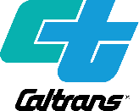
PUBLIC NOTICE
California Department of Transportation, District 4: Interstate 680/Sunol Boulevard Interchange Improvements Project
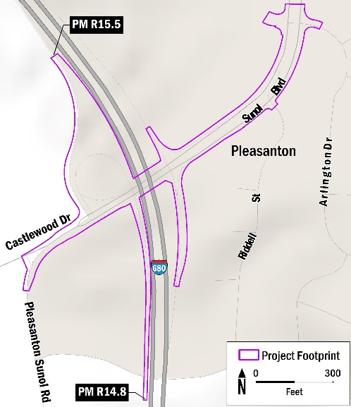
NOTICE OF AVAILABILITY of a Draft Initial Study with Proposed Mitigated Negative Declaration (IS/MND) and virtual open house public meeting.

WHAT’S BEING PLANNED
The California Department of Transportation (Caltrans) District 4, Bay Area, will host a virtual open house public meeting to share information on the proposed Interstate 680/Sunol Boulevard Interchange Improvements Project (project) and answer questions regarding information presented in the IS/MND.
The project would take place along Interstate 680 (I-680), from Post Mile (PM) R14.8 to PM R15.5, and along Sunol Boulevard from Arlington Drive to Castlewood Drive in the City of Pleasanton and unincorporated Alameda County, California. The project would modify intersection traffic controls and lane striping, increase ramp storage, and improve pedestrian and bicycle facilities in the interchange area.
Project Location Map
The purpose of the project is to reduce congestion on Sunol Boulevard, accommodate future traffic volume growth, and improve pedestrian and bicycle access through the interchange. It is needed to address existing congestion on Sunol Boulevard, projected increases in travel demand from future job and housing growth, and gaps in the sidewalk and bicycle lane network through the interchange area.
Caltrans is the California Environmental Quality Act (CEQA) lead agency for the project, and the City of Pleasanton is the project sponsor.

WHAT’S AVAILABLE
The Draft IS/MND is available to read or download on the Caltrans Environmental Document Website here: https://dot.ca.gov/caltrans-near-me/district-4/d4 popular-links/d4 environmental-docs.
For printed copies or assistance, email Daniel.Chan@dot.ca.gov.
TTY users may request copies of the environmental document in alternate formats through the California Relay Service 1 (800) 735-2929 (TTY to Voice), 1 (800) 735-2922 (Voice to TTY), 1 (800) 855-3000 (Spanish TTY to Voice and Voice to TTY), 1-800-854-7784 (Spanish and English Speech-to-Speech) or 711.

WHERE YOU COME IN

Learn More by attending the virtual open house public meeting on Wednesday, April 19, 2023, from 6:00 PM to 7:30 PM to discuss the project and ask questions. Information about the public meeting, including how to log on to the meeting, will be provided at https://dot.ca.gov/caltrans-near-me/district-4/d4 popular-links/d4 environmental-docs.

Submit a comment in writing by May 8, 2023, to Caltrans District 4, Office of Environmental Analysis, ATTN: Daniel Chan, P.O. Box 23660, MS-8B, Oakland, CA 94623-0660, or by email to Daniel.Chan@dot.ca.gov.
Para la traducción de idiomas, use la siguiente información de contacto.
如需语言翻译，请使用以下信息联系
Janis Mara at Janis.Mara@dot.ca.gov or (510) 715-9291
Para la traducción de idiomas, use la siguiente información de contacto.
如需语言翻译，请使用以下信息联系
Alejandro Lopez at Alejandro.Lopez@dot.ca.gov or (510) 385-6856

