CITY OF ATWATER
CATEGORICAL EXEMPTION
ENVIRONMENTAL ASSESSMENT FOR
RSO-PC 0204-22 / CUP 22-11-0100 / SP 22-11-0200

THE PROJECT DESCRIBED HEREIN IS DETERMINED TO BE CATEGORICALLY
EXEMPT FROM THE PREPARATION OF ENVIRONMENTAL DOCUMENTS
PURSUANT TO ARTICLE 19 OF THE STATE CEQA GUIDELINES.

APPLICANT: Jatinder Randhawa
1136 S Jacobs Dr
Mountain House, CA 95391

PROJECT LOCATION: Located in Atwater, CA, near the southwest corner of Applegate Road and Atwater Boulevard on Assessor’s Parcel Number (APN) 001-146-013 & 001-146-017

PROJECT DESCRIPTION:
The applicant is requesting to construct a mini-warehouse facility that will operate seven days a week between 6:00 am and 10:00 pm. The office portion of the project will operate Monday through Friday from 8:00 am to 5:00 pm with two employees per shift and a maximum of four employees during shift change.

The Storage Facility will consist of two buildings totaling approximately 90,124 square feet with 577 storage units and an office. Building A is approximately 11,638 square feet and is located on the east side of the project site. Building B is located on the west side of Building A and is approximately 78,486 square feet, totaling 90,124 square feet (please refer to figure 3). The project will have various storage unit sizes being conditioned and other units not being conditioned; refer to table 1 for further information.

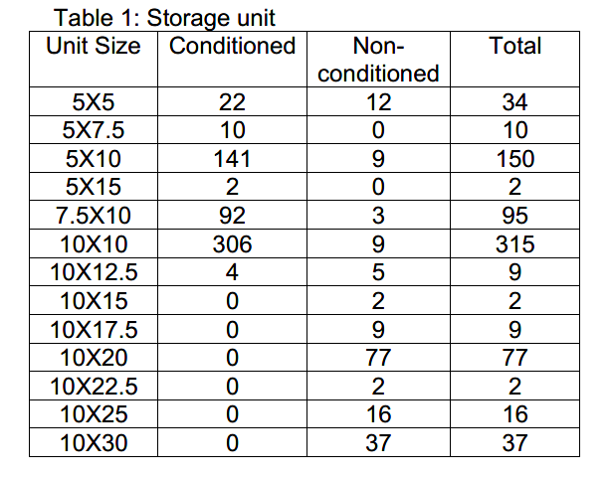

This project is exempt under Sections 15332/Class 32 of the California Environmental Quality Act (CEQA) Guidelines.

Under Section 15332/Class 32, the Project is exempt from CEQA requirements. Section 15332/Class 32 consists of projects characterized as in-fill development meeting conditions described in this section.

- The project is consistent with the applicable general plan designation and all applicable general plan policies as well as with applicable zoning designation and regulations.

- General Plan Consistency. The Project site has a General Plan Land Use Designation of Business Park (Figure 1). According to the Land Use Element in the Atwater General Plan, the Business Park Land Use Designation “provides for large buildings, or a cluster of buildings usually developed in a ‘campus’ style.” The General Plan specifies that business park uses may include manufacturing operations within completely enclosed buildings, associated offices, trade schools, and supporting childcare and retail activities. Further, the General Plan describes effectively screened outdoor storage uses that are quiet and require infrequent use of large trucks for pickup or delivery. The applicable General Plan policy for business parks is Policy LU-2.2 which states the City shall “encourage design of large-scale commercial, industrial, and business park projects that are oriented to a human scale.” In particular, the City has identified an Atwater Redevelopment Area, which the Redevelopment Agency (a separate entity from the City) is tasked with finding and retaining local business. The Project is located within this targeted Redevelopment Project Area and proposes a use – enclosed mini-warehouse for self-storage purposes – that is consistent with the Business Park Land Use Designation. Therefore, the Project is consistent with the applicable general plan designation and all applicable general plan policies for business park uses.

- Zoning Consistency. The Project site is within the Business Park (B-P) Zone District (Figure 2). According to Chapter 17.39, B-P, Business Park District Overlay (Mixed Use District) of the Atwater Municipal Code, the B-P Zone District was established to for a mix of commercial and industrial uses. All uses permitted in the C-O, C-T, C-G, M-1, and M-2 zone districts are permitted in B-P provided they have no adverse environmental impacts. Pursuant to Chapter 17.49.020, warehouses are permitted in the M-1 zone district. Based on the Site Plan (Figure 3), the Project meets and/or exceeds the applicable zoning regulations for the M-1 Zone District as well as the use-specific standards outlined in Chapter 17.49 – Min-Warehouses; however, staff will review details during the site plan review process to ensure compliance with all relevant development standards and design criteria, such as setbacks, height, landscaping, parking, etc. For these reasons, the Project is consistent with the applicable zoning designation and regulations.

- The proposed development occurs within city limits on a project site of no more than five acres substantially surrounded by urban uses. The Project site is an undeveloped ± 2.89-acre parcel in an urbanized area within the city limits of Atwater that is bounded by Union Pacific Railroad to the north, Sycamore Avenue to the south, and approximately 650 feet west of Apple Gate Road on the east. Existing uses within the broader Project area (i.e., within ½-mile radius of the site) comprise a mix of industrial and commercial uses (Figure 4). Although there are several vacant parcels within the project vicinity, a majority of these parcels are planned for Business Park uses (commercial and industrial) and within the Redevelopment Area. As such, the Project occurs within city limits on a site that is no more than five (5) acres and is substantially surrounded by urban uses.

- The project site has no value as habitat for endangered, rare, or threatened species.
The Project site is in an urbanized area in the southern portion of the city of Atwater and has no value as a habitat for endangered, rare, or threatened species for the following reasons:

- The Project would not have a substantial adverse effect, either directly or through habitat modifications, on any species identified as a candidate, sensitive, or special status species in local or regional plans, policies, or regulations, or by the California Department of Fish and Wildlife or the U.S. Fish and Wildlife Service. According to Figure 4-7 of the Atwater General Plan, there are no known special-status wildlife or plant species in the vicinity of the Project. Although vacant, the Project site is surrounded by developed land with parking and curb/gutter that does not provide essential habitat for special-status species. In addition, the site is within an area planned for and developed with industrial and commercial uses; the Project site and area is thereby highly disturbed as a result of development. Thus, the Project would not affect any special-status species.

Figure 1
General Plan Land Use Designation

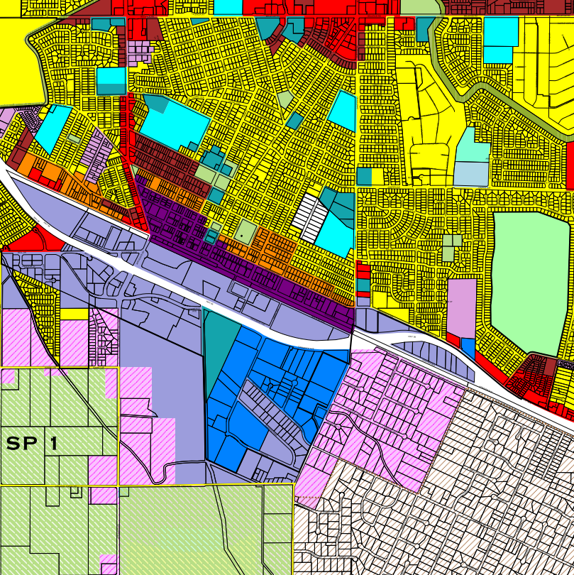 | 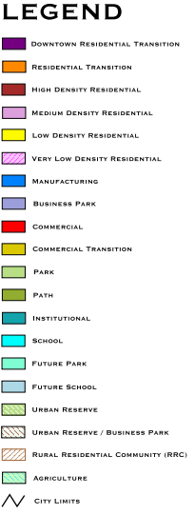
Subject Property
+/- 2.89 acres
N

Figure 2
Zoning Designation

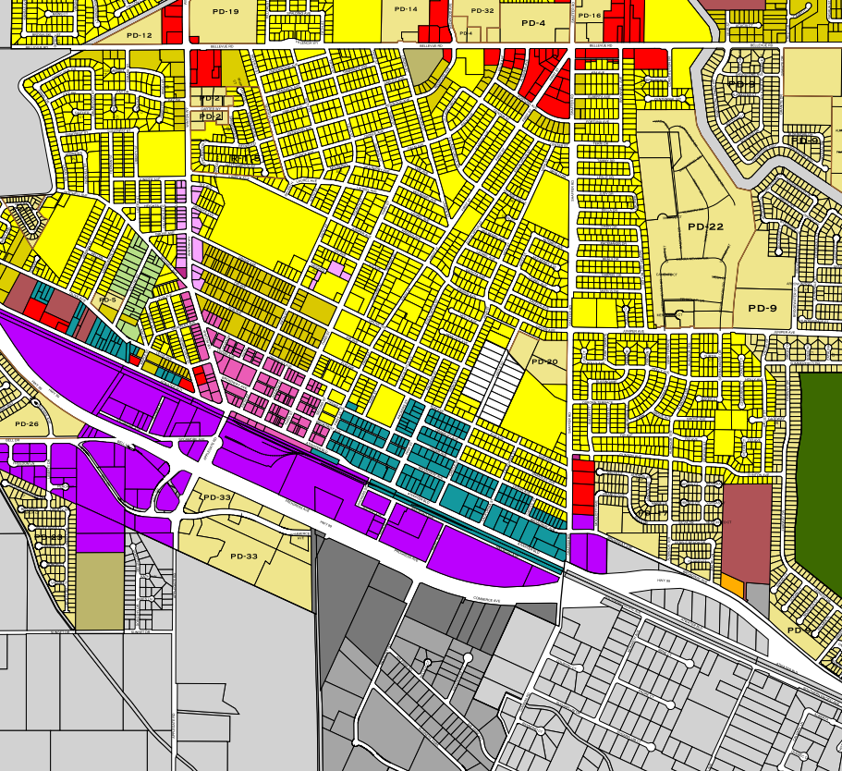 | 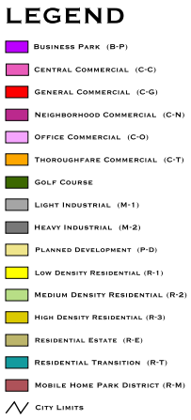
Subject Property
+/- 2.89 acres
N

Figure 3
Project Site Plan
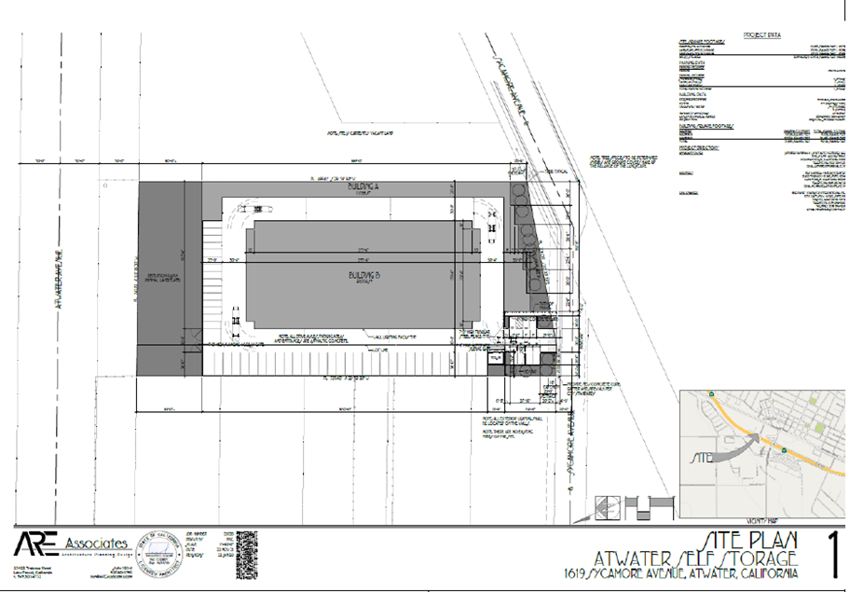

Figure 4
Project Vicinity
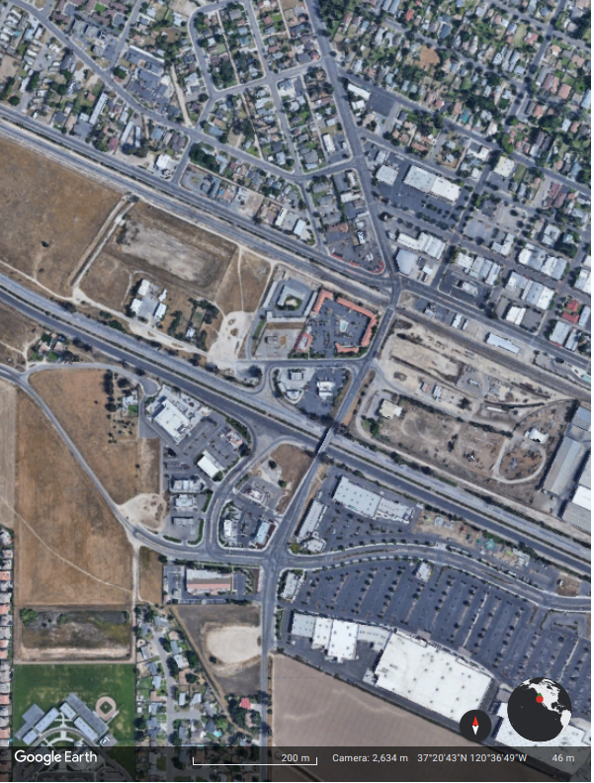

Subject Property
+/- 2.89 acres
N

- The Project would not have a substantial adverse effect on any riparian habitat or other sensitive natural community identified in local or regional plans, policies, or regulations or by the California Department of Fish and Wildlife or the U.S. Fish and Wildlife Service. The Project site does not contain any water features that would provide habitat for riparian or other sensitive natural communities. Further, there are no known riparian habitats or other sensitive natural communities identified within the Project area. According to the Atwater General Plan, wetland habitats within the city and planning area are located immediately north of the Castle Airport (vernal pool and swale concentration), in east Atwater (emergent marsh), and in southeast Atwater (riparian scrub); the site is not located within the vicinity of the wetland sites and is within a developed and urbanized area. As such, the Project would not have an effect on riparian habitats.

- The Project would not have a substantial adverse effect on state or federally protected wetlands (including, but not limited to, marsh, vernal pool, coastal, etc.) through direct removal, filling, hydrological interruption, or other means. A search of the National Wetlands Inventory shows no federally protected wetlands (including but not limited to marsh, vernal pool, coastal, etc.) on the Project site or on parcels adjacent to the Project site. Therefore, the Project would not affect wetlands.

- The Project would not interfere substantially with the movement of any native resident or migratory fish or wildlife species or with established native resident or migratory wildlife corridors or impede the use of native wildlife nursery sites. Although the Project site is undeveloped, it is adjacent to developed property and is within an urbanized area. The site and area are thus disturbed and do not provide appropriate habitat for special-status species. In addition to this, the site does not contain any riparian or other sensitive natural community identified in local or regional plans, or by the National Wetlands Inventory, nor does the site contain any water features that would provide habitat for riparian or other sensitive natural communities. For these reasons, the Project would not interfere with the movement of any special-status species.

- The Project would not conflict with any local policies or ordinances protecting biological resources, such as a tree preservation policy or ordinance. The Atwater General Plan Open Space and Conservation Element outlines policies related to conservation of biological resources and Chapter 12.32 of the Atwater Municipal Code identifies the City’s tree policies. Due to the lack of any identified special-status species or habitat for special-status species on the Project site or within the Project area, the Project would not conflict with any local policies or ordinances protecting biological resources. Therefore, the Project would have no impact.

- The Project would not conflict with the provisions of an adopted Habitat Conservation Plan, Natural Community Conservation Plan, or other approved local, regional, or state habitat conservation plan. The Project site is not subject to an adopted Habitat Conservation Plan, Natural Community Conservation Plan, or other approved local, regional, or state habitat conservation plan. Therefore, construction of the proposed Project would not conflict with the provisions of any adopted habitat conservation plans and no impact would occur.

- Approval of the project would not result in any significant effects relating to traffic, noise, air quality, or water quality.

  - Traffic. Senate Bill (SB) 743 requires that relevant CEQA analysis of transportation impacts be conducted using a metric known as vehicle miles traveled (VMT) instead of Level of Service (LOS). VMT measures how much actual automobile travel (additional miles driven) a proposed project would create on California roads. If the project adds excessive automobile travel onto roads, then the project may cause a significant transportation impact.

The State CEQA Guidelines were amended to implement SB 743 by adding Section 15064.3. Among its provisions, Section 15064.3 confirms that, except with respect to transportation projects, a project’s effect on automobile delay shall not constitute a significant environmental impact. Therefore, LOS measures of impacts on traffic facilities are no longer a relevant CEQA criteria for transportation impacts.

CEQA Guidelines Section 15064.3(b)(4) states that “[a] lead agency has discretion to evaluate a project’s VMT, including whether to express the change in absolute terms, per capita, per household or in any other measure. A lead agency may use models to estimate a project’s VMT and may revise those estimates to reflect professional judgment based on substantial evidence. Any assumptions used to estimate VMT and any revision to model outputs should be documented and explained in the environmental document prepared for the project.” Below is a discussion of the threshold and analysis used to analyze VMT impacts from the proposed Project.

To-date, the lead agency (i.e., City of Atwater) has not established VMT thresholds or guidelines. Wherein existing models or methods are not available to the lead agency to estimate the VMT for the project being considered, provisions of CEQA Guidelines Section 15064.3(b)(3) permits the lead agency to conduct a qualitative analysis. The qualitative analysis may evaluate factors including but not limited to the availability of transit, proximity to other destinations, and construction traffic.

According to page 17 of the Technical Advisory on Evaluating Transportation Impacts in CEQA published by the Governor’s Office of Planning and Research (OPR), “of land use projects, residential, office, and retail projects tend to have the greatest influence on VMT. For that reason, OPR recommends the quantified thresholds described above for purposes of analysis and mitigation. Lead agencies, using more location-specific information, may develop their own more specific thresholds, which may include other land use types.” Since the City of Atwater does not have established thresholds, the Technical Advisory document mentioned above, along with thresholds established by other local jurisdictions (including the City of Fresno) were used to establish a threshold and analyze this project.

Pursuant to the document titled “CEQA Guidelines for Vehicle Miles Traveled Thresholds” prepared for the City of Fresno (a city to the south of Atwater) “a common GHG emissions threshold is 3,000 metric tons (MT) of carbon dioxide equivalent (CO2e) per year. The vehicle emissions are typically more than 50 percent of the total project GHG emissions. Thus, a project with 500 Average Daily Trips (ADT) would generally have total project emissions that could be less than 1,300 MT CO2e/year (i.e., 50 percent or 643 MT CO2e/year coming from vehicle emissions and the other 50 percent coming from other project activities). As this level of GHG emissions would be less than 3,000 MT CO2e/year, the emissions of GHG from a project up to 500 ADT would typically be less than significant.” Based on this analysis and given the fact that the City of Fresno is in the same air basin (San Joaquin Valley Air Basin) as the City of Atwater, allowing the screening out projects that would generate less than 500 ADT is appropriate.

CEQA Guidelines Section 15064.3, “vehicle miles traveled’ refers to the amount and distance of automobile travel attributable to a project.” The term “automobile” refers to on-road passenger vehicles, specifically cars and light trucks. Thus, trips associated with large trucks are excluded from the VMT analysis and only employee and customer trips must be considered for VMT analysis.

Utilizing the City of Fresno’s 500 ADT threshold, the Project’s anticipated trip generation was estimated through the Institute of Transportation Engineers (ITE) Trip Generation Manual, 11th Edition. The applicable land use (ITE Code) is Mini-Warehouse, based on the proposed use and the operations of the previously developed warehouse on the Project site. As shown in Table 1, the Project is anticipated to generate a maximum of 10 daily a.m. peak hour (7a.m. to 9a.m.) trips, and 23 p.m. peak hour (4 p.m. to 6 p.m.) trips. The total number of projected average daily trips generated by the Project will be a maximum of 153 ADT. Since the anticipated trips are under the threshold of 500 trips, the Project can thereby be determined to have a less than significant impact for any net increase in total VMT. Therefore, the Project would not conflict or be inconsistent with CEQA Guidelines Section 15064.3, subdivision (b).

Table 1. Trip Generation for the Proposed Project
Land Use  (ITE Code) | Unit of Measurement | Project Size (in thousands) | Daily |  | A.M. Peak Hour |  | P.M. Peak Hour
 |  |  | Rate | Total | Trip Rate | Total | Trip Rate | Total
Mini-Warehouse (151) | 1,000 SF | 104.96 | 1.45 | 152.19 | 0.09 | 9.45 | 0.15 | 22.83

  - Noise. Although the Project would result in increased ambient noise level at the Project site, compliance with the General Plan and Municipal Code requirements would result in the Project’s compliance with applicable standards. Two (2) noise generating sources of the Project would include construction (short-term, temporary) and operational (long-term) noise, each described below. Overall, the Project would result in a less than significant impact in regard to noise as discussed below.

    - Short-Term Noise: Construction. Construction would result in short-term noise impacts. Temporary construction noise impacts from construction activities would be generated from the use of construction equipment for grading the site and building the proposed structures. Construction would not include equipment such as piledriving that would cause significant noise impacts. Further, Project construction is not expected to result in a significant impact because the noise would be generated during daylight hours and not during evening or more noise-sensitive time periods; and the increase in noise would cease upon completion of the Project. In particular Section 8.44.050 of the Atwater Municipal Code regulates permissible hours of construction between the hours of 7:00 am and 7:00 pm, Monday through Friday, and 9:00 am and 5:00 pm, Saturdays and Sundays. For these reasons, the Project would have a less than significant impact in regard to construction noise impacts.

    - Long-Term Noise: Operations. In terms of noise from operations, the Project would consist of general manufacturing uses in an enclosed warehouse building. According to the General Plan, outside storage for business park uses is limited and must be effectively screened with solid fencing and/or landscaping. This screening would help reduce noise levels. In addition, the General Plan recognizes business park uses to be “quiet and require infrequent use of large trucks for pickup or delivery of parts of products.” Operational noise sources would be similar to those generated in the surrounding area, which comprises similar uses as permitted within the business park land use designation. Further, the Project would be required to comply with the General Plan and Municipal Code requirements. For these reasons, the Project would have a less than significant impact in regard to noise impacts from operations.

  - Air Quality. Air quality planning in the San Joaquin Valley Air Basin is conducted by the San Joaquin Valley Air Pollution Control District (SJVAPCD). The SJVAPCD is responsible for monitoring and regulating air pollutant emissions from stationary, area, and indirect sources within Merced County. CalEEMod was used to determine the potential emissions of regulated criterion pollutants for the Project. CalEEMod defaults were used. Overall, the Project would not have any significant effects relating to air quality for the following reasons:

    - The Project would not conflict with or obstruct implementation of the applicable air quality plan (e.g., by having potential emissions of regulated criterion pollutants which exceed the San Joaquin Valley Air Pollution Control Districts (SJVAPCD) adopted thresholds for these pollutants). The SJVAPCD outlines its significant thresholds in the Guidance for Assessing and Mitigating Air Quality Impacts (GAMAQI). The primary pollutants of concern during project construction and operation are ROG, NOx, CO, PM₁₀ and PM_{2.5}. The SJVAPCD GAMAQI adopted in 2015 contains thresholds for ROG, NOx, CO, PM10, and PM2.5. Table 2. below shows these thresholds and the Project totals in relation to these thresholds (in tons per year). CalEEMod output files are presented in Attachment 1. The CalEEMod model assumes standard inputs typical of light industrial with construction starting in January 2023 and operation starting in 2024. As shown, the construction and operation of the Project are below all significant thresholds.

Table 2. CO, NO_{x}, ROG, PM₁₀, PM_{2.5} Thresholds, Maximum
Emission Source (Tons Per Year) | CO | NO_{x} | ROG | PM₁₀ | PM_{2.5}
Construction
Construction, Average Daily, Unmitigated | 10.6 | 9.12 | 1.34 | .79 | 0.47
Operational
Operational, Average Daily, Unmitigated | 2.25 | 0.02 | 2.75 | 0.005 | 0.005
Total Emissions
Construction and Operational | 12.85 | 9.14 | 4.09 | 0.795 | 0.475
Significance Threshold | 100 | 10 | 10 | 15 | 15
Exceed Threshold? | No | No | No | No | No
Source: CalEEMod, Version 2022.1, ran on October 19, 2022.

Additionally, the Project shall comply with all rules and regulations administered by the SJVAPCD including but not limited to Regulation VIII - Fugitive PM₁₀ Prohibitions, Rules 8011-8081 which intend to minimize human-generated PM₁₀ emissions (e.g. dust and dirt) and Indirect Source Review, Rule 9510 which intends to minimize NO_{x} and PM₁₀ emissions through on-site mitigation or district-administered projects off-site.

Overall, the Project would not have potential emissions of regulated criterion pollutants that exceed the SJVAPCD adopted thresholds and the proposed project shall be conditioned to meet additional rules and regulations administered by the SJVAPCD to minimize and mitigate on-site emissions, in addition to considerations of recommendations provided by the SJVAPCD. As such, the Project would comply with all relevant air quality plans and policies and thus, would not result in any significant effects relating to air quality.

    - The Project would not result in a cumulatively considerable net increase of any criteria pollutant for which the project region is non-attainment under an applicable federal or state ambient air quality standard. The San Joaquin Valley Air Basin is in non-attainment for ozone, PM₁₀, and PM_{2.5}, which means that certain pollutants' exposure levels are often higher than the normal air quality requirements. The requirements have been set to protect public health, particularly the health of vulnerable populations. Therefore, if the concentration of those contaminants exceeds the norm, some susceptible individuals in the population are likely to experience adverse health effects. Concentration of the pollutant in the air, the length of time exposed and the individual's reaction are factors that affect the extent and nature of the health effects. Although the construction and operations of the Project would not exceed the thresholds of significant for criteria pollutants as set by the GAMAQI (See Table 2), there are PM₁₀, and PM_{2.5} emissions associated with the Project and the Project would thereby contribute to cumulative increases. However, the construction and operational emissions analysis shows that the Project is well below the substantial thresholds of the GAMAQI and thus the project is compliant with the applicable Air Quality Attainment Plan. Therefore, the Project would not result in significant cumulative health impacts because the emissions are not at a level that would be considered cumulatively significant. As such, the Project would have a less than significant impact.

    - The Project would not expose sensitive receptors to substantial pollutant concentrations. Sensitive receptors are defined as people that have an increased sensitivity to air pollution or environmental contaminants. Sensitive receptor locations include schools, parks and playgrounds, day care centers, nursing homes, hospitals, and residential dwelling unit(s). The site is in an industrial and commercial area with the nearest receptors being multi-family-family development to the north of the Project site on the other side of the Union Pacific Railroad and Atwater Boulevard (approximately 220 feet north). As stated above, emissions during construction or operations would not reach the significance thresholds and are not anticipated to result in concentrations that reach or surpass ambient air quality requirements. In addition, the project proposes an enclosed warehouse for mini-storage uses, which is not a use that results in excessive pollutant concentrations which could impact sensitive receptors.

    - The Project would not result in other emissions (such as those leading to odors) adversely affecting a substantial number of people. Specific land uses that are considered sources of undesirable odors include landfills, transfer stations, composting facilities, sewage treatment plants, wastewater pump stations, asphalt batch plants and rendering plants. The Project would not consist of such land uses and is unlikely to produce odors that would be considered to adversely affect a substantial number of people. Further, there are no major odor-generating sources within the Project area. Although some odors would be emitted during construction of the site (i.e., through diesel fuel and exhaust from equipment), these odors would be temporary and last only during construction activities. For these reasons, the odor impacts associated with the Project would be less than significant.

  - Water Quality. The City of Atwater provides water service for residences, commercial establishments, manufacturing plants, institutional facilities, and parks within the city limits. The water supply is obtained from the Merced Subbasin and consists of a groundwater system of wells and a one (1)-million-gallon elevated steel reservoir that is used for peaking storage and fire flows. The City of Atwater Public Works Department has determined that, with all conditions of approval incorporated into the Project, the City has adequate water supply to serve the Project, as it is proposed on a site that is of a type and intensity of development that is consistent with the planned land use designation for which it was previously planned. The Project would be required to construct new individual water services for potable and landscape purposes to the City of Atwater’s Standards and Specifications in addition to all water control plans and other hydrological requirements including Chapter 13.22 of the Atwater Municipal Code which contains the City’s storm water management and discharge control regulations. Through compliance with all conditions of approval provided by the City of Atwater Public Works and Community Development Department Engineering Division, the Project would not violate any water quality standards or waste discharge requirements or otherwise substantially degrade surface or ground water quality. For these reasons, the Project would not result in any significant effects relating to water quality.

- The site can be adequately served by all required utilities and public services.

  - Utilities and Service Systems. The Project site is located within the city limits of Atwater and will be required to connect to water, sewer, stormwater, and wastewater services provided by the City of Atwater and may be subject to fees to be provided such services. Private companies provide solid waste collection and disposal and electricity and natural gas. Although the Project site is undeveloped and may be required to construct new lines to connect to City services, the site is adjacent to developed parcels and it has been determined by the City that it has adequate capacity to accommodate the Project as a permitted use is the designated zone district. Through compliance with all conditions of approval provided by the City of Atwater Public Works and Community Development Department Engineering Division, the Project would be adequately served by all required. For these reasons, the Project site can be adequately served by all required utilities.

  - Public Services. The Project site is located within the city limits of Atwater and thus, would receive public services provided by the City of Atwater and shall be subject to applicable fees to provide such services. Services provided are described as follows.

    - Fire Protection. Fire protection services in the city are provided by Cal Fire. The Project will be required to comply with all fire safety measures outlined in the Atwater Municipal Code Chapter 15.28, which adopts by reference the current California Fire Code. Given the fact the Project would be required to meet standard requirements which includes the current Fire Code at the time of issuance of building, the impact of the Project would be less than significant.

    - Police Protection. The Project will be served by the Atwater Police Department. The Project will be required to comply with any and all conditions received from the Police Department, all applicable current local, state, and federal law, and all applicable provisions from the Atwater Municipal Code. As such, the Project would not significantly impact police protection services or require the construction of new or altered facilities. Therefore, the Project would have a less than significant impact.

    - Schools. The Project proposes an industrial use and would not result in a net increase in the area population. Thus, because of the nature of the Project and the characteristics of the area (i.e., industrial, and commercial), there would be no increased demand for existing schools and the Project would thereby not result in adverse physical impacts or the need for altered or new facilities. Therefore, the Project would have no impact.

    - Parks. Park and recreational facilities are typically impacted by an increase in use from proposed residential development. The Project proposes an industrial use and would not result in a net increase in the area population. Thus, because of the nature of the Project and the characteristics of the area (i.e., industrial, and commercial), there would be no increased demand for existing neighborhood and regional parks, or other recreation facilities associated with the Project and the Project would thereby not result in adverse physical impacts or the need for altered or new facilities. Therefore, the Project would have no impact.

Based on the analysis contained above, none of the exceptions to Categorical Exemptions set forth in the CEQA Guidelines, Section 15300.2 apply to this Project:

- Location. Classes 3, 4, 5, 6, and 11 are not applicable to the proposed Project, therefore such location considerations are not applicable.

- Cumulative Impact. The City’s Municipal Code would ensure that implementation of successive projects of the same type in the same place, over time would not constitute a significant, cumulative impact.

- Significant Effect. Based on the analysis provided above, the Project is not expected to have a significant effect on the environment due to unusual circumstances.

- Scenic Highways. According to the California State Scenic Highway System Map, the Project is not located near a State-designated scenic highway and therefore, the Project would not damage scenic resources within a state scenic highway.

- Hazardous Waste Sites. The Project site is not included on any list compiled pursuant to Section 65962.5 of the Government Code.

- Historical Resources. According to the Atwater General Plan and the California Office of Historic Preservation, there are no local, state, or federal designated historical resources on the Project site or within the Project Area (i.e., ½-mile radius). Therefore, the Project would not impact any historical resources.

Overall, the Project is consistent with the applicable general plan designation and policies as well as the applicable zoning designation and regulations. It occurs within city limits on a site less than five (5)-acres in size within an urbanized area. The highly disturbed site within an urbanized area has no value as habitat for endangered, rare, or threatened species. Further, the Project would not result in any significant effects relating to traffic, noise, air quality, or water quality and can be adequately served by all required utilities and public services. As such, the proposed Project is not expected to have a significant effect on the environment. Accordingly, a categorical exemption, as noted above, has been prepared for the Project.

Date: March 15, 2023

Prepared By: Precision Civil Engineering, Inc.

Submitted by: Sam Rashe
Samuel J. Rashe
Senior Planner
City of Atwater
(209) 357-6342

