Work Summary
The Department of Water Resources (DWR) and the San Joaquin River Conservancy (SJRC) are working to advance several floodplain restoration projects to improve salmonid habitat and recharge along the Upper San Joaquin River. As part of this effort, the project team is interested in water level monitoring along a 5-mile stretch of river downstream of HWY 41 that includes several SJRC properties. The project team is proposing to install 8 surface water level loggers along this reach to collect data that can be used to calibrate hydraulic models and inform surface and shallow groundwater dynamics. The loggers would all be accessed through SJRC properties and would be visited several times over the next year. The installations would be designed to include minimal disturbance of vegetation and soils and are intended for rapid deployment so that data can be collected during this winter. A typical installation would include several T-posts driven into the soil, and PVC instrument housing for a level logger attached with a cable.
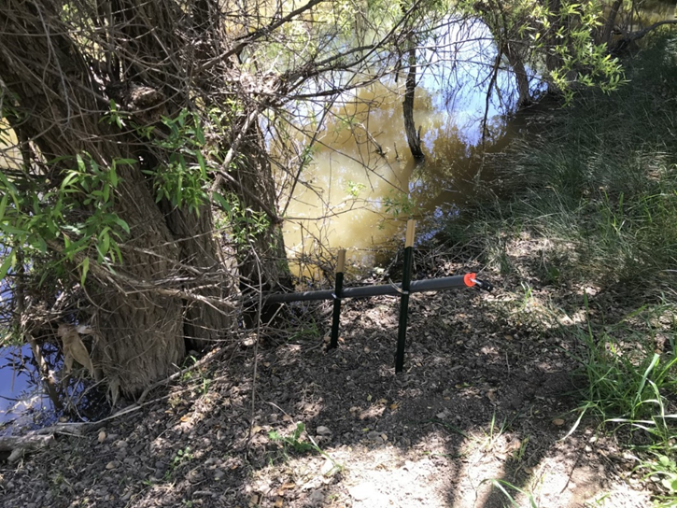
Figure 1. Example of Similar Installation

Work Location
Work will occur in Fresno and Madera Counties. Logger will be installed at the locations in Table 1 and shown in Figure 2.
Table 1. Logger Locations
Name | Latitude | Longitude | County
SJR 02 | 36.85053 | -119.816978 | Madera
SJR 03 | 36.852109 | -119.818027 | Madera
SJR 04 | 36.855311 | -119.836966 | Madera
Sycamore 01 | 36.854959 | -119.819194 | Madera
SJR 01 | 36.867953 | -119.80648 | Madera
Van Buren 02 | 36.869712 | -119.806253 | Madera
Van Buren 01 | 36.873642 | -119.80016 | Madera
Ball Ranch 01 | 36.936127 | -119.7383 | Fresno
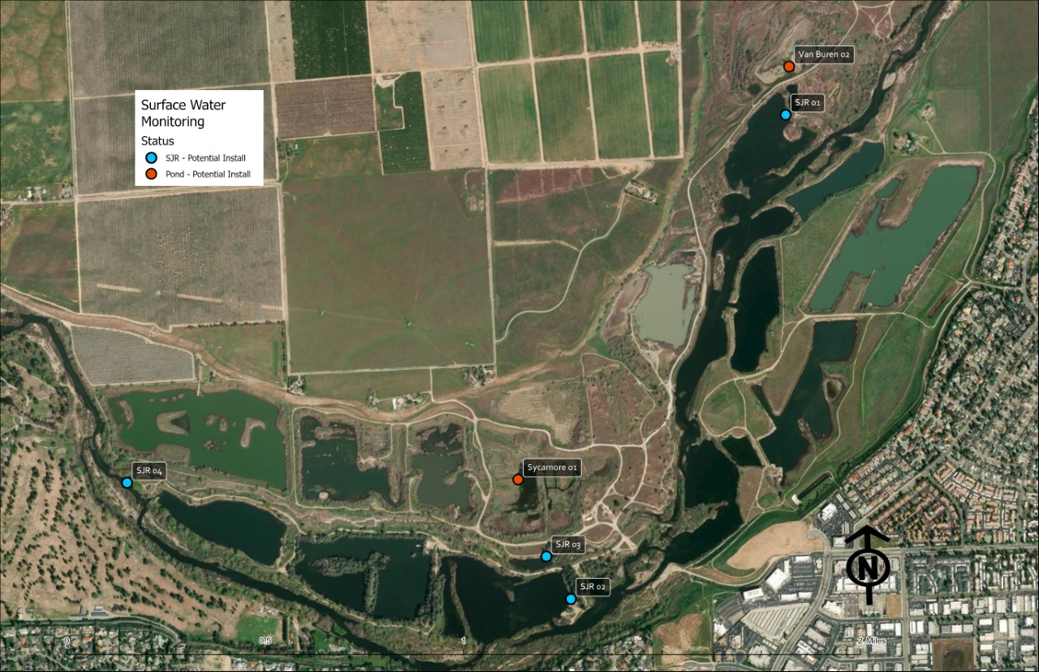
Figure 2. Logger Locations

