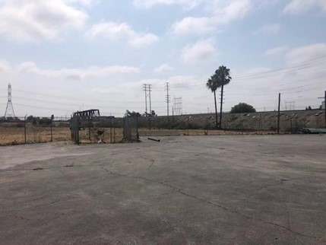

Former Armstrong, Inc. Site
CEQA Exemption Report
prepared by
BLODGETT BAYLOSIS ENVIRONMENTAL PLANNING
2211 HACIENDA BOULEVARD, SUITE 107
HACIENDA HEIGHTS, CALIFORNIA 91745
August 2022

Table of Contents

Table of Contents 1
CEQA Exemption Report 1
1. Introduction 1
2. Project Site and Existing Conditions 1
3. Project Description 5
Background 5
Lead Agency Approval 5
Scope of Work 5
4. Consistency Analysis 6
General Rule CE Applicability 6
Pre-Excavation Activities 6
Excavation Activities 6
5. Summary 7
6. References 7
Figures
Figure 1 Regional Location Map 3
Figure 2 Project Site and Location 4

This page intentionally left blank.

CEQA Exemption Report
This report serves as the technical documentation of an environmental analysis performed by Blodgett Baylosis Environmental Planning for the excavation and remediation of soil containing asbestos at the Armstrong Inc., site (Project). The intent of the analysis is to document whether the Project is exempt from the California Environmental Quality Act (CEQA) pursuant to CEQA Guidelines Section 15061(b)(3) (Common Sense Exemption). The report provides an introduction, project description, and an evaluation of the Project’s consistency with the Common Sense Exemption. The report concludes that the project is exempt pursuant to the Common Sense Exemption.

Introduction
Under the Common Sense Exemption, CEQA exempts activities have no possibility of causing a significant effect on the environment. The Common Sense Exemption states that “Where it can be seen with certainty that there is no possibility that the activity in question may have a significant effect on the environment, the activity is not subject to CEQA.”
Blodgett Baylosis Environmental Planning evaluated the Project to determine whether there is any evidence to suggest that the Project could possibly result in a significant environmental impact. As discussed in the following sections of this report, Blodgett Baylosis Environmental Planning concludes that there is no possibility the Project will result in significant environmental impacts, and therefore the project is eligible for the Common Sense Exemption.

Project Site and Existing Conditions
The Project is located at 5037 Patata St. in the City of South Gate (South Gate). Figure 1 shows the regional location of the Project and Figure 2 shows an aerial photograph of the Project’s location within its neighborhood (Project Site).
The Project Site is located within the corporate boundaries of the City of South Gate. South Gate is located approximately ten miles southeast of downtown Los Angeles and 13.5 miles north of the port of Long Beach. South Gate is bounded by the cities of Huntington Park, Cudahy, and Bell Gardens on the north; unincorporated Los Angeles County areas to the west; Lynwood and Paramount on the south; and Downey to the east. The location of South Gate in a regional context is shown in Exhibit 2-1. A citywide map is provided in Exhibit 2-2. The Project Site’s latitude and longitude are 33° 95’56̍.75” N, –118° 76°66’29” W.5 The 27.12-acre Project Site is located within the northeastern portion of South Gate (refer to Exhibit 2-2). The applicable Assessor’s Parcel Number (APN) for the Project Site is 6224-031-003.
The Project Site is located in the northeastern corner of South Gate, which generally consists of manufacturing and distribution uses. Residential development extends along the northern boundary of the Project Site within the corporate boundaries of the City of Cudahy. A vicinity map of the Project Site is provided in Exhibit 2-3. The Project Site is generally bounded by the Los Angeles River along the eastern side, Patata Street and the Union Pacific Railroad (Patata Industrial Lead line) is located to the south, an industrial property and Wilcox Avenue is located to the west, and the aforementioned residential neighborhood is located to the north. Local access to the Project Site is provided by Patata Street, which connects to Atlantic Avenue, located approximately 0.30 mile to the west of the Project Site. Atlantic Avenue provides access to I-710 via Firestone Boulevard.
The majority of the Project Site was previously occupied by the former Armstrong World Industries plant with the former improvements having consisted of approximately 239,200 square feet of manufacturing- related floor area. This plant is now closed and there are no operations being conducted at this time. The western portion of the Project Site was occupied by manufacturing buildings that have since been demolished. The eastern portion of the Project Site, located next to the Los Angeles River, is vacant and undeveloped. The previous buildings that occupied the Project Site included a 5,630-square-foot office building, a 216,600-square-foot concrete manufacturing building, and a 16,970-square-foot metal building.
The only remaining structural improvements include building foundations, broken concrete and asphalt circulation and parking areas, and some unmaintained landscaping. An existing operational cellular tower is located in the east-central portion of the Project Site. Historic aerial photographs show that the Project Site contained structures on the western half of the Project Site dating back to 1954. The Project Site has no street frontage and has a single point of ingress and egress that is located at the eastern terminus of Patata Street.

Figure 1 Regional Location Map
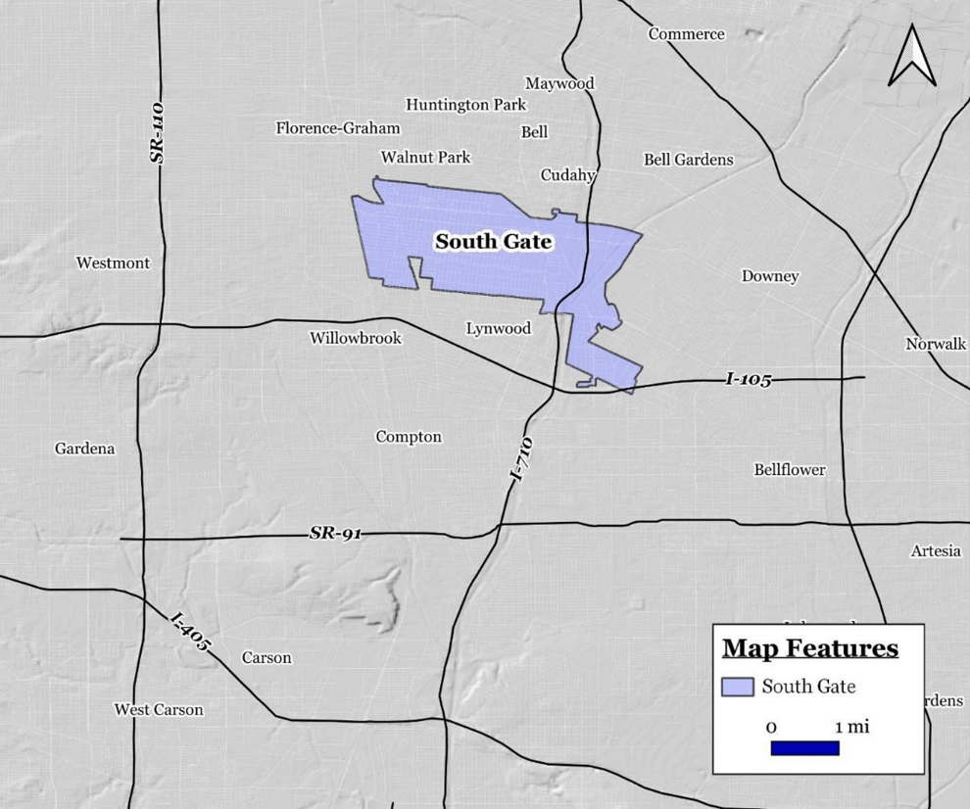
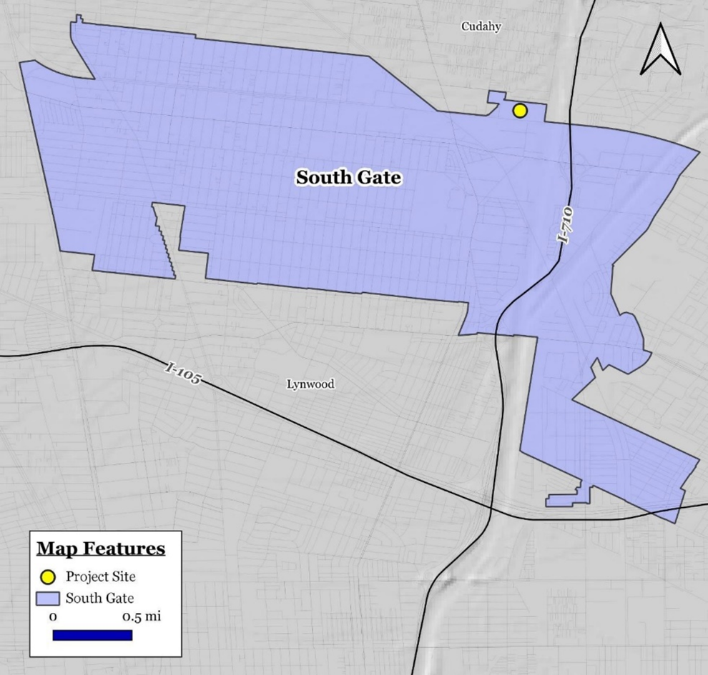

Figure 2 Project Site and Location
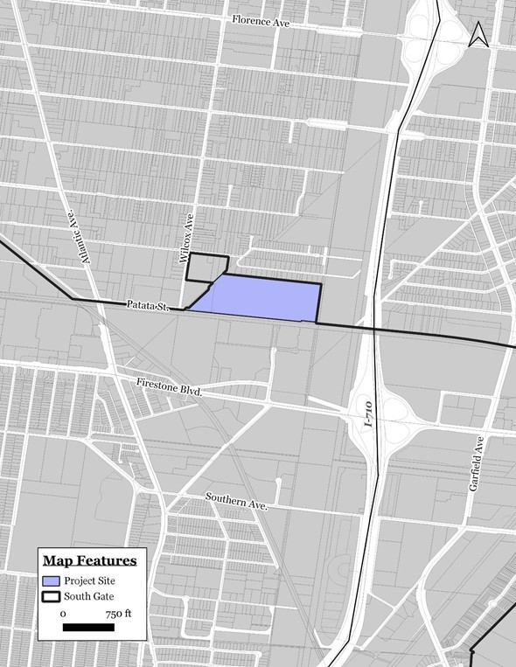

Project Description

Background
In January 2020, Armstrong entered into a Corrective Action Consent Agreement (CACA) with the California Department of Toxic Substances Control (DTSC) to investigate possible source areas on the site associated with a regional volatile organic compound (VOC) issue. The CACA included a list of possible chemicals of concern (COCs) which included asbestos. In March 2021, Armstrong sold the property to South Gate Owner, LP. (SGO). Since acquisition, SGO has assumed the obligations of the CACA, including the independent obligation to complete any necessary soil remediation, per the terms of the CACA.
Therefore, the remediation required under the CACA has independent utility because it is an independent obligation, requiring remediation is to occur regardless of whether the Project Site is developed in the future.

Lead Agency Approval
DTSC is contemplating whether to approve an Interim Measures Workplan for the remediation and excavation of soil containing asbestos. DTSC’s authority to approve the Project stems from Section 5.1 through Section 5.5 of the CACA. Because DTSC is ultimately responsible for overseeing the remediation and excavation of the soil containing asbestos, DTSC is acting as the lead agency for this Project.

Scope of Work
The Project involves the excavation and off-site disposal of asbestos-containing materials. Excavation of the asbestos-containing materials will be completed by a State-licensed asbestos abatement contractor, under the direction of a Certified Asbestos Consultant (CAC) and a California Professional Geologist from Ardent. DTSC will oversee the soil remediation.
Five areas within the Project Site were identified as requiring remediation. As presented below, the estimated volume of the soil to be remediated was calculated in bank cubic yards (i.e., in-place volumes, yd3). A 1.3 expansion factor was applied, and the volumes were recalculated as excavated cubic yards. These volumes were calculated based on a conversion factor of 1.5 tons per cubic yards.
- Area 1: 7,822 bank yd3, or 10, 168 excavated yd3, or 15,253 tons
- Area 2: 8,329 bank yd3, or 10, 827 excavated yd3, or 16,241 tons
- Area 3: 5,332 bank yd3, or 6,932 excavated yd3, or 10,400 tons
- Area 4: 564 bank yd3, or 733 excavated yd3, or 1,100 tons
- Area 5: 1,260 bank yd3, or 1,637 excavated yd3, or 2,455 tons
Areas 1 through 4 will be excavated with a backhoe operated by Three D Service Company, Inc. (Three D) of Pomona, California, a state licensed abatement contractor. The excavated soil will be direct-loaded onto trucks and “burrito-wrapped” with Visqueen plastic. These materials will be transported off-site under hazardous waste manifests to Waste Management Azusa Land Reclamation, an off-site facility licensed to accept asbestos-containing waste. Area 5 will be remediated by excavation at a later date.

Consistency Analysis

General Rule CE Applicability
Pursuant to the Common Sense Exemption, CEQA exempts activities that can be seen with certainty to have no possibility for causing a significant effect on the environment. The Common Sense Exemption provides that “CEQA applies only to projects which have the potential for causing a significant effect on the environment. Where it can be seen with certainty that there is no possibility that the activity in question may have a significant effect on the environment, the activity is not subject to CEQA.”
The Project meets the above criteria because the excavation required to remediate the site is minimal and all excavation activities are required to comply with the strict regulatory standards set forth in the CACA and the South Coast Air Quality Management District (SCAQMD) rules applicable to excavation activities.

Pre-Excavation Activities
A Health and Safety Plan (HASP) was prepared as part of Ardent’s Soil Management Plan (SMP) for the site, dated June 9, 2021. The HASP will be used by Ardent personnel and its subcontractors. Ardent has also prepared a Transportation Plan associated with the hauling of the contaminated materials. This Transportation Plan was prepared in accordance with the DTSC’s Hazardous Materials Transportation Guides (DTSC, 1991) and Transportation Plan Preparation Guidance for Site Remediation (DTSC, 1994). The Plan outlines the waste characteristics, destination, mode of transportation, route(s), traffic control and loading plan, record keeping, health and safety, and contingency plan associated with transporting asbestos-containing soil and/or tile chips known to exist at the Project Site.
Prior to excavation activities, a Procedure 5 Work Plan will be prepared in accordance with Rule 1403 and submitted to the SCAQMD. Upon approval of the Procedure 5 Work Plan, DTSC and SCAQMD will be notified of the proposed schedule.

Excavation Activities
Prior to and during excavation, Ardent will monitor ambient air. Each day before excavation activities begin, Ardent will collect baseline ambient air data which will include project boundary monitoring of PM10 and meteorological conditions, including wind direction and velocity. During excavation activities, and as described below, air monitoring is required to be undertaken, which will include nuisance and fugitive dust, worker safety, and particulate emissions from soils with toxic air contaminants. The SCAQMD regulations that apply to the development activities include Rules 402, 403, 1403, and 1466. Rule 1403 pertains to the removal of asbestos-containing materials and identifies procedures to limit asbestos emissions to the environment, and includes survey and notification requirements.

Summary
Based on the limited scope and operations of the Project, the Project meets the criteria for the Common Sense Exemption.
The Project will not result in any long-term emissions because the Project is anticipated to only take approximately 6 months to complete. The Project will not result in any short-term emissions because the remediation and excavation activities is generally limited to removing the contaminated soils from the Project site and transporting it to the Azusa landfill approximately 26 miles away from the Project site. The Project Applicant is anticipating only 60 truck trips per day over the six month period. Therefore, the Project will not have any air quality impacts because the Project has a short lifespan and generally only requires hauling contaminated soils a short distance
Due to the current state of the project site and the level of development in the surrounding area, the Project site does not offer a suitable habitat for any rare and/or endangered species. There are no local or regional plans, policies, or regulations that identify any riparian habitat or other sensitive natural community, nor does the California Department of Fish and Wildlife identify any such habitat. The portions of the Los Angeles River that are located near the Project site are concrete-lined and do not offer suitable riparian vegetation. The U/S. Fish and Wildlife Service National Wetlands Inventory Wetlands Mapper does not identify any wetlands in the vicinity of the Project site. Therefore, the Project will not have any impacts on biological resources.
A records search for the Project site and a 0.5-mile radius beyond the Project boundaries was conducted at the SCCIC located at California State University, Fullerton. The current inventories of the NRHP, the CRHR, the CHL list, the CPHI list, and the California BERD for Los Angeles County were also reviewed to determine the existence of previously documented local historical resources. The results of the records search indicate that two historic resources have been recorded within 0.5-mile of the Project site. None of which are located within the Project boundaries. There are also seven area-specific survey reports on file within the 0.5-mile radius; one report (LA-11993) addresses the Project site, and two reports (LA-08255 and LA-04834) are immediately south of the project boundaries. These reports indicate that the Project site and the surrounding area have previously been surveyed for cultural resources. The results of the surveys did not identify any cultural resources. Therefore, the Project will not result in any cultural resource impacts.
The SCAQMD recommends calculating the total greenhouse gas emissions for the construction activities, dividing it by a 30-year project life. The SCAQMD has adopted interim GHG thresholds for development projects within the South Coast Air Basin. According to the SCAQMD, the interim thresholds for this Project would be 10,000 MTCO2E per year. The excavation and remediation of the Project site would not result anywhere near 10,000 MTCO2E per year over 30 years because the Project is only estimated to last six months and generally only involves transporting contaminated soils to the nearby Azusa landfill. Therefore, the Project will not result in any significant GHG emissions.
The distance from the site to the landfill is approximately 26 miles, which will take approximately 45 minutes during the hours of 9:00 am to 3:00 pm. However, during the peak driving times (7:00 am to 9:00 am), considered “rush-hour traffic,” the route will take approximately 1 hour to complete. Approximately 20 trucks will be used daily with each truck making 3 roundtrips. The loading and transporting of materials are anticipated to take place from 7:00 am to 3:00 pm, Monday through Friday, over a 15-week period. Given the short distance between the Project site and the landfill and the relatively minimal number of trips to the landfill, the Project will not result in any significant GHG emissions.
The Project only involves remediating and excavating contaminated soil from the Project site to the Azusa landfill. As such, the Project will not result in any waste water discharge or degrade ground water quality, nor will the Project substantially decrease groundwater supplies or interfere with groundwater recharge. The Project will also not substantially alter any existing drainage pattern. The Project site is not located within a 100-year flood plain. Instead, the Project site has an annual probability of flooding of less than 0.2 percent and represents areas outside the 500-year flood plain. Therefore, the Project will not have any hydrology impacts.

References
Google Maps. Website accessed on February 22, 2022 and Site Surveys conducted by Blodgett Baylosis Environmental Planning.
California Department of Toxic Substances Control (DTSC). 2019a. EnviroStor. https://www.envirostor.dtsc.ca.gov/public/. (accessed February 2019).
2019b.
Hazardous Waste and Substances Site List (Cortese List). http://www.dtsc.ca.gov/SiteCleanup/ Cortese_List.cfm. (accessed February 2019).
United States Geological Survey. South Gate 7 ½ Minute Quadrangle. 1994.
Los Angeles County Department of Public Works. Flood Zone Determination Website. http:// dpw.lacounty.gov/wmd/floodzone/.
FEMA. Flood Zones, Definition/Description. http://www.fema.gov/floodplain-management/ flood-zones.
Revised Interim Measures Work Plan for Subsurface Asbestos. Ardent Environmental Group, Inc. (July 1, 2022).

