WHITNEY CONCETTA WELL 60 CONNECTION to the NORTH SERVICE AREA

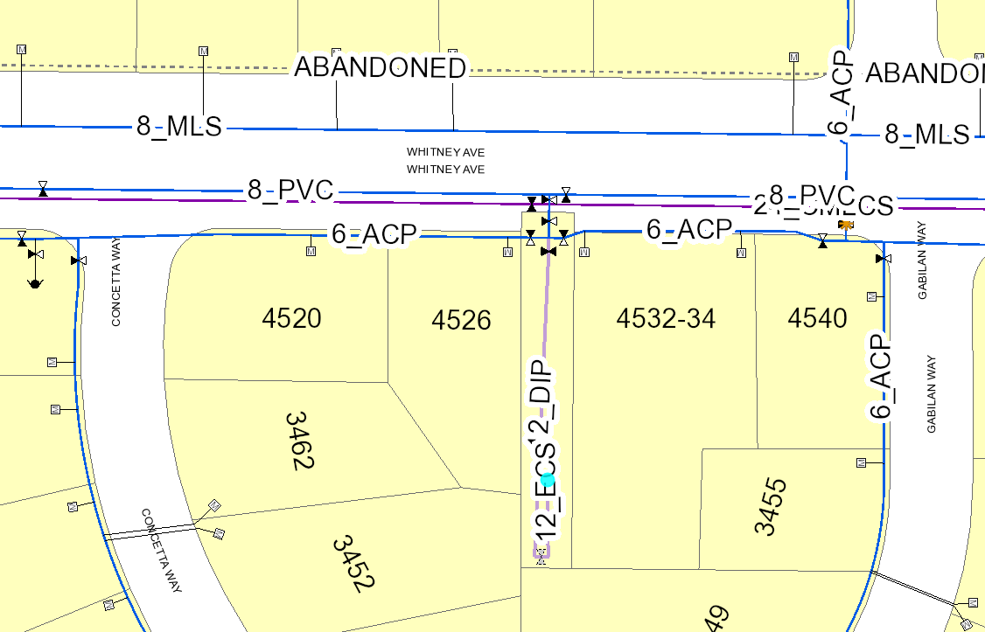
Extend main to 8-inch MLS
Well 60
South Service Area
North Service Area

