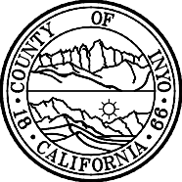

Planning Department  168 North Edwards Street Post Office Drawer L  Independence, California 93526 | Phone: (760) 878-0263  FAX: (760) 872-2712  E-Mail: inyoplanning  @inyocounty.us

To whom it may concern,

Re: SCH # 2022110323
Project: Renewable Energy Permit 2022-02/Barker- Trona 4

I have an updated Notice of Approval that has extended the public comment period.
I would like to know if this can be posted on Schedule 2022110323

I have attached the new recorded NOA.

Thank you,

Cynthia Draper
Inyo County Assistant Planner
760-878-0265

