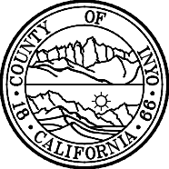

Planning Department  168 North Edwards Street Post Office Drawer L  Independence, California 93526 | Phone: (760) 878-0263  FAX: (760) 872-2712  E-Mail: inyoplanning  @inyocounty.us

To whom it may concern,

Re: SCH # 2022110323
Project: Renewable Energy Permit 2022-02/Barker- Trona 4

I am requesting a change to a published document.

I made a clerical error on the first page of the Initial Study with Mitigated Negative Declaration.

It reads that the 30-day public review period is August 20, 2022 when it should read
August 20, 2023.

Thank you,

Cynthia Draper
Inyo County Assistant Planner
760-878-0265

