Initial Study/Proposed
Negative Declaration

for the
Tehama General Plan Update

September 1, 2022

City of Tehama
250 Cavalier Dr, Tehama, CA 96090
530-384-1501
INITIAL STUDY AND ENVIRONMENTAL EVALUATION

Project Title: | City of Tehama 2022 General Plan Update
Lead Agency Name and Address: | City of Tehama  250 Cavalier Dr.  Tehama, CA 96090
Contact Person information | Carolyn Steffan, City Administrator  csteffan@cityoftehama.us  530-384-1501
City’s Environmental Consultants | Brian Greer  brian@dynamicplanning.co  510-253-0054

Introduction
The purpose of the project is to conduct environmental review for the 2022 General Plan Update in accordance with §15120 et seq. of the California Environmental Quality Act (CEQA) Guidelines for the City of Tehama’s 2022 General Plan Update.
This Initial Study has been prepared to identify and assess the anticipated environmental impacts of the City of Tehama’s 2022 General Plan Update. The Initial Study is also intended to assess whether any environmental effects of the project are susceptible to substantial reduction or avoidance by the choice of specific revisions in the project, by the imposition of conditions, or by other means (§ 15152(b)(2) of the California Environmental Quality Act (CEQA) Guidelines). If such revisions, conditions, or other means are identified, they will be identified as mitigation measures.
This Initial Study relies on State CEQA Guidelines §§ 15064 and 15064.4 in its determination of the significance of environmental effects. According to §15064, the finding as to whether a project may have one or more significant effects shall be based on substantial evidence in the record, and that controversy alone, without substantial evidence of a significant effect, does not trigger the need for an EIR.

Project Background/Project Description
California State law requires each city and county to adopt a general plan “for the physical development of the County or City, and land outside its boundaries which in the planning agency’s judgment bears relation to its planning” (Gov. Code 65300). The General Plan has seven mandated elements which include Land Use, Circulation, Housing, Conservation, Open Space, Noise, and Safety.
The Tehama General Plan details the community’s long‐term vision and policy framework enabling the City to develop according to its stated goals. This plan identifies the manner in which the City is intending to grow, where it should (and should not) develop, requirements for improvements to public infrastructure, and provisions needed to protect and strengthen the unique community character that has defined Tehama since its inception.
The adoption of the Updated General Plan requires that the Tehama City Council approve and adopt the Initial Study/Mitigated Negative Declaration through a public hearing with proper notification. The Tehama General Plan is intended to establish the policy framework for future growth and redevelopment of the City over the next 20 years. The plan’s focus is on preserving the rural agriculture character of the community. The preservation of the open space within and surrounding the city are of significant concern to the community.
After adoption, the General Plan becomes an official policy document that is intended to substantially influence subsequent decisions regarding capital expenditures, approvals of land-use or intensity changes, zoning regulation amendments, and similar legislative or administrative actions pertaining to the growth and redevelopment of the community.
The proposed project consists of an update to the 2004 City of Tehama General Plan (from the 1972 Plan). The project includes updates to the Land use, Circulation, Noise, Conservation and Open Space elements. Both the Safety and Housing Elements were updated and approved separately in 2021. They have been incorporated into this General Plan update for the purpose of maintaining consistency.
This update to the 2003 General Plan is used as a baseline for any additional environmental impacts as a result of this new General Plan Update. Very minor changes have been made between the 2003 and this 2022 General Plan Update which primarily consist of more recent information and compliance with more recent State planning laws. The City has experienced very limited growth over the last 20 years with population increase of about 31 people between 2010 and 2020 (growth rate of about 7.4 percent) and there is no expectation for significant growth over the next 20 years. Growth is somewhat limited to the amount of vacant land for future development (32 housing units at build-out) and significant environmental constraints to development, such as floodplain location (see Figure 1 ). All vacant residential lots are located within flood zones which require more expensive construction, such as all building being required to be elevated at least three feet above the base flood elevation. Same properties described in 2004 General Plan remain as the available developable land in the 2022 update. The 2022 update is primarily a technical update to ensure consistency between General Plan elements and reformatting elements into an aesthetically pleasing format to be utilized for years to come.

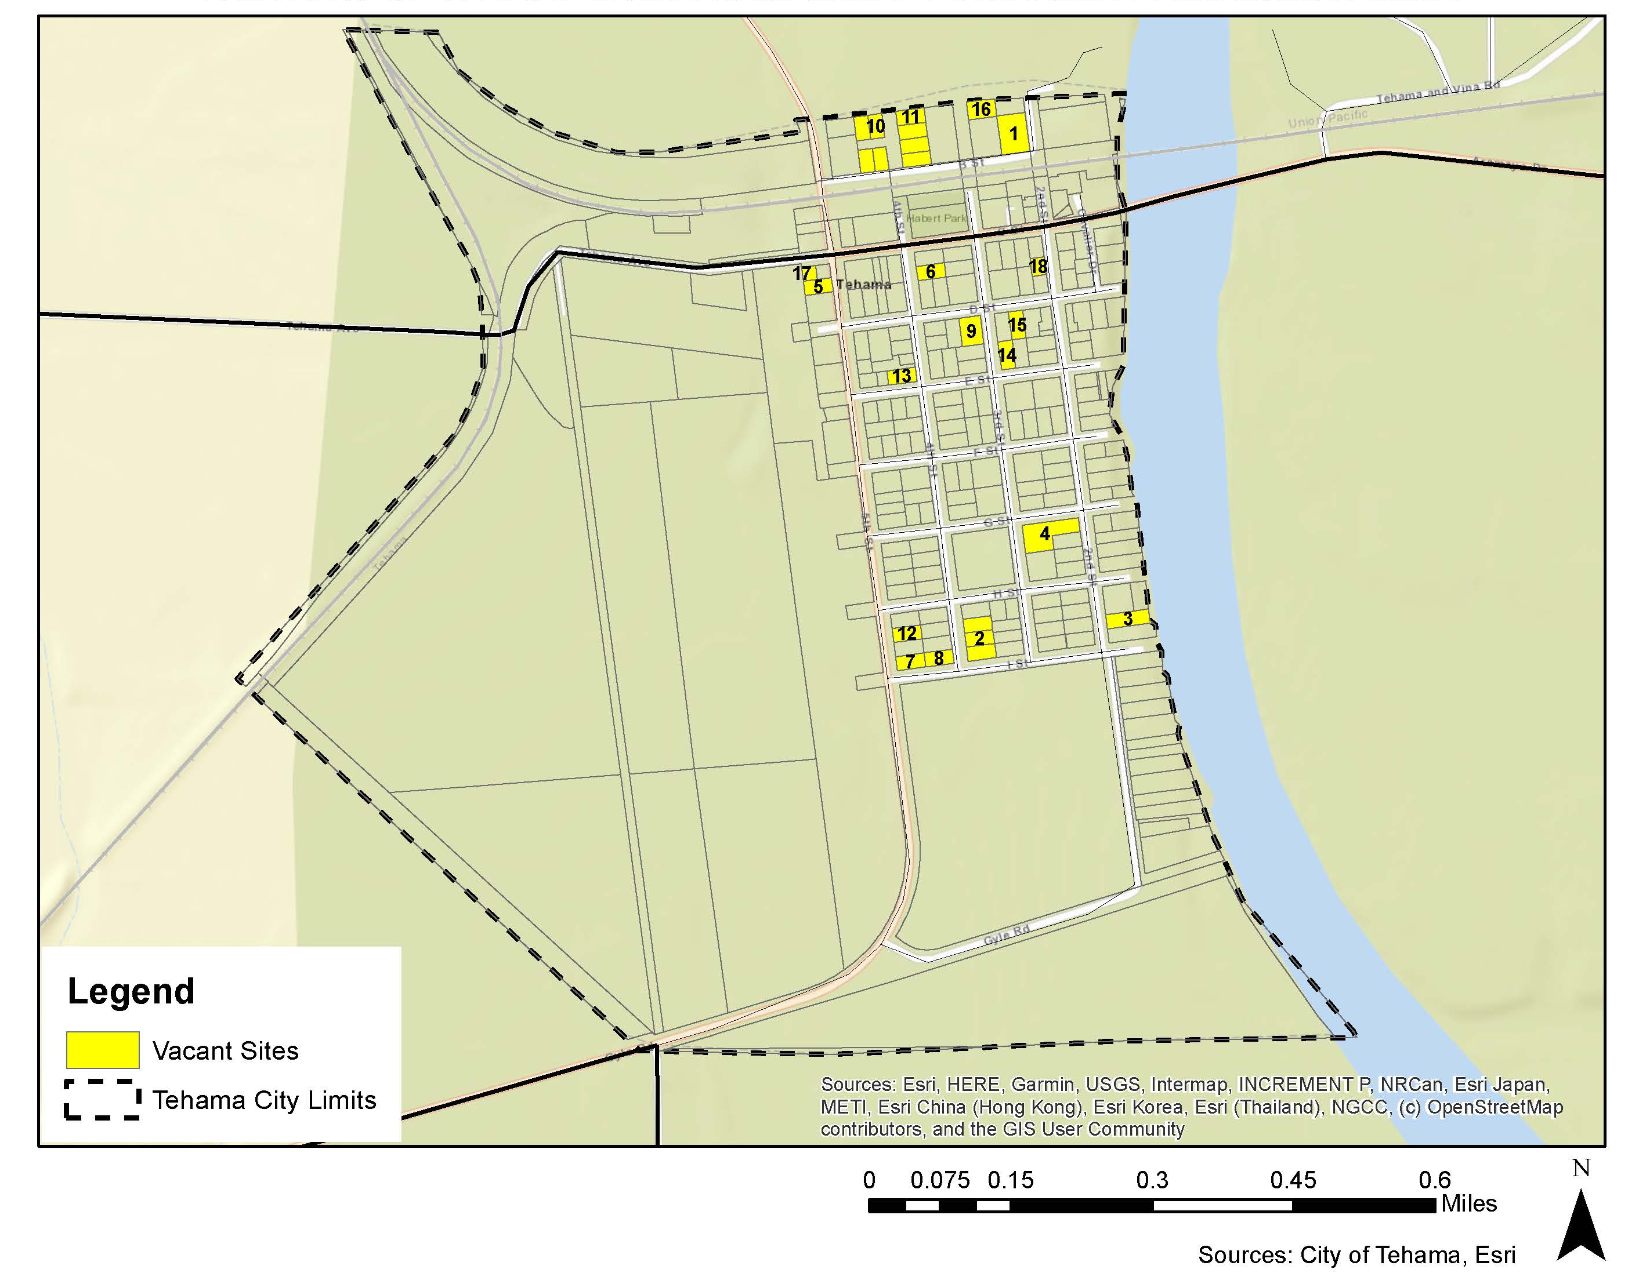
Figure 1: Vacant Residential Land in the City of Tehama:

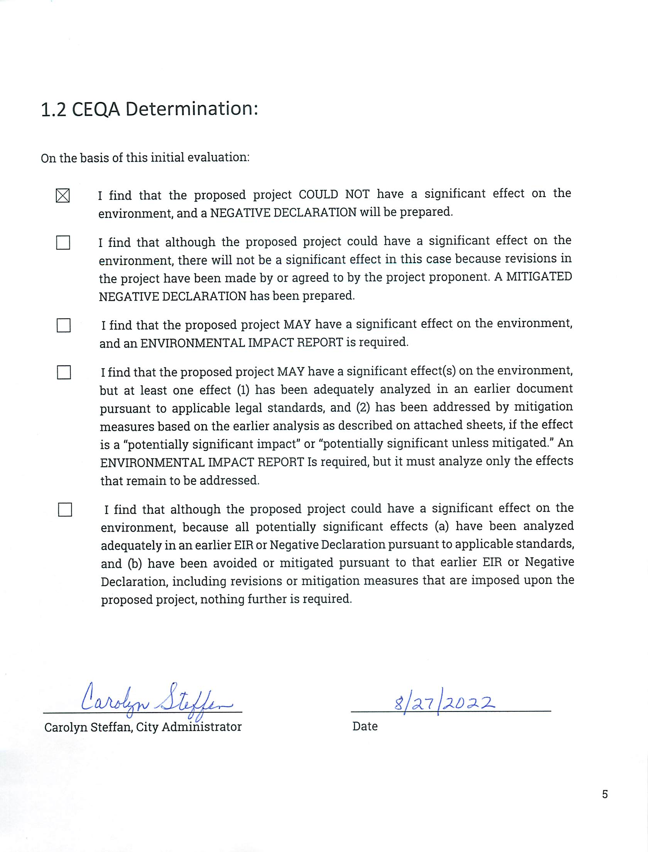

Environmental Impact Analysis

The environmental factors checked below would be potentially affected by this project, involving at least one impact that is a “Potentially Significant Impact” as indicated by the checklist on the following pages.
□ | Aesthetics | □ | Agriculture Resources | □ | Air Quality
□ | Biological Resources | □ | Cultural Resources | □ | Geology/Soils
□ | Hazards & Hazardous Materials | □ | Hydrology/Water Quality | □ | Greenhouse Gas Emissions
□ | Mineral Resources | □ | Noise | □ | Land Use/Planning
□ | Public Services | □ | Recreation | □ | Population/Housing
□ | Utilities/Service Systems | □ | Mandatory Findings of Significance | □ | Transportation/Traffic

Evaluation of Environmental Impacts
Responses to the following questions and related discussion indicate if the proposed project will or will potentially have a significant adverse impact on the environment, either individually or cumulatively with other projects. All phases of project planning, implementation, and operation are considered. Mandatory Findings of Significance are located in Section 2.1.18.

Aesthetics
Except as provided in Cal. Pub. Res. Code § 21099, would the project:
Issues and Supporting Evidence | Potentially Significant Impact | Potentially Significant Unless Mitigation Incorporated | Less Than Signif. Impact | No Impact
- Have a substantial adverse effect on a scenic vista? | ☐ | ☐ | ☐ | ☒
- Substantially damage scenic resources, including, but not limited to, trees, rock outcroppings, and historic buildings within a state scenic highway? | ☐ | ☐ | ☐ | ☒
- In non-urbanized areas, substantially degrade the existing visual character or quality of public views of the site and its surroundings? (Public views are those that are experienced from a publicly accessible vantage point). If the project is in an urbanized area, would the project conflict with applicable zoning and other regulations governing scenic quality? | ☐ | ☐ | ☐ | ☒
- Create a new source of substantial light or glare that would adversely affect day or nighttime views in the area? | ☐ | ☐ | ☐ | ☒

Discussion
The City of Tehama is presently a small urban area surrounded by agricultural land uses. Implementation of the General Plan would not result in significant urban and suburban growth, which could alter the visual setting or character. Growth in Tehama is not expected to occur due to development restrictions imposed by being located with the floodplain.
The General Plan Update will not, in and of itself, result in aesthetic impacts to scenic vistas, scenic resources, or visual character, and will not create sources of substantial light or glare which adversely affects views. All future development will require project-specific environmental evaluation in order to determine that any potential impacts are less than significant.

Agricultural and Forest Resources
Would the project:
Issues and Supporting Evidence | Potentially Significant Impact | Potentially Significant Unless Mitigation Incorporated | Less Than Signif. Impact | No Impact
- Convert Prime Farmland, Unique Farmland, or Farmland of Statewide Importance (Farmland), as shown on the maps prepared pursuant to the Farmland Mapping and Monitoring Program of the California Resources Agency, to non-agricultural use? | ☐ | ☐ | ☐ | ☒
- Conflict with existing zoning for agricultural use, or a Williamson Act contract? | ☐ | ☐ | ☐ | ☒
- Conflict with existing zoning for, or cause rezoning of, forest land (as defined in Public Resources Code §12220(g)), timberland (as defined by Public Resources Code section 4526), or timberland zoned Timberland Production (as defined by Government Code §51104(g)) or result in the loss of forest land or conversion of forest land to non-forest use? | ☐ | ☐ | ☐ | ☒
- Involve other changes in the existing environment which, due to their location or nature, could result in conversion of Farmland, to non-agricultural use? | ☐ | ☐ | ☐ | ☒

Discussion
The General Plan Land Use element is not identifying any additional sites for residential development or changing density standards. The project will not make changes to the existing environment, which will result in the conversion of farmland to non-agricultural use. A goal of this project is to retain the rural and agricultural character that exists in the City of Tehama.
The General Plan will not, in and of itself, result in impacts to farmland, forestland, Williamson Act contracts, timberland, or timberland-zoned Timberland Production. All future development will require project-specific environmental evaluation in order to determine that any potential impacts are less than significant. At such time that a development proposal is considered, that project will be subject to adopted development guidelines/standards and any impacts identified with the development project will be addressed through mitigation measures specific to the impact. Future development projects will be reviewed on individual basis to determine if there is any impact on agricultural resources.

Air Quality
Would the project:
Issues and Supporting Evidence | Potentially Significant Impact | Potentially Significant Unless Mitigation Incorporated | Less Than Signif. Impact | No Impact
- Conflict with or obstruct implementation of the applicable air quality plan? | ☐ | ☐ | ☐ | ☒
- Result in a cumulatively considerable net increase of any criteria pollutant for which the project region is in non-attainment under an applicable federal or state ambient air quality standard)? | ☐ | ☐ | ☐ | ☒
- Expose sensitive receptors to substantial pollutant concentrations? | ☐ | ☐ | ☐ | ☒
- Result in other emissions (such as those leading to odors) adversely affecting a substantial number of people? | ☐ | ☐ | ☐ | ☒

Discussion
Ambient air quality is described in terms of compliance with State and Federal standards, and the levels of air pollutant concentrations considered safe, to protect the public health and welfare. These standards are designed to protect people most sensitive to respiratory distress, such as the elderly, very young children, persons with asthma or other illnesses, and persons engaged in strenuous work or exercise. The EPA has established national ambient air quality standards (NAAQS) for seven air pollution constituents. As permitted by the Clean Air Act, California has adopted more stringent air emissions standards (SAAQS), and expanded the number of regulated air constituents.
The California Air Resources Board (CARB) is required to designate areas of the state as attainment, nonattainment, or unclassified for any state standard. An “attainment” designation for an area signifies that pollutant concentrations do not violate the standard for that pollutant in that area. A “nonattainment” designation indicates that a pollutant concentration violated the standard at least once.
Circulation elements in a general plan should estimate air quality impacts associated with changes in land use and projected vehicle trips and speeds. Land use in Tehama is not expected to change notably due to development restrictions imposed by being located within the floodplain; therefore, land use is not expected to impact air quality. However, increases in local traffic and through-traffic, especially of heavy truck traffic along the local truck route, could impact air quality in the community. Air quality impacts resulting from increases in through-traffic were not modeled for this General Plan and should be addressed in the future, but emissions of local traffic have been modeled in the past. The results indicated that emissions for reactive organic gases, carbon monoxide, and nitrogen oxides are expected to decrease through replacement of older vehicles with new, more efficient ones. Particulate levels are expected to stay about the same. Since Tehama County is in attainment with the air quality standards for all four pollutants, maintain current emissions levels or a decrease in emissions will not affect the county’s attainment status. Such a decrease could help offset emissions resulting from through-traffic emissions increases; however, emissions from heavy truck traffic traveling through the community is still of concern. As such, the General Plan update offers several policies aimed at decreasing truck traffic within the city limits, in addition to increasing use of alternative, low-emissions forms of transportation.
The General Plan update will not, in and of itself, result in impacts to air quality or plans for air quality, or produce pollutants or odors. At such time that a development proposal is considered, that project will be subject to adopted development guidelines/standards and any impacts identified with the development project will be addressed through mitigation measures specific to the impact.

Biological Resources
Would the project:
Issues and Supporting Evidence | Potentially Significant Impact | Potentially Significant Unless Mitigation Incorporated | Less Than Signif. Impact | No Impact
a. Have a substantial adverse effect, either directly or through habitat modifications, on any species identified as a candidate, sensitive, or special status species in local or regional plans, policies or regulations, or by the California Department of Fish and Wildlife or U.S. Fish and Wildlife Service? | ☐ | ☐ | ☐ | ☒
b. Have a substantial adverse effect on any riparian habitat or other sensitive natural community, including oak woodland, identified in local or regional plans, policies or regulations, or by the California Department of Fish and Game or U.S. Fish and Wildlife Service? | ☐ | ☐ | ☐ | ☒
c. Have a substantial adverse effect on state or federally protected wetlands, (including, but not limited to, marsh, vernal pool, coastal wetlands, etc.), through direct removal, filling, hydrological interruption or other means? | ☐ | ☐ | ☐ | ☒
d. Interfere substantially with the movement of any native resident or migratory fish or wildlife species or with established native resident or migratory wildlife corridors, or impede the use of native wildlife nursery sites? | ☐ | ☐ | ☐ | ☒
e. Conflict with any local policies or ordinances protecting biological resources, such as a tree preservation policy or ordinance? | ☐ | ☐ | ☐ | ☒
f. Conflict with the provisions of an adopted Habitat Conservation Plan, Natural Community Conservation Plan, or other approved local, regional or state habitat conservation plan? | ☐ | ☐ | ☐ | ☐

Discussion
The General Plan update is a policy-level document and will not, in and of itself, result in impacts to wetlands, fish, wildlife, or plans and policies related to habitat conservation. At such time that a development proposal is considered, that project will be subject to adopted development guidelines/standards and any impacts identified with the development project will be addressed through mitigation measures specific to the impact.

Cultural Resources
Would the project:
Issues and Supporting Evidence | Potentially Significant Impact | Potentially Significant Unless Mitigation Incorporated | Less Than Signif. Impact | No Impact
- Cause a substantial adverse change in the significance of a historical resource pursuant to Section 15064.5? | ☐ | ☐ | ☐ | ☒
- Cause a substantial adverse change in the significance of an archaeological resource pursuant to Section 15064.5? | ☐ | ☐ | ☐ | ☒
- Disturb any human remains, including those interred outside of dedicated cemeteries? | ☐ | ☐ | ☐ | ☒

Discussion
This section evaluates the proposed Project’s potential impacts on archaeological, historical, and paleontological resources. Resources of concern include, but are not limited to, prehistoric and historic artifacts, burials, sites of religious or cultural significance to Native American groups, and historic structures.
The General Plan update will not, in and of itself, result in impacts to cultural resources, including historic, archeological, and paleontological resources. At such time that a development proposal is considered, that project will be subject to adopted development guidelines/standards and any impacts identified with the development project will be addressed through mitigation measures specific to the impact.
Also, refer to Section 2.1.17, Tribal Cultural Resource.

Energy
Would the project:
Issues and Supporting Evidence | Potentially Significant Impact | Potentially Significant Unless Mitigation Incorporated | Less Than Signif. Impact | No Impact
- Result in potentially significant environmental impact due to wasteful, inefficient, or unnecessary consumption of energy resources during project construction or operation? | ☐ | ☐ | ☐ | ☒
- Conflict with or obstruct a state or local plan for renewable energy or energy efficiency? | ☐ | ☐ | ☐ | ☒

Discussion
The General Plan Update sets forth policies promoting energy conservation and energy efficiency. Adoption and implementation of the General Plan would not involve wasteful, inefficient, or unnecessary energy use or conflict with a state or local plan for renewable energy or energy efficiency.
The General Plan update will not, in and of itself, result in impacts to energy resources or renewable energy or energy efficiency planning; impacts due to the project are less than significant. All future development will require project-specific environmental evaluation in order to determine that any potential impacts are less than significant.

Geology and Soils
Would the project:
Issues and Supporting Evidence | Potentially Significant Impact | Potentially Significant Unless Mitigation Incorporated | Less Than Signif. Impact | No Impact
- Directly or indirectly cause potential substantial adverse effects, including the risk of loss, injury, or death, involving:
i) Rupture of a known earthquake fault, as delineated on the most recent Alquist-Priolo Earthquake Fault Zoning Map issued by the State Geologist for the area or based on other substantial evidence of a known fault? Refer to Division of Mines and Geology Special Publication 42. | ☐ | ☐ | ☐ | ☒
ii) Strong seismic ground shaking? | ☐ | ☐ | ☐ | ☒
iii) Seismic-related ground failure, including liquefaction? | ☐ | ☐ | ☐ | ☒
iv) Landslides? | ☐ | ☐ | ☐ | ☒
- Result in substantial soil erosion or the loss of topsoil? | ☐ | ☐ | ☐ | ☒
- Be located on a geologic unit or soil that is unstable, or that would become unstable as a result of the project, and potentially result in on- or off-site landslide, lateral spreading, subsidence, liquefaction or collapse? | ☐ | ☐ | ☐ | ☒
- Be located on expansive soil, as defined in Table 18-1-B of the Uniform Building Code (1994), creating substantial direct or indirect risks to life or property? | ☐ | ☐ | ☐ | ☒
- Have soils incapable of adequately supporting the use of septic tanks or alternative wastewater disposal systems where sewers are not available for the disposal of wastewater? | ☐ | ☐ | ☐ | ☒
- Directly or indirectly destroy a unique paleontological resource or site or unique geologic feature? | ☐ | ☐ | ☐ | ☒

Discussion
The City of Tehama is not in a seismically active region, and there is low potential that the area will be subject to at least moderate earthquakes one or more times over the next century. Throughout recorded history, no major earthquakes have been recorded in Tehama. There are no faults in, around, or near the City of Tehama and the closest identified potentially active fault is the Battle Creek Fault, located approximately 23 miles north of the city.
The City of Tehama is in the northern Sacramento River Valley. Soils of the floodplains where the city is located form relatively flat or gently sloping areas along the Sacramento River and its tributaries. Minor slope failure and erosion along streambanks will likely occur during heavy rainfall as they have in the past. However, due to the mostly flat terrain of the region, landslides are not a hazard of significant concern in Tehama.
The General Plan area encompasses an area that is identified to utilize septic tank systems and not connect to a public municipal wastewater disposal system. The General Plan update is a policy-level document and does not include any specific development, however future development project involving any septic system installed on a proposed lot must be installed pursuant to Tehama County Environmental Health improvement standards. Therefore, no significant impacts from sewage disposal are expected.
The General Plan Update will not, in and of itself, result in impacts to soil resources or from earthquakes, landslides, or other seismic events, so any impacts are less than significant. At such time that a development proposal is considered, that project will be subject to adopted development guidelines/standards and any impacts identified with the development project will be addressed through mitigation measures specific to the impact.

Greenhouse Gas Emissions
Would the project:
Issues and Supporting Evidence | Potentially Significant Impact | Potentially Significant Unless Mitigation Incorporated | Less Than Signif. Impact | No Impact
- Generate greenhouse gas emissions, either directly or indirectly, that may have a significant impact on the environment? | ☐ | ☐ | ☐ | ☒
- Conflict with an applicable plan, policy or regulation adopted for the purpose of reducing the emissions of greenhouse gases? | ☐ | ☐ | ☐ | ☒

Discussion
GHG emissions produced by the residential sector are the result of natural gas and other fossil fuel consumption used for heating and cooking applications. Electricity usage by buildings results in GHG emissions that occur at the power plants and transmission lines used to provide that energy, which may or may not be located within the City limits. All residential development in the city of Tehama must comply with the standards in Title 20, Energy Building Regulation, and Title 24, Energy Conservation Standards of the California Code of Regulations, including CALGreen, to reduce GHG emissions in new construction.
The General Plan Land Use element is not identifying any additional sites for residential development or changing density standards. Development of more than one unit could occur throughout the city on existing lots due to the passing of SB 9, but due to site restrictions such as floodplain, and the minimum lot area required for septic systems for all dwellings, the City would not foresee more than the 32 additional housing units mentioned in the build out analysis. Similarly, the General Plan contains policies and programs intended to further the goals of reducing GHG emissions resulting from new development.
The General Plan Update will not, in and of itself, result in impacts to greenhouse gas emissions, climate change impacts, or any applicable plan, policy, or regulation reducing those impacts. At such time that a development proposal is considered, that project will be subject to adopted development guidelines/standards and any impacts identified with the development project will be addressed through mitigation measures specific to the impact.

Hazards and Hazardous Materials
Would the project:
Issues and Supporting Evidence | Potentially Significant Impact | Potentially Significant Unless Mitigation Incorporated | Less Than Signif. Impact | No Impact
- Create a significant hazard to the public or the environment through the routine transport, use or disposal of hazardous materials? | ☐ | ☐ | ☐ | ☒
- Create a significant hazard to the public or the environment through reasonably foreseeable upset and accident conditions involving the release of hazardous materials into the environment? | ☐ | ☐ | ☐ | ☒
- Emit hazardous emissions or handle hazardous or acutely hazardous materials, substances or waste within one-quarter mile of an existing or proposed school? | ☐ | ☐ | ☐ | ☒
- Be located on a site which is included on a list of hazardous materials sites compiled pursuant to Government Code §65962.5 and, as a result, would it create a significant hazard to the public or the environment? | ☐ | ☐ | ☐ | ☒
- For a project located within an airport land use plan area or, where such a plan has not been adopted, within two miles of a public airport or a public use airport, would the project result in a safety hazard or excessive noise for people residing or working in the project area? | ☐ | ☐ | ☐ | ☒
- Impair implementation of, or physically interfere with, an adopted emergency response plan or emergency evacuation plan? | ☐ | ☐ | ☐ | ☒
- Expose people or structures, either directly or indirectly, to a significant risk of loss, injury or death involving wildland fires? | ☐ | ☐ | ☐ | ☒

Discussion
The Land Use Element of the General Plan identifies sites designated for residential development. The General Plan Land Use element is not identifying any additional sites for residential development or changing density standards. Development of more than one unit could occur throughout the city on existing lots due to the passing of SB 9, but due to site restrictions such as floodplain, and the minimum lot area required for septic systems for all dwellings, the City would not foresee more than the 32 additional housing units mentioned in the build out analysis.
None of the Planning Area or sites identified in the vacant sites are known to contain contaminants and/or hazardous waste. The project is not located on a site which is included on a list of hazardous materials sites compiled pursuant to Government Code Section 65962.5 and would not create a significant hazard to the public or the environment (Envirostar-California Department of Toxic and Substance Control).
The City of Tehama is not located within the boundaries of an airport land use plan or within two miles of a public airport.
The General Plan will not, in and of itself, result in impacts from hazardous materials, airports, toxic emissions, wildfires, and other emergencies. At the time of development, all existing roads will be required to remain open during the construction period so there will be no interference with an emergency response plan or emergency evacuation plan.
To maintain a high level of fire safety the City strictly enforces a weed abatement ordinance. In addition, , the future development of various sites throughout the city will eliminate the existing open fields which create a potential fire hazard during the summer months. At such time that a development proposal is considered, that project will be subject to adopted development guidelines/standards and any impacts identified with the development project will be addressed through mitigation measures specific to the impact.
2.1.10 Hydrology and Water Quality
Would the project:
Issues and Supporting Evidence | Potentially Significant Impact | Potentially Significant Unless Mitigation Incorporated | Less Than Signif. Impact | No Impact
- Violate any water quality standards or waste discharge requirements or otherwise substantially degrade surface or ground water quality? | ☐ | ☐ | ☐ | ☒
- Substantially decrease groundwater supplies or interfere substantially with groundwater recharge such that the project may impede sustainable groundwater management of the basin? | ☐ | ☐ | ☐ | ☒
- Substantially alter the existing drainage pattern of the site or area, including through the alteration of the course of a stream or river, or through the addition of impervious surfaces, in a manner which would: | ☐ | ☐ | ☐ | ☒
- result in substantial erosion or siltation on- or off-site; | ☐ | ☐ | ☐ | ☒
- substantially increase the rate or amount of surface runoff in a manner which would result in flooding on- or offsite; | ☐ | ☐ | ☐ | ☒
- create or contribute runoff water which would exceed the capacity of existing or planned stormwater drainage systems or provide substantial additional sources of polluted runoff; or | ☐ | ☐ | ☐ | ☒
- impede or redirect flood flows? | ☐ | ☐ | ☐ | ☒
- In flood hazard, tsunami, or seiche zones, risk release of pollutants due to project inundation? | ☐ | ☐ | ☐ | ☒
- Conflict with or obstruct implementation of a water quality control plan or sustainable groundwater management plan? | ☐ | ☐ | ☐ | ☒

Discussion
The water system within the City of Tehama is a public system owned by the city. Tehama’s water supply comes from a series of two wells that tap an underlying aquifer found to be of excellent quality and without record of contamination. Rich, 20-foot-deep Columbian soils percolate out impurities and added chlorination practices during flood conditions ensure that any potential for bacterial intrusion is quickly mitigated. In addition, septic systems and leach fields located within the city do not usually fail except from old age and, even then, they generally pose no threat to the community’s water system. As such, the likelihood of groundwater contamination within Tehama is essentially non-existent. Based on availability of this excellent groundwater for municipal use, capacity to serve the community now and into the future is also sufficient.
The City regulates many aspects of construction and development through requirements and ordinances established in the Tehama City Code. Implementation of the General Plan will not increase impacts on water resources. Growth is limited to the amount of existing vacant sites. 32 additional housing units could be constructed on the 24 vacant sites. The Residential zone in the city permits one single-family structure per lot. Development of more than one unit could occur throughout the city on existing vacant sites due to the passing of SB 9, however due to significant environmental constraints to development, such as floodplain location, and the minimum lot area required for septic systems for all dwellings. These residential lots will require more expensive construction, such as all building being required to be elevated at least three feet above the base flood elevation. The City would not foresee more than the 32 additional housing units mentioned in the buildout analysis.
Adequate public services and facilities are available for all vacant, residentially zoned land within the City of Tehama.
The City will comply with the Tehama County Hazardous Waste Management Plan to mitigate the impacts of residential development. Flooding potential exists alongside watercourses in the Planning Area, most notably areas surrounding Sacramento River. The entire city of Tehama lies within a 100-year flood zone.
The General Plan Update will not, in and of itself, result in impacts to drainage, runoff, erosion, flooding, or natural disasters. All future development will require project-specific environmental evaluation in order to determine that any potential impacts are less than significant. Potential impacts to hydrology and water quality are location-specific and cannot be assessed in a meaningful way until the location of a project site is known. Future development will result in the addition of new impervious surfaces to each specific development project site. However, this is a normal consequence associated with the development of previously undeveloped parcels of land. At such time that a development proposal is considered, that project will be subject to adopted development guidelines/standards and any impacts identified with the development project will be addressed through mitigation measures specific to the impact.

2.1.11 Land Use Planning
Would the project:
Issues and Supporting Evidence | Potentially Significant Impact | Potentially Significant Unless Mitigation Incorporated | Less Than Signif. Impact | No Impact
- Physically divide an established community? | ☐ | ☐ | ☐ | ☒
- Cause a significant environmental impact due to a conflict with any applicable land use plan, policy or regulation adopted for the purpose of avoiding or mitigating an environmental effect? | ☐ | ☐ | ☐ | ☒

Discussion
The General Plan will not, in and of itself, physically divide a community or conflict with any land use or habitat conservation plans. All future development will require project-specific environmental evaluation to ensure that the implementation of that specific project does not conflict with any applicable habitat conservation plans or natural communities’ conservation plans and determine that any potential impacts are less than significant. At such time that a development proposal is considered, that project will be subject to adopted development guidelines/standards and any impacts identified with the development project will be addressed through mitigation measures specific to the impact.

Mineral Resources
Would the project:
Issues and Supporting Evidence | Potentially Significant Impact | Potentially Significant Unless Mitigation Incorporated | Less Than Signif. Impact | No Impact
- Result in the loss of availability of a known mineral resource that would be of value to the region and the residents of the state? | ☐ | ☐ | ☐ | ☒
- Result in the loss of availability of a locally important mineral resource recovery site delineated on a local general plan, specific plan or other land use plan? | ☐ | ☐ | ☐ | ☒

Discussion
The State Mining and Geology Board (SMGB) prioritizes areas to be classified as containing significant mineral resources and areas to be designated as containing mineral deposits of regional or statewide significance. Mineral Resource Zone (MRZ) categories are used to identify areas of identified, undetermined, and unknown mineral resource significance. No MRZ designations have been applied to the City of Tehama.

Noise
Would the project result in:
Issues and Supporting Evidence | Potentially Significant Impact | Potentially Significant Unless Mitigation Incorporated | Less Than Signif. Impact | No Impact
- Generation of a substantial temporary or permanent increase in ambient noise levels in the vicinity of the project in excess of standards established in the local general plan or noise ordinance or of applicable standards of other agencies? | ☐ | ☐ | ☐ | ☒
- Generation of excessive groundborne vibration or groundborne noise levels? | ☐ | ☐ | ☐ | ☒
- For a project located within the vicinity of a private airstrip or an airport land use plan area or, where such a plan has not been adopted, within two miles of a public airport or a public use airport, would the project expose people residing or working in the project area to excessive noise levels? | ☐ | ☐ | ☐ | ☒

Discussion
Generally, noise is not a significant problem in the City of Tehama since there are very few major sources of noise within the city or surrounding area.

A significant amount of truck traffic passes through town, noise resulting from this truck route is, at times, significant, but mostly limited to day-time hours. County Highways A8 and A11 will continue to have noise levels higher than is desirable in a rural residential environment, but no mitigation for current conditions is planned. If, in the future, Caltrans or Tehama County were to consider widening the road or conduct other improvements on either highway, a noise analysis and mitigation plan would be developed as part of an environmental review process.

Union Pacific Railroad predicts an increase in the number of trains in the future, which may result in increased noise levels. To protect the welfare of Tehama residents, the City may seek mitigation for train noise in the future, potentially by establishing a Quiet Zone or Partial Quiet Zone or by installing wayside horn signals at the 5th Street railroad crossing.
There is no airport located within or adjacent to the city limits. The closest airport with a significant amount of air traffic is the Red Bluff Municipal Airport located approximately 14 miles northwest of the City.
Although aircraft flying overhead is occasionally audible, the city is not located within either airport influence area.
The General Plan Update will not, in and of itself, create noise impacts. All future development will require project-specific environmental evaluation in order to determine that any potential impacts are less than significant. At such time that a development proposal is considered, that project will be subject to adopted development guidelines/standards and any impacts identified with the development project will be addressed through mitigation measures specific to the impact.

Population and Housing
Would the project:
Issues and Supporting Evidence | Potentially Significant Impact | Potentially Significant Unless Mitigation Incorporated | Less Than Signif. Impact | No Impact
- Induce substantial unplanned population growth in an area, either directly (e.g., by proposing new homes and businesses) or indirectly (e.g., through extension of roads or other infrastructure)? | ☐ | ☐ | ☐ | ☒
- Displace substantial numbers of existing people or housing, necessitating the construction of replacement housing elsewhere? | ☐ | ☐ | ☐ | ☒

Discussion
Significant population growth in Tehama is not expected occur over the next 20 years. Growth is somewhat limited to the amount of existing vacant sites. 32 additional housing units could be constructed on the 24 vacant sites. The Residential zone in the city permits one single-family structure per lot. Development of more than one unit could occur throughout the city on existing vacant sites due to the passing of SB 9, however due to significant environmental constraints to development, such as floodplain location , and the minimum lot area required for septic systems for all dwellings,. These residential lots will require more expensive construction, such as all building being required to be elevated at least three feet above the base flood elevation. The City would not foresee more than the 32 additional housing units mentioned in the buildout analysis.
The City of Tehama received a RHNA allocation of 12 new residential units (2021-2029). The current zoning for potential housing sites will allow for the development of housing that will meet the needs of all income groups. The development standards that apply to the City’s residential zone are reasonable and will not inhibit the production of lower-income housing. As a result, this project will not displace any existing residents, as it facilitates adequate housing for all City residents.
The General Plan update sets forth programs and policies to facilitate housing conservation, maintenance, and diversity, and no aspect of the project involves the displacement of people. The General Plan will not, in and of itself, create population and housing impacts. All future development will require project-specific environmental evaluation in order to determine that any potential impacts are less than significant. At such time that a development proposal is considered, that project will be subject to adopted development guidelines/standards and any impacts identified with the development project will be addressed through mitigation measures specific to the impact.

Public Services
Would the project result in substantial adverse physical impacts associated with the provision of new or physically altered governmental facilities, need for new or physically altered governmental facilities, the construction of which could cause significant environmental impacts, in order to maintain acceptable service ratios, response times or other performance objectives for any of the following public services:
Issues and Supporting Evidence | Potentially Significant Impact | Potentially Significant Unless Mitigation Incorporated | Less Than Signif. Impact | No Impact
- Fire protection? | ☐ | ☐ | ☐ | ☒
- Police protection? | ☐ | ☐ | ☐ | ☒
- Schools? | ☐ | ☐ | ☐ | ☒
- Parks? | ☐ | ☐ | ☐ | ☒
- Other public facilities? | ☐ | ☐ | ☐ | ☒

Discussion
The City contracts with Tehama County for police and fire service. Adequate levels of police and fire protection service will be maintained with the additional housing units projected for construction in the City over current and future planning period. The projected housing production in the City is not of the magnitude that is expected to adversely affect the delivery of these services to the citizens of Tehama. Moreover, by closely monitoring new development, any improvements that are needed to maintain adequate service levels can be readily identified and carried out. Therefore, police and fire protection are not constraints on growth in the city.
The City of Tehama is part of the Los Molinos Unified School District and students are bused across the river to nearby Los Molinos for elementary and high school. At present, the sole educational facility located within city limits is a Federal Head Start Program that occupies the historic Tehama Grammar School.
The General Plan Update will not, in and of itself, impact the provision of public services, including fire and police protection, schools, and parks for those land use designations. Any future proposals will be required to pay impact fees that have been established to reduce the potential impact of public services and to meet fire-flow requirements and provide adequate rights-of-way for fire and police vehicles. All future development will require project-specific environmental evaluation in order to determine that any potential impacts are less than significant. At such time that a development proposal is considered, that project will be subject to adopted development guidelines/standards and any impacts identified with the development project will be addressed through mitigation measures specific to the impact.

Recreation
Would the project:
Issues and Supporting Evidence | Potentially Significant Impact | Potentially Significant Unless Mitigation Incorporated | Less Than Signif. Impact | No Impact
- Increase the use of existing neighborhood and regional parks or other recreational facilities such that substantial physical deterioration of the facility would occur or be accelerated? | ☐ | ☐ | ☐ | ☒
- Include recreational facilities, or require the construction or expansion of recreational facilities, which might have an adverse physical effect on the environment? | ☐ | ☐ | ☐ | ☒

Discussion
The City of Tehama maintains three parks, which are designated as Parks and Open Space on. Habert Park occupies a 2.3-acre site located at the north end of town between 3rd and 4th Streets and Belbeck Park, dedicated in 1981, is located on a 2.3-acre site in the same block as the old Tehama Grammar School along 3rd Street. Both parks have picnic areas and softball fields, along with children’s play apparatus. Old Bridge Park is an undeveloped park area of approximately 0.7 acres with direct river access located north of C Street.
Implementation of the proposed General Plan update will not, in and of itself, impact any existing recreational facilities. It will not increase the use of existing recreational facilities or require the construction or expansion of recreational facilities. All future development will require project-specific environmental evaluation in order to determine that any potential impacts are less than significant. Any future proposals will be required to pay impact fees that have been established to reduce the potential impact of public services. At such time that a development proposal is considered, that project will be subject to adopted development guidelines/standards and any impacts identified with the development project will be addressed through mitigation measures specific to the impact.

Transportation/ Traffic
Would the project:
Issues and Supporting Evidence | Potentially Significant Impact | Potentially Significant Unless Mitigation Incorporated | Less Than Signif. Impact | No Impact
- Conflict with a program, plan, ordinance, or policy addressing the circulation system, including transit, roadway, bicycle, and pedestrian facilities? | ☐ | ☐ | ☐ | ☒
- Conflict or be inconsistent with CEQA Guidelines Section 15064.3(b) (criteria for analyzing transportation impacts – vehicle miles traveled)? | ☐ | ☐ | ☐ | ☒
- Substantially increase hazards due to a geometric design feature (e.g., sharp curves or dangerous intersections) or incompatible uses (e.g., farm equipment)? | ☐ | ☐ | ☐ | ☒
- Result in inadequate emergency access? | ☐ | ☐ | ☐ | ☒

Discussion
The General Plan Land Use element is not identifying any additional sites for residential development or changing density standards. Development of more than one unit could occur throughout the city on existing lots due to the passing of SB 9, but due to site restrictions such as floodplain, and the minimum lot area required for septic systems for all dwellings, the City would not foresee more than the 32 additional housing units mentioned in the build out analysis. The General Plan will not, in and of itself, impact the circulation system, congestion management, air traffic, the safety of design features, and policies, plans, and programs related to transportation. All future development will require project-specific environmental evaluation in order to determine that any potential impacts are less than significant.
Potential impacts to transportation and traffic are location-specific and cannot be assessed in a meaningful way until the location of a project site is known. Traffic congestion and other impacts are measured on the basis of the specific intensity of development at a given location. At such time that a development proposal is considered, that project will be subject to adopted development guidelines/standards and any impacts identified with the development project will be addressed through mitigation measures specific to the impact. A new traffic analysis will be prepared for that specific project that will recommend specific mitigation measures necessary to reduce any identified impacts to less than significant levels.

Tribal Cultural Resources
Would the project:
Issues and Supporting Evidence | Potentially Significant Impact | Potentially Significant Unless Mitigation Incorporated | Less Than Signif. Impact | No Impact
- A resource listed or eligible for listing in the California Register of Historical Resources, or in a local register of historical resources as defined in PRC §5020.1(k)? | ☐ | ☐ | ☐ | ☒
- A resource determined by the lead agency, in its discretion and supported by substantial evidence, to be significant pursuant to criteria set forth in subdivision (c) of PRC §5024.1? In applying the criteria set forth in subdivision (c) of PRC §5024.1, the lead agency shall consider the significance of the resource to a California Native American tribe. | ☐ | ☐ | ☐ | ☒

Discussion
In accordance with AB 52 (specifically PRC 21080.3.1), Native American consultation is required upon request by a California Native American tribe that has previously requested that the City provide it with notice of such projects. Pursuant to provisions of AB 52, the City contacted all tribes referenced from the Native American Heritage Commission Tribe list for Tehama to see if any were interested in consultation regarding this project. No responses or requests for consultation by any of these tribes were received.
Chapter 532, Statutes of 2014 (i.e., AB 52), requires Lead Agencies to evaluate a project’s potential to impact “tribal cultural resources.” Such resources include “sites, features, places, cultural landscapes, sacred places, and objects with cultural value to a California Native American Tribe that are eligible for inclusion in the California Register of Historical Resources or included in a local register of historical resources.” AB 52 also gives Lead Agencies the discretion to determine, supported by substantial evidence, whether a resource qualifies as a “tribal cultural resource.”
The proposed project is an update to the City of Tehama General Plan. The General Plan consists of a long-term policy program for the community’s future development. The General Plan Update will not, in and of itself, result in impacts to tribal resources. All future development will require project-specific environmental evaluation in order to determine that any potential impacts are less than significant.

Utilities and Service Systems
Would the project:
Issues and Supporting Evidence | Potentially Significant Impact | Potentially Significant Unless Mitigation Incorporated | Less Than Signif. Impact | No Impact
- Require or result in the relocation or construction of new or expanded water, wastewater treatment, or storm water drainage, electric power, natural gas, or telecommunications facilities, the construction of which could cause significant environmental effects? | ☐ | ☐ | ☐ | ☒
- Have sufficient water supplies available to serve the project and reasonably foreseeable future development during normal, dry, and multiple dry years? | ☐ | ☐ | ☐ | ☒
- Result in a determination by the wastewater treatment provider that serves or may serve the project that it has adequate capacity to serve the project’s projected demand, in addition to the provider’s existing commitments? | ☐ | ☐ | ☐ | ☒
- Generate solid waste in excess of state or local standards, or in excess of the capacity of local infrastructure, or otherwise impair the attainment of solid waste reduction goals? | ☐ | ☐ | ☐ | ☒
- Comply with federal, state and local management and reduction statutes and regulations related to solid waste? | ☐ | ☐ | ☐ | ☒

Discussion
The proposed project is an update the City of Tehama General Plan. The General Plan consists of a long-term policy program for the community’s future development. Presently, all vacant residentially designated land within the City of Tehama is in close proximity to required infrastructure systems (e.g., streets, water, gas, and electrical distribution systems). With the basic infrastructure in place, this is not a constraint to the production of housing and there is sufficient capacity to serve the General Plan’s projects projected buildout.
The Tehama County Solid Waste Management Agency provides solid waste management oversight, and solid waste reduction and recycling program services for the cities of Red Bluff, Corning, and Tehama, and the unincorporated areas of Tehama County. They own a recycling facility and landfill northwest of Red Bluff. The landfill license with the state was recently upgraded to increase daily maximum solid waste tonnage from 600 to 700 tons per day. It has adequate solid waste capacity to meet demand for all future development projects in the City of Tehama, as well as other sharing agencies.
The General Plan Update will not, in and of itself, impact public utilities service for communication, water, sewer, solid waste disposal, and storm drainage. All future development will require project-specific environmental evaluation in order to determine that any potential impacts are less than significant. At such time that a development proposal is considered, that project will be subject to adopted development guidelines/standards and any impacts identified with the development project will be addressed through mitigation measures specific to the impact.

Mandatory Findings of Significance
Issues and Supporting Evidence | Potentially Significant Impact | Potentially Significant Unless Mitigation Incorporated | Less Than Signif. Impact | No Impact
Does the project have the potential to substantially degrade the quality of the environment, substantially reduce the habitat of a fish or wildlife species, cause a fish or wildlife population to drop below self-sustaining levels, threaten to eliminate a plant or animal community, substantially reduce the number or restrict the range of rare or endangered plants or animals, or eliminate important examples of the major periods of California history or prehistory? | ☐ | ☐ | ☐ | ☒
Does the project have impacts that are individually limited, but cumulatively considerable? "Cumulatively considerable" means that the incremental effects of a project are considerable when viewed in connection with the effects of past projects, the effects of other current projects, and the effects of probable future projects. | ☐ | ☐ | ☐ | ☒
Does the project have environmental effects that will cause substantial adverse effects on human beings, either directly or indirectly? | ☐ | ☐ | ☐ | ☒

Discussion
Implementation of the General Plan will not create any significant or adverse impacts. Potential site-specific impacts that cannot be known at this time will be addressed in conjunction with any development proposal submitted for the individual project sites. No new impacts are anticipated as a result of the General Plan Update.

Senate Bill (SB) 9 (Chapter 162, Statutes of 2021) requires ministerial approval of a housing development with no more than two primary units in a single-family zone, the subdivision of a parcel in a single-family zone into two parcels, or both. SB 9 facilitates the creation of up to four housing units in the lot area typically used for one single-family home.

