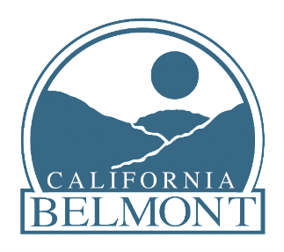

NOTICE OF AVAILABILITY AND INTENT TO ADOPT THE INITIAL STUDY/MITIGATED NEGATIVE DECLARATION FOR THE MONTE CRESTA DRIVE HILLSIDE ROAD IMPROVEMENT PLAN PROJECT
(APPLICATION NO. PA-2018-0054)

TO: All Interested Parties
SUBJECT: Notice of Availability of and Intent to Adopt the Initial Study/Mitigated Negative Declaration (IS/MND) for a Project to extend Monte Cresta Drive by 335 feet from its existing terminus at Monte Cresta Drive and Sequoia Way.

PROJECT SPONSOR: Meng Huang

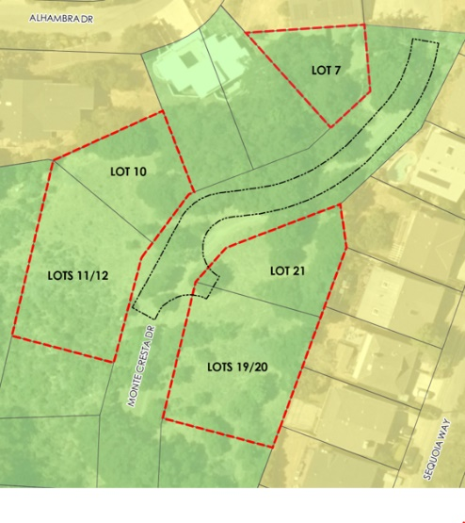
PROJECT LOCATION: The Project is located in a developed residential neighborhood in the City of Belmont in San Mateo County. The proposed project is located south of the intersection of Monte Cresta Drive and Sequoia Way at the top of a northwest-facing slope overlooking San Juan Canyon.

PROJECT DESCRIPTION: The City of Belmont has received an application from Meng Huang (applicant) for the Monte Cresta Drive Extension Project (project), which would extend Monte Cresta Drive by 335 feet from its existing terminus at Monte Cresta Drive and Sequoia Way. The Monte Cresta Drive extension would provide access to five unimproved parcels, Assessor’s Parcel Numbers (APNs) 043-234-170 (Lot 21), 043-234-210 (Lot 19/20), 043-232-090 (Lot 10), 043-232-130 (Lot 11/12) and 043-232-270 (Lot 7). The extension of Monte Cresta Drive would facilitate potential future development of single-family homes on the five undeveloped parcels.

ENVIRONMENTAL REVIEW: City of Belmont Community Development Department has prepared a document to evaluate the potential environmental impacts of the proposed project described below. The document, an Initial Study and Mitigated Negative Declaration (IS/MND), found that all potential environmental impacts could be mitigated to a less-than-significant level. This notice, provided in accordance with State Public Resource Code and CEQA Guidelines, is to announce that the IS/MND is available for review by the public, agencies, and interested parties, and provides instructions for submitting comments on the document.

MATERIALS: The IS/MND is available at the Community Development Major Development Projects webpage: [https://www.belmont.gov/departments/community-development/major-development-projects]

Copies of the IS/MND and all documents referenced in the IS/MND are also available for review at the Community Development Department at One Twin Pines Lane, Belmont, CA 94002, and the Belmont Library at 1110 Alameda de las Pulgas, Belmont, CA 94002. Additional information may be requested by contacting the project manager listed below.

GETTING INVOLVED: The 30-day public review period on the IS/MND runs from August 5, 2022 to September 6, 2022. To submit comments, please email Rob D. Gill at rgill@belmont.gov or mail comments to the following address:
Rob D. Gill
Senior Planner - City of Belmont
Community Development Department
One Twin Pines Lane, Belmont, CA 94002 Suite 110

Comments on the IS/MND should be submitted by September 6, 2022, at 5:00PM. Comments received after this date will still be included in the public record for consideration by the decision-making body but might not be included in the staff report for more advanced consideration.

WHERE &WHEN: Following the close of the IS/MND public review period, the decision-making body will hold a public hearing to consider the adoption of the IS/MND. A hearing date has not yet been scheduled. A hearing notice will be issued at least ten (10) days prior to the confirmed hearing date.

