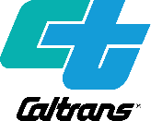
PUBLIC NOTICE
California Department of Transportation, District 4:
State Route 1 Multi-Asset Roadway Rehabilitation Project
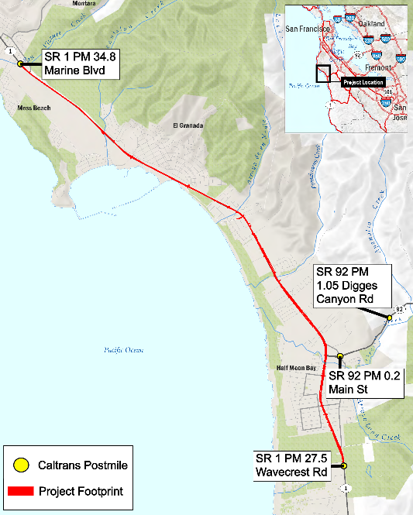
NOTICE OF AVILABILITY of a Draft Initial Study with Proposed Negative Declaration (IS/ND) and Online Public Meeting
Project Location Map

WHAT’S BEING PLANNED
The California Department of Transportation (Caltrans) District 4 will host an online public meeting on the evening of July 13, 2022 to share information on a proposed roadway rehabilitation project and to answer questions about the Draft Initial Study with Proposed Negative Declaration (IS/ND).
The project would take place along State Route 1 (SR 1), from postmile 27.5 in Half Moon Bay to postmile 34.8, south of Moss Beach. The project area also includes one spot location along State Route 92. The project would rehabilitate existing pavement, improve bus stops and traffic monitoring systems, and install “Complete Streets” elements such as bike lanes and crosswalks.
The purpose of the project is to improve ride quality, enhance safety and access for all travelers including cyclists and pedestrians, improve drainage, and extend the life of the roadway so that it requires minimal maintenance in the future.
Caltrans is the California Environmental Quality Act (CEQA) lead agency and sponsor for the project.

HOW TO GET INVOLVED

Visit CaltransEnvironmental.com to:

View and download the Draft Initial Study with Proposed Negative Declaration (IS/ND).

Get instructions for attending the online public meeting on Wednesday, July 13, 2022, from 5:30 p.m. to 7:00 p.m.

Learn more about the project.

Submit comments in writing by Friday, July 24, 2022.

By email to: John.Seal@dot.ca.gov

By mail to:
Caltrans District 4
ATTN: John Seal
P.O. Box 23660, MS-8B
Oakland, CA 94623-0660

For printed copies of the Draft IS/ND or assistance, email John.Seal@dot.ca.gov.
TTY users may request copies of the document in alternate formats through the California Relay Service: 1 (800) 735-2929 (TTY to Voice), 1 (800) 735-2922 (Voice to TTY), 1 (800) 855-3000 (Spanish TTY to Voice and Voice to TTY), 1-800-854-7784 (Spanish and English Speech-to-Speech), or 711.

For language translation, use the following contact information.
Para la traducción de idiomas, use la siguiente información de contacto.
如需语言翻译，请使用以下信息联系
Alejandro Lopez, Alejandro.Lopez@dot.ca.gov (510) 385-6856

