CITY OF ADELANTO
NOTICE OF INTENT TO ADOPT A MITIGATED NEGATIVE DECLARATION

SUBJECT: | Notice of Intent to Adopt a Mitigated Negative Declaration
LEAD AGENCY: | City of Adelanto Community Development Department, Planning Division 11600 Air Expressway Adelanto, California 92301
PROJECT NAME: | Hopland Street Development; CUP 19-02, TPM 20060, and LDP 19-02.
PROJECT APPLICANT: | David Mojadidi  12221 Circula Panorama Place
 | Santa Ana, California 92705.
CITY/  COUNTY: | City of Adelanto, San Bernardino County
LOCATION: | The proposed project site is located at 13178 Hopland Street. Adelanto, California 92301. The corresponding Assessor Parcel Number (APN) is 445-052-40. The proposed project site is located near the intersection of Hopland Street and Amethyst Street in the southeasterly portion of the city.
PROJECT DESCRIPTION: | The City of Adelanto is reviewing an application submitted by David Mojadidi to develop an approximately 5-acre (217,652 square-foot) parcel within the southeasterly portion of the City of Adelanto. The proposed project involves construction consisting of eight (8) one-story cannabis cultivation, manufacturing, and distribution building that would be constructed around a cul-de-sac roadway with the total floor area of 92,926 square feet. The proposed development will be used as a cannabis cultivation, manufacturing, and distribution facility. In addition, 100 standard parking spaces, 8 ADA compliant stalls, and 8 loading spaces will be provided. The project site has a land use and zoning designation of Light Manufacturing (LM).
ENVIRONMENTAL INFORMATION: | The proposed project site is located on a 5-acre (217,652 square-feet) parcel that is currently vacant and undeveloped. The property currently has a General Plan and Zoning land use designation of Light Manufacturing (LM). Access to the project site would be provided by a cul-de-sac roadway connection on the south side of the project site along Hopland Street.
FINDINGS: | The environmental analysis provided in the attached Initial Study indicates that the proposed project will not result in any significant adverse unmitigable impacts. For this reason, the City of Adelanto determined that a Mitigated Negative Declaration is the appropriate CEQA document for the proposed project. The following findings may be made based on the analysis contained in the attached Initial Study. The proposed project will not have the potential to substantially degrade the quality of the environment, substantially reduce the habitat of a fish or wildlife species, cause a fish or wildlife population to drop below self-sustaining levels, threaten to eliminate a plant or animal community, substantially reduce the number, or restrict the range of a rare or endangered plant or animal or eliminate important examples of the major periods of California history or prehistory. The proposed project will not have impacts that are individually limited, but cumulatively considerable. The proposed project will not have environmental effects which will cause substantial adverse effects on human beings, either directly or indirectly.
PUBLIC REVIEW AND COMMENT: | The City of Adelanto invites you to comment on the Initial Study/ Mitigated Negative Declaration. The public review period begins June 7, 2022 and ends on  July 7, 2022. Written comments must be received at the City of Adelanto Community Development Department, Planning Division located at 11600 Air Expressway, Adelanto, California 92301. Attention: Louis Morales, Contract Planner or via email at lmorales@ci.adelanto.ca.us by 5:30 PM on July 7, 2022. Copies of the Initial Study and Mitigated Negative Declaration will be available for public review at the following locations:  City of Adelanto Community Development Department, Planning Division  11600 Air Expressway  Adelanto, California 92301  Copies of the IS/MND can also be found online at: https://www.ci.adelanto.ca.us/201/Planning-Division.
Mr. Morales contact number with the City is (760) 246-2300 extension 11128. A Planning Commission hearing is tentatively scheduled for July 20, 2022.

Date: June 7, 2022
Marc Blodgett, CEQA Consultant to the City of Adelanto

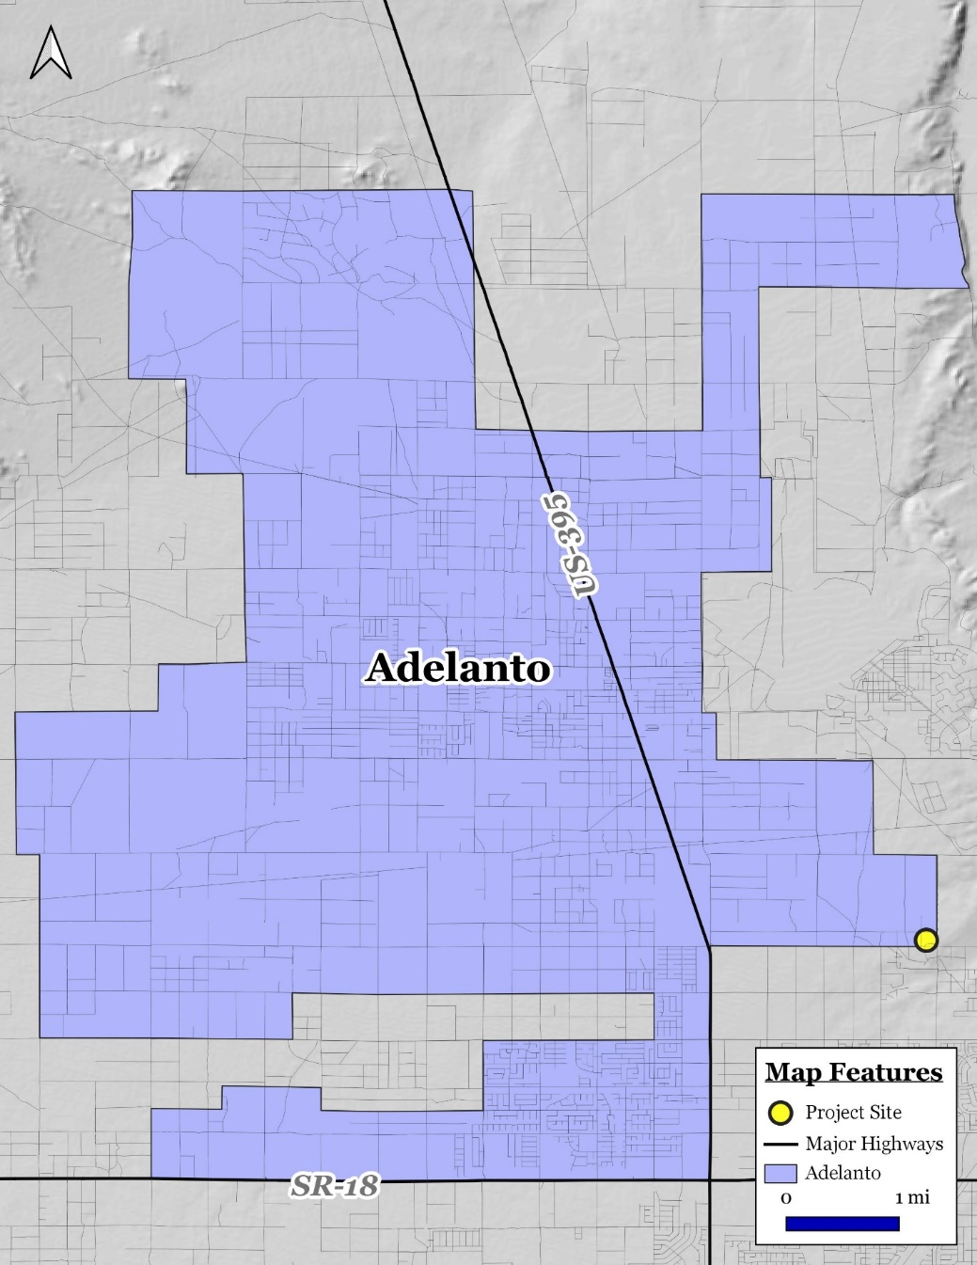

Figure 1: Citywide Map

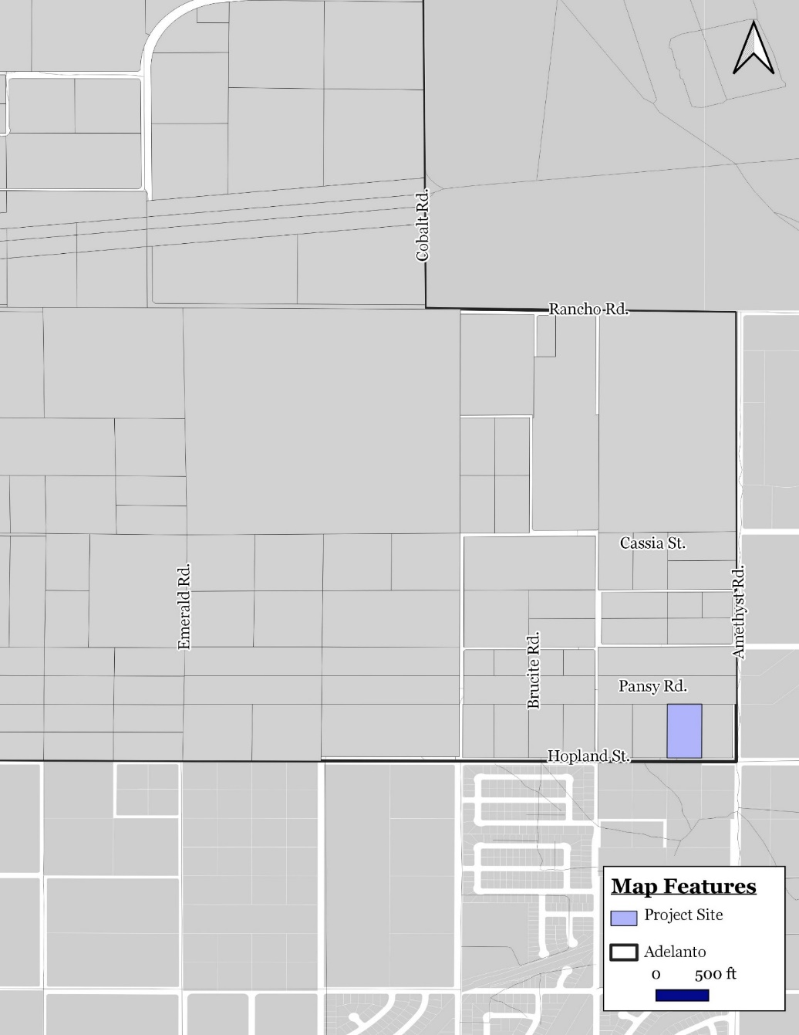

Figure 2: Project Site Location

