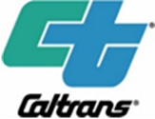
PUBLIC NOTICE
Notice of Intent to Adopt a Negative Declaration
RIV 74 Lake Elsinore Maintenance Station
Announcement of Virtual Public Meeting
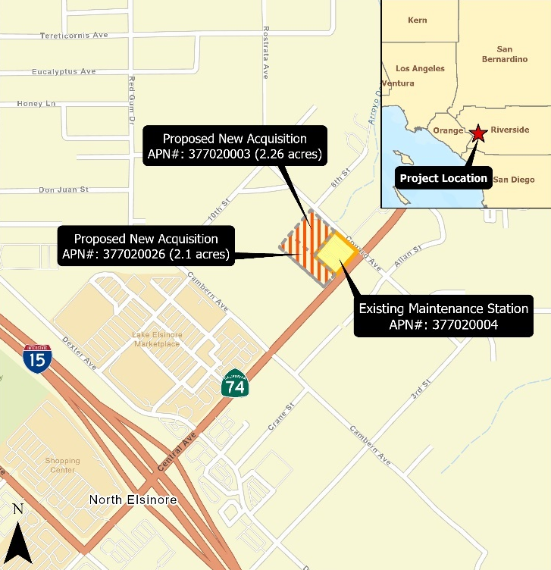
WHAT IS BEING PLANNED? | The California Department of Transportation (Caltrans) proposes to construct a 3,000 square-foot maintenance building to expand an existing maintenance facility and expand parking lots to accommodate Caltrans personnel. The project is located on State Route (SR) 74 near the city of Lake Elsinore, at Postmile (PM) 17.8, in the unincorporated area of Riverside County. The proposed project also includes the upgrade of curb ramps on Conard Ave. to meet American Disability Act (ADA) standards.
WHY THIS NOTICE? | Caltrans has studied the effects that this project may have on the environment. Our studies show it will not significantly affect the quality of the environment. The report that explains why is called a Negative Declaration/Initial Study. This notice is to tell you of the preparation of the Proposed Negative Declaration and Initial Study and of its availability for you to read and offer you the opportunity to attend a virtual public meeting, or to provide comments.
WHAT’S AVAILABLE | Maps for the Proposed Negative Declaration and Initial Study, and other project information, are available for review and copying at the Caltrans District 8 Office (464 W 4th St., San Bernardino, CA 92401) on weekdays from 8 am to 4 pm. Due to COVID-19 protocols, please provide a minimum 24-hour notice prior to visiting the District office to view available documents.
WHERE YOU  COME IN | Do you have any comments about processing the project with a Negative Declaration and the Initial Study? Do you disagree with the findings of our study as set forth in the Proposed Negative Declaration? Would you care to make any other comments on the project? Please submit your comments by email to: D8.1J320.Comments@dot.ca.gov or in writing to the following address, no later than June 6, 2022, to:  Antonia Toledo, Senior Environmental Planner  Office of Environmental Studies D  California Department of Transportation, District 8  464 W. 4th Street, MS-820  San Bernardino, CA 92401-1400  The date we will begin accepting comments is May 6, 2022.  If there are no major comments, Caltrans will proceed with the project’s design.
WHEN AND WHERE | A virtual presentation and Q&A will be held live on the Zoom platform, Thursday, May 26th from 6:00 to 7:00 p.m. The meeting is being held virtually due to social distancing considerations.  To participate in the meeting using a computer, please visit the following link:  https://us06web.zoom.us/webinar/register/WN_pfefEenjRfykmPzG_72_hw  Webinar ID: 853 3972 7739  Passcode: 5851  To participate in the meeting using a landline telephone:  Phone: +1 213 338 8477  Individuals who require special accommodations (American Sign Language interpreter, documentation in alternate formats, etc.) are requested to contact Antonia Toledo at (909) 501-5741 at least 7 days prior to the scheduled hearing date. TDD users may contact the California Relay Service TDD line at 1 (800) 735-2929 or Voice Line at 1 (800) 735-2922.
CONTACT | For more information about this project or any transportation matter, please contact the Caltrans District 8 Office of Public Affairs at (909) 383-4631.  For individuals with sensory disabilities, this document may be made available in Braille, large print, audiocassette, or a computer disk. To obtain a copy in one of these formats, please write to Terri Kasinga, Chief, Public and Media Affairs, 464 W. 4th Street, MS 1247, San Bernardino, CA 92401 (909) 383-4646 or you may contact the California Relay Service at 1 (800) 735-2929 (TTY to Voice), 1 (800) 735-2922 (Voice to TTY), 1 (800) 854-7784 (From or to Speech to Speech) or dial 711.  EA 08-1J320 (PN 0818000017)

