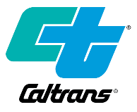
PUBLIC NOTICE

Notice of Intent to Adopt a Mitigated Negative Declaration

SBd 18 Drainage/Culverts and ITS
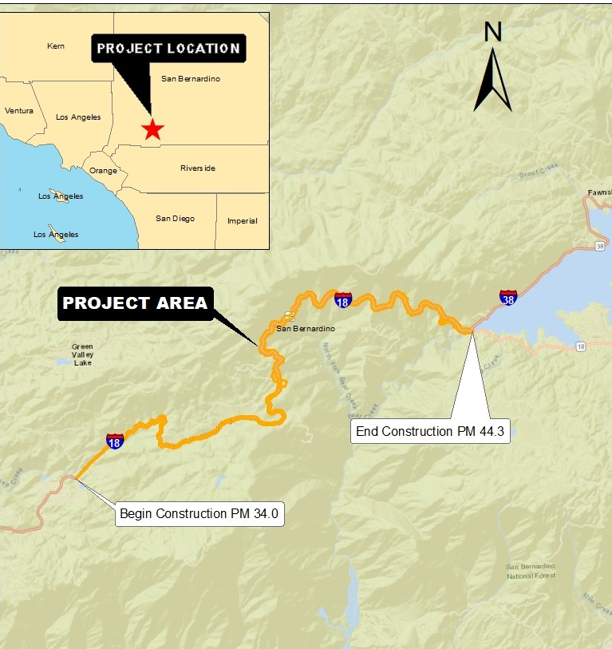

WHAT’S  BEING PLANNED | The California Department of Transportation (Caltrans) proposes to restore 26 culverts on State Route 18 (SR-18), in San Bernardino County, from Arrowbear Drive to 1.3 miles west of Big Bear Lake Dam (PM 34.0/44.3), as shown on the Location Map. The scope of work consists of restoring deteriorating culverts by replacing or repairing them. The project also includes the installation of a new wireless Changeable Message Sign (CMS) at PM 37.3 in the northbound direction, and upgrading the existing Metal Beam Guardrail (MBGR) to Midwest Guardrail System (MGS).
WHY THIS AD? | Caltrans has studied the effects this project may have on the environment. Our studies show it will not significantly affect the quality of the environment. The report that explains why is called an Initial Study (with Proposed Mitigated Negative Declaration). This notice is to tell you of the preparation of the Initial Study (with Proposed Mitigated Negative Declaration) and of its availability for you to read, and to also offer the opportunity to request a public hearing or to provide comments, and the intent to adopt this Mitigated Negative Declaration.
WHAT’S AVAILABLE | Copies of the Initial Study (with Proposed Mitigated Negative Declaration), including associated maps, and other project information are available at the California Department of Transportation, District 8 at 464 W. 4th Street, 6th Floor, MS 823, San Bernardino, CA 92401-1400 or by request via email (gabrielle.duff@dot.ca.gov) or via phone (909) 501-5142.
WHERE YOU COME IN | Do you have any comments about processing the project with an Initial Study with Proposed Mitigated Negative Declaration? Do you disagree with the findings of our study as set forth in the Initial Study with Proposed Mitigated Negative Declaration? Would you care to make any other comments on the project? We’d like to hear what you think. Please submit your comments via email or in writing, no later than May 23, 2022 to:  California Department of Transportation  ATTN: Gabrielle Duff, Senior Environmental Planner  464 W. 4th Street, MS 829  San Bernardino, CA 92401-1400;  or via email to gabrielle.duff@dot.ca.gov  Please use “SBd Drainage/Culverts and ITS on SR-18” in the subject line of the email.  The date we will begin accepting comments is April 21, 2022. If there are no major comments, Caltrans will proceed with the project’s design.
CONTACT | For more information about this project please contact the Caltrans District 8 Office of Public Affairs at (909) 383-4631. For individuals with sensory disabilities, this document can be made available in Braille, in large print, on audiocassette, or on computer disk. To obtain a copy in one of these alternate formats, call or write to Gabrielle Duff, Senior Environmental Planner, 464 W. 4th Street, MS 827, San Bernardino, California 92401-1400; or use the California Relay Service 1-800-735-2929 (TTY to Voice), 1-800-735-2922 (Voice to TTY), 1-800-854-7784 (From or to Speech to Speech), or dial 711.  EA 08-1J310 (PN 081800018)

