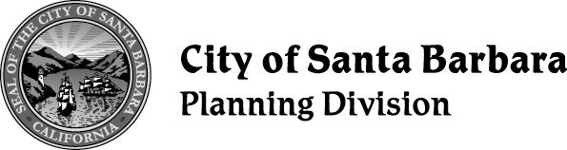
NOTICE OF EIR PREPARATION/ NOTICE OF ENVIRONMENTAL SCOPING HEARING

Date: April 11, 2022
To: | State Clearinghouse City Clerk  Clerk of the Board  Neighbors and Interested Parties | From: | Planning Division City of Santa Barbara  P.O. Box 1990  Santa Barbara, CA 93102-1990 (805) 564-5470

Project Title: Housing Element and Climate Action Plan Update
Project Location: City of Santa Barbara and the City of Santa Barbara Sphere of Influence
Project No.: PLN2022-00108
Public Scoping Hearing: Thursday April 21, 2022, at 1:00 PM, City Council Chambers, Santa Barbara City Hall, De La Guerra Plaza, 735 Anacapa Street.
Project Description: The project is the proposed Housing Element Update, Climate Action Plan (CAP) Update, and related land use and zoning amendments. The proposed Housing Element and CAP would apply to the entire geographic area located within the boundaries of the City of Santa Barbara and the City of Santa Barbara’s Sphere of Influence. The City and Sphere of Influence boundaries are shown in Figure 1.
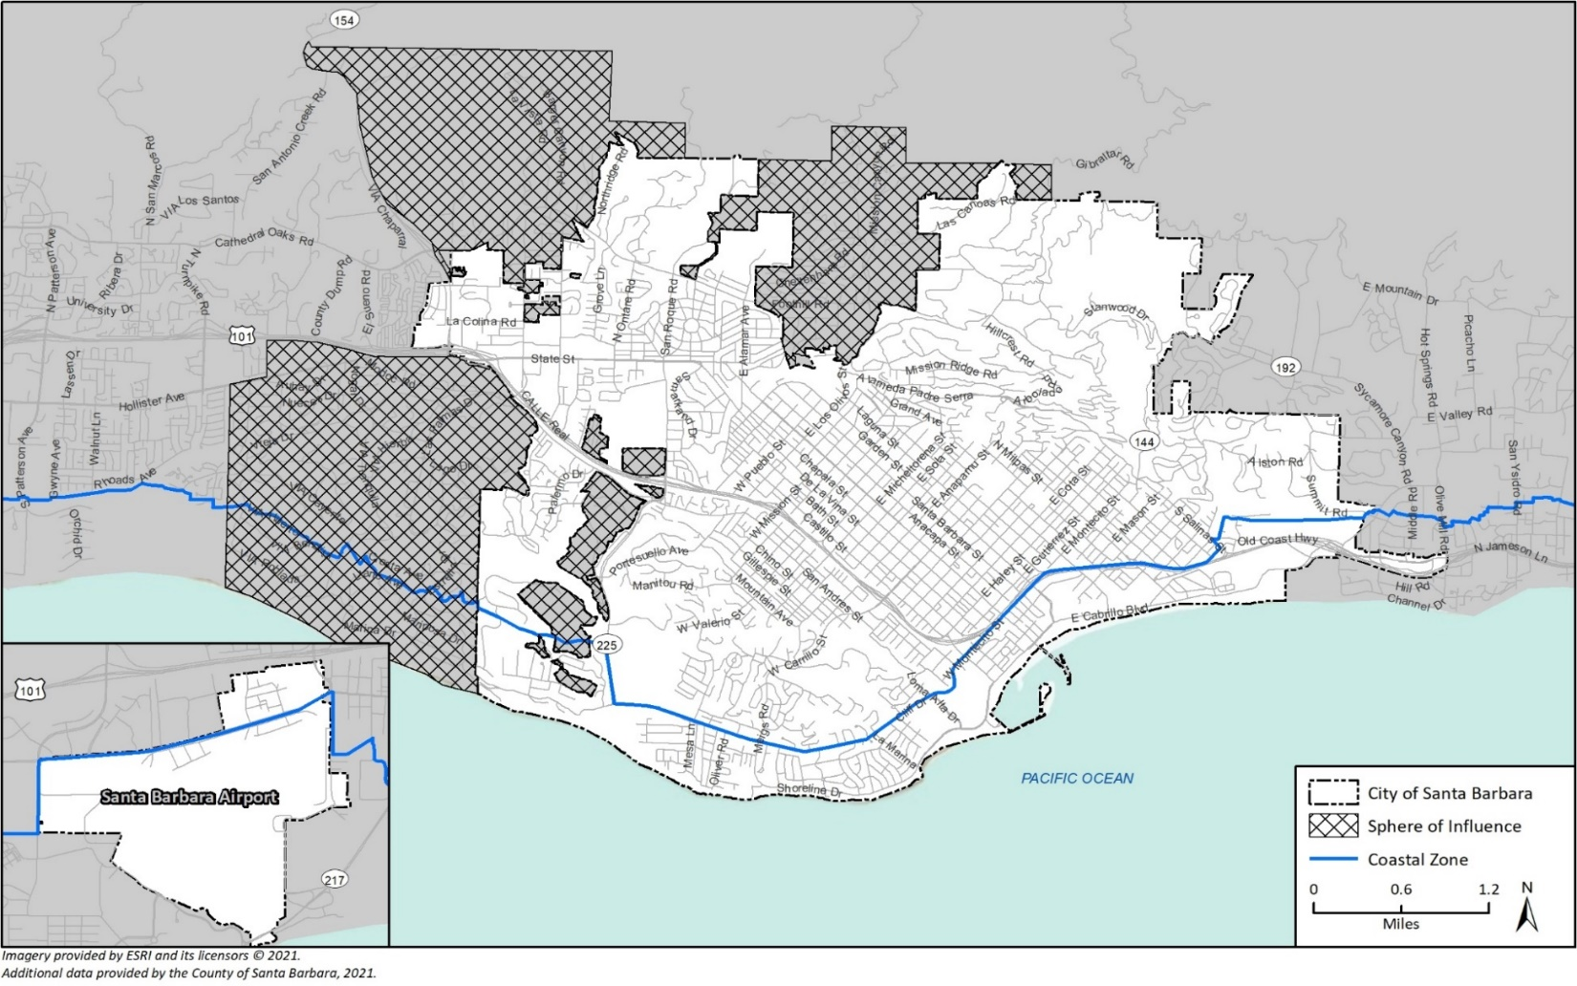
Figure 1: City of Santa Barbara, Sphere of Influence, and Coastal Zone Boundary
Housing Element Update: The proposed Housing Element Update will establish programs, policies and actions to further the goal of meeting the existing and projected housing needs of all household income levels of the community; provide evidence of the City’s ability to accommodate the Regional Housing Needs Assessment (RHNA) allocation through the year 2031; and identify any land use and zoning amendments needed to reach the required housing capacity.
The Housing Element is a State-required element in the City of Santa Barbara’s General Plan. Housing Elements must be updated at least every eight years with mandatory review and certification by the State Department of Housing and Community Development (HCD). Analysis of buildout scenarios in the updated Housing Element will consider existing and projected zoning capacity with the RHNA allocation and HCD’s requirements. Santa Barbara’s RHNA allocation for the 2023-2031 planning period is 8,001 units, which is distributed among four income categories (HCD 2020). The Program Environmental Impact Report (Program EIR) would identify an appropriate buffer in addition to the RHNA allocation and include an analysis of potential environmental impacts.
In accordance with State law (Government Code Sections 65580 – 65588), the Housing Element must include the following:
- An assessment of the city’s population, household, and housing stock characteristics, to inform existing and future housing needs by household types, and special needs populations.
- An analysis of resources and constraints related to housing production and preservation, including governmental regulations, infrastructure requirements and market conditions such as land, construction, and labor costs as well as restricted financing availability.
- Identification of the City’s quantified objectives for the 2023-2031 RHNA and inventory of sites determined to be suitable for housing.
- An analysis of opportunities for energy conservation in residential development.
- Review of the 2015-2023 Housing Element to identify progress and evaluate the effectiveness of previous policies and programs.
- A Housing Plan to address the City’s identified housing needs, including housing goals, policies, and programs.
- An assessment of fair housing patterns, trends, conditions, and practices to identify and remedy significant disparities in access to opportunity.
Climate Action Plan Update: In 2020, City Council adopted a goal of carbon neutrality by 2035. Net zero emissions means removing as much greenhouse gas (GHG) emissions from the atmosphere as emitted by sources that the City has influence over. To reach this goal, the City is updating the 2012 CAP and has launched a climate action campaign called Together to Zero. The CAP Update will include a new community-wide GHG emissions inventory and new climate action strategies. Strategies address issues such as electrifying transportation, switching from vehicle to active transportation, improving infrastructure to support telecommuting, decarbonizing the energy and building sectors, and supporting sequestration of carbon.
Components of the CAP Update may result in physical changes to the environment that could potentially have significant impacts and will be considered in the Program EIR. While individual projects resulting from these measures have not been identified for the purposes of environmental review in the Program EIR, the types of actions will be taken into account in considering potential environmental impacts that could occur through implementation of the CAP. For example, projects or actions such as installation of electric vehicle charging stations or new bicycle or pedestrian facilities would introduce physical changes associated with construction and could alter pedestrian and vehicular traffic patterns.
Additionally, electrification retrofits may change the physical environment through the need for upgraded service and electrical panels, branch circuit upgrades, and installation of condensate drains to facilitate the installation of electric heat pumps for water and space heating. Such upgrades and additions may require physical changes that would be dependent upon the year of building construction and location of service panels and utilities. In some cases, such improvements may include modifications to the interior and/or exterior of buildings for wiring and panel replacement and may require minor excavation for connection of drainage to sewer systems. Future plans or projects requiring discretionary approval would be subject to environmental review under the California Environmental Quality Act (CEQA), and individual impact analyses will identify required plan- or project-specific mitigation measures where applicable.
Program EIR Scope of Analysis: The Program EIR will evaluate effects on the environment that may occur as a result of future growth within the City until 2035 based on the Housing Element and CAP Updates. As a Program EIR, the analysis will be citywide and more general than a project-specific EIR for a development. An EIR is an informational document intended to allow the public and decision-makers to consider potential environmental impacts and any measures to avoid or lessen significant effects, prior to actions to adopt the updated Housing Element or CAP. The Program EIR will have a full scope of analysis. An Initial Study checklist was therefore not prepared as part of the NOP process since all CEQA resources will be thoroughly addressed in the forthcoming Program EIR. The proposed scope of the Program EIR includes the following:
- Existing Conditions. The Program EIR will describe the current environmental setting and infrastructure, which will constitute the baseline physical conditions by which the City will determine whether an impact is significant.
- Environmental Effects. The Program EIR will identify estimated future environmental effects associated with additional growth and development activity to the year 2035 with existing programs and the Housing Element and Climate Action Plan Updates. Impacts citywide or to areas within the City will be examined, as well as cumulative impacts in conjunction with future development in the region.
- EIR impact analysis topics will include: Aesthetics; Air Quality; Biological Resources; Cultural Resources; Energy; Greenhouse Gas Emissions; Geology; Hazards; Hydrology and Water Quality; Noise; Population and Housing; Public Services; Recreation; Transportation; Tribal Cultural Resources; Utilities and Service Systems; and Wildfire.
- Mitigation Measures. The Program EIR will identify measures that could feasibly lessen significant adverse environmental impacts, such as land use/growth policy changes, City programs, and new standard mitigation measures to apply to individual future developments.
- Policy Consistency. The Program EIR will analyze environmental effects that may arise from potential consistency or inconsistency between the Housing Element and Climate Action Plan Updates and existing regional and local plans adopted to protect the environment.
- Alternatives to the Project. The Program EIR will provide a comparative impact evaluation for a range of reasonable alternatives that would feasibly attain most of the basic project objectives of the Housing Element and Climate Action Plan Updates while avoiding or lessening any significant environmental effects. The range of alternatives may include alternative future growth scenarios and policy options including a “No Project” Alternative as a baseline analysis that evaluates the impacts of future growth if current policies continued. .
Comments: Comments on the proposed Program EIR scope of analysis are invited from public agencies, community interest groups, and individual members of the public. We request the views of public agencies as to the scope and content of environmental information be germane to agency statutory responsibilities for the project. Some agencies may need to use the Program EIR prepared by our agency when considering approvals for the project. Please provide the name of an agency contact person, if applicable.
Written comments on the Program EIR scope of analysis should be sent at the earliest possible date, but received no later than May 11, 2022, at 4:30 p.m. Please send your written comments to the attention of Julia Pujo, Environmental Analyst at P.O. Box 1990, Santa Barbara, CA 93102-1990 or JPujo@SantaBarbaraCA.gov.
Public Hearing: An environmental scoping hearing to receive public comments on the proposed Program EIR scope of analysis will be held before the Planning Commission on April 21, 2022.
AMERICANS WITH DISABILITIES ACT: In compliance with the Americans with Disabilities Act, if you need special assistance to gain access to, comment at, or participate in this meeting, please contact the Planning Division Office at (805) 564-5470, extension 4535. If possible, notification at least 48 hours prior to the meeting will enable the City to make reasonable arrangements in most cases.
Meetings can be viewed live on City TV-18, or on your computer via http://www.SantaBarbaraCA.gov/Government/Video/ Meeting rebroadcast schedule can be found at https://www.santabarbaraca.gov/gov/depts/cityadmin/programming.asp.

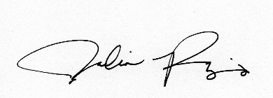
Signature:

Julia Pujo, Environmental Analyst

Telephone: (805) 564-5470 ext. 4467

