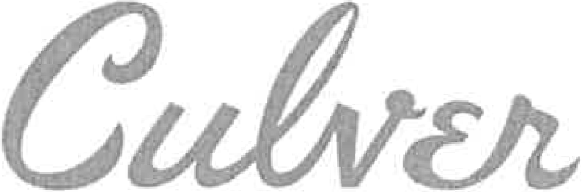(310) 253-5710
•
FAX (310) 253-5721

9770 CULVER BOULEVARD, CULVER CITY, CALIFORNIA 90232-0507

DATE: March 1, 2022 - Los Angeles County Clerk
NOTICE OF EXEMPTION

Governor's Office of Planning and

Attention: Environmental Filing/Registration
12400 Imperial Highway, Suite 2001
No/Walk, CA 90650
Research
1400 Tenth Street, Room 121
Sacramento, CA 95814

PROJECT:
Title and Case No.:

Address/Location: Project Description:

Resolution Amending Design and. Development Standards for Installation of Wireless Facilities in the Public Right-of-Way Related to their Preferred Placement Pursuant to Culver City Municipal Code Section 11.20.065.E.4; and Resolution Amending the Standard Conditions of Approval for Wireless Encroachment Permits Related to Insurance Policy Coverage Requirements for Installation of Wireless Facilities in the Public Rights-Of-Way Pursuant to Culver City Municipal Code Section 11.20.065.H.1
Citywide
Amendments to the existing regulations for the review, design and installation of wireless and other telecommunications facilities in Culver City's public rights-of­ way.

APPLICANT: The City of Culver City

CULVER CITY APPROVAL ACTION:

1. The City Council of the City of Culver City on February 28, 2022.
The decision-making body, in adopting the amendments to the regulations described above, determined such amendments are exempt from further environmental impact assessment per the CEQA guidelines:

Type of Exemption: CEQA Section:
Categorical
15061(b)(3)

2. Reason why pro ject is Exempt (brief): The amendments to the Design and Development Standards and the Conditions of Approval are exempt from the California Environmental Quality Act (CEQA) pursuant to CEQA Guidelines Section 15061(b)(3) because it can be seen with certainty that there is no possibility such amendments will have a significant effect on the environment. The amendments to the Design and Development Standards and the Conditions of Approval, by themself, do not result in any direct physical changes in the environment, as they only amend existing standards and other terms and conditions that may be applied to a subsequent project. Applications submitted under these amended regulations will be subject to further environmental review.

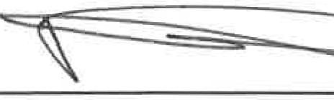3/1/22_
Yanni Demitri, Director of Public Works I City Engineer

