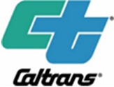
PUBLIC NOTICE
Notice of Intent to Adopt a Mitigated Negative Declaration
State Route 243 Pavement Rehabilitation
Do you want a public hearing on changes proposed for Route 243?
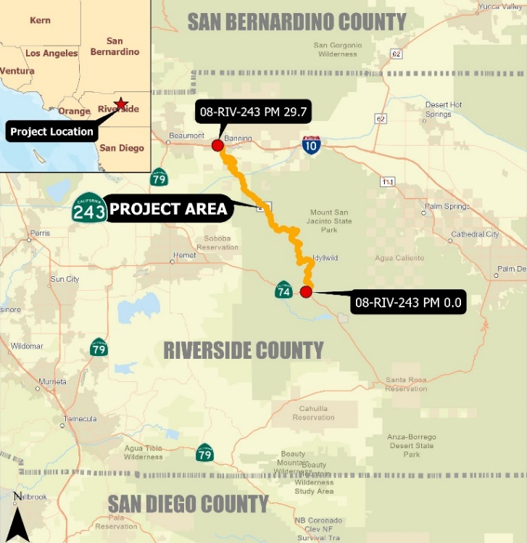
WHAT IS BEING PLANNED? | The California Department of Transportation (Caltrans) proposes to rehabilitate the pavement on State Route 243 (SR-243), from 0.75 mile south of Forest Service Road to 0.5 mile south of Wilson Street, Post Mile 0.0 to Post Mile 29.7, between the cities of Banning and Mountain Center in unincorporated areas of Riverside County. The proposed project includes pavement rehabilitation, culvert repair, Midwest guardrail system upgrades, sign panel replacement, lighting rehabilitation, curb ramp upgrades, and roadside safety improvements.
WHY THIS NOTICE? | Caltrans has studied the effects that this project may have on the environment. Our studies show it will not significantly affect the quality of the environment. The report that explains why is called a Mitigated Negative Declaration/Initial Study. This notice is to tell you of the preparation of the Proposed Mitigated Negative Declaration and Initial Study and of its availability for you to read.
WHAT’S AVAILABLE | Maps for the Proposed Mitigated Negative Declaration and Initial Study, and other project information, are available for review and copying at the Caltrans District 8 Office (464 W 4th St., San Bernardino, CA 92401) on weekdays from 8 am to 4 pm.
WHERE YOU  COME IN | Do you have any comments about processing the project with a Mitigated Negative Declaration and the Initial Study? Do you disagree with the findings of our study as set forth in the Proposed Mitigated Negative Declaration? Would you care to make any other comments on the project? Would you like a public hearing? Please submit your comments or request for public hearing by email to: D8.1J450.Comments@dot.ca.gov or in writing to the following address, no later than March 21, 2022 to:  Antonia Toledo, Senior Environmental Planner  Office of Environmental Studies “D”  California Department of Transportation, District 8  464 W. 4th Street, MS-820  San Bernardino, CA 92401-1400  The date we will begin accepting comments is February 18, 2022.  If there are no major comments or requests for a public hearing, Caltrans will proceed with the project’s design.
CONTACT | For more information about this project or any transportation matter, please contact the Caltrans District 8 Office of Public Affairs at (909) 383-4631.  For individuals with sensory disabilities, this document may be made available in Braille, large print, audiocassette, or a computer disk. To obtain a copy in one of these formats, please write to Terri Kasinga, Chief, Public and Media Affairs, 464 W. 4th Street, MS 1247, San Bernardino, CA 92401 (909) 383-4646 or you may contact the California Relay Service at 1 (800) 735-2929 (TTY to Voice), 1 (800) 735-2922 (Voice to TTY), 1 (800) 854-7784 (From or to Speech to Speech) or dial 711.  EA 08-1J450 (PN 0818000043)

