CITY OF HALF MOON BAY
NOTICE OF INTENT
TO ADOPT A MITIGATED NEGATIVE DECLARATION
Project Title: Half Moon Bay Corporation Yard Upgrade Project Initial Study/Mitigated Negative Declaration
Project Location: 880 Stone Pine Road, Half Moon Bay, CA
Project Description:
The subject of this Initial Study/Mitigated Negative Declaration (IS/MND) under the California Environmental Quality Act (CEQA) is the proposed Half Moon Bay Corporation Yard Upgrade Project (project), which consists of constructing improvements and upgrades to City-owned property at the City’s existing Corporation Yard at 880 Stone Pine Road, Half Moon Bay, California. The property currently contains the City’s Corporation Yard facilities, as well as several Environmentally Sensitive Areas (ESHAs) and a Conservation Trail Easement. The project would be composed of the following improvements: a new access road would be constructed and the old access road loop abandoned; the approximately 4-acre Corporation Yard area would receive upgrades to the Corporation Yard facilities, including a new fabric tension warehouse (warehouse) building, trash and landscape materials enclosure (materials enclosure), solar field, roadways, parking areas, gates, and fencing; and approximately 12 acres of ESHAs, including a 50-foot riparian buffer area around Pilarcitos Creek and 100-foot wetland buffer area around an existing impoundment, would be protected with the installation of wildlife fencing including wildlife tunnels under the new access road. The remaining approximately 4-acre portion of the parcel (remainder area) would not receive any improvements. The remainder area is not a part of the project but may be developed under a subsequent project. The project is planned to be implemented in two phases. In Phase 1, the site would be cleared, prepared, and graded; water and electrical utilities would be upgraded; wildlife corridor fencing would be installed; a portion of the existing fencing within the 100-foot buffer of the impoundment would be removed; and a new materials enclosure, solar field, roadways, parking areas, gates, and fencing would be constructed. The existing dirt/gravel loop roadway would be removed. Preparation would include demolition of some existing features, including the existing trash bins, and removal of a number of existing metal shipping containers and trailers. Under Phase 2, the project would construct the new warehouse, including the foundation and the following interior improvements to the warehouse: storage rooms, offices, kitchenette, locker room, restrooms/shower rooms, and new electrical and utilities. The project includes installation of new fencing around a portion of the Corporation Yard area to fully enclose it and a security gate at the entrance of the Corporation Yard. Security lighting would be included at the gate and on the warehouse and materials enclosure.
Construction of the Corporation Yard upgrades would commence in April 2022 and take approximately 4 to 6 months to complete over the course of 2 to 3 years. This IS/MND includes a description of the existing environmental setting of the project and the environmental effects that may result from construction and operation of the project.
The public review period for the respective proposed Mitigated Negative Declaration based on the Initial Study will begin on January 18, 2022 and end February 17, 2022. You are encouraged to submit written comments regarding the proposed Mitigated Negative Declaration. You may do so by submitting written comments to the Public Works Department prior to the end of the review period. Copies of the application, environmental documents, and all reference documents associated with the project are available for review through the Public Works Department; telephone (650) 726-8265. Written comments may be submitted to the Public Works Department or via email at TSeeley@hmbcity.com.
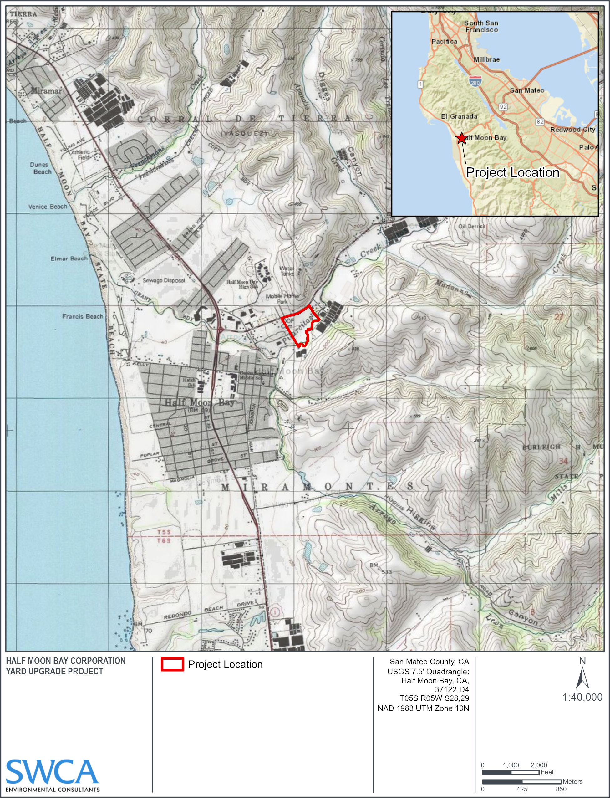
Project Location Map

