CEQA INITIAL STUDY

Use Permit: UP-21;7-2 Lyons Commercial Storage and Residence and
Zone Change: ZC-21;7-1 Planned Development (PD)

APN: 003-460-044

November 2021
Prepared by:
Krista Ruesel, Planner
Amador County Planning Department
810 Court Street
Jackson, CA 95642
(209) 223-6380

This Page is Intentionally Left Blank

Table of Contents
PROJECT DESCRIPTION 5
EVALUATION OF ENVIRONMENTAL IMPACTS PER CEQA: 7
ENVIRONMENTAL FACTORS POTENTIALLY AFFECTED: 8
DETERMINATION: (To be completed by the Lead Agency) 8
Figure A: Proposed Site Plan; Big Horse & Little Cattle Co. 9
Figure B: Context Map 10
Figure C: Site Map- Aerial 11
Figure D: Existing Zoning District(s) 12
Figure F: Existing General Plan Designation 13
Chapter 1. AESTHETICS 14
Chapter 2. AGRICULTURE AND FOREST RESOURCES 16
Chapter 3. AIR QUALITY 18
Chapter 4. BIOLOGICAL RESOURCES 19
Figure 4a: Migratory Birds List (IPAC 2020) 21
Figure 4b: California Native Plant Society Database Query 21
Figure 4d: USFW Wetlands Mapper (IPAC database) 23
Chapter 5. CULTURAL RESOURCES 25
Chapter 6. ENERGY 27
Chapter 7. GEOLOGY AND SOILS 28
Figure 7a: Soil Map Unit Legend 30
Figure 7b: Soil Map Legend 30
Figure 7c: Soil Map 31
Chapter 8. GREENHOUSE GAS EMISSIONS 32
Chapter 9. HAZARDS AND HAZARDOUS MATERIALS 33
Chapter 10. HYDROLOGY AND WATER QUALITY 35
Chapter 11. LAND USE AND PLANNING 37
Chapter 12. MINERAL RESOURCES 38
Figure 12a: CGS Geologic Map of the Sacramento quadrangle, CA 1:250,000 (1981) 38
Figure 12a: CGS Geologic Map of California (CGS- webportal) 39
Chapter 13. NOISE 40
Chapter 14. POPULATION AND HOUSING 42
Chapter 15. PUBLIC SERVICES 43
Chapter 16. RECREATION 44
Chapter 17. TRANSPORTATION / TRAFFIC 45
Chapter 18. TRIBAL CULTURAL RESOURCES 47
Chapter 19. UTILITIES AND SERVICE SYSTEMS 49
Chapter 20. WILDFIRE 51
Chapter 21. MANDATORY FINDINGS OF SIGNIFICANCE 52

Project Overview

Project Title: | Use Permit: UP-21;7-2 Lyons Commercial Storage and Residence and  Zone Change: ZC-21;7-1 Planned Development (PD)
Project Location: | Southwest of the intersection of Camanche Pkwy North and Camanche Rd., North of the Camanche North Shore Subdivision at APN 003-460-044.
Property Owner(s)  Project Representative | William & Alma Lyons 1999 Revocable Trust.  Delta Engineering
Zoning(s): | Existing: H, Highway Commercial;  Proposed: PD, Planned Development
General Plan Designation(s): | SPA, Special Planning Area
Lead Agency Name and Address: | Amador County Planning Department  810 Court Street, Jackson, Ca 95642
Contact Person/Phone Number: | Krista Ruesel, Planner  209-233-6380
Date Prepared: | November, 2021
Other public agencies whose approval is required (e.g., permits, financing approval, or participation agreement.)

PROJECT DESCRIPTION
Project Location
This project site is located along the major collector of Camanche Road (county-maintained) approximately 6 miles south of the City of Ione and just north of the unincorporated, Camanche North Shore community and Camanche Reservoir. The property is entirely within the unincorporated County and outside the boundaries or the sphere of influence of any incorporated municipality. The property is included within Supervisorial District 2, served by Jackson Valley Fire Protection District and Jackson Valley Irrigation District/AWA?
Site Characteristics
The existing site is a single ±12.9-acre parcel. The north-central portion of the site is gradually slowed to the south, the west contains a prominent knoll, and the southern portion of the site more moderately sloped. The site sparsely vegetated characterized primarily by non-native grasses. There are no known mine shafts, tunnels, air shafts, or open hazardous excavations. The parcel is triangular with frontage northwest along Camanche Parkway North, southeast fronting along Camanche Rd, and the southwest property line abutting residential parcels included within the Camanche North Shore Residential Subdivision community. There are no existing structures or improvements on the property and proposed improvements would include the following:
- paved encroachment and on-site circulation and parking areas,
- self-storage buildings of various sizes and configurations
- perimeter security fencing
- identification signage (complying with Amador County Code 19.32 Signage)
- Security lighting and monitoring equipment
- Landscaping and other forms of visual screening
- Stormwater management facilities
- One office building with associated parking and improvements
- One single-family dwelling served by a well and septic system?
- Utilities and ancillary improvements or accessory structures related to the construction and/or operation of the above facilities.
Land Use
The land uses proposed are consistent with the Zone Change application, ZC-21;-1 proposing a change from the H, Highway Commercial zoning district to the PD, Planned Development zoning district. There are no by-right uses within the H zoning district, with conditional uses limited to those described by County Code Section 19.24 (H), which can be summarized as hotels, motels, retail, service stations, commercial recreation, and outdoor signage. As all of these uses do require a discretionary permit as does any project located within the PD zoning district (See Attachment A: County Code Section 19.24.038 PD Zoning District Regulations ), the proposed zone change to PD does not affect the level of evaluation of the proposed project. The PD zoning designation is consistent with the existing SPA, Special Planning Area General Plan Designation.
Surrounding Land Uses
Surrounding property uses include commercial and rural-density residential use to the North of the project site, and residential single family to the southwest bordering the project site, and vacant land to the east. The nearest city is the City of Ione, approximately 6 miles to the north. The unincorporated community of Camanche North Shore is directly south of the parcel, and the unincorporated Community of Buena Vista is approximately 3 miles northeast.
Lead Agency
The lead agency is the public agency that has the principal responsibility for carrying out or approving a project that may have a significant effect upon the environment. In accordance with California Environmental Quality Act (CEQA) Guidelines Section 15051(b)(1), “the lead agency will normally be the agency with general governmental powers, such as a city or county, rather than an agency with a single or limited purpose.” Amador County is the lead agency for this project.
PROBABLE ENVIRONMENTAL EFFECTS AND SCOPE OF MITIGATED MND/MMRP
The Initial Study (IS) will analyze a broad range of potential environmental impacts associated with the proposed project. Information will be drawn from the Amador County General Plan, technical information provided by the applicant to date, and any other reputable information pertinent to the project area. This information includes existing Environmental Laws and Executive Orders, Coordination with other agencies and authorities. In the case that no immitigable, significant impacts are identified through the IS, a Mitigated Negative Declaration (MND) will be filed pursuant to CEQA requirements. Mitigation measures proposed serve to aid in the avoidance, minimization, rectification, reduction or elimination of impacts.
In the case that through the Environmental Assessment/Initial Study, it is determined that there will be significant, immitigable impacts, an Environmental Impact Report (EIR) may be required prior to project approval. Consistent with CEQA and the requirements of Amador County, each environmental chapter will include an introduction, technical approach, environmental setting, regulatory setting, standards of significance, identification of environmental impacts, the development of mitigation measures and monitoring strategies, cumulative impacts and mitigation measures, and level of significance after mitigation measures.
EVALUATION OF ENVIRONMENTAL IMPACTS PER CEQA:
1) A brief explanation is required for all answers except "No Impact" answers that are adequately supported by the information sources a lead agency cites in the parentheses following each question. A "No Impact" answer is adequately supported if the referenced information sources show that the impact simply does not apply to projects like the one involved (e.g., the project falls outside a fault rupture zone). A "No Impact" answer should be explained where it is based on project-specific factors as well as general standards (e.g., the project will not expose sensitive receptors to pollutants, based on a project-specific screening analysis).
2) All answers must take account of the whole action involved, including off-site as well as on-site, cumulative as well as project level, indirect as well as direct, and construction as well as operational impacts.
3) Once the lead agency has determined that a particular physical impact may occur, then the checklist answers must indicate whether the impact is potentially significant, less than significant with mitigation, or less than significant. "Potentially Significant Impact" is appropriate if there is substantial evidence that an effect may be significant. If there are one or more "Potentially Significant Impact" entries when the determination is made, an EIR is required.
4) "Negative Declaration: Less Than Significant With Mitigation Incorporated" applies where the incorporation of mitigation measures has reduced an effect from "Potentially Significant Impact" to a "Less Than Significant Impact." The lead agency must describe the mitigation measures, and briefly explain how they reduce the effect to a less than significant level (mitigation measures from "Earlier Analyses," as described in (5) below, may be cross-referenced).
5) Earlier analyses may be used where, pursuant to the tiering, program EIR, or other CEQA process, an effect has been adequately analyzed in an earlier EIR or negative declaration. Section 15063(c) (3) (D). In this case, a brief discussion should identify the following:
a) Earlier Analysis Used. Identify and state where they are available for review.
b) Impacts Adequately Addressed. Identify which effects from the above checklist were within the scope of and adequately analyzed in an earlier document pursuant to applicable legal standards, and state whether such effects were addressed by mitigation measures based on the earlier analysis.
c) Mitigation Measures. For effects that are "Less than Significant with Mitigation Measures Incorporated," describe the mitigation measures which were incorporated or refined from the earlier document and the extent to which they address site-specific conditions for the project.
6) Lead agencies are encouraged to incorporate into the checklist references to information sources for potential impacts (e.g., general plans, zoning ordinances). Reference to a previously prepared or outside document should, where appropriate, include a reference to the page or pages where the statement is substantiated.
7) Supporting Information Sources: A source list should be attached, and other sources used or individuals contacted should be cited in the discussion.
8) This is only a suggested form, and lead agencies are free to use different formats; however, lead agencies should normally address the questions from this checklist that are relevant to a project's environmental effects in whatever format is selected.
9) The explanation of each issue should identify:
a) The significance criteria or threshold, if any, used to evaluate each question; and
b) The mitigation measure identified, if any, to reduce the impact to less than significance.

ENVIRONMENTAL FACTORS POTENTIALLY AFFECTED:
The environmental factors checked below would be potentially affected by this project, involving at least one impact that is a “Potentially Significant Impact,” as indicated by the checklist on the following pages.
 | Aesthetics |  | Agriculture and Forestry Resources |  | Air Quality
 | Biological Resources |  | Cultural Resources |  | Geology / Soils
 | Greenhouse Gas Emissions |  | Hazards & Hazardous Materials |  | Hydrology / Water Quality
 | Land Use / Planning |  | Mineral Resources |  | Noise
 | Population / Housing |  | Public Services |  | Recreation
 | Transportation / Traffic |  | Utilities / Service Systems |  | Mandatory Findings of Significance
 | Wildfire |  | Energy |  | Tribal Cultural Resources

DETERMINATION: (To be completed by the Lead Agency)

On the basis of the initial evaluation:

I find that the proposed project COULD NOT have a significant effect on the environment, and a NEGATIVE DECLARATION will be prepared.
I find that although the proposed project could have a significant effect on the environment, there will not be a significant effect in this case because revisions in the project have been made by or agreed to by the project proponent. A MITIGATED NEGATIVE DECLARATION will be prepared.
I find that the proposed project MAY have a significant effect on the environment, and an ENVIRONMENTAL IMPACT REPORT is required.
I find that the proposed project MAY have a “potentially significant impact” or “potentially significant unless mitigated” impact on the environment, but at least one effect 1) has been adequately analyzed in an earlier document pursuant to applicable legal standards, and 2) has been addressed by mitigation measures based on the earlier analysis as described on attached sheets. An ENVIRONMENTAL IMPACT REPORT is required, but it must analyze only the effects that remain to be addressed.
I find that although the proposed project could have a significant effect on the environment, because all potentially significant effects (a) have been analyzed adequately in an earlier EIR or NEGATIVE DECLARATION pursuant to applicable standards, and (b) have been avoided or mitigated pursuant to that earlier EIR or NEGATIVE DECLARATION, including revisions or mitigation measures that are imposed upon the proposed project, nothing further is required.

_______________________________________ _________________________
Planning Department Date

Figure A: Proposed Site Plan; Lyons Commercial Storage Facility and Residence
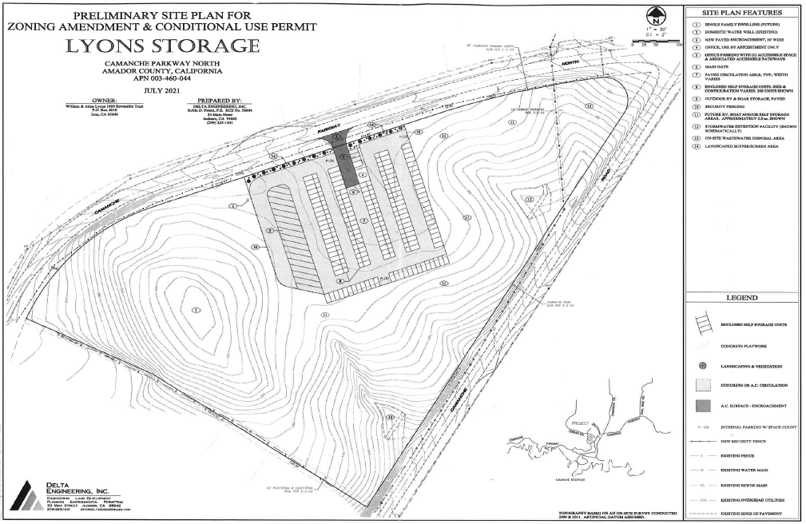

Figure B: Context Map
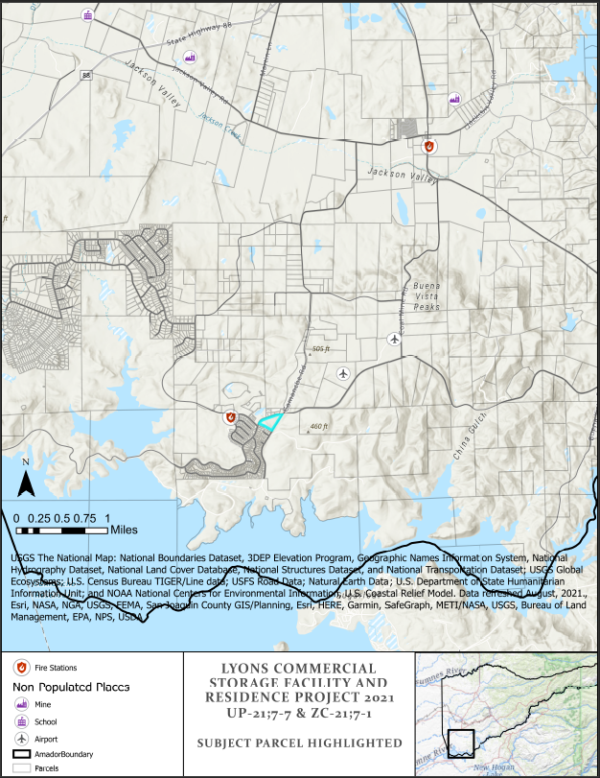

Figure C: Site Map- Aerial
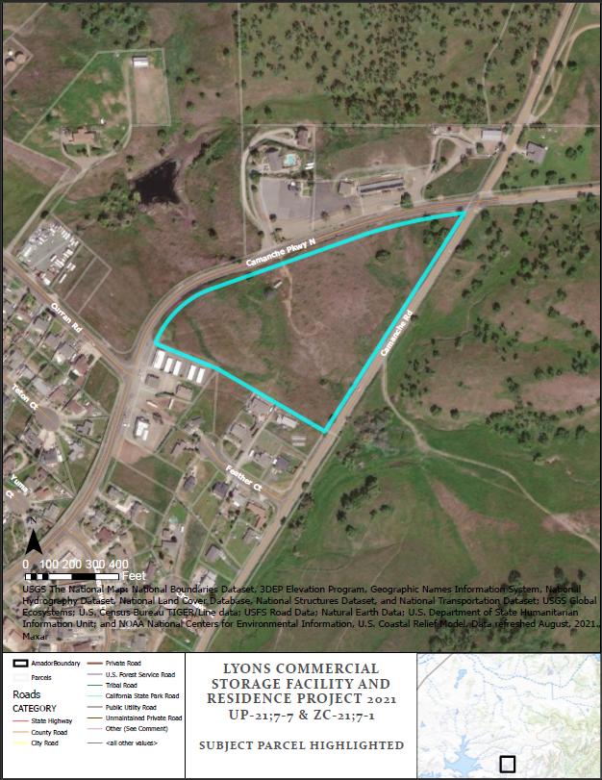
Aerial Map

Figure D: Existing Zoning District(s)
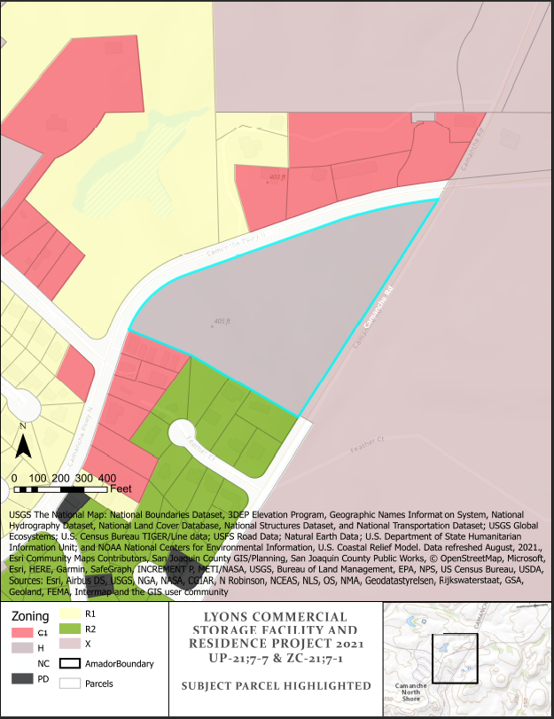

Figure F: Existing General Plan Designation
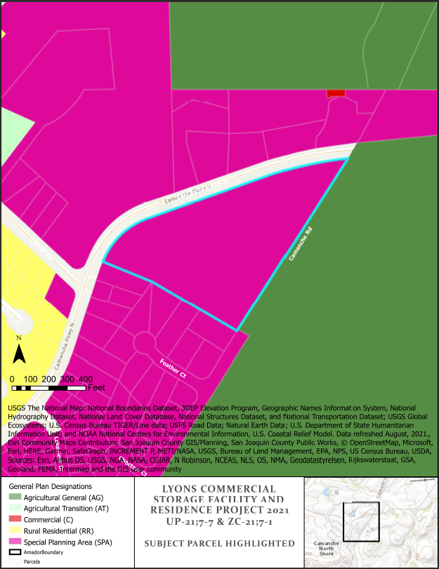

Chapter 1. AESTHETICS
Would the Project: | Potentially Significant Impact | Less Than Significant Impact with Mitigation Incorporated | Less Than Significant Impact | No Impact
- Have a substantial adverse effect on a scenic vista?
- Substantially damage scenic resources, including, but not limited to, trees, rock outcroppings, and historic buildings within a state scenic highway?
- In nonurbanized areas, substantially degrade the existing visual character or quality of public views of the site and its surroundings? (Public views are those that are experienced from publicly accessible vantage point). Would the project conflict with applicable zoning and other regulations governing scenic quality?
- Create a new source of substantial light or glare which would adversely affect day or nighttime views in the area?
Discussion/Conclusion/Mitigation:
- Scenic Vistas: For the purposes of determining significance under CEQA, a scenic vista is defined as a viewpoint that provides expansive views of a highly valued landscape for the benefit of the general public. A substantial adverse impact to a scenic vista would be one that degrades the view from such a designated location. No governmentally designated scenic vista has been identified within the project area. In addition, no specific scenic view spot has been identified in the project area. Therefore, there is no impact.

- Scenic Highways: The project is not located within a designated scenic highway corridor. There is no impact.

- There are no officially designated scenic vistas in the project area, and the proposed uses are less intense than that would be potentially occupied within the H zoning district. The storage area is considered a commercial use which would affect short-range views, however determination whether these effects are considered negative or positive is subjective and unquantifiable. Mitigation Measure AES-1 addresses lighting and glare that may be introduced by commercial uses of the property, with limitations on the proposed security lighting and monitoring equipment to reduce impacts to neighboring properties. Mitigation Measure AES-2 recommends that additional conditions of approval be added to mitigate aesthetic impact to nearby properties. Impacts are less than significant impact with mitigations incorporated.

- Existing sources of light are from nearby residences and other various agricultural or residential uses, as well as traffic along the roadways. The project will result in increased outdoor lighting consistent with commercial use of the property. Any additional light introduced through the uses proposed by this project shall be limited by the proposed hours of operation and otherwise comply with the Amador County General Plan. Mitigation Measures AES-1 and AES-2 address visual impacts and lighting. There is a less than significant impact with mitigations incorporated.

Mitigation Measures:

AES-1 Commercial Light and Glare: Any lighting installations must be compliant with County regulations, and be conditioned to incorporate measures to reduce light and reflectance pursuant to Amador County General Plan Mitigation Measure 4.1-4. This includes measures to reduce light and reflectance including limitation of all installed lighting with this project to full-cutoff, fully-shielded fixtures directed downwards with color correlative temperature (CCT) less than or equal to 3000K. Motion sensors and automatic shutoffs shall be used to limit all lighting fixtures in use after facility is closed to the public or after 10:00 p.m. THE PLANNING DEPARTMENT AND BUILDING DEPARTMENT SHALL MONITOR THIS CONDITION.

AES-2 Visual Impact: Measures shall be taken to mitigate aesthetic impact to nearby properties. These measures may include, but are not limited to the inclusion landscape buffers along the residential bordering property lines, security fencing color palette consisting of neutral color(s) or color(s) matching adjacent structures, and screening of the proposed utility and ancillary other improvements related to the construction and/or operation of the commercial facilities.
Source: Amador County Planning Department, Amador County General Plan and Final Environmental Impact Report (FEIR).

Chapter 2. AGRICULTURE AND FOREST RESOURCES
In determining whether impacts to agricultural resources are significant environmental effects, lead agencies may refer to the California Agricultural Land Evaluation and Site Assessment Model (1997) prepared by the California Dept. of Conservation as an optional model to use in assessing impacts on agriculture and farmland. In determining whether impacts to forest resources, including timberland, are significant environmental effects, lead agencies may refer to information compiled by the CA Dept. of Forestry and Fire Protection regarding the state’s inventory of forest land, including the Forest and Range Assessment Project and the Forest Legacy Assessment project; and forest carbon measurement methodology provided in Forest Protocols adopted by the California Air Resources Board. – Would the project: | Potentially Significant Impact | Less Than Significant Impact with Mitigation Incorporated | Less Than Significant Impact | No Impact
- Convert Prime Farmland, Unique Farmland, or Farmland of Statewide Importance (Farmland), as shown on the maps prepared pursuant to the Farmland Mapping and Monitoring Program of the CA Resources Agency, to non-agricultural use?
- Conflict with existing zoning for agricultural use, or a Williamson Act contract?
- Conflict with existing zoning for, or cause rezoning of, forest land (as defined in PRC §12220(g)), timberland (as defined in PRC §4526), or timberland zoned Timberland Production (as defined by Government Code § 51104(g))?
- Result in the loss of forest land or conversion of forest land to non-forest use?
- Involve other changes in the existing environment which, due to their location or nature, could result in conversion of Farmland, to non-agricultural use or conversion of forest land to non-forest use?
Discussion/Conclusion/Mitigation:
- Farmland Conversion: The project site is occupied entirely by areas classified as Other Land as determined by the USDA Department of Conservation (2016). The proposed project includes the addition of a commercial storage facility and residence. This proposed expansion of uses does not convert agricultural lands nor introduce additional uses which would detract from any existing agricultural uses, nor would this project convert any agricultural areas to non-agricultural uses. The USDA-designated land classification of Other Land is not determined as unique agricultural resources. There is no impact.

- The property is not enrolled under the California Land Conservation (Williamson) Act nor does it qualify under the income requirements for inclusion into a contract. As the property does not qualify prior to the proposed project, this project would not affect the property’s ability to qualify and therefore there is no impact.

- The area is not zoned for forest land or timberland nor utilized for forest land or timber production, therefore there is no impact.

- The area is not considered forest land, or zoned as forest land or timberland, therefore there is no impact.

- This project does not introduce any additional use or impact that would introduce significant changes to nearby property uses. There is no impact to farmland or forest land through this project.

Figure 3a: California Important Farmland (USGS)
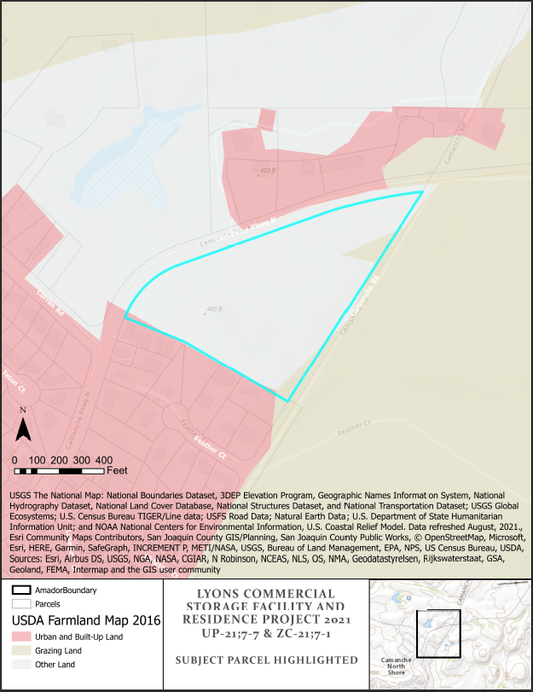
Source: California Important Farmland: 1984-2016 Map, California Department of Conservation; Amador County General Plan; Amador County Planning Department; CA Public Resources Code, Food and Agricultural Code Sections 19020, 21281.5, and 21070 “Custom Livestock Slaughterhouse” and “USDA Exempt Meat Establishment.”

Chapter 3. AIR QUALITY
Where available, the significance criteria established by the applicable air quality management or air pollution control district may be relied upon to make the following determinations. Would the Project: | Potentially Significant Impact | Less Than Significant Impact with Mitigation Incorporated | Less Than Significant Impact | No Impact
- Conflict with or obstruct implementation of the applicable air quality plan?
- Violate any air quality standard, result in substantial increase of any criteria pollutant, or substantially contribute to an existing or projected air quality violation under an applicable local, federal, or state ambient air quality standard (including releasing emissions which exceed quantitative thresholds for ozone precursors)?
- Expose sensitive receptors to substantial pollutant concentrations?
- Result in other emissions (example: Odors) adversely affecting a substantial number of people?
Discussion/Conclusion/Mitigation:
- The project site is within the jurisdiction of the Amador Air District. Amador Air District is responsible for attaining and maintaining compliance with the NAAQS and CAAQS in the Mountain Counties Air Basin (MCAB) through the regulation of pollution emissions from stationary and industrial sources. As there is no proposed change in use through this Use Permit, there is no impact to implementation of any applicable air quality plans.

- The proposed project would not generate a significant increase in operational or long-term emissions. The existing development climate of the area is a combination of commercial and residential uses. The project will not introduce any additional uses or uses beyond what is allowed by the “PD,” zoning proposed, or incompatible with the SPA Special Planning General Plan designation. Future development of the property would be required to comply with the General Plan regarding construction emissions and related project-level emissions. Mitigation Measure AIR-1 is included to minimize vehicle idling times to reduce air quality impacts. There is a less than significant impact with mitigation(s) incorporated relative to air quality standards.

- Sensitive receptors are uses that have an increased sensitivity to air pollution or environmental contaminants. Sensitive receptor locations include schools, parks and playgrounds, day care centers, nursing homes, hospitals, and residential dwelling units. The nearest incorporated city is Ione, located approximately four-and a half (4.5) miles to the north. The project is directly north of the Camanche North Shore residential community, characterized by scattered residences. Though there are sensitive receptors a short distance from the project site, the project itself does not introduce any significant increases of air pollution or environmental contaminants which would affect the surrounding populations. For these reasons, there would be no substantial increase the exposure of sensitive receptors to substantial pollutant concentrations. There is a less than significant impact.

- The proposed project would not generate any significantly objectionable odors beyond that which is permitted under the existing uses and this project would not introduce an increase of objectionable odors discernable at property boundaries. This project results in a less than significant impact.

Mitigation Measure(s)

AIR-1 Permittee shall meet requirements that may be deemed necessary by the Air District based upon site conditions and operations. The project shall require that idling times for vehicles be limited to a maximum of 5 minutes to reduce operational emissions of criteria pollutants per General Plan Mitigation Measure 4.3-2a
Source: Amador Air District, Amador County Planning Department, Amador County General Plan Mitigation Measure 4.3.

Chapter 4. BIOLOGICAL RESOURCES
Would the project: | Potentially Significant Impact | Less Than Significant Impact with Mitigation Incorporated | Less Than Significant Impact | No Impact
- Have a substantial adverse effect, either directly or through habitat modifications, on any species identified as a candidate, sensitive, or special status species in local or regional plans, policies, or regulations, or by the CA Dept. of Fish and Game or U.S. Fish and Wildlife Service?
- Have a substantial adverse effect on any riparian habitat or other sensitive natural community identified in local or regional plans, policies, or regulations or by the CA Dept. of Fish and Game or U.S. Fish and Wildlife Service?
- Have a substantial adverse effect on federally protected wetlands as defined by Section 404 of the Clean Water Act (including, but not limited to, marsh, vernal pool, coastal, etc.) through direct removal, filling, hydrological interruption, or other means?
- Interfere substantially with the movement of any native resident or migratory fish or wildlife species or with established native resident or migratory wildlife corridors, or impede the use of native wildlife nursery sites?
- Conflict with any local policies or ordinances protecting biological resources, such as a tree preservation policy or ordinance?
- Conflict with the provisions of an adopted Habitat Conservation Plan, Natural Community Conservation Plan, or other approved local, regional, or state habitat conservation plan?
Discussion/Conclusion/Mitigation:
- The Information for Planning and Consultation (IPAC) database provided through the U.S. Fish and Wildlife Service was reviewed to determine if any special status animal species or habitats occur on the project site or in the project area. The National Marine Fisheries Service Habitat Conservation Map from NOAA did not identify any Habitat Areas of Particular Concern (HAPC) nor EFH Protected Areas within the project area. The Marine Fish and Wildlife Bios did not identify any State Marine Projected Areas (MPAs) Areas of Special Biological Significance.
CDFW IPAC database identified potential habitat area for Monarch Butterfly (Danaus plexippus), a candidate endangered species, seven (7) threatened species including the Giant Garter Snake (Thamnophis gigas), California Red-legged Frog (Rana draytonii), California Tiger Salamander (Ambystoma californiense), Delta Smelt (Hypomesus transpacificus), Valley Elderberry Longhorn Beetle (Desmocerus californicus dimorphus), and Vernal Pool Fairy Shrimp (Branchinecta lynchi), and Ione Manzanita (Arctostaphylos myrtifolia). Vernal Pool Tadpole Shrimp (Lepidurus packardi) is an endangered animal species and Ione (Irish Hill) Buckwheat (Erigonum apricum (incl.var prostratum) is an endangered plant, both of which were identified by CDFW IPAC for potential presence on site. Mitigation Measures BIO-1, BIO-2, BIO-3, BIO-4, and BIO-5 are required in order to ensure that impacts are less than significant with mitigations incorporated with any future development of the site. In the case that any of these species are found on the project site and which would experience potential impacts through future site development, the proper authorities shall be notified and all construction and/or ground disturbing activity halted so that additional mitigation measures may be prescribed.
The California Native Plant Society (CNPS) Inventory of Rare and Endangered Plants identified seven (7) plants found in Quad 3812048 (Ione) where the property is located. These plants are shown in Figure 5a, below. CNDDB Bios- NLCD Land Cover (2016) identified “Herbaceous” areas within and around the property area with Developed/Open Space areas along the roadway and access roads. Additionally, CNDDB Bios identified additional possible species in the quad where the project is located, referenced by Figure 4c. As the proposed project would include ground disturbing activity, the above listed mitigation measures would be implemented to reduce impacts to less than significant with mitigations incorporated.
- Riverine Community: CDFW IPAC and the US Fish and Wildlife National Wetlands mapper did not identify potentially sensitive Riparian areas within the project area. Any part of this project which would affect seasonal flows or surface waters would be subject to regulation under Section 404 of the Clean Water Act or other State/Federal statutes, according to the US Fish and Wildlife Service (IPAC, BIOS). Mitigation measure HYD-1 requires erosion control and runoff management to be consistent with county code and thus avoid impacts to existing surface water off-site and on other nearby properties. There is a less than significant impact with mitigations incorporated.

- Federally Protected Wetlands (National Wetland Inventory (NWI)): The project site does not include any federally protected wetlands according to the National Wetlands Inventory. Any part of this project which would affect wetlands found off-site would potentially be subject to regulation under Section 404 of the Clean Water Act or other State/Federal statutes, according to the US Fish and Wildlife Service (IPAC, BIOS). There is a less than significant impact with mitigations incorporated.

- Movement of Fish and Wildlife: The project site contains potential habitat for 15 migratory bird species, listed in Figure 4a. In addition to the mentioned Migratory Bird species, Delta Smelt (Hypomesus transpacificus) is an anadromous pelagic fish which migrates from the San Joaquin Delta and Suisun Bay estuaries upstream to spawn seasonally. There is no mapped habitat for Delta Smelt in the project location. In the event that any of the special-status species are found within the project site, the proper authorities shall be notified and all construction and/or ground disturbing activity halted so that additional mitigation measures may be prescribed. Mitigation Measures BIO-1, BIO-2, and BIO-5 are required to render impacts less than significant with mitigation incorporated.

- The proposed project would not conflict with local policies adopted for the protection biological resources. As the site is not wooded and has no Oak Woodlands identified on the project site, there is no impacts to Oak Woodlands. No impact would occur.

- Amador County does not have an adopted Habitat Conservation Plan, Natural Community Conservation Plan, or other approved local, regional, or state habitat conservation plans. No impact would result.

Figure 4a: Migratory Birds List (IPAC 2020)
Species Name | Common Name | Birds of Conservation Concern Listed | Other Conservation List
Haliaeetus leucocephalus | Bald Eagle | Non-BCC Vulnerable | Bald and Golden Eagle Protection Act
Aechmophorus clarkii | Clark’s Grebe | BCC Rangewide (CON)
Cypseloides niger | Black Swift | BCC Rangewide
Geothylpis trichas sinuosa | Common Yellowthroat | BCC-BCR
Aquila chrysaetos | Golden Eagle | Non-BCC Vulnerable | Bald and Golden Eagle Protection Act
Carduelis lawrencei | Lawrence’s Goldfinch | BCC Rangewide (CON)
Marbled Godwit | Limosa fedoa | BCC Rangewide (CON)
Picoides nuttalli | Nuttall’s Woodpecker | BCC-BCR
Baeolophus inornatus | Oak Titmouse | BCC Rangewide (CON)
Carpodacus cassinii | Cassin’s Finch | BCC Rangewide (CON)
Olive-sided Fllycatcher | Olive-sided Flycatcher | BCC-Rangewide (CON)
Agelaius tricolor | Tricolored Blackbird | BCC Rangewide (CON)
Chamaea fasciata | Wrentit | BCC Rangewide (CON)
Pica nuttalli | Yellow-billed Magpie | BCC Rangewide (CON)
Tringa semipalmata | Willet

Figure 4b: California Native Plant Society Database Query
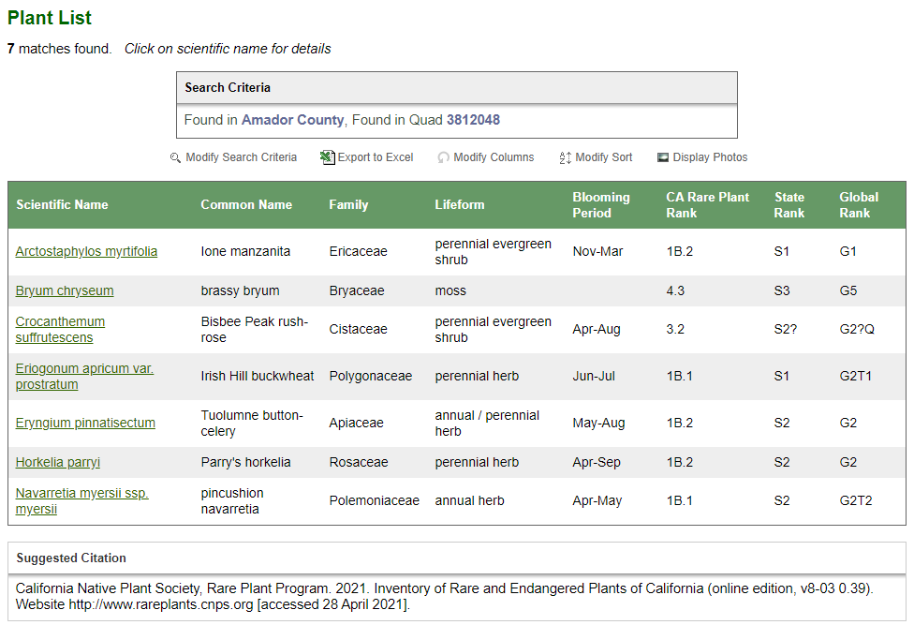

Figure 4d: Wetlands Mapper (National Wetlands Inventory, FWS)
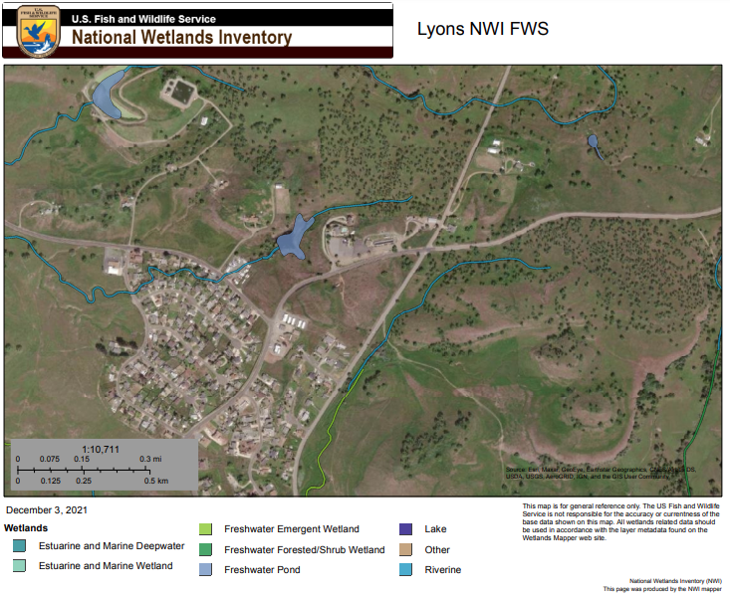

Mitigation Measures:
BIO-1 Special-Status Species – Animals- Special-status animal species should be avoided to the maximum extent practicable. If complete avoidance is infeasible, project impacts will need to be quantified and mitigation developed to reduce the impacts to a less-than-significant level. Mitigation may include preservation and enhancement of on and/or off-site populations, transplanting individuals to a preservation area, or other actions, subject to the approval of CDFW, USFWS, or CNPS. Prior to ground disturbing activity, a Biological Resource Analysis shall be prepared to document the presence of any special status species, and the project site plan shall be modified to avoid disturbance to those species as determined necessary by the County and CDFW, USFWS, or CNPS.
BIO-2 Ground Disturbance Timing for Nesting Birds- To avoid impacts to nesting bird species or birds protected under the Migratory Bird Treaty Act, all ground disturbing activities conducted between February 1 and September 1 must be preceded by a pre-construction survey for active nests, to be conducted by a qualified biologist. This survey should be conducted within two weeks prior to any construction activities. The purpose of this survey is to determine the presence or absence of nests in an area to be potentially disturbed. If nests are found, a buffer depending upon the species and as determined by a qualified biologist in consultation with the California Department of Fish and Wildlife and shall be demarcated with bright orange construction fencing. Any vegetation clearing should be schedule outside of the avian nesting season (February 1 through August 31) or survey should be conducted immediately prior to vegetation removal. If active nests are found, vegetation removal should be delayed until the young fledge. No ground disturbing or other construction activities shall occur within this buffer until the County-approved biologist has confirmed that breeding/nesting is completed and the young have fledged the nest. Nesting bird surveys are not required for ground disturbing activities occurring between September 2 and January 31.
BIO-3 Special-Status Species – Plants- Special-status plant populations should be avoided to the maximum extent practicable. If complete avoidance is infeasible, project impacts will need to be quantified and mitigation developed to reduce the impacts to a less-than-significant level. Mitigation may include preservation and enhancement of on and/or off-site populations, transplanting individual plants to preservation area, or other actions, subject to the approval of CDFW, USFWS, or CNPS.
BIO-4 Plant Survey- Prior to any construction activity related to any discretionary project, a biological and/or rare plant survey shall be conducted to determine if there are any special-status plants within the project area and which may potentially be disturbed. Surveys shall be timed according to the blooming period for the target species, and known reference populations will be visited prior to surveys to confirm the species is blooming where known to occur. If special-status species are identified, avoidance zones may be established around plant populations to clearly demarcate areas for avoidance. Avoidance measures and buffer distances may vary between species, and the specific avoidance zone distance will be determined in coordination with the appropriate resource agencies. For individual specimens, highly visible temporary construction fencing shall be placed at least 10 ft. away from the drip line of the plant. No construction activity or grading would be permitted within the buffer zone. Where avoidance is infeasible, and the plant subject to removal or potential damage from construction, the project applicant shall develop and implement a mitigation plan pursuant to State and Federal regulation. The mitigation plan shall provide for no net loss of habitat and shall include, but is not limited to, relocation of the affected plants, replanting, and monitoring of relocated and planted specimens.
BIO-5 Wetland and Riparian Habitat (BIO-5): Compete avoidance of wetlands is conservatively recommended to ensure compliance with wetland laws. Site development shall implement erosion control plans, and best management practices (BMPs) that prevent the discharge of sediment into nearby drainage are found, a buffer depending upon the species and as determined by a qualified biologist in consultation with the California Department of Fish and Wildlife and shall be demarcated with bright orange construction fencing.. No ground disturbing or other construction activities shall occur within this buffer until the County and CDFW approved biologist has confirmed that there is no unmitigated impact to existing riparian or wetland habit.
Source: California Department of Fish and Wildlife BIOS, U.S. Fish and Wildlife Service IPAC, California Native Plant Society (CNPS) California Department of Fish and Wildlife Habitat Conservation Planning, Migratory Bird Treaty Act, NOAA, National Wetlands Inventory, 2019, Amador County Planning Department,

Chapter 5. CULTURAL RESOURCES
Would the project: | Potentially Significant Impact | Less Than Significant Impact with Mitigation Incorporated | Less Than Significant Impact | No Impact
- Cause a substantial adverse change in the significance of a historical resource as defined in §15064.5?
- Cause a substantial adverse change in the significance of an archaeological resource pursuant to §15064.5?
- Directly or indirectly destroy a unique paleontological resource or site?
- Disturb any human remains, including those interred outside of formal cemeteries?
Discussion/Conclusion/Mitigation:
(A.)(B.)(C.)(D.)
Cultural resources include prehistoric and historic period archaeological sites; historical features, such as rock walls, water ditches and flumes, and cemeteries; and architectural features. Cultural resources consist of any human-made site, object (i.e., artifact), or feature that defines and illuminates our past. Prehistoric resources sites are found in foothill areas, areas with high bluffs, rock outcroppings, areas overlooking deer migratory corridors, or above bodies of water. Grading and other soil disturbance activities of previously undisturbed land on the project site have the potential to uncover historic or prehistoric cultural resources. In the case that any ground disturbing or construction activity is proposed in the future which does encroach onto any previously undisturbed land, additional environmental review would be necessary including but not limited to requiring the developer to halt construction upon the discovery of as-yet undiscovered significant prehistoric sites, documenting and/or avoiding these resources, informing the County Planning Department, and consultation with a professional archeologist.
Discretionary permits for projects “that could have significant adverse impacts to prehistoric or historic-era archeological resources” in areas designated by the Amador County General Plan as being moderate-to-high cultural resource sensitivity are required to have a Cultural Resource Study prepared prior to project approval, per Mitigation Measures 4.5-1a, 4.5-1b, and 4.5-2 of the Amador County Implementation Plan. The project site is located in an area of moderate cultural resource sensitivity.
A Cultural Resources Study was prepared for this project, with recommendations as follows: “In the unlikely event that buried archaeological resources are encountered during any ground-disturbing activity, all work in the immediate vicinity of the find must cease and the permitting agency notified for further instruction. If human remains or other evidence of a grave is encountered, all work musts top and the County Coroner notified immediately in accordance with California law” (Windmiller). Proposed mitigations CULTR-1 and CULTR-2 are included and will require additional study to be performed in the case that this use requires any ground-disturbing activity, consistent with the recommendations made in the study. There is a less than significant impact with mitigations incorporated to cultural resources.

Mitigation Measures
CULTR-1 During ground-disturbing activity, if paleontological, historic or pre-historic resources such as chipped or ground stone, fossil-bearing rock, large quantities of shell, historic debris, building foundations, or human bone are inadvertently discovered, the operator/permittee shall immediately cease all such activities within 100 feet of the find and notify the applicable agency. A qualified archaeologist shall be contracted by the operator/permittee to assess the significance of the find and prepare an evaluation, avoidance or mitigation plan, as appropriate, which shall be implemented before resuming ground disturbing activities.
CULTR-2 Immediately cease any disturbance of the area where such suspected remains are discovered and any nearby areas reasonably suspected to overlie adjacent remains until the Amador County Coroner is Amador County General Plan FEIR AECOM County of Amador 4.5-15 Cultural Resources contacted, per Section 7050.5 of the California Health and Safety Code,. The coroner shall, within two working days:
Determine if an investigation of cause of death is required;
      - Determine if the remains are most likely that of Native American origin, and if so suspected, the coroner shall notify the California Native American Heritage Commission (NAHC) within 24 hours of making his or her determination.
      - The descendants of the deceased Native Americans shall make a recommendation to the operator/ permittee for the means of handling the remains and any associated grave goods as provided in Public Resources Code (PRC) Section 5097.98.
      - The NAHC shall immediately notify those persons it believes to be most likely descended from the deceased Native American.
      - The descendants may, with the permission of the landowner or their representative, inspect the site of the discovered Native American remains and may recommend possible treatment or disposition within 24 hours of their notification.
      - Whenever the NAHC is unable to identify a descendent, or the descendent identified fails to make a recommendation, or the landowner or his or her authorized representative rejects the recommendation of the descendent and the mediation provided for in subdivision (k) of PRC Section 5097.94 fails to provide measures acceptable to the landowner, the landowner or his or her authorized representative shall reinter the human remains and items associated with Native American burials with appropriate dignity on the property in a location not subject to further subsurface disturbance.
Source: Amador County Planning Department, Amador County General Plan Environmental Impact Report, Amador County Implementation Plan 2016, California Health and Safety Code, California Native American Heritage Commission (NAHC), CA Office of Historic Preservation, State of California Resources Agency Department of Parks and Recreation Primary Records (DPR 523A), Records Search Results for APNs: 015-220-065 NCIC, Amador County Planning Department, Windmiller Consulting Inc. Cultural Resources Assessment for Lyons Storage (2021).

Chapter 6. ENERGY
Would the project: | Potentially Significant Impact | Less Than Significant Impact with Mitigation Incorporated | Less Than Significant Impact | No Impact
- Result in potentially significant environmental impact due to wasteful, inefficient, or unnecessary consumption of energy resources, during project construction or operation?
- Conflict with or obstruct a state or local plan for renewable energy or energy efficiency?
Discussion/Conclusion/Mitigation:
A. Long-term project construction or long-term operational changes resulting in substantial energy use shall conform to the Amador County General Plan energy use requirements, and any other applicable requirements under the State of California. There is a less than significant impact.
B. The only local energy plan is the Energy Action Plan (EAP) which provides incentives for homeowners and business owners to invest in higher-efficiency energy services. The project would not conflict with or obstruct any state or local plan for energy management, therefore there is no impact.
Sources: Amador County EAP, Amador County Planning Department.

Chapter 7. GEOLOGY AND SOILS
Would the project: | Potentially Significant Impact | Less Than Significant Impact with Mitigation Incorporated | Less Than Significant Impact | No Impact
- Expose people or structures to potential substantial adverse effects, including the risk of loss, injury or death involving:
- Rupture of a known earthquake fault, as delineated on the most recent Alquist-Priolo Earthquake Fault Zoning Map issued by the State Geologist for the area or based on other substantial evidence of a known fault? Refer to Division of Mines and Geology Special Publication 42.
- Strong seismic ground shaking?
- Seismic-related ground failure, including liquefaction?
- Landslides?
- Result in substantial soil erosion or the loss of topsoil?
- Be located on a geological unit or soil that is unstable, or that would become unstable as a result of the project, and potentially result in on- or off-site landslide, lateral spreading, subsidence, liquefaction or collapse?
- Be located on expansive soil, as defined in Table 18-1-B of the Uniform Building Code (1994), creating substantial risks to life or property?
- Have soils incapable of adequately supporting the use of septic tanks or alternative waste water disposal systems where sewers are not available for the disposal of waste water?
- Directly or indirectly destroy a unique geological site or feature?
Discussion/Conclusion/Mitigation:
- The project site is not located within an Alquist-Priolo Earthquake Fault Zone and no active faults are located on or adjacent to the property, as identified by the U.S. Geologic Survey mapping system. Therefore, no impact would occur. The State Geologist has determined there are no known sufficiently active or well-defined faults or areas subject to strong ground shaking, liquefaction, landslides, or other ground failure in Amador County as to constitute a potential hazard to structures from surface faulting or fault creep. The project location has not been evaluated for liquefaction hazards or seismic landslide hazards by the California Geological Survey. There is no impact.

- According to the project location as mapped in Figure 7a-c by the Natural Resources Conservation Service (NRCS, 2017), the property where the project is located is characterized by 11.5 acres of Inks loam and Rock land with 3-45 % slopes and 1.4 acres of Pardee cobbly loam, 3-31 percent slopes. Grading Permits are required for any earthmoving of 50 or more cubic yards, and are reviewed and approved by the County in accordance with Ordinance 1619 (County Code 15.40) with conditions/requirements applied to minimize potential erosion. Presence of the above listed soil types does not require additional regulatory action nor does it indicate special circumstance requiring any under County code. The property will include grading which, with the implementation of Mitigation Measures GEO-1, HYD-1, and BIO-1, 2, 3, and 4, is a less than significant impact.

- Slopes most susceptible to earthquake-induced failure include those with highly weathered and unconsolidated materials on moderately steep slopes (especially in areas of previously existing landslides). The actuators of landslides can be both natural events, such as earthquakes, rainfall, and erosion, and human activities. Those induced by man are most commonly related to large grading activities that can potentially cause new slides or reactivate old ones when compacted fill is placed on potentially unstable slopes. Conditions to be considered in regard to slope instability include slope inclination, characteristics of the soil materials, the presence of groundwater and degree of soil saturation. This project will not impact the stability of existing geological units or soil, nor impact potential landslides, lateral spreading, subsidence, liquefaction or collapse. There is no impact of this project on the aforementioned conditions.

- Expansive or collapsible soils are characterized by the ability to undergo significant volume change (shrink and swell) as a result of variation in soil moisture content. Soil moisture content can change due to many factors, including perched groundwater, landscape irrigation, rainfall, and utility leakage. Requirement of a grading permit requires building inspection and grading permit issuance for any substantial earthmoving or construction of structures, and as it is unlikely that even if expansive soils are found at the project site, that there would be impacts detrimental to the project, property, or current uses with the current regulation implemented through construction. There is no impact.

- Soil conditions within the project site must be determined to be suitable for on-site sewage systems permissible for this type of land division. Mitigation Measure GEO-1 requires compliance with Amador County Code regarding sewage disposal requirements for projects of this nature. Mitigation Measure UTL-1 requires review and approval of the existing wastewater treatment system utilized by this project. There is a less than significant impact with mitigation incorporated.

- The proposed project would not destroy or greatly impact any known unique geological site or feature. There is a less than significant impact.
Mitigation Measure:
GEO-1 SEWAGE DISPOSAL: Retain the services of a qualified professional (a registered professional engineer, registered environmental health specialist, or licensed engineering geologist experienced in on-site sewage disposal system design) to review the existing on-site wastewater treatment system that is to serve the project. This qualified professional shall evaluate existing and proposed wastewater flows and assess the current condition of the system. He or she shall then either: 1) Certify that the existing onsite wastewater treatment system may be expected to provide acceptable service for the proposed use, or 2) specify any modification, expansion, replacement or treatment that would be needed for such certification to be possible.

Figure 7a: Soil Map Unit Legend
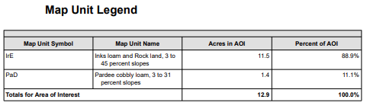

Figure 7b: Soil Map Legend
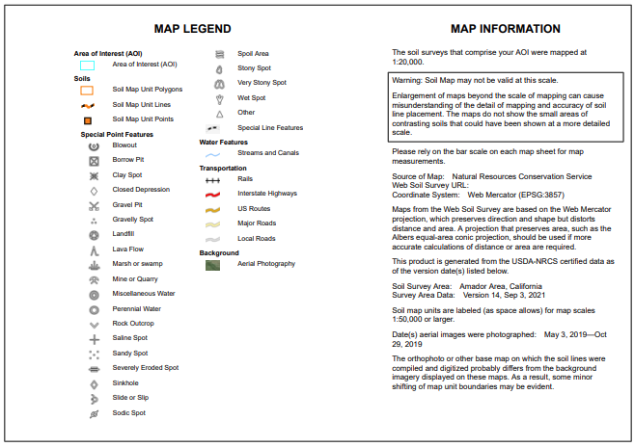

Figure 7c: Soil Map
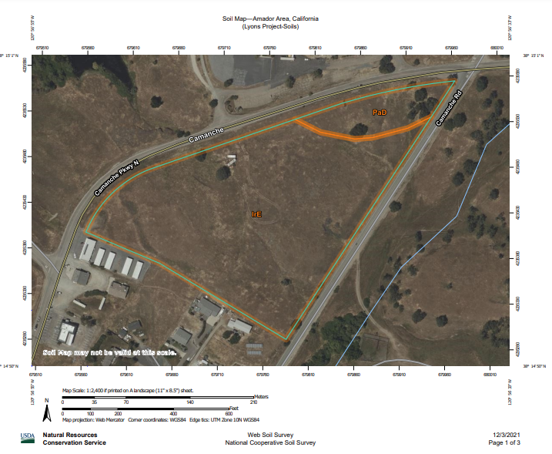

Sources: Soil Survey-Amador County; Amador County Planning Department, Environmental Health Department, National Cooperative Soil Survey, Amador County General Plan EIR, California Geologic Survey: Alquist-Priolo Earthquake Fault Zones Maps.

Chapter 8. GREENHOUSE GAS EMISSIONS
Would the project: | Potentially Significant Impact | Less Than Significant Impact with Mitigation Incorporated | Less Than Significant Impact | No Impact
- Generate greenhouse gas emissions, either directly or indirectly, that may have a significant impact on the environment?
- Conflict with an applicable plan, policy, or regulation adopted for the purpose of reducing the emissions of greenhouse gases?
Discussion/Conclusion/Mitigation:
- This project is not anticipated to generate substantial increase in emissions. The project would not generate significant greenhouse gas emissions or result in significant global climate change impacts, with the implementation of Mitigation Measure AIR-1, limiting vehicular idling times. There is a less than significant impact with mitigation incorporated.

- There is no applicable plan, policy, or regulation adopted for the purpose of reducing the emissions of greenhouse gases. Any increase in emissions would comply with regulations and limits established by the California Air Resources Board (CARB) and Amador Air District. Therefore there is no impact.
Sources: Amador County General Plan, Amador Air District, Amador County Municipal Codes, Assembly Bill 32 Scoping Plan- California Air Resources Board (CARB), Amador County General Plan EIR.

Chapter 9. HAZARDS AND HAZARDOUS MATERIALS
Would the project: | Potentially Significant Impact | Less Than Significant Impact with Mitigation Incorporated | Less Than Significant Impact | No Impact
- Create a significant hazard to the public or the environment through the routine transport, use, or disposal of hazardous materials?
- Create a significant hazard to the public or the environment through reasonably foreseeable upset and accident conditions involving the release of hazardous materials into the environment, or otherwise introduce potential hazards to residents or property?
- Emit hazardous emissions or handle hazardous or acutely hazardous materials, substances, or waste within one-quarter mile of an existing or proposed school?
- Be located on a site which is included on a list of hazardous materials sites compiled pursuant to Government Code §65962.5 and, as a result, would it create a significant hazard to the public or the environment? Or otherwise be influenced by other notable hazards?
- For a project located within an airport land use plan or, where such a plan has not been adopted, within two miles of a public airport or public use airport, would the project result in a safety hazard for people residing or working in the project area?
- For a project within the vicinity of a private airstrip, would the project result in a safety hazard for people residing or working in the project area?
- Impair implementation of or physically interfere with an adopted emergency response plan or emergency evacuation plan?

Discussion/Conclusion/Mitigation:

- Hazardous Materials Transport and Handling: The project does not significantly increase risk to the public or the environment through the routine transport, use, or disposal of hazardous materials. There is a less than significant impact.

B. Hazardous Materials Upset and Release: Potential impacts of hazardous material handling, transport, or release through this project is mitigated by oversight of the Amador County Environmental Health department pursuant to state law. There is a less than significant impact.

C. The nearest public schools are located more than 4 miles away. Schools would not be exposed to hazardous materials, substances, or waste due to the project, and there would be no impact.

- Pursuant to Government Code Section 65962.5, the project site was queried for past-to-current records regarding information collected, compiled, and updated by the Department of Toxic Substances Control and Secretary for Environmental Protection (EPA) evaluating sites meeting the “Cortese List” requirements. The project site also was also searched on the California EPA’s Superfund Enterprise Management System (SEMS) database and the US EPA Facility Registry Service (FRS) however there were no specific flags for the project on either site. CalEPA GeoTracker identified no potential hazardous materials within the project area or near vicinity (1 mile radius) therefore there is a less than significant impact.

The project does not propose any significant changes in use, intensity, or major construction, therefore there is a less than significant impact regarding hazardous materials on site.

E The nearest public use airport to the project site is the Westover Field Airport located in Martell, located approximately 10 miles away. The proposed project is located outside the safety compatibility zones for the area airports, and due to the significant distance from the project site, there is no impact to people working on the project site.

F The nearest private airport to the project site is located at 4875 Camanche Parkway North, approximately 1.4 miles away from the property. The proposed use will not negatively affect the airport or airport usage, nor will the project be negatively affected in turn. There is no impact to safety hazards associated with airport operations are anticipated to affect people working or residing within the project site.

G The proposed project is located directly off of Camanche Rd., a county-maintained minor collector. Amador County has an adopted Local Hazard Mitigation Plan (LHMP), updated in January of 2014. The proposed project does not include any actions that physically interfere with any emergency response or emergency evacuation plans. There is a less than significant impact.

Mitigation Measure(s)

HAZ-1 Hazardous Materials Upset and Release: Prior to activation of the use permit, the applicant shall provide documentation to the Amador County Environmental Health Department that the site is in full compliance with the requirements of the Unified Program regarding hazardous materials business plan requirements, hazardous waste generation, treatment or storage, aboveground petroleum storage, and underground tanks. If a hazardous materials business plan is required, the emergency response portion shall include a plan for the evacuation of visitors in the event of a hazardous materials incident. The applicant shall substantially comply with all requirements of the Unified Program throughout the life of the Use Permit.

HAZ-2 Hazardous Materials Storage

Sources: Amador County Planning Department, Superfund Enterprise Management System database (SEMS), Department of Toxic Substances Control Envirostor database, Geotracker, California State Water Control Board (CA SWRBC), California Stormwater Quality Association (CASQA), Local Hazard Mitigation Plan (LHMP).

Chapter 10. HYDROLOGY AND WATER QUALITY
Would the project: | Potentially Significant Impact | Less Than Significant Impact with Mitigation Incorporated | Less Than Significant Impact | No Impact
- Violate any water quality standards or waste discharge requirements or otherwise substantially degrade surface or ground water quality?
- Substantially deplete groundwater supplies or interfere substantially with groundwater recharge such that there would be a net deficit in aquifer volume or a lowering of the local groundwater table level (e.g., the production rate or pre-existing nearby wells would drop to a level which would not support existing land uses or planned uses for which permits have been granted)?
- Substantially alter the existing drainage pattern of the site or area, including through the alteration of the course of a stream or river or through the addition of impervious surfaces, in a manner which would:
- Result in substantial erosion or siltation on- or off-site?
- Substantially increase the rate or amount of surface runoff in a manner which would result in flooding on- or off-site?
- Create or contribute runoff water which would exceed the capacity of existing or planned stormwater drainage systems or provide substantial additional sources of polluted runoff?
- Impede or redirect flood flows or place housing within a 100-year flood hazard area as mapped on a federal Flood Hazard Boundary or Flood Insurance Rate Map or other flood hazard delineation map?
- In a flood hazard, tsunami, or seiche zone, risk release of pollutants due to project inundation or increase risk of such inundation?
- Otherwise substantially degrade water quality?
- Expose people or structures to a significant risk of loss, injury or death involving flooding, including flooding as a result of the failure of a levee or dam?
- Conflict with or obstruct implementation of a water quality control plan or sustainable groundwater management plan?
Discussion/Conclusion/Mitigation:
A The proposed project would increase the impermeable surfaces on-site but would not result in a significant increase in urban storm water runoff. The County requires a grading permit (County Code Chapter 15.40) for any earthmoving in excess of 50 cubic yards. This requirement is included as Mitigation Measure HYD-1. The impacts are less than significant with mitigation incorporated.
B The proposed project would not significantly require the use of, or otherwise interfere with, available groundwater supplies with the implementation of Mitigation Measure HYD-1. There is a less than significant impact with mitigations incorporated.
Ci-ii The proposed project is not projected to significantly contribute to any increase in erosion, siltation, surface runoff, or redirection of flood flows with implementation of Mitigation Measure HYD-1. There is a less than significant impact with mitigation incorporated.
C iii The project would not contribute runoff water which would exceed the capacity of existing or planned stormwater drainage systems with implementation of Mitigation Measure HYD-1. There is a less than significant impact with mitigation incorporated.
C iv The project is located in Flood Zone X, meaning that the northern portion of the site is outside of the Standard Flood Height Elevation and of minimal flood hazard (Zone X). The proposed project does not involve the construction of housing on the property. Impact are less than significant with respect to placing housing within a 100-year flood hazard area for this project.
D There is no known risk mapped on the California Department of Conservation CGS Information Warehouse regarding landslides. This parcel map is a division of land which does not propose changes of use or additional development therefore a less than significant impact to/from flood flows.
E The project would not substantially degrade water quality through its operation. Conditions of additional project approval include submission of plans to the Amador County Environmental Health Department, obtainment of a Grading Permit through the Amador County Building Department, included as Mitigation Measure HYD-1. Mitigation Measure UTL-2 addresses the water quality of on-site wells. There is a less than significant impact with mitigations incorporated regarding water quality resulting from this project.
F It is highly unlikely that the project would be subject to inundation by seiche, tsunami, or mudflow as the project site is not in any FEMA mapped DFIRM Flood Zones. There would not be substantial risk for property or people through the failure of levees or dams introduced by this project, therefore there is a less than significant impact regarding risk or loss.
G There is no existing water quality control plan or sustainable groundwater management plan in the vicinity of this project. Compliance with SGMA would be required for future water usage. There is a less than significant impact.
Mitigation Measures
HYD-1 Grading Permits and Erosion Control: Prior to the issuance of permits for site-specific development, drainage and grading permits shall be prepared by a licensed civil engineer and submitted to the Amador County Building Department for approval. Drainage plans shall demonstrate that new development would not increase peak storm flows and that adequate capacity exists downstream to accommodate increased stormwater volume. All site-specific development shall implement appropriate stormwater runoff best management practices (BMPs) and design features to protect receiving water quality consistent with Amador County standards, and any required National Pollution Discharge Elimination System (NPDES) permits administered by the State Water Resources Control Board (SWRCB) must be obtained prior to project execution.
Sources: Amador County Planning Department, California State Water Resources Control Board (CSWRCB), California Stormwater Quality Association (CASQA). CA Department of Conservation, USGS-USDA Forest Service Quad Map, USGS Landslide Hazards Program, CA Department of Conservation CGS Information Warehouse.

Chapter 11. LAND USE AND PLANNING
Would the project: | Potentially Significant Impact | Less Than Significant Impact with Mitigation Incorporated | Less Than Significant Impact | No Impact
- Physically divide an established community?
- Conflict with any applicable land use plan, policy, or regulation of an agency with jurisdiction over the project (including, but not limited to the general plan, specific plan, local coastal program, or zoning ordinance) adopted for the purpose of avoiding or mitigating an environmental effect?
- Conflict with any applicable habitat conservation plan or natural community conservation plan?
Discussion/Conclusion/Mitigation:
A The subject property is currently vacant. The proposed project would not divide an established community and is consistent with the General Plan designation of SPA, Special Planning Area. This project does not propose a significant increase in density and will likely service nearby residents. There is a less than significant impact.
B The project includes the zone change to PD which is consistent with the General Plan designation of SPA. Proposed uses are commercial and residential and would not inherently introduce significant impacts to the neighboring properties (residential uses). This project’s location at a primary intersection in the area supports the proposed use. There is a less than significant impact with the mitigations incorporated with the project and implementation of the Conditions of Approval for the project. There is a less than significant impact with mitigations incorporated.
C The project site is not included in any adopted habitat conservation plans or natural community conservation plans. Therefore, the project would not conflict with any such plans and no impact would result.
Sources: Amador County General Plan, Amador County Municipal Codes, Amador County Planning Department.

Chapter 12. MINERAL RESOURCES
Would the project: | Potentially Significant Impact | Less Than Significant Impact with Mitigation Incorporated | Less Than Significant Impact | No Impact
- Result in the loss of availability of a known mineral resource that would be of value to the region and the residents of the state?
- Result in the loss of availability of a locally-important mineral resource recovery site delineated on a local general plan, specific plan or other land use?
Discussion/Conclusion/Mitigation:
A & B According to the California Division of Mines and Geology Mineral Land Classification Map, this project is located in the Sutter Creek 15-Minute Quadrangle which has a reported SMARA Study Area, conducted in 1983. This project would not restrict access to any mineral resources on site. This project will not encroach onto any of the other properties and therefore not interfere with any present or future access to known mineral resource areas. There are no proposed structures or changes in use, therefore there is a less than significant impact to any mineral resources.

Figure 12a: CGS Geologic Map of the Sacramento quadrangle, CA 1:250,000 (1981)

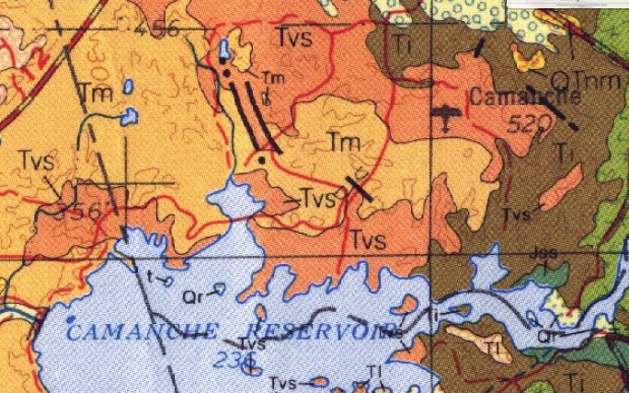
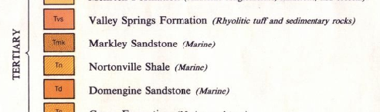

Figure 12a: CGS Geologic Map of California (CGS- webportal)

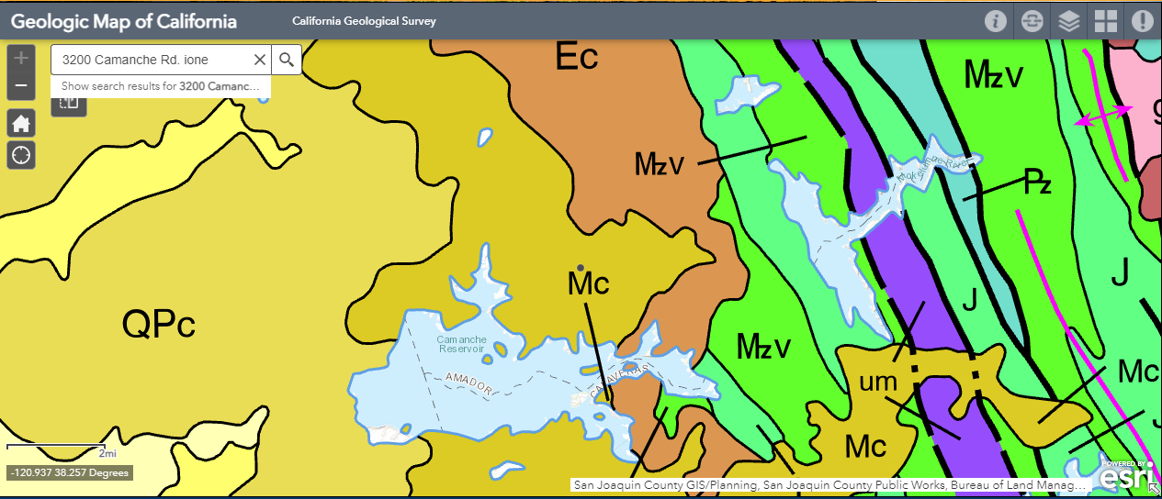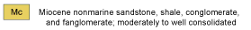

Source: Amador County Planning Department, California Geological Survey https://maps.conservation.ca.gov/cgs/gmc/); Wagner, D.L., Jennings, C.W., Bedrossian, T.L., and Bortugno, E.J.; Geologic map of the Sacramento quadrangle, California, 1:250,000: California Division of Mines and Geology, Geologic Map 1A; 1981.

Chapter 13. NOISE
Would the project: | Potentially Significant Impact | Less Than Significant Impact with Mitigation Incorporated | Less Than Significant Impact | No Impact
- Exposure of persons to or generation of noise levels in excess of standards established in the local general plan or noise ordinance, or applicable standards of other agencies?
- Exposure of persons to or generation of excessive groundborne vibration or groundborne noise levels?
- Contribute to substantial permanent increase in ambient noise levels in the project vicinity above levels existing without the project?
- Contribute to substantial temporary or periodic increase in ambient noise levels in the project vicinity above levels existing without the project?
- For a project located within an airport land use plan or, where such a plan has not been adopted, within two miles of a public airport or public use airport, would the project expose people residing or working in the project area to excessive noise levels?
- For a project within the vicinity of a private airstrip, would the project expose people residing or working in the project area to excessive noise levels?
Discussion/Conclusion/Mitigation:
A The project would result in low levels of noise-related impacts related to the proposed commercial storage facility. Limitation of hours of operation would reduce noise impacts to residents nearby, and the project would be subject to regulation by the Amador County Code regarding nuisance noise conditions. There is a less than significant impact.
B The proposed project would include the construction activity which may generate ground-borne vibration, noise, or use construction activities. There are no additional uses which would propose the use of heavy equipment for an extended period of time beyond what is expected for the construction of the facility. There is a less than significant impact.
C & D The presented project will not introduce significant increased noise. Noise levels generated would not exceed applicable noise standards established in the General Plan, and the property would be subject to Amador County noise regulations (Chapter 9.44). There is a less than significant impact.
E & F Public and private airports would not be impacted by this project. No impact would result.
Sources: Amador County Planning Department, Amador County General Plan: Noise Element, General Plan Mitigation Measure 4.11.

Chapter 14. POPULATION AND HOUSING
Would the project: | Potentially Significant Impact | Less Than Significant Impact with Mitigation Incorporated | Less Than Significant Impact | No Impact
- Induce substantial population growth in an area, either directly (for example, by proposing new homes and businesses) or indirectly (for example, through extension of roads or other infrastructure)?
- Displace substantial numbers of existing housing, necessitating the construction of replacement housing elsewhere?
- Displace substantial numbers of people, necessitating the construction of replacement housing elsewhere?
Discussion/Conclusion/Mitigation:
A The project would not significantly increase the developmental density allowed on the affected property. Current zoning of H, Highway Commercial does not allow residential use however surrounding residential contexts establish this property as appropriate for single-family residential uses. The proposed project propose an increase in housing, with the expansion of uses to include residential uses of the property. Establishment of appropriate ingress and egress and compliance with Amador County requirements regarding traffic and encroachments regulate the proposed small-scale traffic increase with the addition of a residence and commercial operation, therefore there is a less than significant impact.
B & C The property is currently vacant and no resident housing stock would be depleted through this project. There is no impact to available resident housing.
Sources: Amador County Planning Department.

Would the project: | Potentially Significant Impact | Less Than Significant Impact with Mitigation Incorporated | Less Than Significant Impact | No Impact
Result in substantial adverse physical impacts associated with the provision of new or physically altered governmental facilities, need for new or physically altered governmental facilities, the construction of which could cause significant environmental impacts, in order to maintain acceptable service ratios, response times or other performance objectives for any of the public services:
- Fire protection?
- Police protection?
- Schools?
- Parks?
- Other public facilities?

Chapter 15. PUBLIC SERVICES
Discussion/Conclusion/Mitigation:
A The project site is currently served by the Jackson Valley Fire Protection District (JVFPD). The nearest fire station is JVFPD Station 171 located off of Curran Rd. and Quiver Dr. in the Camanche North Shore Subdivision, approximately half a mile west of the project site. Mutual aid agreements coordinate protection service between City or Community Fire Protection Jurisdictions, and CalFire. The project requires annexation to Community Facilities District 2006-1, included as Mitigation measure PUB-1. A less than significant impact with mitigations incorporated related to fire protection services would occur.
B The project site is currently served by the Amador County Sheriff’s Department. The nearest Sheriff station is located at 700 Court St., Jackson, which serves the unincorporated area of the County. Proposed improvements would not result in additional demand for sheriff protection services. Mutual aid agreements coordinate police action between City and County police protection service. Ione is located closer to the project site than the Sheriff Department office in Jackson, CA. California Highway Patrol (CHP) also provides police protection associated with the State Highways; the nearest highways to this project are CA State Hwy 88 located northwest of the project site. As these various agencies all provide various police and emergency services, this project would not result in the provision of or need for new or physically altered sheriff or police protection facilities. There is a less than significant impact to police protection services.
C&D This project includes the construction of one additional residential unit. Because the demand for schools, parks, and other public facilities is driven by population, the proposed project would not significantly increase demand for those services at this time as the property is not going to experience any change in zoning or general plan designation. As such, the proposed project would result in a less than significant impact on these public services.
E There is no physical change or additional inconsistent uses proposed, therefore would not be significant additional pressure on other solid waste processing/transfer facilities. There is a less than significant impact.
Mitigation Measure
PUB-1 Prior to recordation of any final map, the subdivider shall participate in the annexation to the County’s Community Facilities District No. 2006-1.
Sources: Amador County Planning Department.

Chapter 16. RECREATION
Would the project: | Potentially Significant Impact | Less Than Significant Impact with Mitigation Incorporated | Less Than Significant Impact | No Impact
- Would the project increase the use of existing neighborhood and regional parks or other recreational facilities such that substantial physical deterioration of the facility would occur or be accelerated?
- Does the project include recreational facilities or require the construction or expansion of recreational facilities which might have an adverse physical effect on the environment?
Discussion/Conclusion/Mitigation:
A&B The proposed project would increase opportunity for residential development (one dwellings) thus presenting minor increased demand for parks or recreational facilities. The proposed project would not significantly affect use of existing facilities, nor would it require the construction or expansion of existing recreational facilities at his time. The proposed project would have a less than significant impact on recreational facilities.
Source: Amador County Planning Department.

Chapter 17. TRANSPORTATION / TRAFFIC
Would the project: | Potentially Significant Impact | Less Than Significant Impact with Mitigation Incorporated | Less Than Significant Impact | No Impact
- Conflict with an applicable plan, ordinance or policy establishing measure of effectiveness for the performance of the circulation system, taking into account all modes of transportation including mass transit and non-motorized travel and relevant components of the circulation system, including but not limited to intersections, streets, highways and freeways, pedestrian and bicycle paths, and mass transit?
- Conflict with an applicable congestion management program, including, but not limited to level of service standards and travel demand measures, or other standards established by the county congestion management agency for designated roads or highways?
- Result in a change in air traffic patterns, including either an increase in traffic levels or a change in location that results in substantial safety risks?
- Substantially increase hazards due to a design feature (e.g., sharp curves or dangerous intersections) or incompatible uses (e.g., farm equipment)?
- Result in inadequate emergency access?
- Conflict with adopted policies, plans, or programs regarding public transit, bicycle, or pedestrian facilities, or otherwise decrease the performance or safety of such facilities?
- Conflict with or be inconsistent with CEQA Guidelines §15064.3, subdivision (b)?
Discussion/Conclusion/Mitigation:
A&B The proposed project would not cause a substantial increase in traffic, reduce the existing level of service, or create any significant congestion at any intersection nor would it conflict with an applicable plan, ordinance or policy establishing measures of effectiveness for the performance of the circulation system. Caltrans, Amador County Department of Transportation and Public Works, and other applicable transportation agencies have been included in circulation of this project. There would be a less than significant.
C The proposed project would not be located within any Westover Airport safety zones (Westover Field Airport Land Use Compatibility Plan Draft 2017). Therefore, the project would not result in a change in air traffic patterns, including either an increase in traffic levels or a change in location that would result in a safety risk. No impact would result.
D The proposed project would not have significant impacts to transportation nor necessitate additional mitigation. Mitigation Measure TRA-1 includes the requirement that an encroachment permit be obtained for the proposed uses, to the satisfaction of the Public Works Department. Encroachments must conform to the regulations found in Chapter 12.10 of County Code. Grading must conform to Chapter 15.40 (See Mitigation Measure HYD-1) there is a less than significant impact with mitigations incorporated.
E The proposed project must comply with the Fire and Life Safety Ordinance (Chapter 15.30) with Mitigation Measure TRA-2. There is less than significant impact with mitigation incorporated.
F The project would not affect alternative transportation. Therefore, the proposed project is consistent with the policies, plans, and programs supporting alternative transportation, and there would be no impact.
G Pursuant to CEQA Guidelines §15064.3, subdivision (b) the County’s qualitative analysis of this project establishes there are no significant impacts to traffic. There is no impact to the implementation of this project with respects to CEQA Guidelines §15064.3(b).
Mitigation Measures:
TRA-1 The property must maintain a primary access onto a County road and obtain all necessary encroachment permits (Chapter 12.10) and grading permits (Chapter 15.40) required for the proposed uses, as regulated by the Amador County Department of Transportation and Public Works (Mitigation Measure HYD-1).
TRA-2 The proposed project must comply with the Fire and Life Safety Ordinance (Chapter 15.30).
Sources: Amador County Planning, California Fire and Life Safety (Chapter 15.30), California Environmental Quality Act (CEQA) Guidelines 2019.

Chapter 18. TRIBAL CULTURAL RESOURCES
Would the project: | Potentially Significant Impact | Less Than Significant Impact with Mitigation Incorporated | Less Than Significant Impact | No Impact
- Cause a substantial adverse change in the significance of a tribal cultural resource, defined in Public Resources Code § 21074 as either a site, feature, place, cultural landscape that is geographically defined in terms of the size and scope of the landscape, sacred place, or object with cultural value to a California Native American tribe, and that is:
- Listed or eligible for listing in the California Register of Historical Resources, or in a local register of historical resources as defined in Public Resources Code section 5020.1(k)?
- A resource determined by the lead agency, in its discretion and supported by substantial evidence, to be significant pursuant to criteria set forth in subdivision (c) of Public Resources Code § 5024.1. In applying the criteria set forth in subdivision (c) of Public Resource Code § 5024.1, the lead agency shall consider the significance of the resource to a California Native American tribe?
Discussion/Conclusion/Mitigation:
Tribal cultural resources” are defined as (1) Sites, features, places, cultural landscapes, sacred places, and objects with cultural value to a California Native American tribe that are either of the following:
(A) Included or determined to be eligible for inclusion in the California Register of Historical Resources.
(B) Included in a local register of historical resources as defined in subdivision (k) of Section 5020.1.
These may include non-unique archaeological resources previously subject to limited review under CEQA. Assembly Bill 52, which became effective in July 2015, requires the lead agency (in this case, Amador County) to begin consultation with any California Native American tribe that is traditionally and culturally affiliated with the geographic area of the proposed project prior to the release of a negative declaration, mitigated negative declaration, or environmental impact report if: (1) the California Native American tribe requested to the lead agency, in writing, to be informed by the lead agency through formal notification of proposed projects in the geographic area that is traditionally and culturally affiliated with the tribe, and (2) the California Native American tribe responds, in writing, within 30 days of receipt of the formal notification and requests the consultation (Public Resources Code Section 21080.3.1[b]).
A As defined by Public Resources Code section 21074 (a) there were no tribal cultural resources identified in the project area therefore the project would not cause a substantial adverse change in any identified tribal cultural resources. Additionally, the Ione Band of Miwok Indians, the Buena Vista Band of Me-Wuk Indians, the Shingle Springs Band of Miwuk Indians, and the Washoe Tribe of Nevada and California were notified of this project proposal and did not submit materials referencing tribal cultural resources affected by this project. Any identified cultural resources or potentially significant resources would be preserved and avoided by future development consistent with the provisions of Mitigation Measure CULTR-3. Impacts to Tribal Cultural Resources on this site are less than significant with the mitigation measures incorporated in CULTR-3.
Sources: Amador County Planning Department, California Public Resources Code; National Park Service National Register of Historic Places, North Central Information Center Records, Department of Parks and Recreation Record (2020).

Chapter 19. UTILITIES AND SERVICE SYSTEMS
Would the project: | Potentially Significant Impact | Less Than Significant Impact with Mitigation Incorporated | Less Than Significant Impact | No Impact
- Require or result in the relocation or construction of new or expanded systems (causing significant environmental effects):
  - Water or wastewater treatment facilities
  - Stormwater drainage facilities
  - Electric power facilities
  - Natural gas facilities
  - Telecommunications facilities
- Exceed wastewater treatment requirements of the applicable Regional Water Quality Control Board?
- Have sufficient water supplies available to serve the project from existing entitlements and resources (for the reasonably foreseeable future during normal, dry, or multiple dry years), or are new or expanded entitlements needed?
- Result in determination by the wastewater treatment provider which serves or may serve the project that it has adequate capacity to serve the project’s projected demand in addition to the provider’s existing commitments?
- Be served by a landfill with sufficient permitted capacity to accommodate the project’s solid waste disposal needs while not otherwise impairing the attainment of solid waste reduction goals?
- Generate solid waste in excess of state or local standards or in excess of the capacity of local infrastructure?
- Comply with federal, state, and local statues and regulations related to solid waste?
Discussion/Conclusion/Mitigation:
A i. As the project proposes additional uses which are dependent on the provision of services support additional uses, the applicant must provide evidence of availability of water and wastewater disposal consistent with the requirements by Amador County Environmental Health, included as Mitigation Measure UTL-1. Due to the small scale of the project and lack of changes in use, this project would not require a Stormwater Pollution Prevention Permit (SWPPP) from State Water Resources Control Board. There is a less than significant impact with mitigation incorporated.
A ii. Stormwater drainage on site will need to be redirected and will necessitate the project proponent obtain a grading permit (Chapter 15.40) through the Building Department in order to regulate stormwater drainage and runoff. As there is no proposed physical changes of the property proposed with this project there is no impact.
Aiii-v. No new or expanded stormwater or drainage facility, electric power facility, natural gas facility, or telecommunications facility would be necessary over the course of this project and therefore would not cause any environmental effects as a result. There is no impact.
B. The proposed project would not exceed wastewater treatment requirements of the applicable Regional Water Quality Control Board or result in the expansion of water or wastewater treatment facilities. Therefore, a less than significant impact related to these utilities and service systems would occur.
C. The project is not located within the service area of an existing public water system. Mitigation Measure UTL-1 and UTL-2 require the applicant to verify sufficient water services for the proposed parcels. The impacts are less than significant with mitigation incorporated.
- The project will not increase demands of any wastewater treatment provider beyond what existing systems are prepared to serve. Mitigation Measure UTL-1 addresses provision of sufficient irrigation improvements required for project approval. There is a less than significant impact with mitigation incorporated.
E-G The project will not produce an increase in solid waste disposal needs beyond what would be addressed by County and State requirements therefore. There is a less than significant impact.
Mitigation Measure
UTL-1 Wastewater Systems: Applicant retain the services of a qualified professional (a registered professional engineer, registered environmental health specialist, or licensed engineering geologist experienced in on-site sewage disposal system design) to review the existing on-site wastewater treatment system that is to serve the project. This qualified professional shall evaluate existing and proposed wastewater flows and assess the current condition of the system. He or she shall then either: 1) Certify that the existing onsite wastewater treatment system may be expected to provide acceptable service for the proposed use, or 2) specify any modification, expansion, replacement or treatment that would be needed for such certification to be possible. THE AMADOR COUNTY ENVIRONMENTAL HEALTH DEPARTMENT SHALL MONITOR THIS CONDITION.
UTL-2 Well Water Quality: The water well that is to serve the project shall be sampled for total coliforms and E. coli, as well as nitrate and nitrite. The results shall be generated by an accredited laboratory and provided in writing to the Amador County Environmental Health Department. Test results must demonstrate that the water produced is absent for total coliform and E. coli, and does not exceed the nitrate and nitrite primary maximum contaminant levels listed in California Code of Regulations, Title 22, Table 64431-A.

UTL-3 Well Service/Water Supply: In accordance with Section 14.06.055 of Amador County Code, the well that is to serve the project shall be evaluated by a registered professional engineer, who is to submit an evaluation for review and approval by the Environmental Health Department. This evaluation shall describe estimated water demand and whether or not the water well may be expected to serve the proposed use. If needed, the engineer shall propose storage or other design features that must be implemented to ensure an adequate water supply.

Sources: Amador County Planning Department, Amador County Environmental Health Department, Jackson Valley Irrigation District (JVID).

Chapter 20. WILDFIRE
If located in or near state responsibility areas or lands classified as very high fire hazard severity zones, would the project: | Potentially Significant Impact | Less Than Significant Impact with Mitigation Incorporated | Less Than Significant Impact | No Impact
- Substantially impair an adopted emergency response plan or emergency evacuation plan?
- Due to slope, prevailing winds, and other factors, exacerbate wildfire risks, and thereby expose project occupants to pollutant concentrations from a wildfire or the uncontrolled spread of a wildfire?
- Require the installation or maintenance of associated infrastructure (such as roads, fuel breaks, emergency water sources, power lines, or other utilities) that may exacerbate fire risk or that may result in temporary or ongoing impacts to the environment?
- Expose people or structures to significant risks, including downslope or downstream flooding or landslides, as a result of runoff, post-fire slope instability, or drainage changes?
- Expose people or structures to a significant risk of loss, injury or death involving wildland fires, including where wildlands are adjacent to urbanized areas or where residences are intermixed with wildlands?
Discussion/Conclusion/Mitigation:
A The project shall not impair any adopted emergency response plan or emergency evacuation plan. There is no significant impact.
B The project does not exacerbate wildfire risks through significant change in slope, prevailing winds, or other major factors. The project would not require the installation of emergency services and infrastructure that may result in temporary or ongoing environmental risks or increase in fire risk. Therefore there is no impact.
C The project shall not require the installation or maintenance of associated infrastructure that may exacerbate fire risk or impact the environment. Mitigation Measure TRA-1 requires compliance with 15.30 regarding fire access, therefore there is no significant impact with mitigation incorporated.
D&E The project will not expose people or structure to any new significant risks regarding flooding, landslides, or wildland fire risk. The project is located in Moderate Fire Risk Zone and therefore shall conform to all standard Fire Safety Regulations as determined by Amador County Fire Department and California Building Code. The project is located approximately 2 miles from the Ione Fire Station as well as less than a mile from the Camanche and Jackson Valley stations, and therefore will not require any increased fire protection due to this project. There is no impact.
Source: Amador County Planning, Amador County Office of Emergency Services, Calfire Fire Hazard Severity Zone Map.

Chapter 21. MANDATORY FINDINGS OF SIGNIFICANCE
Would the Project: | Potentially Significant Impact | Less Than Significant Impact with Mitigation Incorporated | Less Than Significant Impact | No Impact
- Does the project have the potential to degrade the quality of the environment, substantially reduce the habitat of a fish or wildlife species, cause a fish or wildlife population to drop below self-sustaining levels, threaten to eliminate a plant or animal community, reduce the number or restrict the range of a rare or endangered plant or animal or eliminate important examples of the major periods of California history or prehistory?
- Does the project have impacts that are individually limited, but cumulatively are considerable? (“Cumulatively considerable” means that the incremental effects of a project are considerable when viewed in connection with the effects of past projects, the effects of other current projects, and the effects of probable future projects)?
- Does the project have environmental effects which will cause substantial adverse effects on human beings, either directly or indirectly?
Discussion/Conclusion/Mitigation:
A The project will not degrade the quality of the environment and no habitat, wildlife populations, and plant and animal communities would be significantly impacted by this project. All environmental topics are either considered to have "No Impact," "Less Than Significant Impact," or "Less than Significant Impacts with Mitigation Incorporated."
Mitigation measures included with this Initial Study include the following, summarized:
AES-1 Light and Glare shall be mitigated consistent with the Amador County General Plan to avoid unnecessary light pollution onto adjoining properties.
AES-2 Visual Impact- measures shall be taken to mitigate aesthetic impact to nearby properties
BIO-1 Special Status Animal Species Mitigation plan will reduce biological impacts consistent with BMPs developed with CDFW and USFW;
BIO-2 Ground Disturbance Timing for Nesting Birds, and Survey will be conducted prior to any construction;
BIO-3 Special Status Plant Species Mitigation will be developed in conjunction with regulation by CDFW, USFW, and CNPS;
BIO-4 Plant Survey will be conducted prior to ground disturbance resultant from any discretionary project.
BIO-5
CULTR-1 Historic/Cultural Resources, if found, shall be protected consistent with General Plan Mitigation Measures 4.5-1 and 4.5-2;
CULTR-2 Human Remains, if discovered, shall be protected consistent with General Plan Mitigation Measure 4.5-3.
GEO-1 Prior to recordation of any final map, the permittee shall demonstrate compliance with Amador County Code Sections 14.12.130 regarding sewage disposal.
HAZ-1 Hazardous Materials Upset and Release
HAZ-2
HYD-1 Prior to the issuance of permits for site-specific development, drainage and grading permits shall be prepared by a licensed civil engineer and submitted to the Amador County Building Department for approval.
PUB-1 Prior to recordation of any final map, the subdivider shall participate in the annexation to the County’s Community Facilities District No. 2006-1.
TRA-1 Project applicant must obtain and maintain a primary access onto a County road and obtain all necessary encroachment permits (Chapter 12.10);
TRA-2 The proposed project must comply with Fire and Life Safety Ordinance (Chapter 15.30 of Amador County Code) (Transportation and Traffic);
UTL-1 Applicant must verify sufficient water and wastewater disposal services to meet minimum requirements by Amador County Environmental Health Department, prior to final map recordation.
UTL-2 Applicant must verify sufficient water and well service and quality requirements as determined by Amador County Environmental Health Department, prior to final map recordation.
UTL-3 Registered professional engineer shall verify sufficient well service with the Amador County Environmental Health Department prior to final map recordation.
B In addition to the individually limited impacts discussed in the previous chapters of this Initial Study, CEQA requires a discussion of “cumulatively considerable impacts”, meaning the incremental effects of a project in connection with the effects of past, current, and probable future projects. These potential cumulatively considerable impacts may refer to those resulting from increased traffic to and from the general area, overall resource consumption, aesthetic and community character, and other general developmental shifts.
Evaluation of these potentially cumulative impacts may be conducted through two alternative methods as presented by the CA State CEQA Guidelines, the list method and regional growth projections/plan method. As this project is independent and unique to the County, the latter is most appropriately employed to evaluate an individual project’s contribution to potential cumulative significant impacts in conjunction with past, current, or reasonably foreseeable future projects. Thresholds of significance may be established independently for the project evaluated depending on potentially cumulative impacts particular to the project under review, but shall reference those established in the 2016 General Plan EIR and be supplemented by other relevant documents as necessary. According to CEQA Guidelines §15064.7, thresholds of significance may include environmental standards, defined as “(1) a quantitative, qualitative, or performance requirement found in an ordinance, resolution, rule, regulation, order, plan, or other environmental requirement; (2) adopted for the purpose of environmental protection; (3) addresses the environmental effect caused by the project; and, (4) applies to the project under review” (CEQA Guidelines §15064(d)). CEQA states that an EIR may determine a project’s individual contribution to a cumulative impact, and may establish whether the impact would be rendered less than cumulatively considerable with the implementation of mitigation or reduction strategies. Any impacts would only be evaluated with direct associations to the proposed project. If cumulative impacts when combined with the impact product of the specific project are found to be less than significant, minimal explanation is required. For elements of the environmental review for which the project is found to have no impact through the Initial Study, no additional evaluation of cumulative impacts is necessary.
No past, current, or probable future projects were identified in the project vicinity that, when added to project-related impacts, would result in cumulatively considerable impacts. The intent of the project is to expand existing Though the project does increase the scope of allowed activities, uses are consistent with that evaluated with 2016 General Plan and the existing General Plan Designation of SPA, Special Planning Area and due to the unique characteristics of the site in the context of the application, does not propose uses inherently inconsistent with the surrounding area. The proposed project is not inconsistent with the Amador County General Plan and no cumulatively considerable impacts would occur with development of the proposed project. Impacts would be less than significant with mitigation incorporated.
C There have been no impacts discovered through the review of this application demonstrating that there would be substantial adverse effects on human beings directly or indirectly relating the project. There is no proposed development and the current uses of the project shall remain unaffected by the proposed uses. All potentially significant impacts have been mitigated to a less-than-significant level through mitigation measures and Conditions of Approval proposed with the project, therefore, there is a less than significant impact with mitigations incorporated.
Sources: Chapters 1 through 21 of this Initial Study./
References: Amador County General Plan; Amador County General Plan EIR; Amador Air District; Amador County Municipal Codes; Fish & Wildlife’s IPAC and BIOS databases; Migratory Bird Treaty Act; California Native Plant Society; California Air Resources Board; California Department of Conservation; Migratory Bird Treaty Act; California Department of Forestry and Fire Protection; California Geologic Survey: Alquist-Priolo Earthquake Fault Zones; State Department of Mines & Geology; Superfund Enterprise Management System Database (SEMS); Department of Toxic Substances Control Envirostor Database; Geotracker; Amador County GIS; Amador County Zoning Map; Amador County Municipal Codes; Amador County Soil Survey; California Native American Heritage Commission; Amador Fire Protection District; California Air Resources Board (ARB); California State Water Resources Control Board (CSWRCB); California Stormwater Quality Association (CASQA); California Environmental Quality Act 2019 Guidelines (CEQA); California Public Resources Board; Caltrans District 10 Office of Rural Planning; Amador County Important Farmland Map, 2016; Commenting Department and Agencies; Amador County Community Development Agency and Departments. All sources cited herein are available in the public domain, and are hereby incorporated by reference.
NOTE: Authority cited: Sections 21083, 21083.05, Public Resources Code. Reference: Section 65088.4, Gov. Code; Sections 21080, 21083.05, 21095, Pub. Resources Code; Eureka Citizens for Responsible Govt. v. City of Eureka (2007) 147 Cal. Appl. 4th 357; Protect the Historic Amador Waterways v. Amador Water Agency (2004) 116 Cal. App. 4th at 1109; San Franciscans Upholding the Downtown Plan v. city and County of San Francisco (2002) 102 Cal. App. 4th 656.

