To: D Office of Planning and Research
P.O. Box 3044, 1400 Tenth St. Rm. 212 Sacramento, CA 95812-3044
D Clerk of the Board of Supervisors County of Santa Barbara
105 E. Anapamu Street, Room 407 Santa Barbara, CA 93101

Subject: Filing of Notice of Exemption
From: City of Goleta
130 Cremona Drive, Suite B Goleta, CA 93117

CITY^{t,}O^{)_}f.

GOLETA

Project Title: Renewable Energy System Energy Services Contract at Goleta City Hall

Project Applicant: City of Goleta

Project Location (Address and APN): Goleta City Hall, 130 Cremona Drive, Suite B Goleta, CA 93117

Description of Nature, Purpose and Beneficiaries of Project: On December 5, 2017, the City of Goleta committed to moving the city's municipal facilities and community-wide electricity supply to 100% renewable power by 2030. The City also resolved to have at least 50 percent of electricity use by municipal facilities come from renewable sources by 2025. To meet these goals and to improve the reliability and resiliency of the local energy grid, in 2019 the City of Goleta developed and adopted the Strategic Energy Plan (SEP), a city-specific roadmap to reach 100% renewable energy. The City is taking a step towards implementing the SEP by entering into an Energy Services Contract at Goleta City Hall to install a renewable energy system including shade structures with mounted photovoltaic panels, and to add underground utility connections to the existing building in the parking areas. The Energy Services Contract includes the implementation of energy-related improvements that will reduce the cost of energy through the installation and operation of a solar energy facility at Goleta City Hall.

Name of Public Agency Approving the Project: City of Goleta

Name of Person or Agency Carrying Out the Project: City of Goleta

Exempt Status: (check one)
- Ministerial (Sec. 15369)
- Statutory (Sec. 21080.35)
- Categorical Exemption: (Sec. 15354)
- Emergency Project (Sec. 15359)
Cite specific CEQA Guideline Sub-Section( s) 15301 and 15303

Reason(s) why the project is exempt:
The Goleta City Hall shade structures and solar photovoitaic system are minor alterations t9 the existing facilities. Goleta City Hall is an existing structure with minor eKterior alteration to install solar panels on shade structures in the. parking lot. The project is statutorily exempt from the provisions of CEQA pursuant to California Public Resources Code Section 21080.35 (installing solar systems on existing roofs and existing parking lots), and that it is further categorically exempt from the provisions of

CEQA per Sections 15301 (minor alterations to existing facilities), and 15303 (limited construction of small facilities) of Title 14 of the California Code of Regulations.

15301 Class 1 consists of the operation, repair, maintenance, permitting, leasing, licensing, or minor alteration of existing public or private structures, facilities, mechanical equipment, or topographical features, involving negligible or no expansion of existing or former use. The types of " existing facilities" itemized below are not intended to be all­ inclusive of the types of projects, which might fall within Class 1:
- Interior or exterior alterations involving such things as interior partitions, plumbing, and electrical conveyances;
- Existing facilities of both investor and publicly owned utilities used to provide electric power, natural gas, sewage, or other public utility services.

15303 Class 3 consists of construction and location of limited numbers of new, small facilities or structures; installation of small new equipment and facilities in small structures; and the conversion of existing small structures from one use to another where only minor modifications are made in the exterior of the structure. The numbers of structures described in this section are the maximum allowable on any legal parcel:
- Water main, sewage, electrical, gas, and other utility extensions, including street improvements, of reasonable length to serve such construction.
- Accessory (appurtenant) structures including garages, carports, patios, swimming pools, and fences.

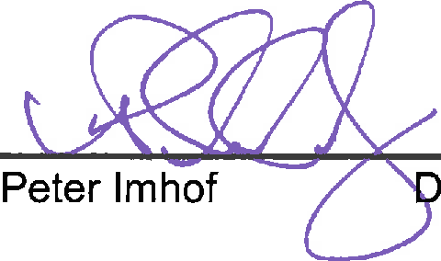
City of Goleta Contact Person and Telephone Number:

irector, Planning & Environmental Review

D te

