STATE OF CALIFORNIA GAVIN NEWSOM, Governor
JENNIFER LUCCHESI, Executive Officer
(916) 574-1800 Fax (916) 574-1810
California Relay Service TDD Phone 1-800-735-2929
from Voice Phone 1-800-735-2922

CALIFORNIA STATE LANDS COMMISSION
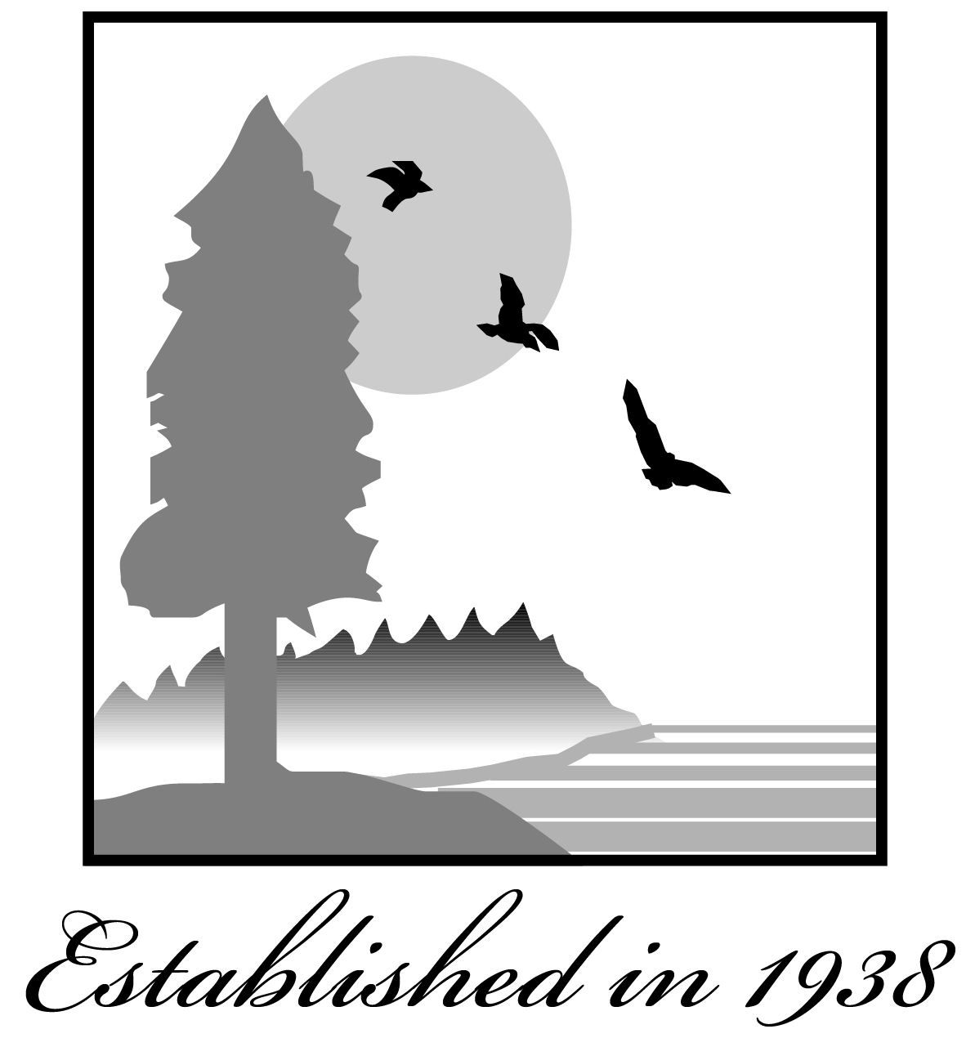
100 Howe Avenue, Suite 100-South
Sacramento, CA 95825-8202

Contact Phone: (916) 574-1890

NOTICE OF EXEMPTION
File Ref: Lease 802; A3089
Item: 16

Title: Issuance of a General Lease – Public Agency Use – Lease 802

Location: Sovereign land in the North Fork of the Mokelumne River, adjacent to Assessor’s Parcel Number 146-0470-001 and 146-0470-003, at Dead Horse Island, near Walnut Grove, Sacramento County; and Assessor’s Parcel Number 069-020-190, at Staten Island, near Walnut Grove, San Joaquin County.

Description: Authorize issuance of a General Lease – Public Agency Use beginning August 25, 2021, for a term of 20 years, for the continued use and maintenance of an existing bridge, known as the Dead Horse Island Bridge.

Name of Approving Public Agency: California State Lands Commission

Name of Proponent (Person or Agency): Reclamation District No. 2111

Exempt Status:

[√] Categorical Exemption:

CLASS 1, EXISTING FACILITIES (Cal. Code Regs., tit. 2, § 2905, subd. (a)(2))

Reasons for exemption:

Issuance of a 20-year General Lease – Public Agency Use for the above-mentioned structures will not cause a physical change in the environment and will not change existing activities in the area. There is no reasonable possibility that the activity will have a significant effect on the environment due to unusual circumstances. Therefore, the project will not have a significant effect on the environment and the above categorical exemption applies.

DATE RECEIVED FOR FILING AND POSTING BY THE

GOVERNOR’S OFFICE OF PLANNING AND RESEARCH
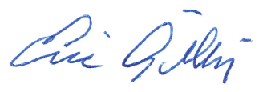
ERIC GILLIES, Assistant Chief
Environmental Planning and Management Division

Contact Person: Christine Day (916) 574-1900

