Notice of Exemption Form D

To: | Office of Planning and Research | From: California Energy Commission
 | PO Box 3044 | 1516 Ninth Street, MS-48
 | 1400 Tenth Street, Room 113 | Sacramento, CA 95814
 | Sacramento, CA 95812-3044

Project Applicant: Electric Power Research Institute, Inc.

Project Title: Characterizing Emissions from California Biomethane Facilities
REVISED for site change (original filed 8/3/2020)

Project Location:
Address City County
23546 American Ave Hilmar, CA-95324 Merced

Description of Nature, Purpose and Beneficiaries of Project:
This project conducts ambient measurements of greenhouse gases and other air pollutants (with some collection of liquid and solid samples) and does not require any permits.

Name of Public Agency Approving Project: California Energy Commission

Name of Person or Agency Carrying Out Project: Electric Power Research Institute, Inc.

Exempt Status: (check one)
Ministerial Exemption (Pub. Resources Code § 21080(b)(1); Cal. Code Regs., tit 14, § 15268); Declared Emergency (Pub. Resources Code § 21080(b)(3); Cal. Code Regs., tit 14, § 15269(a)); Emergency Project (Pub. Resources Code § 21080(b)(4); Cal. Code Regs., tit 14, § 15269(b)(c)); Categorical Exemption. State type and section number
X
Cal. Code Regs., tit 14, § 15306 Statutory Exemptions. State code number.
Common Sense Exemption. (Cal. Code Regs., tit 14, §15061(b)(3))

Reasons why project is exempt:

15306 - The project consists of 1) basic data collection, research, experimental management, and resource evaluation activities, and 2) It will not result in a serious or major disturbance to an environmental resource.

Lead Agency
Contact Person: Maninder Thind Area code/Telephone/Ext: 916-776-0819

If filed by applicant:
- Attach certified document of exemption finding.
- Has a Notice of Exemption been filed by the public agency approving the project? Yes No
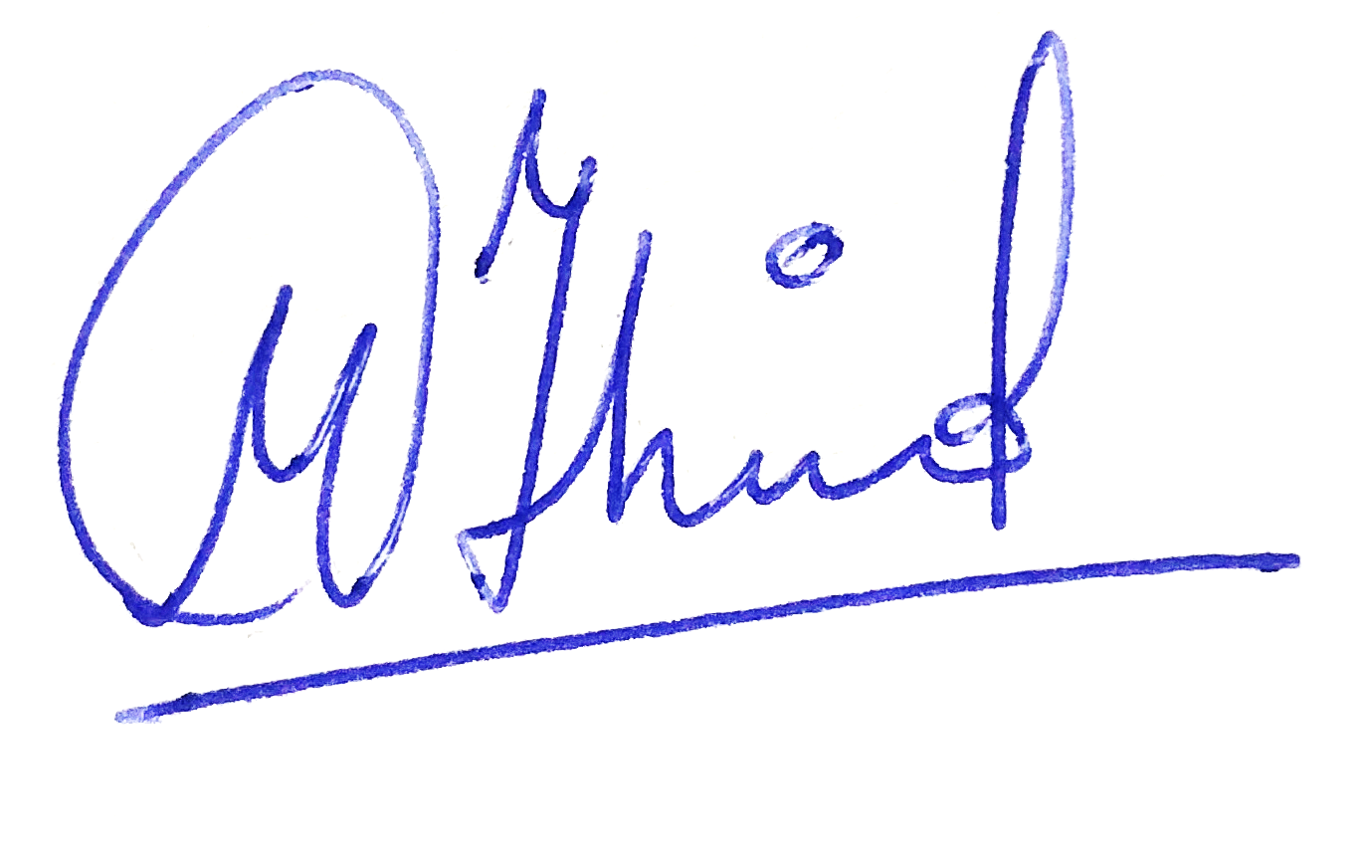

Signature: Date: 5/12/2021

Title:

Air Resources Engineer

Signed by Responsible Agency

Signed by Lead Agency
X

Signed by Applicant Date received for filing at OPR:

