State of California - Department of Fish and Wildlife
2017 ENVIRONMENTAL FILING FEE CASH RECEIPT
DFW 753.5a (Rev. 01/01/17) Previously DFG 753.5a
RECEIPT NUMBER:
07 - 04062017 - 088
STATE CLEARINGHOUSE NUMBER (If applicable)

SEE INSTRUCTIONS ON REVERSE. TYPE OR PRINT CLEARLY.
LEAD AGENCY  City of Richmond | LEADAGENCY EMAIL |  | DATE  04/06/2017
COUNTY/STATEAGENCY OF FILING |  |  | DOCUMENT NUMBER
[ Contra Costa |  |  | 2017-108
PROJECT TITLE
Urban Greening Master Plan (PLN11-085)

PROJECT APPLICANT NAME  City of Richmond | PROJECT APPLICANT EMAIL | PHONE NUMBER  (510) 620-6841
PROJECT APPLICANT ADDRESS  450 Civic Center Plaza | CITY ISTATE  Richmond JCa | ZIP CODE  94804
PROJECT APPLICANT (Check appropriate box)
[Z] Local Public Agency D School District D Other Special District D.State Agency D Private Entity

CHECK APPLICABLE FEES:
D Environmental Impact Report (EIR) | $3,078.25 | $ | 0.00
0 Mitigated/Negative Declaration (MND)(ND) | $2,216.25 | $ | 2,216.25
D Certified Regulatory Program document (CRP) | $1,046.50 | $ | 0.00
D Exempt from fee
D Notice of Exemption (attach)
D CDFW No Effect Determination (attach)
D Fee previously paid (attach previously issued cash receipt copy)

D Water Right Application or Petition Fee (State Water Resources Control Board only) | $850.00 | $ | 0.00
0 County documentary handling fee |  | $ | 50.00
D Other |  | $
PAYMENT METHOD:
D Cash D Credit 0 Check □ Other #14138 TOTAL RECEIVED $ 2,266.25

SIGNATURE |  | ///? | !AGENCY OF FILING PRINTED NAME AND TITLE
X | ' |  | IP.Cornelius, Deputy County Clerk

County Receipt Number 2889999

ORIG INAL . PRO JECT APPLICANT COPY - CDFW/ASB COPY - LEAD AGENCY COPY - COUNTY C LER K DFW 753.5a (Rev. 20151215)

Print Form

Notice of Determination Appendix D

To:
D Office of Planning and Research
U.S. Mail: Street Address:
P.O. Box 3044 1400 Tenth St., Rm 113 Sacramento, CA 95812-3044 Sacramento, CA 95814
County Clerk
County of: Contra Costa Address: 555 Escobar Street Martinez, CA 94553

From:
Public Agency: City of Richmond Address: 450 Civic Center Plaza Richmond, CA 94804

Contact Lina Velasco, Project Manager II Phone:(510) 620-6841

Lead Agency (if different from above):

Address: _ _ _ _ _ _ _ _ _ _ _ _ _ _ _

Contact:_ _ _ _ _ _ _ _ _ _ _ _ _ _ _
Phone:_ _ _ _ _ _ _ _ _ _ _ _ _ _ _ _

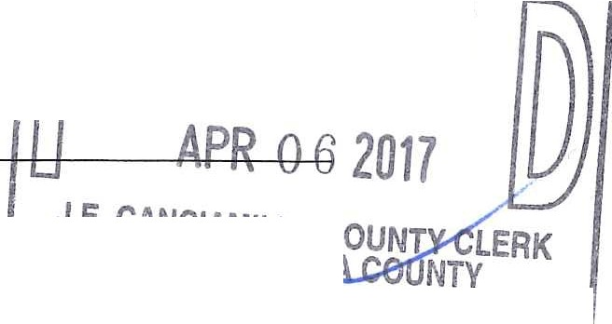SUBJECT: Filing of Notice of Determination in compliance with Section 21108 or,.;_1.152 of the Public Resources Code. I D n n
@ -
State Clearinghouse Number (if submitted to State Clearinghouse): // FJ
Project Title: Urban Greening Master Plan (PLN11-085)

Project Applicant: -City o-f Ri-chm- on- d - - - - - - - - - - - - - - - - - - --t---=,...
Project Location (include county): Richmond, Contra Costa County

, - fiaf::j5!.r.,

Project Description:
- - - - - - - - - -- - - - ---t;;; ==aa: = =.!D E PUrrr.Jv

The proposed project consists of the adoption of the City of Richmond Urban Greening Master Plan (Plan) as well as construction of several recommended projects that have been identified in the Plan. The Urban Greening Master Plan is intended to serve as a guide for the development and enhancement of the City's urban forest. The Plan proposes code changes, details planting guidelines, and identifies greening opportunities to help the City achieve its green vision. The implementation projects identified in the Plan represent focus areas where greening strategies could be effectively implemented on City-owned properties and within the existing public right-of-way.
This is to advise that the City of Richmond City Council has approved the above ( Lead Agency or D Responsible Agency)
described project on 4/4/2017 and has made the following determinations regarding the above (date)
described project.
- The project [D will will not] have a significant effect on the environment.
- D An Environmental Impact Report was prepared for this project pursuant to the provisions of CEQA A Negative Declaration was prepared for this project pursuant to the provisions of CEQA.
- Mitigation measures [ were D were not] made a condition of the approval of the project.
- A mitigation reporting or monitoring plan [ was D was not] adopted for this project.
□
- A statement of Overriding Considerations [ was was not] adopted for this project.
- Findings [ were D were not] made pursuant to the provisions of CEQA.
This is to certify that the final EIR with comments and responses and record of project approval, or the negative Declaration, is available to the General Public at:
Planning Division, 450 Civic Center Plaza, 2nd Floor, Richmond, CA
Signature (Public Agency): f}izd/ffe Title: Project Manager II
Date: 4/6/2017 Date Received for filing at QPR: _ _ _ _ _ _ _ _ _

Authority cited: Sections 21083, Public Resources Code.
Reference Section21000-21174, Public Resources Code. Revised 2011

