Initial Environmental Study / Checklist

City of Laguna Beach, California

1. Project Title
South Laguna Fuel Modification Project

2. Lead Agency Name and Address
City of Laguna Beach
Laguna Beach Fire Department
505 Forest Ave.
Laguna Beach, CA 92651

3. Contact Person and Phone Number
Mike Rohde, Program Manager
Laguna Beach Fire Department
Wildland Fire Defense & Fuels Management
Office: (949) 464-6683

4. Project Location
The proposed project consists of fuel modification zone (FMZ) 20 (South Laguna) and FMZ 21 (Sunset), as shown in Figure 1. FMZ 20 encompasses the canyons and hillsides bounded roughly on the west by Ceanothus Drive, Alta Loma Drive, Holly Drive, and Ocean View Street; on the south by West Street, Valido Road, and Paseo del Sur; and wrapping around East Georges Way, Mar Vista Avenue, and Eagle Rock Way.
FMZ 21 is located on the hillsides to the east of the neighborhoods between Eagle Rock Way to the north and Vista Del Sol to the south. 3rd Avenue, Mar Vista Avenue, Sunset Avenue, and Hillhaven Ranch Way generally follow the orientation of FMZ 21. The north end of FMZ 21 ties into FMZ 20 and the west end ties into the existing FMZ 8.

5. Project Sponsor’s Name and Address
Laguna Beach Fire Department
505 Forest Ave.
Laguna Beach, CA 92651

6. General Plan Designations
FMZ 20 (South Laguna) would traverse the following General Plan Designations: OS (Open Space), RHP (Residential Hillside Protection), and VLD (Village Low Density).
FMZ 21 (Sunset) would traverse the following General Plan Designations: OS (Open Space), RHP (Residential Hillside Protection), VLD (Village Low Density), and PI (Public/Institutional).

7. Zoning
FMZ 20 (South Laguna) would traverse the following Land Use Zones: OS/C (Open Space/Conservation Zone), R/HP (Residential/Hillside Protection Zone), and R1 (Residential Low Density Zone).
FMZ 21 (Sunset) would traverse the following Land Use Zones: OS/C (Open Space/Conservation Zone), R/HP (Residential/Hillside Protection Zone), R1 (Residential Low Density Zone), and I (Institutional Zone).

8. Description of the Project
The City of Laguna Beach Fire Department (LBFD) proposes to apply fuel management practices in the South Laguna area within the City of Laguna Beach, California (see Figure 1). FMZ 20 (South Laguna) and FMZ 21 (Sunset) would consist of approximately 100-foot-wide zones of cleared vegetation. Removal of heavy vegetation would reduce potential wildfire ignition of primarily residential properties, increase the evacuation time for residents, and provide better access for firefighters to protect structures. In addition, the proposed project would reduce fire line intensity, reduce wildfire rates of spread, and improve occupant safety. Lastly, it would protect High and Very High Value Habitat containing special-status plant species.
Since the 1950s, the City of Laguna Beach has maintained a system of fuel breaks for protection from wildfires. After the 1993 wildfires, the program was expanded, and now the City currently maintains 27 FMZs managed by goat-grazing and hand crews. In 2019, the City received a $1 million grant through Assembly Bill 109 to provide funds for fuel modification in the South Laguna area. The California Department of Natural Resources awarded the grant to fund fuel modification activities in FMZ 20 and 21. According to the City of Laguna Beach, the project site lies in a Very High Fire Hazard Severity Zone, and any wildfire would be an immediate threat to structures. The proposed project would establish fuel breaks directly around wildland-urban interface to protect residential and public property. The LBFD would oversee the construction and maintenance of the fuel breaks in FMZ 20 and 21.
FMZ 20, an approximately 7.9-acre stretch of land, predominantly borders the northern portion of the South Laguna residential neighborhood as well as the South Coast Water District office and water reservoir (see Figure 2). The homes in this neighborhood are adjacent to large portions of densely vegetated steep hillsides and are susceptible to wildfire hazards. The majority of FMZ 20 is located within Aliso and Wood Canyons Wilderness Park and includes the beginning of Valido Trail. FMZ 20 contains a variety of native and disturbed habitat and also contains an intact population of big-leaved crownbeard, a State- and federally-listed threatened species. Other plant species within FMZ 20 include coastal sagebrush, coastal sage scrub, lemonade berry, laurel sumac, bigpod ceanothus, bush rue, southern maritime scrub, and chamise. According to the City of Laguna Beach’s GIS Constraints layers, large portions of FMZ 20 are designated as High/Very High Value Habitat and Seismic Hazard Landslide Areas. Areas categorized as Very High Value Habitat or have had rare plant sightings were surveyed by a qualified biologist in spring 2021 and the project design was further refined to avoid rare plants and minimize vegetation clearance in these areas. Exclusion areas in FMZ 20 would be established near West Street/Paseo Del Mar to avoid disturbance of known cultural resources (see Figure 2). These exclusion areas may be reduced once vegetation clearing has begun under the supervision of a qualified archaeologist (see Mitigation Measure CUL-3).
Seismic Hazard Landslide Areas would require specific treatment measures to minimize erosion hazards. According to the project geotechnical report for FMZ 20, the majority of FMZ 20 is underlain at the surface to relatively shallow depths by hard bedrock, which has a very low susceptibility to surficial failure (i.e., soil collapse or instability). No mapped landslides are present on the slopes within FMZ 20 (see Appendix E). Plant species in the lower drainage areas include southern willow scrub and non-native ornamental plants. Table 1 provides the recommended access points to reach FMZ 20 treatment areas (see Figure 2). The City will work with the contractor and homeowners to obtain access to the project site.
Table 1. FMZ 20 (South Laguna) Access Points
- Valido Trailhead (Valido Rd.)
- Mar Vista Avenue (north end near gate)
- Intersection of Eagle Rock Way and Mar Vista Ave. (near 22311 Eagle Rock Way)¹
- E. George’s Way (private road with locked gate)¹
- 31462 Ceanothus Dr. (no on-road parking)¹
Note: (1) Access requires homeowner permission.
Similar to FMZ 20, FMZ 21 is located on steep, densely vegetated slopes that pose the risk of wildfire hazards to nearby structures. FMZ 21 consists of approximately 12.5 acres and is predominantly on the east side of residential single-family homes and Mission Hospital Laguna Beach between Eagle Rock Way to the north and Vista Del Sol to the south (see Figure 3). Two portions of FMZ 21 are within High/Very High Value Habitat. The heavily vegetated steep slopes within and above FMZ 21 pose a risk of wildfire damage to adjacent homes, valuable habitat, and homes at the top of Niguel Hill and Monarch Crest. FMZ 21, like FMZ 20, is also moderately impacted by non-native ornamental plants as well as existing fuel breaks likely established by homeowners. The areas with relatively intact native habitat contain bigpod ceanothus, spiny redberry, bush rue, southern maritime scrub, lemonade berry, laurel sumac, toyon, and chamise. The lower portions of existing drainages are largely disturbed and planted with ornamental vegetation, with small amounts of remaining native vegetation including mulefat, elderberry, and giant wild rye. One population of big-leaved crownbeard occurs in and adjacent to the north end of FMZ 21. Additionally, a small population of Coulter’s Matilija Poppy (included in the California Native Plant Society Inventory of Rare and Endangered Plants as limited distribution) occurs near 1 Hillhaven Ranch Way. Portions of FMZ 21 that have been categorized as Very High Value Habitat or have had rare plant sightings were surveyed by a qualified biologist in spring 2021 and the project design further refined to avoid rare plants and minimize vegetation clearance in these areas. Table 2 provides the recommended access points to reach FMZ 21 treatment areas (see Figure 3). The City will work with the contractor and homeowners to obtain access to the project site.
Table 2. FMZ 21 (Sunset) Access Points
- Intersection of Eagle Rock Way and Mar Vista Ave. (Valido Rd.)
- South end of Eagle Rock Way (near 22311 Eagle Rock Way)
- East end of 3rd Ave. (near 22401 3rd Ave.)
- Sunset Ave. near intersection with Mar Vista Ave. (near hospital)
- Intersection of 8th Ave. and Sunset Ave.
- Intersection of Sunset Ave. and Hillhaven Ranch Way
- 22351 Eagle Rock Way (private driveway)¹
- 22315 Mar Vista Ave. (private driveway)¹
- Hillhaven Ranch Way (private road with locked gate)¹
Note: (1) Access requires homeowner permission.
Fuel Management Zone Treatment Protocols. The City’s fuel modification zone treatment protocols, which are included as Appendix A to this Initial Study, have been developed based on the best available science and studies. The proposed project was designed using the City’s treatment protocols.
All fuel management activities would be conducted within FMZ 20 and FMZ 21 to reduce available vegetation for potential wildfire ignition within approximately 100 feet of developed structures. Fuel management methods would focus exclusively on hand crews due to the presence of special-status species and steepness of topography. Fuel loads would be reduced or completely removed depending on species composition. Non-native vegetation would be completely removed, while sensitive native vegetation such as coastal sage scrub would be reduced by 50 percent.
FMZ 20 and FMZ 21 would be managed by hand crews, as goat-grazing would be infeasible due to steep terrain and presence of sensitive vegetation communities. Portions of both FMZ 20 and FMZ 21 would require specific treatment methods or complete avoidance to avoid impacts to biological resources and known cultural resources (see Figures 2 and 3). A 25-foot buffer would be established on either side of “blue-line” streams (i.e., a waterbody such as a creek or stream that appears as a broken or solid blue line on a U.S. Geographical Survey topographic map). Approximately 1.7 acres in FMZ 20 and approximately 2 acres in FMZ 20 would be within these buffers, which would be limited to the removal of non-native plant species using hand crews only. Approximately 0.9 acres of FMZ 20 and approximately 0.011 acres of FMZ 21 containing big-leaved crownbeard and Coulter’s Matilija poppy would be excluded from fuel modification activities to avoid impacts to this species. In erosion-prone areas, such as steep slopes and the areas previously cleared by homeowners in FMZ 21, measures would include worker fall protection (e.g., field personnel would be trained in fall prevention, and crews would be restricted from working on slopes where field supervisors or staff judge conditions to be unsafe for unprotected work) and post-treatment erosion control measures (e.g., scattered cut brush clippings, jute netting, straw bales, and related efforts as recommended by consulting geologists). If any special-status plants or animals are found, a trained biological monitor would flag such areas before treatment to ensure the species are protected and avoided. Within these flagged buffers, 50 percent removal may not be feasible. Prudent herbicide use may be used only in cases of spot treatment of invasive vegetation removal as determined by a biologist. Any necessary treatments outside of this range would be subject to removal of only targeted non-native, invasive weeds, or tree thinning and dead branch removal.
Treatment recommendations for FMZ 20 and FMZ 21 (see Figures 2 and 3) based on habitat type and existence of any sensitive species within the zones were developed based on initial biological surveys conducted by Laguna Canyon Foundation. Table 3 provides the recommended acreages for each treatment type. These acreages may be slightly modified as the project is refined based on conditions at time of implementation.
Table 3. Proposed Treatment by Acreage
Treatment Methods | FMZ 20 | FMZ 21
Hand | 4.4 | 10.5
Stream buffers (invasive control only) | 1.7 | 1.82
Privately cleared | N/A | 0.92
Exclusion areas (big-leaved crownbeard, Coulter’s Matilija poppy, and cultural resources) | 1.8 | 0.011
Total | 7.9 | 12.5
Source: #22 – Laguna Canyon Foundation, Fuel Modification Zone Proposed Expansions, Initial Survey Results, Analysis and Recommendations for the City of Laguna Beach, California, October 31, 2018.
Hand Crew Removal. As described in the Treatment Protocols for Fuel Modification Zones Subject to Coastal Development Permitting (see Appendix A), hand crew treatment would be used in most portions of FMZ 20 and FMZ 21 in compliance with the California Coastal Act. Up to 14 hand crew workers (2 groups of 7 workers each) would be working in an FMZ at a given time. The average crew size would be 7 workers. The initial phase of vegetation removal would include the following steps:
- Fuel Modification will be conducted by hand crews with chainsaws, brush-cutters, and other hand tools.
- Hand crew fuel modification conducted in high or very high value habitat shall generally be limited to a width of 100 feet.
- Crews will cut down all non-native vegetation (including unmaintained ornamental vegetation) and dead/dying native vegetation and carefully remove dead branches from trees and large shrubs. As noted above, an exception may be made where non-native shrubs are providing shading/nurse plant benefits for big-leaved crownbeard, as determined by the biological monitor.
- Special care will be exercised to distinguish dormant native vegetation from dead/dying native vegetation.
- Tree-form shrubs (e.g., Laurel Sumac (Malosma laurina), Toyon (Heteromeles arbutifolia), Lemonade Berry (Rhus integrifolia) that are over 6 feet tall will be carefully pruned of their lower branches to increase the Crown Base Height to 50 percent of the plant height. For example, a 10-foot-tall plant would have its lower branches removed to a height of 5 feet. Branches will be pruned to within 1 inch or less of the branch crown. Southern Maritime Chaparral shrub species shall be left fully intact except as noted below, and not pruned initially. Alternatively, with the discretion of a qualified biologist, some plants may be pruned beginning from the upper branches, depending on the species and need for such pruning.
- For large tree species within FMZ’s, non-native trees (Pinus, Eucalyptus, Washingtonia, et. al.) shall be considered for removal on a case-by-case basis, taking into consideration their potential ignitability, potential to spread fire from or across the FMZ, and property/tree ownership.
- Native large trees (Quercus, Platanus, et. al.) shall be pruned of dead components, and lower small branches removed to a height of 8 feet or one half their height, whichever is less, so as to disrupt “fuel ladder” potential. Dead and down tree components on the ground below large trees shall be removed.
Where there is still over 50 percent vegetative cover after the above material has been removed, the contractor will remove healthy live vegetation in accordance with the hierarchical list below, beginning with the first species listed, then in descending order through the list until 50 percent vegetative cover has been attained:
- Coastal Goldenbush (Isocoma menziesii)  - Coyote Brush (Baccharis pilularis)  - California Buckwheat (Eriogonum fasciculatum)  - Black Sage (Salvia mellifera)  - California Sagebrush (Artemisia californica) | - Monkeyflower (Mimulus aurantiacus)  - Laurel Sumac (Malosma laurina)  - Toyon (Heteromeles arbutifolia)  - Lemonade Berry (Rhus integrifolia)

Stumps will be cut to within 4 inches or less of the ground. Thinning of healthy, live vegetation will be done in a dispersed manner to avoid creating new large openings. All healthy specimens of Southern Maritime Chaparral species including Bush Rue (Cneoridium dumosum), Spiny Redberry (Rhamnus crocea) and Bigpod Lilac (Ceanothus megacarpus) will be retained.
As described in Treatment Protocols for Fuel Modification Zones Subject to Coastal Development Permitting (see Appendix A), ephemeral water drainages or stream courses would be treated if invasive plant species such as pampas grass is found. The primary invasive vegetation treatment would be herbicide application within a 25-foot buffer on either side of any blue-line drainage or stream that crosses the treatment areas as defined by a USGS map or City Website. Additional site-specific steps consistent with best environmental practice may be implemented to establish breaks in fuel continuity in corridors formed by long drainages. These corridors pose a fire hazard to nearby residences in the event of a wildfire.
Herbicides may be used for spot treatment of invasive species as identified and determined by a biologist. Herbicide treatment would be specific and limited to its intended use to not pose any risk to nearby sensitive species or water courses. Herbicides would never be used on a landscape scale to remove large expanses of vegetation.
Fire safety and prevention measures during fuel management activities would include requiring fire extinguishers and hand tools on site, prohibiting smoking, prohibiting operation of power tools during red flag warnings, and implementing proper fueling locations and practices.
Erosion Control. The majority of roots of perennial plants would be left in place to minimize erosion. Mulch and other erosion control measures (such as scattered cut brush clippings, straw wattles, straw bales, and/or jute netting) would be installed as necessary for additional protection without being obtrusive, as recommended by the project geotechnical report (provided as Appendix E). Haul paths would be minimized and rehabilitated with mulch or other methods as deemed appropriate by the project biologist. Areas of relatively low slope (i.e., below 33 percent or 1:3 grade) would be mulched to an adequate depth to minimize weed propagation and ongoing maintenance needs.
Disposal and Maintenance. As mentioned in the Treatment Protocols for Fuel Modification Zones Subject to Coastal Development Permitting, all non-native vegetation waste would be removed from the site, transported via truck or dumpster, and hauled to a green waste recycler. The nearest green waste recycling facility to the site is Tierra Verde Industries at 8065 Marine Way, Irvine, CA 92618, but the contractor would ultimately determine the recycling site. Green waste that is not accepted by the green waste recycler would be hauled to a landfill. Under the proposed project, chipped native vegetation and mulch would be reused for erosion control within the project site. Chipped waste, excluding non-native and/or invasive waste, may also be deposited over bare earth to a maximum depth of 10 to 12 inches for dust control within the FMZs. Excess materials would be hauled away for disposal as green waste. All efforts would be made to recycle as much native waste on site as possible. Native vegetation under 3 inches in diameter may be processed with hand tools on site and spread as mulch as an alternative to hauling and chipping, if it does not cover living native species and does not exceed 12 inches in depth. All trash and litter found on the project site would be removed and hauled to a landfill. The amount of trash and litter is expected to be minimal.
At the conclusion of the grant term, fuel break maintenance would be conducted by the City of Laguna Beach. The City would maintain fuel breaks by pruning, weeding, and controlling invasive vegetation, which may include spot treatment with herbicides.
Schedule. Fuel modification activities are expected to occur over the course of approximately one year. Vegetation removal would occur during normal business hours from 8:00 a.m. to 5:00 p.m. Monday through Friday, excluding weekends, federal holidays, and adverse weather conditions such as rain and Red Flag conditions. The grant schedule denotes initial clearing of vegetation in January 2022, and grant-funded field activities would conclude by mid-December 2022. The grant provides some funding for project audits by the State and final reporting in the first couple months of 2023. Continued maintenance is expected to occur annually into perpetuity with City funding and includes vegetation thinning and invasive species control.

9. Surrounding Land Uses and Setting
The landscape adjacent to FMZ 20 and FMZ 21 consists of heavy chaparral and coastal sage scrub, along with populations of non-native and invasive plant species in disturbed areas. FMZ 20 and FMZ 21 are located at the lower elevations of steep canyon slopes.
The land surrounding FMZ 20 and FMZ 21 is predominantly low-density single-family residential uses, with public/institutional uses (municipal water and healthcare facilities) at 31633 West Street and along Coast Highway. FMZ 20 and FMZ 21 would serve as a barrier between the urban-wildland interface, as steep, undeveloped canyon slopes and hillsides are located to the east and north of development in these areas. The majority of FMZ 20 would overlap the southern portion of Aliso and Wood Canyons Wilderness Park and surround Valido Trail, which provides access to the park. In addition to surrounding homes, FMZ 20 would also partially surround the northern, eastern, and southern boundaries of the South Coast Water District office and reservoir (located at 31593 West Street), and FMZ 21 would border the eastern end of several medical buildings, including Mission Hospital Laguna Beach.

10. Other Public Agencies Whose Approval Is Required (e.g., permits, financing approval, or participation agreement)
The proposed project would require the following approvals:
- City of Laguna Beach Planning Commission
- Coastal Development Permit, California Coastal Commission

Attachments
Figure 1: South Laguna Fuel Modification Project Location
Figure 2: Fuel Modification Zone 20 (South Laguna) Recommended Treatment and Exclusion Areas
Figure 3: Fuel Modification Zone 21 (Sunset Study Area) Recommended Treatment and Exclusion Areas

APPENDICES ARE PROVIDED ON CD WITH HARD COPIES
Appendix A: Treatment Protocols for Fuel Modification Zones Subject to Coastal Development Permitting
Appendix B: Air Quality Calculations
Appendix C: Biological Resources Report
Appendix D: Cultural Resources Assessment Report for the South Laguna Fuel Modification Project
Appendix E: Geotechnical Reports
- Geotechnical Evaluation of Potential Slope Stability Impacts, Proposed Fuel Modification Program, Zone 20, Northern South Laguna Community Area, Laguna Beach, California.
- Geotechnical Evaluation of Potential Slope Stability Impacts, Proposed Fuel Modification Program, Zone 21, South Laguna and Sunset Drive Area, Laguna Beach, California.
Appendix F: Paleontological Resources Summary for the South Laguna Fuel Modification Project
Appendix G: Policy Consistency Analysis Memo

Figure 1: South Laguna Fuel Modification Project Location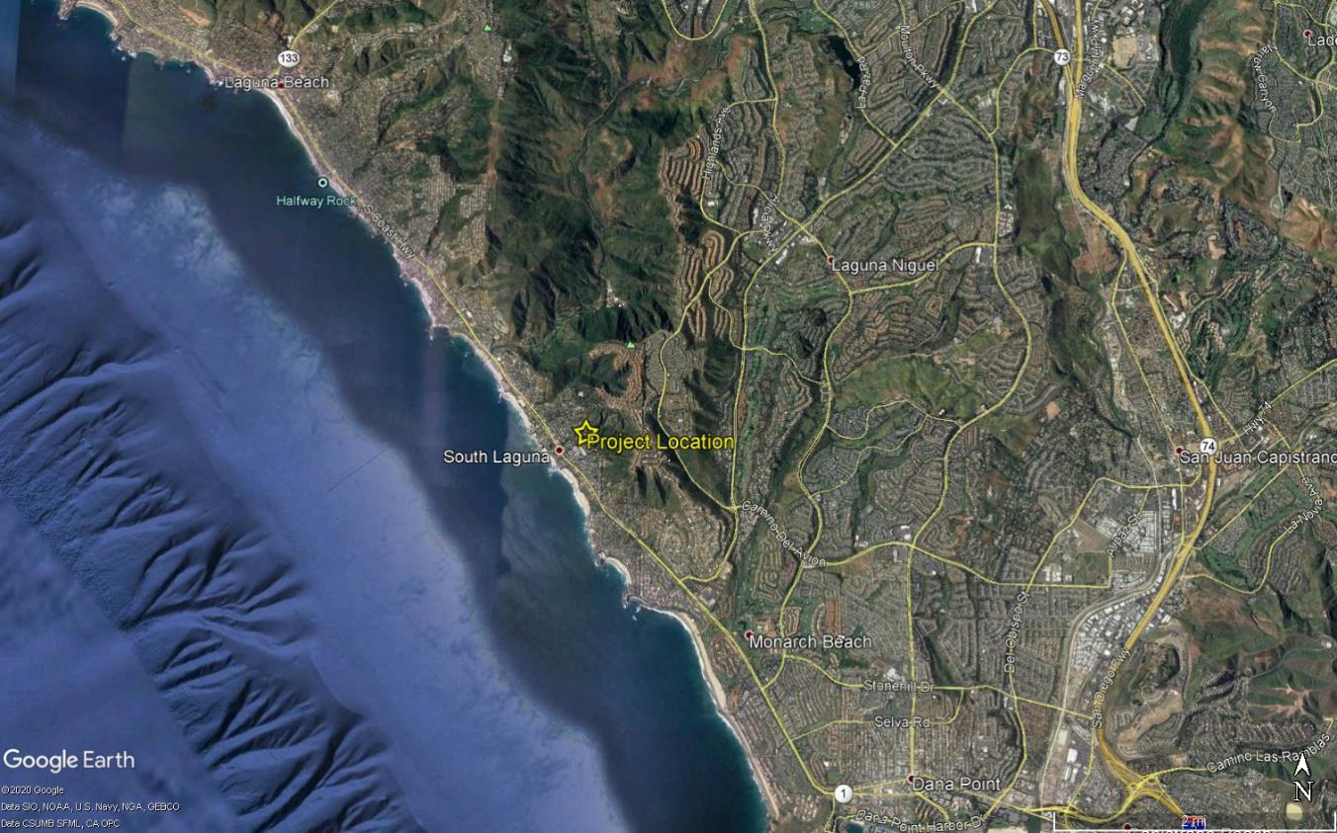

Figure 2: Fuel Modification Zone 20 (South Laguna) Treatment and Exclusion Areas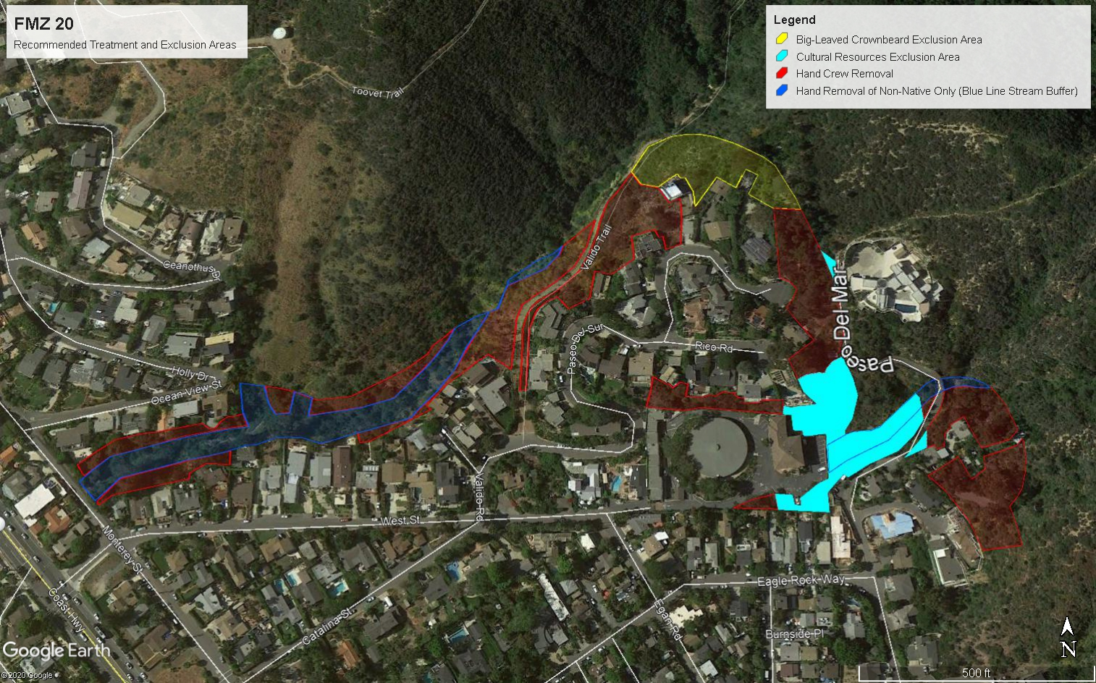

Figure 3: Fuel Modification Zone 21 (Sunset Study Area) Treatment and Exclusion Areas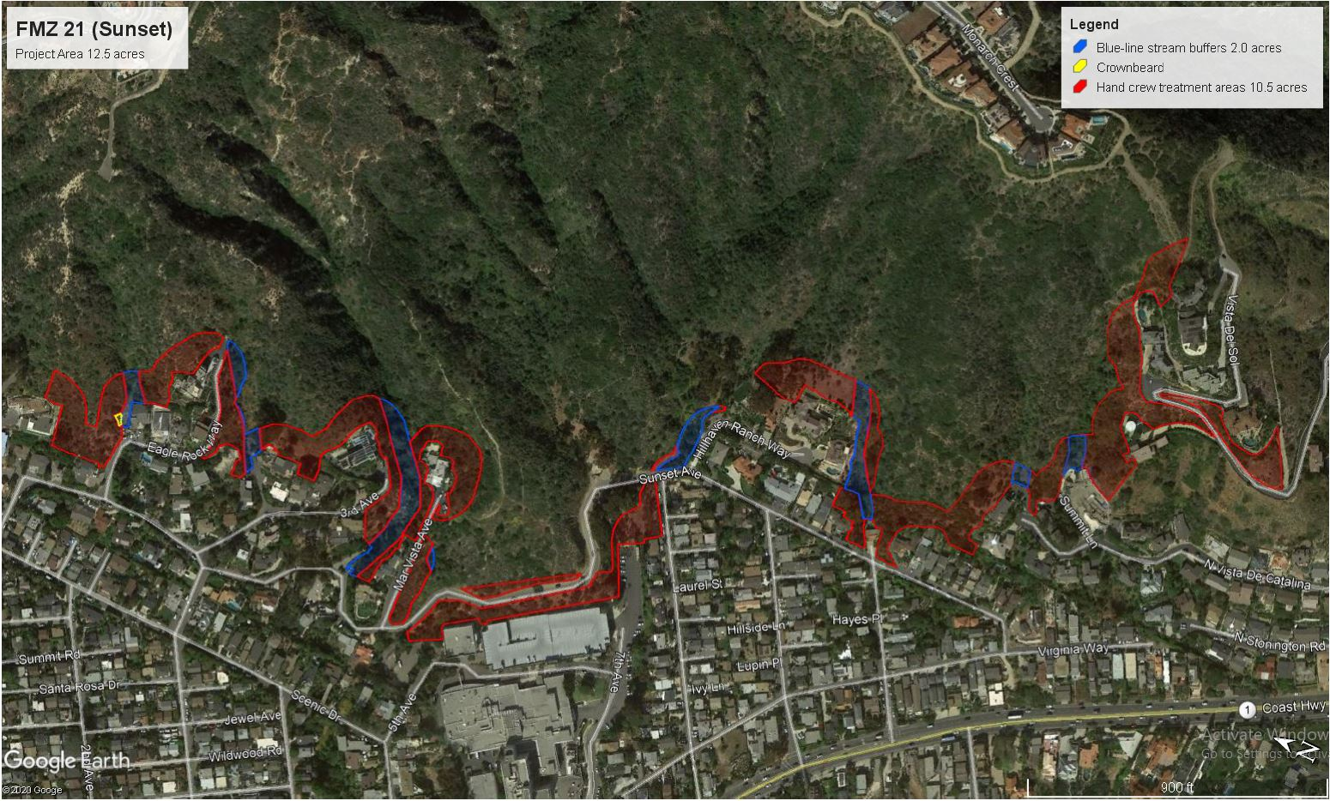

Environmental Factors Potentially Affected
The environmental factors checked below would be potentially affected by this project, involving at least one impact that is a “Potentially Significant Impact” and requiring implementation of mitigation as indicated by the checklist on the following pages.
Aesthetics Agriculture & Forestry Resources Air Quality
Biological Resources Cultural Resources Energy
Geology/Soils Greenhouse Gas Emissions Hazards/Hazardous Materials
Hydrology/Water Quality Land Use/Planning Mineral Resources
Noise Population/Housing Public Services
Recreation Transportation Tribal Cultural Resources
Utilities/Service Systems Wildfire Mandatory Findings of
Significance

Determination
On the basis of this initial evaluation:

I find that the Proposed Project COULD NOT have a significant effect on the environment, and a NEGATIVE DECLARATION will be prepared.
I find that although the Proposed Project could have a significant effect on the environment, there will not be a significant effect in this case because revisions in the project have been made by or agreed to by the project proponent. A MITIGATED NEGATIVE DECLARATION will be prepared.
I find that the Proposed Project MAY have a significant effect on the environment, and an ENVIRONMENTAL IMPACT REPORT is required.
I find that the Proposed Project MAY have a “potentially significant impact” or “potentially significant unless mitigated” impact on the environment, but at least one effect 1) has been adequately analyzed in an earlier document pursuant to applicable legal standards, and 2) has been addressed by mitigation measures based on the earlier analysis as described on attached sheets. An ENVIRONMENTAL IMPACT REPORT is required, but it must analyze only the effects that remain to be addressed.
I find that although the Proposed Project could have a significant effect on the environment, because all potentially significant effects (a) have been analyzed adequately in an earlier EIR or NEGATIVE DECLARATION pursuant to applicable standards, and (b) have been avoided or mitigated pursuant to that earlier EIR or NEGATIVE DECLARATION, including revisions or mitigation measures that are imposed upon the Proposed Project, nothing further is required.

__________________________________________________________________________________________________________________________________________________________________ ___________________________________________________________
Mike Rohde, Program Manager Date
Laguna Beach Fire Department

