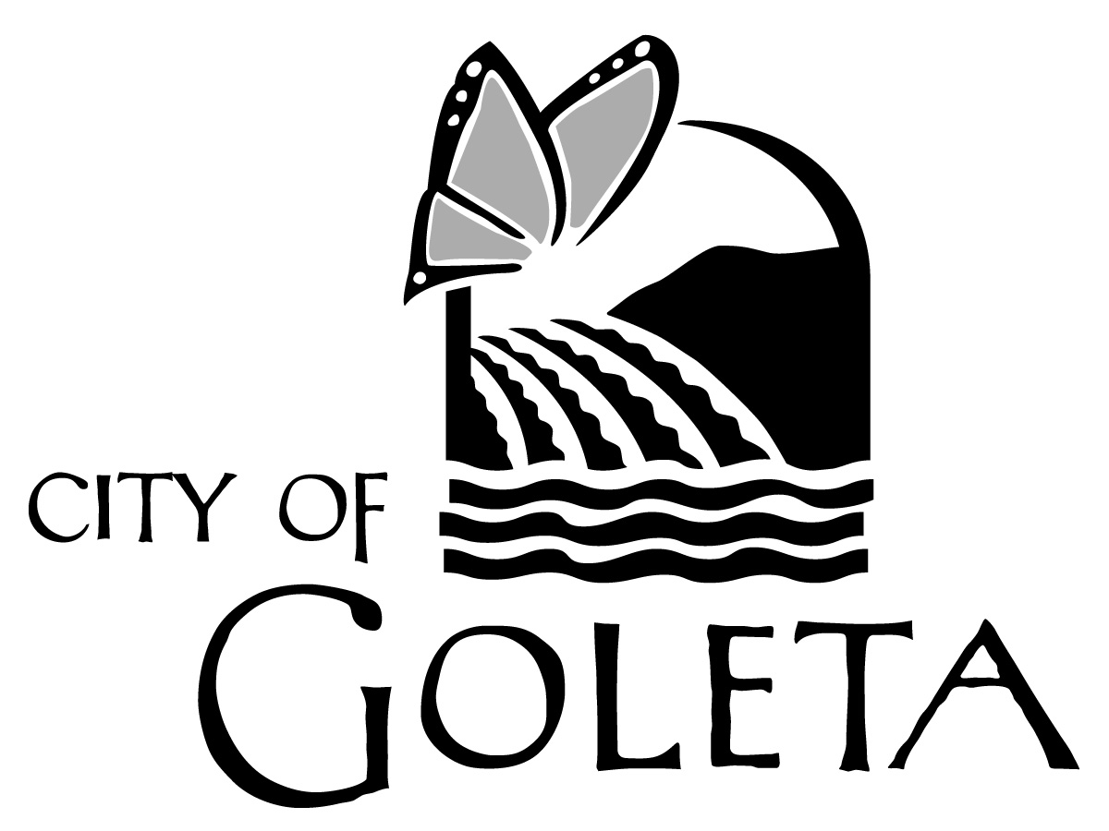

NOTICE OF INTENT TO ADOPT
A DRAFT MITIGATED
NEGATIVE DECLARATION
June 18, 2021

GOLETA ENERGY STORAGE PROJECT
CASE NO. 19-0201-DP, 19-0202-DPAM, 19-0202-CUP, 19-0001-SUB
Located at 6864 &6868 Cortona Dr.;
APN 073-140-027

NOTICE IS HEREBY GIVEN that the City of Goleta has completed a Draft Mitigated Negative Declaration (MND) for the Goleta Energy Storage Project, described below, and invites comments on the adequacy and completeness of the environmental analysis described in the Draft MND. The 30-day public review period commences on Friday, June 18, 2021 and will conclude on Monday, July 19, 2021 at 5pm. All interested persons are encouraged to submit written comments. All letters should be addressed to Planning and Environmental Review, 130 Cremona Drive, Suite B, Goleta, CA 93117, to the attention of Kathy Allen, Supervising Senior Planner or via email to kallen@cityofgoleta.org.

All comments must be received no later than July 19, 2021 at 5:00 P.M.

Project Location: The project site is approximately 5.88 gross acres and is located at 6864 and 6868 Cortona Drive. The Assessor’s Parcel Number is 073-140-027. The project site is located in the Inland area of the City, has a Business Park (I-BP) land use designation and is zoned Business Park (BP).

Project Description: Laurel Perez of Suzanne Elledge Planning and Permitting Services (SEPPS) on behalf of Goleta Energy Storage, LLC has requested approval of a Tentative Parcel Map, Conditional Use Permit, a Development Plan, and a Development Plan Amendment with associated adjustment to the landscaping development standard per Section 17.59.040 of Title 17 of the Goleta Municipal Code. The existing Research and Development Building would remain on site and the site was initially developed via an As-Built Development Plan, Case No. 04-35-DP. The project includes:

- Proposed Conditional Use Permit and Development Plan for the development and operation of a 60-megawatt lithium-ion battery energy facility containing energy storage cabinets (Megapacks) manufactured by Tesla along with supporting equipment such as transformers, inverters and other electrical distribution equipment. Each megapack has pre-installed energy storage components that are contained in a steel cabinet enclosure. The current design includes the installation of up to 62 Megapacks. The project also includes an on-site electrical substation with a transformer, and the construction of an underground connection (tie line) to the existing SCE Isla Vista substation located west of and adjacent to Storke Road, approximately 300 feet west of the project site. The underground tie line would be constructed using directional drilling beneath the Storke Road right-of-way.
- Proposed Tentative Parcel Map to divide the existing 5.88-acre project site parcel into two lots. Proposed Lot 1 would be addressed as 6864 Cortona Drive, be 2.66 gross acres in size, and be used for the Goleta Energy Storage Project. Proposed Lot 2 would be addressed as 6868 Cortona Drive and be 3.22 gross acres in size, The existing 60,068 square foot research and development building located within the boundaries of proposed Lot 2 would be retained.
- Proposed Development Plan Amendment to 04-35-DP and a proposed Adjustment to a landscaping development standard is associated with the existing development (60,068 square foot research and development building) located on proposed Lot 2.

The proposed Goleta Energy Storage facility would be accessed from Cortona Drive along two proposed reciprocal access easements over proposed Lot 2.

ENVIRONMENTAL REVIEW FINDINGS: The proposed Draft Mitigated Negative Declaration has been prepared pursuant to the requirements of the California Environmental Quality Act (CEQA) (Public Resources Code, §§ 21000 et seq.), the regulations promulgated thereunder (14 Cal. Code of Regulations, §§ 15000, et seq.), and the City’s Environmental Review Guidelines. The City of Goleta is acting as the Lead Agency for this project.

The Draft Mitigated Negative Declaration identifies and discusses potential impacts, mitigation measures, monitoring requirements, and residual impacts for identified environmental issue areas. No significant and unavoidable impacts are identified as resulting from the project. Potentially significant but mitigable effects on the environment are anticipated in the following areas: biological resources and cultural resources.

CORTESE LIST: The project site is listed on the GeoTracker database of hazardous site records maintained by the California State Water Resources Control Board (RWQCB) as enumerated under Section 65962.5 of the California Government Code (the “Cortese list”).

DOCUMENT AVAILABILITY and FURTHER INFORMATION: The Draft Mitigated Negative Declaration is posted on the City’s website at www.cityofgoleta.org/city-hall/planning-and-environmental-review/ceqa-review Copies of the Draft MND are also available in electronic format (CD) for $7.00 per CD. For more information about this project, contact project planner Kathy Allen at (805) 961-7545.

PUBLIC COMMENT: All interested persons are encouraged to submit written comments regarding the environmental analysis and project. All letters should be addressed to Kathy Allen, Goleta City Hall, 130 Cremona Drive, Suite B, Goleta, CA 93117 or (kallen@cityofgoleta.org). Letters must be received prior to the end of the public review period. For inquiries in Spanish, please contact Sandra Rodriguez, Management Assistant, at 805-961-7576 or srodriguez@cityofgoleta.org.

REVIEW PROCESS:
- Accept Comments on the Draft MND until July 19, 2021
- Conduct a Public Hearing by the Planning Commission to review the request for Conditional Use Permit, Tentative Parcel Map, Development Plan, Development Plan Amendment with adjustment approvals and acceptance of the Mitigated Negative Declaration. Date for this hearing has not been determined and additional notice will be provided.

Note: If you challenge the City’s final action on this project in court, you may be limited to only those issues you or someone else raised at the public hearing described in this notice, or in written correspondence delivered to the City on or before the date of the hearing (Government Code §65009[b][2]).

Note: The complete application and project file, including any environmental analysis prepared in connection with the application, are currently only available electronically due to the temporary closure of City Hall to the public in response to the COVID-19 pandemic. You may request a copy of these materials from the staff planner as instructed above.

Publish: Santa Barbara News-Press June 18, 2021
Santa Barbara Independent, June 24, 2021

