CITY OF HALF MOON BAY
NOTICE OF INTENT
TO ADOPT A MITIGATED NEGATIVE DECLARATION
Project Title: Poplar Street Pedestrian Pathway Project Initial Study/Mitigated Negative Declaration
Project Location: Poplar Pedestrian Pathway, North of Poplar Street between Railroad Avenue and the Coast Trail
Project Description:
The project involves the removal, widening, and replacement of the existing Poplar Street Pedestrian Pathway. The section of pathway east of the existing bridge, which is approximately 979 feet long, would be widened to 10 feet with an additional 2 feet of decomposed granite shoulder. This section of path would be tapered at its western end to match the bridge. The section of pathway west of the bridge, which is approximately 35 feet long, would remain 8 feet wide with an additional 2 feet of decomposed granite shoulder. A border of decomposed granite and/or headerboard will be placed adjacent to the pathway. The existing fence and 8-foot-wide footbridge would remain in place (Figure 1-3, Project Design Plans; Appendix A).
The project would add approximately 1,700 square feet (0.04 acre) of new pavement to the existing 8,091 square feet (0.19 acre) of pathway, resulting in a total of approximately 9,790 square feet (0.22 acre). Approximately 811 square feet (0.02 acre) of the shoulder on the north side of the pathway closest to Railroad Avenue will be re-graded to meet ADA standards. The total project size is approximately 0.25 acre.
Traffic calming improvements to Poplar Street are also part of the project scope, including speed tables and traffic signs for the speed tables. Three signs will be located on the existing split-rail fence on the north side of Poplar Street, and three signs will be installed on new sign posts on the south side of Poplar Street, outside of the roadside ditch.
The public review period for the respective proposed Mitigated Negative Declaration based on the Initial Study will begin on June 11, 2021 and end July 12, 2021. You are encouraged to submit written comments regarding the proposed Mitigated Negative Declaration. You may do so by submitting written comments to the Public Works Department prior to the end of the review period. Copies of the application, environmental documents, and all reference documents associated with the project are available for review through the Public Works Department; telephone (650) 726-8265. Written comments may be submitted to the Public Works Department or via email at jwoo@hmbcity.com.
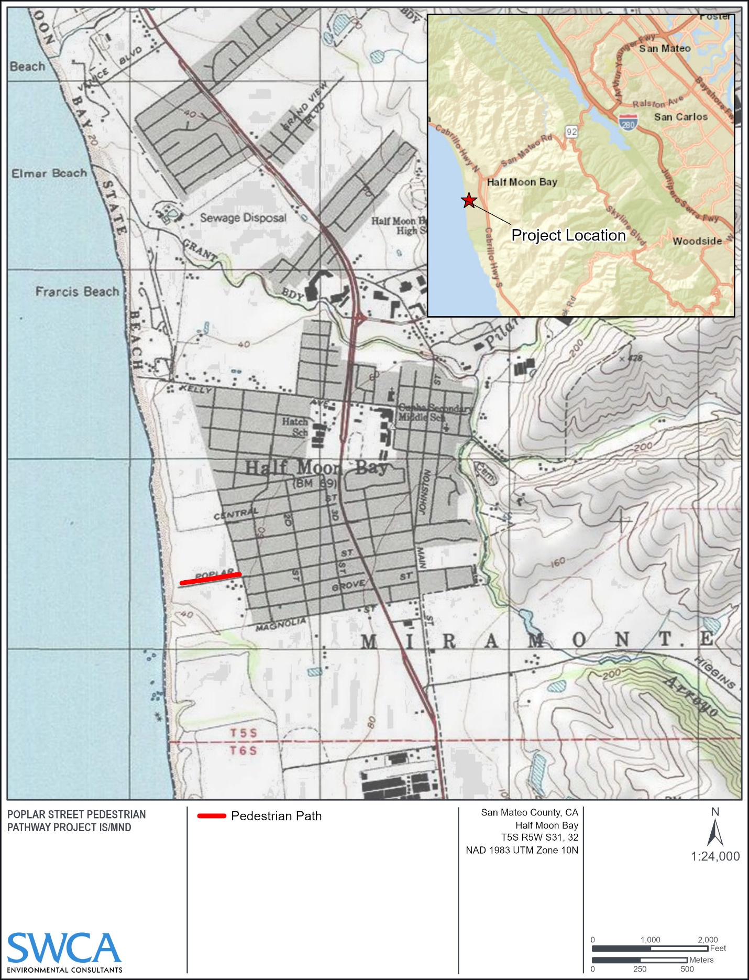
Project Location Map

