Distribution Protection Units (DPUs)

SEL-351 Protection System

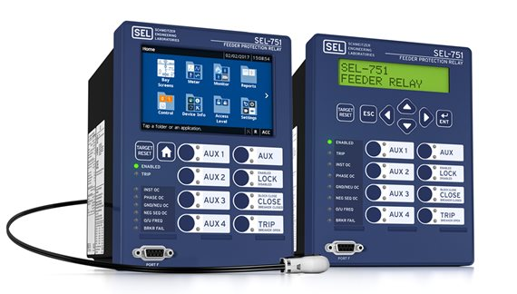
SEL-751 Feeder Protection Relay

