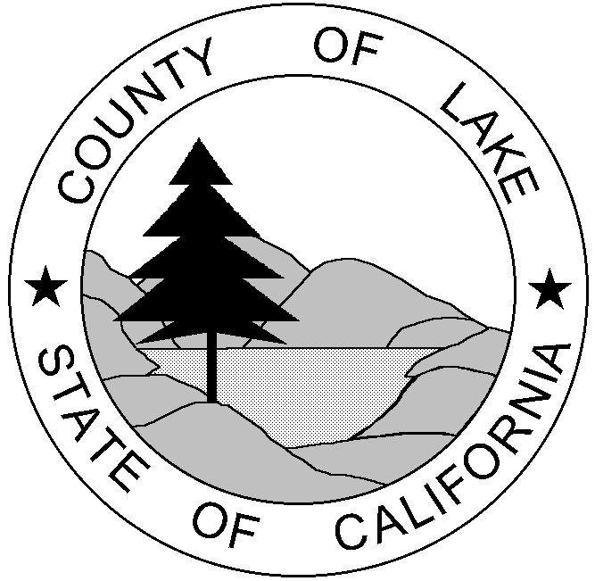
COUNTY OF LAKE
COMMUNITY DEVELOPMENT DEPARTMENT
Courthouse - 255 N. Forbes Street
Lakeport, California 95453
Telephone 707/263-2221 FAX 707/263-2225

`

MEMORANDUM

TO: Office of Planning and Research

FROM: Lake County Planning Department

SUBJECT: SCH# 2021030650, ‘Blue Lake Organics’ commercial cannabis cultivation, file no. UP 20-45. Correction to Project Description and CEQA Evaluation on Initial Study and Support Documents.

DATE: December 9, 2022

ATTACHMENTS: 1. Revised Initial Study
2. Revised NOC
3. Revised NOI
4. Revised Summary Form

MESSAGE:
On December 1, 2022, Lake County published an IS/MND regarding a Major Use Permit for commercial cannabis cultivation. Following publication of the IS/MND, staff became aware that the scope of the project on the Notice of Intent was inaccurate. The Notice of Intent was amended and re-sent to neighboring property owners and to OPR on December 9, 2022 with new review dates. The Initial Study was slightly amended to reflect four phases of site development occuring over a 4 or 5 year time-frame.

Lake County is requesting OPR to un-publish the December 1, 2022 CEQA submittal associated with SCH#2021030650, and will upload the corrected materials once the December 1, 2022 materials are unpublished.

