County Clerk
Interested Parties
COUNTY OF LAKE
NOTICE OF INTENT
TO ADOPT A MITIGATED NEGATIVE DECLARATION
Project Title: Floribunda Farms / Michael Blum; Minor Use Permit (MUP 19-14); Initial Study (IS 19-20)
Project Location: 11444 Bottle Rock Road, Kelseyville, CA, 95451

APN No.: 011-068-23

Project Description: The applicant is requesting approval of a minor use permit for the cultivation of commercial cannabis. The applicant is requesting the following licenses:
- Three (3) A-Type 1C small outdoor licenses
- One (1) Type 13 Self Distribution license
- As proposed, the total outdoor cultivation area would be 14,664 sq. ft. in size
- One new 1,800 sq. ft. greenhouse would be built

The public review period for the respective proposed Mitigated Negative Declaration based on Initial Study IS 19-20 will begin on November 29, 2020 and end on January 2, 2021. You are encouraged to submit written comments regarding the proposed Mitigated Negative Declaration. You may do so by submitting written comments to the Planning Division prior to the end of the review period. Copies of the application, environmental documents, and all reference documents associated with the project are available for review through the Community Development Department, Planning Division; telephone (707) 263-2221. Written comments may be submitted to the Planning Division or via email at eric.porter@lakecountyca.gov.
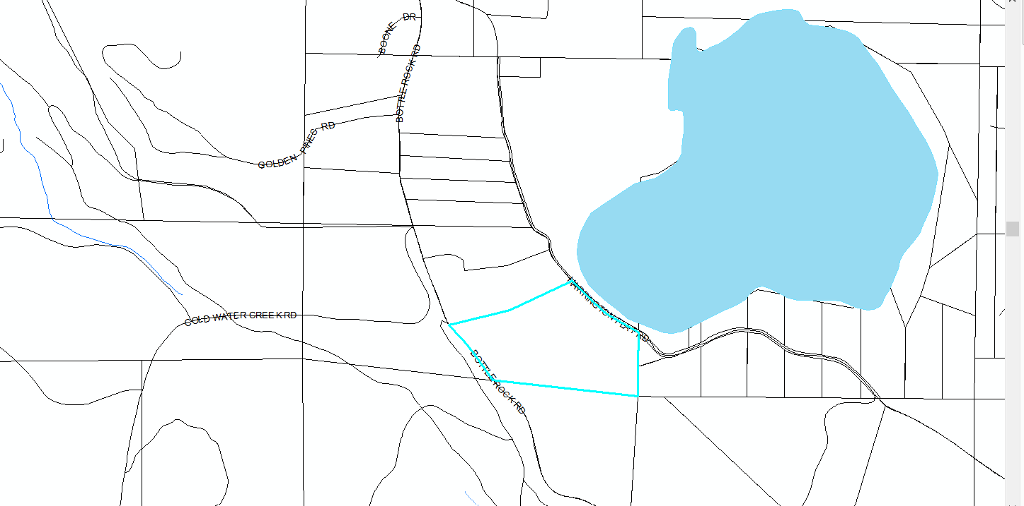
Vicinity Map of Blum Property

