CALIFORNIA ENVIRONMENTAL QUALITY ACT NOTICE OF EXEMPTION

To: Office of Planning and Research State Clearinghouse
P.O. Box 3044, 1400 Tenth Street, Room 212 Sacramento, CA 95812-3044
From: Department of Toxic Substances Control Permitting Division
8800 Cal Center Drive Sacramento, CA 95826

Project Title: EMERGENCY PERMIT FOR TREATMENT OF HAZARDOUS WASTES, ALZA CORP., VACAVILLE, CALIFORNIA
Project Location: 700 Eubanks Dr., Vacaville, CA, Solano County
Project Applicant: Holly Renn, Senior Environmental Engineer, ALZA Corp. Approval Action Under Consideration by DTSC: Emergency Permit Statutory Authority: California Health and Safety Code, Chapter 6.5
Project Description: The California Department of Toxic Substances Control (DTSC), pursuant to authority granted under California Code of Regulations, Title 22, Division 4.5, Chapter 20, Section 66270.61, has issued an Emergency Permit to ALZA Corp. (ALZA) (EPA ID# CAD982475964) to treat hazardous waste through a controlled reaction with a chemical solution. Specifically, including one 1-liter container of tetrahydrofuran, peroxide forming materials, must be stabilized prior to transport to a permitted treatment, storage, and disposal facility.

The hazardous waste item is expired and is currently being stored on the ALZA located at 700 Eubanks Dr., Vacaville, CA 95688. DTSC has determined as a safety precaution to prevent an accident or severe injury, an Emergency Permit should be issued to chemically stabilize the hazardous wastes prior to transportation off-site by Clean Harbors Environmental Service (CHES).
Background: Above chemical produce peroxide forming compound as it degrades (i.e. after the product’s expiration date). The peroxide forming compound produced may be unstable at relatively low concentrations, resulting in fire and/or explosion if improperly handled. Static electricity or heating from sunlight may be enough to trigger some reaction, making transport of non-stabilized chemicals hazardous. Chemical stabilization is recommended prior to transport to a permitted treatment, storage, and disposal facility.
Project Activities: The treatment of the hazardous waste involves the addition of solution to the container in a controlled manner to reduce the reactive or ignitable characteristics of the chemical. Treatment will take place within a designated exclusion zone. Only technicians from CHES will be allowed in the exclusion zone. Movement, preparation, and treatment of the items will be in accordance with established standards.
Within 10 business days of the expiration of this permit, ALZA will submit a final report, signed in accordance with Title 22, California Code of Regulations section 66270.11(d). The report shall include certification that the treatment area has been cleared of all residual hazardous waste generated from this emergency treatment and all generated waste has been properly managed.
The Emergency Permit is effective beginning November 13, 2020 and shall expire on January 11, 2021.
Name of Public Agency Approving Project: Department of Toxic Substances Control
Name of Person or Agency Carrying Out Project: Clean Harbors Environmental Service on behalf of ALZA
Exempt Status: Emergency Project [PRC, Sec. 21080(b)(4); 14 CCR, Sec.15269(b)(c)]
Reasons Why Project is Exempt: This action is necessary to prevent an emergency. Chemical stabilization of the chemical is necessary prior to transportation to a permitted treatment, storage, and disposal facility to prevent accidental fire and/or explosion during transport.
The administrative record for this project is available to the public by appointment at the following location: Department of Toxic Substances Control
Permitting Division 8800 Cal Center Drive Sacramento, CA 95826

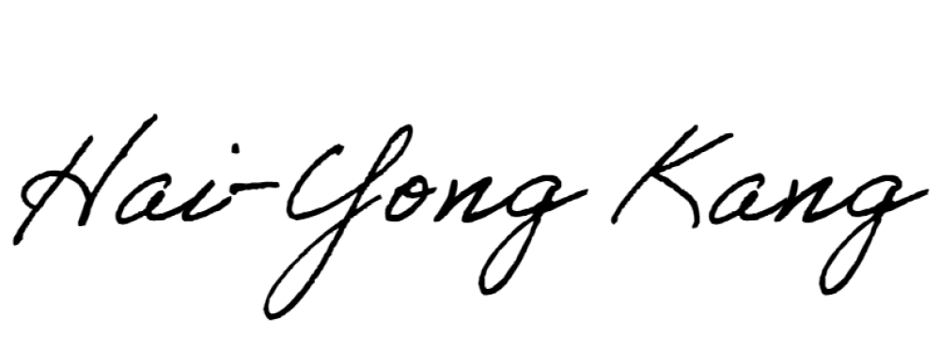Contact Person Hai-Yong Kang
November 13, 2020
Contact Title Hazardous Substances Engineer
Phone Number 916-255-6522

Approver Signature

Date

Approver Name Hai-Yong Kang
Approver’s Title Hazardous Substances Engineer
Approver’s Phone Number 916-255-6522

TO BE COMPLETED BY OPR ONLY
Date Received for Filing and Posting at OPR:

