CALIFORNIA ENVIRONMENTAL QUALITY ACT NOTICE OF EXEMPTION

To: Office of Planning and Research State Clearinghouse
P.O. Box 3044, 1400 Tenth Street, Room 212 Sacramento, CA 95812-3044
From: Department of Toxic Substances Control Permitting Division
8800 Cal Center Drive Sacramento, CA 95826

Project Title: EMERGENCY PERMIT FOR TREATMENT OF HAZARDOUS WASTE, BIO-RAD LABORATORIES LIFE SCIENCES, CONTRA COSTA COUNTY, CALIFORNIA
Project Location: 3110 Regatta Boulevard, Richmond, California 94804
County: Contra Costa County
Project Applicant: Bio-Rad Laboratories Life Sciences
Approval Action Under Consideration by DTSC: Emergency Permit
Statutory Authority: California Health and Safety Code, Chapter 6.5
Project Description: The California Department of Toxic Substances Control (DTSC), pursuant to authority granted under California Code of Regulations, Title 22, Division 4.5, Chapter 20, Section 66270.61, has issued an Emergency Permit to the Bio-Rad Laboratories Life Sciences, (EPA ID# CAD981453871) to treat hazardous waste through a controlled reaction with a chemical solution. Specifically, one 5-gallon containers of PDOT waste must be stabilized prior to transport to an authorized hazardous waste treatment, storage, and disposal facility.

These chemicals are currently being stored at Bio-Rad Laboratories Life Sciences located at 3110 Regatta Boulevard, Richmond, California 94804. DTSC has determined as a safety precaution to prevent an accident or severe injury, an Emergency Permit should be issued to chemically stabilize the hazardous waste prior to storage and eventual transportation off-site by Triumvirate Environmental, Inc. (TEI).

Background: PDOT waste is a peroxide forming material. The peroxides produced may be unstable at relatively low concentrations, resulting in fire and/or explosion if improperly handled. Further instability can be introduced as the chemical and/or the storage container degrades (i.e. after the product’s expiration date). Chemical stabilization is recommended prior to transport to a permitted treatment, storage, and disposal facility.

Project Activities: The treatment of the hazardous waste involves the addition of solution to the containers in a controlled manner to reduce the reactive or ignitable characteristics of the chemical. Treatment will take place within a designated exclusion zone. Only technicians from TEI will be allowed in the exclusion zone. Movement, preparation, and treatment of the containers will be in accordance with established standards.

Within 10 business days of the expiration of this permit, Bio-Rad Laboratories Life Sciences will submit a final report, signed in accordance with Title 22, California Code of Regulations section 66270.11(d). The report shall include certification that the treatment area has been cleared of all residual hazardous waste generated from this emergency treatment and all generated waste has been properly managed.

The Emergency Permit is effective beginning October 27, 2020 and shall expire on January 24, 2021.

Name of Public Agency Approving Project: Department of Toxic Substances Control
Name of Person or Agency Carrying Out Project: Triumvirate Environmental, Inc.
Exempt Status: Emergency Project [PRC, Sec. 21080(b)(4); 14 CCR, Sec.15269(c)]
Reasons Why Project is Exempt: This action is necessary to prevent an emergency. Chemical stabilization of the chemicals is necessary prior to transportation to an authorized hazardous waste treatment, storage, and disposal facility to prevent accidental fire and/or explosion during transport.
The administrative record for this project is available to the public by appointment at the following location:

Department of Toxic Substances Control File Room
Permitting Division 8800 Cal Center Drive

Sacramento, CA 95826

Contact Person Vinke Menardo

Contact Title
Hazardous Substances Engineer

Phone Number (916) 255-6668

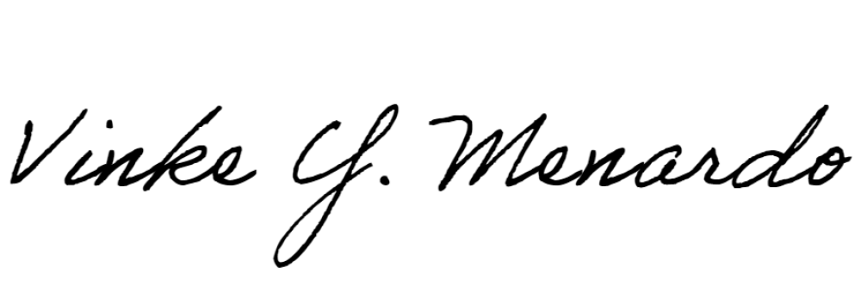Date:
Approver’s Signature:
October 29, 2020

Approver’s Name Vinke Menardo
Approver’s Title
Hazardous Substances Engineer
Approver’s Phone Number (916) 255-6668

TO BE COMPLETED BY OPR ONLY

Date Received for Filing and Posting at OPR:

