Notice of Completion Project Description

The applicant requests approval of a Minor Use Permit to allow a new 1-story Law Office Building of 6,200 square feet and associated site work including on-site parking facilities and off-site street frontage improvement at 21137 Calistoga Road (Hwy 29) on Lake County APN 024-368-01 in Middletown, California. The project parcel size is approximately 0.45 acres in size (19,602 square feet) and currently developed with a commercial retail building approximately 2,060 square foot in size, which will be demolished to construct the infrastructure. The project is located adjacent to Highway 29 also known as Calistoga Road maintained by California Department of Transportation (Caltrans). The 1-story structure utilizes parapet wall along the Calistoga Road (Hwy 29) and Young Street frontages. The proposed vehicle entries are accessed from Young and Bush Streets.

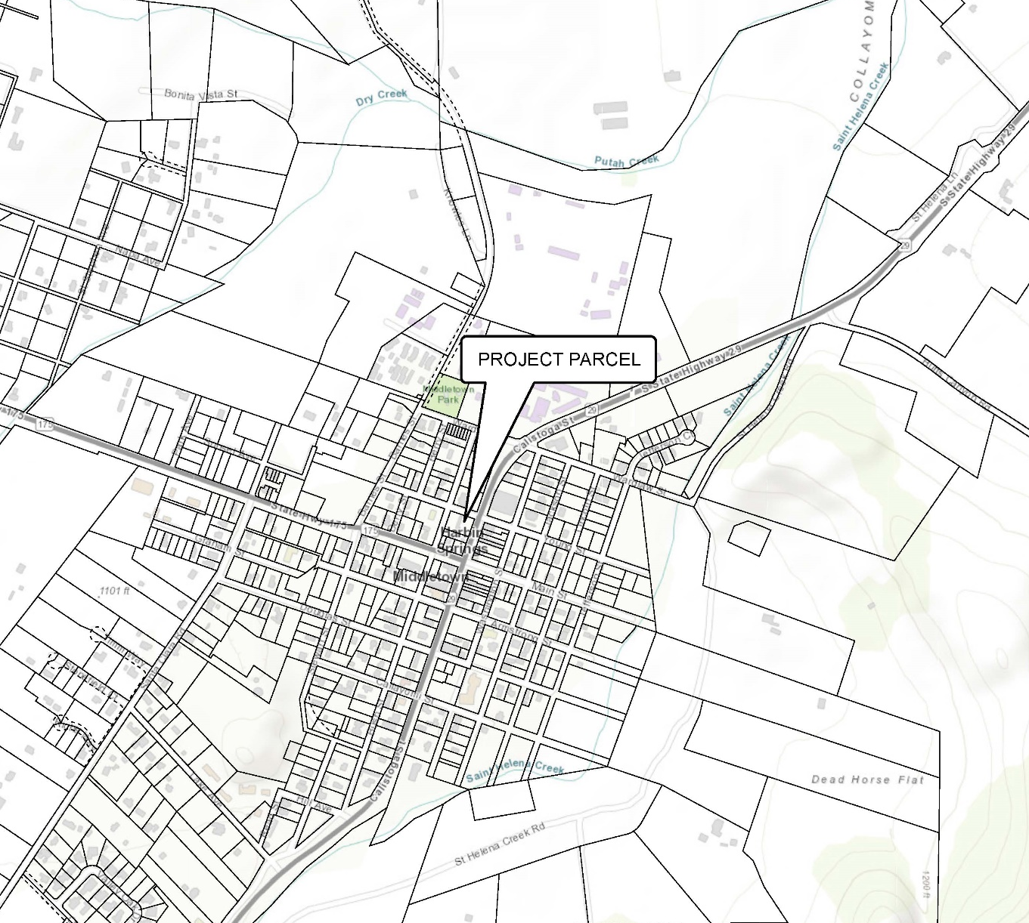

VINCINITY MAP North

