NOTICE OF AVAILABILITY
OF THE DRAFT INITIAL STUDY/ENVIRONMENTAL ASSESSMENT (IS/EA) FOR THE MANTHEY ROAD BRIDGE REPLACEMENT PROJECT
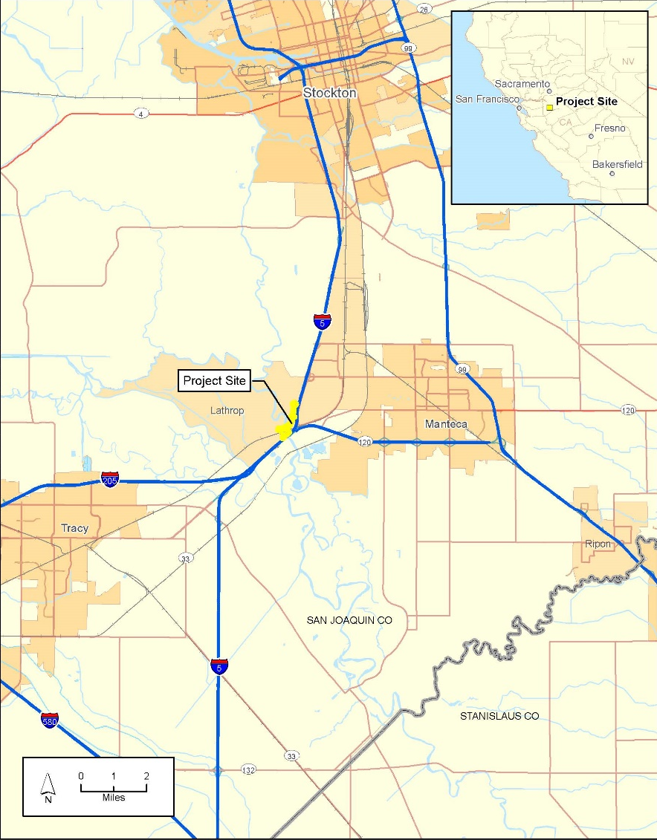

WHAT’S BEING PLANNED | The City of Lathrop (City), in cooperation with California Department of Transportation (Caltrans), proposes to replace the Manthey Road Bridge to address issues of safety and circulation and to improve bicycle and pedestrian access. The replacement bridge will be along the proposed Golden Valley Parkway alignment. The Draft IS/EA evaluates a Build Alternative and a No-Build Alternative.
WHY THIS AD | The City and Caltrans have studied the effects this project may have on the environment. This notice is to tell you of the preparation of the Draft IS/EA and of its availability for you to read and participate in a public review and comment.  The proposed work would have effects on historic properties and biological resources which would be reduced with the implementation of mitigation measures and therefore would not be adverse.  The proposed project is listed in the San Joaquin County of Government’s fiscally constrained 2018 Regional Transportation Plan/Sustainable Communities Strategy and the financially constrained 2019 Federal Transportation Improvement Program.

WHAT’S AVAILABLE | The Draft IS/EA and other project information are available for review and copying at the Caltrans District 10 Office, 1976 East Charter Way/East Dr. Martin Luther King, Jr. Blvd., Stockton, California, on weekdays from 8:30 AM to 4:30 PM. The Draft IS/EA is also available for download:
 | https://www.ci.lathrop.ca.us/com-dev/page/public-review-documents
WHERE YOU COME IN | You are invited to review the Draft IS/EA for the Manthey Road Bridge Replacement project and submit comments. Please mail your comments to Caltrans, District 10, Attn: Dominic Vitali, District 10 Environmental, 1976 East Charter Way/East Dr. Martin Luther King, Jr. Blvd., Stockton, CA 95205 or email them to dominic.vitali@dot.ca.gov. Your comments must be postmarked no later than October 11, 2020.
CONTACT | Individuals who require documents in alternative formats are requested to contact the District 10 Department of Transportation, Attn: Dominic Vitali, District 10 Environmental at the address above, or call (209) 948-7427 (voice). TDD users may contact the California Relay Service TDD line at 1-800-735-2929 (TTY to Voice), 1-800-735-2922, (Voice to TTY), 1-800-855-3000 (Spanish TTY to Voice and Voice to TTY), 1-800-854-7784 (Spanish and English Speech-to-Speech) or 711.

