County Clerk
Interested Parties
COUNTY OF LAKE
NOTICE OF INTENT
TO ADOPT A MITIGATED NEGATIVE DECLARATION
Project Title: White Buffalo / KJ Hopkins; Minor Use Permit (MUP 19-05); Initial Study (IS 19-10)
Project Location: 12299 Elk Mountain Road, Upper Lake, CA

APN No.: 002-025-11

Project Description: The applicant is requesting approval of a minor use permit for the cultivation of commercial cannabis. Cultivation will occur on the same site that had been approved for medicinal marijuana cultivation in 2017 through Article 72 of the Lake County Zoning Ordinance. The applicant is requesting the following licenses:
- (1) A-Type 2 small outdoor license
- (1) Type 13 Self Distribution license

The public review period for the respective proposed Mitigated Negative Declaration based on Initial Study IS 19-10 will begin on June 8, 2020 and end on July 13, 2020. You are encouraged to submit written comments regarding the proposed Mitigated Negative Declaration. You may do so by submitting written comments to the Planning Division prior to the end of the review period. Copies of the application, environmental documents, and all reference documents associated with the project are available for review through the Community Development Department, Planning Division; telephone (707) 263-2221. Written comments may be submitted to the Planning Division or via email at eric.porter@lakecountyca.gov.
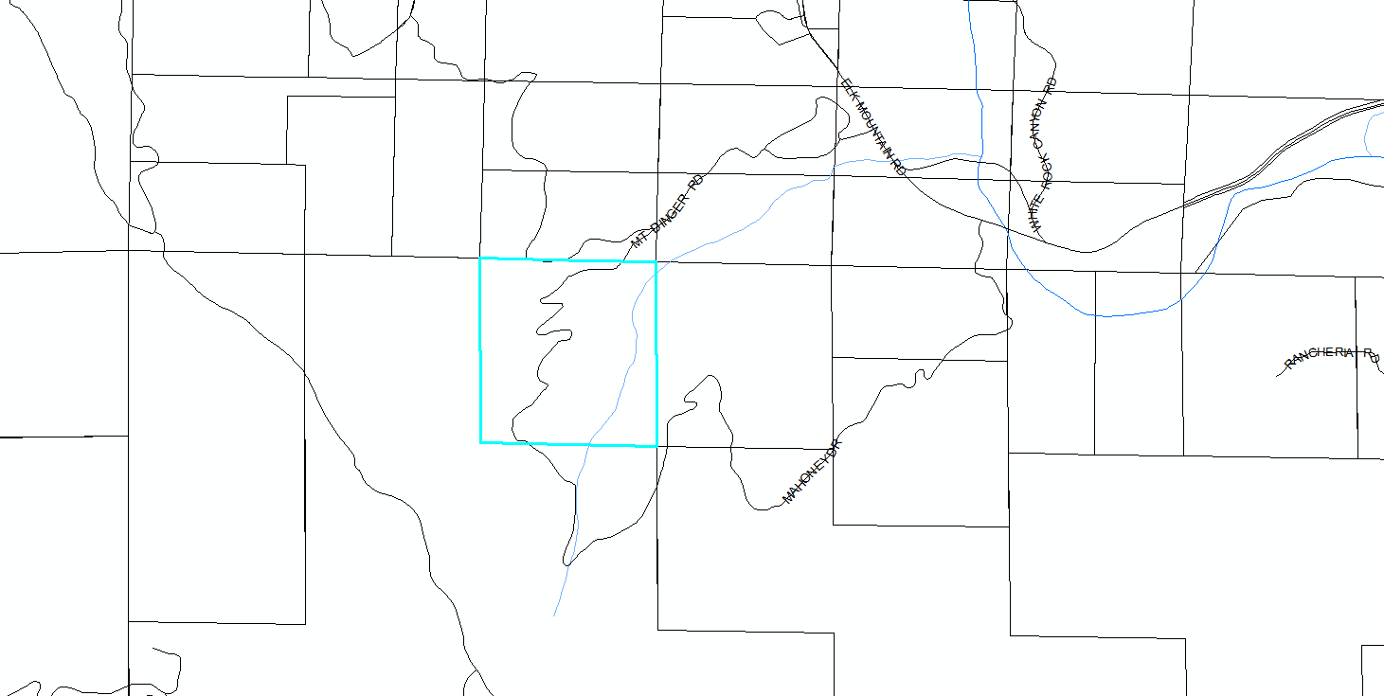
Vicinity Map of Hopkins Property

