|  |
| --- |
| **NOTICE OF INTENT TO ADOPT A MITIGATED NEGATIVE DECLARATION** |



Pursuant to the requirements of the California Environmental Quality Act (CEQA) Section 15072, this notice is to advise that the City of Menifee, as lead agency, has completed and is issuing notification of the availability and intent to adopt an Initial Study/Mitigated Negative Declaration (IS/MND), for the project as described below.

**Project Title:** **“Haun and Holland Mixed Use Center” Tentative Parcel Map No.37121 (Planning Application No. 2016-185)**

**Project Location:** The project site is bound by Interstate 215 (I-215) to the east, Haun Road to the west, Holland Road to the south, and Piedra Road to the North (APN 360-130-003), within the City of Menifee, County of Riverside, State of California.

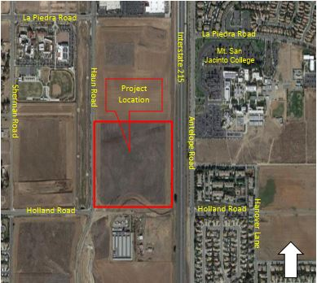**Project Proposal:** Tentative Parcel Map No. 37121 proposes to subdivide the approximately 37 acre site into six (6) parcels for the potential future development of commercial, office, retail and/or industrial uses and dedicates a portion of the parcels to public streets. As the site lies within the General Plan land use designation of Economic Development Corridor – Community Core (EDC-CC), it must comply with the EDC zoning in accordance with Menifee Municipal Code (MMC) Chapter 9.140 and include a Conceptual Master Plan (CMP). The CMP identifies anticipated future uses for the Project and how they relate to existing or proposed development on adjacent properties. CMP’s are reviewed on an administrative level by the City’s Community Development Director and are not formally approved or adopted. For this project, the CMP is being utilized to establish uses and intensities for the impact analysis. Only the tentative parcel map would be formally approved.

**Project Data:** **General Plan Land Use:** Economic Development Corridor-Community Corridor (EDC-CC). **Zoning:** Economic Development Corridor-Community Corridor (EDC-CC).

**Hazardous Materials:** The applicant has certified that the project site is not a listed toxic site pursuant to Government Code Section 65962.5.

**Public Review Period:** As mandated by State law, the minimum public review period for this document is 30 days. The IS/MND is available for public review and comment **beginning May 19, 2020** and **ending** **June 18, 2020**. All comments on the IS/MND must be submitted **in writing** to the address or e-mail address provided below and received **no later than 5:00 PM Thursday, June 18, 2020**.

CITY OF MENIFEE COMMUNITY DEVELOPMENT DEPARTMENT

Attn: Jason Moquin, Contract Planner

29844 Haun Road

Menifee, CA 92586

(951) 462-7353

[jmoquin@rinconconsultants.com](mailto:jmoquin@rinconconsultants.com)

**Public Hearings:** Notification of the date, time, and place of future public hearings will be provided in compliance with City and CEQA requirements.

**Document Availability:** A copy of the IS/MND is available electronically at [www.cityofmenifee.us](http://www.cityofmenifee.us)/325/Environmental-Notices-Documents.