|  |  |
| --- | --- |
|  | County Clerk |
|  | Interested Parties |

**COUNTY OF LAKE**

**NOTICE OF INTENT**

**TO ADOPT A MITIGATED NEGATIVE DECLARATION**

**Project Title**: **Jason Jones;** Use Permit (UP 18-32); Initial Study (IS 18-40)

**Project Location: 26066 and** 27084 Jerusalem Grade Road, Middletown, CA 95461

**APN No’s: 013-017-62 and 013-017-66**

**Project Description:** The applicant is requesting approval of a minor use permit for the cultivation of commercial cannabis. The applicant is requesting the following licenses:

* (1) A-Type 3 medium outdoor license
* (1) Type 13 Self Distribution license

**The public review period for the respective proposed Mitigated Negative Declaration based on Initial Study IS 18-40 will begin on May 1, 2020 and end on May 31, 2020.** You are encouraged to submit written comments regarding the proposed Mitigated Negative Declaration. You may do so by submitting written comments to the Planning Division prior to the end of the review period. Copies of the application, environmental documents, and all reference documents associated with the project are available for review through the **Community Development Department, Planning Division; telephone (707) 263-2221**. Written comments may be submitted to the Planning Division or via email at [eric.porter@lakecountyca.gov](mailto:eric.porter@lakecountyca.gov).

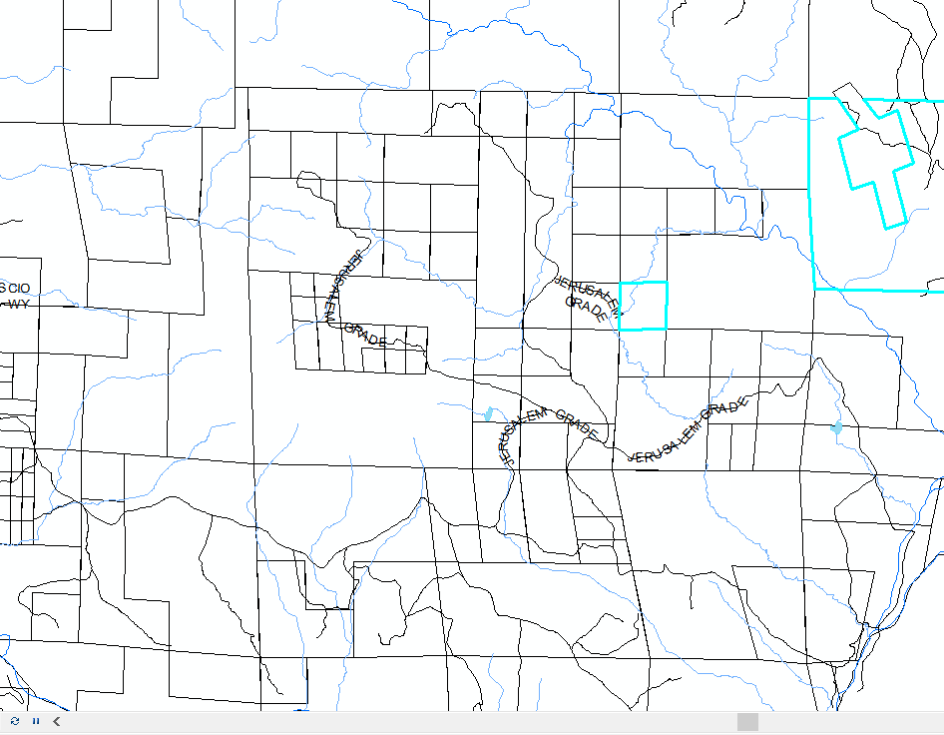

Vicinity Map of Jones Property