County Clerk
Interested Parties
COUNTY OF LAKE
NOTICE OF INTENT
TO ADOPT A MITIGATED NEGATIVE DECLARATION
Project Title: Noble Farms / Patricia Lanier; Minor Use Permit (MUP 18-28); Initial Study (IS 18-33)
Project Location: 18211 Ponderosa Trail, Lower Lake, CA

APN No.: 012-048-11

Project Description: The applicant is requesting approval of a minor use permit for the cultivation of commercial cannabis through a 6 phase process. The applicant is requesting the following licenses:
- (1) A-Type 1C small outdoor license
- (1) A-Type 2B small mixed light license
- (1) Type 13 Self Distribution license

The public review period for the respective proposed Mitigated Negative Declaration based on Initial Study IS 18-33 will begin on March 12, 2020 and end on April 13, 2020. You are encouraged to submit written comments regarding the proposed Mitigated Negative Declaration. You may do so by submitting written comments to the Planning Division prior to the end of the review period. Copies of the application, environmental documents, and all reference documents associated with the project are available for review through the Community Development Department, Planning Division; telephone (707) 263-2221. Written comments may be submitted to the Planning Division or via email at eric.porter@lakecountyca.gov.
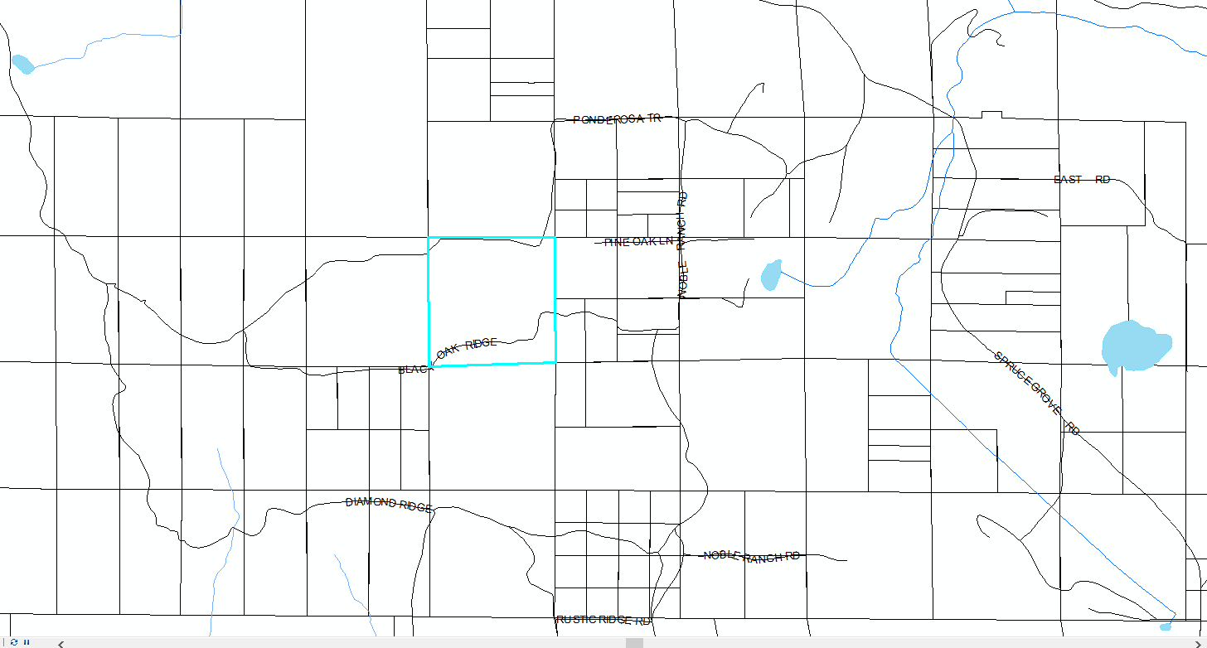
Vicinity Map of Lanier Property

