
COUNTY OF LAKE
COMMUNITY DEVELOPMENT DEPARTMENT
Planning Division
Courthouse - 255 N. Forbes Street
Lakeport, California 95453
Telephone 707/263-2221 FAX 707/263-2225

Dated: March 6, 2020

CALIFORNIA ENVIRONMENTAL QUALITY ACT

ENVIRONMENTAL CHECKLIST FORM

INITIAL STUDY IS 18-33

- Project Title: Patricia Lanier

- Permit Number: Minor Use Permit, MUP 18-28
Initial Study, IS 18-33

- Lead Agency Name and Address: County of Lake
Community Development Department
Courthouse – 255 North Forbes Street
Lakeport CA 95453

- Contact Person: Eric Porter, Associate Planner (707) 263-2221

- Project Location(s): 18211 Ponderosa Trail, Lower Lake, CA 95457
APN: 012-048-11

- Project Sponsor’s Name/Address: Patricia Lanier
18587 Black Oak Ridge Road
Lower Lake, CA 95457

7. General Plan Designation: Agriculture

- Zoning: “A”; Agriculture

- Description of Project: (Describe the whole action involved, including but not limited to later phases of the project, and any secondary, support, or off-site features necessary for its implementation. Attach additional sheets if necessary).
Supervisor District: District One (1)
Flood Zone: None
Slope: Generally flat to gentle slope (under 20%)
Fire Hazard Severity Zone: SRA (entire site); Moderate to High
Earthquake Fault Zone: None
Dam Failure Inundation Area: Not located within Dam Failure Inundation Area
Parcel Size: 40.65 Acres

On June 13, 2018, the applicant initially requested the following medicinal cultivation activities:

- M - Type 1: "specialty outdoor": Outdoor cultivation for medicinal cannabis without the use of light deprivation and/or artificial lighting in the canopy area at any point in time of less than or equal to 5,000 square feet of total canopy size on one premises, or up to 50 mature plants on noncontiguous plots.

- M - Type 2B: "small mixed-light": Cultivation for medicinal cannabis in a greenhouse, glasshouse, conservatory, hothouse, or other similar structure using light deprivation and/or artificial lighting below a rate of 25 watts per square foot between 5,001 and 10,000 square feet, inclusive, of total canopy size on one premises.

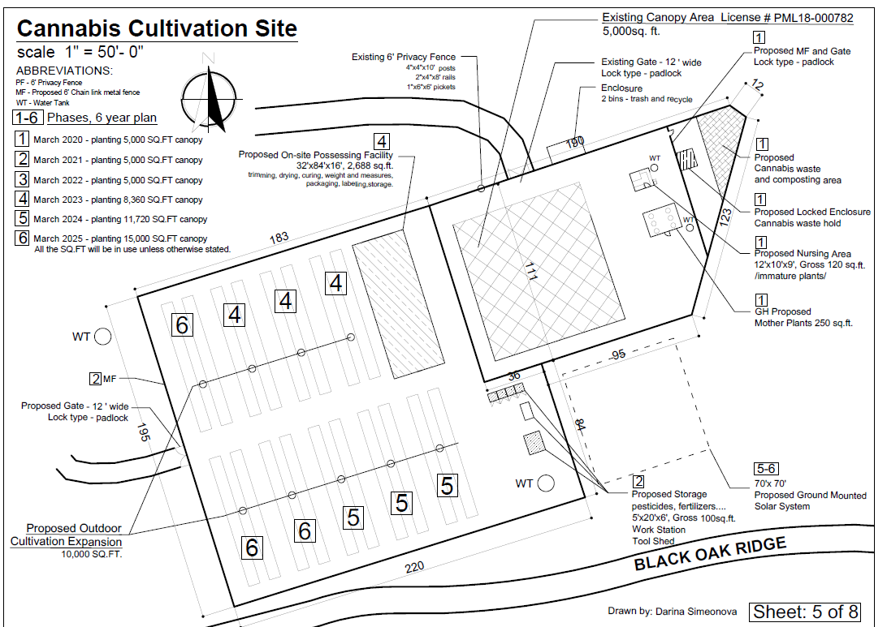

The Plan proposes gradual increases in the size and scale of the mixed light areas as follows:

Phase 1: 5,000 s.f. of canopy; estimated 6,500 s.f. of cultivation area. Target date: March 2020
Phase 2: continue with Phase I canopy / cultivation area. Target date: March 2021
Phase 3: continue with Phase I canopy / cultivation area. Target date: March 2022
Phase 4: add 3,360 s.f. of canopy, 4,000 s.f. of cultivation area. Target date: March 2023
Phase 5: add 3,360 s.f. of canopy; 4,000 s.f. of cultivation area. Target date: March 2024
Phase 6: add 3,280 s.f. of canopy; 3,500 s.f. of cultivation area. Target date: March 2025

*Note: the proposed processing building, the internal road improvements, the fencing and security cameras will be constructed and installed within Phase 1.

Construction

Construction of the processing building will take approximately two to four months. An estimated 10 to 20 weekly construction-related trips are likely to occur. This site was granted ‘Self Certification’ in 2017 which allowed the cultivation of medicinal cannabis. Due to the prior self-certification, the proposed cannabis cultivation area is within an existing fenced in area, and the interior driveway is already in place.

Staging of equipment will occur on the existing interior driveway.

The Phase I greenhouses will be built concurrently with the processing building, and will take between one and two months to build.

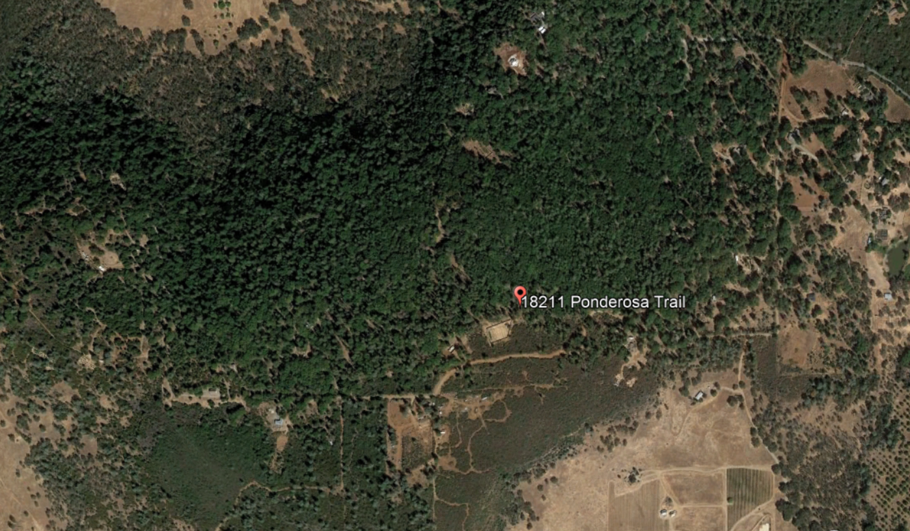
- Surrounding Land Uses and Setting: Briefly describe the project’s surroundings:

North: “RR” Rural Residential, “RL” Rural Lands and “APZ” Agricultural Preserve. Parcel sizes range from approximately 2 to 150 acres. Two of the near northern lots contain dwellings.

South: “A” Agriculture and “RR” Rural Residential. Parcel sizes range from approximately 5 to 40 acres in size. The southern neighboring lot contains an unpermitted cannabis cultivation area and a dwelling.

East: “RR” Rural Residentially-zoned land. Parcel sizes range from approximately 5 to 10 acres in size. About half of the adjacent or nearby lots to the east contain dwellings.

West: “APZ” Agriculture Preserve. Parcel is 150 acres in size.

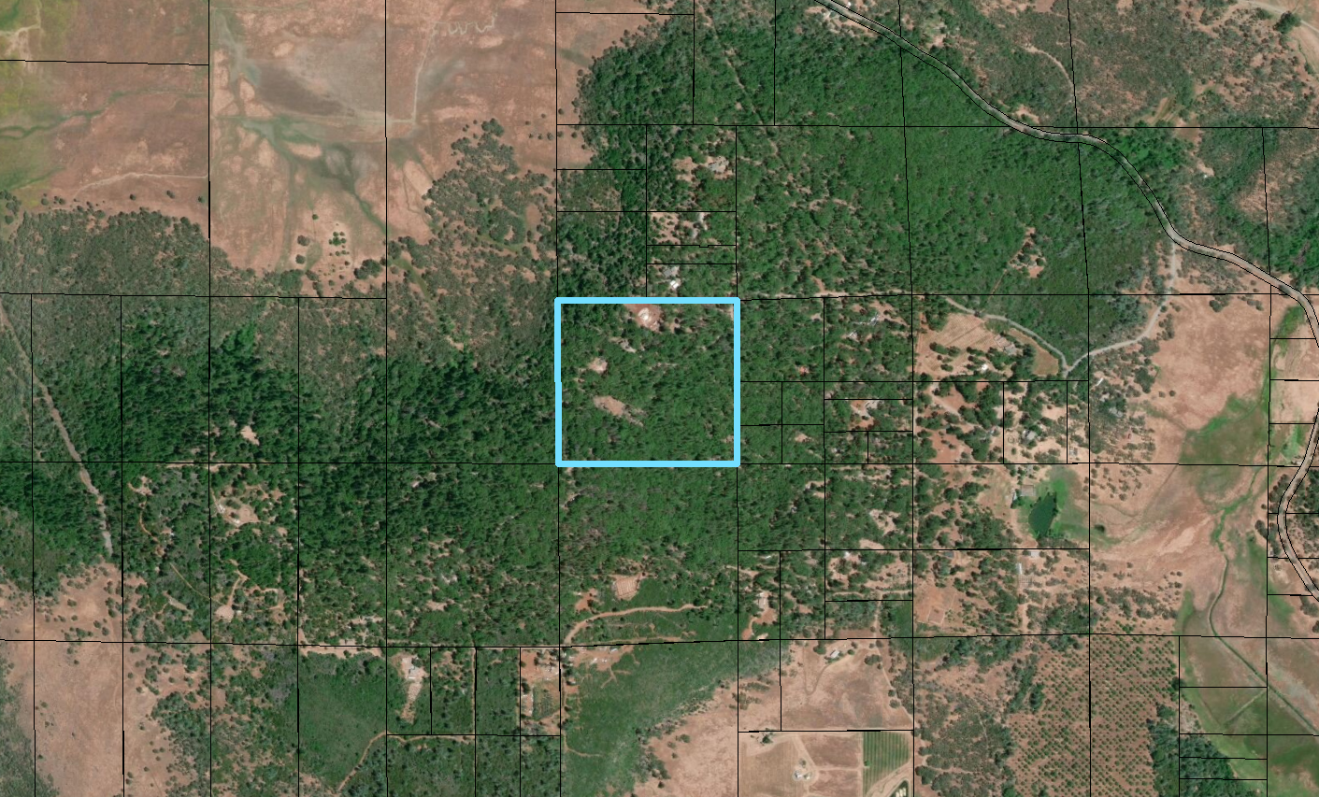
Aerial Photo of Site and Surrounding Properties

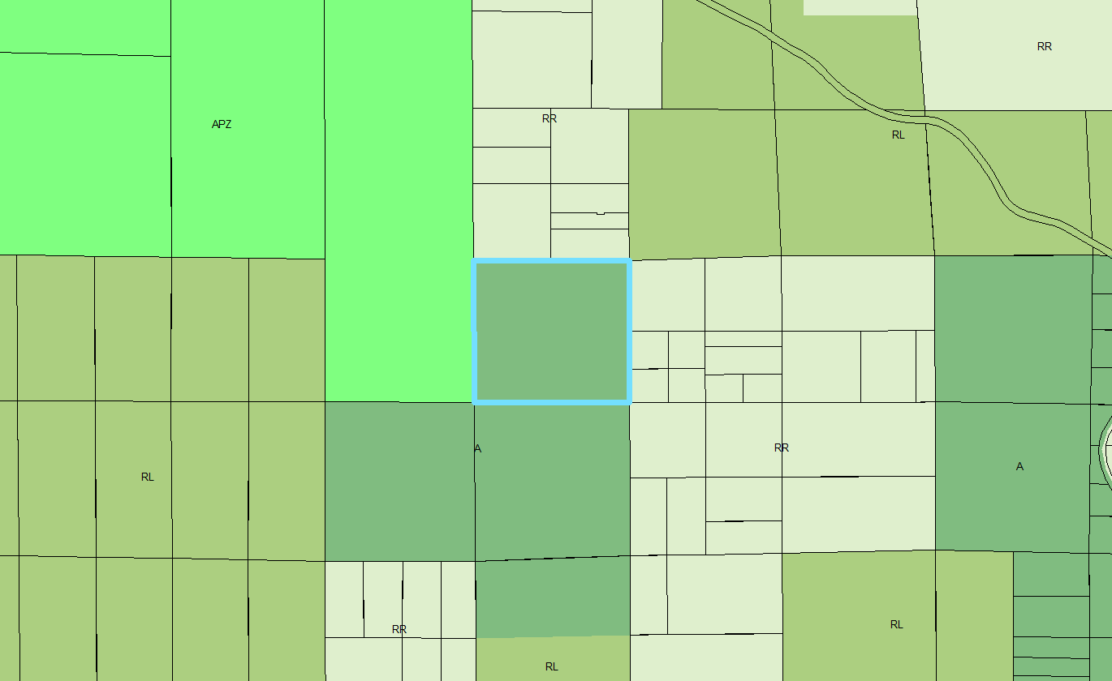
Zoning of Site and Surrounding Properties

Other public agencies whose approval may be required (e.g., Permits, financing approval, or participation agreement.)

Lake County Community Development Department
Lake County Department of Environmental Health
Lake County Air Quality Management District
Lake County Department of Public Works
Lake County Department of Public Services
Lake County Agricultural Commissioner
Lake County Sheriff Department
South Lake County Fire Protection District (CalFire)
Central Valley Water Resource Control
California Department of Forestry & Fire Protection (CalFire)
California Department of Food and Agriculture (CalCannabis)
California Department of Pesticides Regulations
California Department of Public Health
California Department of Consumers Affairs

- Have California Native American tribes traditionally and culturally affiliated with the project area requested consultation pursuant to Public Resources Code section 21080.3.1? If so, is there a plan for consultation that includes, for example, the determination of significance of impacts to tribal cultural resources, procedures regarding confidentiality, etc.? Note: Conducting consultation early in the CEQA process allows tribal governments, lead agencies, and project proponents to discuss the level of environmental review, identify and address potential adverse impacts to tribal cultural resources, and reduce the potential for delay and conflict in the environmental review process. (See Public Resources Code section 21080.3.2.) Information may also be available from the California Native American Heritage Commission’s Sacred Lands File per Public Resources Code section 5097.96 and the California Historical Resources Information System administered by the California Office of Historic Preservation. Please also note that Public Resources Code section 21082.3 (c) contains provisions specific to confidentiality.
All 11 Tribes located in Lake County were notified of this proposal. The Koi Nation indicated that they were interested in this project, and a Cultural Study and site plans were sent to the Koi Nation for their review and comment on February 26, 2020. No follow up comments have been received to date.
ENVIRONMENTAL FACTORS POTENTIALLY AFFECTED:
The environmental factors checked below would be potentially affected by this project, involving at least one impact that is a “Potentially Significant Impact” as indicated by the checklist on the following pages.

 | Aesthetics |  | Greenhouse Gas Emissions |  | Population / Housing
 | Agriculture & Forestry |  | Hazards & Hazardous Materials |  | Public Services
 | Air Quality |  | Hydrology / Water Quality |  | Recreation
 | Biological Resources |  | Land Use / Planning |  | Transportation
 | Cultural Resources |  | Mineral Resources |  | Tribal Cultural Resources
 | Geology / Soils |  | Noise |  | Utilities / Service Systems
 | Wildfire Energy |  |  |  | Mandatory Findings of Significance

DETERMINATION: (To be completed by the lead Agency)
On the basis of this initial evaluation:

I find that the proposed project COULD NOT have a significant effect on the environment, and a NEGATIVE DECLARATION will be prepared.

I find that although the proposed project could have a significant effect on the environment, there will not be a significant effect in this case because revisions in the project have been made by or agreed to by the project proponent. A MITIGATED NEGATIVE DECLARATION will be prepared.

I find that the proposed project MAY have a significant effect on the environment, and an ENVIRONMENTAL IMPACT REPORT is required.

I find that the proposed project MAY have a “potentially significant impact” or “potentially significant unless mitigated” impact on the environment, but at least one effect 1) has been adequately analyzed in an earlier document pursuant to applicable legal standards, and 2) has been addressed by mitigation measures based on the earlier analysis as described on attached sheets. An ENVIRONMENTAL IMPACT REPORT is required, but it must analyze only the effects that remain to be addressed.

I find that although the proposed project could have a significant effect on the environment, because all potentially significant effects (a) have been analyzed adequately in an earlier EIR or NEGATIVE DECLARATION pursuant to applicable standards and (b) have been avoided or mitigated pursuant to that earlier EIR or NEGATIVE DECLARATION, including revisions or mitigation measures that are imposed upon the proposed project, nothing further is required.

Initial Study Prepared By:
Eric Porter, Associate Planner

Date:
SIGNATURE

Scott DeLeon – Interim Community Development Director
Community Development Department

Section 1 - EVALUATION OF ENVIRONMENTAL IMPACTS:

1) A brief explanation is required for all answers except "No Impact" answers that are adequately supported by the information sources a lead agency cites in the parentheses following each question. A "No Impact" answer is adequately supported if the referenced information sources show that the impact simply does not apply to projects like the one involved (e.g., the project falls outside a fault rupture zone). A "No Impact" answer should be explained where it is based on project-specific factors as well as general standards (e.g., the project will not expose sensitive receptors to pollutants, based on a project-specific screening analysis).

2) All answers must take account of the whole action involved, including off-site as well as on-site, cumulative as well as project-level, indirect as well as direct, and construction as well as operational impacts.

- Once the lead agency has determined that a particular physical impact may occur, and then the checklist answers must indicate whether the impact is potentially significant, less than significant with mitigation, or less than significant. "Potentially Significant Impact" is appropriate if there is substantial evidence that an effect may be significant. If there are one or more "Potentially Significant Impact" entries when the determination is made, an EIR is required.

- "Negative Declaration: Less Than Significant With Mitigation Incorporated" applies where the incorporation of mitigation measures has reduced an effect from "Potentially Significant Impact" to a "Less Than Significant Impact." The lead agency must describe the mitigation measures, and briefly explain how they reduce the effect to a less than significant level (mitigation measures from Section XVII, "Earlier Analyses," may be cross-referenced).

5) Earlier analyses may be used where, pursuant to the tiering, program EIR, or other CEQA process, an effect has been adequately analyzed in an earlier EIR or negative declaration. Section 15063(c)(3)(D). In this case, a brief discussion should identify the following:
a) Earlier Analysis Used. Identify and state where they are available for review.
b) Impacts Adequately Addressed. Identify which effects from the above checklist were within the scope of and adequately analyzed in an earlier document pursuant to applicable legal standards, and state whether such effects were addressed by mitigation measures based on the earlier analysis.
c) Mitigation Measures. For effects that are "Less than Significant with Mitigation Measures Incorporated," describe the mitigation measures, which were incorporated or refined from the earlier document and the extent to which they address site-specific conditions for the project.

6) Lead agencies are encouraged to incorporate into the checklist references to information sources for potential impacts (e.g., general plans, zoning ordinances). Reference to a previously prepared or outside document should, where appropriate, include a reference to the page or pages where the statement is substantiated.

- Supporting Information Sources: A source list should be attached, and other sources used or individuals contacted should be cited in the discussion.

- This is only a suggested form, and lead agencies are free to use different formats; however, lead agencies should normally address the questions from this checklist that are relevant to a project's environmental effects in whatever format is selected.

9) The explanation of each issue should identify:
a) the significance criteria or threshold, if any, used to evaluate each question; and
b) the mitigation measure identified, if any, to reduce the impact to less than significance

KEY: 1 = Potentially Significant Impact
2 = Less Than Significant with Mitigation Incorporation
3 = Less Than Significant Impact
4 = No Impact

IMPACT  CATEGORIES* | 1 | 2 | 3 | 4 |  | All determinations need explanation.  Reference to documentation, sources, notes and correspondence. |  |  | Source Number**
I. AESTHETICS
Would the project:
a) Have a substantial adverse effect on a scenic vista? |  |  | X |  |  | There are no scenic vistas on or adjacent to the subject site.  The project site is located on a property that is surrounded by dense vegetation; the topography and natural vegetation would act as a natural screen. The cultivation area is not visible from any adjacent lots or any public roads. The fencing around the cultivation area will need to be screened; this will be a condition of approval. No further mitigation measures are necessary to comply with this impact category.  Less Than Significant Impact |  |  | 1, 2, 3, 4, 6, 9
b) Substantially damage scenic resources, including, but not limited to, trees, rock outcroppings, and historic buildings within a state scenic highway? |  |  | X |  |  | There are no scenic resources on the site, such as trees, rock outcroppings or historic buildings.  Less Than Significant Impact |  |  | 1, 2, 3, 4, 6, 9
c) Substantially degrade the existing visual character or quality of public views the site and its surroundings? If the project is in an urbanized area, would the project conflict with applicable zoning and other regulations governing scenic quality? |  |  | X |  |  | The site is accessible from a private roadway (‘Ponderosa Trail’) located off of Black Oak Ridge Road. Due to the dense topography and natural vegetation, the visual character and quality of public views would not be impacted. Additionally, no physical changes to the site are proposed and/or needed. The site is not located within an urbanized area.  Less Than Significant Impact |  |  | 1, 2, 3, 4, 6, 9
d) Create a new source of substantial light or glare which would adversely affect day or nighttime views in the area? |  | X |  |  |  | The project has a slight potential to create additional light through exterior security lighting and greenhouse lighting. A lighting plan showing fixture types and locations is required and shall meet the County’s recommended darkskies.org lighting standards.  Mitigation Measure AES-1 - All greenhouses incorporating artificial lighting shall be equipped with blackout film/material to be used at night for maximum light blockage to lessen the impact on the surrounding parcels and the dark skies. Applicant shall submit a Blackout Film/Materials Plan to the Community Development Department for review and approval prior to issuance of any permits.  Less than Significant Impact with mitigation measure AES-1 added |  |  | 1, 2, 3, 4, 5, 6, 9
- AGRICULTURE AND FORESTRY RESOURCES
In determining whether impacts to agricultural resources are significant environmental effects, lead agencies may refer to the California Agricultural Land Evaluation and Site Assessment Model (1997) prepared by the California Dept. of Conservation as an optional model to use in assessing impacts on agriculture and farmland. In determining whether impacts to forest resources, including timberland, are significant environmental effects, lead agencies may refer to information compiled by the California Department of Forestry and Fire Protection regarding the state’s inventory of forest land, including the Forest and Range Assessment Project and the Forest Legacy Assessment Project; and forest carbon measurement methodology provided in Forest protocols adopted by the California Air Resources Board.
Would the project:
a) Convert Prime Farmland, Unique Farmland, or Farmland of Statewide Importance (Farmland), as shown on the maps prepared pursuant to the Farmland Mapping and Monitoring Program of the California Resources Agency, to non-agricultural use? |  |  | X |  |  | Although the site is zoned ‘Agriculture’, the project site contains soil that is mapped as “Other Land”. There is an APZ-zoned property immediately west of the subject site (under Williamson Act contract), however the western adjacent lot is not actively growing crops. The subject site is not under a Williamson Act contract.  Less than Significant Impact |  |  | 1, 2, 3, 4, 5, 7, 8, 11, 13
b) Conflict with existing zoning for agricultural use, or a Williamson Act contract? |  |  | X |  |  | The site will not conflict with existing zoning and is not under Williamson Act contract. Less than Significant Impact |  |  | 1, 2, 3, 4, 5, 7, 8, 11, 13
c) Conflict with existing zoning for, or cause rezoning of, forest land (as defined in Public Resources Code section 12220(g)), timberland (as defined by Public Resources Code section 4526), or timberland zoned Timberland Production (as defined by Government Code section 51104(g))? |  |  |  | X |  | The proposed project will not conflict with existing zoning and/or cause the rezoning of forest land as defined by Public Resource Code section 4526, or of timberland as defined by Government Code section 51104(g).  No Impact |  |  | 1, 2, 3, 4, 5, 7, 8, 11, 13
d) Result in the loss of forest land or conversion of forest land to non-forest use? |  |  |  | X |  | See response to Section II (c). The project would not result in the loss or conversion of forest land to a non-forest use.  No Impact |  |  | 1, 2, 3, 4, 5, 7, 8, 11, 13
e) Involve other changes in the existing environment which, due to their location or nature, could result in conversion of Farmland, to non-agricultural use or conversion of forest land to non-forest use? |  |  |  | X |  | As proposed, this project would not induce changes to existing farmland that would result in its conversion to non-agricultural use.  No Impact |  |  | 1, 2, 3, 4, 5, 7, 8, 11, 13
III. AIR QUALITY
Where available, the significance criteria established by the applicable air quality management or air pollution control district may be relied upon to make the following determinations.
Would the project:
a) Conflict with or obstruct implementation of the applicable air quality plan? |  | X |  |  |  | The project has some potential to result in short- and long-term air quality impacts. Dust and fumes may be released as a result of vehicular traffic, including small delivery vehicles. Odors generated by the plants, particularly during harvest season, will need to be mitigated either through passive means (separation distance), or active means (Odor Control Plan). Additionally, implementation of mitigation measures below would further reduce air quality impacts to less than significant. Less Than Significant with Mitigation Measures added:  AQ-1: Prior to obtaining the necessary permits and/or approvals for any phase, applicant shall contact the Lake County Air Quality Management District and obtain an Authority to Construct (A/C) Permit for all operations and for any diesel powered equipment and/or other equipment with potential for air emissions.  AQ-2: All mobile diesel equipment used must be in compliance with State registration requirements. Portable and stationary diesel powered equipment must meet the requirements of the State Air Toxic Control Measures for CI engines.  AQ-3: The applicant shall maintain records of all hazardous or toxic materials used, including a Material Safety Data Sheet (MSDS) for all volatile organic compounds utilized, including cleaning materials. Said information shall be made available upon request and/or the ability to provide the Lake County Air Quality Management District such information in order to complete an updated Air Toxic emission Inventory. |  |  | 1, 3, 4, 5, 10, 21, 24, 31, 36
b) Violate any air quality standard or result in a cumulatively considerable net increase in an existing or projected air quality violation? |  |  | X |  |  | The County of Lake is in attainment of state and federal ambient air quality standards. Burning cannabis waste is prohibited within the commercial cannabis ordinance for Lake County, and use of generators is only allowed during a power outage. On-site construction is likely to occur over a relatively short period of time (estimated between 2 and 4 months), and minimal construction would be required to build several greenhouses and a processing building. It is unlikely that this use would generate enough particulates during and after construction to violate any air quality standards. Less than Significant Impact |  |  | 1, 3, 4, 5, 10, 21, 24, 31, 36
c) Expose sensitive receptors to substantial pollutant concentrations? |  |  | X |  |  | 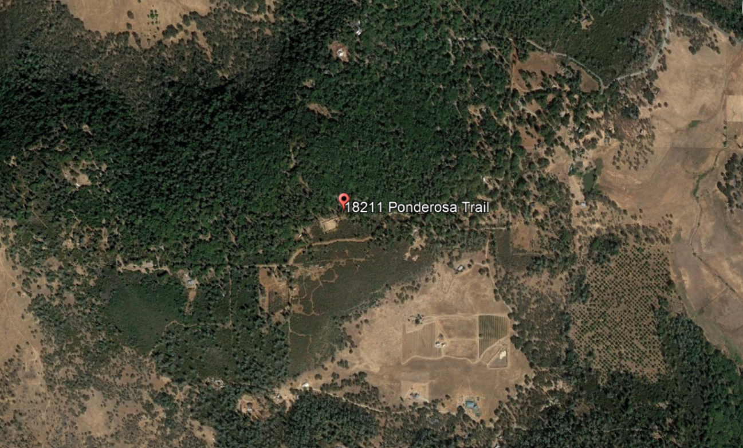The nearest residence appears to be located approximately 600 feet to the southwest according to Google Earth measurement. This neighboring house is located upwind of the normal prevailing wind direction in this area; prevailing winds typically originate from the north / northwest and blow to the south / southeast. Also, the neighboring lot was also approved for commercial cannabis cultivation in 2019 (Littlefield Minor Use Permit).  Less than Significant Impact |  |  | 1, 3, 4, 5, 10, 21, 24, 31, 36
d) Result in substantial emissions (such as odors or dust) adversely affecting a substantial number of people? |  | X X X |  |  |  | The cultivation area on the site was previously disturbed by the approval of ‘self certification’ for medicinal marijuana in 2017, and minimal site disturbance is needed to implement the phased project as proposed. The applicant will be required to submit an Odor Control Plan as a condition of approval, and will need to mitigate both the mixed light and outdoor cultivation areas through the use of filtration system(s) and odor-masking means such as fragrant plants around the perimeter of the outdoor growing area.  Implementation of mitigation measures AQ-1 through AQ-3 will reduce impacts to less than significant. |  |  | 1, 2, 3, 4, 5, 10, 21, 24, 31, 36
IV. BIOLOGICAL RESOURCES
Would the project:
a) Have a substantial adverse effect, either directly or through habitat modifications, on any species identified as a candidate, sensitive, or special status species in local or regional plans, policies, or regulations, or by the California Department of Fish and Game or U.S. Fish and Wildlife Service? |  | X |  |  |  | The applicant provided a Biological Assessment, prepared by Natural Investigations Co., dated July 27, 2018.  The Assessment concluded the following:  No significant impacts to biological resources were identified from project implementation. Operational impacts can be avoided by careful compliance with the County Grading Plan, and if required, an erosion control plan.  The following general recommendations are made:  • If additional land clearing is performed in the future, a pre-construction special-status species survey is recommended.  • If tree felling is performed in the future, a pre-construction nesting bird survey is recommended.  • If development of a project will result in the removal of commercial tree species, one of the following permits is needed: Less than 3 Acre Conversion Exemption; Christmas Tree; Dead, Dying or Diseased; Fuelwood or Split Products Exemption; a Public Agency, Public and Private Utility Right  of Way Exemption; a Notice of Exemption from Timberland Conversion Permit for Subdivision; or an Application for Timberland Conversion Permit.  The following mitigation measures are added in response to the findings / recommendation within the Biological Study provided:  BIO-1: If additional land clearing is performed in the future, a pre-construction special-status species survey is required.  BIO-2: If tree felling is performed in the future, a pre-construction nesting bird survey is required.  BIO-3: If development of a project will result in the removal of commercial tree species, one of the following permits is needed: Less than 3 Acre Conversion Exemption; Christmas Tree; Dead, Dying or Diseased; Fuelwood or Split Products Exemption; a Public Agency, Public and Private Utility Right of Way Exemption; a Notice of Exemption from Timberland Conversion Permit for Subdivision; or an Application for Timberland Conversion Permit.  Less than Significant Impact with mitigation measures BIO-1 through BIO-4 added. (BIO-4 is on the next page) |  |  | 1, 2, 3, 4, 5, 11, 12, 13, 16, 17, 21, 24, 29, 30, 31, 32, 33, 34
b) Have a substantial adverse effect on any riparian habitat or other sensitive natural community identified in local or regional plans, policies, and regulations or by the California Department of Fish and Game or U.S. Fish and Wildlife Service? |  | X |  |  |  | The Biological Study submitted indicated that this project would not adversely affect significant riparian lands, wetlands, marshes, or other significant wildlife habitats or sensitive communities. No wetland or riparian habitats or sensitive natural communities were found on the property, so no impacts to sensitive habitats are anticipated. The nearest blue line stream to the project site is an unnamed intermittent stream nearly ½ mile to the east of the site. As no streams, riparian habitats, or sensitive communities are located within ¼ mile of the site, no indirect impacts on these ecosystems would occur as a result of the cultivation operations. In addition, irrigation water for the cultivation is from the existing residential water supply, which uses an existing, permitted groundwater well, so no water will be extracted from surface streams.  The Biological Assessment provided made three recommendations that are added as mitigation measures BIO-1, BIO-2, BIO-3 and BIO-4 (next page).  Less than Significant Impact with mitigation measures BIO-1 through BIO-4 added |  |  | 1, 2, 3, 4, 5, 11, 12, 13, 16, 17, 29, 30, 31, 32, 33, 34
c) Have a substantial adverse effect on state or federally protected wetlands (including, but not limited to, marsh, vernal pool, coastal, etc.) through direct removal, filling, hydrological interruption, or other means? |  |  | X |  |  | The County’s CNDDB GIS layer shows no sensitive mapped species on the subject site, which is consistent with the data provided in the Biological Study regarding wetlands.  Further, the Biological Study states:  There are no non-wetland water resources, such as watercourses, within the Study Area.  The Study Area does not have a significant erosion potential, because slopes are not steep, areas of ground disturbance are small, and vegetated buffers are present. Therefore, no mitigation is required.  The total area of ground disturbance from installation of the cultivation operation is approximately 1 acre; if 1 acre or more of land is disturbed, the Cultivator will need to enroll for coverage under the General Permit for Discharges of Storm Water Associated with Construction Activity (Construction General Permit, 2009-0009-DWQ).  Less than Significant Impact |  |  | 1, 2, 3, 4, 5, 11, 12, 13, 16, 17, 21, 24, 29, 30, 31, 32, 33, 34
d) Interfere substantially with the movement of any native resident or migratory fish or wildlife species or with established native resident or migratory wildlife corridors, or impede the use of native wildlife nursery sites? |  |  | X |  |  | The Biological Study submitted stated that there were no observed native resident or migratory fish or wildlife species within the study area.  Less than Significant Impact |  |  | 1, 2, 3, 4, 5, 11, 12, 13, 16, 17, 21, 24, 29, 30, 31, 32, 33, 34
e) Conflict with any local policies or ordinances protecting biological resources, such as a tree preservation policy or ordinance? |  | X |  |  |  | The Biological Study states:  The Study Area is not within any designated listed species’ critical habitat. There is no evidence that project implementation impacted any special-status habitats. Therefore, no mitigation is required.  Implementation of the project will not interfere substantially with the movement of any native resident or migratory fish or wildlife species or with established native resident or migratory wildlife corridors, or impede the use of native wildlife nursery sites.  Implementation of the project does not conflict with any county or municipal policies or ordinances protecting biological resources, such as a tree preservation policy or ordinance.  We are not aware of any commercial tree species being removed for this project.  If tree felling is performed in the future, a pre-construction nesting bird survey is recommended.  The project does not conflict with the provisions of an adopted Habitat Conservation Plan, Natural Community Conservation Plan, or other approved governmental habitat conservation plan. The Study Area is not within the coverage area of any conservation plan.  Mitigation measure BIO-4 is added as follows;  BIO-4: If tree felling is performed in the future, a pre-construction nesting bird survey shall be conducted prior to any tree removal.  Less than Significant Impact with mitigation measure BIO-4 added. |  |  | 1, 2, 3, 4, 5, 11, 12, 13, 16, 17, 21, 24, 29, 30, 31, 32, 33, 34
f) Conflict with the provisions of an adopted Habitat Conservation Plan, Natural Community Conservation Plan, or other approved local, regional, or state habitat conservation plan? |  |  |  | X |  | No special conservation plans have been adopted for this site and no impacts are expected.  No Impact |  |  | 1, 2, 3, 4, 5, 11, 12, 13, 16, 17, 21, 24, 29, 30, 31, 32, 33, 34
V. CULTURAL RESOURCES
Would the project:
a) Cause a substantial adverse change in the significance of a historical resource pursuant to §15064.5? |  |  | X |  |  | A Cultural Resources Evaluation was conducted for the subject parcel involved with this proposal by Dr. John. Parker of Archaeological Research on December 23, 2018.  The Cultural Resources Evaluation stated: “As no significant historic or prehistoric cultural materials were encountered during the field inspection, it has been determined that no significant cultural sites exist on the parcel.”  The applicant is not moving or removing any soil on the site. Above ground pots using imported soil will be used for the outdoor and mixed light cannabis plants.  Less than Significant Impact |  |  | 1, 3, 4, 5, 11, 14, 15
b) Cause a substantial adverse change in the significance of an archeological resource pursuant to §15064.5? |  |  | X |  |  | Please see response to Section V(a). The applicant is proposing minimal site disturbance. Lake County establishes Cultural conditions of approval that require the local overseeing tribe be notified if any artifacts or other potentially significant finds are discovered during site disturbance, and the County requires training for all employees to be able to recognize potentially significant artifacts or remains are discovered during site disturbance. Given the findings in the Archeological Study conducted, it appears unlikely that this site contains sensitive artifacts or Tribal use. Also, an AB 52 notice was submitted for this site to 11 local tribes; no request for consultation resulted, however the Koi Nation requested a copy of the cultural study, which has been supplied to the Tribe. Less than Significant Impact |  |  | 1, 3, 4, 5, 11, 14, 15
c) Disturb any human remains, including those interred outside of formal cemeteries? |  |  | X |  |  | Please see response to Section V(a). The Cultural Study stated that it was unlikely that any significant findings, including human remains, appear likely on this site. The amount of new site disturbance that would occur is minimal. Less than Significant Impact |  |  | 1, 3, 4, 5, 11, 14, 15
VI. ENERGY
Would the project:
a) Result in a potentially significant environmental impact due to wasteful, inefficient, or unnecessary consumption of energy, or wasteful use of energy resources, during project construction or operation? |  |  | X |  |  | The applicant states that she will use an on-grid power system as the primary energy source. The outdoor cultivation areas will have minimal need for power. The likely power sources include the security system, the well pump, low-wattage lighting used within the greenhouses, although none is proposed, and any outdoor lighting that might be needed in the future.  Less than Significant Impact | 1, 3, 4, 5, 11, 14, 15
b) Conflict with or obstruct a state or local plan for renewable energy or energy efficiency? |  |  | X |  |  | There are no mandatory energy reductions for cultivation activities within Article 27 of the Lake County Zoning Ordinance unless the applicant proposes ‘indoor cultivation’ (not proposed with this application).  Less than Significant Impact. | 1, 3, 4, 5, 11, 14, 15
VII. GEOLOGY AND SOILS
Would the project:
a) Directly or indirectly cause potential substantial adverse effects, including the risk of loss, injury, or death involving:  - Rupture of a known earthquake fault, as delineated on the most recent Alquist- Priolo Earthquake Fault Zoning Map issued by the State Geologist for the area or based on other substantial evidence of a known fault? Refer to Division of Mines and Geology Special Publication 42.  - Strong seismic ground shaking?  - Seismic-related ground failure, including liquefaction?  - Landslides? |  |  | X |  |  | Earthquake Faults  There are no mapped earthquake faults on or adjacent to the subject site.  Seismic Ground Shaking and Seismic–Related Ground Failure, including liquefaction.  The mapping of the site’s soil indicates that the soil is stable and not prone to liquefaction.  Landslides  According to the Landslide Hazard Identification Map prepared by the California Department of Conservation, Division of Mines and Geology, the area is considered generally stable.  Less Than Significant Impact |  |  | 1, 3, 4, 5, 6, 7, 10, 17, 18, 19, 21, 24, 25
b) Result in substantial soil erosion or the loss of topsoil? |  |  | X |  |  | Minimal grading and/or earth movement will result with this project. The applicant will need to import soil for the pots, however this will not have any effect on the potential for erosion or the loss of topsoil.  Less than Significant Impact |  |  | 1, 3, 4, 5, 6, 7, 10, 16, 17, 18, 19, 21, 24, 25, 30
c) Be located on a geologic unit or soil that is unstable, or that would become unstable as a result of the project, and potentially result in on-site or off-site landslide, lateral spreading, subsidence, liquefaction or collapse? |  |  | X |  |  | The shrink-swell potential for the project soil type is low to moderate. The applicant will use existing cultivation areas and above-ground pots. The soil on the site is mapped as ‘stable’ on the County GIS data base. Additionally, minimal construction will occur for the proposed infrastructure.  Less Than Significant Impact |  |  | 1, 3, 4, 5, 6, 7, 10, 16, 17, 18, 19, 21, 24, 25, 30
d) Be located on expansive soil, as defined in Table 18-1-B of the Uniform Building Code (1994), creating substantial direct or indirect risks to life or property? |  |  | X |  |  | The mapped soil on the site has minimal shrink-swell potential.  Less Than Significant Impact |  |  | 1, 3, 4, 5, 6, 7, 10, 16, 17, 18, 19, 21, 24, 25, 30
e) Have soils incapable of adequately supporting the use of septic tanks or alternative wastewater disposal systems where sewers are not available for the disposal of waste water? |  |  |  | X |  | The project site will be served through an existing on-site septic system. The 40 acre site is large enough to support the existing in-ground septic system.  No Impact |  |  | 1, 3, 4, 5, 6, 7, 10, 16, 17, 18, 19, 21, 24, 25, 29, 30
f) Directly or indirectly destroy a unique paleontological resource or site or unique geologic feature? |  |  |  | X |  | There will be minimal site disturbances occurring with this project to prepare the pad for the drying building and greenhouses according to the Cultural Study provided, which indicated that there are no unique paleontological or geologic features on the site.  No Impact |  |  | 1, 3, 4, 5, 11, 14, 15
VIII. GREENHOUSE GAS EMISSIONS
Would the project:
a) Generate greenhouse gas emissions, either directly or indirectly, that may have a significant impact on the environment? |  |  | X |  |  | In general, greenhouse gas emissions come from construction activities (vehicles) and from post-construction activities (vehicles and burning primarily). Burning plant material is prohibited in Lake County, and projected trips generated will be between 4 and 8 per day during and after construction. An average single family dwelling generates 9.55 average daily trips according to the International Transportation of Engineer’s manual; this cultivation proposal will generate less daily trips than a typical dwelling both during and after construction takes place.  Less than Significant Impact |  |  | 1, 3, 4, 5, 21, 24, 29, 30, 31, 32, 34, 36
b) Conflict with an applicable plan, policy or regulation adopted for the purpose of reducing the emissions of greenhouse gases? |  |  | X |  |  | This project will not conflict with any adopted plans or policies for the reduction of greenhouse gas emissions.  Less than Significant Impact |  |  | 1, 3, 4, 5, 21, 24, 29, 30, 31, 32, 34, 36
IX. HAZARDS AND HAZARDOUS MATERIALS
Would the project:
a) Create a significant hazard to the public or the environment through the routine transport, use, or disposal of hazardous materials? |  |  | X |  |  | This proposal will use organic pest control and fertilizers. This will significantly limit potential environmental hazards that would otherwise result. Cannabis waste is required to be chipped and disbursed on site; burning cannabis waste is prohibited in Lake County. All pesticides and fertilizers are required to be stored in a locked and secure facility as are being proposed by the applicant. The site is not within a flood zone, so flood-related impacts are not anticipated.  Less than Significant Impact |  |  | 1, 3, 4, 5, 10, 13, 17, 21, 24, 25, 29, 30, 31, 32, 33, 34, 36
b) Create a significant hazard to the public or the environment through reasonable foreseeable upset and accident conditions involving the release of hazardous materials into the environment? |  |  | X |  |  | The pesticides and fertilizers proposed are mostly organic, and will be stored in a secure building. The site preparation will require some light construction equipment; all equipment staging shall occur on previously disturbed areas on the site.  Less than Significant Impact |  |  | 1, 3, 4, 5, 10, 13, 17, 20, 21, 24, 25, 29, 30, 31, 32, 33, 34, 36
c) Emit hazardous emissions or handle hazardous or acutely hazardous materials, substances, or waste within one-quarter mile of an existing or proposed school? |  |  |  | X |  | The proposed project is not located within one-quarter mile of an existing or proposed school.  No Impact |  |  | 1, 3, 4, 5, 10, 13, 17, 21, 24, 25, 29, 30, 31, 32, 33, 34, 36
d) Be located on a site which is included on a list of hazardous materials sites compiled pursuant to Government Code Section 65962.5 and, as a result, would it create a significant hazard to the public or the environment? |  |  |  | X |  | The project site is not listed as a site containing hazardous materials in the databases maintained by the Environmental Protection Agency (EPA).  No Impact |  |  | 1, 3, 4, 5, 10, 13, 17, 21, 24, 25, 29, 30, 31, 32, 33, 34, 36
e) For a project located within an airport land use plan or, where such a plan has not been adopted, within two miles of a public airport or public use airport, would the project result in a safety hazard or excessive noise for people residing or working in the project area? |  |  |  | X |  | The project is not located within two (2) miles of an airport and/or within an Airport Land Use Plan.  No Impact |  |  | 1, 3, 4, 5, 20, 22
f) Impair implementation of or physically interfere with an adopted emergency response plan or emergency evacuation plan? |  |  | X |  |  | The project would not impair or interfere with an adopted emergency response or evacuation plan.  Less Than Significant Impact |  |  | 1, 3, 4, 5, 20, 22, 35, 37
g) Expose people or structures, either directly or indirectly, to a significant risk of loss, injury or death involving wildland fires? |  |  | X |  |  | The site is mapped as Moderate to High Fire Risk. The project will not further heighten fire risks on the site, and will actually provide a small fire break where the cultivation activity will occur. The applicant will adhere to all Federal, State and local fire requirements/regulations for setbacks and defensible space; these setbacks are applied at the time of building permit review.  Less than Significant Impact |  |  | 1, 3, 4, 5, 20, 35, 37
X. HYDROLOGY AND WATER QUALITY
Would the project:
a) Violate any water quality standards or waste discharge requirements or otherwise substantially degrade surface or ground water quality? |  |  | X |  |  | The project parcel is current served by an existing onsite septic and well. The applicant shall adhere to all Federal, State and Local regulations regarding wastewater treatment and water usage requirements. Less Than Significant Impact |  |  | 1, 3, 4, 5, 13, 21, 23, 24, 25, 29, 31, 32, 33, 34
b) Substantially decrease groundwater supplies or interfere substantially with groundwater recharge such that the project may impede sustainable groundwater management of the basin? |  |  | X |  |  | The cultivation site was previously disturbed by a legal medicinal marijuana cultivation that occurred during 2017 and 2018 under former Article 72 of the Lake County Zoning Ordinance (since removed). The project would not alter a stream or river, nor would it substantially increase the amount of runoff that would result in flooding. There are no above-ground water sources on the subject site or near the cultivation area.  Less than Significant Impact |  |  | 1, 3, 4, 5, 13, 21, 23, 24, 25, 29, 31, 32, 33, 34
c) Substantially alter the existing drainage pattern of the site or area, including through the alteration of the course of a stream or river or through the addition of impervious surfaces, in a manner which would:  - Result in substantial erosion or siltation on- or off-site;  - Substantially increase the rate or amount of surface runoff in a manner which would result in flooding on- or off-site;  - Create or contribute to runoff water which would exceed the capacity of existing or planned stormwater drainage systems or provide substantial additional sources of polluted runoff;  - Impede or redirect flood flows? |  |  | X |  |  | The applicant has stated that the total cultivation area is about 0.5 acres in size, however the actual cultivation area is about 18,000 s.f. in gross area at the end of phase 6. The outdoor cultivation area will remain permeable, since above-ground pots can act as water absorption, since water can pass through the above-ground pots and be absorbed into the soil. The amount of non-permeable surface to be added includes the drying building and 10 greenhouses. The drying building is shown to be 32’ x 84’ in size (2,688 s.f.); the house and garage will be using some of the interior space for storage and drying as well; the house is 1,527 s.f. in total area, and the garage is estimated at 400 s.f. (size not shown on site plan). The greenhouses vary in size; eight (8) are 1,250 square feet in size (24’ x 84’); one (1) is 24’ x 60’, and one (1) is 250 square feet in area. Also, the applicant is proposing a rainwater catchment system to augment the well water as a secondary irrigation water source consisting of (2) 10,000 gallon tanks.  Less than Significant Impact |  |  | 1, 3, 4, 5, 13, 21, 23, 24, 25, 29, 31, 32, 33, 34
d) In flood hazard, tsunami, or seiche zones, risk release of pollutants due to project inundation? |  |  | X |  |  | The project site is not located in a flood plain, tsunami or seiche zone. Further, all chemicals including pesticides, fertilizers and other potentially toxic chemicals shall be stored in a locked and secured 5’ x 20’ storage building, and shall adhere to all Federal, State and Local agency requirements.  Less than Significant Impact |  |  | 1, 3, 4, 5, 13, 21, 23, 24, 25, 29, 31, 32, 33, 34
e) Conflict with or obstruct implementation of a water quality control plan or sustainable groundwater management plan? |  |  | X |  |  | The proposed use will not conflict with or obstruct the implementation of water quality control plan or ground water management plan as all hazardous materials including pesticides and fertilizers will be stored in a locked / secured shed, and will meet all Federal, State and Local agency requirements for hazardous material storage and handling.  Less than Significant Impact |  |  | 1, 3, 4, 5, 10, 13, 21, 23, 24, 25, 29, 31, 32, 33, 34
XI. LAND USE AND PLANNING
Would the project:
a) Physically divide an established community? |  |  |  | X |  | The proposed project site would not physically divide an established community.  No Impact |  |  | 1, 3, 4, 5, 6, 35
b) Cause a significant environmental impact due to a conflict with any land use plan, policy, or regulation adopted for the purpose of avoiding or mitigating an environmental effect? |  |  | X |  |  | This project is consistent with the Lake County General Plan, the Lower Lake Area Plan and the Lake County Zoning Ordinance.  Less than Significant Impact |  |  | 1, 3, 4, 5, 20, 21, 22, 27, 28
XII. MINERAL RESOURCES
Would the project:
a) Result in the loss of availability of a known mineral resource that would be of value to the region and the residents of the state? |  |  |  | X |  | The Aggregate Resource Management Plan (ARMP) does not identify this project as having an important source of aggregate.  No Impact |  |  | 1, 3, 4, 5, 26
b) Result in the loss of availability of a locally important mineral resource recovery site delineated on a local general plan, specific plan, or other land use plan? |  |  |  | X |  | The County of Lake’s General Plan, the Lower Lake Area Plan nor the Lake County Aggregate Resource Management Plan designates the project site as being a locally important mineral resource recovery site.  No Impact |  |  | 1, 3, 4, 5, 26
XIII. NOISE
Would the project result in:
a) Generation of a substantial temporary or permanent increase in ambient noise levels in the vicinity of the project in excess of standards established in the local general plan or noise ordinance, or applicable standards of other agencies? |  |  | X |  |  | Noise related to cannabis cultivation typically occurs either during construction, or as the result of machinery related to greenhouses (fans or odor control devices), or to emergency backup generators during power outages.  This project will have some minimal site preparation (hours of construction are limited through standard conditions of approval). The greenhouses will be assessed for noise specifications at the time of building permit review. The County has established noise thresholds that must be met. There may be a need for an emergency backup generator, however generator usage would be limited to power outages.  Less than Significant Impact |  |  | 1, 3, 4, 5, 13
b) Generation of excessive groundborne vibration or groundborne noise levels? |  |  | X |  |  | The project is not expected to create unusual groundborne vibration due to facility operation. The low level truck traffic during construction and for deliveries would create a minimal amount of groundborne vibration.  Less Than Significant Impact |  |  | 1, 3, 4, 5, 13
XIV. POPULATION AND HOUSING
Would the project:
a) Induce substantial unplanned population growth in an area, either directly (for example, by proposing new homes and businesses) or indirectly (for example, through extension of roads or other infrastructure)? |  |  |  | X |  | The project will not induce population growth.  No Impact |  |  | 1, 3, 4, 5
b) Displace substantial numbers of existing people or housing, necessitating the construction of replacement housing elsewhere? |  |  |  | X |  | No housing will be displaced as a result of the project.  No Impact |  |  | 1, 3, 4, 5
XV. PUBLIC SERVICES
Would the project:
a) Would the project result in substantial adverse physical impacts associated with the provision of new or physically altered governmental facilities, need for new or physically altered governmental facilities, the construction of which could cause significant environmental impacts, in order to maintain acceptable service ratios, response times or other performance objectives for any of the public services:  - Fire Protection?  - Police Protection?  - Schools?  - Parks?  - Other Public Facilities? |  |  |  | X |  | The project does not propose housing or other uses that would necessitate the need for new or altered government facilities. There will not be a need to increase fire or police protection, schools, parks or other public facilities as a result of the project’s implementation.  No Impact |  |  | 1, 3, 4, 5, 13, 17, 20, 21, 22, 23, 24, 27, 28, 29, 30, 31, 32, 33, 34, 36, 37
XVI. RECREATION
Would the project:
a) Increase the use of existing neighborhood and regional parks or other recreational facilities such that substantial physical deterioration of the facility would occur or be accelerated? |  |  |  | X |  | The project will not have any impacts on existing parks or other recreational facilities. No Impact |  |  | 1, 3, 4, 5
b) Does the project include recreational facilities or require the construction or expansion of recreational facilities which might have an adverse physical effect on the environment? |  |  |  | X |  | This project will not necessitate the construction or expansion of any recreational facilities. No Impact |  |  | 1, 3, 4, 5
XVII. TRANSPORTATION
Would the project:
a) Conflict with a plan, ordinance or policy addressing the circulation system, including transit, roadways, bicycle lanes and pedestrian paths? |  |  | X |  |  | The proposed project site is accessed from Ponderosa Trail, a private road, which connects with Noble Ranch Road, an unpaved County road. A minimal increase in traffic is anticipated due to construction, maintenance and weekly and/or monthly incoming and outgoing deliveries through the use of van-type delivery vehicles. Daily employee trips are anticipated to be between 4 and 8 trips, slightly less than a new single family dwelling.  Less than Significant Impact |  |  | 1, 3, 4, 5, 9, 20, 22, 27, 28, 35
b) For a land use project, would the project conflict with or be inconsistent with CEQA guidelines section 15064.3, subdivision (b)(1)? |  |  | X |  |  | CEQA chapter 15064.3, subdivision (b)(1) requires analysis for thresholds of significance for a land use project. Projects in Lake County that produce more than 50 average daily trips (ADT) are looked at more carefully than smaller land use projects such as this one, and projects that generate 200 or more ADT require a traffic impact study. The site will use ‘Ponderosa Trail’, which connects with Noble Ranch Road. Both roads are unpaved but well maintained, and are evaluated more in-depth within the Wildfire section of this Initial Study. Given the sparse population in this area, neither road has congestion issues, delays or other more urban-like traffic issues.  Less than Significant Impact |  |  | 1, 3, 4, 5, 9, 20, 22, 27, 28, 35
c) For a transportation project, would the project conflict with or be inconsistent with CEQA Guidelines section 15064.3, subdivision (b)(2)? |  |  |  | X |  | The project will not conflict with or be inconsistent with CEQA Guidelines section 15064.3, subdivision (b)(2).  No Impact |  |  | 1, 3, 4, 5, 9, 20, 22, 27, 28, 35
d) Substantially increase hazards due to a geometric design feature (e.g., sharp curves or dangerous intersections) or incompatible uses (e.g., farm equipment)? |  |  | X |  |  | No changes to Ponderosa Trail are proposed, nor do any appear to be needed.  Less than Significant Impact |  |  | 1, 3, 4, 5, 9, 20, 22, 27, 28, 35
e) Result in inadequate emergency access? |  |  |  | X |  | As proposed, this project will not impact existing emergency access. No Impact |  |  | 1, 3, 4, 5, 9, 20, 22, 27, 28, 35
- TRIBAL CULTURAL RESOURCES
Would the project cause a substantial adverse change in the significance of a tribal cultural resource, defined in Public Resources Code section 21074 as either a site, feature, place, cultural landscape that is geographically defined in terms of the size and scope of the landscape, sacred place, or object with cultural value to a California Native American tribe, and that is:
a) Listed or eligible for listing in the California Register of Historical Resources, or in a local register of historical resources as defined in Public Resources Code section 5020.1(k), or |  |  |  | X | Please see response to Section V (Cultural Resources).  No Impact |  |  | 1, 3, 4, 5, 11, 14, 15
b) A resource determined by the lead agency, in its discretion and supported by substantial evidence, to be significant pursuant to criteria set forth in subdivision (c) of Public Resources Code section 5024.1. In applying the criteria set forth in subdivision (c) of Public Resources Code 5024.1, the lead agency shall consider the significance of the resource to a California Native American tribe. |  |  |  | X | Please see response to Section V (Cultural Resources).  No Impact |  |  | 1, 3, 4, 5, 11, 14, 15
- UTILITIES AND SERVICE SYSTEMS
Would the project:
a) Require or result in the relocation or construction of new or expanded water, wastewater treatment or storm water drainage, electric power, natural gas, or telecommunications facilities, the construction or relocation of which could cause significant environmental effects? |  |  | X |  |  | The subject parcel is served by an existing well and septic system. The applicant shall adhere to all Federal, State and Local regulations regarding wastewater treatment and water usage requirements.  Less than Significant Impact |  |  | 1, 3, 4, 5, 29, 32, 33, 34, 37
b) Have sufficient water supplies available to serve the project and reasonably foreseeable future development during normal, dry and multiple dry years? |  |  | X |  |  | The applicant is using a combination of an existing on-site well, nine 10,000 gallon water storage tanks, and a 20,000 gallon rainwater catchment storage system. Based on the annual projected water usage of 72,000 gallons, the applicant has adequate water supply to serve the project into the reasonably foreseeable future, including during dry and multiple dry years.  Less Than Significant Impact |  |  | 1, 3, 4, 5, 29, 32, 33, 34, 36, 37
c) Result in a determination by the wastewater treatment provider, which serves or may serve the project that it has adequate capacity to serve the project’s projected demand in addition to the provider’s existing commitments? |  |  | X |  |  | The site is served by an existing septic system with no known issues regarding adequacy.  Less Than Significant Impact |  |  | 1, 3, 4, 5, 29, 32, 33, 34
d) Generate solid waste in excess of State or local standards or in excess of the capacity of local infrastructure? |  |  | X |  |  | The existing landfill has sufficient capacity to accommodate the project’s solid waste disposal needs for the next 5 years according to Lars Ewing, Manager of Public Services in Lake County.  Less than Significant Impact |  |  | 1, 3, 4, 5, 28, 29, 32, 33, 34, 36
e) Negatively impact the provision of solid waste services or impair the attainment of solid waste reduction goals? |  |  | X |  |  | The applicant will chip and spread the cannabis waste on site, and the estimated total amount of solid waste from this project is between 200 and 400 pounds annually.  Less than Significant Impact |  |  | 1, 3, 4, 5, 29, 32, 33, 34, 36
f) Comply with federal, state, and local management and reduction statutes and regulations related to solid waste? |  |  | X |  |  | The County uses a standard condition of approval regarding compliance with all federal, state and local management for solid waste. The cultivator must chip and spread any vegetative waste on-site, and the estimated total amount of solid waste from this project is between 200 and 400 pounds annually.  Less than Significant Impact |  |  | 1, 3, 4, 5, 29, 32, 33, 34, 36
- WILDFIRE
If located in or near state responsibility areas or lands classified as very high fire hazard severity zones, would the project:
a) Impair an adopted emergency response plan or emergency evacuation plan? |  |  | X |  |  | The subject site is accessed by Noble Ranch Road, an unpaved County road. The property is located within an SRA (high fire) area.  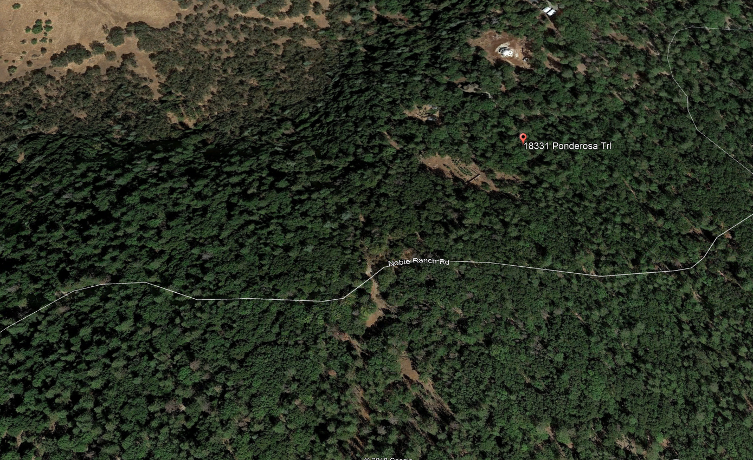  The fire risk on the site is Moderate (eastern 2/3) to High (western 1/3).  Although the surrounding area contains hilly terrain that is steep and heavily treed, the cannabis cultivation site is generally flat, and is accessible per PRC 4290 and 4291 standards. The use of this property as a commercial cannabis cultivation site will not further exacerbate the risk of injury or death due to a wildfire; the site is no more prone to excessive fire risk than most other properties in Lake County. Further, the trips generated by this use will be roughly the equivalent of a single family dwelling (around 4 to 8 average daily trips) based on the number of employees proposed.  Less than Significant Impact |  |  |  | 1, 2, 4, 5, 6, 20, 23, 31, 35, 37, 38
b) Due to slope, prevailing winds, and other factors, exacerbate wildfire risks, and thereby expose project occupants to pollutant concentrations from a wildfire or the uncontrolled spread of a wildfire? |  |  | X |  |  | The fire risk on the site is Moderate to High. The slope on the site varies from 0% to greater than 30%. Prevailing wind direction is from the north/northwest, but the prevailing wind direction in the event of a wildfire in this area would be of little consequence given the dense tree coverage and significant slopes in this area. The new cultivation area does not further exacerbate the risk of wildfire, or the overall effect of pollutant concentrations to area residents in the event of a wildfire.  Less than Significant Impact |  |  |  | 1, 2, 4, 5, 6, 20, 23, 31, 35, 37, 38
c) Require the installation or maintenance of associated infrastructure (such as roads, fuel breaks, emergency water sources, power lines or other utilities) that may exacerbate fire risk or that may result in temporary or ongoing impacts to the environment? |  |  | X |  |  | The site improvements proposed are minimal, and do not rise to the level of warranting additional roads. The site has heavy vegetation, however the responsible Fire Districts, who were notified of this action, have not indicated that additional fire breaks are necessary.  Less than Significant Impact |  |  |  | 1, 2, 4, 5, 6, 20, 23, 31, 35, 37, 38
d) Expose people or structures to significant risks, including downslope or downstream flooding or landslides, as a result of runoff, post-fire slope instability, or drainage changes? |  |  | X |  |  | There is little chance of risks associated with post-fire slope runoff, instability or drainage changes based on the lack of site changes that would occur by this project.  Less than Significant Impact |  |  |  | 1, 2, 4, 5, 6, 20, 23, 31, 35, 37, 38
- MANDATORY FINDINGS OF SIGNIFICANCE
a) Does the project have the potential to substantially degrade the quality of the environment, substantially reduce the habitat of a fish or wildlife species, cause a fish or wildlife population to drop below self-sustaining levels, threaten to eliminate a plant or animal community, substantially reduce the number or restrict the range of a rare or endangered plant or animal or eliminate important examples of the major periods of California history or prehistory? |  |  | X |  |  | The project proposes a Cultivation of Commercial cannabis in previously disturbed area. As proposed, this project is not anticipated to significantly impact habitat of fish and/or wildlife species or cultural resources with the incorporated mitigation measures described above. |  |  | All
b) Does the project have impacts that are individually limited, but cumulatively considerable? (“Cumulatively considerable” means that the incremental effects of a project are considerable when viewed in connection with the effects of past projects, the effects of other current projects, and the effects of probable future projects)? |  | X |  |  |  | Potentially significant impacts have been identified related to Aesthetics, Air Quality, and Biological Resources. These impacts in combination with the impacts of other past, present and reasonably foreseeable future projects could cumulatively contribute to significant effects on the environment. Implementation of and compliance with mitigation measures identified in each section as project conditions of approval would avoid or reduce potential impacts to less than significant levels and would not result in cumulatively considerable environmental impacts. |  |  | All
c) Does the project have environmental effects which will cause substantial adverse effects on human beings, either directly or indirectly? |  | X |  |  |  | The proposed project has potential to result in adverse indirect or direct effects on human beings. In particular, to Aesthetics, Air Quality and Biological Resources have the potential to impact human beings. Implementation of and compliance with mitigation measures identified in each section as conditions of approval would not result in substantial adverse indirect or direct effects on human beings and impacts would be considered less than significant. |  |  | All

* Impact Categories defined by CEQA

**Source List
- Lake County General Plan
- Lake County GIS Database
- Lake County Zoning Ordinance
- Lower Lake Area Plan
- Lanier Cannabis Cultivation Application – Minor Use Permit.
- U.S.G.S. Topographic Maps
- U.S.D.A. Lake County Soil Survey
- Lake County Important Farmland Map, California Department of Conservation Farmland Mapping and Monitoring Program
- Department of Transportation’s Scenic Highway Mapping Program, (http://www.dot.ca.gov/hq/LandArch/16_livability/scenic_highways/index.htm)
- Lake County Serpentine Soil Mapping
- California Natural Diversity Database (https://www.wildlife.ca.gov/Data/CNDDB)
- U.S. Fish and Wildlife Service National Wetlands Inventory
- Biological Assessment for Lanier property; prepared by Natural Investigations and dated July 27, 2018.
- Cultural Site Assessment Survey – Dr. John Parker, December 23, 2018.
- California Historical Resource Information Systems (CHRIS); Northwest Information Center, Sonoma State University; Rohnert Park, CA.
- Water Resources Division, Lake County Department of Public Works Wetlands Mapping.
- U.S.G.S. Geologic Map and Structure Sections of the Clear Lake Volcanic, Northern California, Miscellaneous Investigation Series, 1995
- Official Alquist-Priolo Earthquake Fault Zone maps for Lake County
- Landslide Hazards in the Eastern Clear Lake Area, Lake County, California, Landslide Hazard Identification Map No. 16, California Department of Conservation, Division of Mines and Geology, DMG Open –File Report 89-27, 1990
- Lake County Emergency Management Plan
- Lake County Hazardous Waste Management Plan, adopted 1989
- Lake County Airport Land Use Compatibility Plan, adopted 1992
- California Department of Forestry and Fire Protection - Fire Hazard Mapping
- National Pollution Discharge Elimination System (NPDES)
- FEMA Flood Hazard Maps
- Lake County Aggregate Resource Management Plan
- Lake County Bicycle Plan
- Lake County Transit for Bus Routes
- Lake County Environmental Health Division
- Lake County Grading Ordinance
- Lake County Natural Hazard database
- Lake County Countywide Integrated Waste Management Plan and Siting Element, 1996
- Lake County Water Resources
- Lake County Waste Management Department
- California Department of Transportation (CALTRANS)
- Lake County Air Quality Management District website
- South Lake County Fire Protection District
- Site Visit – April 10, 2019

