County Clerk
Interested Parties
COUNTY OF LAKE
NOTICE OF INTENT
TO ADOPT A MITIGATED NEGATIVE DECLARATION
Project Title: Konocti Farms / Craig Shell; Major Use Permit (UP 18-45); Initial Study (IS 18-63)
Project Location: 3300 Dessie Drive, Lakeport, CA

APN No.: 005-019-18

Project Description: The applicant is requesting approval of a major use permit for the cultivation of commercial cannabis. The applicant is requesting the following licenses:
- (1) A-Type 3 medium outdoor license
- (1) A-Type 2 small outdoor license
- (1) Type 13 Self Distribution license

The public review period for the respective proposed Mitigated Negative Declaration based on Initial Study IS 18-63 will begin on March 12, 2020 and end on April 11, 2020. You are encouraged to submit written comments regarding the proposed Mitigated Negative Declaration. You may do so by submitting written comments to the Planning Division prior to the end of the review period. Copies of the application, environmental documents, and all reference documents associated with the project are available for review through the Community Development Department, Planning Division; telephone (707) 263-2221. Written comments may be submitted to the Planning Division or via email at eric.porter@lakecountyca.gov.

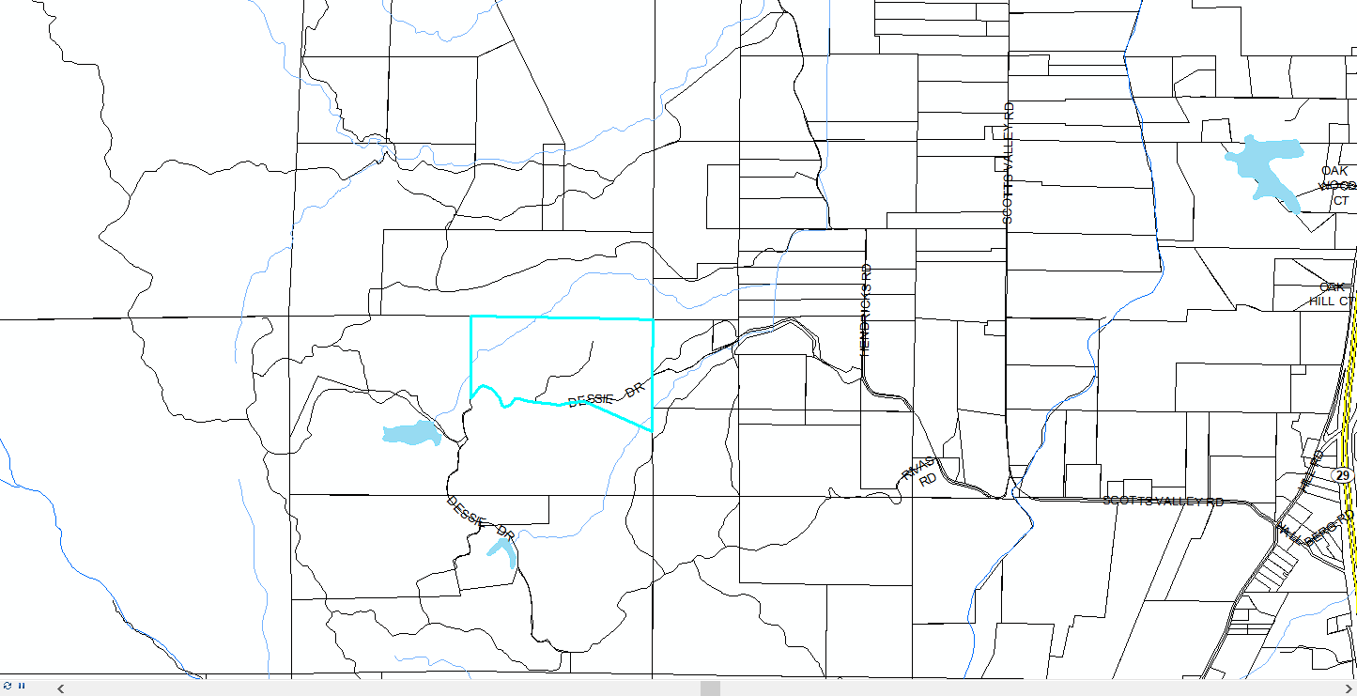
Vicinity Map of Konocti Farms Property

