NOTICE OF INTENT

Initial Study/Mitigated Negative Declaration

For

Town of Discovery Bay - Diffuser Outfall Repairs

(According to Title 14, California Code of Regulations; chapter 3. Guidelines for Implementation of the California Environmental Quality Act

Article 6. Negative Declaration Process, Sections 15070 to 15075)

Proposed Project and Location
The purpose of the proposed project is to up-grade Plant 2 of the Town of Discovery Bay’s waste water treatment plant, and specifically, the plant 2 diffuser system. This plant is located diagonally across State Highway 4 from Plant 1. State Highway 4 forms the north boundary of the site, separating it from open agricultural land. The R D-800 drainage canal forms the west and south boundary of the Plant 2 site, separating it from open agricultural land. There is open agricultural land to the east of the plant. The site is nearly flat at about 10 feet below sea level. Plant 2 consists of an oxidation ditch, secondary clarifier with lift station, pump station, ultraviolet disinfection system, modified flow splitter box, and two sludge lagoons.
This existing outfall of plant 2, constructed in May 2004, is comprised of a multi-port diffuser structure developed by Flow Science, Inc. After operating the outfall for approximately 9 years, the Town of Discovery Bay noticed a gradual performance degradation of the effluent pumping system. The pumps were not able to discharge the design flow through the outfall, and operators suspected that it was plugged with sediment. On May 15, 2013 an underwater visual inspection of the outfall was conducted, including 123 ft of High-density polyethylene (HDPE) pipe comprised of 18-in, 10-in and 6-in pipe segments. The result of the inspection revealed that, out of the 36 diffuser ports, two of them were missing and no flow (except for one port) was observed in the downstream-most 6-in segment.
Subsequent tests and inspections in 2013 and 2017 confirmed that the diffuser was damaged and/or obstructed with sediment. The proposed replacement outfall diffuser is necessary to comply with the Regional Water Quality Control Board, Region 5 – Central Valley Region (RWQCB5) Water Discharge Requirements Order No. R5-2003-0067 and National Pollutant Discharge Elimination System (NPDES) Permit No. CA0078590. The repairs and replacement sections planned for the outfall structure would restore the original dispersion functionality to comply with the RWQCB5 requirements. It would consist of the originally designed 36 ports within a constant 18-in diameter HDPE pipe segment that would release treated effluent into Old River at a non-erosive rate while effectively dispersing effluent to dilute concentrations of listed pollutant parameters (Figure 1).
The specific objectives of the proposed project are as follows:

- Restore original operational performance capability to the outfall to meet dilution requirements for copper, ammonia, nitrate/nitrite and other parameters listed in the NPDES permit issued by the RWQCB5.
- Make improvements to the outfall that would facilitate maintenance and improve the operational performance between maintenance cycles.
- Include a means for flushing sediment trapped within the outfall as it impedes hydraulic performance and reduces effluent dilution effectiveness.
- Install an onshore valve or coupling connection downstream of the existing Harris syphon breaker to enable operators to isolate the outfall pipeline from the plant.

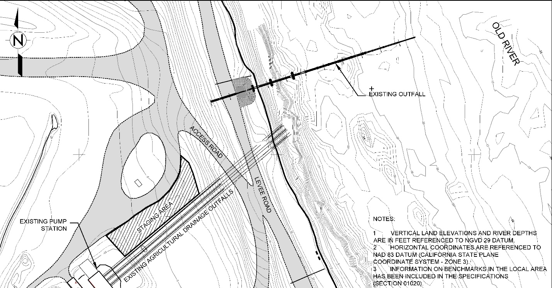

Figure 1. Schematic of Existing Outfall and Diffuser and Proposed Project
Construction work is projected to be conducted between June and August 2020 and continue for approximately 2-3 weeks. Work would occur only during daylight hours and not during weekends or on State Holidays to avoid unnecessary impact; however, weekend or holiday work could be implemented to address emergencies or unforeseen circumstances impacting construction or delays in the mobilization schedule.

- Thursday, December 19, 2019 through Wednesday, January 8, 2020 open period to receive comments
- Public Meetings have or will be scheduled for the public to review the project as follows:
  - Town of Discovery Bay Board Meeting, Notice of Intent to Adopt Mitigated Negative Declaration, Wednesday, December 18, 2019
  - Town of Discovery Bay Board Meeting, Adoption of Mitigated Negative Declaration, Date TBD
- A Draft Initial Study/Mitigated Negative Declaration (IS/MND) has been prepared for this project pursuant to the provisions of California Environmental Quality Act (CEQA). The Draft IS/MND prepared for this project demonstrates that the proposed project will not have any significant or unmitigatable effects on the environment. As a result of the adoption of this document and the implementation of the proposed mitigation measures, the proposed project will not have any significant or unmitigatable effects on the environment. The Draft IS/MND and all related analysis are available to the General Public in the following locations:

Online:

Public Location:
1601 Discovery Bay Blvd, Discovery Bay, CA 94505
Monday thru Friday, 8am to 5:30pm
Saturday, 9:30am to 5pm
Town of Discovery Bay:
1601 Discovery Bay Blvd, Discovery Bay, CA 94505
Monday thru Friday, 8:30am to 5pm
- The project is not identified on any of the lists enumerated under Section 65962.5 of Government Code as containing hazardous waste.
- Attachments included with this noticing:
  - Exhibit A – Mitigated Negative Declaration and Initial Environmental Impact Analysis

