Winship Avenue Bridge over San Anselmo Creek Replacement Project (Bridge No. 27C0074) Initial Study/Mitigated Negative Declaration

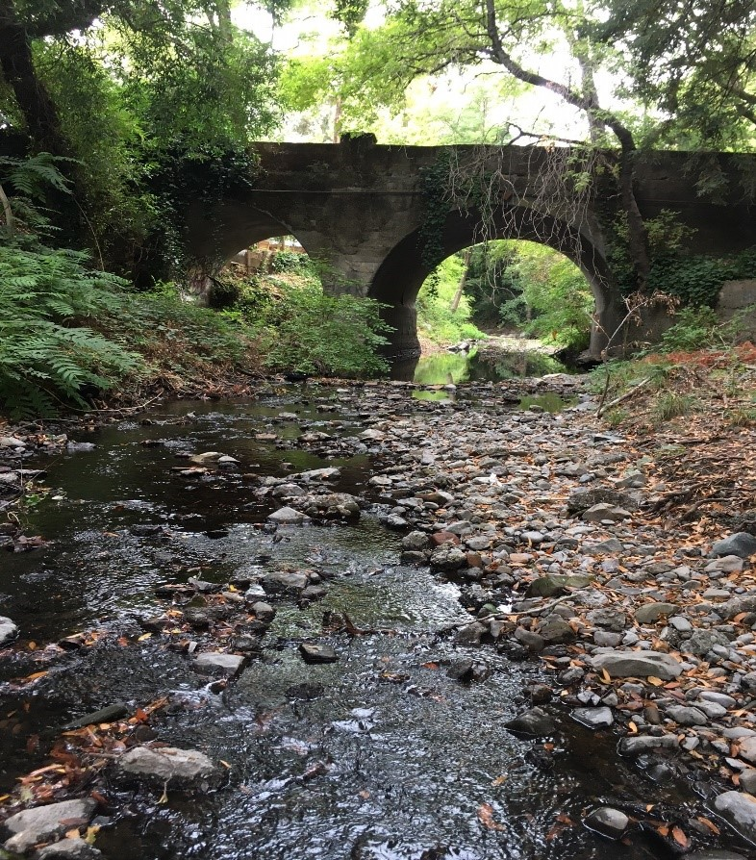
Prepared for:
Town of Ross Public Works Department
January 2020
Prepared by:
Consulting
Engineers and
Scientists
Winship Avenue Bridge over San Anselmo Creek Bridge Replacement Project (Bridge No. 27C0074) Initial Study/Proposed Mitigated Negative Declaration
Prepared for:
CEQA Lead Agency:
Town of Ross Public Works Department
P.O. Box 320
Ross, CA 94957
Contact:
Richard Simonitch
Public Works Director/Town Engineer
415.453.1453

Prepared by:
GEI Consultants, Inc.
2868 Prospect Park Drive, Suite 400
Sacramento, CA 95670
Contact:
Ray Weiss
Project Manager
916.361.4500

January 2020

This page intentionally left blank.

Table of Contents
Abbreviations and Acronyms iii
Chapter 1. Mitigated Negative Declaration 1-1
1.1 Introduction 1-1
1.2 Purpose of the Initial Study 1-1
1.3 Project Information 1-2
1.4 Environmental Determination 1-3
Chapter 2. Project Description 2-1
2.1 Introduction 2-1
2.2 Project Background 2-1
2.3 Project Objectives 2-3
2.4 Project Location and Setting 2-4
2.5 Project Description 2-6
2.6 Required Permits and Approvals 2-12
2.7 Mitigation and Best Management Practices 2-13
2.8 Oversized Figures 2-13
Chapter 3. Initial Study Checklist 3-1
3.1 Introduction 3-1
3.2 Evaluation of Environmental Impacts 3-1
3.3 Aesthetics 3-3
3.4 Agriculture and Forestry Resources 3-7
3.5 Air Quality 3-9
3.6 Biological Resources 3-14
3.7 Cultural Resources 3-47
3.8 Energy 3-53
3.9 Geology and Soils 3-55
3.10 Greenhouse Gas Emissions 3-59
3.11 Hazards and Hazardous Materials 3-62
3.12 Hydrology and Water Quality 3-66
3.13 Land Use and Planning 3-79
3.14 Mineral Resources 3-80
3.15 Noise 3-81
3.16 Population and Housing 3-89
3.17 Public Services 3-90
3.18 Recreation 3-91
3.19 Transportation 3-92
3.20 Tribal Cultural Resources 3-95
3.21 Utilities and Service Systems 3-97
3.22 Wildfire 3-99
3.23 Mandatory Findings of Significance 3-101
Chapter 4. References Cited 4-111

Tables
Table 1-1. Summary of Mitigation Measures 1-4
Table 2-1. Proposed Construction Work Order and Schedule 2-7
Table 2-2. Tree Removal Estimates Resulting from the Proposed Project 2-8
Table 2-3. Proposed Equipment and Purpose 2-12
Table 2-4. Project Related Permits and Approvals 2-13
Table 3-1. Viewer Sensitivity 3-4
Table 3-2. Land Cover Types and Approximate Acreages within The Project Site. 3-17
¹ The total acreage does not include the acreage for paved roads over waters. 3-17
Table 3-3. Land Cover Types and Impacts within The Project Site. 3-42
¹ The total acreage does not include the acreage for paved roads over waters. 3-42
Table 3-4. Previously Recorded Resources within 0.25 miles of the Project Site 3-48
Table 3-5. Native American Contact Efforts 3-49
Table 3-6. Peak Discharges at the Winship Avenue Bridge Location (in cfs) 3-74
Table 3-7. Simulated Water Surface Elevations at the Winship Avenue Bridge 3-75
Table 3-8. Short-Term (15 Minute) Ambient Noise Monitoring Results 3-82
Table 3-9. Approximate Reaction of People and Damage to Buildings from Construction Vibration Levels 3-83
Table 3-10. Vibration Thresholds 3-84
Table 3-11. Vibration Velocities for Construction Equipment 3-87

Figures
Figure 2-1. Regional Location and Project Vicinity 2-5
Figure 2-2. Proposed Project Site Plan (Including Area of Potential Effect) 2-15
Figure 2-3. Proposed Project Offsite Staging Area 2-16
Figure 2-4. Proposed Project Bridge Abutment Locations 2-17
Figure 2-5. Proposed Project Scour Countermeasure Locations 2-18
Figure 2-6. Proposed Project Traffic Detour Routes 2-19
Figure 3-1. Land Cover Types within the Project Site 3-16
Figure 3-2. Vegetation and Land Cover Type Impacts within the Project Site 3-44
Figure 3-3. Ross Valley Watershed and Project Location 3-68
Figure 3-4. Inundation Areas During the One-Percent-Annual-Chance Exceedance Flood Event in Ross Valley 3-70
Figure 3-5. Map Showing Change in Water Surface Extent and Depth Between Existing Condition and Project Completion. Flood Event: 100-Year Flood (Upper) 3-77
Figure 3-6. Map Showing Change in Water Surface Extent and Depth Between Existing Condition and Project Completion. Flood Event: 100-Year Flood (Lower) 3-78
Figure 3-7. Ross Valley Flood Protection and Watershed Program 3-105
Figure 3-8. Location of Most Likely Future-Foreseeable Projects 3-106
Figure 3-9. Map Showing Change in Water Surface Extent and Depth Between Existing Condition and Project Completion. Flood Event: 100-Year Flood (Upper) 3-108
Figure 3-10. Map Showing Change in Water Surface Extent and Depth Between Existing Condition and Project Completion. Flood Event: 100-Year Flood (Upper) 3-109

Abbreviations and Acronyms
AASHTO | American Association of State Highway and Transportation Officials
AB | Assembly Bill
ADA | Americans With Disabilities Act
ADT | Average Daily Traffic
APE | Area of Potential Effect
ASR | Archaeological Survey Report
BAAQMD | Bay Area Air Quality Management District
BCC | Bird of Conservation Concern
BMPs | Best Management Practices
BSA | Biological Study Area
Caltrans | California Department of Transportation
CAAQS | California Ambient Air Quality Standards
CARB | California Air Resources Board
CCR | California Code of Regulations
CDFW | California Department of Fish and Wildlife
CDO | Cease and Desist Order
CEQA | California Environmental Quality Act
CESA | California Endangered Species Act
CFGC | California Fish and Game Code
Cfs | Cubic feet per second
CGS | California Geological Survey
CH4 | Methane
CNDDB | California Natural Diversity Database
CNEL | community noise equivalent level
CNPS | California Native Plant Society
CO2 | carbon dioxide
CRHR | California Register of Historical Resources
CRPR | California Rare Plant Rank
dB | decibel
dBA | A-weighted sound level
DBH | diameter at breast height
DPM | Diesel Particulate Matter
EFH | Essential Fish Habitat
EIR | Environmental Impact Report
EPA | U.S. Environmental Protection Agency
ESU | Evolutionarily Significant Unit
FCMCW | Friends of Corte Madera Creek Watershed
FE | Federally Endangered
FEMA | Federal Emergency Management Agency
FESA | Federal Endangered Species Act
FHWA | Federal Highway Administration
FSTIP | Federal State Transportation Improvement Program
FTA | Federal Transit Administration
GHGs | Greenhouse gases
HAPC | Habitat Areas of Particular Concern
HBP | Highway Bridge Program
HPSR | Historic Property Survey Report
HUC | Hydrologic Unit Code
ILE | Institute of Lighting Engineers
IS/MND | Initial Study/proposed Mitigated Negative Declaration
IPAC | Information, Planning, and Conservation System
Ldn | day/night sound level
LOS | level of service
MBTA | Migratory Bird Treaty Act
MLD | Most Likely Descendant
MMWD | Marin Municipal Water District
NMFS | National Marine Fisheries Service
MUTCD | Manual of Traffic Control Devices
N2O | nitrogen dioxide
NAAQS | National Ambient Air Quality Standards
NAHC | Native American Heritage Commission
NEPA | National Environment Policy Act
NO_{X} | nitrogen oxides
NWIC | Northwest Information Center
NRHP | National Register of Historic Places
OEHHA | Office of Environmental Health Hazard Assessment
OHWM | Ordinary High Water Mark
PCE | Primary Constituent Elements
PFMC | Pacific Fishery Management Council
PM₁₀ | PM equal to or less than 10 micrometers in diameter
PM_{2.5} | PM equal to or less than 2.5 micrometers in diameter
PPV | Peak Particle Velocity
ROG | reactive organic gases
RSP | Rock Slope Protection
RVSD | Ross Valley Sanitary District
RWQCB | Regional Water Quality Control Board
SE | State Endangered
SHECAP | Sanitary Sewer Hydraulic Evaluation and Capacity Assurance Plan
SSC | Species of Special Concern
SWPPP | Stormwater Pollution Prevention Plan
TAC | Toxic Air Contaminants
USACE | U.S. Army Corps of Engineers
USFWS | U.S. Fish and Wildlife Service
USGS | U.S. Geologic Survey
WPCP | Water Pollution Control Program

This page intentionally left blank.

Mitigated Negative Declaration

Introduction
The Town of Ross Public Works Department (Town) has prepared this Initial Study/proposed Mitigated Negative Declaration (IS/MND) in compliance with the California Environmental Quality Act (CEQA) and the State CEQA Guidelines to address the potentially significant environmental impacts of the proposed Winship Avenue over San Anselmo Creek Bridge Replacement Project (Bridge No. 27C0074) (proposed project) located on Winship Avenue, just east of Sir Francis Drake Boulevard in the Town of Ross, California. The Town is the lead agency under CEQA.
To satisfy specific CEQA requirements for the proposed project, this document includes:
a proposed MND and the environmental determination (see Chapter 1),
location and description of the proposed project (see Chapter 2),
initial study checklist (see Chapter 3).

Purpose of the Initial Study
This document is an IS/MND prepared in accordance with CEQA (California Public Resources Code, Section 21000 et seq.) and the State CEQA Guidelines (Title 14, Section 15000 et seq. of the California Code of Regulations [CCR]). The purpose of this IS is to (1) determine whether proposed project implementation would result in potentially significant or significant impacts on the physical environment; and (2) incorporate mitigation measures into the proposed project design, as necessary, to eliminate the proposed project’s potentially significant or significant project impacts or reduce them to a less-than-significant level. An MND is prepared if the IS identified potentially significant impacts, but: (1) revisions in the proposed project plans or proposals mitigate the impacts to a point where clearly no significant impacts would occur; and (2) there is no substantial evidence, considering the whole record before the agency, that the proposed project as revised may have a potentially significant or significant impact on the physical environment.
An IS presents environmental analysis and substantial evidence in support of its conclusions regarding the significance of environmental impacts. Substantial evidence may include expert opinion based on facts, technical studies, or reasonable assumptions based on facts. An IS is neither intended nor required to include the level of detail provided in an environmental impact report (EIR).
CEQA requires that all State and local government agencies consider the potentially significant and significant environmental impacts of projects they propose to carry out or over which they have discretionary authority, before implementing or approving those projects. The public agency that has the principal responsibility for carrying out or approving a proposed project is the lead agency for CEQA compliance (State CEQA Guidelines, CCR Section 15367). The Town has principal responsibility for carrying out the proposed project and is therefore the CEQA lead agency for this IS/MND.
If there is substantial evidence (such as the findings of an IS) that a proposed project, either individually or cumulatively, may have a significant or potentially significant impact on the physical environment, the lead agency must prepare an EIR (State CEQA Guidelines, CCR Section 15064[a]). If the IS concludes that impacts would be less than significant, or that mitigation measures committed to by the Town would clearly reduce impacts to a less-than-significant level, a Negative Declaration or MND can be prepared.
After the required public review of this document is complete, the Town will consider all comments received on the IS/MND, the entirety of the administrative record for the project, and whether to adopt the proposed MND and a Mitigation Monitoring and Reporting Program and approve the proposed project.

Project Information
1. Project title: | Winship Avenue Bridge over San Anselmo Creek Bridge Replacement Project (Bridge No. 27C0074)
2. Lead agency name and address: | Town of Ross Public Works Department  P.O. Box 320  Ross, CA 94957
3. Contact person and phone number: | Richard Simonitch, Public Works Director/Town Engineer  415.453.1453
4. Project location: | The project site is in an urban residential area  along San Anselmo Creek on Winship Avenue, directly east of Sir Francis Drake Boulevard in the Town of  Ross, Marin County. Per the United States Geological Survey, the site is in the San Rafael (1995) 7.5-minute United States Geological Survey (USGS) quadrangle, township 2 north, range 6 west, section 31, latitude 37.9693N, longitude -122.5599W
5. Project sponsor's name and address: | Town of Ross Public Works Department
6. General plan designation: | Medium Low Density (Area C – Traditional Neighborhood)
7. Zoning: | Single Family Residential (R-1_B-10)
8. Description of project:  (Describe the whole action involved, including but not limited to later phases of the project, and any secondary, support, or off-site features necessary for its implementation. Attach additional sheets if necessary.) | The Town of Ross Public Works Department (Town) proposes to replace the existing Winship Avenue Bridge (No. 27C0074) over San Anselmo Creek, which is required to ensure current safety and design standards for bridges and roadways are maintained. As part of the project, the Ross Valley Sanitary District (RVSD will relocate and update the existing 6-inch gravity sewer line that is currently within the existing bridge deck. The primary objective of the sewer line upgrade is to relieve hydraulic and structural deficiencies with aging RVSD infrastructure within the town of Ross.  Replacement of the existing bridge structure would occur with a single span, cast-in-place or precast concrete slab type bridge with a curb-to-curb width of 20 feet and a 4.5-foot-wide walkway on the north side. The roadway profile would be raised up to 4 feet to meet flood control requirements. The new single-span bridge would be supported on concrete abutments placed in the streambed. The existing sewer line will be updated with a larger 24-inch diameter steel case pipeline (containing two 6-inch siphons) consistent with current wastewater collection standards demonstrating how the use of multiple pipes for inverted siphons provide needed system redundancy that reduces the risk of sewer overflow in the event of pipeline clogs.
9. Surrounding land uses and setting: Briefly describe the project's surroundings: | The project setting is single family residential, with nearby land uses, including San Anselmo Creek, a residential neighborhood, several small businesses, and parking for downtown San Anselmo, which is located further to the north of the project site.
10. Other public agencies whose approval is required (e.g., permits, financing approval, or participation agreement.) | California Department of Fish and Wildlife, San Francisco Bay Regional Water Quality Control Board, State Water Resources Control Board, the United States Fish and Wildlife Service, and U.S. Army Corps of Engineers.
11. Have California Native American tribes traditionally and culturally affiliated with the project area requested consultation pursuant to Public Resources Code (PRC) Section 21080.3.1? If so, is there a plan for consultation that includes, for example, the determination of significance of impacts to tribal cultural resources, procedures regarding confidentiality, etc.?  Note: Conducting consultation early in the CEQA process allows tribal governments, lead agencies, and project proponents to discuss the level of environmental review, identify and address potential adverse impacts to tribal cultural resources, and reduce the potential for delay and conflict in the environmental review process. (See PRC Section 21080.3.2.) Information may also be available from the California Native American Heritage Commission’s Sacred Lands File per PRC Section 5097.96 and the California Historical Resources Information System administered by the California Office of Historic Preservation. Please also note that PRC Section 21082.3(c) contains provisions specific to confidentiality. | The Town has sent letters requesting AB 52 consultation to the following federally recognized tribes and California tribes.  Buffy McQuillen  Federated Indians of Graton Rancheria  A request to consult with the Town was received on October 24, 2019, with technical documentation sent on November 19, 2019. A follow-up phone call was completed by the Town on December 19, 2019.  Additionally, The California Department of Transportation has sent letters to the following two (2) federally recognized tribes, as part of the Section 106 compliance process for the proposed project.  Gene Bevelot  Federated Indians of Graton Rancheria  Greg Sarris  Federated Indians of Graton Rancheria

Environmental Determination

Summary
The Town has prepared an IS to assess the potential effects of the proposed project on the environment in the project area. The analysis of potential environmental impacts from the proposed project is based on data gathered for this project and other projects within the project vicinity. Chapter 3 of this document contains the analysis and discussion of potential environmental impacts of the proposed project. Based on the issues evaluated in that chapter, it was determined that:
The proposed project would result in no impacts on the following issue areas:
- Agriculture and Forestry Resources
- Energy
- Land Use and Planning
- Mineral Resources
- Population and Housing
- Recreation
- Public Services/Utilities and Service Systems
The proposed project would result in less-than-significant impacts on the following issue areas:
Aesthetics
Geology and Soils
Greenhouse Gas Emissions
The proposed project would result in less-than-significant impacts after mitigation implementation on the following issue areas:
Air Quality  Biological Resources  Cultural Resources  Hazards/Hazardous Materials and Wildfire | Hydrology and Water Quality  Noise  Transportation  Tribal Cultural Resources

Mitigation Measures
Mitigation measures have been identified to reduce all potentially significant impacts of the proposed project. Implementation of identified mitigation measures would avoid or reduce all the proposed project’s potentially significant impacts to a less than significant level. The mitigation measures are summarized below in Table 1-1 by initial study topic.
Table 1-1. Summary of Mitigation Measures
Initial Study Topic | Mitigation Measure
Air Quality | Mitigation Measure AIR-1: BAAQMD Basic Construction Measures  Mitigation Measure AIR-2: Diesel Exhaust Emissions Reduction Measures
Biological Resources | Mitigation Measure BIO-1: Conduct Species Preconstruction Surveys  Mitigation Measure BIO-2: Conduct Environmental Awareness Training  Mitigation Measure BIO-3: Implement Water Quality Best Management Practices  Mitigation Measure BIO-4: Biological Monitor and On-Site Monitoring  Mitigation Measure BIO-5: Limited Project Duration, Disturbance, and Footprint  Mitigation Measure BIO-6: Implement a Fish Rescue Plan  Mitigation Measure BIO-7: Water Diversion and Dewatering  Mitigation Measure BIO-8: Steelhead Critical Habitat and EFH Protection  Mitigation Measure BIO-9: Implement Tree Protection Measures  Mitigation Measure BIO-10: Implement Creek Bed and Bank Protection Measures  Mitigation Measure BIO-11: Return Temporarily Disturbed Areas to Pre-Project Conditions  Mitigation Measure BIO-12: Nesting Bird Protection  Mitigation Measure BIO-13: Roosting Bat Protection
Cultural Resources | Mitigation Measure CUL-1: Native American Coordination  Mitigation Measure CUL-2: Discovery of Cultural Resources during Ground-Disturbing Activities  Mitigation Measure CUL-3: Accidental Finding of Human Remains
Hazards & Hazardous Materials | Mitigation Measure HAZ-1: Implement BMPs for Wildland Fire Prevention
Hydrology & Water Quality | Mitigation Measure BIO-3: Implement Water Quality Best Management Practices  Mitigation Measure BIO-7: Water Diversion and Dewatering
Noise | Mitigation Measure N-1: Construction Noise Reducing Best Management Practices  Mitigation Measure N-2: Construction Vibration Reducing Best Management Practices
Transportation | Mitigation Measure TC-1: Prepare and Implement a Traffic Detour and Control Plan
Tribal Cultural Resources | Mitigation Measure CUL-1: Native American Coordination  Mitigation Measure CUL-2: Discovery of Cultural Resources during Ground-Disturbing Activities  Mitigation Measure CUL-3: Accidental Finding of Human Remains
Wildfire | Mitigation Measure HAZ-1: Implement BMPs for Wildland Fire Prevention

Determination (To be completed by the Lead Agency)
On the basis of this initial evaluation:
☐ |  | I find that the proposed project COULD NOT have a significant effect on the environment, and a NEGATIVE DECLARATION will be prepared.
☒ |  | I find that although the proposed project could have a significant effect on the environment, there will not be a significant effect in this case because revisions in the project have been made by or agreed to by the project proponent. A MITIGATED NEGATIVE DECLARATION will be prepared.
☐ |  | I find that the proposed project MAY have a significant effect on the environment, and an ENVIRONMENTAL IMPACT REPORT is required.
☐ |  | I find that the proposed project MAY have a "potentially significant impact" or "potentially significant unless mitigated" impact on the environment, but at least one effect 1) has been adequately analyzed in an earlier document pursuant to applicable legal standards, and 2) has been addressed by mitigation measures based on the earlier analysis as described on attached sheets. An ENVIRONMENTAL IMPACT REPORT is required, but it must analyze only the effects that remain to be addressed.
☐ |  | I find that although the proposed project could have a significant effect on the environment, because all potentially significant effects (a) have been analyzed adequately in an earlier EIR or NEGATIVE DECLARATION pursuant to applicable standards, and (b) have been avoided or mitigated pursuant to that earlier EIR or NEGATIVE DECLARATION, including revisions or mitigation measures that are imposed upon the proposed project, nothing further is required.
 | 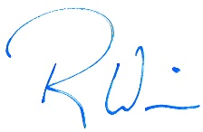  For Richard Simonitch |  |  | January 2, 2020
 | Signature |  |  | Date
 | Richard Simonitch |  |  | Public Works Director/Town Engineer
 | Print Name |  |  | Title
 | Town of Ross
 | Agency

Project Description

Introduction
The Town of Ross (Town) proposes to replace the existing Winship Avenue Bridge (Bridge No. 27C0074) over San Anselmo Creek (proposed project), considered by the California Department of Transportation (Caltrans) to be well beyond its original design service of 50 years (classified Functionally Obsolete), with a replacement structure that is consistent with current roadway and sidewalk design standards and would improve the hydrologic capacity of the creek at the bridge location.
As a related project, the Ross Valley Sanitary District (RVSD) also proposes to relocate and update the existing 6-inch gravity sewer line, currently within the existing Winship Avenue Bridge deck, which is necessary to relieve hydraulic and structural deficiencies associated with aging RVSD infrastructure within the Town. Coordination of the design and construction phases of these related projects will ensure environmental impacts are minimized within the study area.
To assess the environmental impacts of these related projects, this chapter includes design details and the expected construction process (e.g., equipment types, timing, etc.) for both the bridge and sewer line replacement projects. Background information, along with a general site description, and a list of related regulatory permits and approvals required for the projects are also provided below.

Project Background
For the purposes of the analysis provided in this Initial Study/Mitigated Negative Declaration, the term “proposed project” includes both the bridge replacement and the sewer line components.

Bridge Replacement Component
The primary purpose of the project is to meet current design and safety standards for bridges and roads while improving creek hydraulics and minimizing impacts to San Anselmo Creek and the surrounding residential properties.
The term “Functionally Obsolete” is a federal designation that means a bridge isn't up to current building standards. Often this means the lanes are too narrow or there is no shoulder on the side of the bridge for stalled cars. Less frequently it means there could be structural problems serious enough to warrant a "high priority of corrective action." The Federal Highway Administration uses a scoring system to determine whether to label a bridge "functionally obsolete."

Periodic inspections by Caltrans have classified the existing Winship Avenue Bridge (built in 1925) as Functionally Obsolete, with a low Sufficiency Rating of 54.6, due to having a narrow travel way of 18.25-feet curb to curb. Consequently, to address this design consideration and hydraulic deficiencies (see below) associated with the existing structure, a bridge replacement option is currently under consideration for the project. While rehabilitation of the bridge was considered by the Town Council during the earlier planning phase of the project, design plans for the original bridge structure were (and continue to be) unavailable for review, making an understanding of important design features (i.e., foundation capacity) for the existing structure impossible to determine without considering excavation or destructive materials testing of significant portions of the existing bridge, the extent of which could affect the existing structures continued use or its ability to be rehabilitated.
The existing 94-year old bridge is considered well beyond its original design service of 50 years and does not align well with the natural creek channel in its current position. Additionally, the existing bridge’s small hydraulic opening is a contributor to flooding concerns in the Town as flood flows have overtopped the bridge deck in the past. Accordingly, the current Marin County Flood Control Zone 9 hydraulic studies show the bridge being overtopped by the design 100-year event as it does not provide an adequate waterway opening, with the existing center pier wall and the tight waterway openings constricting high-stage flood flows. The proposed project will replace the existing bridge with a hydraulically sufficient bridge (identified as San Anselmo Creek Improvement Measure #005 under the County’s Capital Improvement Plan Study, 2011) that supports the flood control and channel improvements being pursued by the Town and the Marin County Flood Control District.
The proposed project is being implemented by Caltrans and the Town as part of the Highway Bridge Program (HBP) within the Federal State Transportation Improvement Program (FSTIP). Briefly, the purpose of the HBP is to replace or rehabilitate publicly owned bridges that the State and Federal Highway Administration have deemed significantly important but unsafe, due to structural deficiencies, physical deterioration, or functional obsolescence. Federal funding is available to local agencies annually, which HBP utilizes to provide reimbursement for eligible projects. For the purposes of compliance with the National Environment Policy Act (NEPA), Caltrans is identified as the “Lead Agency”, with the Town of Ross identified as the “Lead Agency” for compliance with the California Environmental Quality Act (CEQA).

Sewer Line Component
The primary purpose of the sewer line component is to address hydraulic and structural deficiencies from aging RVSD infrastructure within the Town by providing local sewer line upgrades consistent with current industry standards and practices that also ensure system redundancy in the event of a pipeline clog or failure.
The RVSD was established in 1899, with district offices located approximately 15 miles north of San Francisco and directly south of the City of San Rafael. The RVSD serves the wastewater collection needs of approximately 56,000 customers in Fairfax, San Anselmo, Ross, Larkspur, Bon Air, Sleepy Hollow, Kentfield, Kent Woodlands, Oak Manor, Greenbrae, and Murray Park.
Between 2008 and 2013, the RVSD experienced an increase in the number and severity of sewer overflows. On May 13, 2013, the San Francisco Bay Regional Water Quality Control Board (RWQCB) issued a cease and desist order (CDO) No. R2-2013-0020 in response to instances where sewer system overflows reached waters of the state. The CDO required the RVSD to develop and implement an Infrastructure Assess Management Plan (IAMP), which identifies projects to rehabilitate and replace RVSD deficient wastewater facilities through the year 2020. The RVSD’s Sanitary Sewer Hydraulic Evaluation and Capacity Assurance Plan (SHECAP) recommended replacing 190 feet of 6-inch sewer line across the Winship Avenue Bridge with an 8-inch line. The proposed design will replace the single 6-inch line with dual 6-inch lines, or alternatively, 8-inch and 6-inch lines within a slightly larger casing. This design provides both increased capacity and redundancy. The primary purpose of this replacement is to prevent overflows. The increased capacity of the line will address these overflows but is not considered growth-inducing as additional capacity (beyond the current project) would be necessary to support both growth and address overflows.
The existing sewer line is built within the bridge superstructure of the existing Winship Avenue Bridge and will need to be relocated as part of the larger bridge project. Six (6) different pipeline relocation options (including gravity, pump station/force main, open cut trench, and jack and bore alternatives) using evaluation criteria that addressed construction, maintenance, environmental, easement acquisition, and cost factors. Results of the evaluation determined that maintaining the existing pipeline profile underneath the replacement bridge (gravity option) would not be feasible due the pipeline’s profile below the 100-year storm elevation. The depth of the proposed bridge abutments (roughly 35 feet) would also limit the selection of an alignment below the bridge (horizontal direction drill option). The open cut trench option was also deemed infeasible due to the removal of several large trees and the extensive creek restoration activities resulting from implementation of this construction option across San Anselmo Creek. Consequently, in consideration of these design constraints and the desire to minimize environmental impacts to San Anselmo Creek, the RVSD is proposing a jack and bore construction option under the channel just upstream of the new bridge.
For the purposes of the analysis provided in this Initial Study/Mitigated Negative Declaration (IS/MND), the term “proposed project” includes both the bridge replacement and sewer line relocation components.

Project Objectives
Specific objectives of the bridge component are to replace the existing Winship Avenue Bridge with a new structure that:
- Meets current design standards for roadway and sidewalk width, compliance with the Americans With Disabilities Act (ADA), and stability;
- Provides a larger hydraulic opening for passage of water in San Anselmo Creek at Winship Avenue to improve drainage in the Town;
- Shifts the bridge opening eastward to better align with the channel's historic alignment;
- Incorporates architecture consistent with the existing bridge and the surrounding neighborhood; and
- Minimizes environmental impacts to local resources.
Specific objectives of the sewer line component include:
- Provides for necessary system reliability and operational flexibility by ensuring an adequate sanitary sewer line that meets peak demands;
- Minimize neighborhood service disruptions by coordinating the design, permitting, and construction schedules with the schedules for the bridge replacement project; and
- Develop a project with minimal environmental impacts to San Anselmo Creek, key local resources, and the surrounding community.

Project Location and Setting
The project site is located on Winship Avenue, just east of Sir Francis Drake Boulevard in the Town of Ross, California (Figure 2-1). Elevations on site range between approximately 25 and 50 feet above mean sea level in an area with gentle slopes. Natural features include San Anselmo Creek (and its associated riparian corridor), which the proposed project crosses (see Photo 1). The creek banks are generally steep and deeply cut below the floodplain, with a riparian area comprised of both native and non-native vegetation. To prevent erosion, the creek has been semi-channelized in many locations where the banks have been reinforced with rock slope protection (RSP), concrete, and retaining walls.

Surrounding Land Uses
Land uses surrounding the project site are comprised of single-family residential uses to the north, east, and south of the site. Sir Francis Drake Boulevard (see Photo 2) is located to the west along with several small businesses, and parking for downtown San Anselmo, further to the north of the project site.

Land Use Designations and Zoning
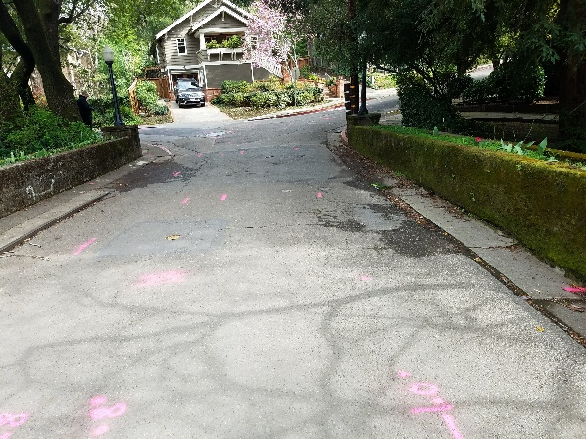
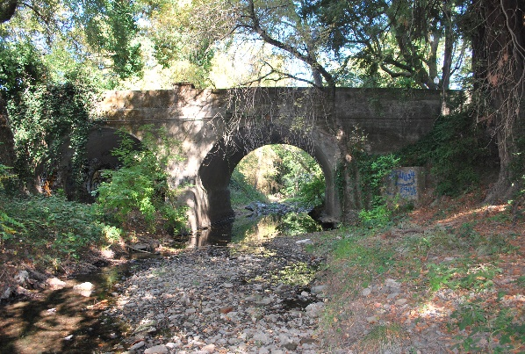
The project site is designated as Medium Low Density (Area C – Traditional Neighborhood) under the existing Town of Ross General Plan and zoned as Single Family Residential (R-1_B-10). Per the Town’s Zoning Code, R-1 is defined as single family residence district and B is defined as special building site district. No lands in the study area are designated or zoned for Agriculture Preserve, Timber Lands, or are associated with an executed Williamson Act contract.
Photo 2: View of Existing Bridge Deck and Residential Land Uses
Photo 1: View of Existing Bridge Profile and Creek Banks
Figure 2-1. Regional Location and Project Vicinity
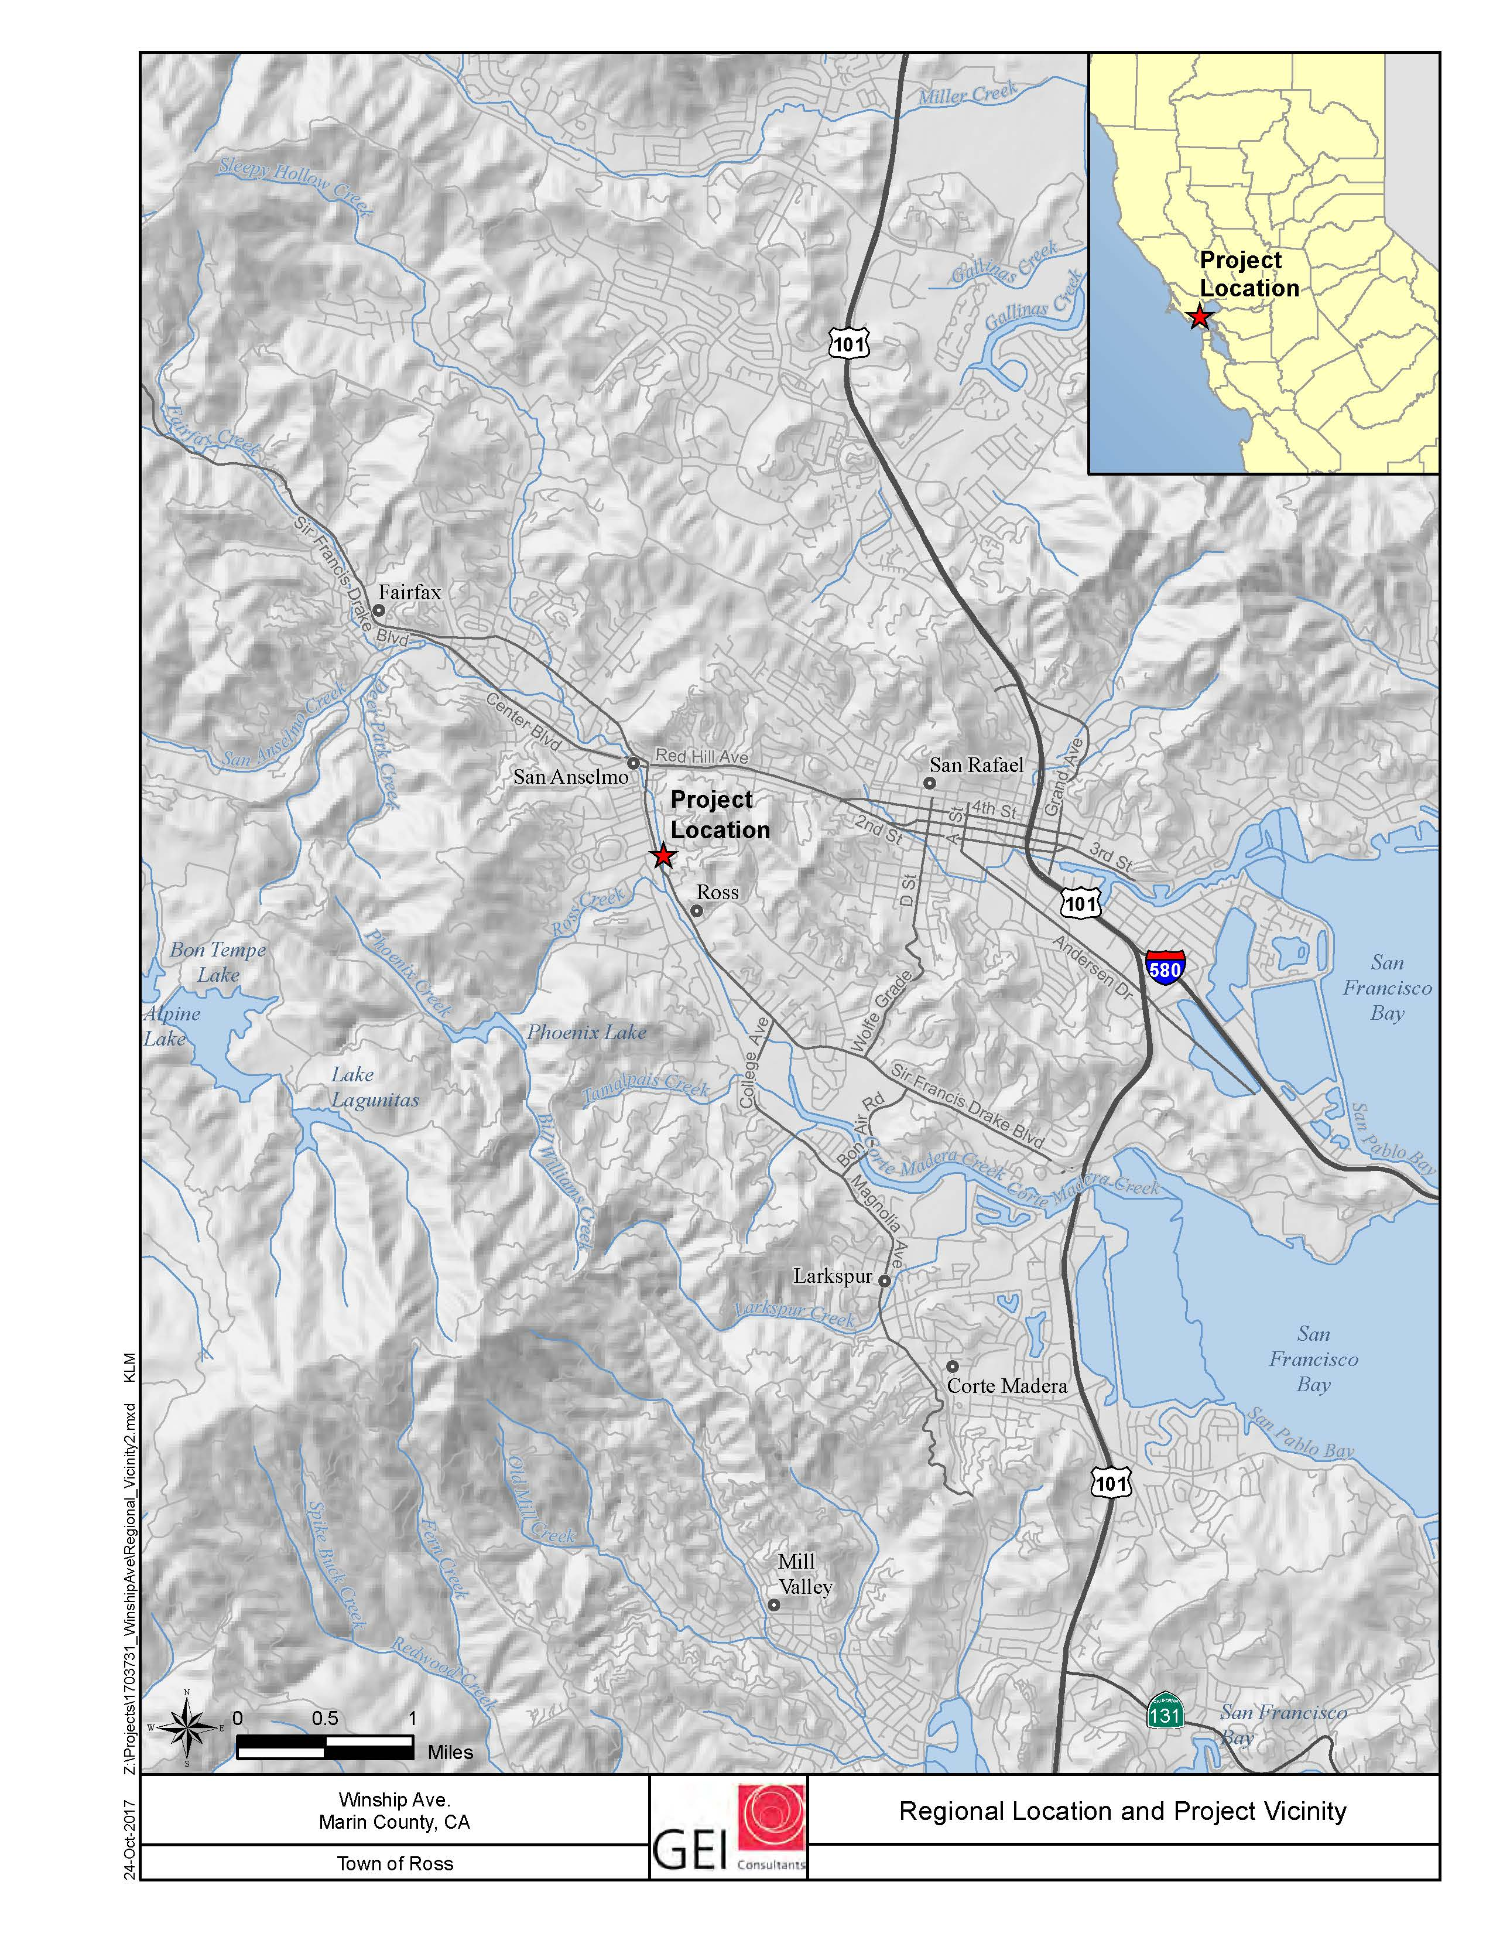

Project Description
The proposed project would replace the existing bridge with a new bridge in essentially the same location, but with a slightly modified alignment that shifts the bridge opening eastward to better align with the creek channel’s historic alignment. This section begins with a description of the existing bridge structure, the proposed replacement structure and the construction process. The design details for the sewer line component are more fully described below in Section 2.5.2 “Construction Process”. Figures 2-2 through 2-6, referenced in this chapter, are oversized to show details of the construction process and are all located below in Section 2.8 “Oversized Figures”.
The site encompasses approximately 0.90 acre, with the construction footprint including the existing bridge, the San Anselmo Creek bed directly under the bridge deck (extending approximately 50 linear feet north and 75 linear feet south of the bridge deck), and areas adjacent to the existing bridge abutments (see Figure 2-2 in Section 2.8, below). While some limited construction staging would occur on site, the Town of Ross Maintenance Yard (located ½ mile from the project site at 35 Sir Francis Drake Boulevard) would be primarily used for construction staging and parking (see Figure 2-3 in Section 2.8, below). This close by staging location will reduce the intensity of on-site construction-related effects (i.e., visual, noise, and dust).

Description of Existing Bridge
The existing bridge is a cast-in-place, reinforced concrete, earth-filled double-arch structure (supported by a wide center pier wall in the creek and two abutments near the creek banks) built in 1925. It is approximately 45 feet long measured at the abutment walls but has retaining walls and railings that extend beyond each end of the bridge for a total length of approximately 90 feet. Several unique design features of the existing bridge include the reinforced concrete planters incorporated into the bridge railings (see Photo 3) and four metal light standards at the bridge corners, which carry the Westinghouse logo (see Photo 4).
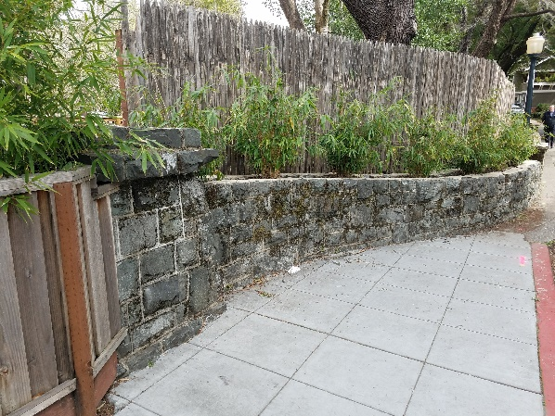
The bridge is a little over 26 feet wide, carrying two narrow (9 foot) lanes of traffic nearly 20 feet above the creek bed. As previously mentioned, the existing bridge is considered functionally obsolete due to a narrow travel way of 18.25-feet curb to curb. Additionally, the existing 2.75-foot north side walkway is not wide enough and thus does not meet ADA standards.
Photo 3: View of Concrete Planter along Bridge Railing
Photo 4: View of Existing Light Standard (Northeast Corner)
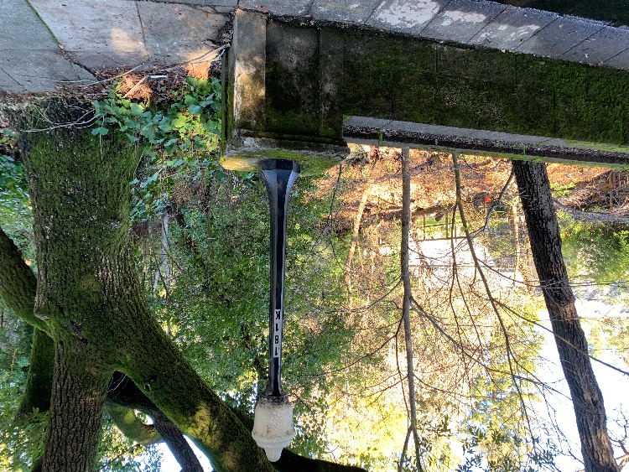

Construction Process
The primary activities and time periods that will comprise the construction process for the proposed project are summarized below in Table 2-1. The following section provides additional details regarding these activities.
Table 2-1. Proposed Construction Work Order and Schedule
Activity | Estimated Dates
Preconstruction Surveys & Environmental Awareness Training | March – May
Install Sewer Line Component | May
Initial Site Construction Activities  Clearing Project Site and Installing Environmental Fencing  Install Water Diversion (if necessary)  Install Erosion Control Measures | May – June
Remove Existing Bridge Structure | June
Construction of the New Bridge  Footing construction at abutments  Abutment construction  Place cast-in-place or precast concrete slab type bridge  Finish bridge deck and complete barriers  Install Erosion / Scour Countermeasures  Reconstruct Roadway Approaches  Restore Project Site | July to October

Preconstruction Surveys and Environmental Awareness Training
Onsite preconstruction activities would be focused on completing the regulatory agency (see Section 2.6 “Required Permits and Approvals” below) permitting conditions and implementation of the proposed project’s mitigation monitoring and reporting plan. Key activities would focus on completion of the following:
- Nesting bird/raptor surveys (Mitigation Measure BIO-1).
- Preconstruction species surveys (Mitigation Measure BIO-1).
- Construction worker environmental awareness training (Mitigation Measure BIO-2).

Install Sewer Line Component
To accommodate the sanitary sewer line component, the RVSD plans to relocate the line just north (upstream) of the proposed replacement bridge and below the scour depth of the creek bed using a trenchless construction method (jack and bore). The existing 6-inch line, within the bridge deck, will be replaced with a dual 6-inch sewer siphon on a 24-inch diameter steel case pipeline. Replacing a single gravity line with a dual siphon lines is consistent with current wastewater collection standards demonstrating how the use of multiple pipes for inverted siphons provide needed system redundancy that reduces the risk of sewer overflow in the event of pipeline clogs. Implementation of this trenchless construction method (i.e., jack and bore) will include both an insertion pit (roughly 10 feet wide by 30 feet long) and a receiving pit (roughly 10 feet wide by 10 feet long) to be excavated at each end of a pipe segment. As shown in Figure 2-2, the pit locations are within the existing roadway of Winship Avenue, well outside the San Anselmo Creek bed and bank area. Both the insertion and the receiving pit will require short-term dewatering of shallow groundwater resulting from soil removal and filling activities. The disposal of collected groundwater will be discharged to the existing sanitary sewer system or the storm drain system. Pretreatment of collected groundwater and compliance with any permitting requirements of RVSD, the RWQCB, and the Town of Ross will also be required. No dewatering of the creek will be necessary, as the depth of the new pipeline will be approximately 10 feet below the San Anselmo Creek bed.

Initial Site Construction Activities
Prior to removal of the existing bridge structure, the initial stages of construction would include site clearing and vegetation removal, the installation of environmental fencing around sensitive trees and habitats, and implementation of a water diversion system, if necessary due to creek flow conditions. Additional details are provided below.

Site Clearing, Vegetation Removal, and Tree Preservation Measures
Portions of the project site within the San Anselmo Creek area would require site clearing and vegetation removal. Tree removal, as shown in Table 2-2, would be required to allow equipment to access the project site and within the construction footprint of the new bridge. Construction of the new bridge abutments will result in temporary impacts to the seven existing Coast redwood trees located on APN# 072-161-02 (southeast corner of bridge) These Coast redwood trees meet the definition of a “protected tree” under the Town’s tree ordinance, with diameter at breast height (DBH) ranging from 11.1 inches to over 40 inches. To address these tree and vegetation impacts, several tree preservation measures (see Mitigation Measure BIO-9) will be incorporated into the design plans and implemented (including monitoring by a licensed arborist during portions of the construction process, arborist root pruning, potential cabling, and trunk armoring) to minimize tree removal in the project area. The construction contractor will also be responsible for the installation of environmental fencing, monitoring, and the protection of on-site sensitive habitats to the extent feasible as more fully described in mitigation measures (see Mitigation Measures BIO-4, BIO-5, BIO-8, and BIO-10).
Table 2-2. Tree Removal Estimates Resulting from the Proposed Project
Location | Species | Number | Approximate DBH
Upstream Right Bank | Oregon Ash  Black Locust | 2  1 | 6 & 20 inches  22 inches
Downstream Right Bank | Oregon Ash  Red Willow  Tree of Heaven | 1  1  1 | 2 inches  29 inches  2 inches
Upstream Left Bank | Oregon Ash  White Alder  California bay | 2  2  4 | 2 & 4 inches  7 & 26 inches  18, 25, 34 & 34 inches
Downstream Right Bank | Box Elder | 1 | 10 inches
Source: Natural Environment Study for Winship Avenue Bridge Replacement Project (Garcia and Associates, 2019a)

Proposed Dewatering Methods
Since work would occur during the low flow season, only localized dewatering is anticipated at the abutment locations to control groundwater during abutment construction. If water is flowing in the creek, water will be channelized through a cofferdam system at each abutment location. A temporary water diversion system (including a creek pipe diversion system) may be required to isolate the work area from flowing water. The temporary water diversion system will likely consist of a series of large diameter plastic pipes that would extend upstream and downstream of the proposed excavation areas, but within the construction area shown in Figure 2-2. Temporary berms consisting of clean crushed rock or gravel bags are typically located at both ends of the pipes to create a dam for the water. The berms will also have an impervious membrane made up of heavy-duty plastic to keep water from seeping into the work area. Impacted waters located in the work area would either be treated per Storm Water Pollution Prevention Plan (SWPPP) requirements or disposed of per RWQCB requirements. Activities within the channel would commence after appropriate dewatering and storm water quality best management practices (BMPs) are in place.

Erosion Control
As a result of permitting conditions from the California Department of Fish and Wildlife (Section 1602 Streambed Alteration Agreement), the RWQCB, and as referenced in Mitigation Measure BIO-3 “Implement Water Quality Best Management Practices”, the construction contractor will be required to install temporary BMPs (including silt fencing, straw bales/fiber rolls, etc.) to control any runoff or erosion from the project site into the surrounding waterways. These temporary BMPs would be installed prior to any construction operations and would remain in place for the duration of the construction period. The removal of these BMPs would be the final operation, along with project site cleanup and restoration. BMPs would consist of all applicable federal, state, and local erosion and sediment control policies including those outlined under the Marin County Stormwater Pollution Prevention Program.

Remove Existing Bridge Structure
The demolition of the existing bridge would involve typical concrete removal methods including saw-cutting and jackhammering. The existing concrete railings would be jackhammered and removed in pieces. After removing the earth fill from over the arch barrels, segments of the superstructure would be broken into relatively large pieces and removed by a crane situated on the roadway. The piers would be jackhammered to about 3 feet below streambed elevation or simply removed depending on how deep the existing footings are placed. Any pier remnants that are deeper than 3 feet below streambed elevation would be abandoned in place.
Removing the existing piers will involve excavating a strip approximately 30 feet long, 5 feet wide, and up to 4 feet deep below the existing streambed at the pier location.

Construction of the New Bridge
The new bridge is designed to ensure consistency with current roadway and sidewalk design standards and improve waterway capacity within San Anselmo Creek by eliminating the bridge piers in the waterway and raising the elevation of the bridge deck approximately 4 feet. A single span, cast-in-place or precast concrete slab type bridge is proposed under the project, which would also provide for a travel way width of 20 feet (18.25-feet existing) and a 4.5-foot walkway (2.75-foot existing) on the north side. Note that the north side sidewalk ties in with existing area/neighborhood sidewalks. The slightly arched shaped roadway profile will need to be raised up to 4 feet to meet hydraulic requirements (bridge soffit to clear the 100-year flood and/or the 50-year flood + 2 feet).
With the project proposed as a single-span bridge supported on concrete abutments placed in the streambed, the proposed bridge opening would be approximately 6 feet longer than the existing bridge opening. The new west bridge abutment would extend toward the middle of the creek by approximately 7 feet and the east abutment away from the middle approximately 13 feet to more closely match upstream and downstream creek dimensions (see Figure 2-4 in Section 2.8, below).
New abutment foundations would be supported on spread footings founded in relatively shallow bedrock (approximately 10 to 12 feet deep). Vertical concrete abutments would be formed on top of these footings and a concrete bridge deck would be cast-in-place on top of the abutments using temporary shoring spanning the low flow channel or a creek pipe diversion system (if necessary due to creek flows). Sheet pile driving activities would be relatively short term, requiring 2 or 3 days of work using a pile driver or impact hammer to ensure the piles reach required depth to bedrock. To control the seepage of water into the excavated area, seal course concrete may be placed within the cofferdam limits below the footings. New bridge abutment footing areas are estimated to be 12 feet by 28 feet, with a slightly larger area required, 14 feet by 30 feet, for the temporary excavation shoring.
Temporary excavation shoring (driven sheet piles, secant piles, or driven/drilled soldier piles) and de-watering will be required during construction, given the presence of granular soils in the creek and likelihood that the creek will run at low levels all summer. Shoring systems may be placed in a rectangular configuration around the perimeter of the proposed footings and will retain the surrounding soil while excavation occurs for abutment construction. Several existing storm drain culvert outfalls are located both within the existing abutments and in close proximity to the existing bridge. These outfalls will be reconstructed with the new bridge in approximately the same location.
The elevation of the bridge deck and the adjacent approach roadway and sidewalks would be raised a maximum of approximately 4 feet, tapering down to meet the existing pavement grade, just before the roadway’s intersection with Sir Francis Drake Avenue 100 feet to the west and the Winship Avenue intersection 40 feet to the east. Some reconstruction of the curb, gutter, and sidewalk at the east approach on Winship Avenue, as well as some portions of the driveway apron at 20 Winship Avenue will require reconstruction.
The new bridge would have concrete railings (i.e., Texas Type C411 and T411 bridge railings) with window openings, similar to those used for the recently replaced Lagunitas Road Bridge (No. 27C0071) over Corte Madera Creek in the Town of Ross. Design of the new bridge will either preserve the existing light standards (see Photo’s 3 and 4, above) or have similar light pedestals/electroliers installed as those used for the Lagunitas Bridge. Reuse of the existing planter boxes and stones may also be integrated into the approach design work for the proposed project.

Construction Activities in the Creek Channel
As previously described, some work will be necessary within the San Anselmo Creek channel to remove the existing piers and abutments and to construct the new abutments. Additionally, to address historic flooding and creek scour impacts, the project will require modifications to the existing creek channel, including creek contour grading and the placement of scour countermeasures (buried rock-slope-protection) and biotechnical bank stabilization to better align creek flows consistent with the channel’s historic alignment (See Figure 2-5 in Section 2.8, below). Rock-slope-protection or RSP will all be subsurface RSP, as shown in the figure. Subsurface RSP may be buried up to a foot or more. Depending on creek flows during the time of construction, a temporary creek diversion may be necessary as the work is completed; the creek typically has some water year around.
Construction excavations within the creek channel (new bridge abutments) would be restricted to as near the banks of the creek to the maximum extent practicable, and work conducted in the creek bed would be restricted to the period between June 15 and October 15 when the creek is flowing at its lowest point.
The construction timeframe for the sewer line component would be coordinated with and occur just prior to the bridge replacement to minimize construction-related impacts to the surrounding area. The construction period for the sewer work would be restricted to a roughly 4-week period beginning in mid-May and completing before June 15th.

Utility Relocation
There are three utilities within the existing Winship Avenue Bridge deck: a 2-inch PG&E gas line, a 6-inch Marin Municipal Water District (MMWD) water line, and a 6-inch RVSD sanitary sewer line. The gas and water lines can be placed out of service by the utility owners prior to bridge demolition and placed in casings in the new bridge deck. Relocation of the RVSD sewer line is one of the primary construction activities under the proposed project and is more fully described above at the beginning of this section.
Existing 42-inch and 18-inch storm drain culvert outlets are located at the west bridge abutment. It is anticipated that these lines will remain in place and be extended as necessary to outlet at the new west bridge abutment. On the east side of the bridge two 12-inch storm drain lines outlet behind the bridge railings. The 12-inch lines will likely be realigned slightly to outlet behind the new bridge rails.
Overhead AT&T, Comcast and PG&E utility lines will have to be temporarily relocated or de-energized for the installation of the new bridge. Additional utility lines and poles may be required to temporary relocate (or shoefly) the overhead lines around the immediate construction area. Any temporary relocations would occur within the proposed construction area shown in Figure 2-2.
Right of Way
Implementation of the bridge replacement component will require a small amount of right-of-way adjacent to the existing 34-foot-wide (varies slightly) public street right-of-way. Both abutment wingwalls on the east end of the bridge angle away from the roadway and will require additional small areas of right-of-way on each side of the roadway to encompass the work and provide space for future creek bank maintenance. These small areas will not directly impact building structures and will affect APN# 072-151-06 (northeast corner of bridge) and APN# 072-161-02 (southeast corner of bridge). Additionally, a portion of the existing deck located on APN# 072-161-01 (southwest corner of bridge) encroaches on the road right of way and may conflict with the replacement bridge wingwall construction at that location.
Relocation of the sewer line component, just north of the existing structure and outside of the proposed bridge footprint, will require a 15-foot easement across the creek channel located on APN# 072-151-06.

Construction Schedule, Site Access, and Equipment Staging
The proposed project is scheduled for construction during the late spring/fall of 2021, with much of the work to take place during the summer months within the waterway of San Anselmo Creek when flows are at their lowest levels. Primary construction activities would take place once the existing bridge is closed and would follow a simple two-step phasing: bridge demolition followed by new bridge construction, with foundation work in the creek followed by superstructure construction. The proposed order of work and associated schedule was previously provided above in Table 2-1. A general list of equipment that would be used during the construction process is identified below in Table 2-3.
Table 2-3. Proposed Equipment and Purpose
Equipment | Construction Purpose
Asphalt Concrete Paver | Paving roadways
Backhoe | Soil manipulation and drainage work
Bobcat | Fill distribution
Bulldozer/Loader/Haul Truck/Scraper | Earthwork construction, cleaning and grubbing
Crane | Removal and placement of bridge components, placing of forms, and rebar
Dump Truck | Fill material delivery/surplus removal
Excavator | Soil contouring and scour countermeasure placement
Front-end Loader | Dirt or gravel manipulation
Grader | Ground leveling
Pile Driver / Vibratory Hammer | Placement and removal of sheet piles
Drill Rig | Drilling holes for pile placement
Roller | Earthwork and compacting
Truck with Seed Sprayer | Erosion control and landscaping
Water Truck | Earthwork construction and dust control
Concrete Pump Truck | Delivery and placement of ready-mix concrete
Boring Machine | Installation of sewer line

Winship Avenue is a local road with three (3) connecting legs to the Town’s principal arterial, Sir Francis Drake Boulevard. While a primary project goal is to expedite construction to minimize traffic disruption, Winship Avenue at the bridge site would be closed during the construction period for a 5 to 6-month period. Residential through traffic would be routed to the north and south along Winship Avenue to Sir Francis Drake Boulevard (see Figure 2-6, in Section 2.8, below).
The construction contractor will require a staging area for equipment, deliveries, parking and field office which will be located near the Town offices at the southwest corner of the Lagunitas Bridge between the creek and Ross Commons. Both projects will use the proposed staging areas shown in Figures 2-2 and 2-3. Construction activities would require anywhere from 10 to 20 construction employees. Employees would park at the maintenance yard staging area and car pool to the project site.

Required Permits and Approvals
Major permits or approvals that would likely be required for the proposed project are identified below in Table 2-4. The following summary is based on recommendations provided during the June 2018 Marin County Project Coordination Meeting with representatives of the California Department of Fish and Wildlife and other regulatory agencies.
Table 2-4. Project Related Permits and Approvals
Agency | Permit/Approval
U.S. Army Corps of Engineers (USACE) | Clean Water Act Section 404 Permit for discharge of fill to Waters of the U.S.
U.S. Fish and Wildlife Service (USFWS) & National Marine Fisheries Service (NMFS) | Endangered Species Act (ESA) compliance; Section 7 consultation. Consultation will take place through the Caltrans NEPA approval process.
State Historic Preservation Office | Section 106 of the National Historic Preservation Act. Consultation will take place through the Caltrans NEPA approval process.
California Department of Fish and Wildlife (CDFW) | Section 1602 Streambed Alteration Agreement.
Regional Water Quality Control Board (RWQCB) | Clean Water Act Section 401 Certification and Clean Water Act Section 402 National Pollutant Discharge Elimination System Stormwater Permit for General Construction.
Town of Ross | Design and CEQA review from Town Council. Encroachment, Grading, and a Tree Permit, consistent with Ross Municipal Code Chapter 12.24.080.

Mitigation and Best Management Practices
Various environmental control measures will be required by the proposed project and incorporated into the project’s construction plans and specifications. These may include the use of erosion control and silt fencing best management practices (BMPs) around jack and bore pit locations and other construction impact areas consistent with applicable federal, state, and local regulations including those outlined under the Marin County Stormwater Pollution Prevention Program. Additional BMPs would be enforced to maintain site appearance, control dust, and provide noise attenuation if needed. Biological and cultural resources technical reports have been completed which identify measures that would be included in the contract documents to address potential impacts, including the need for preconstruction nesting bird surveys, revegetation measures, and other species avoidance measures. Other control measures will include water quality and environmental spill contingency plans for work near the creek channel. The construction contractor will also be required to obtain encroachment permits from the Town. These permits will also contain specific requirements for traffic control and parking, emergency access, pavement restoration, noise control, allowable work hours, and provide for the safety of residents, pedestrians, and motorists. Coordination would be established and maintained with residents and businesses around the project site and a mechanism for monitoring construction activities and addressing any complaints would be implemented, with any damaged landscaped and/or hardscaped areas restored.

Oversized Figures
This section provides the following oversized figures which illustrate the construction process described above in Section 2.5 “Project Description”:
- Figure 2-2. Proposed Project Site Plan (Including Area of Potential Effect)
- Figure 2-3. Proposed Project Offsite Staging Area
- Figure 2-4. Proposed Project Bridge Abutment Locations
- Figure 2-5. Proposed Project Scour Countermeasure Locations
- Figure 2-6. Proposed Project Traffic Detour Routes

This page intentionally left blank.

Figure 2-2. Proposed Project Site Plan (Including Area of Potential Effect)
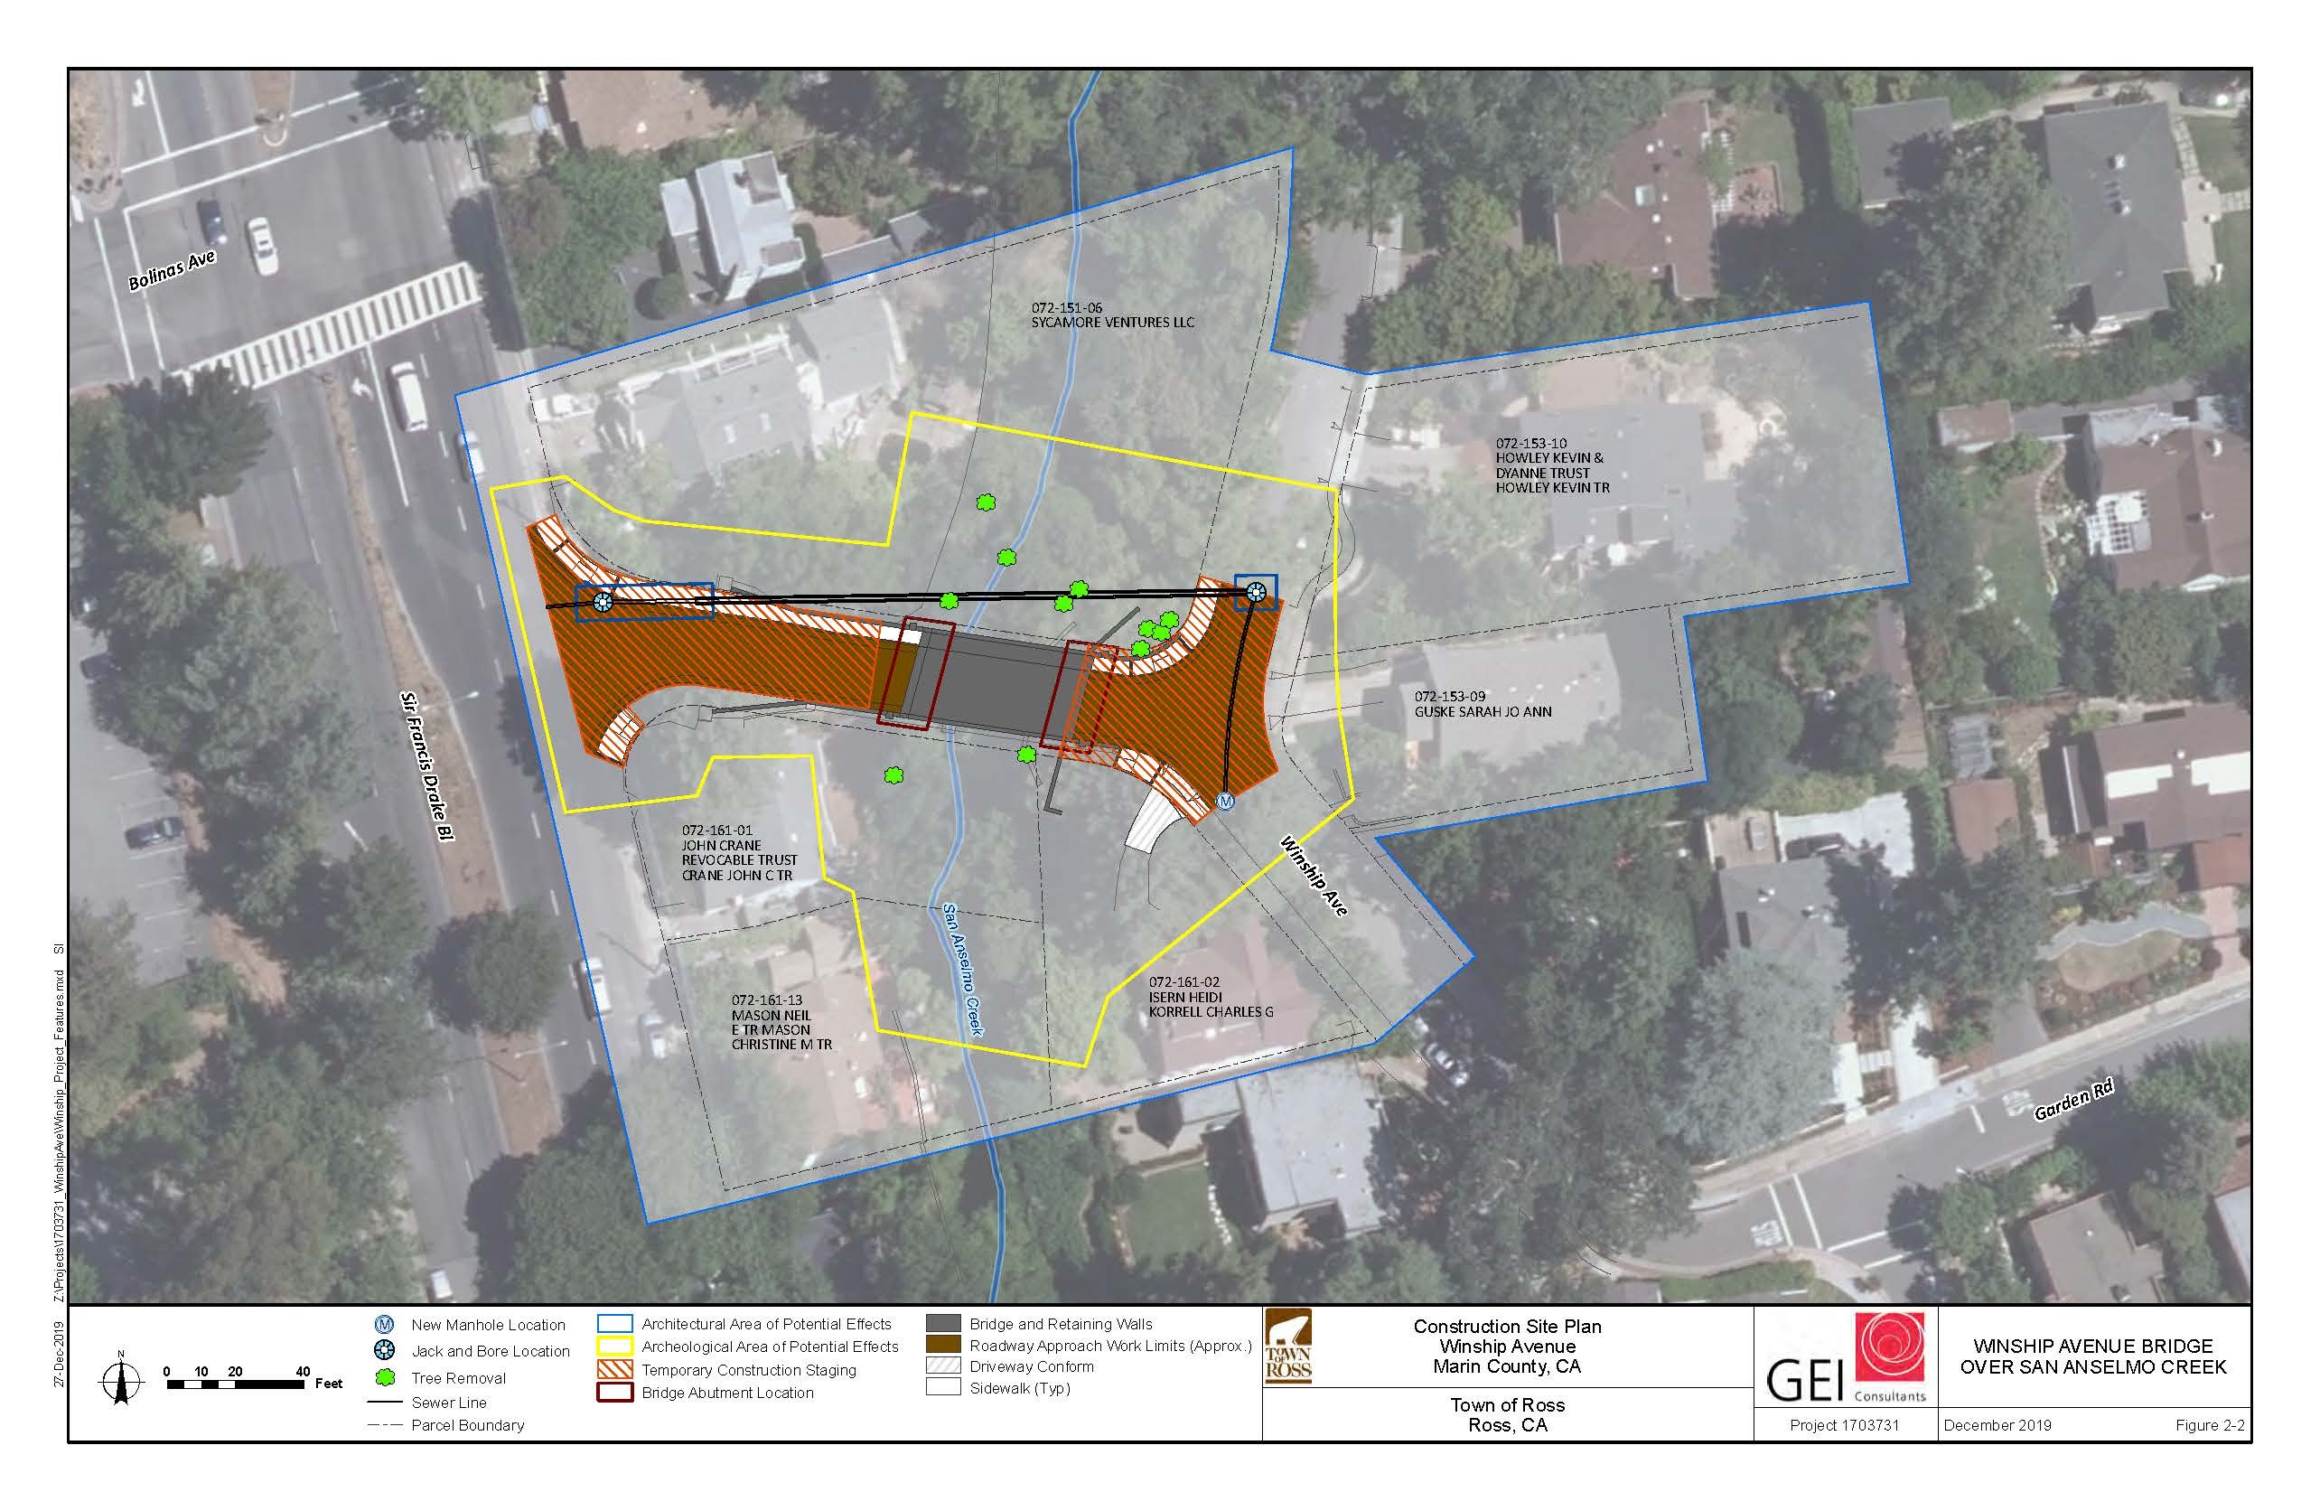

Figure 2-3. Proposed Project Offsite Staging Area
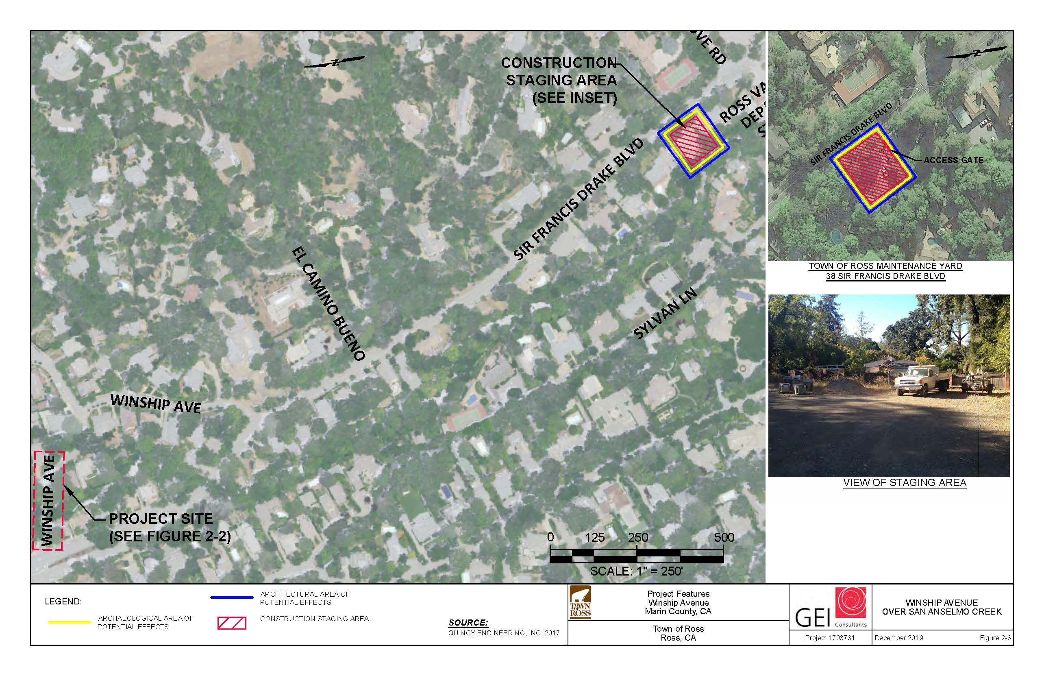

Figure 2-4. Proposed Project Bridge Abutment Locations

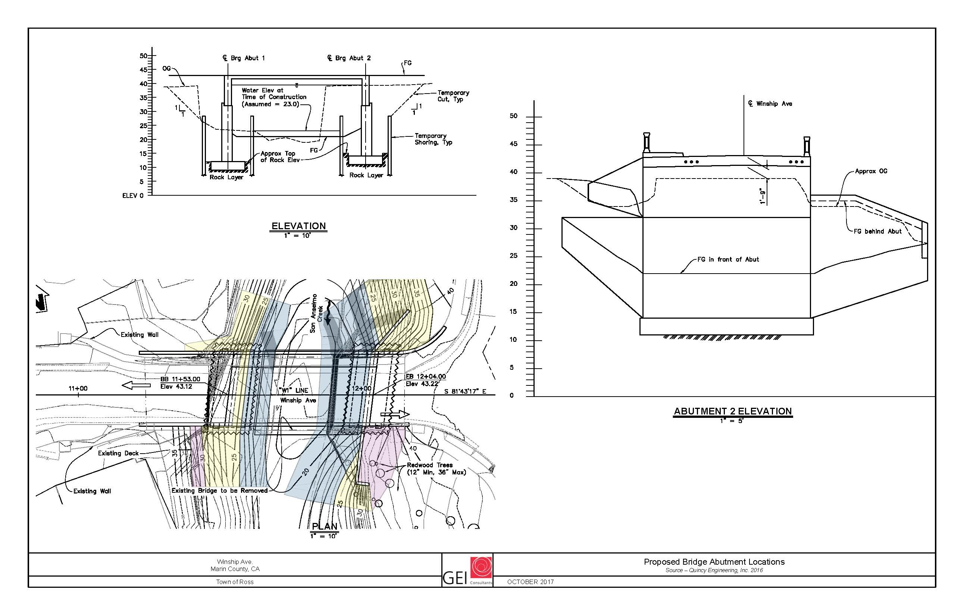
Figure 2-5. Proposed Project Scour Countermeasure Locations
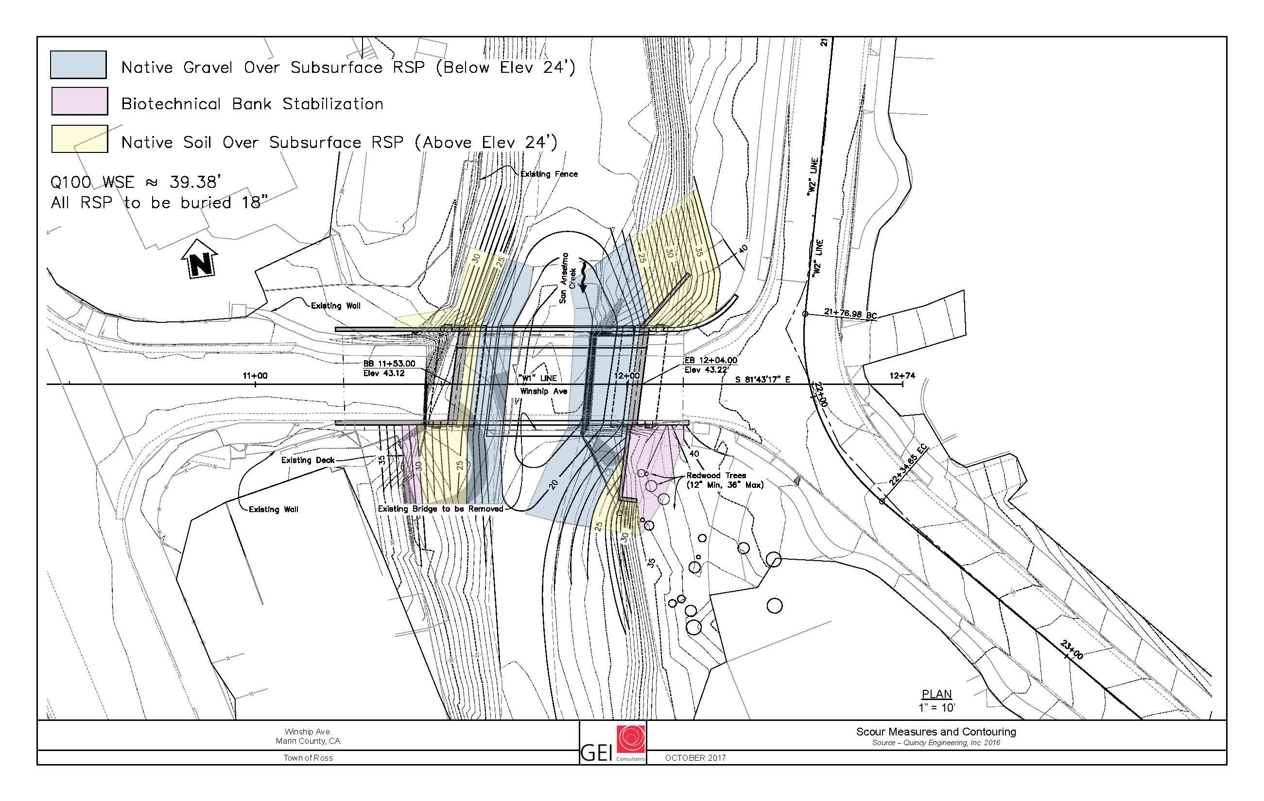

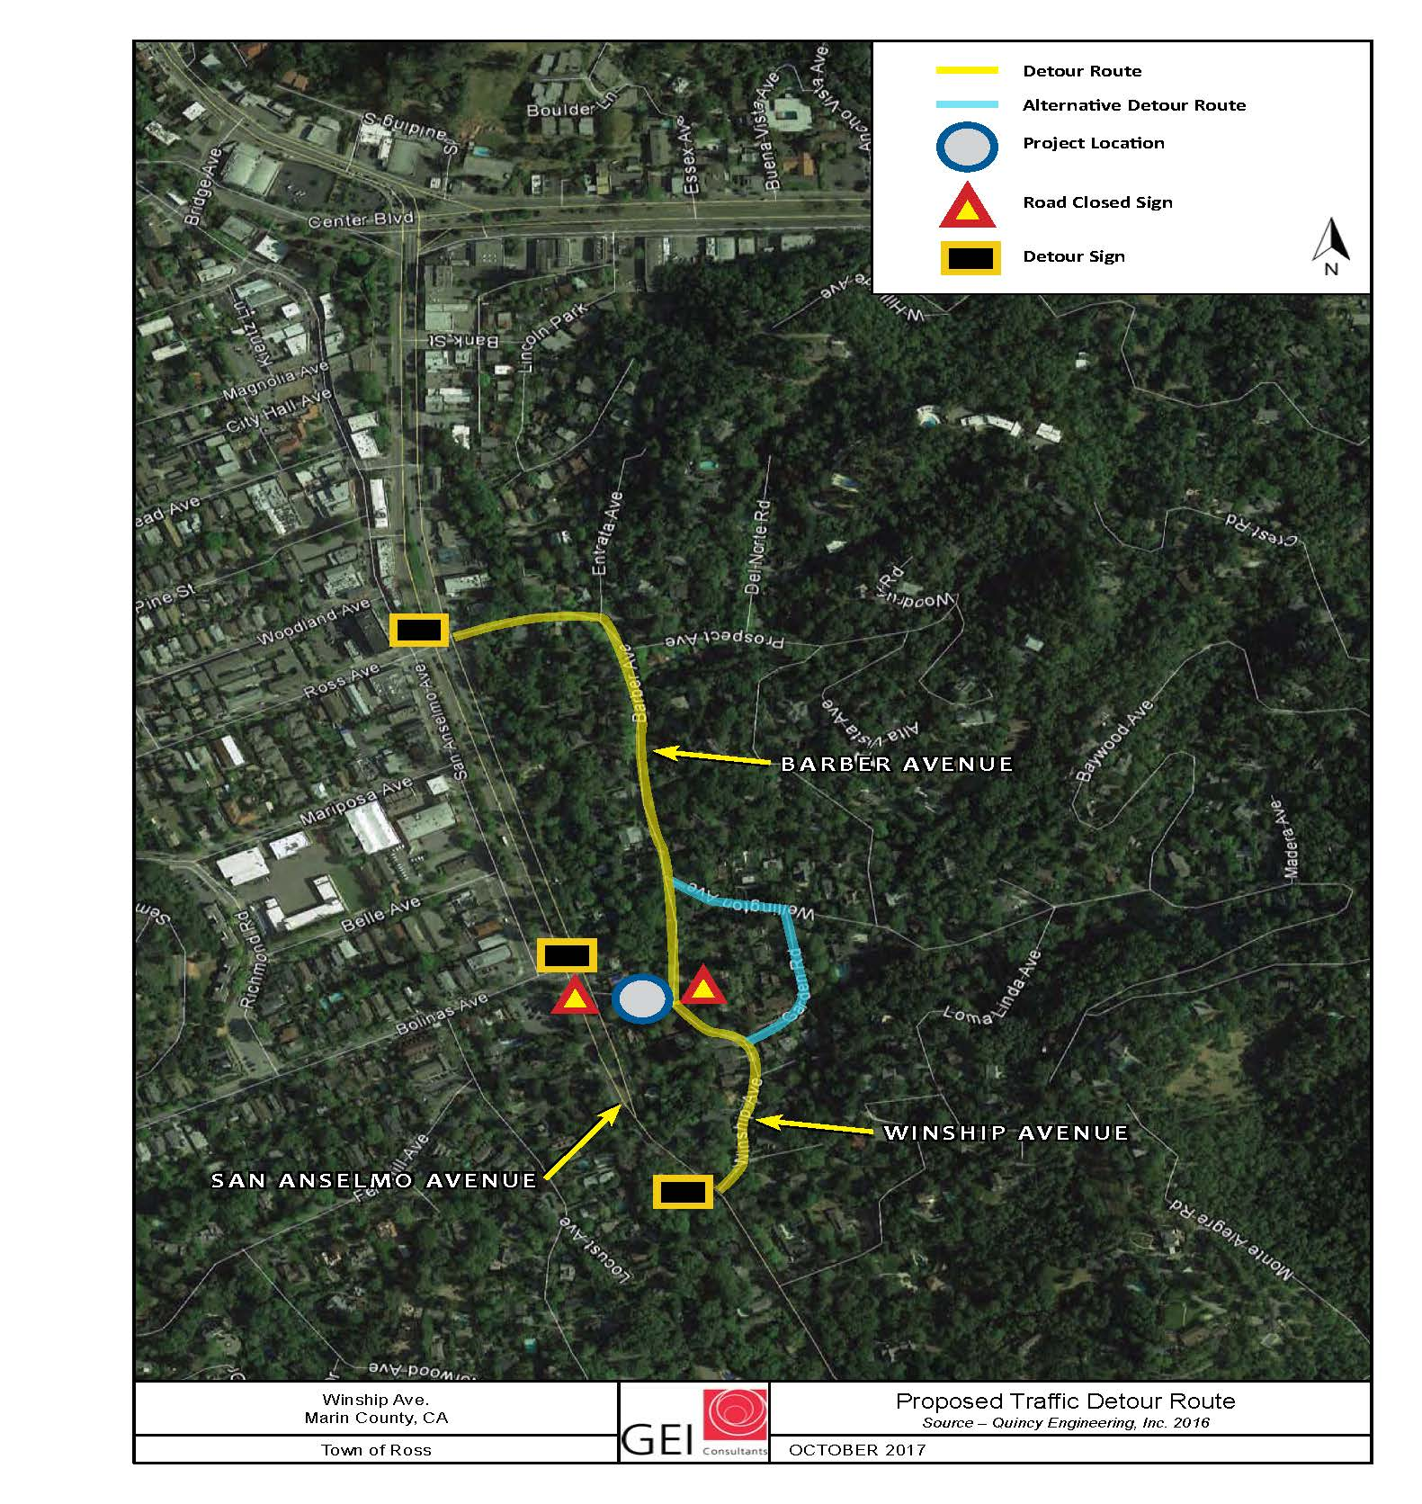
Figure 2-6. Proposed Project Traffic Detour Routes

This page intentionally left blank.

Initial Study Checklist

Introduction
In compliance with the CEQA Guidelines, the Town has prepared the following initial study checklist to analyze the environmental impacts of the proposed project. This checklist uses Appendix G of the CEQA Guidelines to provide a basis for the analysis of the resource areas addressed. An evaluation of potential impacts and mitigation measures to reduce potentially significant impacts is presented in the analysis.
The environmental factors checked below would be potentially affected by this project, involving at least one impact that is a "Potentially Significant Impact" as indicated by the checklist on the following pages. However, all impacts would be mitigated to a less than significant level as indicated on the following pages.
☐ | Aesthetics | ☐ | Agriculture and Forestry Resources | ☒ | Air Quality
☒ | Biological Resources | ☒ | Cultural Resources | ☐ | Energy
☐ | Geology/Soils | ☐ | Greenhouse Gas Emissions | ☒ | Hazards and Hazardous Materials
☒ | Hydrology/Water Quality | ☐ | Land Use/Planning | ☐ | Mineral Resources
☒ | Noise | ☐ | Population/Housing | ☐ | Public Services
☐ | Recreation | ☒ | Transportation | ☒ | Tribal Cultural Resources
☐ | Utilities/Service Systems | ☒ | Wildfire | ☐ | Mandatory Findings of Significance

Evaluation of Environmental Impacts
1) A brief explanation is required for all answers except "No Impact" answers that are adequately supported by the information sources a lead agency cites in the parentheses following each question. A "No Impact" answer is adequately supported if the referenced information sources show that the impact simply does not apply to projects like the one involved (e.g., the project falls outside a fault rupture zone). A "No Impact" answer should be explained where it is based on project-specific factors as well as general standards (e.g., the project will not expose sensitive receptors to pollutants, based on a project-specific screening analysis).
2) All answers must take account of the whole action involved, including off-site as well as on-site, cumulative as well as project-level, indirect as well as direct, and construction as well as operational impacts. Operations and maintenance impacts of the proposed project are routine, minimal, and essentially the same as current operations and maintenance of the existing facilities. There is no potential for a significant impact to any resource category from project operations and maintenance of the existing and proposed facilities.
3) Once the lead agency has determined that a particular physical impact may occur, then the checklist answers must indicate whether the impact is potentially significant, less than significant with mitigation, or less than significant. "Potentially Significant Impact" is appropriate if there is substantial evidence that an effect may be significant. If there are one or more "Potentially Significant Impact" entries when the determination is made, an EIR is required. “Beneficial impact” is also identified where appropriate to provide full disclosure of any benefits from implementing the proposed project.
4) "Less-than-Significant Impact with Mitigation Incorporated" applies where the incorporation of mitigation measures has reduced an effect from "Potentially Significant Impact" to a "Less-than-Significant Impact." The lead agency must describe the mitigation measures, and briefly explain how they reduce the effect to a less-than-significant level (mitigation measures from "Earlier Analyses," as described in (5) below, may be cross-referenced).
5) Earlier analyses may be used where, pursuant to the tiering, program EIR, or other CEQA process, an effect has been adequately analyzed in an earlier EIR or negative declaration (Section 15063[c][3][D]). In this case, a brief discussion should identify the following:
a) Earlier Analysis Used. Identify and state where they are available for review.
b) Impacts Adequately Addressed. Identify which effects from the above checklist were within the scope of and adequately analyzed in an earlier document pursuant to applicable legal standards, and state whether such effects were addressed by mitigation measures based on the earlier analysis.
c) Mitigation Measures. For effects that are a "Less-than-Significant Impact with Mitigation Measures Incorporated," describe the mitigation measures which were incorporated or refined from the earlier document and the extent to which they address site-specific conditions for the project.
6) Lead agencies are encouraged to incorporate into the checklist references to information sources for potential impacts (e.g., general plans, zoning ordinances). Reference to a previously prepared or outside document should, where appropriate, include a reference to the page or pages where the statement is substantiated.
7) Supporting Information Sources: A source list should be attached, and other sources used or individuals contacted should be cited in the discussion.
8) This is only a suggested form, and lead agencies are free to use different formats; however, lead agencies should normally address the questions from this checklist that are relevant to a project's environmental effects in whatever format is selected.
9) The explanation of each issue should identify:
a) the significance criteria or threshold, if any, used to evaluate each question; and
b) the mitigation measure identified, if any, to reduce the impact to less than significance.
Significance thresholds are identified for certain resources, but others are not explicitly identified because there is clearly no impact or the checklist question itself serves as the significance threshold.

Aesthetics
Environmental Issue | Potentially  Significant  Impact | Less-than-Significant Impact with  Mitigation  Incorporated | Less-than-Significant  Impact | No  Impact | Beneficial Impact
- AESTHETICS.
Except as provided in PRC Section 21099, would the project:
- Have a substantial adverse effect on a scenic vista? | ☐ | ☐ | ☐ | ☒ | ☐
- Substantially damage scenic resources, including, but not limited to, trees, rock outcroppings, and historic buildings within a State scenic highway? | ☐ | ☐ | ☐ | ☒ | ☐
- In non-urbanized areas, substantially degrade the existing visual character or quality of public views of the site and its surroundings? (Public views are those that are experienced from a publicly accessible vantage point.) If the project is in an urbanized area, would the project conflict with applicable zoning and other regulations governing scenic quality? | ☐ | ☐ | ☒ | ☐ | ☐
- Create a new source of substantial light or glare which would adversely affect day or nighttime views in the area? | ☐ | ☐ | ☒ | ☐ | ☐

Environmental Setting
Visual Character. The project site is located along Winship Avenue, just east of Sir Francis Drake Boulevard, within a single-family neighborhood identified as Area C (Traditional Neighborhood) under the current Town of Ross General Plan. Traffic volumes along Winship Avenue (local roadway) are limited to those associated with the surrounding residential land uses, while those along Sir Francis Drake Boulevard are much greater given the roadways function as a principal arterial for central Marin County. Daily traffic volume on Sir Francis Drake Boulevard varies, ranging from approximately 17,000 vehicles on the two-lane section in the Towns of Fairfax and San Anselmo to about 36,000 vehicles on the four-lane section in Kentfield (ESA, 2018). Current ADT for Winship Avenue is significantly lower and estimated at 210 vehicles per day (Kittelson and Associates, 2018).
The overall visual character of the immediate area is dominated by views of surrounding single-family residential homes, many with densely vegetated parcels and San Anselmo Creek. The visual character of the project site is characterized by two features:
- Winship Avenue Bridge and Roadway. Winship Avenue is a paved, two lane, narrow local roadway that provides access to the surrounding neighborhood. The roadway connects to Sir Francis Drake Boulevard near the project site. San Anselmo Creek flows under Winship Avenue, crossing the creek at the Winship Avenue Bridge, a concrete 90-foot long, 26-foot wide bridge.
- San Anselmo Creek. San Anselmo Creek is a low-gradient perennial creek characterized by lateral scour pool and riffle sequences and is heavily impacted by incised banks and channel armoring. The upstream banks are both vegetated and variably armored with RSP and the downstream right bank is also armored, first with RSP and then with a concrete retaining wall further downstream (right and left banks are defined from the perspective of looking downstream).
Viewer Exposure and Sensitivity. Viewer sensitivity is a measure of viewer exposure and viewer awareness. Factors that affect the level of viewer concern are described below in Table 3-1.
Table 3-1. Viewer Sensitivity
Factor | Characteristics
Type of and Frequency of Use | Daily use from the motorists and residents on Winship Avenue
Public Interest | Low (limited views outside of immediate area)
Adjacent Land Uses | Residential Land Uses – Single Family Homes

Winship Avenue serves predominantly residential traffic traveling from the neighborhood to outside locations within the Town and the surrounding area, via Sir Francis Drake Boulevard. Viewer sensitivity for residents driving along Winship Avenue between their homes and Sir Francis Drake Boulevard is low due to the low number of viewers and limited area affected by the proposed project, as well as limited visibility of the area from Sir Francis Drake Boulevard.
Scenic Routes and Vistas. According to the Caltrans Scenic Highway inventory, portions of State Route 1, 101, and 37 are considered eligible for listing as a scenic highway (Caltrans, 2019). However, these roadways are not located near the project site and there are no other scenic highway designations in the project vicinity. While the Town of Ross General Plan does not identify any official scenic vistas within the Town’s Planning Area, General Plan Policy 3.5 “View Protection” identifies several important view locations (including surrounding hillsides and ridgelines, Mt. Tamalpais, and Bald Hill) requiring preservation. Views of surrounding hillsides, ridgelines, or Bald Hill are not easily visible from the project site.
Light and Glare. Light pollution is defined as any adverse effect of artificial light, including sky glow, glare, light trespass, light clutter, decreased visibility at night, and energy waste. Existing sources of light and glare are generally from streetlights, residences, and from traffic on Sir Francis Brake Boulevard and Winship Avenue.

Discussion
- Have a substantial adverse effect on a scenic vista?
There are no designated scenic vistas within the project vicinity and the proposed project would not be visible from any designated scenic vista. Consequently, no impact would occur.
b) Substantially damage scenic resources, including, but not limited to, trees, rock outcroppings, and historic buildings within a State scenic highway?
The project site is not located on or near a state designated scenic highway and will not result in damage to scenic resources within a state scenic highway. Consequently, no impact would occur.
c) In non-urbanized areas, substantially degrade the existing visual character or quality of public views of the site and its surroundings? (Public views are those that are experienced from publicly accessible vantage point.) If the project is in an urbanized area, would the project conflict with applicable zoning and other regulations governing scenic quality?
Construction. Construction is anticipated to take approximately 20 weeks. During construction, the following activities and equipment may be easily seen in the project vicinity:
- Work crews accessing the project site
- Removal of vegetation from the proposed roadway alignment
- Large pieces of equipment used for moving earth; trenching ditches; transporting, lifting, and placing equipment; hauling concrete; spraying water to control dust; and other construction activities
Construction activities would be temporary and limited to daylight hours. Due to the relatively flat topography in the project vicinity, fugitive dust from construction may be temporarily visible to motorists traveling on Winship Avenue near the project site. Dust plumes may obscure views to the surrounding landscape over a short period of time; however, dust generation would be temporary and limited in extent. Additionally, implementation of the applicable Bay Area Air Quality Management District recommended dust control measures (see Section 3.5 “Air Quality”) would be completed as part of the project to minimize dust generation. Consequently, this impact would be less than significant, with no additional mitigation measures required.
Operation. Implementation of the proposed project will require the removal of some vegetation along San Anselmo Creek; however, replanting (using native vegetation) and erosion control measures (see Mitigation Measures BIO-3, BIO-5, BIO-9, BIO-10, and BIO-11 in Section 3.6 “Biological Resources”) would be completed as part of the project to restore the construction site to pre-project conditions. While the project will result in short-term, construction-related visual impacts (i.e., dust, equipment, construction vehicles), no vertical features (such as cellular towers, storage tanks, or utility lines) or new sources of lighting are included with the project that would result in permanent negative effects to existing views in the study area. Designing the new bridge for visual compatibility with the original structure and with the Town’s historic character will minimize the nature and magnitude of the visual change resulting from replacement of the bridge. For example, as more fully described above in Chapter 2, Section 2.5.2 “Construction Process”, the proposed project will either preserve the existing light standards or have similar light pedestals/electroliers installed as those used for the recently replaced Lagunitas Bridge. As previously described, public views of the site are limited to passing motorists or pedestrians and viewer sensitivity is considered low, given the site’s limited visibility outside the immediate area. Therefore, the project will not result in a negative adverse impact to the visual character of the site. Consequently, this impact is less-than-significant, with no additional mitigation measures required.

d) Create a new source of substantial light or glare which would adversely affect day or nighttime views in the area?
Implementation of the proposed project includes raising the elevation of the bridge deck (or profile) up to 4 feet. Eastbound vehicles along Winship Avenue may potentially increase illumination or glare to the windows of residents immediately surrounding the project site. Factors that would determine the increased level of illumination include vehicle headlight distribution, presence/density of vegetation, and auto barriers along the sides of the bridge.
While no local light or glare trespass standards related to vehicle headlights (or similar intermittent illumination) are available, the Institution of Lighting Engineers (ILE) has suggested standards or limits that area based upon different environmental zones for light trespass by roadway lighting or other always-on lighting, in terms of the amount of light that is cast on the surface of a window. For the project study area (single family residential), the environmental zone would likely be E2, which is characterized as an area of low ambient brightness in an outer urban or rural residential area (Macdonald Architects, 2017). The recommendation for E2 zones is 1 lux, which would likely be surpassed by some of the larger vehicles and higher-illumination headlight vehicles (SUV or delivery truck) expected to use the new bridge. However, due to the sporadic nature of vehicles crossing the bridge and the projected increased illumination being relatively minor (1 to 2 lux), the overall increased level of illumination is not considered excessive under the ILE standard (MacDonald Architects, 2017).
Regarding glare, visual glare is caused by a significant difference in the illumination level between the darkness of what a person is visually focusing on and the brightness of a glare source within their field of vision. A vehicle’s headlights at night could be such a glare source, if the vehicle is oriented directly at someone’s field of view in the residence. However, the degree of glare is contingent on the lighting levels in the residences (which would affect the illumination difference that causes glare) or where and what the people in the residences are doing (which would affect where their field of vision would be and if the headlights would be in their field of vision). Additionally, all three of these conditions must be met for visual glare to occur, (1) the headlights must be oriented into a residence’s window, (2) the person must be visually focused on something relatively dark, and (3) the headlights must come into the person’s field of view. Due to the low traffic volumes along Winship Avenue and the sporadic nature of vehicles crossing the bridge, in combination with the irregular schedules and habits of people in the residences surrounding the project site, the likelihood of all three visual glare conditions being met regularly is considered unlikely. Therefore, this situation should not be considered excessive illumination. (MacDonald Architects, 2017)
Consequently, the impact resulting from substantial new sources of light and glare is less-than- significant, with no additional mitigation measures required.

Agriculture and Forestry Resources
Environmental Issue | Potentially  Significant  Impact | Less-than-Significant Impact with  Mitigation  Incorporated | Less-than-Significant  Impact | No  Impact | Beneficial Impact
- AGRICULTURE AND FORESTRY RESOURCES.
In determining whether impacts to agricultural resources are significant environmental effects, lead agencies may refer to the California Agricultural Land Evaluation and Site Assessment Model (1997, as updated) prepared by the California Department of Conservation as an optional model to use in assessing impacts on agriculture and farmland. In determining whether impacts to forest resources, including timberland, are significant environmental effects, lead agencies may refer to information compiled by the California Department of Forestry and Fire Protection regarding the State’s inventory of forest land, including the Forest and Range Assessment Project and the Forest Legacy Assessment project; and forest carbon measurement methodology provided in Forest Protocols adopted by the California Air Resources Board. Would the project:
- Convert Prime Farmland, Unique Farmland, or Farmland of Statewide Importance (Farmland), as shown on the maps prepared pursuant to the Farmland Mapping and Monitoring Program of the California Resources Agency, to non-agricultural use? | ☐ | ☐ | ☐ | ☒ | ☐
- Conflict with existing zoning for agricultural use, or a Williamson Act contract? | ☐ | ☐ | ☐ | ☒ | ☐
- Conflict with existing zoning for, or cause rezoning of, forest land (as defined in PRC Section 12220(g)), timberland (as defined by PRC Section 4526), or timberland zoned Timberland Production (as defined by Government Code Section 51104(g))? | ☐ | ☐ | ☐ | ☒ | ☐
- Result in the loss of forest land or conversion of forest land to non-forest use? | ☐ | ☐ | ☐ | ☒ | ☐
- Involve other changes in the existing environment which, due to their location or nature, could result in conversion of Farmland, to non-agricultural use or conversion of forest land to non-forest use? | ☐ | ☐ | ☐ | ☒ | ☐

Discussion
a) Convert Prime Farmland, Unique Farmland, or Farmland of Statewide Importance (Farmland), as shown on the maps prepared pursuant to the Farmland Mapping and Monitoring Program of the California Resources Agency, to non-agricultural use?
As described in Chapter 2 “Project Description”, the project site does not contain any Important Farmlands as identified by the California Department of Conservation’s Farmland Mapping and Monitoring Program, parcels with an active Williamson Act contract, or lands designated as Forest or Timberlands. Additionally, the project would replace an existing bridge, with construction activities concentrated within and directly adjacent to the existing roadway, thus remaining consistent with existing development and current zoning and land use designations. Therefore, the project will not result in the conversion of Important Farmland, Timberland/Forest resources or is expected to encourage the non-renewal or cancellation of Williamson Act contracted lands. Consequently, no impact would occur.
b) Conflict with existing zoning for agricultural use, or a Williamson Act contract?
See checklist Item “a” above.
c) Conflict with existing zoning for, or cause rezoning of, forest land (as defined in Public Resources Code Section 12220(g)), timberland (as defined by PRC Section 4526), or timberland zoned Timberland Production (as defined by Government Code Section 51104(g))?
See checklist Item “a” above.
d) Result in the loss of forest land or conversion of forest land to non-forest use?
See checklist Item “a” above.
e) Involve other changes in the existing environment which, due to their location or nature, could result in conversion of Farmland, to non-agricultural use or conversion of forest land to non-forest use?
See checklist Item “a” above.

Air Quality
Environmental Issue | Potentially  Significant  Impact | Less-than-Significant Impact with  Mitigation  Incorporated | Less-than-Significant  Impact | No  Impact | Beneficial Impact
- AIR QUALITY.
Where available, the significance criteria established by the applicable air quality management district or air pollution control district may be relied on to make the following determinations. Would the project:
- Conflict with or obstruct implementation of the applicable air quality plan? | ☐ | ☐ | ☒ | ☐ | ☐
- Result in a cumulatively considerable net increase of any criteria pollutant for which the project region is non-attainment under an applicable Federal or State ambient air quality standard? | ☐ | ☒ | ☐ | ☐ | ☐
- Expose sensitive receptors to substantial pollutant concentrations? | ☐ | ☒ | ☐ | ☐ | ☐
- Result in other emissions (such as those leading to odors) adversely affecting a substantial number of people? | ☐ | ☐ | ☒ | ☐ | ☐

Environmental Setting
Criteria Air Pollutants and Existing Air Quality Conditions. The U.S. Environmental Protection Agency (EPA) has identified criteria air pollutants that are a threat to public health and welfare. These pollutants are called “criteria” air pollutants because standards have been established for each of them to meet specific public health and welfare criteria. These air pollutants include ozone, particulate matter less than 10 microns in diameter (PM10), particulate matter less than 2.5 microns in diameter (PM2.5), and nitrogen dioxide (NO2).
The Bay Area Air Quality Management District (BAAQMD) operates a regional monitoring network of air quality monitoring stations to measure the ambient concentrations of criteria air pollutants. Existing levels of air pollutants in the study area can be inferred from ambient air quality measurements conducted by BAAQMD at its stations within and close to the project site. The monitoring station that best represents the air quality in the project site is located at 534 4th Street in San Rafael, which provided a 5-year (2014 through 2018) summary of emissions data collected at this station for ozone, PM10, PM2.5, and NO2. Air quality emission data is also compared to the California Ambient Air Quality Standards (CAAQS) and National Ambient Air Quality Standards (NAAQS).
Air quality monitoring station data indicates there were no exceedances of State or national ozone standards between 2014 and 2018 (California Air Resources Board, 2019). The 24-hour State PM10 standard was exceeded twelve times over the past 5 years (all in 2018) and the 24-hour national PM10 standard was exceeded six times (all in 2018) over the same period. The national 24-hour PM2.5 standard was exceeded 24 times between 2013 and 2015. Additionally, there were measured exceedances of the annual average State (31 times) and the national PM2.5 standards (46 times). (California Air Resources Board, 2019)
Sensitive Receptors. For the purposes of this air quality analysis, sensitive receptors are defined as facilities and land uses that include members of the population that are particularly sensitive to the effects of air pollutants, such as children, the elderly, and people with illnesses. Examples include residential areas, schools, hospitals, and daycare centers. Six residences are located adjacent to the project site, with additional residences located throughout the surrounding neighborhood, within 1,000 feet of the project site. The nearest school and daycare facility to the project site are the Wade Thomas Elementary School located at 150 Ross Avenue (roughly a mile from the project site) and the Ross Cottage Nursery School located at 7 Shanley Lane (located approximately 700 feet from the project site). The nearest hospitals are the Kentfield Hospital and the Kaiser Permanente San Rafael Medical Center, both located several miles from the project site.
Construction Air Quality Emissions. Construction of the proposed project would generate temporary criteria pollutant exhaust emissions through the use of heavy-duty construction equipment, such as excavators and graders, and through vehicle trips generated from worker vehicles and haul trucks traveling to and from the project site. In addition, fugitive dust emissions would result from demolition of the existing bridge structure and various soil-handling and debris-management activities. Construction emissions can vary substantially from day to day, depending on the level of activity, the specific type of construction activity, and prevailing weather conditions.
As previously described, fugitive dust emissions are typically generated during construction phases. Studies have shown that the application of best management practices (BMPs) at construction sites significantly controls fugitive dust and individual measures have been shown to reduce fugitive dust by anywhere from 30 to 90 percent (BAAQMD, 2010). The BAAQMD has identified eight Basic Construction Mitigation Measures to control fugitive dust emissions from construction activities for all projects and 13 Additional Construction Mitigation Measures for all projects where construction-related emissions would exceed one or more of the BAAQMD’s significance thresholds (BAAQMD, 2017).

Discussion
a) Conflict with or obstruct implementation of the applicable air quality plan?
This impact is determined based on whether the proposed project would conflict with or obstruct implementation of the local air quality plan and/or applicable portions of the State Implementation Plan, which would lead to increases in the frequency or severity of existing air quality violations. As a bridge replacement project (with the primary objective of maintaining public safety), the proposed project would not increase roadway capacity or service capabilities that would induce unplanned growth, remove an existing obstacle to growth, or lead to permanent increases in vehicle miles travelled by existing motorists. Therefore, the proposed project would not conflict with or obstruct implementation of the applicable air quality plan. Consequently, this impact is less-than-significant, with no mitigation measures required.

b) Result in a cumulatively considerable net increase of any criteria pollutant for which the project region is non-attainment under an applicable Federal or State ambient air quality standard?
The project site is in a region designated as non-attainment of the CAAQS (i.e., ozone, PM10, and PM2.5) and NAAQS (i.e., ozone and PM2.5). While air quality estimates or modelling were not generated for this project, it is assumed that combustion-related emissions, some of which are precursors to ozone, would be well below BAAQMD significance thresholds and would have minimal impact on ambient air quality at the project site or in the region, based on a review of similar bridge replacement projects. However, the proposed project may generate construction-related diesel exhaust and dust that could impact air quality in the region. Fugitive dust would also be generated from use of vehicles and equipment as well as during earth-moving and bridge demolition activities. Impacts to air quality from emissions generated during construction would be relatively short and limited to the 6-month construction period; however, the proposed project’s contribution of fugitive dust and ozone precursors to the region, which is in nonattainment, may be potentially significant. Implementation of Mitigation Measure AIR-1 requires the use of dust and engine emission control measures during the construction process, which would reduce the impact to less than significant. Therefore, the proposed project would have a less-than-significant impact with mitigation incorporated.
Mitigation Measure AIR-1: BAAQMD Basic Construction Measures.
To limit dust, criteria pollutants, and precursor emissions associated with construction, the Town and the RVSD shall ensure the following BAAQMD-recommended Basic Construction Measures shall be implemented and included in all contract specifications for components constructed under the proposed project:
- All exposed surfaces (e.g., parking areas, staging areas, soil piles, graded areas, and unpaved access roads) shall be watered two times per day.
- All haul trucks transporting soil, sand, or other loose material off-site shall be covered.
- All visible mud or dirt track-out onto adjacent public roads shall be removed using wet power vacuum street sweepers at least once per day. The use of dry power sweeping is prohibited.
- All vehicle speeds on unpaved roads shall be limited to 15 mph.
- All roadways, driveways, and sidewalks to be paved shall be completed as soon as possible.
- Idling times shall be minimized either by shutting equipment off when not in use or reducing the maximum idling time to 5 minutes (as required by the California airborne toxics control measure Title 13, Section 2485 of California Code of Regulations [CCR]). Clear signage shall be provided for construction workers at all access points.
- All construction equipment shall be maintained and properly tuned in accordance with manufacturer’s specifications. All equipment shall be checked by a certified mechanic and determined to be running in proper condition prior to operation.
- Post a publicly visible sign with the telephone number and person to contact at the Town regarding dust complaints. This person shall respond and take corrective action within 48 hours. The BAAQMD’s phone number shall also be visible to ensure compliance with applicable regulations.
Responsibility: Town / RVSD / Construction Contractor
Timing: Before and During Construction Activities
c) Expose sensitive receptors to substantial pollutant concentrations?
The BAAQMD has established thresholds of significance for exposure to toxic air contaminants (TACs) based on the projected increase in human health risk. Projects that would result in increased cancer risk of greater than 10 in a million or increased noncancer risk greater than a Hazard Index of 1.0 are considered to have a significant impact. In addition, an increase in annual average ambient PM2.5 concentrations in excess 0.3 micrograms per cubic meter would be considered a significant impact. The BAAQMD recommends that lead agencies assess the incremental toxic air contaminant (TAC) exposure risk to all sensitive receptors within a 1,000-foot radius of a project’s fence line.
Project operation (that is, use of the replacement bridge and sewer line) would not result in new TAC emissions. However, project construction activities would result in emission of diesel particulate matter (DPM) from use of diesel-powered trucks and equipment. DPM is considered to be a TAC, with both carcinogenic and noncarcinogenic health effects. The nearest sensitive receptors to the project site are the six residences located adjacent to the project sites.
The dose to which receptors are exposed is the primary factor affecting health risk from exposure to TACs. Dose is a function of the concentration of a substance or substances in the environment and the duration of exposure to the substance. According to the California Office of Environmental Health Hazard Assessment (OEHHA), health risk assessments, which determine the exposure of sensitive receptors to TAC emissions, should be based on a 70-year exposure period when assessing TACs (such as DPM) that have only cancer or chronic non-cancer health effects. However, such health risk assessments should be limited to the duration of the emission-producing activities associated with the project (OEHHA, 2015).
Construction related activities are expected to last up to 6 months, with the level of activity and equipment use varying depending on the specific construction stage. Use of an offsite staging area would help to reduce the number of vehicle trips travelling to the project site. Implementation of the dust and ozone precursor emission reducing measures under Mitigation Measure AIR-1would result in a reduction of DPM emissions and PM2.5. With DPM emissions considered relatively minor and the short exposure time, the proposed project would not be expected to substantially increase cancer or non-cancer health risks for nearby sensitive receptors. However, certain individuals, such as pregnant women, infants, and children, are more sensitive to toxic air contaminants (OEHHA, 2015). Even short-term exposure to TACs could result in an increased risk of adverse health effects resulting in a potentially significant impact. Implementation of the diesel reducing measures included in Mitigation Measure AIR-2 would further reduce TAC emissions and exposure, which would reduce the impact to less than significant. Therefore, the proposed project would have a less-than-significant impact with mitigation incorporated.
Mitigation Measure AIR-2: Diesel Exhaust Emissions Reduction Measures.
To limit dust and DPM emissions associated with construction, the Town and the RVSD shall ensure the following measure is implemented and included in all contract specifications for components constructed under the proposed project:
- All off-road diesel-powered equipment with engines greater than 25 horsepower used in Project construction shall meet the California Air Resources Board’s most recent certification standard for off-road heavy-duty diesel engines.
Responsibility: Town / RVSD / Construction Contractor
Timing: Before and During Construction Activities
d) Result in other emissions (such as those leading to odors) adversely affecting a substantial number of people?
Combustion emissions from the use of diesel fuel in construction equipment, as well as tar or asphalt used for any paving improvements, could generate localized objectionable odors. If sensitive receptors are located in the immediate vicinity of these activities, odors could be perceivable and constitute a nuisance impact. Construction of the proposed project would take up to six months to complete and would take place within the construction hours specified by the Town. Construction equipment and paving activities would not be static, and on any given day may take place at different parts of the construction site, which would help to not expose any one set of receptors to odors over the entire duration of the construction period. Any objectionable odors generated by project construction and perceived by sensitive receptors would occur on a short-term basis or would be intermittent. Implementation of the dust and diesel reducing measures included in Mitigation Measures AIR-1 and AIR-2 would further reduce the potential for construction odors. Consequently, this impact is less-than-significant, with no additional mitigation measures required.

Biological Resources
Environmental Issue | Potentially  Significant  Impact | Less-than-Significant Impact with  Mitigation  Incorporated | Less-than-Significant  Impact | No  Impact | Beneficial Impact
- BIOLOGICAL RESOURCES.
Would the project:
- Have a substantial adverse effect, either directly or through habitat modifications, on any species identified as a candidate, sensitive, or special status species in local or regional plans, policies, or regulations, or by the California Department of Fish and Wildlife or U.S. Fish and Wildlife Service? | ☐ | ☒ | ☐ | ☐ | ☐
- Have a substantial adverse effect on any riparian habitat or other sensitive natural community identified in local or regional plans, policies, or regulations or by the California Department of Fish and Wildlife or U.S. Fish and Wildlife Service? | ☐ | ☒ | ☐ | ☐ | ☐
- Have a substantial adverse effect on State or Federally protected wetlands (including, but not limited to, marsh, vernal pool, coastal, etc.) through direct removal, filling, hydrological interruption, or other means? | ☐ | ☒ | ☐ | ☐ | ☐
- Interfere substantially with the movement of any native resident or migratory fish or wildlife species or with established native resident or migratory wildlife corridors, or impede the use of native wildlife nursery sites? | ☐ | ☒ | ☐ | ☐ | ☐
- Conflict with any local policies or ordinances protecting biological resources, such as a tree preservation policy or ordinance? | ☐ | ☒ | ☐ | ☐ | ☐
- Conflict with the provisions of an adopted Habitat Conservation Plan, Natural Community Conservation Plan, or other approved local, regional, or State habitat conservation plan? | ☐ | ☐ | ☐ | ☒ | ☐

Environmental Setting
A Natural Environment Study (Garcia and Associates, 2019a) was prepared for the proposed project that included a biological evaluation, botanical/rare plant survey, native tree survey, and wetland delineation of the study area (referred to as the Biological Study Area or BSA) to evaluate site conditions and potential impacts to biological and botanical species from project activities. Other primary references consulted include species lists and information gathered using the United States Fish and Wildlife Service’s (USFWS) Information, Planning, and Conservation System (IPAC), California Department of Fish and Wildlife’s (CDFW) Natural Diversity Database (CNDDB), the California Native Plant Society’s (CNPS) list of rare and endangered plants, and literature review. The Natural Environment Study conclusions are the result of field survey findings and research to determine the potential for special-status species to occur within the study area and/or if these species could be impacted by project-related construction and operation activities.
Garcia and Associates biologists conducted a reconnaissance-level field visit to determine the likelihood of sensitive resources occurring within the study area or BSA. Biologists walked the entirety of the BSA to document plant communities and habitat types. The survey focused on determining whether the BSA contained suitable habitat to support special-status species and whether jurisdictional waters and wetlands were present. In addition, the Ordinary High Water Mark (OHWM) of San Anselmo Creek was delineated within the BSA in accordance with the Regulatory Guidance Letter: Ordinary High Water Mark Identification (USACE, 2005). All animals or animal signs (e.g., tracks, scat) observed in the BSA during the reconnaissance survey are listed in Appendix G of the Natural Environment Study.
A Garcia and Associates botanist conducted a rare plant survey of the BSA on July 26, 2019. All the special-status plant species with likelihood to occur were identifiable at this time. The botanist walked all suitable habitat within the BSA and identified all plant taxa to the lowest taxonomic level required to determine if any special-status plants occurred. No special-status plants were found. A complete list of all plants observed in the BSA is included in Appendix H of the Natural Environment Study.
Garcia and Associates biologists conducted a tree inventory of the project site concurrent with the rare plant survey on July 26, 2019. Inventoried trees included all those with DBH of equal to or greater than 2 inches that are located within the project site and indicated for removal on the project tree removal exhibit (see Appendix I of the Natural Environment Study). In addition, several trees that were not indicated on the exhibit (likely due to their small size), but that are presumed to be scheduled for removal based on their location, were also inventoried. Each tree scheduled for removal as a result of the proposed project was identified to species and measured using a DBH tape.

Natural Communities (Habitats and Land Cover Types)
The San Anselmo Creek watershed is dominated by mixed hardwood forests (CDFW 2013). Vegetation in the BSA is associated with the riparian corridor of the lower reaches of San Anselmo Creek which is largely limited to the area directly on or around the creek banks. The riparian corridor abruptly abuts the urban backyard landscapes at the tops of the banks and is generally comprised of native riparian trees and non-native shrubs and vines. In the BSA and the surrounding sections of San Anselmo Creek, much of the stream corridor has been channelized or armored and the remaining stream banks are typically heavily invaded by non-native plants, most notably Himalayan blackberry (Rubus armeniacus) and English ivy (Hedera helix). There are no undisturbed riparian communities in the BSA. The vegetation type that was observed within the BSA, Alnus rhombifolia Forest Alliance – white alder groves, is described below. The classification of vegetation is based on A Manual of California Vegetation, 2nd Edition (Sawyer et al. 2009) which describes all major vegetation types known in California. The natural vegetation types are called “alliances” and can be further classified into “associations,” both of which are floristically defined vegetation types identified by their dominant and/or characteristic species.
The BSA also includes San Anselmo Creek which is identified as an aquatic feature. Other land cover types in the BSA include landscaped/ruderal, paved roadway, and developed. Table 3-2 and Figure 3-1 show the land cover types and approximate acreages within the project site.
Figure 3-1. Land Cover Types within the Project Site
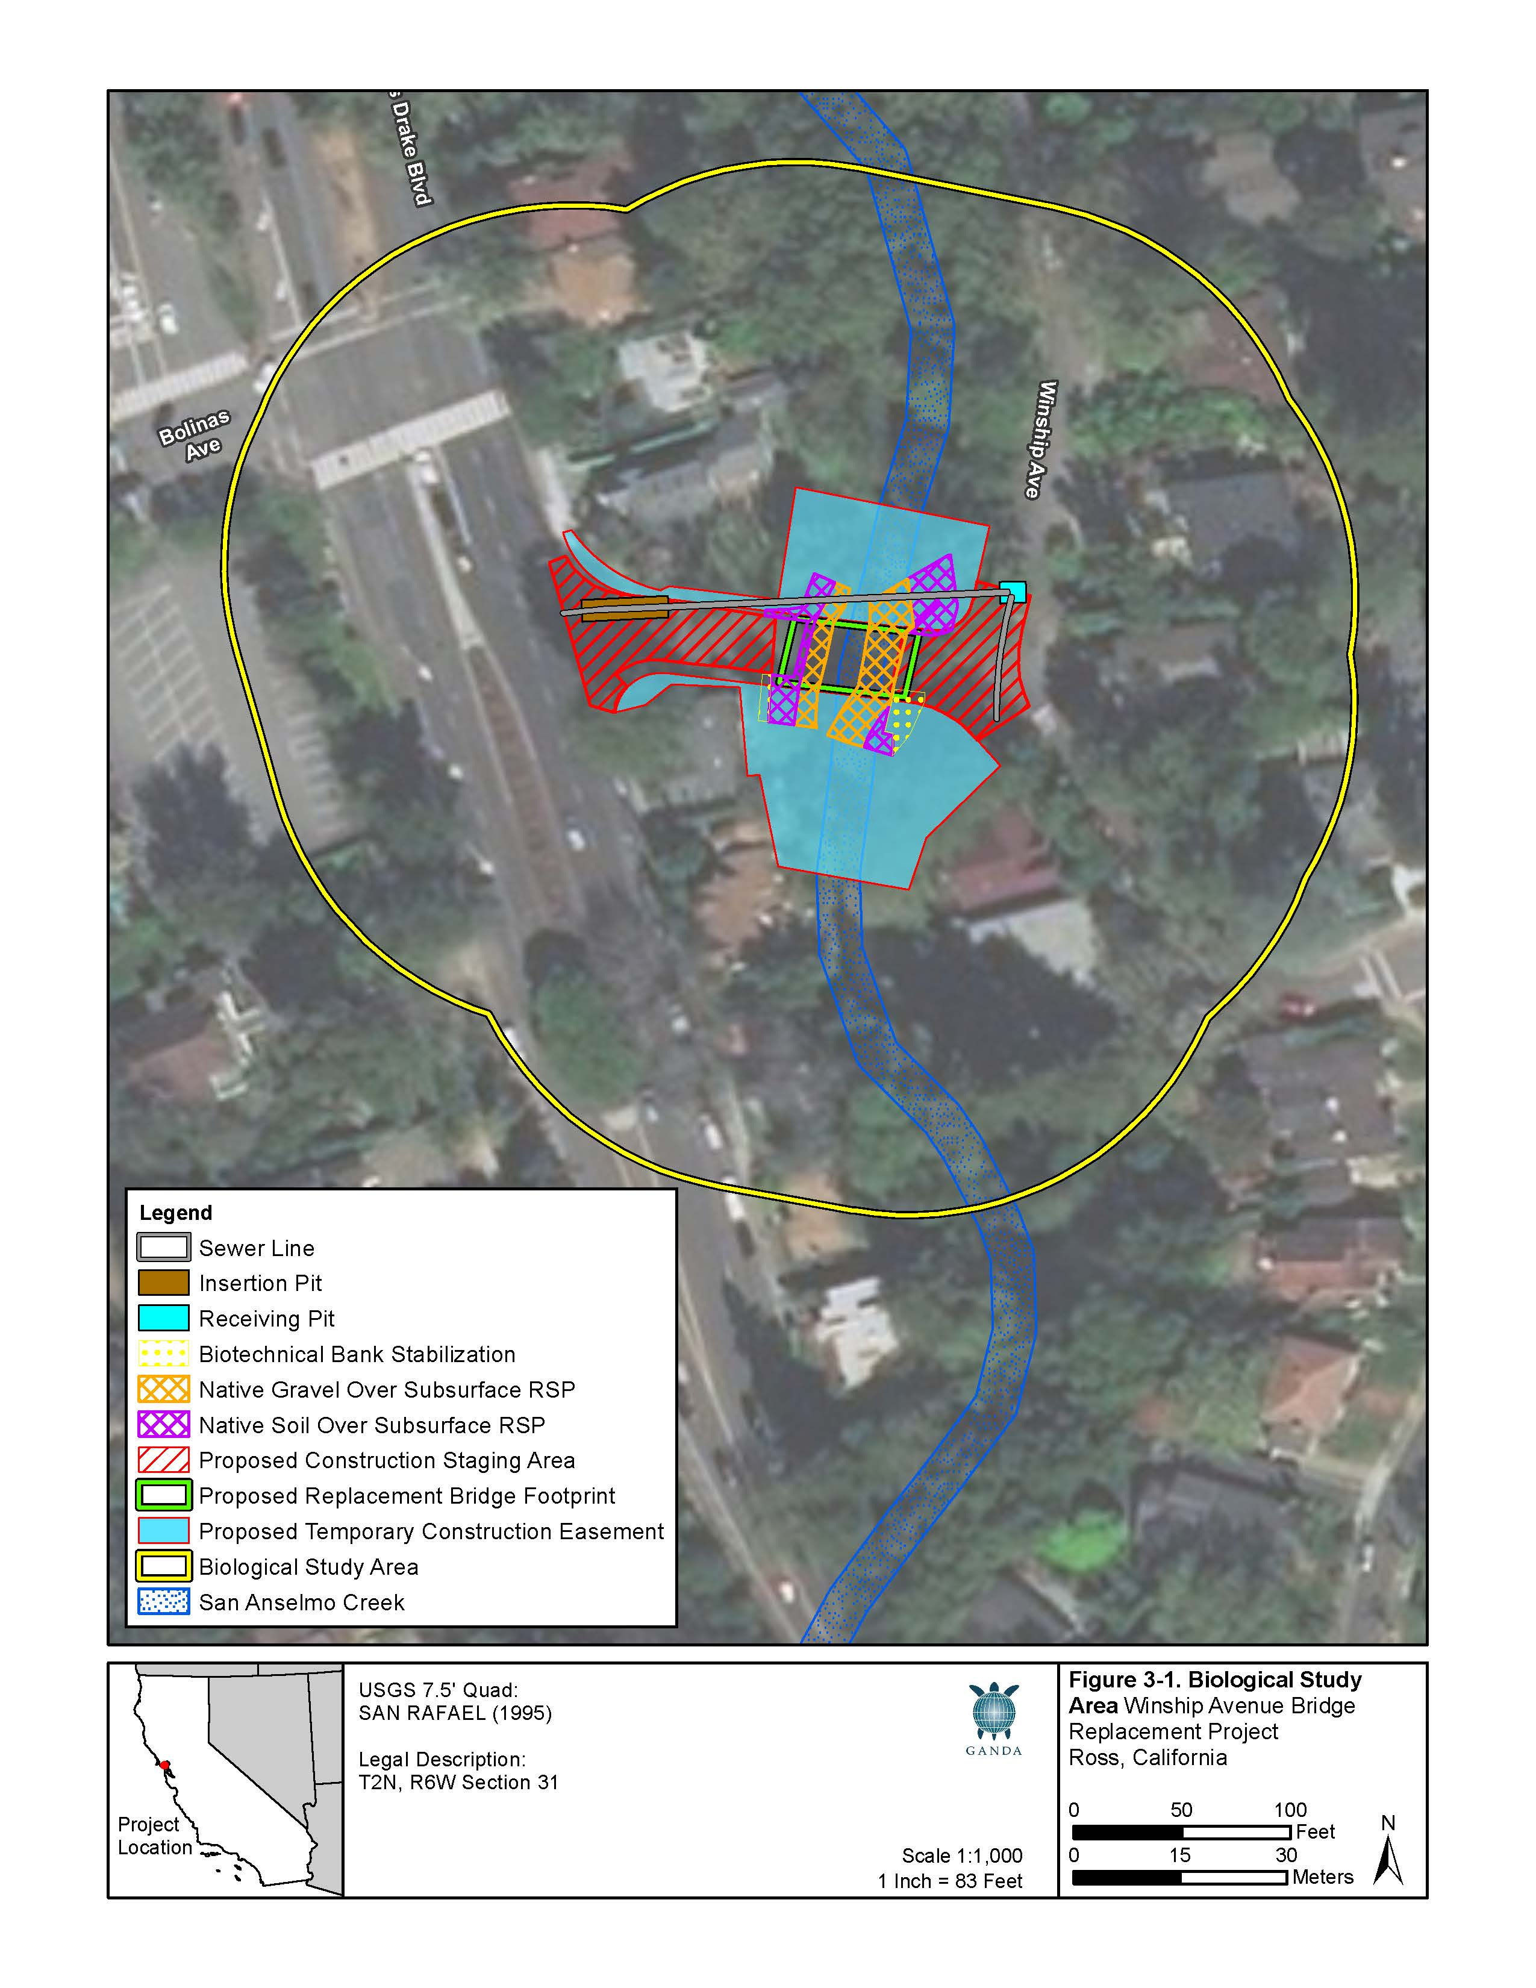

Table 3-2. Land Cover Types and Approximate Acreages within The Project Site.
Land Cover Type | Acreage
Alnus rhombifolia Forest Alliance – White alder groves | 0.23
Aquatic features¹ | 0.09
Residential/landscaped | 0.02
Paved roadway/sidewalks | 0.16
Total¹ | 0.49
¹ The total acreage does not include the acreage for paved roads over waters.
Alnus rhombifolia Forest Alliance – White alder groves. White alder groves can be found in various habitats such as riparian corridors, seeps, stream banks, and floodplains. They are most commonly found throughout cismontane California in inland foothills and lower montane zones, typically in thin strips along perennial stream corridors (Sawyer et al. 2009). The alliance is either dominated by white alder (Alnus rhombifolia) or co-dominated with other tree species or, if not dominant or co-dominant, is composed of mature trees that comprise greater than 5 percent of the canopy (Sawyer et al. 2009). Associations include those for stands lacking a well-defined shrub layer, those with a well-defined shrub layer, and those with a mixed tree canopy (Sawyer et al. 2009).
Within the BSA, the Alnus rhombifolia Forest Alliance along San Anselmo Creek has a mixed tree canopy with various other native and non-native tree species including California bay (Umbellularia californica), Oregon ash (Fraxinus latifolia), box elder (Acer negundo), coast redwood (Sequoia sempervirens), naturalized Northern California black walnut (Juglans hindsii), California buckeye (Aesculus californica), red willow (Salix laevigata), blue elderberry (Sambucus nigra spp. caerulea), tree of heaven (Ailanthus altissima), black locust (Robinia pseudoacacia), Peruvian peppertree (Schinus molle), and blackwood acacia (Acacia melanoxylon). The tree canopy is generally mature and the stream corridor beneath is almost completely shaded. Immediately downstream of the bridge on the left bank there is a small stand of coast redwoods.
The understory in the BSA is mostly comprised of invasive shrubs and vines, predominantly English ivy and Himalayan blackberry but also bamboo (Phyllostachys bambusoides), French broom (Genista monspessulana), and milkflower cotoneaster (Cotoneaster lacteus). The shrub layer also includes a small proportion of common native riparian species such as poison oak (Toxicodendron diversilobum), snowberry (Symphoricarpos albus), and chokecherry (Prunus virginiana). The herbaceous vegetation along the creek bed and banks includes native and non-native species including giant horsetail (Equisetum telmateia ssp. braunii), California polypody (Polypodium californicum), California maidenhair (Adiantum jordanii), bear’s breech (Acanthus mollis), field hedge parsley (Torilis arvensis), poison hemlock (Conium maculatum), black mustard (Brassica nigra), spearmint (Mentha spicata), stinging nettle (Urtica dioica), California bee plant (Scrophularia californica), coppertips (Crocosmia x crocosmiiflora), water smartweed (Persicaria amphibia), annual dogtail (Cynosurus echinatus), panic veldtgrass (Ehrharta erecta), foxtail barley (Hordeum murinum), California melic grass (Melica californica), tall cyperus (Cyperus eragrostis), and Bolander’s sedge (Carex bolanderi).
Within the staging area at the Town of Ross Maintenance Yard, a few trees, including valley oak (Quercus lobata), coast redwood, box elder, California bay, black locust, and plum (Prunus sp.), occur along the fence lines. English ivy was observed along the back fence and the adjacent left bank of Corte Madera Creek. The riparian corridor of Corte Madera Creek adjacent to the staging area had an open, mature riparian canopy including species such as California bay, valley oak, and big-leaf maple (Acer macrophyllum).
Aquatic Features – San Anselmo Creek. San Anselmo Creek is part of the Corte Madera Creek watershed, located in eastern Marin County and extending from the San Francisco Bay into the foothills of Mount Tamalpais. Corte Madera Creek and its 29 named tributaries comprise approximately 44 miles of stream corridor (FCMCW 2017). The San Anselmo Creek watershed drains an area of about 14.7 square miles, of which approximately 70 percent is natural environment and 30 percent is urban (CDFW 2013). The headwaters of San Anselmo Creek are located within open space and MMWD lands east of Pine Mountain and west of the Town of Fairfax. Cascade Creek, a major tributary, drains from Cascade Canyon to the north and joins San Anselmo Creek approximately 1 mile below its headwaters. From there, San Anselmo Creek flows east through the Town of Fairfax to its confluence with another major tributary, Fairfax Creek, and then flows east through the Town of San Anselmo where it is joined by Sleepy Hollow Creek, the last major tributary stream. From this point, it flows southeast through the project area and becomes Corte Madera Creek at its confluence with Ross Creek approximately 0.25 mile downstream of the project. Corte Madera Creek continues to flow southeast through the Town of Ross where it is encased by a concrete-lined channel for 1 mile. It then enters a tidal saltmarsh near the Town of Kentfield which drains into San Pablo Bay near the Town of Corte Madera.
The proposed project is in the lower reaches of San Anselmo Creek within the urbanized corridor of eastern Marin County. The lower reaches of San Anselmo Creek are heavily altered from decades of grazing, logging, and farming of the area, and ultimately urbanization. The creek banks are generally steep and deeply cut below the floodplain. To prevent erosion, the creek has been semi-channelized in many locations where the banks have been reinforced with RSP, concrete, and retaining walls.
In the BSA, San Anselmo Creek is a low-gradient perennial creek characterized by lateral scour pool and riffle sequences and is heavily impacted by incised banks and channel armoring. Several lateral scour pool/riffle sequences identified within the BSA are associated with RSP, undercut banks, the bridge structure, and a concrete retaining wall. On average, pool depths ranged between 0.5 and 2.5 feet deep at the time of the field survey. The creek substrate within the BSA is generally gravels and sand in the pools and cobbles and gravels in the riffle sections. The upstream banks are both variably armored with RSP and the downstream right bank is also armored, first with RSP and then with a concrete retaining wall further downstream (right and left banks are defined from the perspective of looking downstream).
USGS stream gage No. 11460000 is located on Corte Madera Creek approximately 0.5 mile downstream of the BSA and started acquiring data in 1951. USGS gage data show reduced flows during May through October with the lowest flows in August and the highest in January, on average (USGS 2017). In August of 1988 and 1989 and in September 1988, 1991, and 1992, the data show no flows (USGS 2017). Mean flow at this location in the wet season (approximately November through April) is between 15 and 87 cubic feet per second and mean flow during the dry season (approximately May through October) is between 0.32 and 4.1 cubic feet per second (USGS 2017).
The physical conditions of Corte Madera Creek adjacent to the staging area at the Town of Ross Maintenance Yard are similar to those of San Anselmo Creek at the project location; however, Corte Madera Creek was not entered during the survey and the streambed could not be viewed from the staging area. Corte Madera Creek at this location has a natural bottom and its lateral width is approximately 20 feet. The staging area is located just above the left bank of the creek; it is a level, heavily disturbed dirt and gravel yard in frequent use by heavy equipment and as a storage space for equipment and materials.
Within the BSA, San Anselmo Creek is classified in the National Wetland Inventory as a semi-permanently flooded upper perennial creek with an unconsolidated bottom (USFWS 2017). There are no jurisdictional wetlands features identified within the BSA. Vegetation in the BSA consists mostly of native riparian trees in the canopy and mostly non-native shrubs and vines in the understory.

Common Animal Species
Invertebrates. According to the Friends of Corte Madera Creek Watershed (FCMCW) report Fish and Wildlife of the Corte Madera Creek Watershed (2004), aquatic invertebrates documented in the Ross area include water striders (Gerridae), water scorpions (Nepidae), giant water bugs (Belostomatidae), water boatmen (Corixidae), water bugs (Naucoridia and Dytiscidae), diving beetles (Dytiscidae), whirligig beetles (Gyrinidae), Dobsonfly (Corydalinae) larvae, caddisfly (Trichoptera) larvae, damselfly (Zygoptera) nymphs, dragonfly (Anisoptera) nymphs, mayfly (Ephemeroptera) nymphs, mosquitoes (Culicidae), gnats (Nematocera), and black flies (Simuliidae). Signal crayfish (Pacifastacus leniusculus) were observed in San Anselmo Creek within the BSA during the field survey. Benthic macroinvertebrate sampling in freshwater reaches of the watershed found dipteran (fly) larvae were most numerous with pulmonate snails tending to dominate the biomass (FCMCW 2004).
Fish. Numerous fish species are known from the freshwater streams of the Corte Madera Creek watershed (MCWP 2017; FCMCW 2004). Surveys conducted by California Department of Fish and Game (CDFG) from 1960 through 1980 found five dominant fish taxa: rainbow trout/steelhead (Oncorhynchus mykiss), threespine stickleback (Gasterosteus aculeatus), California roach (Lavinia symmetricus), sculpin (Cottus sp.), and Sacramento sucker (Catostomus occidentalis), as well as occasional observations of coho salmon (Oncorhynchus kisutch [extirpated]). Other fish species that have been reported from the freshwater portions of the watershed include Pacific lamprey (Entosphenus tridentatus), Chinook salmon (Oncorhynchus tshawytscha), brown trout (Salmo trutta [non-native]), Sacramento pikeminnow (Ptychocheilus grandis), common carp (Cyprinus carpio [non-native]), mosquitofish (Gambusia affinis [non-native]), topsmelt (Atherinops affinis), Sacramento perch (Archoplites interruptus [extirpated]), tule perch (Hysterocarpus traski [extirpated]), and black crappie (Pomoxis nigromaculatus [non-native]) (A.A. Rich and Associates 2000; FCMCW 2004).
Fish surveys of the watershed conducted in 1999 found that of the five most abundant taxa (rainbow trout/steelhead, threespine stickleback, California roach, sculpin, and Sacramento sucker), trout were most numerous in San Anselmo Creek, followed by roach, stickleback, sculpin, and suckers (A.A. Rich and Associates 2000). CDFW conducted a stream assessment of San Anselmo Creek in 2009 and observed the same assemblage of fish species (CDFW 2013). Coho salmon were last reported in the watershed in 1984 (Leidy et al. 2005a). According to FCMCW (2017), pairs of adult Chinook salmon seen in 2001 and 2003 are likely aberrant from Sacramento River runs. Leidy identified both riffle sculpin (Cottus gulosus) and prickly sculpin (Cottus asper) in the lower reaches of Corte Madera Creek. Rainbow trout/steelhead juveniles and sculpin were observed in San Anselmo Creek within the BSA during the field survey.
Coho Salmon. Winter spawning runs of coho salmon (Central California Coast Evolutionarily Significant Unit [ESU]) are now considered extirpated from the watershed (Leidy 2007); however, they were common up until the 1970s. Anecdotally, during some years in the 1950s, spawning coho salmon were so abundant where San Anselmo Creek runs through the Sir Francis Drake High School campus, approximately 1.5 miles upstream of the project, that “the students could gather them up” (FCMCW 2017). Corte Madera Creek watershed streams are considered priority streams for restoration of coho salmon within the Central California Coast ESU in the San Francisco Bay estuary (Leidy et al. 2005).
Steelhead. Unlike coho salmon, which are considered extirpated from the Corte Madera Creek watershed, steelhead continue to utilize the streams (FCMCW 2017). San Anselmo Creek above, below, and within the BSA is designated critical habitat for steelhead (USFWS 2019). CDFG surveys in the 1960s reported that the majority of the steelhead nursery area in San Anselmo Creek was in the lower half of the creek (where the project area is located). CDFG surveys in 1969 estimated the steelhead population of San Anselmo Creek to be 23,000 individuals with juveniles inhabiting the 2 miles of creek between the confluence with Fairfax Creek and Winship Avenue Bridge (Leidy 2005b). Surveys in the 1990s and in 2009 consistently found O. mykiss of multiple age classes in the Corte Madera Creek watershed, which suggests good natural propagation. San Anselmo Creek may be the most important Corte Madera Creek tributary in terms of salmonid production (Leidy 2005b). Based on their stream habitat assessment survey conducted in 2009, the CDFW recommends that San Anselmo Creek be managed as “an anadromous, natural production stream” (CDFW 2013), which is their management designation for “all streams and stream reaches that currently support anadromous fish or are restorable to do so. These streams, reaches, and naturally reproducing stocks provide the foundation of the [C]DFG salmon management program” (CDFW 2010). Juvenile steelhead/rainbow trout were observed in the BSA during the field survey in pools located approximately 100 feet upstream and 175 feet downstream of the bridge, respectively (approximately 75 to 100 individuals total in a range of size classes between approximately 50 and 150 millimeters).
Amphibians and Reptiles. Herpetofauna known from the watershed include the California newt (Taricha torosa), California giant salamander (Dicamptodon ensatus), arboreal salamander (Aneides lugubris), California slender salamander (Batrachoseps attenuatus), yellow-eyed ensatina (Ensatina eschscholtzii xanthoptica), bay chorus frog (Pseudacris regilla), foothill yellow-legged frog, western pond turtle (Emys marmorata), Coast Range fence lizard (Sceloporus occidentalis bocourtii), California alligator lizard (Elgaria multicarinata multicarinata), Pacific ring-necked snake (Diadophis punctatus amabilis), California king snake (Lampropeltis californiae), Pacific gopher snake (Pituophis catenifer catenifer), common sharp-tailed snake (Contia tenuis), various garter snakes (Thamnophis spp.), and northern Pacific rattlesnake (Crotalus oreganus oreganus) (FCMCW 2004). California red-legged frogs (Rana draytonii) are not known to occur within the watershed but could occur in suitable habitat. There are recent records of breeding populations of foothill yellow-legged frogs from upper San Anselmo Creek and two tributary streams, Cascade Creek and Carey Camp Creek; these frogs are located approximately four to five miles upstream of the BSA (Garcia and Associates 2018 and 2019, unpublished data). These new records demonstrate an extant and robust population that was previously unknown prior to focused surveys in 2018. No amphibians or reptiles were observed during the field survey.
Birds. Avifauna in and around the lower reaches of San Anselmo Creek include many species found in riparian and adjacent upland terrestrial habitats in the north Bay Area including oak woodland, grassland, mixed hardwood and conifer forest, and urban areas. Some common bird species include mourning dove (Zenaida macroura), band-tailed pigeon (Patagioenas fasciata), Anna’s hummingbird (Calypte anna), acorn woodpecker (Melanerpes formicivorus), California scrub-jay (Aphelocoma californica), chestnut-backed chickadee (Poecile rufescens), oak titmouse (Baeolophus inornatus), bushtit (Psaltriparus minimus), American robin (Turdus migratorius), northern mockingbird (Mimus polyglottos), house finch (Haemorhous mexicanus), spotted towhee (Pipilo maculatus), California towhee (Melozone crissalis), song sparrow (Melospiza melodia), and dark-eyed junco (Junco hyemalis). Other species that reside in riparian habitats and are known to occur in lower San Anselmo Creek include mallard (Anas platyrhynchos), common merganser (Mergus merganser), green heron (Butorides virescens), Cooper’s hawk (Accipiter cooperii), red-shouldered hawk (Buteo lineatus), belted kingfisher (Megaceryle alcyon), Pacific-slope flycatcher (Empidonax difficilis), black phoebe (Sayornis nigricans), warbling vireo (Vireo gilvus), yellow warbler (Setophaga petechia), Wilson’s warbler (Cardellina pusilla), and black-headed grosbeak (Pheucticus melanocephalus) (FCMCW 1996; 2004). Band-tailed pigeon, Anna’s hummingbird, American crow (Corvus brachyrhynchos), chestnut-backed chickadee, and dark-eyed junco were heard or seen within the BSA during the field survey.
Mammals. Common mammals of Corte Madera Creek watershed that may occur in the BSA include Virginia opossum (Didelphis virginiana [non-native]), vagrant shrew (Sorex vagrans), bats (Chiroptera), western gray squirrel (Sciurus griseus), eastern fox squirrel (Sciurus niger [non-native]), deer mouse (Peromyscus maniculatus), dusky-footed wood rat (Neotoma fuscipes), Norway rat (Rattus norvegicus [non-native]), northern raccoon (Procyon lotor), striped skunk (Mephitis mephitis), and mule deer (Odocoileus hemionus) (FCMCW 2004). Gray squirrels, eastern fox squirrels, and mule deer sign (hoof prints) were observed in the BSA during the field survey. Bats commonly utilize a variety of habitats near water and may roost in trees, in the bridge, or in other structures in the BSA.

Habitat Connectivity - Established Native Resident or Migratory Wildlife Corridors
San Anselmo Creek is an important dispersal and migration corridor for wildlife. Most significantly, it is used for fish passage between the lower estuarine reaches of Corte Madera Creek and the San Francisco Bay and the upper stream reaches of San Anselmo Creek and its tributaries. There are no barriers blocking fish passage downstream of the BSA; however, several temporal barriers (impassable to all fish some of the time) impede movement of anadromous fish between spawning and summer rearing habitat in Corte Madera Creek and its tributaries, including San Anselmo Creek. These include a poorly designed fish ladder immediately upstream of the concrete channel that runs through Ross and Kentfield and several culverts and low dams (FCMCW 2017). Multiple temporal, partial (impassable to some fish all of the time), and total barriers exist upstream of the BSA in San Anselmo Creek and in its tributaries, Sleepy Hollow and Fairfax creeks (Ross Taylor and Associates 2006).

Special Status Species
Special-status species are plant and wildlife taxa that are legally protected under the Federal and California Endangered Species Acts (FESA), (CESA), or other State regulations, and species that are considered sufficiently rare by the scientific community to warrant conservation concern. The desktop literature and database review performed for the BSA (and surrounding area) identified 78 special-status plant and 85 special-status wildlife taxa. Of these, six plant and 28 wildlife taxa were determined to have at least some potential to occur in the BSA; these taxa, and their habitat requirements, are listed and more fully described in Appendix B, C, and E of the Natural Environment Study. Some of the special-status taxa identified in the literature review are not expected to be present in the BSA due to lack of suitable habitat or because the BSA is outside the known range of the taxon.
Special-Status Plants. A complete list of special-status plants that are known to occur or have potential to occur in the project region is provided in Appendix B, C, and E of the Natural Environment Study. The list of species is based on USFWS and CNPS information and was cross-referenced against CNDDB occurrence records. Only species determined to have potential to occur in the project BSA are discussed below. Based on the literature review, familiarity with the flora in the project region, and reconnaissance survey results, the six special-status plant taxa listed below are considered to have low potential to occur in the BSA. No special-status species were found during the rare plant survey conducted in late spring/summer of 2019.
- Sonoma alopecurus (Alopecurus aequalis var. sonomensis), Federally Endangered and California Rare Plant Rank (CRPR) 1B.1;
- Napa false indigo (Amorpha californica var. napensis), CRPR 1B.2;
- Marsh sandwort (Arenaria paludicola), Federally Endangered, State Endangered, and CRPR 1B.1;
- Seaside bittercress (Cardamine angulata), CRPR 2B.1;
- Western leatherwood (Dirca occidentalis), CRPR 1B.2, and,
- North Coast semaphore grass (Pleuropogon hooverianus), State Threatened and CRPR 1B.1.
Special-Status Wildlife. A complete list of special-status animals that are known to occur or have potential to occur in the project region is provided in Appendix B, C, and E of the Natural Environment Study. The list is based on the USFWS and NMFS official species lists and the CNDDB. Only species with potential to occur in the BSA are described below. San Anselmo Creek is designated critical habitat for steelhead (discussed above). Based on the literature review, familiarity with fauna in the project region, and the field survey results, the 25 special-status wildlife taxa listed below are considered to have at least some potential to occur within the BSA. Nesting birds and roosting bats, which are protected by the Migratory Bird Treaty Act (MBTA) and the California Fish and Game Code (CFGC), are also addressed.
- Marin hesperian (Vespericola marinensis), tracked by CNDDB;
- Western bumble bee (Bombus occidentalis), tracked by CNDDB;
- San Francisco Bay Area leaf-cutter bee (Trachusa gummifera), tracked by CNDDB;
- Pacific lamprey (Entosphenus tridentatus), CDFW Species of Special Concern (SSC);
- Chinook salmon (Central Valley Fall/Late Fall-run ESU) (Oncorhynchus tshawytscha), NMFS and CDFW SSC;
- Chinook salmon (Sacramento River Winter-run DPS) (Oncorhynchus tshawytscha), Federally Endangered (FE) and State Endangered (SE);
- Steelhead (Central California Coast DPS) (Oncorhynchus mykiss), Federally Threatened (FT);
- Riffle sculpin (Cottus gulosus), CDFW SSC;
- California giant salamander (Dicamptodon ensatus), CDFW SSC;
- California red-legged frog (Rana draytonii), FT and CDFW SSC;
- Foothill yellow-legged frog (Rana boylii), Candidate State Threatened (ST);
- Western pond turtle (Emys marmorata), CDFW SSC;
- Northern spotted owl (Strix occidentalis caurina), FT, ST, and CDFW SSC;
- Cooper’s hawk (Accipiter cooperii), CDFW Watch List;
- Allen’s hummingbird (Selasphorus sasin), USFWS Bird of Conservation Concern (BCC);
- Nuttall’s woodpecker (Picoides nuttallii), USFWS BCC;
- Oak titmouse (Baeolophus inornatus), USFWS BCC;
- Yellow warbler (Setophaga petechia), USFWS and CDFW SCC;
- Saltmarsh common yellowthroat (Geothlypis trichas sinuosa), USFWS BCC and CDFW SCC;
- Fox sparrow (Passerella iliaca), USFWS BCC;
- Western red bat (Lasiurus blossevillii), CDFW SSC;
- Pallid bat (Antrozous pallidus), CDFW SSC;
- Townsend’s big-eared bat (Corynorhinus townsendii), CDFW SSC;
- Hoary bat (Lasiurus cinereus), tracked by CNDDB; and,
- Ringtail (Brassariscus astutus), State Fully Protected species.
Special-Status Species Critical Habitat. San Anselmo Creek and Corte Madera Creek are designated critical habitat for steelhead (central California coast DPS). Steelhead critical habitat in the Corte Madera Creek watershed extends from Corte Madera Creek upstream to endpoints in Cascade Creek, San Anselmo Creek, Fairfax Creek, Sleepy Hollow Creek, Ross Creek, Tamalpais Creek, and Larkspur Creek (USFWS 2005). The lateral extent of the critical habitat is the width of the creek determined by the OHWM (within the project area, this is approximately 25 feet).
Essential Fish Habitat. The BSA is located within the San Pablo Bay - Below San Pablo Dam USGS 4th Field Hydrologic Unit (Number 18050002) which is designated as Pacific Coast Salmon Essential Fish Habitat (EFH) for Chinook and coho salmon (NMFS 2014a). EFH is defined as “waters and substrate necessary to fish for spawning, breeding, feeding or growth to maturity;” and “waters” are further defined as “aquatic areas and their associated physical, chemical, and biological properties that are used by fish and may include aquatic areas historically used by fish where appropriate” (PFMC 2014). The BSA is included within the Chinook and coho salmon EFH without known current Chinook or coho salmon distribution (Stadler et al. 2011). The Pacific Fishery Management Council (PFMC) developed five potential habitat areas of concern (HAPCs) within the Pacific Coast Salmon EFH: 1) complex channels and floodplain habitats, 2) thermal refuges, 3) spawning habitat, 4) estuaries, and 5) marine and estuarine submerged aquatic vegetation (PFMC 2014).

Migratory Bird Treaty Act
Nesting birds, including raptors, passerines, and non-passerines, are afforded protections under the MBTA and CFGC. The nesting period for birds is typically February 1 through August 31, although hummingbirds and some raptors are known to begin nesting in late December. The following is a list of special-status bird taxa that may occur within the BSA:
- Cooper’s hawk (Accipiter cooperii), CDFW Watch List (nesting);
- Allen’s hummingbird (Selasphorus sasin), USFWS BCC (breeding);
- Rufous hummingbird (Selasphorus rufous), USFWS BCC;
- Nuttall’s woodpecker (Picoides nuttallii), USFWS BCC;
- Oak titmouse (Baeolophus inornatus), USFWS BCC;
- Wrentit (Chamaea fasciata), USFWS BCC;
- Yellow warbler (Setophaga petechia), USFWS BCC and CDFW SSC (nesting);
- Saltmarsh common yellowthroat (Geothlypis trichas sinuosa), USFWS BCC and CDFW SSC;
- Spotted towhee (Pipilo maculatus), USFWS BCC; and
- Fox sparrow (Passerella iliaca), USFWS BCC (wintering).

Discussion
a) Have a substantial adverse effect, either directly or through habitat modifications, on any species identified as a candidate, sensitive, or special-status species in local or regional plans, policies, or regulations, or by the California Department of Fish and Wildlife or the U.S. Fish and Wildlife Service?
A Natural Environment Study (Garcia and Associates, 2019), which includes a Preliminary Delineation of Waters of the United States Report, was prepared for the proposed project to evaluate site conditions and potential impacts to sensitive habitats, biological species and botanical species. The report conclusions are the result of field survey findings and research to determine the potential of special-status species to occur within the study area, and/or if these species could be impacted by project activities. The following information is summarized from the Natural Environment Study.
Impacts of the proposed project on biological resources could result from vegetation removal, grading, and RSP placement during construction. In-water work could result in temporary disturbance to aquatic biological resources, with work restricted to periods of low-flow, most likely beginning in May. Terrestrial impacts (outside the creek channel) are considered to be relatively minor, because project implementation would be restricted to the developed surfaces along Winship Avenue and at the Town of Ross Maintenance Yard where equipment and materials may be temporarily staged.

Special-Status Plant Species
As previously described above, only six of the identified 78 special-status plant species (Sonoma Alopecurus, Napa false indigo, Marsh sandwort, Seaside bittercress, Western leatherwood, and North Coast semaphore grass) would be expected to occur in the study area. However, these species were not observed within the BSA during the July 2019 rare plant survey, which was conducted at a time that all special-status plant species with likelihood to occur were identifiable and would have been detectable if they occurred there. Therefore, the proposed project would have no impact on special-status plant species.

Special-Status Invertebrate Species
Three species of invertebrates that are tracked by the CNDDB, Marin hesperian (Vespericola marinensis), western bumble bee (Bombus occidentalis), and San Francisco Bay Area leaf-cutter bee (Trachusa gummifera), were determined to have at least some likelihood to occur in the BSA or it was not possible to determine whether or not they could occur.
Marin hesperian is a land snail which inhibits moist places including riparian areas in the larger coastal brushland and chaparral communities of Marin County and is found under cow-parsnip (Heracleum maximum) leaves, around spring seeps, and in leaf mold along streams. Although this species is known to occur in the vicinity of the BSA in habitats similar to San Anselmo Creek (such as Lagunitas and San Geronimo creeks), the BSA is considerably more disturbed than the locations where this species is apt to occur and also lacks seeps, springs, and cow-parsnip, making it very unlikely that this species would occur, even if it did historically.
Western bumble bees inhabit open grassy areas, urban parks and gardens, chaparral and scrub areas, and mountain meadows and typically nest in abandoned rodent burrows. This species is known from within 3 miles of the BSA and could occur incidentally in gardens around or within the BSA but would not be expected to reside or nest in the BSA.
No information was found on the habitat requirements or distribution of the San Francisco Bay Area leaf-cutter bee so it could not be determined whether the BSA contains suitable habitat for this species. It is known from two occurrences, one on Carson Ridge on MMWD land and the other described only as “San Francisco.”
All three of these species are tracked by the CNDDB but are not otherwise listed or proposed for listing as special-status species. None of these species are not considered likely to occur in the BSA or likely to be affected by the proposed project. Therefore, the proposed project would have no impact on special-status invertebrate species.

Special-Status Fish Species
Pacific Lamprey. Pacific lamprey, listed as an SSC by the CDFW, has a low likelihood to occur within the BSA. Based on their lifecycle and the low-flow conditions of San Anselmo Creek in the summer months, no spawning adults, nests, eggs, or emerging larvae would be expected in the BSA during the project’s in-stream work window (June 15 - October 15) (USFWS 2010), but adults residing in freshwater, lamprey larva (ammocoetes), and outmigrating juvenile lamprey may be present. In the unlikely event that lampreys are detected in the project area, vegetation removal and dewatering activities may temporarily affect this species. Potential loss of this SSC listed species would be a potentially significant impact.
Implementation of the species avoidance (including preconstruction surveys, environmental awareness training for construction workers, site monitoring, fish rescue plan measures, water diversion/dewatering measures, site replanting, and water quality best management practices identified in Mitigation Measures BIO-1 through BIO-11 (more fully described below) would reduce the potentially significant impact associated with disturbance and loss of lamprey habitat to a less-than-significant level.
Mitigation Measure BIO-1: Conduct Species Preconstruction Surveys
Prior to ground disturbing activities, a CDFW and/or USFWS qualified/approved biologist(s) shall conduct preconstruction surveys for special-status species and habitats in and adjacent to the proposed project site. The CDFW and/or the USFWS shall be notified within 24 hours if any unanticipated listed species are identified during these surveys. Preconstruction surveys include the following:
Special Status Fish Surveys: One week before the start of construction, a qualified fisheries biologist shall assess the project area for the presence of special status fish species based upon current water conditions. If special status fish species are determined to have the potential for presence in the project area, the following avoidance and minimizations measures shall be implemented. If the creek bed is entirely dry, no further measures from this measure shall be necessary.
- The biologist shall be on-site during all dewatering events to capture, handle, and safely relocated CESA/FESA-listed salmonids.
- Before and during dewatering of the construction site, juvenile steelhead and other fishes shall be captured and relocated out of the project area into suitable habitat, preferably downstream, to avoid direct mortality and minimize the possible stranding of fish in isolated pools. Fish in the project area shall be captured by dip net, seine, or, if necessary, by a qualified electrofishing technician using the appropriate techniques to minimize harassment and harm to fish. Electrofishing, if used, shall be conducted according to NMFS Guidelines for Electrofishing Waters Containing Salmonids Listed under the Endangered Species Act (NMFS, 2000).
- After all fish are removed from the project area, if water diversion is necessary, water shall be diverted around the project area to a point downstream of all project- related activities. Temporary cofferdams shall be constructed to prevent fish from re-entering the project area until completion of all construction in the creek.
- If channel diversions or cofferdams are needed, a qualified biologist shall monitor the construction site during placement and removal to ensure that any adverse effects to salmonids are minimized.
- Fill material for cofferdams shall be fully confined with the use of plastic sheeting, sheetpiles, sandbags, or with other nonporous containment methods, such that sediment does not come in contact with stream flow or in direct contact with the natural streambed. All loose fill material for cofferdams shall be completely removed from the channel by October 15. Alternatively, clean gravel or clean crushed stone may be used without plastic sheeting, sandbags, etc.
- A report shall be submitted to NMFS documenting the effects of construction and relocation activities on listed salmonids and performance of avoidance and minimization measures.
Herpetofauna - Foothill Yellow-legged Frog Surveys: Focused foothill yellow-legged frog surveys shall be conducted prior to construction. These surveys shall consist of four site surveys which shall include a tadpole survey in spring, a metamorph survey in late summer, and two breeding surveys in early spring. The foothill yellow-legged frog surveys shall be conducted by biologists following the Peek et al. protocol (Peek et al. 2017). In addition, a focused pre-construction survey of the BSA shall be conducted a maximum of 48 hours prior to the start of construction activities for special-status species within the project site. The preconstruction herpetofauna survey shall be performed by a biologist(s) with experience conducting surveys for all life stages of California red-legged frog (Rana draytonii) and foothill yellow-legged frog (Rana boylii). The survey shall include a thorough search of potential refugia for frogs and salamanders within the project site. If California giant salamanders (Dicamptodon ensatus) or western pond turtles (Emys marmorata) are observed within the project site, a biologist shall relocate the individuals the shortest distance possible to habitat unaffected by construction activities and increased project monitoring may be warranted. If California red-legged frogs or foothill yellow-legged frogs are found, they shall be protected from disturbance or relocated as per consultation with regulatory agencies.
Nesting Bird Surveys: A nesting bird survey shall be performed by a CDFW/USFWS qualified biologist within one month prior to the start of construction and again five days prior to the start of construction activities. If there is a lapse in project-related work of more than 7 days, additional surveys shall be conducted unless the work is occurring outside the nesting season (February 15 to August 31). Surveys for nesting birds within and around the project site shall be conducted by the approved biologist regularly during construction. Active nests shall be flagged for avoidance. If active bird nests are found, an adequate setback shall be established around the nest location and construction activities restricted within this no-disturbance zone until the biologist has confirmed that any young birds have fledged and are able to function outside the nest location. Required setback distances for the no-disturbance zone shall be based on input received from the CDFW and may vary depending on species and sensitivity to disturbance.
Roosting Bat Surveys: Focused surveys by a CDFW qualified bat biologist should be conducted to determine whether bats are roosting within or near to the project site, which species are utilizing which roosts and when, and whether there are maternity colonies which may be disturbed or lost due to the project. Most importantly, the bridge and all trees subject to removal should be thoroughly inspected for crevice roosts that may be utilized by day-roosting maternity colonies. Surveys for maternity colonies shall be conducted during the summer of the year before the project is scheduled so that any such roosts can be removed/replaced or exclusionary measures can be put in place prior to the onset of the non-volant period. If bat roosts are found during surveys, avoidance, minimization, and mitigation strategies outlined in the California Bat Mitigation Techniques, Solutions, and Effectiveness (H.T. Harvey & Associates 2004) shall be used as guidance to protect bats and their habitat.
Timing: Before and during construction.
Responsibility: Town of Ross / RVSD / Construction Contractor.
Mitigation Measure BIO-2: Conduct Environmental Awareness Training
All construction personnel shall attend a mandatory environmental education program delivered by an approved biologist prior to working on the proposed project. The training shall include: a description of protected biological resources including identification of special-status species and habitats that may occur within the proposed project construction area; an explanation of the status of these species and habitats and their protection under the Endangered Species Act and other laws; the measures to be implemented to conserve listed species and their habitats as they relate to the work site; descriptions of the boundaries within which construction may occur; and, all of the mitigation measures and BMPs to be followed during project implementation. If new construction personnel are added to the proposed project, they must receive the mandatory training before starting work.
Timing: Before and during construction.
Responsibility: Town of Ross / RVSD / Construction Contractor.
Mitigation Measure BIO-3: Implement Water Quality Best Management Practices (BMPs)
Before any ground-disturbing activities, the Town shall prepare and implement a Storm Water Pollution Prevention Program (SWPPP) (as required under the State Water Resources Control Board’s General Construction Permit Order 2009-0009-DWQ [and as amended by most current order(s)]) or a Water Pollution Control Program (WPCP) as applicable, that includes erosion control measures and construction waste containment measures to ensure that waters of the state are protected during and after project construction. The Plan (a SWPPP or WPCP) shall include site design to minimize offsite storm water runoff that might otherwise affect adjacent stream habitat.
The Plan (a SWPPP or WPCP) shall be prepared with the following objectives: (a) to identify pollutant sources, including sources of sediment, that may affect the quality of storm water discharges from the construction of the proposed project; (b) to identify BMPs to reduce or eliminate pollutants in storm water discharges and authorized non-storm water discharges from the project during construction; (c) to outline and provide guidance for BMP monitoring; (d) to identify proposed project discharge points and receiving waters; (e) to address post-construction BMP implementation and monitoring; and (f) to address sedimentation, siltation, and turbidity.
The Town shall also require that the construction contractor implement the following or similar Caltrans Standard BMPs, Section 13. Water Pollution Control of the Caltrans Standard Specifications (Caltrans 2018) and the Caltrans Construction Site BMPs Manual (Caltrans 2017), to protect water quality within San Anselmo Creek.
- No discharge of pollutants from vehicle and equipment cleaning are allowed into storm drains or watercourses.
- Construction equipment will be cleaned and inspected prior to use.
- Vehicle and equipment fueling and maintenance operations must be at least 50 feet away from watercourses. If refueling or servicing of equipment within 50 feet of a watercourse is necessary, secondary containment and absorbent pads will be used.
- Stationary equipment located within or adjacent to San Anselmo Creek or Corte Madera Creek will be positioned over secondary containment.
- Concrete wastes collected in washouts and water from curing operations will be collected and disposed of, and not allowed into watercourses. All grindings and asphaltic-concrete waste will be stored within previously disturbed areas absent of habitat and 150 feet, at a minimum, from any aquatic habitat, culvert, or drainage feature. If storage of grindings and asphaltic-concrete waste within 150 feet of Corte Madera Creek is necessary (i.e., at the Town of Ross Maintenance Yard), secondary containment and absorbent pads will be used; in addition, a protective barrier will be installed between the yard and the creek to prevent any spills and run-off from entering the creek.
- Sediment control will be implemented. On-site stockpiles will be isolated with silt fence, filter fabric, and/or straw bales/fiber rolls. Erosion, sediment, and material stockpile BMPs will be employed between work areas and the adjacent waterway. No fill or runoff will be allowed to enter waterways at any time.
- Hazardous materials will not be stored within 200 feet of San Anselmo Creek or Corte Madera Creek. If storage of hazardous materials within 200 feet of Corte Madera Creek is necessary (i.e., at the Town of Ross Maintenance Yard), secondary containment and absorbent pads will be used; in addition, a protective barrier will be installed between the yard and the creek to prevent any spills and run-off from entering the creek.
Timing: Before and during construction.
Responsibility: Town of Ross / RVSD / Construction Contractor.
Mitigation Measure BIO-4: Biological Monitor and On-Site Monitoring
The Town shall approve a qualified biologist(s) to provide services for the proposed project. If required by proposed project permits, the names and qualifications of the biological monitor(s) shall be submitted to the USFWS/NMFS for their approval prior to initiating construction activities for the proposed project. The approved monitor shall be on-site for all designated activities as required by the agencies during consultation.
The biologist(s) shall be on-site during in-water activities as required by proposed project permits, as well as for all designated activities required by the agencies during consultation. The biologist(s) shall keep copies of applicable permits in their possession when on site. Through the Town or their designee, the approved biologist(s) shall be given the authority to communicate either verbally, by telephone, email or hardcopy with all proposed project personnel to ensure permit requirements are fully implemented. Through the Town or their designee, the approved biologist(s) shall have the authority to stop proposed project activities to avoid take of listed species or if he or she determines that any permit requirements are not being fully implemented. The approved biologist shall monitor construction activities to ensure that adverse impacts to water quality, vegetation communities, aquatic resources, special habitats, and special-status species and their habitats are avoided and minimized and shall document and report any issues. The approved biologist shall be responsible for identifying, monitoring, and maintaining non-disturbance buffers for nesting birds and/or roosting bats.
During in-water activities, the approved biologist shall continuously monitor all activities (e.g., installation and removal of cofferdams and pipes) for the purpose of avoiding and minimizing any undue impacts to steelhead and other special-status aquatic species (fish and herpetofauna), steelhead critical habitat, and habitat areas of particular concern (HAPC) and Essential Fish Habitat (EFH) for coho and Chinook salmon, and to ensure that the diversion and dewatering devices are functioning properly. An approved aquatic biologist shall also be present for the purpose of removing and relocating any listed species that were not detected during the fish rescue or could not be removed and relocated prior to construction. The approved aquatic biologist shall be present at the work site until all listed species have been removed and relocated.
The approved biologist shall maintain detailed records of the species, numbers, life stages, and size classes of special-status species observed, collected, relocated, injured, or killed; as well as recording the date and time of each activity or observation and shall provide this information to NMFS and CDFW in a report/memo, as necessary. The approved biologist shall also maintain detailed records of any impacts to special-status habitats (to primary constituent elements [PCEs] of steelhead critical habitat and to HAPCs of coho and Chinook salmon EFH) and provide this information to NMFS.
Timing: Before and during construction.
Responsibility: Town of Ross / RVSD / Construction Contractor.
Mitigation Measure BIO-5: Limited Project Duration, Disturbance, and Footprint
To minimize impacts to the environment, construction-related disturbances and the project footprint shall both be limited to the minimum amount needed to complete the project. The duration and amount of construction-related disturbance in the creek channel shall also be limited to the extent practicable. Additionally, work in the San Anselmo Creek channel shall be restricted to the period from June 15 to October 15, when stream flow will be lowest and outside of the adult migration, spawning, incubation, larval phase, and smolt outmigration periods of steelhead (Oncorhynchus mykiss), coho salmon (Oncorhynchus kisutch), and Chinook salmon (Oncorhynchus tshawytscha). Construction shall be restricted to daylight hours to avoid the need for artificial lighting at night (which can attract and disturb fish and wildlife).
Timing: Before and during construction.
Responsibility: Town of Ross / Construction Contractor.
Mitigation Measure BIO-6: Implement a Fish Rescue Plan
A fish rescue plan shall be developed and implemented by the approved aquatic biologist in coordination with NMFS and/or CDFW. Individual organisms shall be relocated the shortest distance possible to an adjacent upstream area with sufficient aquatic habitat. Within occupied habitat, capture, handling, exclusion, and relocation activities shall be completed no earlier than 48 hours before construction begins. If electrofishing is conducted, it must be performed by an approved biologist following NMFS guidelines (NMFS 2000).
During fish relocation, all organisms shall be kept in water to the maximum extent possible and captured steelhead shall be kept in cool, shaded, well-aerated water and protected from disturbance and overcrowding until they are released. To avoid predation, two containers shall be used: one for young-of-the-year fish and one for second- or third-year fish. Captured fish shall be relocated to suitable upstream rearing habitat that is as close to the dewatered area as possible while meeting the survival needs (adequate water quality/quantity, cover, and forage) of both the relocated individuals and the fish already inhabiting the relocation site.
The fish rescue plan shall include methods for detecting and relocating lamprey larva (ammocoetes) following the recommendations in Electrofishing Recommendations for Sampling Larval Pacific Lampreys in Best Management Practices to Minimize Adverse Effects to Pacific Lamprey (Entosphenus tridentatus) (USFWS 2010).
Timing: Before and during construction.
Responsibility: Town of Ross / Construction Contractor.
Mitigation Measure BIO-7: Water Diversion and Dewatering
If flowing water is present in the channel, the flow shall be diverted around the work area by creating a temporary diversion to isolate a dry active construction work area following BMP NS-5: Clear Water Diversion in the Caltrans Construction Site BMP Manual (Caltrans 2017). The temporary diversion shall be installed as close as possible to the construction area to minimize impacts to the flow of the stream and shall be constructed to ensure a tight seal with the creek bed to allow for a dry work area and minimize downstream turbidity. As necessary, water behind the dam shall be pumped out and piped to a downstream location. Any water intake structure shall be installed, operated, and maintained in accordance with current NMFS, USFWS, and CDFW criteria, or as developed in cooperation with NMFS, USFWS, and CDFW to accommodate site-specific conditions. Water shall be released or pumped downstream at an appropriate rate to maintain downstream flows and the outlet of all diversions shall be positioned such that the discharge of water does not result in bank erosion or channel scour and maintains pre-project hydraulic conditions. The length of the pipe shall be the minimum necessary to safely convey the flow through the construction site and shall be placed on the streambed at natural grade. Diverted flows shall be returned to the stream channel immediately downstream of the work area. Immediately upon completion of in-channel work, temporary fills, diversion cofferdams, and other in-channel structures shall be removed in a manner that minimizes disturbance to downstream flows and water quality. Creek diversion shall be limited to the minimum amount of time necessary to support construction activities.
If there is no flow in the creek during the construction period, only localized dewatering or short cofferdams shall be needed at the abutment locations to control groundwater during abutment construction. Impacted waters located in the work area shall either be treated per the requirements of a SWPPP or disposed of per RWQCB requirements. All activities within the channel shall commence only after appropriate BMPs for dewatering and protecting water quality are in place.
Timing: Before and during construction.
Responsibility: Town of Ross / Construction Contractor.
Mitigation Measure BIO-8: Steelhead Critical Habitat and EFH Protection
Downed trees, stumps, boulders, and other refuge adjacent to the construction site shall remain undisturbed. Thermal refugia (pools) and suitable spawning sites adjacent to the construction site shall also remain undisturbed. Disturbances to steelhead critical habitat and EFH shall be documented by the approved biologist and provided to NMFS as necessary.
Timing: Before and during construction.
Responsibility: Town of Ross / Construction Contractor.
Mitigation Measure BIO-9: Implement Tree Protection Measures
Tree preservation measures including root pruning, cabling, trunk armoring, and monitoring by a licensed arborist shall be incorporated into the project design and implemented during project planning and construction to minimize tree removal and loss in the project area. The project shall comply with the Town’s tree protection ordinance, which will include procuring a tree removal permit and submitting a tree protection plan.
Timing: Before and during construction.
Responsibility: Town of Ross / Construction Contractor.
Mitigation Measure BIO-10: Implement Creek Bed and Bank Protection Measures
The creek bed and banks shall be protected to prevent permanent impacts from temporary construction access and project construction. Native substrates removed during excavations and earthwork shall be stockpiled and returned to the creek bed and banks following project construction as part of the site restoration effort. The creek bed and banks shall be restored to natural and stable conditions following construction and revegetated with native riparian plantings. Additional measures that must be complied with include the following:
- If riparian vegetation must be cut back, it shall be to the minimum height necessary (no lower than ground level) in order to promote rapid re-growth.
- Downed trees, stumps, boulders, and other basking sites and refuges within aquatic habitat surrounding the project site shall remain undisturbed and any minor, temporary disturbance restored to natural and stable conditions following construction.
- Debris containment shall be provided to keep bridge debris from falling into San Anselmo Creek during demolition and construction activities.
- All food-related trash items such as wrappers, cans, bottles, and food scraps shall be disposed of in closed containers and removed at least once a day from the work area.
- No firearms shall be allowed in the active construction area except for those carried by authorized security personnel, or local, state, or federal law enforcement officials.
- To prevent harassment, injury, or mortality of sensitive species, no pets of proposed project personnel shall be permitted on the project site.
- Proposed project personnel shall not engage in hunting or fishing within the project area.
- RSP installation shall follow fish passage guidelines consistent with the California Salmonid Stream Restoration Manual (CDFW 2010) and the NMFS Anadromous Salmonid Passage Facility Design (NMFS 2008).
Timing: During and after construction.
Responsibility: Town of Ross / Construction Contractor.
Mitigation Measure BIO-11: Return Temporarily Disturbed Areas to Pre-Project Conditions
Modified or disturbed portions of the stream channel, banks, and riparian areas shall be restored to natural and stable contours (elevations, profile, and gradient). Native substrates removed during excavations and earthwork shall be stockpiled and returned to the creek bed and banks. A native grass seed mix shall be applied to areas disturbed by construction, creek access, and contouring, as well as to areas where native soils overlay the buried RSP. Existing non-native vegetation, such as Himalayan blackberry and English ivy, shall be replaced with native riparian plantings. Riparian trees shall be planted in areas on-site and in-kind to those requiring removal for construction access. Riparian plants shall also be planted along the banks in the areas of bank stabilization, RSP placement, and any disturbed areas. Live willow cuttings shall be used at the appropriate lower bank elevations (just above bank toe).
Timing: During and after construction.
Responsibility: Town of Ross / Construction Contractor.
Chinook Salmon Central Valley Fall/Late Fall-Run ESU and Sacramento River Winter-Run ESU. Two ESUs of Chinook salmon (Oncorhynchus tshawytscha), the Central Valley Fall/Late Fall-run and the Sacramento River Winter-run, have a low likelihood to occur in the BSA. The Central Valley fall/late fall-run is listed as an SSC by NMFS and CDFW and the Sacramento River winter-run is listed by the USFWS and CDFW as endangered. No Chinook salmon were observed during the field survey for this project and they are not expected to occur in San Anselmo Creek or within the BSA with any regularity, if at all. San Anselmo Creek would not support spawning Sacramento River winter-run Chinook salmon because there is not adequate water quantity or flow during their spawning season (typically early summer). However, if present, direct impacts from temporary disturbance are anticipated to this species and its habitat due to the project-related dewatering and potential relocation efforts. Potential loss of this federal and state listed species would be a potentially significant impact.
Implementation of the species avoidance (including preconstruction surveys, environmental awareness training, site monitoring, fish rescue plan measures, water diversion/dewatering measures, site replanting, water quality best management practices, and wildlife refugia protection) measures identified in Mitigation Measures BIO-1 through BIO-11 (more fully described above) would reduce the potentially significant impact associated with disturbance and loss of Chinook salmon species and habitat to a less-than-significant level. In addition, the increase in creek capacity resulting from a single span bridge and from the removal of fill from the creek bed and banks will result in a net increase in habitat for salmonids in the project area. Following construction, restoration of the creek’s flow, bed, and banks to previous conditions and potentially improving habitat by increasing native riparian plantings would maintain or improve habitat conditions for salmon.
Steelhead Central California Coast DPS. The Central California Coast DPS of winter-run steelhead is a Federally Threatened species with a high likelihood to occur in the BSA. This species has both an anadromous form known as “steelhead” and a resident form known as “rainbow trout.” Rainbow trout are not federally listed and both forms may be found within Corte Madera Creek (Leidy 2005b, 2007; A.A. Rich and Associates 2000). According to NMFS, any species found in waters that are accessible to steelhead is considered a steelhead and afforded the protection of the federal ESA. Juvenile steelhead/rainbow trout were observed in the BSA during the field survey in pools located approximately 100 feet upstream and 175 feet downstream of the bridge, respectively (approximately 75 to 100 individuals total in a range of size classes between approximately 50 and 150 millimeters). Steelhead are known to occur in San Anselmo and Corte Madera creeks and both creeks were designated critical habitat for this species in 2005 (USFWS 2005).
If present during construction, impacts to this species from temporary disturbances associated with the project are anticipated due to fish relocation, creek dewatering, and a temporary increase in sediment mobilization. If juvenile steelhead are relocated out of the construction area prior to dewatering, relocation efforts could result in injury or mortality to pre-smolt juvenile steelhead; additionally, if juveniles escape capture, they may be adversely affected by dewatering activities. In the past, NMFS has estimated that fish rescue and dewatering activities in similar situations would result in mortality to less than 3 percent of individuals present (NMFS 2014b). Additional direct impacts to steelhead include the temporary loss of suitable habitat during project construction from dewatering of the project site. Indirect impacts to steelhead and steelhead habitat may include competition with other juveniles at relocation sites; increases in downstream turbidity during re-watering and during the first high flows following construction as a result of project work on the banks and within the channel; changes to water temperature due to obstruction or alteration of flow and/or due to removal of thermal refugia, including shade and deep pools; disturbance to, or removal of, forage (such as macroinvertebrate communities in dewatered areas); removal of cover such as aquatic and emergent vegetation, boulders, and woody debris; and, disturbances to substrates. Potential loss of this federally listed species would be a potentially significant impact.
Implementation of the species avoidance (including preconstruction surveys, environmental awareness training, site monitoring, fish rescue plan measures, water diversion/dewatering measures, site replanting, water quality best management practices, wildlife refugia protection, and Steelhead Critical Habitat and EFH protection) measures identified in Mitigation Measures BIO-1 through BIO-11 (more fully described above) would reduce the potentially significant impact associated with disturbance and loss of steelhead species and habitat to a less-than-significant level. In addition, the project design incorporates a larger hydraulic opening for water passage under the bridge than currently exists (a result of fill removal and added area under the bridge from the new bridge design), removes a mid-channel pier present in the existing bridge, and also realigns the bridge opening to the creek channel; all of these design attributes would directly benefit steelhead habitat at the project location by minimizing bank erosion and scouring during flood events and improving fish passage. Following construction, restoration of the creek’s flow, bed, and banks to previous conditions and potentially improving habitat by increasing native riparian plantings would maintain or improve habitat conditions for steelhead.
Riffle Sculpin. Riffle sculpin (Cottus gulosus) are listed as SSC by CDFW and have a high likelihood to occur in the BSA. Riffle sculpin are known from Corte Madera Creek from near the Town; prickly sculpin (Cottus asper), however, are also known from this location, as well as upstream locations in the Towns of San Anselmo (Madrone Avenue Bridge) and Fairfax (Leidy 2007). These two species can co-occur, and sculpin were observed within the BSA during the field survey. Sculpin are difficult to identify to species and no species identification was made in the field during the survey for this project.
If present during construction, impacts to this species from temporary disturbances associated with the project are anticipated due to fish relocation, creek dewatering, and a temporary increase in sediment mobilization. If riffle sculpin are relocated out of the construction area prior to dewatering, relocation efforts could result in injury or mortality to juvenile species; additionally, if juveniles escape capture, they may be adversely affected by dewatering activities. Additional direct impacts to this species include the temporary loss of suitable habitat during project construction from dewatering of the project site. Indirect impacts to species and habitat may include competition with other juveniles at relocation sites; increases in downstream turbidity during re-watering and during the first high flows following construction as a result of project work on the banks and within the channel; changes to water temperature due to obstruction or alteration of flow and/or due to removal of thermal refugia, including shade and deep pools; disturbance to, or removal of, forage (such as macroinvertebrate communities in dewatered areas); removal of cover such as aquatic and emergent vegetation, boulders, and woody debris; and, disturbances to substrates. Potential loss of this SSC listed species would be a potentially significant impact.
Implementation of the species avoidance (including preconstruction surveys, environmental awareness training, site monitoring, fish rescue plan measures, water diversion/dewatering measures, site replanting, water quality best management practices, wildlife refugia protection, and Steelhead Critical Habitat and EFH protection) measures identified in Mitigation Measures BIO-1 through BIO-11 (more fully described above) would reduce the potentially significant impact associated with disturbance and loss of riffle sculpin species and habitat to a less-than-significant level. Similar to steelhead, the project design incorporates a larger hydraulic opening for water passage under the bridge than currently exists (a result of fill removal and added area under the bridge from the new bridge design), removes a mid-channel pier present in the existing bridge, and also realigns the bridge opening to the creek channel; all of these design attributes would directly benefit riffle sculpin habitat at the project location. Following construction, restoration of the creek’s flow, bed, and banks to previous conditions and potentially improving habitat by increasing native riparian plantings would maintain or improve habitat conditions for riffle sculpin.

Special-Status Reptile and Amphibian Species
California Giant Salamander. California giant salamander (Dicamptodon ensatus) has a low to moderate likelihood to occur within the BSA. California giant salamanders are listed by CDFW as SSC. No California giant salamanders were observed during the field survey for this project. They are known to occur in Marin County and in the Corte Madera Creek watershed, this species is very likely to occur in upper San Anselmo Creek and its tributaries. However, the narrow, urbanized riparian corridor within the BSA is not especially suitable habitat for this species.
If present during construction, impacts to this species from temporary disturbances associated with the project are anticipated due to vegetation removal, creek dewatering, and other construction activity within the creek bed and bank. If California giant salamanders are located under refugia in upland habitat within the BSA, they could also be impacted by construction activities. However, as larval and adult salamanders are mobile, and breeding is not common in the BSA, it is anticipated that any salamanders in the impact area will move away from the project activities. Potential loss of this SSC listed species would be a potentially significant impact.
Implementation of the species avoidance (including preconstruction surveys, environmental awareness training, site monitoring, water diversion/dewatering measures, site replanting, water quality best management practices, and wildlife refugia protection) measures identified in Mitigation Measures BIO-1 through BIO-11 (more fully described above) would reduce the potentially significant impact associated with disturbance and loss of California giant salamander species and habitat to a less-than-significant level.
California Red-Legged Frog. California red-legged frogs (Rana draytonii) have a low likelihood to occur within the BSA. California red-legged frogs are listed by USFWS as Threatened and by CDFW as SSC. California red-legged frogs inhabit lowlands and foothills near permanent (or mostly permanent) sources of deep water with emergent aquatic vegetation or shrubby riparian vegetation including freshwater marshes, stock ponds, and riparian habitats. Permanent or semi-permanent, slow moving or still water is required for juvenile rearing (11 to 20 weeks) and upland habitats are used for aestivation, refuge, and foraging (these upland aestivation habitats are required when waters are ephemeral). No California red-legged frogs were observed during the field survey for this project. No records could be found of any protocol surveys being conducted in San Anselmo Creek for this species. California red-legged frogs are not known to occur in San Anselmo Creek or anywhere within the Corte Madera Creek watershed (CDFW 2019, MCWP 2017); however, this area is within the historic range of this frog. There are no CNDDB records of California red-legged frogs within 5 miles of the BSA (CDFW 2019).
If present during construction, impacts to this species from temporary disturbances associated with the project are anticipated due to vegetation removal, creek dewatering, and other construction activity within the creek bed and bank. While California red-legged frogs are not expected to occur in the BSA, potential loss of this federal and state listed species would be a potentially significant impact.
Implementation of the species avoidance (including preconstruction surveys, environmental awareness training, site monitoring, water diversion/dewatering measures, site replanting, water quality best management practices, and wildlife refugia protection) measures identified in Mitigation Measures BIO-1 through BIO-11 (more fully described above) would reduce the potentially significant impact associated with disturbance and loss of California red-legged frog species and habitat to a less-than-significant level.
Foothill Yellow-Legged Frog. Foothill yellow-legged frogs (Rana boylii) have a low to moderate likelihood to occur within the BSA. Foothill yellow-legged frogs are listed by CDFW as Candidate Threatened. No foothill yellow-legged frogs were observed during the field survey for this project. No records could be found of any protocol surveys being conducted in lower San Anselmo Creek for this species. Recently, Garcia and Associates biologists documented breeding foothill yellow-legged frogs in the upper San Anselmo Creek watershed, approximately 4.5 miles upstream of the BSA (Garcia and Associates 2018 and 2019); these frogs were previously unknown to occur despite multiple years of fish surveys conducted along the stream reaches. There are also CNDDB records of foothill yellow-legged frogs within 5 miles of the BSA from Cataract Creek, Big Carson Creek, and Little Carson Creek (CDFW 2019). The potential suitable habitat within the project area for foothill yellow-legged frogs is considered somewhat marginal for the following reasons:
- Presence of predatory native and domestic animals (signal crayfish, raccoons, cats, and dogs);
- Urbanization, steep banks, and channelized nature of the creek in the BSA; and,
- High percent canopy cover and associated reduced basking habitat.
If present during construction, impacts to this species from temporary disturbances associated with the project are anticipated due to vegetation removal, creek dewatering, and other construction activity within the creek bed and bank. If Foothill Yellow-legged frogs are located under refugia in upland habitat within the BSA, they could also be impacted by construction activities. However, as frogs are mobile, and breeding is not common in the BSA, it is anticipated that any frogs in the impact area will move away from the project activities. Potential loss of this state listed species would be a potentially significant impact.
Implementation of the species avoidance (including preconstruction surveys, environmental awareness training, site monitoring, water diversion/dewatering measures, site replanting, water quality best management practices, and wildlife refugia protection) measures identified in Mitigation Measures BIO-1 through BIO-11 (more fully described above) would reduce the potentially significant impact associated with disturbance and loss of Foothill Yellow-legged frog species and habitat to a less-than-significant level.
Western Pond Turtle. The western pond turtle (Emys marmorata) is listed as an SSC by CDFW. Western pond turtles are found in quiet water of freshwater aquatic habitats including rivers, streams, lakes, ponds, marshes, and irrigation ditches, usually with aquatic vegetation, from California to Washington. No western pond turtles were detected during the field survey. There are no records of western pond turtles in San Anselmo Creek (CDFW 2019; MCWP 2017; FCMCW 1996). There are few potential basking sites within the BSA, which is heavily shaded. No suitable nesting habitat was identified within the BSA or adjacent uplands; however, the BSA could serve as a dispersal habitat for western pond turtles. The nearest CNDDB records are from Phoenix Lake, Lagunitas Lake, Bon Tempe Creek, and Alpine Lake on Mount Tamalpais (CDFW 2019).

If present during construction, impacts to this species from temporary disturbances associated with the project are anticipated due to vegetation removal, creek dewatering, and other construction activity within the creek bed and bank. If turtles are located under refugia in upland habitat within the BSA, they could also be impacted by construction activities. However, as turtles are mobile, and breeding is not common in the BSA, it is anticipated that any turtles in the impact area will move away from the project activities. Potential loss of this state listed species would be a potentially significant impact.
Implementation of the species avoidance (including preconstruction surveys, environmental awareness training, site monitoring, water diversion/dewatering measures, site replanting, water quality best management practices, and wildlife refugia protection) measures identified in Mitigation Measures BIO-1 through BIO-11 (more fully described above) would reduce the potentially significant impact associated with disturbance and loss of western pond turtle species and habitat to a less-than-significant level.

Special-Status Bird Species
Northern Spotted Owl. The northern spotted owl (Strix occidentalis caurina) is listed as Federally Threatened and State Threatened, CDFW SSC, and is protected under the MBTA. Northern spotted owls occur in many types and age-classes of forests, usually old-growth forests, in the Pacific Coast region from southwestern British Columbia to central California. No northern spotted owls were detected during the field survey. Nesting owls are not expected in the BSA because of the surrounding urban environment and the abundance of natural habitat nearby; however, owls could utilize the area while foraging. There are 20 known spotted owl territories within 5 miles of the BSA; the closest is near Phoenix Lake, approximately 1.3 miles southwest of the BSA (CDFW 2019).

If present during construction, impacts to this species from temporary disturbances associated with the project are anticipated due to vegetation/tree removal. Potential loss of this federal and state listed species would be a potentially significant impact. Implementation of the species avoidance (including preconstruction surveys, environmental awareness training, site monitoring, site replanting, water quality best management practices, and nesting bird protection) measures identified in Mitigation Measures BIO-1 through BIO-5, BIO-8 through BIO-11 (more fully described above), and Mitigation Measure BIO-12 (described below) would reduce the potentially significant impact associated with disturbance and loss of northern spotted owl species and habitat to a less-than-significant level.
Mitigation Measure BIO-12: Nesting Bird Protection.
Avian nesting season shall be considered February 15 – August 31 for this project. This timeframe covers the nesting season of most of the birds expected in the project vicinity, raptors and non-raptors. Tree removal and vegetation trimming shall occur outside of the nesting season to the extent possible.
If work must occur within 250 feet of active raptor or special-status species nests or within 50 feet of active passerine nests, a non-disturbance buffer shall be established at a distance sufficient to minimize disturbance based on the nest location, topography, cover, the species’ sensitivity to disturbance, and the intensity/type of potential disturbance. Active nests found shall be demarcated with flagging and a non-disturbance buffer zone shall be established. An initial 250-foot buffer shall be established for raptors and special-status species and a 50-foot buffer for all other nests. The non-disturbance buffer shall be visibly marked to prevent encroachment of construction activities. An approved biologist may reduce the buffer size based on construction activities and observations of nesting behavior. Active nests shall be monitored by an approved biologist to determine when the nest is no longer active, and non-disturbance buffers shall remain in place until the nest is no longer active (i.e., either when the young have fledged or the nest has failed). If nesting bird protections will impact construction windows established to protect other listed species (i.e., fish), then the appropriate agencies shall be consulted to establish alternate avoidance measures.
Timing: Before and during construction.
Responsibility: Town of Ross / RVSD / Construction Contractor.

Protected Migratory Birds and Raptors
Nesting birds, including raptors, passerines, and non-passerines, are afforded protections under the MBTA and CFGC. The nesting period for birds is typically February 1 through August 31, although hummingbirds and some raptors are known to begin nesting in late December. The following is a list of special-status bird taxa that may occur within the BSA:

- Cooper’s hawk (Accipiter cooperii), CDFW Watch List (nesting);
- Allen’s hummingbird (Selasphorus sasin), USFWS BCC (breeding);
- Rufous hummingbird (Selasphorus rufous), USFWS BCC;
- Nuttall’s woodpecker (Picoides nuttallii), USFWS BCC;
- Oak titmouse (Baeolophus inornatus), USFWS BCC;
- Wrentit (Chamaea fasciata), USFWS BCC;
- Yellow warbler (Setophaga petechia), USFWS BCC and CDFW SSC (nesting);
- Saltmarsh common yellowthroat (Geothlypis trichas sinuosa), USFWS BCC and CDFW SSC;
- Spotted towhee (Pipilo maculatus), USFWS BCC; and
- Fox sparrow (Passerella iliaca), USFWS BCC (wintering).

The BSA and surrounding area provides suitable nesting habitat for numerous species of birds protected under the MBTA and CFGC. Several common species observed during the field survey that also have potential to nest within the BSA include Anna’s hummingbird, chestnut-backed chickadee, and dark-eyed junco. Special-status species with potential to nest within the BSA include Cooper’s hawk, Allen’s hummingbird, Nuttall’s woodpecker, oak titmouse, yellow warbler, and spotted towhee. Unlike many bridges, the concrete arches of the Winship Avenue Bridge are not likely to support structure-nesting birds such as swallows and black phoebes.

The proposed project has the potential for direct and indirect impacts to nesting birds through nest abandonment, nest failure, nest destruction, and premature fledging. If present during construction, impacts to this species from temporary disturbances associated with the project are anticipated due to vegetation/tree removal. Potential impacts on active nests of these bird species would be a potentially significant impact. Implementation of the species avoidance (including preconstruction surveys, environmental awareness training, site monitoring, site replanting, water quality best management practices, and nesting bird protection) measures identified in Mitigation Measures BIO-1 through BIO-5, BIO-8 through BIO-11 (more fully described above), and Mitigation Measure BIO-12 (described above) would reduce the potentially significant impact associated with disturbance and loss of protected bird species and their habitat to a less-than-significant level.

Special Status Mammal Species
Ringtail. The ringtail (Brassariscus astutus) is listed by the CDFW as a Fully Protected species. Ringtails occur in many habitats, including coniferous forests, oak woodlands, pinyon pine-juniper woodlands, chaparral, and deserts. They are often found in rocky areas, near cliffs, canyons, or talus slopes. They are also often associated with riparian habitats. They frequent disturbed and natural spaces as well as areas near human habitation. No ringtails were detected during the field survey. There are no suitable den sites in the BSA; however, ringtails could utilize the area while foraging. There are no CNNDB records of this species in Marin County (CDFW, 2019)

No impacts to ringtails are expected to occur as a result of the project because ringtails would only be expected in the project area while foraging at night and construction is only scheduled to occur during daylight hours. However, ringtails could be temporarily displaced by construction activities. Implementation of the species avoidance (including preconstruction surveys, environmental awareness training, site monitoring, site replanting, water quality best management practices, and nesting bird protection) measures identified in Mitigation Measures BIO-1 through BIO-12 (more fully described above) would ensure impacts to ringtails and their habitat are less-than-significant.

Bats. The CFGC (Section 4150) prohibits take of bats. Bats utilize a variety of habitats but are often found near water and may roost in large colonies or singly, both during the day or at night, in trees (in foliage, under bark, or in hollows and cavities), in rocks or crevices in natural and man-made environments, in structures (including bridges), and caves or cave-like spaces such as mines. Three bat species that are listed by CDFW as Species of Special Concern and one species that is tracked by CNDDB have a low or moderate likelihood to occur in the BSA: western red bat (Lasiurus blossevillii), pallid bat (Antrozous pallidus), Townsend’s big-eared bat (Corynorhinus townsendii), and hoary bat (Lasiurus cinereus). Western red bats and hoary bats, which roost in tree foliage, and pallid bats and Townsend’s big-eared bats, which can roost in bridges, have some likelihood to roost in the BSA; in addition, there are other bat species that are not special-status which may roost in the existing bridge structure or in trees within the BSA.

No bats or bat sign (sound, guano, staining) were observed during the field survey. No suitable day roost habitat was observed on the underside of the bridge (no expansion joints or vertical crevices). No cavity-like spaces were observed. The Winship Avenue Bridge does not meet all the preferred criteria for bat roosting sites, but it does meet some. It is mostly shaded, so does not retain as much heat as sites with full sun exposure, it is located within a suburban setting, and lacks some preferred features such as crevices and protective nooks; however, it is situated over a creek within natural habitat (riparian corridor), it is a cast-in-place concrete-reinforced arch bridge (a bridge type known to be utilized by bats), and it is old (built in 1909), all characteristics of bridges preferred for roosting by bats.
Trees within the BSA also provide suitable roosting habitat for bats, primarily in crevices or possibly hollows; the favored trees for foliage-roosting bats are large cottonwoods and sycamores which do not occur in the BSA (H.T. Harvey and Associates 2004). An approximately 3-foot-wide concrete culvert (dry at the time of survey) located under the right bank side of the bridge structure is probably not suitable roosting habitat; night roosts are not typically found in small culverts, and day roosts in culverts are usually in warm, concrete box culverts that are 5 to 10 feet tall (Keeley and Tuttle 1999).
Because the bridge does not contain any vertical crevices or expansion joints, and no bats or bat sign were observed during the field survey, the bridge is not considered to be used by day-roosting maternity colonies. However, other types of less obvious crevices in bridge structures that are less frequently used as roosts, such as where the bridge meets the banks or RSP, may exist; likewise, trees in the BSA were not thoroughly inspected for bat sign during the field survey. Night roosts are possible under the bridge; however, because the bridge is a concrete arch with no sidewalls, it lacks the protection of girders and abutment or sidewall joints often used by night-roosting bats.
Bridge removal, tree removal, and vegetation trimming may result in a temporary and permanent loss of roosting habitat. If bats are using the BSA (and especially the bridge or trees immediately surrounding the work area), temporary impacts could result from project-related disturbances including noise, vibration, and other activities or equipment used near roost sites. Potential impacts on roosting or foraging habitat would be a potentially significant impact. Implementation of the species avoidance (including preconstruction surveys, environmental awareness training, site monitoring, site replanting, water quality best management practices, and nesting bird protection) measures identified in Mitigation Measures BIO-1 through BIO-5, BIO-8 through BIO-11 (more fully described above), and Mitigation Measure BIO-13 (described below) would reduce the potentially significant impact associated with disturbance and loss of protected bat species and their habitat to a less-than-significant level.

Mitigation Measure BIO-13: Roosting Bat Protection
If roosts are found within the existing bridge structure or trees subject to removal, measures shall be taken to avoid, minimize, and/or mitigate impacts to the roost(s) following existing protocols for impacts to bat roosts, such as those outlined in California Bat Mitigation Techniques, Solutions, and Effectiveness (H.T. Harvey & Associates 2004). Active roosts within 100 feet of the project site that can be avoided shall be flagged and a non-disturbance buffer zone shall be established. The non-disturbance buffer zone shall be visibly marked to prevent encroachment of construction activities. An approved biologist may reduce the buffer size based on construction activities and observations of roosting behavior. Active roosts shall be monitored by the approved biologist. If roosting bat protections will impact construction windows established to protect other listed species (i.e., fish), then the appropriate agencies shall be consulted to establish alternate avoidance measures.
Timing: Before and during construction.
Responsibility: Town of Ross / RVSD / Construction Contractor.
- Have a substantial adverse effect on any riparian habitat or other sensitive natural community identified in local or regional plans, policies, or regulations or by the California Department of Fish and Wildlife or U.S. Fish and Wildlife Service?
Natural communities occurring in the BSA include white alder forest alliance and aquatic features. In addition, San Anselmo and Corte Madera creeks are both designated critical habitat for the Central California Coast DPS of winter-run steelhead and are considered EFH for Chinook and coho salmon (USFWS 2005; PCFM 2014). Table 3-3 summarizes temporary and permanent impacts to all habitats (including sensitive natural communities) and Figure 3-2 identifies their location within the project site.
Within the study area, the bed, bank and channel of San Anselmo Creek are regulated by CDFW under Section 1602 of the CFGC for protecting fish and wildlife resources; white alder forest alliance habitat along the stream bank may be evaluated as part of the Section 1602 permit. While the proposed project has been sited to minimize impacts within the project site by using developed areas (roadway approaches and the Town of Ross Maintenance Yard) for construction and equipment staging, construction of the proposed project will result in 0.18 acres of temporary impacts (see Table 3-3) to mixed white alder forest alliance habitat and 0.06 acres of aquatic habitat designated as critical habitat and EFH. These temporary impacts would occur during project construction activities including site access, placement of RSP, creek contouring, and bank stabilization.
Table 3-3. Land Cover Types and Impacts within The Project Site.
Land Cover Type | Area of Temporary Impacts (acres) | Area of Permanent Impacts (acres)
Alnus rhombifolia Forest Alliance – White alder groves | 0.18 | 0.06
Aquatic features¹ | 0.06 | 0.04
Residential/landscaped | 0.02 | 0.00
Paved roadway/sidewalks | 0.12 | 0.04
Total¹ | 0.39 | 0.12
¹ The total acreage does not include the acreage for paved roads over waters.
The project would result in approximately 0.04 acre of permanent impacts to critical habitat/EFH from installation of the new bridge abutments and bank contouring and RSP placement below the OHWM. The new bridge abutments would add approximately 672 square feet and 56 linear feet of fill to critical habitat/EFH and the new RSP would add approximately 153 cubic yards of fill to critical habitat/EFH. However, the removal of approximately 277 cubic yards of fill below the OHWM will result in a net increase in the amount of critical habitat/EFH in the project area. The widened bridge deck would increase permanent shading over San Anselmo Creek by approximately 210 square feet. Other potential permanent impacts to steelhead critical habitat may include changes to water temperature due to removal of thermal refugia including shade and deep pools and removal of cover such as boulders and woody debris.
As part of the proposed project, the Town will obtain a California Fish and Game Code 1600-1602 Streambed Alteration Agreement (SAA) from the CDFW. Implementation of all SAA permit requirements and sensitive habitat restoration measures including preservation of steelhead critical habitat and riparian/native vegetation habitat re-planting requirements (see Mitigation Measures BIO-5, BIO-8, BIO-9, BIO-10, and BIO-11, more fully described above) will be required to mitigate impacts to these sensitive natural communities. Under these measures, existing non-native vegetation would be replaced in-kind except that non-native invasive species, such as Himalayan blackberry and English ivy, which are prevalent in the shrub layer, would be replaced with native riparian plantings. Additionally, the implementation of best management practices to protect wildlife (Mitigation Measures BIO-1 through BIO-13, more fully described above) and the erosion prevention measures/water quality best management practices provided under Mitigation Measure BIO-3 (also more fully described above), would serve to further minimize impacts to riparian vegetation. Consequently, this impact is less-than-significant with incorporation of Mitigation Measures BIO-1 through BIO-13.
- Have a substantial adverse effect on State or Federally protected wetlands (including, but not limited to, marsh, vernal pool, coastal, etc.) through direct removal, filling, hydrological interruption, or other means?
San Anselmo Creek and Corte Madera Creek are aquatic features within the BSA. A survey of San Anselmo Creek was performed at the project location to delineate the OHWM and lateral extent of San Anselmo Creek in accordance with USACE guidelines (USACE 2005). The Town of Ross Maintenance Yard is adjacent to Corte Madera Creek. With implementation of standard BMPs, no impacts would occur to Corte Madera Creek. For this reason, no further field data was collected for Corte Madera Creek and potential impacts are not discussed further.
In the BSA, San Anselmo Creek has a negligible gradient and a gravel/cobble/sand bottom. It is classified in the National Wetland Inventory as a semi-permanently flooded upper perennial creek with an unconsolidated bottom (USFWS 2017). San Anselmo Creek was flowing at the project location during the site visit in August 2017. There were no jurisdictional wetlands features identified within the BSA.
Approximately 0.04 acre of jurisdictional waters (see Table 3-3, above) would experience permanent impacts. Permanent impacts to the creek bed would occur where the new bridge abutments are installed and where creek contouring and placement of buried RSP occur below the OHWM. The new bridge abutments would result in permanent impacts to approximately 672 square feet and 56 linear feet of jurisdictional waters and streambank. Biotechnical bank stabilization would occur on both downstream banks over a total area of approximately 396 square feet. RSP and other cut and fill work would impact approximately 80 linear feet along the creek channel and banks. The total amount of fill placed within jurisdictional waters would be approximately 153 cubic yards, including RSP, over a 0.07-acre area; however, the project would remove approximately 277 cubic yards of fill from below the OHWM resulting in a net reduction of approximately 124 cubic yards of fill from below the OHWM. The widened bridge deck would also permanently increase shading over San Anselmo Creek by approximately 210 square feet.
Approximately 0.06 acre of jurisdictional waters (see Table 3-3) would experience temporary impacts from the proposed project. Temporary impacts include construction equipment access,
Figure 3-2. Vegetation and Land Cover Type Impacts within the Project Site
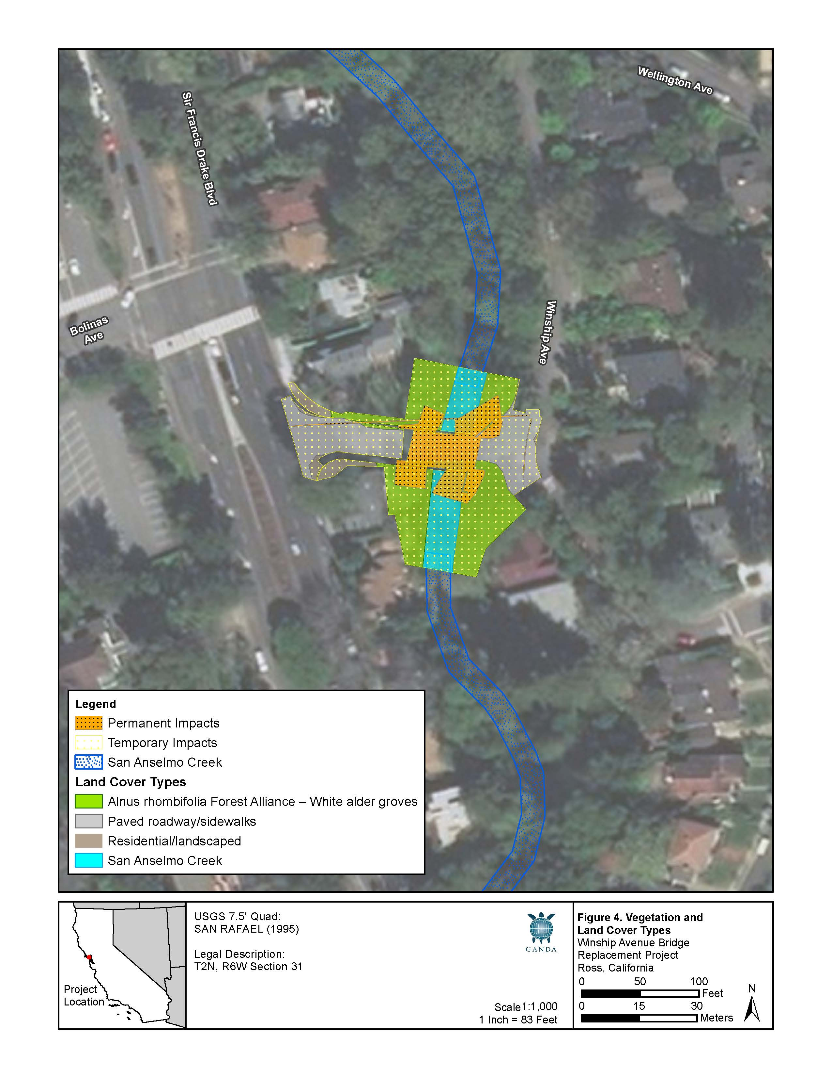

the potential diversion of low creek flows, and disturbance to the creek bed and banks during removal of the old bridge and construction of the new bridge.
As part of the proposed project, the Town will obtain a Clean Water Act Section 404 Nationwide Permit from the USACE; a Clean Water Act Section 401 Water Quality Certification Waiver from the Regional Water Quality Control Board; and implementation of a Storm Water Pollution Prevention Plan (SWPPP). Implementation of all permit requirements will be required to mitigate these impacts. Additionally, the implementation of best management practices to protect wildlife habitats (Mitigation Measures BIO-1 through BIO-13 – more fully described above) and the erosion prevention measures/water quality best management practices provided under Mitigation Measure BIO-3 (also more fully described above), would serve to further minimize impacts to wetlands. Consequently, this impact is less-than-significant with incorporation of Mitigation Measures BIO-1 through BIO-13.
d) Interfere substantially with the movement of any native resident or migratory fish or wildlife species or with established native resident or migratory wildlife corridors, or impede the use of native wildlife nursery sites?
See checklist Item “a” through “c” above.
e) Conflict with any local policies or ordinances protecting biological resources, such as a tree preservation policy or ordinance?
The proposed project is likely to require the removal of 15 trees (see Table 2-1, Chapter 2. “Project Description”) within the white alder forest alliance habitat, which is part of the San Anselmo Creek riparian corridor in the project site. In addition to these trees, several other trees are to be protected in place but may potentially be impacted by construction activities surrounding them. These include a grove of coast redwoods just downstream of the bridge on the left bank that is well-documented in the arborist’s report (Urban Forestry Associates 2017); a Northern California black walnut with a DBH of approximately 25-30 inches located in a private yard adjacent to the upstream, right bank side of the bridge; and, a box elder with a DBH of approximately 8 inches located at the south corner of the intersection of Winship Avenue and Sir Francis Drake Boulevard.
Permanent impacts include the removal of 15 riparian trees, as well as other shrubs, vines, and herbaceous plants in the project site. This vegetation would be replaced in-kind except that non-native invasive species, such as Himalayan blackberry and English ivy, which are prevalent in the shrub layer, would be replaced with native riparian plantings. Temporary impacts would occur to 0.18 acre of white alder groves where vegetation may be impacted during bridge construction activities including site access, placement of RSP, creek contouring, and bank stabilization. Construction of the new bridge abutments will also result in temporary impacts to the seven existing Coast redwood trees located on APN# 072-161-02 (southeast corner of bridge). These Coast redwood trees meet the definition of a “protected tree” under the Town’s tree ordinance, with diameter at breast height (DBH) ranging from 11.1 inches to over 40 inches.
As part of the proposed project, the Town will comply with Town’s Municipal Code Chapter 12.24.080 (“Tree Protection Ordinance”) which requires that a tree permit be obtained to alter or remove any trees greater than 1 inch DBH in the public right-of-way, greater than 6 inches DBH on unimproved parcels, and/or any significant or protected trees, as defined therein, on improved parcels. A tree replacement plan is also required as part of the Tree Protection Ordinance requirements. Implementation of all permit requirements will be required to mitigate these impacts. Additionally, the implementation of best management practices to protect native trees and vegetation (Mitigation Measures BIO-5, BIO-8, BIO-9, BIO-10, and BIO-11 – more fully described above) and the erosion prevention measures/water quality best management practices provided under Mitigation Measure BIO-3 (also more fully described above), would serve to further minimize impacts to native trees and vegetation. Consequently, this impact is less-than-significant with incorporation of Mitigation Measures BIO-5, BIO-8, BIO-9, BIO-10, and BIO-11.
f) Conflict with the provisions of an adopted Habitat Conservation Plan, Natural Community Conservation Plan, or other approved local, regional, or State habitat conservation plan?
There are no adopted habitat conservation plans, natural community conservation plans, or other approved plans that apply to the project site. No impact would occur.

Cultural Resources
Environmental Issue | Potentially  Significant  Impact | Less-than-Significant Impact with  Mitigation  Incorporated | Less-than-Significant  Impact | No  Impact | Beneficial Impact
- CULTURAL RESOURCES.
Would the project:
- Cause a substantial adverse change in the significance of a historical resource pursuant to California Code of Regulations (CCR) Section 15064.5? | ☐ | ☒ | ☐ | ☐ | ☐
- Cause a substantial adverse change in the significance of an archaeological resource pursuant to CCR Section 15064.5? | ☐ | ☒ | ☐ | ☐ | ☐
- Disturb any human remains, including remains interred outside of dedicated cemeteries? | ☐ | ☒ | ☐ | ☐ | ☐

Environmental Setting
A Historic Property Survey Report (HPSR) / Archaeological Survey Report (ASR) (Garcia and Associates, 2019b) and an Area of Potential Effect (APE) Map were prepared for the Town and Caltrans, that included archival research and outreach to the Native American Heritage Commission (NAHC) and local Native American representatives and/or tribal contacts, as detailed below. A pedestrian survey of the APE was also performed by a qualified archaeologist on August 10, 2017, with the survey results included in the HPSR/ASR.
The APE (or “study area”, as referenced in other sections of this Initial Study) incorporates all areas subject to project-related impacts, including staging areas and grading limits, as shown in Figures 2-2 and 2-3 (see Chapter 2, above). The project study area includes the existing bridge (Bridge No. 27C0074), the San Anselmo Creek bed directly under the bridge deck (extending approximately 50 linear feet north and 75 linear feet south of the bridge deck), and areas adjacent to the existing bridge abutments.

Archival Search and Literature Review
As part of the background research for this project, a records search (File No. 17-0286) at the Northwest Information Center (NWIC) of the California Historical Resources Information System at Sonoma State University, Rohnert Park was conducted. Records consulted at the NWIC included the National Register of Historic Places (NRHP), the California Register of Historical Resources (CRHR), the California Historic Landmarks list, topographic maps showing the locations of sites or surveys, and historic topographic maps. A 0.25-mile search radius was utilized.
The NWIC records search indicated that three studies have been conducted within a 0.25-mile radius of the APE or project site. Search results indicate that one cultural resources investigation has been conducted within the Winship Bridge APE, the Caltrans Historic Bridges Inventory Update (McMorris 2004). This study concluded that the Winship Bridge does not appear to meet the criteria for listing in the NRHP. Archival research indicates that the Winship Avenue Bridge dates to 1926, with the original bridge dating to the 1912 subdivision of the Winship Tract, and that John B Leonard was not the designing engineer. Two cultural resources investigations have been conducted within the Sir Francis Drake Boulevard Staging Area APE (Kandler 1978; Stables 1979), one of which resulted in the identification of one prehistoric archaeological resource (P-21- 002794). In total, previously conducted studies have identified 1 built environment resource and 2 prehistoric archaeological resources, as summarized below in Table 3-4. The full record search is included in the HPSR/ASR.
Table 3-4. Previously Recorded Resources within 0.25 miles of the Project Site
Site Name | Resource Type / Name | Proximity to APE | NRHP/CRHR Eligibility Status
P-21-001331 (proposed project) | Bridge – Winship Avenue | Within APE | Ineligible
P-21-000294 / CA-MRN-311 | Prehistoric – Shell Mound | Within APE | Not Formally Evaluated
P-21-002794 | Prehistoric – Redeposited Shell Midden | 170 feet South of APE | Not Formally Evaluated
Source: Archaeological Survey Report for Winship Avenue Bridge Replacement Project (Garcia and Associates, 2019b)

Field Survey
On August 10, 2017, a Garcia and Associates archaeologist conducted an intensive pedestrian survey using 15-meter interval transects within the APE, including the project site and the staging area at the Town of Ross Maintenance Yard, just north of the Ross Valley Fire Station on Sir Francis Drake Boulevard. Overall visibility was poor (0-10 percent), as the majority of each APE was obscured by structures, pavement/sidewalks, and dense vegetation. There are also areas of erosion near the banks of the creek. Portions of the APE overlap with private residential properties, so only soils in the front yard of each private residence could be observed. All area around the direct construction of the bridge were intensively surveyed. All exposed soils were specifically examined for evidence of cultural resources. Field survey results are summarized below.
Winship Avenue Bridge Site. The project site encompasses approximately 0.667 acre, with the construction footprint including the existing bridge (Bridge No. 27C0074), the San Anselmo Creek bed directly under the bridge deck (extending approximately 50 linear feet north and 75 linear feet south of the bridge deck), and areas adjacent to the existing bridge abutments. Upon examination of soils in the sidewalk planters and yards which overlap with the previously recorded resource P-21-000294/CA-MRN-311, no shell, midden soil, or other cultural material was observed. However, shell fragments were observed in soils at the base of a large buckeye tree at the northeast corner of the bridge as well as in soils between the sidewalk and fences along Sir Francis Drake Boulevard, in the westernmost area of the APE. At the site of the bridge, both sides of the creek have significant cut banks, with an approximately 12 to 15-foot elevation difference between the creek bed and street level. The tops of the banks on either side of the creek were either disturbed from construction of adjacent residences or yards, or overhanging ivy obscured soils toward the top. There area is also subjected to heavy erosion. All soils are native. No cultural materials were observed in any visible portion of the banks. The creek bed has been subject to consisted flood episodes and surrounding soils consisted of sand and cobbles. No cultural materials were observed.
Town of Ross Maintenance Yard Site. This portion of the APE (0.243 acres) is a square space that consists of a work yard for storing soils, machinery, and materials for municipal projects. As such, ground visibility was poor. Visible soils were primarily located along the perimeter, and no cultural materials were observed.

Native American Consultation
As part of the tribal consultation process with Native American groups and individuals, as per 36 CFR Part 800.3, the initiation of the Section 106 process, and Assembly Bill (AB) 52 under the provisions of CEQA, Garcia and Associates archaeologist Montse Osterlye contacted the NAHC on September 15, 2017 with a request for a search of the Sacred Lands File for information about cultural resources that may be located within the APE. On March 14, 2019, Garcia and Associates archaeologist Safiya Bal provided a follow-up request for a list of Most Likely Decedents. NAHC responded on March 25, 2019 with a list of interested Native American groups. The NAHC also reported that a search of the Sacred Lands File indicated that there are no sacred sites recorded within the APE. On March 26, 2019, letters describing the project details were mailed to the following Native American contacts listed for Marin County to initiate formal consultation: Gene Bevelot and Greg Sarris of the Federated Indians of Graton Rancheria.
Town staff also contacted Buffy McQuillen of the Federated Indians of Graton Rancheria. Buffy McQuillen followed up with Town staff (via email) on October 24th, 2019, indicating the Tribe’s request to consult with the Town regarding the proposed project. A request for the ASR was also sent to the Town, with a copy of the ASR document sent to the Graton Rancheria on November 19, 2019. A follow-up call to the Tribe was completed on December 19, 2019 and additional coordination will occur through the CEQA process. Table 3-5 provides a summary of Native American consultation activities to date.
Table 3-5. Native American Contact Efforts
Contact | Initial Date Contacted | Method of Contact | Response
Gene Bevelot  Federated Indians of Graton Rancheria | March 26, 2019 | Letter | No response received to date
Greg Sarris  Federated Indians of Graton Rancheria | March 26, 2019 | Letter | No response received to date
Buffy McQuillen  Federated Indians of Graton Rancheria | September 23, 2019 | Letter  Email and Phone Call | Request to consult with Town received on October 24, 2019. Town mails ASR on November 19, 2019. Follow-up phone call on December 19, 2019

Consultation with Other Interested Parties
Garcia and Associates archaeologist Montse Osterlye sent consultation letters informing the Ross Historical Society and Marin History Museum of the proposed project. The letters were sent via electronic mail on September 15, 2017. On September 20, 2017, Osterlye received a reply from a researcher at the Marin History Museum stating that they could not assist on any archaeological investigations. No further responses have been received to date.

Discussion
a) Cause a substantial adverse change in the significance of a historical resource pursuant to in California Code of Regulations Section 15064.5?
A buried prehistoric site (P-21-000294 / CA-MRN-311) is located within the APE; however, the site has not been formally evaluated for consideration as a NRHP/CRHR. The site is a shell midden adjacent to San Anselmo Creek, but outside the direct area of construction impact for the proposed project. The presence of shell fragments in soils at the base of a large buckeye tree at the northeast corner of the bridge, as well as in soils between the sidewalk and fences along Sir Francis Drake Boulevard have potential to be linked to this site. While no new archaeological resources were identified within the APE, the buried site sensitivity assessment conducted for the project indicates there is a Moderate to High potential for the presence of buried prehistoric sites within the APE based on the following factors: 1) the age and sedimentary nature of the native landform underlying artificial fill, 2) the proximity of buried prehistoric sites (P-21-000294/CA-MRN-311 and 3) shell fragments on the surface. Collectively, these factors raise the potential for encountering prehistoric archaeological materials in native soils. Historic-era activities and features within the APE are mostly related to domestic and infrastructure developments. These include the existing Winship Avenue Bridge and surrounding residences to the APE. However, they do not appear to meet the criteria for listing in the NRHP or the CRHR.
Construction of the proposed project would require ground disturbing work during existing bridge removal, sewer line installation, bridge abutment installation, grading, and RSP placement. During construction, the possibility remains that a previously undiscovered historic resource meeting NRHR or CRHR significance criteria may be discovered during project-related ground-disturbing activities. If these actions were to occur, then it would result in a potentially significant impact. Implementation of standard inadvertent discovery procedures (identified in Mitigation Measures CUL-1 and CUL-2) would reduce this potentially significant impact to any previously undiscovered subsurface resources (including tribal resources) to a less-than-significant level. Consequently, this impact is less-than-significant with incorporation of Mitigation Measures CUL-1 and CUL-2.
Mitigation Measure CUL-1: Native American Coordination
To minimize the potential for significant impacts to undiscovered Native American resources during project-related ground disturbing activities, the Town, RVSD, and the construction contractor(s) shall notify a representative of the Federated Indians of Graton Rancheria regarding the project’s construction schedule (including the timing of construction start up and ground disturbance activities). A tribal representative shall be invited to the start-up meeting and the need for any Native American monitoring will be discussed should a potentially significant tribal resource be encountered during subsurface construction activities (e.g., trenching, grading),
Timing: Before and during construction.
Responsibility: Town of Ross / RVSD / Construction Contractor.
Mitigation Measure CUL-2: Discovery of Cultural Resources during Ground-Disturbing Activities
To minimize the potential for significant impacts to undiscovered historical resources and unique archaeological resources during project-related ground-disturbing activities, the Town, RVSD, and the construction contractor(s) shall implement the following:
If a potentially significant historical or archaeological resource is encountered during subsurface construction activities (e.g., trenching, grading), all construction activities within a 50-foot radius of the identified potential resource shall cease until a qualified archaeologist evaluates the item for its significance and records the item on the appropriate State Department of Parks and Recreation (DPR) forms. The archaeologist shall determine whether the item requires further study. If, after the qualified archaeologist conducts appropriate technical analyses, the item is determined to be significant under CEQA, the archaeologist shall recommend feasible mitigation measures, which may include avoidance, preservation in place or other appropriate measure, as outlined in Public Resources Code section 21083.2. Upon the Town’s approval of the recommended mitigation measures, the project proponent shall implement said measures. The Town shall fund the costs of the qualified archaeologist and required analysis and shall include this mitigation measure in every construction contract to inform contractors of this requirement.
Timing: During construction.
Responsibility: Town of Ross / RVSD / Construction Contractor.
b) Cause a substantial adverse change in the significance of an archaeological resource pursuant to California Code of Regulations Section 15064.5?
The State CEQA Guidelines require consideration of unique archaeological resources (CCR Section 15064.5). As used in California PRC Section 21083.2, the term “unique archaeological resource” refers to an archaeological artifact, object, or site about which it can be clearly demonstrated that, without merely adding to the current body of knowledge, there is a high probability that it meets any of the following criteria:
- contains information needed to answer important scientific research questions and that there is a demonstrable public interest in that information,
- has a special and particular quality such as being the oldest of its type or the best available example of its type, or
- is directly associated with a scientifically recognized important prehistoric or historic event or person.
While implementation of the proposed project will result in the construction of a new bridge within the same alignment as the existing bridge, construction activities (including excavations and grading) could potentially damage or destroy any displaced artifacts within the study area boundaries from surrounding archaeological resources. If this were to occur, then it would result in a potentially significant impact. Implementation of resource avoidance and standard inadvertent discovery procedures (identified in Mitigation Measures CUL-1 and CUL-2, see above) would reduce this potentially significant impact to any previously undiscovered subsurface archaeological resources to a less-than-significant level. Consequently, this impact is less-than-significant with incorporation of Mitigation Measures CUL-1 and CUL-2.
c) Disturb any human remains, including remains interred outside of dedicated cemeteries?
No human remains have been identified or discovered in the study area (or surrounding area) and it is not anticipated that human remains, including those interred outside of dedicated cemeteries, would be discovered during ground disturbance activities resulting from the proposed project. However, should human remains, including those interred outside of formal cemeteries and including associated items and materials, be discovered during subsurface activities, the human remains and associated items and materials could be inadvertently damaged resulting in a potentially significant impact. However, implementation of resource discovery and avoidance measures consistent with the California Health and Safety Code and California PRC Section 5024.1, 14 CCR Section 4850 (as described in Mitigation Measure CUL-3) would reduce this potentially significant impact to a less-than-significant level. Consequently, this impact is less-than-significant with incorporation of Mitigation Measures CUL-3.
Mitigation Measure CUL-3: Accidental Finding of Human Remains
- If human remains are found, the California Health and Safety Code requires that excavation be halted in the immediate area and that the Marin County Coroner be notified to determine the nature of the remains. The Coroner is required to examine all discoveries of human remains within 48 hours of receiving notice of a discovery on private of State lands (California Health and Safety Code, Section 7050.5[b]). If the Coroner determines that the remains are those of a Native American, he or she must contact the Native American Heritage Commission (NAHC) by telephone within 24 hours of making that determination (California Health and Safety Code, Section 7050.5[c]).
- Once notified by the Coroner, the NAHC shall identify the person it believes it the Most Likely Descendant (MLD) of the Native American remains. With permission of the legal landowner(s), the MLD may visit the site and make recommendations regarding the treatment and disposition of the human remains and any associated grave goods. This visit should be conducted with 24 hours of the MLD’s notification by the NAHC (California Public Resources Code [PRC], Section 5097.98[a]). If a satisfactory agreement for treatment of the remains cannot be reached, any of the parties may request mediation by the NAHC (California PRC, Section 5097.94[k]). Should mediation fail, the landowner or landowner’s representative must reinter the remains and associated items with appropriate dignity on the property in a location not subject to further subsurface disturbance (California PRC, Section 5097.98[b]).
Timing: During construction.
Responsibility: Town of Ross / RVSD / Construction Contractor.

Energy
Environmental Issue | Potentially  Significant  Impact | Less-than-Significant Impact with  Mitigation  Incorporated | Less-than-Significant  Impact | No  Impact | Beneficial Impact
- ENERGY.
Would the project:
- Result in potentially significant environmental impact due to wasteful, inefficient, or unnecessary consumption of energy resources, during project construction or operation? | ☐ | ☐ | ☒ | ☐ | ☐
- Conflict with or obstruct a State or local plan for renewable energy or energy efficiency? | ☐ | ☐ | ☒ | ☐ | ☐

Environmental Setting
California’s major sources of energy are petroleum products (i.e., gasoline, diesel, and oil), electricity, and natural gas. Implementation of the proposed project would require the temporary use of energy resources for removal and construction of the bridge replacement project over a 6 month construction period. This energy use would primarily be in the form of petroleum products and electricity used to operate construction equipment and consumed during vehicle trips associated with material delivery/debris hauling and commuting workers. Indirect energy use would also occur and include the extraction, production, and transportation of goods and materials needed for construction.
Appendix F (Energy Conservation) and Appendix G (Environmental Checklist Form) of the State CEQA Guidelines do not list potential thresholds of significance for an evaluation of energy related impacts. Consequently, for the purposes of this analysis, the following thresholds of significance from the County’s San Anselmo Flood Risk EIR were considered and an impact was considered significant if implementation of the proposed project would do any of the following when compared against existing conditions:
- Utilize energy, oil, or natural gas in an inefficient manner;
- Encourage activities that would result in the use of large amounts of energy, oil, or natural gas;
- Exceed the capacity of the energy supplier to supply the project’s energy needs with existing or planned supplies; or
- Require the development of new energy resources.

Discussion
a) Result in potentially significant environmental impact due to wasteful, inefficient, or unnecessary consumption of energy resources, during project construction or operation?
Implementation of the proposed project would require the use of energy resources for construction of the proposed project. This energy use would primarily be in the form of petroleum products and electricity used to operate construction equipment and consumed during vehicle trips associated with material delivery/debris hauling and commuting workers. Indirect energy use would also occur and include the extraction, production, and transportation of goods and materials needed for construction.
As described in Chapter 2 Section 2.5.3 “Construction Schedule”, construction activities would be temporary and occur over a time period of six months. Mitigation Measure AIR-1 “BAAQMD Basic Construction Measures (see Section 3.5 “Air Quality”) includes measures (such as reducing vehicle and equipment engine idling times) that would reduce energy consumption and combustion of petroleum products by construction equipment. Structure demolition would be subject to California Code of Regulations, Title 24, Part 11, 2016 California Green Building Code, effective January 1, 2017. This code requires that a minimum of 65 percent of non-hazardous construction and demolition waste is recycled and/or salvaged for reuse in an effort to divert debris from landfills. With implementation of the California Green Building Code standard requirements, impacts associated with project energy use during construction would be less than significant. Consequently, construction-related impacts are less-than-significant, with no mitigation measures required, as they would not encourage inefficient use of energy or require the development of new energy resources to implement.
Implementation of the proposed project would require the use of minimal energy resources for operation and maintenance of the bridge and sewer line components. Maintenance of these structures would require minimal energy use, similar to existing Town/RVSD infrastructure maintenance activities. These activities would occur on an annual, or as-needed, basis. Additionally, the proposed project does not involve constructing buildings for human inhabitation, therefore no energy efficiency policies apply. For these reasons, energy impacts during proposed project maintenance and operation would be less-than-significant, with no mitigation measures required, as they are considered part of existing agency operations and would not require additional sources of energy to implement.
b) Conflict with or obstruct a State or local plan for renewable energy or energy efficiency?
The proposed bridge replacement project would not conflict with or obstruct a plan for renewable energy or energy efficiency. Consequently, no impact would occur.

Geology and Soils
Environmental Issue | Potentially  Significant  Impact | Less-than-Significant Impact with  Mitigation  Incorporated | Less-than-Significant  Impact | No  Impact | Beneficial Impact
- GEOLOGY AND SOILS.
Would the project:
- Directly or indirectly cause potential substantial adverse effects, including the risk of loss, injury, or death involving: | ☐ | ☐ | ☐ | ☒ | ☐
i) Rupture of a known earthquake fault, as delineated on the most recent Alquist-Priolo Earthquake Fault Zoning Map issued by the State Geologist for the area or based on other substantial evidence of a known fault? (Refer to California Geological Survey Special Publication 42.) | ☐ | ☐ | ☐ | ☒ | ☐
ii) Strong seismic ground shaking? | ☐ | ☐ | ☐ | ☒ | ☐
iii) Seismic-related ground failure, including liquefaction? | ☐ | ☐ | ☐ | ☒ | ☐
iv) Landslides? | ☐ | ☐ | ☐ | ☒ | ☐
- Result in substantial soil erosion or the loss of topsoil? | ☐ | ☐ | ☒ | ☐ | ☐
- Be located on a geologic unit or soil that is unstable, or that would become unstable as a result of the project, and potentially result in on or off-site landslide, lateral spreading, subsidence, liquefaction or collapse? | ☐ | ☐ | ☐ | ☒ | ☐
- Be located on expansive soil, as defined in Table 18-1-B of the Uniform Building Code (1994, as updated),), creating substantial direct or indirect risks to life or property? | ☐ | ☐ | ☐ | ☒ | ☐
- Have soils incapable of adequately supporting the use of septic tanks or alternative waste water disposal systems where sewers are not available for the disposal of waste water? | ☐ | ☐ | ☐ | ☒ | ☐
- Directly or indirectly destroy a unique paleontological resource or site or unique geologic feature? | ☐ | ☐ | ☐ | ☒ | ☐

Environmental Setting
The proposed project site is within the geologically complex region of California referred to as the Coast Ranges Geomorphic Province (California Geological Survey [CGS], 2002). The Coast Ranges province lies between the Pacific Ocean and the Great Valley Geomorphic Province (Sacramento and San Joaquin Valleys) and stretches from the Oregon border to the Santa Ynez Mountains near Santa Barbara. This province is marked by northwest-trending elongated ranges and narrow valleys that roughly parallel the coast and the San Andreas Fault Zone. Much of the Coast Ranges province is composed of marine sedimentary deposits, metamorphic rocks, and volcanic rocks. The tectonics of the San Andreas Fault Zone and other major faults in the western part of California have played a major role in the geologic history of the area.
The project site is in a seismically active region of California. The San Francisco Bay Area contains both active (Holocene age, or within the last 11,000 years) and potentially active (Quaternary age, or within the last 1.6 million years) faults and throughout the area, there is the potential for damage resulting from movement along any one of a number of the active faults. It is estimated that the San Francisco Bay Area region as a whole has a 72 percent chance of experiencing an earthquake of Moment Magnitude of 6.7 or higher over the next 30 years; among the various active faults in the region, the San Andreas and the Hayward-Rogers Creek Faults are the most likely to cause such an event in the vicinity of the proposed project. (WGCEP, 2015a; PBS&J, 2010).
The San Andreas Fault is a major northwest-trending, right-lateral, strike-slip fault that extends for about 600 miles from the Gulf of California in the south to Cape Mendocino in the north. This active fault is located approximately 7 miles to the west of the project site. The Hayward-Rodgers Creek Fault Zone is approximately 118 miles in length, located mostly along the base of the hills along the east side of San Francisco Bay and running parallel to the San Andreas Fault Zone. This active fault is located approximately 10 miles east of the project site. The project site is located at elevations between approximately 25 and 50 feet above mean sea level in an area with gentle slopes. The soils in the project site are comprised of Tocaloma-McMullin-Urban land complex, with 30 to 50 percent slopes, in the western portion of the site and Xerothents-Urban land complex, with 0 to 9 percent slopes, in the eastern portion of the site (National Resource Conservation Service, 2017). Tocaloma-McMullin-Urban land complex soils are derived from residuum weathered from sandstone, shale, and conglomerate and are found in hilly settings while Xerothents-Urban land complex soils are derived from Earth spread deposits and are found in tidal flats and valley floors (National Resource Conservation Service, 2017).
Liquefaction refers to the sudden, temporary loss of soil strength during strong ground shaking. This phenomenon can occur where there are saturated, loose, granular deposits subjected to seismic shaking. Liquefaction-related phenomena include settlement, flow failure, and lateral spreading. Based on the results of the Preliminary Foundation Report for Winship Avenue Bridge Replacement (Miller Pacific Engineering Group, 2016) prepared for the proposed project, the primary geologic hazards identified at the site are strong seismic shaking, liquefaction, erosion, and flooding. Other hazards, such as landslides, fault rupture, expansive soil, tsunami inundation, and settlement are not considered significant at the site.

Discussion
a) Directly or indirectly cause potential substantial adverse effects, including the risk of loss, injury, or death involving:
i) Rupture of a known earthquake fault, as delineated on the most recent Alquist-Priolo Earthquake Fault Zoning Map issued by the State Geologist for the area or based on other substantial evidence of a known fault? (Refer to California Geological Survey Special Publication 42.)
Implementation of the proposed project would adhere to construction recommendations in the Caltrans Design Manual and the current design parameters of the Structural Engineers of California Uniform Building Code. With the nearest active faults located 7 miles to the west and 10 miles to the east, the project would not expose people or structures to potential substantial adverse effects involving the rupture of a known earthquake fault, and no impact would occur.
As part of the project’s preliminary design phase, a preliminary foundation report (Miller Pacific Engineering Group, 2016) that included geotechnical site borings and a liquefaction analysis was conducted for the proposed project. Results of the analyses indicated that soils within the project site are prone to liquefaction when subjected to seismic-shaking. However, the preliminary foundation report also noted that liquefaction can only occur in soils that are below the ground water table during a seismic event. Implementation of the proposed project will incorporate the design recommendations from the preliminary foundation report that include removal of potentially liquefiable soils adjacent to the existing bridge abutments and replacement with compacted fill to remove both the potential for liquefaction and associated ground settlements. Compliance with existing regulations, construction best management practices, and the recommendations provided in the project’s preliminary foundation report would address these hazardous geologic and soil issues. Consequently, no impact would occur.
ii) Strong seismic ground shaking?
See checklist Item “ai” above.
iii) Seismic-related ground failure, including liquefaction?
See checklist Item “ai” above.
iv) Landslides?
The project site and surrounding area is flat and has a low potential for landslides. Construction and operation of the proposed project would result in no additional exposure of people to landslides. Therefore, there would be no increased hazard from landslides and no impact.
b) Result in substantial soil erosion or the loss of topsoil?
Construction activities associated with the project would involve grading and excavation activities within the project site. These activities could expose barren soils to sources of wind or water, resulting in the potential for erosion and sedimentation on and off the project site. The Town plans to complete construction in the dry season, such that any surfaces disturbed during construction would be paved or re-vegetated before the raining season, keeping the potential for erosion low. Furthermore, the Town would employ appropriate sediment and erosion control BMPs to minimize the potential for erosion and sedimentation as part of a SWPPP (or as part of a WPCP in accordance with the construction specifications and prepared by a QSP) in accordance with contract specification and with NPDES General Permit for Storm Water Discharges associated with construction activity. Additionally, the implementation of the erosion prevention measures/water quality best management practices provided under Mitigation Measure BIO-1.3 (more fully described above under Section 3.6 “Biological Resources”) would serve to further minimize the project’s impacts to soil loss and substantial soil erosion. Consequently, this impact is less-than-significant with mitigation incorporated.
c) Be located on a geologic unit or soil that is unstable, or that would become unstable as a result of the project, and potentially result in on or off-site landslide, lateral spreading, subsidence, liquefaction or collapse?
See checklist Item “ai” above.
d) Be located on expansive soil, as defined in Table 18-1-B of the Uniform Building Code (1994, as updated), creating substantial direct or indirect risks to life or property?
See checklist Item “ai” above.
e) Have soils incapable of adequately supporting the use of septic tanks or alternative waste water disposal systems where sewers are not available for the disposal of waste water?
Portable toilets would be used for construction workers. The proposed project would not require or include the construction of wastewater disposal systems of any kind. Thus, there would be no impact related to the ability of project site soils to support the use of septic systems.
f) Directly or indirectly destroy a unique paleontological resource or site or unique geologic feature?
The proposed bridge replacement project would not destroy a unique geologic feature. Consequently, no impact would occur.

Greenhouse Gas Emissions
Environmental Issue | Potentially  Significant  Impact | Less-than-Significant Impact with  Mitigation  Incorporated | Less-than-Significant  Impact | No  Impact | Beneficial Impact
- GREENHOUSE GAS EMISSIONS.
Would the project:
- Generate greenhouse gas emissions, either directly or indirectly, that may have a significant impact on the environment? | ☐ | ☐ | ☒ | ☐ | ☐
- Conflict with an applicable plan, policy or regulation adopted for the purpose of reducing the emissions of greenhouse gases? | ☐ | ☐ | ☒ | ☐ | ☐

Environmental Setting
Greenhouse gases (GHGs) are global pollutants, unlike criteria air pollutants and toxic air contaminants. Global climate change can result in increased temperatures; changes in snow and rainfall patterns; and an increase in droughts, tropical storms, and heavy rain events. Listed below are the most prominent GHGs that have been identified as contributing to global climate change:
- Carbon dioxide (CO2)
- Methane (CH4)
- Nitrous oxide (N2O)
- Hydrofluorocarbons (HFCs)
- Perfluorocarbons (PFCs)
- Sulfur hexafluoride (SF6)
The State of California adopted the Global Warming Solutions Act of 2006 (Assembly Bill [AB] 32) on September 27, 2006, to address the threat of global warming caused by the increase in GHG emissions. AB 32 requires a reduction of carbon emissions to 1990 levels by the year 2020. The 1990 emissions were estimated at 427 million metric tons CO2 equivalent (MMCO2e).
In December 2008, the California Air Resources Board (CARB) approved the AB 32 Scoping Plan outlining the state’s strategy to achieve the 2020 GHG emissions limit. The Scoping Plan estimated a reduction of 174 million metric tons CO2e from the transportation, energy, agriculture, forestry, and high climate-change-potential sectors, and proposed a comprehensive set of actions designed to reduce overall GHG emissions in California, improve the environment, reduce dependence on oil, diversify California’s energy sources, save energy, create new jobs, and enhance public health. The Scoping Plan must be updated every 5 years to evaluate the mix of AB 32 policies to ensure that California is on track to achieve the 2020 GHG reduction goal.
In response to the 2030 GHG reduction target stipulated in Executive Order B-30-15 (see discussion below), CARB released the 2017 Climate Change Scoping Plan Update in January 2017 (CARB 2017).
The 2017 Climate Change Scoping Plan Update (Update) sets the groundwork to reach California's long-term climate goals set forth in Executive Orders S-3-05 and B-16-2012 (the latter of these ordered State agencies to facilitate the rapid commercialization of zero-emission vehicles, setting a target for the number of them on California roads and also set a goal for reduction of emissions from the transportation sector). The Update highlights California’s progress toward meeting the near-term 2020 GHG emission reduction goals defined in the initial Scoping Plan. SB 350 was passed in 2015 that requires 40 percent of California electricity sold to retail customers be generated by renewable resources by the end of 2024, 45 percent by 2027, and ultimately 50 percent by 2030.
The project site is under the BAAQMD jurisdiction. The BAAQMD is tasked by CARB under AB 32 to regulate GHG emissions related to discretionary project approvals under CEQA. The Town of Ross has completed a Climate Act Plan.

Discussion
a) Generate greenhouse gas emissions, either directly or indirectly, that may have a significant impact on the environment?
Project construction-related activities would generate a variety of greenhouse gases, such as carbon dioxide (CO2), methane (CH4), and nitrogen dioxide (N2O) from the exhaust of equipment and the exhaust of vehicles for employees, visitors, and construction hauling trips. The project would also result in the short-term generation of aerosols from diesel particulate matter exhaust. Aerosols are short-lived greenhouse gases, as they remain in the atmosphere for approximately one week. The project would emit nitrogen oxides (NOx) and reactive organic gases (ROG), which are ozone precursors. Ozone is a greenhouse gas. However, unlike the other greenhouse gases, ozone in the troposphere is relatively short-lived and is being reduced in the troposphere daily. Overall, these emissions are considered temporary or short-term.
As previously described above in Section 3.5 “Air Quality”, the proposed project would not increase roadway capacity or service capabilities that would induce unplanned growth or remove an existing obstacle to growth that would contribute additional long-term sources of ROG or NOx. The proposed project would generate temporary and short-term construction-related emissions of ROG or NOX; however, Mitigation Measures AIR-1 and AIR-2 (more fully described above in Section 3.5 “Air Quality”) requires implementation of engine emissions control measures which would reduce the impact to less than significant. Therefore, the proposed project would have a less-than-significant impact with mitigation incorporated.
b) Conflict with an applicable plan, policy or regulation adopted for the purpose of reducing the emissions of greenhouse gases?
The Town has adopted a climate action plan to reduce GHG emissions and meet the State’s AB 32 goals. However, the Town’s climate action plan does not contain any measures specific to the construction related activities resulting from the proposed project. Additionally, implementation of the ADA compliant sidewalk improvements included under the proposed project support the recommended land use and transportation strategy actions from the Town’s climate action plan. The proposed project would not conflict with an applicable plan, policy, or regulation adopted for the purpose of reducing the emissions of greenhouse gases. Consequently, this impact is less-than-significant, with no mitigation measures required.

Hazards and Hazardous Materials
Environmental Issue | Potentially  Significant  Impact | Less-than-Significant Impact with  Mitigation  Incorporated | Less-than-Significant  Impact | No  Impact | Beneficial Impact
- HAZARDS AND HAZARDOUS MATERIALS.
Would the project:
- Create a significant hazard to the public or the environment through the routine transport, use, or disposal of hazardous materials? | ☐ | ☐ | ☒ | ☐ | ☐
- Create a significant hazard to the public or the environment through reasonably foreseeable upset and accident conditions involving the release of hazardous materials into the environment? | ☐ | ☐ | ☒ | ☐ | ☐
- Emit hazardous emissions or handle hazardous or acutely hazardous materials, substances, or waste within one-quarter mile of an existing or proposed school? | ☐ | ☐ | ☒ | ☐ | ☐
- Be located on a site which is included on a list of hazardous materials sites compiled pursuant to Government Code Section 65962.5 and, as a result, would it create a significant hazard to the public or the environment? | ☐ | ☐ | ☐ | ☒ | ☐
- For a project located within an airport land use plan or, where such a plan has not been adopted, within two miles of a public airport or public use airport, would the project result in a safety hazard or excessive noise for people residing or working in the project area? | ☐ | ☐ | ☐ | ☒ | ☐
- Impair implementation of or physically interfere with an adopted emergency response plan or emergency evacuation plan? | ☐ | ☐ | ☒ | ☐ | ☐
- Expose people or structures, either directly or indirectly, to a significant risk of loss, injury or death involving wildland fires? | ☐ | ☒ | ☐ | ☐ | ☐

Environmental Setting
All project-related construction activities would include the use of equipment that would use fuels, oil and lubricants, and cleaning solvents. Petroleum products, such as gasoline, diesel fuel, oil, lubricants, and cleaning solvents would be used to fuel and maintain construction vehicles and equipment for construction of all project elements (including sewer line relocation, bridge removal, and new bridge construction). The routine use or reasonably foreseeable upset and accident conditions for the various hazardous materials that would be used during construction and demolition activities could result in inadvertent releases of small quantities of hazardous materials, which could adversely affect construction workers or the environment.
Construction and demolition activities are required to comply with numerous hazardous materials and stormwater regulations designed to ensure that hazardous materials are transported, used, stored, and disposed of in a safe manner to protect worker safety, to reduce the potential for a release of construction-related fuels or other hazardous materials to affect stormwater and downstream receiving water bodies, and to respond to accidental spills, if any. State and federal regulations such as the Resource Conservation and Recovery Act of 1976, Toxic Substances Control Act of 1976, Hazardous and Solid Waste Act of 1984, and the Hazardous Materials Release Response Plans and Inventory Act require measures for the safe transportation, storage, handling, and disposal of hazardous materials used for construction, including implementation of a Hazardous Materials Business Plan, use of appropriate containers, and secondary containment to contain a potential release. As described in Section 3.6, Biological Resources and Section 3.0, Geology and Soils, construction contractors would be required to prepare a SWPPP for construction activities according to the NPDES General Construction Permit requirements and similar related County and Town regulations. The SWPPP must be prepared by a state Qualified SWPPP Developer and implementation of the SWPPP must be overseen by a state Qualified SWPPP Practitioner. The SWPPP would list the hazardous materials (including petroleum products) proposed for use during construction and demolition, and describe spill prevention measures, equipment inspections, equipment and fuel storage, and protocols for responding immediately to spills. A Legally Responsible Person, who is legally authorized to sign and certify permit registration documents, is responsible for obtaining coverage under the permit.

Discussion
a) Create a significant hazard to the public or the environment through the routine transport, use, or disposal of hazardous materials?
Hazardous materials present during project construction may include gasoline, diesel fuel, hydraulic oils, equipment coolants, and any generated wastes that may include these materials. Fueling of equipment and vehicle would be performed on-site. Construction equipment and vehicles would use a minimal amount of hazardous materials. Gasoline and diesel fuel would be stored in small quantities at the staging yards during construction. Although very few individuals live and work in the area, a hazard to the public or the environment could occur through the transport and use of gasoline and diesel fuel on the project site. Spill response and control would be addressed in the project-specific SWPPP or WPCP (more fully described above under Section 3.6 “Biological Resources”). Compliance with the spill control and response measures in the SWPPP or WPCP would reduce the risk to the public and environment from transport and use of hazardous materials. Finally, the sewer line component of the proposed project is considered a beneficial effect of the project as it will contribute to a reduction in the risk of sewer overflow events in the RVSD service area. These sewer overflows can expose the public to a health hazard (from exposure to raw sewage) and contribute to adverse water quality impacts in local water waterways. The impact to the public or the environment from use, disposal, or transport of hazardous materials during construction would be less-than-significant.

b) Create a significant hazard to the public or the environment through reasonably foreseeable upset and accident conditions involving the release of hazardous materials into the environment?
See checklist Item “a” above.
- Emit hazardous emissions or handle hazardous or acutely hazardous materials, substances, or waste within one-quarter mile of an existing or proposed school?
See checklist Item “a” above.
d) Be located on a site which is included on a list of hazardous materials sites compiled pursuant to Government Code Section 65962.5 and, as a result, would it create a significant hazard to the public or the environment?
A review of county, state, and federal databases listing hazardous material sites (including the State of California’s EnviroStor database 2019) determined that the project site is not located on a site included on a list of hazardous materials sites. The project would result in no impacts associated with emissions from hazardous materials sites. Consequently, no impact would occur.
e) For a project located within an airport land use plan or, where such a plan has not been adopted, within two miles of a public airport or public use airport, would the project result in a safety hazard or excessive noise for people residing or working in the project area?
The San Rafael Airport, located at 400 Smith Ranch Rd, San Rafael, CA, is the nearest airport to the project site and is located 8 miles from the project site. The project site is not located within an airport land use plan. The project would have no impacts associated with airport hazards. Consequently, no impact would occur.
f) Impair implementation of or physically interfere with an adopted emergency response plan or emergency evacuation plan?
While not considered a high-volume roadway (current ADT at 210 vehicles), the project will require a short-term roadway closure of Winship Road during sewer line relocation and replacement of the existing bridge structure (and associated roadway approach work) to ensure construction is completed efficiently and with as short a construction period as possible. To minimize traveler delays and ensure residential circulation and access along Winship Avenue, during the construction period, the Town will implement a traffic detour route and the circulation measures included under Mitigation Measure TC-1 (see Section 3.19 “Transportation”) would minimize short-term construction-related roadway/access conflicts resulting from the project. Consequently, this impact is less-than-significant, with no further mitigation required.
g) Expose people or structures, either directly or indirectly, to a significant risk of loss, injury or death involving wildland fires?
Heavy equipment used during project construction has the potential to start a fire on surrounding open space areas near the project site. Vegetation removal activities resulting from the project will help to reduce the potential of wildland fires by providing a clearing, reducing fire fuels and removing fire sustaining litter. In addition, during construction, spark arrestors or turbo chargers (which eliminate sparks in exhaust) and fire extinguishers would be required for all heavy equipment pursuant to Mitigation Measure HAZ-1 that would serve to further minimize wild land fire impacts. Consequently, this impact is less-than-significant with mitigation incorporated.
Mitigation Measure HAZ-1: Implement BMPs for Wildland Fire Prevention
The Town shall ensure that the construction contractor will clear dried vegetation or other materials that could serve as fuel for combustion from construction or building areas. To the extent feasible, the contractor shall keep these areas clear of combustible materials to maintain a firebreak. Construction contractors shall ensure that any construction equipment that normally includes a spark arrester shall be equipped with an arrester in good working order. This includes, but is not limited to, vehicles, heavy equipment, and chainsaws.
Timing: During construction.
Responsibility: Town of Ross / RVSD / Construction Contractor.

Hydrology and Water Quality
Environmental Issue | Potentially  Significant  Impact | Less-than-Significant Impact with  Mitigation  Incorporated | Less-than-Significant  Impact | No  Impact | Beneficial Impact
- HYDROLOGY AND WATER QUALITY.
Would the project:
- Violate any water quality standards or waste discharge requirements or otherwise substantially degrade surface or ground water quality? | ☐ | ☒ | ☐ | ☐ | ☐
- Substantially decrease groundwater supplies or interfere substantially with groundwater recharge such that the project may impede sustainable groundwater management of the basin? | ☐ | ☐ | ☐ | ☒ | ☐
- Substantially alter the existing drainage pattern of the site or area, including through the alteration of the course of a stream or river or through the addition of impervious surfaces, in a manner which would: | ☐ | ☐ | ☒ | ☐ | ☐
i) result in substantial erosion or siltation on- or off-site; | ☐ | ☐ | ☒ | ☐ | ☐
ii) substantially increase the rate or amount of surface runoff in a manner which would result in flooding on- or offsite; | ☐ | ☐ | ☒ | ☐ | ☐
iii) create or contribute runoff water which would exceed the capacity of existing or planned stormwater drainage systems or provide substantial additional sources of polluted runoff; or | ☐ | ☐ | ☒ | ☐ | ☐
iv) impede or redirect flood flows? | ☐ | ☐ | ☒ | ☐ | ☐
- In flood hazard, tsunami, or seiche zones, risk release of pollutants due to project inundation? | ☐ | ☐ | ☐ | ☒ | ☐
- Conflict with or obstruct implementation of a water quality control plan or sustainable groundwater management plan? | ☐ | ☐ | ☒ | ☐ | ☐

Environmental Setting
A Bridge Design Hydraulic Study Report (Stetson Engineers Inc., 2019a) and a Location Hydraulic Study Report (Stetson Engineers Inc., 2019b) have been prepared to identify any (100-year) floodplain encroachments resulting from the project and to present the design and hydraulic conditions of the existing and proposed replacement bridge. Information from these studies was used to prepare the following drainage and water quality section of the IS/MND. Additionally, information from these two studies and the San Anselmo Flood Risk Reduction Project EIR (County of Marin, 2018) was used to identify the potential cumulative effects of the proposed project, which are more fully described in Section 3.23 “Mandatory Findings of Significance”.
Implementation of the proposed project would replace the existing Winship Avenue Bridge, within the same project footprint, with a slightly longer and wider replacement structure. No additional travel lanes are proposed, and construction of the project would not result in any additional impervious surfaces or structures that would affect groundwater quality or recharge within the project study area. Consequently, these issues would not be affected by the proposed project and are not further described in this section.
The project site is located within the Corte Madera Creek (or Ross Valley) Watershed.

Corte Madera Creek Watershed
Corte Madera Creek is a major waterway in Marin County, reaching from the San Francisco Bay to the Town of Fairfax and beyond (see Figure 3-3, below). The Corte Madera Creek watershed ranges in elevation from sea level to 2,571 feet at the East Peak of Mount Tamalpais. The watershed covers 28 square miles in the southeastern quarter of Marin County and encompasses the Towns of Larkspur, Corte Madera, Kentfield, Ross, San Anselmo, and Fairfax. The watershed includes Corte Madera Creek mainstem and major tributaries of Fairfax Creek, San Anselmo Creek, Sleepy Hollow Creek, Tamalpais Creek, and Larkspur Creek. Larkspur and Tamalpais creeks drain directly into the estuary/tidal portion. Ross Creek drains the northern slope of Mt. Tamalpais with Phoenix Lake on the lower reach of the creek; San Anselmo Creek and its tributaries drain the northwestern portion of the watershed. These two creeks join to form Corte Madera Creek, which continues through more than a mile of concrete-lined channel past the confluences of Larkspur and Tamalpais Creeks and into the salt marsh at the mouth.
Corte Madera Creek. Downstream of the confluence of San Anselmo and Ross Creeks, the main channel is called Corte Madera Creek. The lower portion of Corte Madera Creek below the College of Marin is a natural earthen channel that was constructed by the U.S. Army Corps of Engineers in 1968. The Lagunitas Road Bridge cross Corte Madera Creek approximately one mile (respectively) downstream of downtown San Anselmo. The USGS stream gage at Ross (USGS Ross Gage; USGS 11460000) measures flows on Corte Madera Creek, and is located just upstream of Lagunitas Road Bridge. Flood conditions in the watershed are characterized by flows at this gage. Annual peak stream flow measured at the USGS Ross Gage has generally been below 4,000 cubic feet per second (cfs), with the exception of large storms described in greater detail below (USGS, 2017). Corte Madera Creek flows year-round and is tidally-influenced between the San Francisco Bay and the vicinity of Kentfield, approximately 1.5 miles downstream of the proposed project site (National Hydrography Dataset).
Project Site Characteristics. Topography at the project site includes a well-defined creek channel that is located within Ross Valley at the toe end of a westerly facing hillside. The valley floor lies at an elevation of about 40 ft NAVD88 and is flanked with moderately- to steeply-sloping hillsides that range in elevation from approximately 500 ft toward the east and 1,100 ft toward the west. The project area is residential in nature with relatively closely-spaced single-family homes along the streets adjacent to the bridge. Many tightly spaced utilities underlie the roadway and bridge deck. Additionally, an approximate 3.5-ft diameter storm drain outlets through the western abutment.

Figure 3-3. Ross Valley Watershed and Project Location
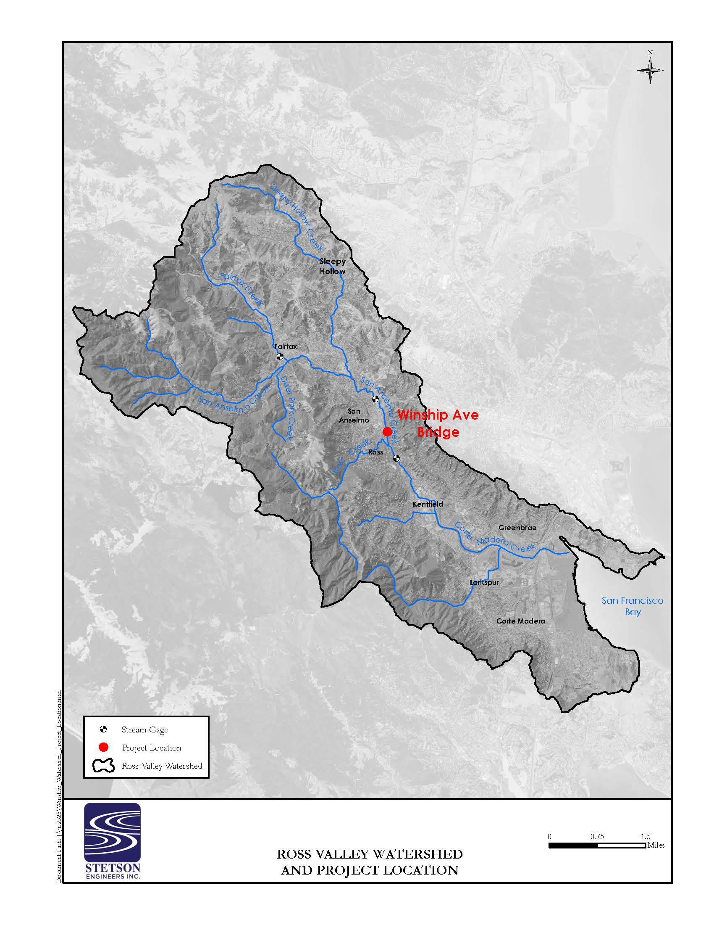
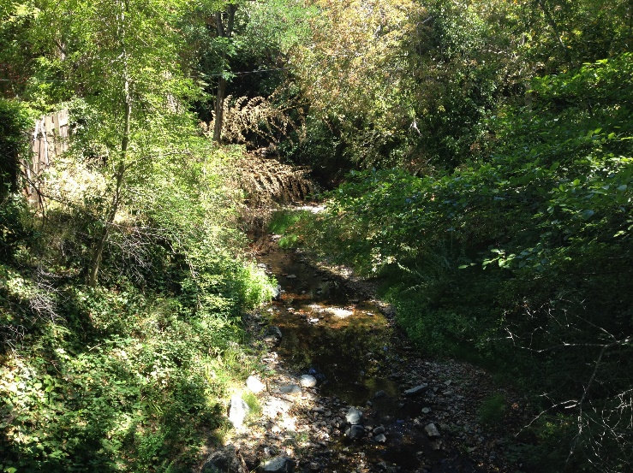
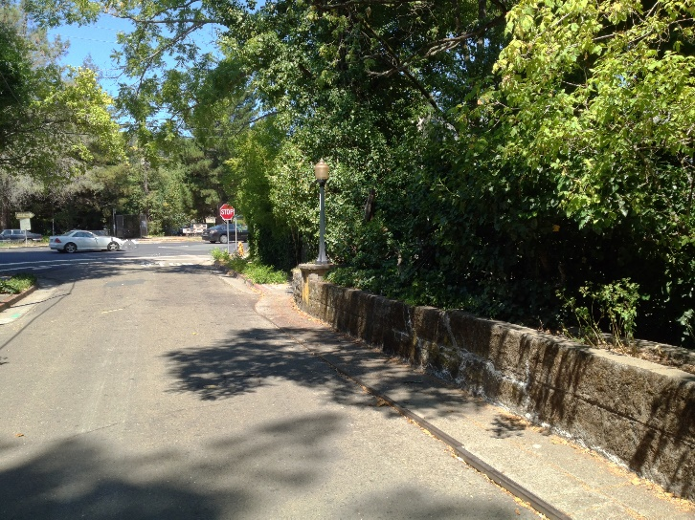
The creek channel directly below the existing bridge is approximately 45 ft wide at top of bank. Relatively steep slopes exist along both creek banks which range from about 2H:1V to 1H:1V (horizontal: vertical) and extend down to a relatively narrow channel bottom (about 18 ft wide) that is about 22 ft below the existing bridge deck. The creek banks are vegetated with ivy, scattered mature trees and shrubs (see Photos 5 and 6, below).
Photo 6: View of Steep Vegetated Creek Banks
Photo 5: View of Surrounding Residential Area

Flooding and Drainage
Several times in recent history Corte Madera Creek has flooded Ross Valley with varying degrees of severity. Prior to establishment in 1951 of the USGS streamflow gaging station on Corte Madera Creek in Ross, flooding was reported in calendar years 1914, 1925, 1937, and 1942. Since 1951 flood flows have been recorded in calendar years 1951, 1955, 1958, 1967, 1969, 1970, 1982, 1983, 1986, 1994, 2005, and 2012. Of these, the two most severe floods occurred in 1982 and 2005, with peak discharges of approximately 7,200 cfs and 6,830 cfs at the Ross streamflow gage; the annual-chances of which were approximately 0.6-percent and 1- percent, respectively. Historical flooding has caused extensive property damage and economic hardship to residents, businesses, and local governments, and has threatened the lives of those living in the floodplain, with at least one recorded death occurring in the 1955 flood and at least one rescue by Urban Search and Rescue personnel during the 2005 flood.
Local Flooding Near Project Site. There are four critical reaches in the Ross Valley watershed where floodwaters overflow and escape from the creek during large floods, one each along Fairfax, Sleepy Hollow, San Anselmo, and Corte Madera/Ross Creeks (Stetson Engineers, Inc., 2011). Both the San Anselmo and Corte Madera/Ross Creek critical reaches are closest to the project site. Figure 3-4 illustrates the 100-year floodplain in the Ross Valley watershed.
The peak discharge of San Anselmo Creek at the border between the Town of San Anselmo and Town of Ross during the 100-year flood is 5,300 cfs (FEMA 2016). During the 10-year flood, the peak discharge at this same location is 3,200 cfs (FEMA 2016). The existing conditions along the downtown reach of San Anselmo Creek are such that that there is approximately a 17 percent chance of flood flows leaving the channel in any given year (Stetson Engineers, Inc., 2011).
During larger floods, floodwaters overflow and escape from the creek, flowing for extended distances on the historical floodplain as separate side-streams apart from the main channel (Stetson Engineers, Inc., 2011). Flooding will occur along San Anselmo Creek during the 100-year flood between Calumet
Figure 3-4. Inundation Areas During the One-Percent-Annual-Chance Exceedance Flood Event in Ross Valley
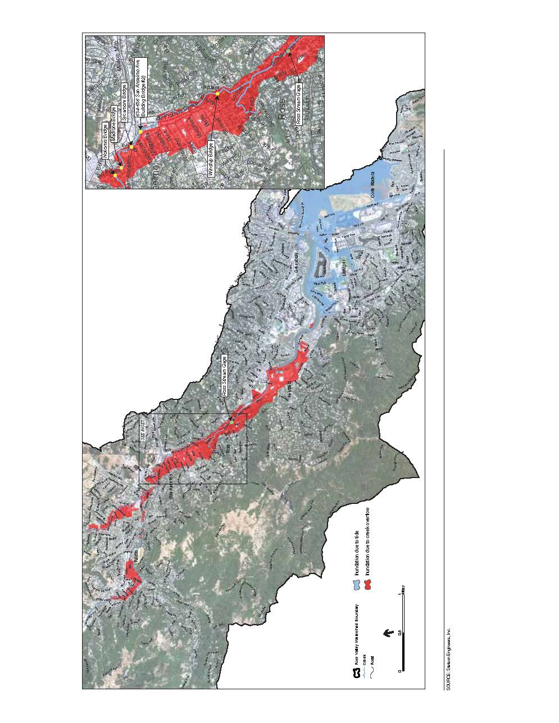
Avenue and Sycamore Avenue due to inadequate channel capacity and backwater caused by the development of commercial structures adjacent to and over the channel in the business district along San Anselmo Avenue. Floodwaters forced from the channel in this latter area will flow through the business and residential area west of San Anselmo Avenue in the form of sheetflow (FEMA, 2016). The diverted flow then travels through San Anselmo and rejoins the channel near its confluence with Ross Creek (PBS&J, 2010). Flood overflows originating near downtown San Anselmo run down Sycamore Avenue and San Anselmo Avenue in San Anselmo, along Shady Lane in Ross, through Ross Commons and along Poplar Avenue in Ross and Kent Avenue in Kentfield before finally returning to the concrete-lined channel downstream of College Avenue in Kentfield. Consequently, these flood overflows are not in the channel at the USGS Ross Gage (PBS&J 2010).

Watershed-Wide Flood Management Program
Replacement of the Winship Avenue Bridge (proposed project) is one of the flood reduction measures developed for the greater Ross Valley Flood Reduction and Watershed Management Program (Ross Valley Program), which is administered by the Marin County Flood Control and Water Conservation District, Flood Zone 9. The primary goal of the Ross Valley Program is to substantially reduce the flood hazard in Ross Valley, with various program objectives designed to integrate restoration of creek ecological and floodplain function and other public resource enhancements with the primary objective of flood protection. Specific objectives of the Ross Valley Program include providing a 100-year flood level of protection throughout Ross Valley; improving riparian and aquatic habitat, particularly to aid in the recovery of special-status anadromous salmonids; and, enhancing access and public enjoyment of the creek. Additional details on implementation of the various program elements (including the proposed project) and their potential cumulative effects are more fully described in Section 3.23 “Mandatory Findings of Significance”.

Discussion
a) Violate any water quality standards or waste discharge requirements or otherwise substantially degrade surface or ground water quality?
Construction Site Stormwater Runoff. Construction-related activities from the proposed project (including both the bridge replacement and sewer line relocation) would occur in areas adjacent to and within San Anselmo Creek could result in violations of water quality standards or waste discharge requirements. Construction could degrade water quality as a result of construction-related soil disturbance and discharge of construction stormwater. Additionally, fuels and other chemicals used during construction could also degrade the water quality of receiving waters if spilled and entrained into stormwater runoff or dewatering discharges.
The primary stormwater pollutant at construction sites is excess sediment. Excess sediment can cloud the water, which reduces the amount of sunlight reaching aquatic plants, clog fish gills, smother aquatic habitat and spawning areas, and impede navigation in waterways. Sediment also transports other pollutants such as nutrients, metals, and oils and greases. Hazardous materials associated with construction equipment and practices, such as fuels, oils, antifreeze, coolants, and other substances, could also adversely affect water quality if released to surface waters.
Construction activities can impact a construction site’s runoff sediment supply and transport characteristics both during and after the construction phase. Excess sediment could be mobilized anywhere earthwork occurs, including during removal of the existing bridge structure and during placement of the new bridge abutments. Additionally, removal of any existing vegetation along the creek banks would expose underlying soils that were previously not as susceptible to erosion. Contact with loose bare soil could entrain sediments into the runoff causing sedimentation of the water which could impact water quality in receiving waters downstream.
As previously described above in Sections 3.6 “Biological Resources” and 3.9 “Geology and Soils”, a SWPPP, or WPCP prepared in accordance with the contract specifications and by a QSP in accordance with contract specifications and with California NPDES General Permit for Storm Water Discharges (associated with construction activity), would be implemented as part of the project. The SWPPP (or WPCP) would require the implementation of appropriate construction BMPs (such as use of check dams and fiber rolls for reducing erosion on slopes and retaining sediment in stormwater) in accordance with Caltrans’s Construction Site Best Management Practices Manual and would ensure no water quality standards or waste discharge requirements would be violated. Additionally, the project is subject to the water quality and erosion prevention provisions outlined under the Clean Water Act Sections 401 and 404 and a CDFW Streambed Alteration Agreement.
Prior to in-channel construction activities, the Town will complete the Section 404 Clean Water Act Nationwide Permitting Process, complete RWQCB Section 401certification, and obtain a Streambed Alteration Agreement with California Department of Fish and Wildlife. Conditions of Approval outlined in the respective permits would help to alleviate any potential water quality impacts resulting from bridge replacement and sewer line relocation activities occurring within Corte Madera Creek. Additionally, the implementation of the erosion prevention measures/water quality best management practices provided under Mitigation Measure BIO-3 (more fully described above under Section 3.6 “Biological Resources”), would serve to further minimize the project’s impacts to soil and substantial soil erosion. Consequently, this impact is less-than-significant, with no further mitigation required.
Construction Dewatering. Construction dewatering at the project site would likely be required to create dry work areas for the jack and bore pit work areas, excavations (new bridge abutment placement) and for work within the creek channel (existing bridge removal). Water pumped from dewatered areas could be redirected to the creek channel downstream of the work area. Sediment or other water pollutants originating from construction equipment or the surrounding disturbed land could be released with the dewatered water, degrading surface water quality. Discharged water could violate water quality standards or substantially degrade water quality.
As previously described above in Section 3.6 “Biological Resources”, water diversion and dewatering BMPs will be implemented under Mitigation Measure BIO-7 (more fully described above under Section 3.6 “Biological Resources”) and will serve to further minimize the project’s water quality impacts resulting from construction dewatering activities. Additionally, the sewer line component of the proposed project is considered a beneficial effect of the project as it will contribute to a reduction in the risk of sewer overflow events in the RVSD service area. These sewer overflows can expose the public to a health hazard (from exposure to raw sewage) and contribute to adverse water quality impacts in local water waterways. Consequently, this impact is less-than-significant, with no further mitigation required.

b) Substantially decrease groundwater supplies or interfere substantially with groundwater recharge such that the project may impede sustainable groundwater management of the basin?
The proposed project would not require the use of groundwater or substantially interfere with groundwater recharge. Replacement of the bridge would not result in new amounts of impervious surfaces that would affect local groundwater levels. Therefore, the project would not substantially deplete groundwater supplies and would not affect groundwater recharge such that a net deficit would occur. Consequently, no impact would occur, with no mitigation required.
c) Substantially alter the existing drainage pattern of the site or area, including through the alteration of the course of a stream or river or through the addition of impervious surfaces, in a manner which would:
i) Result in substantial erosion or siltation on- or off-site;
ii) Substantially increase the rate or amount of surface runoff in a manner which would result in flooding on- or offsite;
iii) Create or contribute runoff water which would exceed the capacity of existing or planned stormwater drainage systems or provide substantial additional sources of polluted runoff; or
iv) Impede or redirect flood flows?
The project site naturally drains into San Anselmo Creek. Direct impacts to the creek from the proposed project include temporary disturbance to and/or permanent alteration of the creek channel, bed, and banks from removal of the existing bridge, construction of the new bridge, and all associated project activities (access to the creek bed, slope recontouring, RSP placement, and bank stabilization) and from de-watering activities and installation of water diversions. Slope recontouring and RSP placement could restrict the natural meander of the channel; however, it is not expected to do so in a meaningful way at this location because San Anselmo Creek is already heavily constrained by the surrounding urban and residential environment and because the proposed project is designed to ultimately improve the hydraulic capacity of the creek. Direct impacts are mostly temporary, short-term impacts that would be minimized or avoided by restoration of the site to its previous conditions following project construction (see Mitigation Measures BIO-10 and BIO-11, as more fully described in Section 3.6 “Biological Resources”). In addition, the project design incorporates removing fill from the creek channel to create a larger hydraulic opening for water passage under the bridge than exists currently and also realigns the bridge opening to the creek channel; both of these design attributes would directly and beneficially affect the creek by minimizing bank erosion and scouring during flood events.
As more fully described in the Location Hydraulic Study Report (Stetson Engineers Inc., 2019b) prepared for the proposed project, a hydraulic analysis was performed using the HEC-RAS 1D/2D unsteady-flow model recently developed for the Corte Madera Creek system (Stetson 2017) to determine the overall flood inundation effects resulting from implementation of various flood control/improvement measures (including replacement of the Winship Avenue Bridge) provided for in the Ross Valley Flood Reduction and Watershed Management Program. The model starts at the San Francisco Bay and extends about 10 miles upstream along the mainstream and tributaries into the upper watershed above Fairfax. The model was calibrated to the December 15, 2016 bankfull event (an approximate 5-year flood), the December 31, 2005 flood event (an approximate 100-year flood) and verified to the January 4, 1982 flood event (an approximate 150-year flood). The model has been peer reviewed/validated by the USACE and has been used in preparing the San Anselmo Flood Risk Reduction Project EIR, the San Anselmo bridge replacement projects, the USACE’s Corte Madera Creek Flood Risk Reduction Project, Marin County’s Lower Corte Madera Creek Levee Evaluation Project, and other flood projects in Ross Valley.
Considering the most likely near-term foreseeable future projects and the Ross Valley watershed-wide flood management plans, the following scenarios were analyzed:
- Existing condition;
- Proposed Winship Avenue Bridge itself only condition; and
- Proposed bridges (include the Winship Avenue Bridge, Nokomis Avenue Bridge, Madrone Avenue Bridge, Center Avenue Bridge, Bridge Avenue Bridge and the Azalea Bridge in Fairfax) under the near-term foreseeable future projects condition.

Table 3-6 shows the estimated 50-year and 100-year peak discharges at the Winship Avenue Bridge for the above different conditions. Table 3-7 shows the simulated 50-year and 100-year water surface elevations (WSE) at the upstream face of the Winship Avenue Bridge under the above different conditions. The existing Winship Avenue Bridge has a soffit elevation at about 37.00 ft NAVD88 and will be pressurized during the 50-year and 100-year flood events without any freeboard. The proposed project would raise the soffit elevation by about 4.10 ft to an elevation at 41.10 ft. The proposed project would meet the freeboard requirements (the greater of 50-year WSE plus 2 ft freeboard or 100-year WSE with clearance) under the scenarios considered.
Table 3-6. Peak Discharges at the Winship Avenue Bridge Location (in cfs)
Condition | 50-Year Peak Discharge |  |  | 100-Year Peak Discharge
 | Main Channel | Overland Flow Path | Total | Main Channel | Overland Flow Path | Total
Existing Condition | 3,920 | 1,470 | 5,390 | 4,000 | 1,980 | 5,980
Proposed Winship Avenue Bridge itself only condition | 3,960 | 1,430 | 5,390 | 4,100 | 1,880 | 5,980
Proposed bridges under the near-term foreseeable future projects condition | 4,260 | 1,130 | 5,390 | 4,420 | 1,560 | 5,980

Table 3-7. Simulated Water Surface Elevations at the Winship Avenue Bridge
Condition | Water Surface Elevation at the Upstream Face of Winship Avenue Bridge |  | Soffit Elevation of the Proposed Project | Available Freeboard (feet)
 | 50-Year Flow Event | 100-Year Flow Event |  | 50-Year Flow Event | 100-Year Flow Event
Existing Condition | 39.53 | 40.15 | 37.00 (Existing Bridge) | -2.53 | -3.15
Proposed Winship Avenue Bridge itself only condition | 38.25 | 38.77 | 41.10 | 2.85 | 2.33
Proposed bridges under the near-term foreseeable future projects condition | 38.43 | 39.03 | 41.10 | 2.67 | 2.07
Figures 3-5 and 3-6 show the changes in the HEC-RAS model-simulated floodplain inundation extent and depth between the proposed project and existing conditions for the 100-year flood. The figures cover both the Upper San Anselmo (Figure 3-5) and Lower San Anselmo (Figure 3-6) areas. The results show that the proposed project would reduce the 100-year water surface elevation by about 1 inch in the floodplain area near Center Blvd and by up to 2 inches near the Ross Creek confluence. In the floodplain area adjacent to the creek channel and upstream of the Winship Bridge, the proposed project would reduce the 100-year water surface elevation by up to 14 inches. The results do not show any increased water surface elevation in the floodplain, indicating that the proposed project would not induce any additional flooding.
Under the near-term foreseeable future projects condition, modeling results show increased water surface elevations by up to 4 inches in the floodplain area between the Winship Avenue and the downstream crossing of the Sir Francis Drake Avenue due to more floodwater in the channel. These potential cumulative effects are more fully described in Section 3.23 “Mandatory Findings of Significance”.
The proposed bridge and road widening would not add a significant amount of new impervious surfaces and would not substantially alter the existing topography or drainage pattern of the creek channel. While there may be a temporary alteration of flow during installation of the proposed bridge, any water diversion structures utilized would be in place over a short-term period and are not considered to significantly alter the existing drainage pattern of the site in a way that would result in substantial erosion or siltation on- or offsite. In addition, standard construction erosion control measures, permit Conditions of Approval, as well as the SWPPP (or WPCP) would be implemented as a part of the project and would ensure that potential construction erosion and siltation would not affect drainages. Consequently, this impact is less-than-significant, with no mitigation required.
d) In flood hazard, tsunami, or seiche zones, risk release of pollutants due to project inundation?
Tsunamis (seismic sea waves) are long-period waves that are typically caused by underwater seismic disturbances, volcanic eruptions, or submerged landslides. Low-lying coastal areas such as tidal flats, marshlands, and former bay margins that have been artificially filled but are still at or near sea level are generally the most susceptible to tsunami inundation. A seiche is caused by the oscillation of the surface of an enclosed body of water such as San Francisco Bay due to an earthquake or large wind event.
In 2009, the California Geological Survey, California Emergency Management Agency, and the Tsunami Research Center at the University of California completed the state’s official tsunami inundation maps. None of the Project elements are within the tsunami inundation zone, which in Ross Valley extends from the bay shoreline inland along Corte Madera Creek to Kentfield (CalEMA, CGS, and USC, 2009). Consequently, no impact would occur.
e) Conflict with or obstruct implementation of a water quality control plan or sustainable groundwater management plan?
See checklist Item “a and b” above.

Figure 3-5. Map Showing Change in Water Surface Extent and Depth Between Existing Condition and Project Completion. Flood Event: 100-Year Flood (Upper)
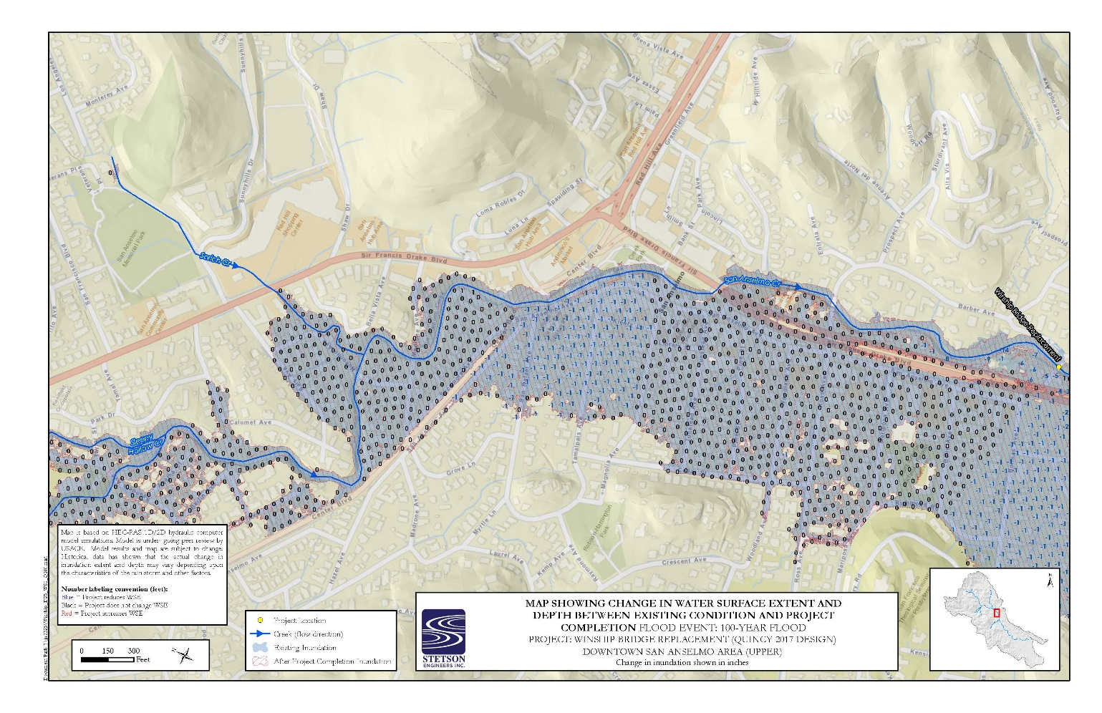

Figure 3-6. Map Showing Change in Water Surface Extent and Depth Between Existing Condition and Project Completion. Flood Event: 100-Year Flood (Lower)

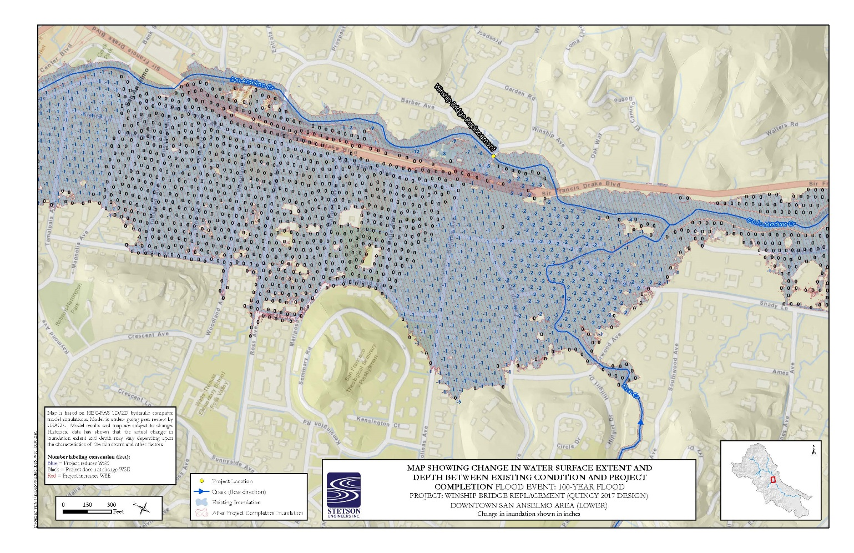

Land Use and Planning
Environmental Issue | Potentially  Significant  Impact | Less-than-Significant Impact with  Mitigation  Incorporated | Less-than-Significant  Impact | No  Impact | Beneficial Impact
- LAND USE AND PLANNING.
Would the project:
- Physically divide an established community? | ☐ | ☐ | ☐ | ☐ | ☒
- Cause a significant environmental impact due to a conflict with any land use plan, policy, or regulation adopted for the purpose of avoiding or mitigating an environmental effect? | ☐ | ☐ | ☐ | ☒ | ☐

Discussion
a) Physically divide an established community?
The proposed project would replace an existing bridge within largely the same alignment and would not result in a physical division or barrier to an established community. Land uses in the immediate project vicinity consist of residential uses. The project is designed to improve public safety, connectivity (including a new sidewalk), and circulation for residents in the project vicinity and any short term-construction-related impacts to local vehicle travel would be minimal. Consequently, implementation of the proposed project would not physically divide an established community and improve public safety by replacing the existing bridge, resulting in a beneficial impact.
b) Cause a significant environmental impact due to a conflict with any land use plan, policy, or regulation adopted for the purpose of avoiding or mitigating an environmental effect?
The proposed replacement of an existing bridge would occur predominately within the Town’s existing right-of-way and the proposed project would remain consistent with the existing site land use and surrounding land use designations, requiring no further change or amendment to the General Plan land use designation or zoning assigned by the Town. Therefore, the project would not conflict with any applicable land use plan, policy, or regulation of an agency with jurisdiction over the project. Consequently, No impact would occur.

Mineral Resources
Environmental Issue | Potentially  Significant  Impact | Less-than-Significant Impact with  Mitigation  Incorporated | Less-than-Significant  Impact | No  Impact | Beneficial Impact
- MINERAL RESOURCES.
Would the project:
- Result in the loss of availability of a known mineral resource that would be of value to the region and the residents of the State? | ☐ | ☐ | ☐ | ☒ | ☐
- Result in the loss of availability of a locally important mineral resource recovery site delineated on a local general plan, specific plan or other land use plan? | ☐ | ☐ | ☐ | ☒ | ☐

Discussion
a) Result in the loss of availability of a known mineral resource that would be of value to the region and the residents of the State?
No mineral extraction activities exist on the project site and mineral extraction is not included as a part of the project. Consequently, no impact would occur.
b) Result in the loss of availability of a locally important mineral resource recovery site delineated on a local general plan, specific plan or other land use plan?
See checklist Item “a” above.

Noise
Environmental Issue | Potentially  Significant  Impact | Less-than-Significant Impact with  Mitigation  Incorporated | Less-than-Significant  Impact | No  Impact | Beneficial Impact
- NOISE.
Would the project:
- Generation of a substantial temporary or permanent increase in ambient noise levels in the vicinity of the project in excess of standards established in the local general plan or noise ordinance, or in other applicable standards of other agencies? | ☐ | ☒ | ☐ | ☐ | ☐
- Generation of excessive groundborne vibration or groundborne noise levels? | ☐ | ☒ | ☐ | ☐ | ☐
- For a project located within the vicinity of a private airstrip or an airport land use plan or, where such a plan has not been adopted, within 2 miles of a public airport or public use airport, would the project expose people residing or working in the project area to excessive noise levels? | ☐ | ☐ | ☐ | ☒ | ☐

Environmental Setting
A Construction Noise Technical Memorandum for the Winship Avenue Bridge Replacement Project (Environmental Science Associates, 2019) has been prepared to described existing noise conditions in the study area and to identify any construction noise reducing measures that may be implemented by the proposed project.

Terminology Used to Define Noise Conditions
Noise can be defined as unwanted and objectionable sound. Sound levels are usually measured and expressed in decibels (dB) with 0 dB corresponding roughly to the threshold of hearing. The method commonly used to quantify environmental sounds consists of evaluating all frequencies of a sound in accordance with a filter that reflects the fact that human hearing is less sensitive at very low and very high frequencies compared to mid-range frequencies. This is called “A” weighting, and the dB level measurement is called the A-weighted sound level (dBA).
A-weighted sound level (dBA) is expressed on a logarithmic (power of 10) scale using a frequency-weighted pattern that duplicates the human ear’s sensitivity to sound. A 70-dBA sound level is approximately twice as loud as a 60-dBA sound level and four times as loud as a 50-dBA sound level.
Sound intensity is normally measured through the A-weighted sound level (dBA). This scale gives greater weight to the frequencies of sound to which the human ear is most sensitive. The A-weighted sound level is the basis for many various sound level metrics, including the day/night sound level (Ldn) and the Community Noise Equivalent Level (CNEL), both of which represent how humans are more sensitive to sound at night. In addition, the equivalent continuous sound level (Leq) is the average sound energy of time-varying noise over a sample period and the Lmax is the maximum instantaneous noise level occurring over a sample period.

Existing Noise Conditions
The existing noise environment in the immediate project area is dominated by traffic noise along Winship Avenue and Sir Francis Drake Boulevard. To quantify the ambient noise levels in the proposed project vicinity, a noise measurement survey was conducted on August 17, 2017 and consisted of one 15-minute short-term (ST) noise measurement taken at a position on Winship Avenue adjacent to the eastern boundary of the project site or APE. The results of the 15-minute short-term noise measurement are presented below in Table 3-8. The noise measurement was conducted using a Larson Davis 831 Type 1 sound level meter. The noise meter was calibrated before and after the noise measurement survey.
Table 3-8. Short-Term (15 Minute) Ambient Noise Monitoring Results
Monitor | Start Time | Leq (dBA) | Lmax (dBA) | Lmax (dBA) | Primary Noise Source(s)
ST-1 | 10:24 AM | 53 | 67 | 42 | Winship Avenue & Sir Francis Drake Boulevard (vehicle and trucks)
Source: Environmental Science Associates, 2017
Sensitive Receptors. Some land uses are considered more sensitive to ambient noise levels than others because of the amount of noise exposure (in terms of both exposure duration and insulation from noise) and the types of activities typically involved for those uses. Residences, schools, day cares, rest homes, hospitals, and churches are generally more sensitive to noise than commercial and industrial land uses. With the project site located within a residential neighborhood, single family residences surround the project site, with the nearest receptors located within 30 feet of the project site.

Local Noise Regulations
The proposed project is subject to the following construction noise regulations of the Town.
Town of Ross General Plan 2007 – 2025. The Town’s General Plan includes Noise/Land Use Compatibility Standards (see Policy 5.6 “Noise/Land Use Compatibility Standards”, Figure 8, on page 23), which apply to the siting and design of new structures and substantial building remodels. Residential exterior noise standards identified as “normally acceptable” are within the 50 to 60 dB (Ldn) range.
The General Plan also includes the following policy specific to construction noise:
- Policy 5.10 Traffic and Construction Noise. Require mitigation of construction and traffic noise impacts on the ambient noise level in the Town.
Town of Ross Municipal Code. Municipal Code Section 9.20.035, Construction, contains the following hourly restrictions for the operation of construction equipment.
- It is unlawful for any person or construction company within the Town limits to perform any construction operation before 8:00 a.m. or after 5:00 p.m., Monday through Friday of each week and not at any time on Saturday, Sunday, or the other holidays listed in Section 9.20.060; except that:
- Work done solely in the interior of a building or structure, the performance of which does not create any noise which is audible from the exterior of the building or structure; or
Work actually physically performed solely by the owner of the property, on Saturday between the hours of 10:00 a.m. and 4:00 p.m. and not at any time on Sundays or other holidays listed in Section 9.20.060 herein.

Construction Vibration
Vibration is an oscillatory motion through a solid medium in which the motion’s amplitude can be described in terms of displacement, velocity, or acceleration. The peak particle velocity (PPV) is most frequently used to describe vibration impacts on buildings and is defined as the maximum instantaneous positive or negative peak of the vibration wave typically expressed in units of inches per second (in/sec). Low-level vibrations frequently cause nuisance secondary vibration, such as a slight rattling of windows, doors, or stacked dishes. The rattling sound can give rise to exaggerated vibration complaints, even though there is very little risk of actual structural damage. In high noise environments, which are more prevalent where groundborne vibration approaches perceptible levels, this rattling phenomenon may also be produced by loud airborne environmental noise causing induced vibration in exterior doors and windows. In suburban environments, such as the project site, sources of groundborne vibration include construction activities and heavy trucks and buses. Typically, groundborne vibration generated by human-made activities attenuates rapidly with distance from the source of the vibration.
Construction activities can cause vibration that varies in intensity depending on several factors. The use of pile driving and vibratory compaction equipment typically generates the highest construction related groundborne vibration levels. The two primary concerns with construction-induced vibration, the potential to damage a structure and the potential to interfere with the enjoyment of life, are evaluated against different vibration limits. Studies have shown that the threshold of perception for average persons is in the range of 0.008 to 0.012 in/sec, PPV (Environmental Science Associates, 2018). Human perception to vibration varies with the individual and is a function of physical setting and the type of vibration. Persons exposed to elevated ambient vibration levels such as people in an urban environment may tolerate a higher vibration level. Structural damage can be classified as cosmetic only, such as minor cracking of building elements, or may threaten the integrity of the building. Construction-induced vibration that can be detrimental to a building is very rare and has only been observed in instances where the structure is in a high state of disrepair and the construction activity (e.g., impact pile driving) occurs immediately adjacent to the structure. Table 3-9 identifies the human reactions and effects on buildings that can be caused by various continuous vibration levels.
Table 3-9. Approximate Reaction of People and Damage to Buildings from Construction Vibration Levels
Velocity Level,  PPV (in/sec) | Human Reaction | Effect on Structures
0.01 | Barely perceptible | No effect
0.04 | Distinctly perceptible | Vibration unlikely to cause damage of any type to any structure
0.08 | Distinctly to strongly perceptible | Recommended upper level of the vibration to which ruins and ancient monuments should be subjected
0.1 | Strongly perceptible | Virtually no risk of damage to normal buildings
0.3 | Strongly perceptible to severe | Threshold at which there is a risk of damage to older residential dwellings such as plastered walls or ceilings
0.5 | Severe – vibrations considered unpleasant | Threshold at which there is a risk of damage to newer residential structures
Source: California Department of Transportation, 2013
The Town’s General Plan and relevant municipal codes do not address vibration or provide numerical thresholds for identifying groundborne vibration impacts. In the absence of local standards for construction equipment vibration, the evaluation presented below uses the vibration thresholds presented in Table 3-10 to assess the significance of groundborne vibration and noise impacts. For adverse human reaction, the analysis applies the “strongly perceptible” threshold of 0.1 in/sec PPV for transient sources (Caltrans, 2013). A threshold of 0.3 in/sec PPV is used for all buildings. The Federal Transit Administration (FTA) provides an equation that may be used to estimate vibration at different distances based on a reference PPV of 25 feet for various construction equipment. Using the FTA equation, the distances at which vibration-generating construction equipment would be lower than the annoyance or damage thresholds were calculated and compared to potential distances to receiving buildings.
Table 3-10. Vibration Thresholds
 | Maximum Peak Particle Velocity (PPV), inches per second (in/sec)
Adverse human reaction (human annoyance) | 0.1
Buildings and Structures | 0.3
Source: California Department of Transportation, 2013

Discussion
a) Generation of a substantial temporary or permanent increase in ambient noise levels in the vicinity of the project in excess of standards established in the local general plan or noise ordinance, or in other applicable standards of other agencies?
Implementation of the proposed project would result in potential noise impacts from short-term construction activities. Regarding long-term or operational noise impacts, implementation of the proposed project would not result in added travel lanes along the project alignment, nor would it move travel lanes substantially closer to any sensitive receptor in the project vicinity. In addition, implementation of the proposed project would not result in any increase in traffic volumes along the project alignment. As such, the project would not result in any new long-term operational noise sources, nor would it move existing operational noise sources (i.e., traffic) closer to existing sensitive land uses. No long-term or operational noise impacts are associated with the project and this topic is not addressed further.
Construction activities necessary to complete the proposed project would generate a considerable amount of noise in the immediate project vicinity. Noise from vehicles, earth-moving operations, and heavy equipment would result in elevated ambient and intermittent noise levels. Noise impacts from construction depend on the noise generated by various pieces of equipment, timing and duration of noise-generating activities, and the distance between construction noise sources and noise-sensitive receptors, and the noise environment in which the proposed project would be constructed. Noise generated during the construction period would vary on a day-to-day basis, depending on the specific activities being undertaken at any given time.
Vehicles and equipment travelling to the project site have the potential to increase vehicle-related noise to nearby sensitive receptors. However, the use of an offsite staging and parking area (Town of Ross Maintenance Yard) would minimize vehicle-related construction noise. A second type of short-term noise impact is related to noise generated during bridge construction. Bridge and sewer line installation would be performed in discrete steps, with each step having its own mix of equipment and, consequently, its own noise characteristics. These various construction operations would change the character of the noise generated at the project site and, therefore, the ambient noise level as construction progresses. The loudest phases of construction include excavation and site preparation phase as the noisiest construction equipment is earthmoving equipment. The nearest single-family residences are located within approximately 25 to 30 feet of where onsite construction would occur. Assuming two of the loudest construction equipment operating at the same time and place (e.g., crane dozer), the nearest existing single-family residence would be exposed to a noise level of approximately 92 dBA Lmax during project construction. Additionally, short-term pile driving may be required to place the temporary sheet piles around the bridge abutment footings. While these activities would be limited to 2 days, use of pile driving equipment (impact or vibratory) would result in higher noise levels (101 dBA at 50 feet) to surrounding residential uses during their use. If this were to occur, then it would result in a potentially significant impact.
According to Caltrans Standard Specification Section 14-8.02 and Caltrans Standard Special Provisions S5-310, noise levels generated during construction shall comply with applicable local, state, and federal regulations. According to the Town’s Municipal Code, noise from construction activity is exempt from the Town noise performance standards provided that all construction in or adjacent to residential areas shall be limited to the daytime hours between 8:00 a.m. and 5:00 p.m. While construction noise would be short-term and intermittent, implementation of limitations on evening construction activities and other construction noise BMPs provided under Mitigation Measure N-1, would minimize construction-related noise impacts to sensitive receptors. Consequently, this impact is less-than-significant with incorporation of Mitigation Measures N-1.
Mitigation Measure N-1: Construction Noise Reducing Best Management Practices
The Town shall ensure the construction contractor implement the following construction noise reducing measures.
- The construction contractor shall ensure that all noise producing construction activities, including warming-up or servicing equipment and any preparation for construction, shall be limited to the hours between 8:00 a.m. and 5:00 p.m. The construction contractor shall locate on-site equipment staging areas to maximize the distance between construction-related noise sources and noise sensitive receptors nearest the project site during construction.
- Distribute to the potentially affected residences and other sensitive receptors within 100 feet of Project construction boundary a “hotline” telephone number, which shall be attended during active construction working hours, for use by the public to register complaints. The distribution shall identify a noise disturbance coordinator who shall be responsible for responding to any local complaints about construction noise. The disturbance coordinator shall determine the cause of the noise complaints and institute feasible actions warranted to correct the problem. All complaints shall be logged noting date, time, complainant’s name, nature of complaint, and any corrective action taken. The distribution shall also notify residents adjacent to the project site of the construction schedule.
- The project contractor shall place all stationary construction equipment so that emitted noise is directed away from the closest off-site sensitive receptors.
- The construction contractor shall prohibit unnecessary idling of internal combustion engines.
- The construction contractor shall ensure that all equipment will have sound control devices that are no less effective than those provided on the original equipment. Further, pavement breakers and jackhammers shall also be equipped with acoustically attenuating shields or shrouds recommended by the manufacturers thereof. In lieu of or in the absence of manufacturers' recommendations, the Director of Public Works shall have the authority to prescribe such means of accomplishing maximum noise attenuation as he deems to be in the public interest, considering the available technology and economic feasibility.
- Use construction noise barriers such as paneled noise shields, barriers, or enclosures adjacent to noisy stationary equipment. Noise control shields shall be made featuring a solid panel and a weather-protected, sound-absorptive material on the construction-activity side of the noise shield.
- To minimize noise levels, attempt to obtain electrical power from PG&E in lieu of providing power by portable generator. If use of utility power is not practicable, generator power may be provided by sound-attenuated and enclosed electric generators. Diesel generators shall not be utilized unless they are provided with sound enclosures, as necessary to comply with local ordinances.
- Whenever construction occurs within 100 feet of a sensitive receptor or has direct line-of sight of a first-floor occupied residence, a temporary six-foot or greater barrier(s) shall be constructed around construction areas to shield the ground floor of the noise-sensitive uses. These barriers shall be of ¾-inch Medium Density Overlay (MDO) plywood sheeting, or other material of equivalent utility and appearance, and shall achieve a Sound Transmission Class of STC-30, or greater.
Timing: During construction.
Responsibility: Town of Ross / RVSD / Construction Contractor.
b) Generation of excessive groundborne vibration or groundborne noise levels?
Temporary sources of groundborne vibration and noise during construction activities at the project site would result from operation of conventional heavy construction equipment such as graders, bulldozers, jack and bore operations, and pile driving. Typical reference vibration levels for these types of equipment are listed below in Table 3-11.
Table 3-11. Vibration Velocities for Construction Equipment
Equipment Activity | PPV at 25 feet  (inches/second)
Pile Driver | 0.170 (typical range)
Large Bulldozer or Caisson drilling (represents tunnel boring machine) | 0.089
Source: Federal Transit Administration, 2006
As described above, sensitive land uses that are exposed to vibration levels that exceeds 0.1 in/sec PPV and 0.3 in/sec PPV would result in adverse human reaction or building damage. The nearest sensitive land uses are approximately 25 to 30 feet from the project site. Assuming the use of a large bulldozer or jack and bore equipment (as part of the sewer line replacement component) during construction, these sensitive land uses would be exposed to a vibration level of approximately 0.089 in/sec PPV, considered below the vibration thresholds resulting in adverse human reactions or building damage. As more fully described above in Chapter 2 “Project Description”, use of short-term pile driving equipment (vibratory hammer or a pile driver) may be required to place the temporary sheet piles around the bridge abutment footings. Use of a vibratory hammer would likely result in similar vibration levels (0.089 in/sec PPV) as those anticipated under the sewer line replacement component (see Table 3-11). Should the use of pile driving equipment be required, vibration levels (see Table 3-11) would slightly exceed those related to an adverse human reaction but would not exceed those related to building damage. While pile driving activities would be short-term and intermittent, monitoring and correction of vibration conditions under Mitigation Measure N-2, would minimize construction-related vibration impacts to sensitive receptors and buildings. Consequently, this impact is less-than-significant with incorporation of Mitigation Measures N-2.
Mitigation Measure N-2: Construction Vibration Reducing Best Management Practices
The Town shall ensure the construction contractor implement the following construction vibration reducing measures.
- Implement a vibration monitoring program to protect buildings, structures, and utilities from extensive vibration during construction during use of onsite pile driving equipment. Vibration monitoring shall be conducted to ensure vibration levels stay below the vibration thresholds of 0.1 in/sec PPV.
- Should pile driving activities result in exceedances of the vibration threshold, the construction contractor will implement the following construction practices:
  - Avoid impact pile-driving where possible in vibration-sensitive areas. Drilled piles or the use of a sonic or vibratory pile driver causes lower vibration levels where the geological conditions permit their use.
  - Select demolition methods not involving impact, where possible. For example, sawing bridge decks into sections that can be loaded onto trucks results in lower vibration levels than impact demolition by pavement breakers, and milling generates lower vibration levels than excavation using clam shell or chisel drops.
Timing: During construction.
Responsibility: Town of Ross / Construction Contractor.
c) For a project located within-the vicinity of a private airstrip or-an airport land use plan or, where such a plan has not been adopted, within 2 miles of a public airport or public use airport, would the project expose people residing or working in the project area to excessive noise levels?
The San Rafael Airport, located at 400 Smith Ranch Rd, San Rafael, CA, is the nearest airport to the project site and is located 8 miles from the project site. The project site is not located within 2 miles of an airport or within an existing or projected airport land use plan. Consequently, no impact would occur.

Population and Housing
Environmental Issue | Potentially  Significant  Impact | Less-than-Significant Impact with  Mitigation  Incorporated | Less-than-Significant  Impact | No  Impact | Beneficial Impact
- POPULATION AND HOUSING.
Would the project:
- Induce substantial unplanned population growth in an area, either directly (for example, by proposing new homes and businesses) or indirectly (for example, through extension of roads or other infrastructure)? | ☐ | ☐ | ☐ | ☒ | ☐
- Displace substantial numbers of existing people or housing, necessitating the construction of replacement housing elsewhere? | ☐ | ☐ | ☐ | ☒ | ☐

Discussion
a) Induce substantial unplanned population growth in an area, either directly (for example, by proposing new homes and businesses) or indirectly (for example, through extension of roads or other infrastructure)?
The proposed project would not directly or indirectly induce growth in the area. The new bridge would more efficiently and safely accommodate existing traffic volumes and would increase safety for pedestrians by meeting current design standards for sidewalk width and compliance with the ADA. The relocated sewer line ensures necessary system reliability to continue meeting peak utility demands and prevent overflows. Although the sewer line is being upsized, the primary purpose is to prevent sewer overflows and will not generate additional capacity to accommodate new population growth under the proposed design. The replacement bridge and roadway approaches would not provide an extension to new destinations beyond the current extent of the existing road. Construction is expected to last up to 6 months (24 weeks) utilizing a construction crew of 12 workers from the surrounding Bay Area workforce. No additional housing or temporary lodging facilities would be required by construction workers commuting to the project site. Consequently, no impact would occur.
b) Displace substantial numbers of existing people or housing, necessitating the construction of replacement housing elsewhere?
Replacing the existing bridge and sewer line with similar infrastructure within largely the same project footprint would not involve the construction, displacement, or demolition of any existing housing structures. Consequently, no impact would occur.

Public Services
Environmental Issue | Potentially  Significant  Impact | Less-than-Significant Impact with  Mitigation  Incorporated | Less-than-Significant  Impact | No  Impact | Beneficial Impact
- PUBLIC SERVICES.
Would the project:
- Result in substantial adverse physical impacts associated with the provision of new or physically altered governmental facilities, or the need for new or physically altered governmental facilities, the construction of which could cause significant environmental impacts, in order to maintain acceptable service ratios, response times, or other performance objectives for any of the public services:
Fire protection? | ☐ | ☐ | ☐ | ☒ | ☐
Police protection? | ☐ | ☐ | ☐ | ☒ | ☐
Schools? | ☐ | ☐ | ☐ | ☒ | ☐
Parks? | ☐ | ☐ | ☐ | ☒ | ☐
Other public facilities? | ☐ | ☐ | ☐ | ☒ | ☐

Discussion
a) Result in substantial adverse physical impacts associated with the provision of new or physically altered governmental facilities, or the need for new or physically altered governmental facilities, the construction of which could cause significant environmental impacts, in order to maintain acceptable service ratios, response times, or other performance objectives for any of the public services:
Fire protection?
Police protection?
Schools?
Parks?
Other public facilities?
Implementing the proposed project would not create new housing or other structures and, therefore, would not require additional public services (including fire or police protection facilities, schools, or parks). Furthermore, the new bridge would more efficiently and safely accommodate existing traffic volumes and would increase safety for pedestrians by meeting current design standards for sidewalk width and compliance with the ADA. The relocated sewer line ensures necessary system reliability to continue meeting peak utility demands. Consequently, no impact would occur.

Recreation
Environmental Issue | Potentially  Significant  Impact | Less-than-Significant Impact with  Mitigation  Incorporated | Less-than-Significant  Impact | No  Impact | Beneficial Impact
- RECREATION.
Would the project:
- Increase the use of existing neighborhood and regional parks or other recreational facilities such that substantial physical deterioration of the facility would occur or be accelerated? | ☐ | ☐ | ☐ | ☒ | ☐
- Include recreational facilities or require the construction or expansion of recreational facilities that might have an adverse physical effect on the environment? | ☐ | ☐ | ☐ | ☒ | ☐

Discussion
a) Increase the use of existing neighborhood and regional parks or other recreational facilities such that substantial physical deterioration of the facility would occur or be accelerated?
As previously described, the proposed project does not include the development of any new residential uses or include other land development that would directly induce additional population growth affecting existing recreation facilities or opportunities. Employment opportunities from the construction phase of the project would not induce any additional population growth within the Town of Ross or Marin County. Therefore, the project would not cause physical deterioration of existing recreational facilities from increased usage or result in the need for new or expanded recreational facilities. Consequently, no impact would occur.
b) Include recreational facilities or require the construction or expansion of recreational facilities that might have an adverse physical effect on the environment?
See checklist Item “a” above.

Transportation
Environmental Issue | Potentially  Significant  Impact | Less-than-Significant Impact with  Mitigation  Incorporated | Less-than-Significant  Impact | No  Impact | Beneficial Impact
- TRANSPORTATION.
Would the project:
- Conflict with a program plan, ordinance or policy addressing the circulation system, including transit, roadway, bicycle and pedestrian facilities? | ☐ | ☒ | ☐ | ☐ | ☐
- Conflict or be inconsistent with CEQA Guidelines Section 15064.3, subdivision (b)? | ☐ | ☒ | ☐ | ☐ | ☐
- Substantially increase hazards due to a geometric design feature (e.g., sharp curves or dangerous intersections) or incompatible uses (e.g., farm equipment)? | ☐ | ☐ | ☐ | ☒ | ☐
- Result in inadequate emergency access? | ☐ | ☒ | ☐ | ☐ | ☐

Discussion
a) Conflict with a program plan, ordinance or policy addressing the circulation system, including transit, roadway, bicycle and pedestrian facilities?
Implementation of the proposed project would help to address roadway safety and pedestrian circulation in the area. The replacement bridge would be built to meet current design standards for lane and shoulder widths, providing a safer crossing for motorists, pedestrians, and emergency response vehicles. The project is being implemented as part of the Caltrans Local Highway Bridge Program, which is a federal- and state sponsored program that provides funding for projects that replace bridges that have been deemed structurally deficient or functionally obsolete.
While the proposed project would not conflict with federal transportation programs or local Town circulation policies, construction of the project would require the temporary closure of Winship Avenue (at the bridge location) during the 5 to 6 month construction period, temporarily affecting local traffic accessing the neighborhood. As part of the project, the Town and the construction contractor would route residential traffic to the north and south along Winship Avenue to Sir Francis Drake (as shown in Figure 2-7, see Chapter 2). Temporary traffic controls will also be implemented to ensure that the project would remain consistent with Town and County requirements regarding traffic control. To minimize traveler delays and ensure residential circulation and access along Winship Avenue, during the construction period, the Town will implementation the traffic detour and circulation measures included under Mitigation Measure TC-1. Consequently, this impact is less-than-significant with incorporation of Mitigation Measures TC-1.
Mitigation Measure TC-1: Prepare and Implement a Traffic Detour and Control Plan
- At least one week prior to the commencement of work, the Town’s contractor’ will be required to provide changeable message signs at each end of Winship Avenue to notify drivers of the upcoming project and potential delays. The contractor shall provide an informational sign at the entry points of the project identifying a contact person and phone number for any concerns or questions.
- During project construction, the Town’s contractor shall use standard cones and barricades to protect the public from entering the construction work area. The contractor will also install advance warning signs to alert approaching motorists of the work zones consistent with the most recent edition of the California Manual of Traffic Control Devices (MUTCD) for sign placement, etc. Advance warning signs may be reflective signs, changeable message boards, cones and barricades. The contractor shall provide flaggers as needed to temporarily hold traffic for staging equipment or construction. The work will be limited to 8 a.m. to 5 p.m., with weekend work if approved by Public Works; no work shall occur on national holidays. Flagging and other means of traffic control will be required to allow for the movement of traffic through the work zone. Cones, signing and flagging for traffic control shall conform to the requirements of the MUTCD.
- Written notice to each homeowner along Winship Avenue and the affected areas around Sir Francis Drake Boulevard shall be provided at least 2 weeks prior to the start of the construction phase.
- No lane closures, delays or blockages on Sir Francis Drake Boulevard shall occur before 9:00a or after 3:00p., other than the bridge closure itself.
Timing: During construction.
Responsibility: Town of Ross / RVSD / Construction Contractor.
b) Conflict or be inconsistent with CEQA Guidelines Section 15064.3, subdivision (b)?
The proposed project does not include the development of any new residential uses or include other land development that would directly induce additional population growth or affect the existing “vehicle miles travelled” by residents or visitors within the area. Replacement of the existing bridge is considered a “Transportation Project” that would have no impact on vehicle miles travelled and therefore is presumed to result in a less than significant transportation impact consistent with CEQA Guidelines 15054.3(b)(2). Consequently, no impact would occur.
See checklist Item “a” above.
c) Substantially increase hazards due to a geometric design feature (e.g., sharp curves or dangerous intersections) or incompatible uses (e.g., farm equipment)?
No hazards due to design features would occur through implementation of the proposed project, as the replacement bridge structure and associated roadway approaches would conform to Town and Caltrans design standards. Therefore, the project would not substantially increase hazards due to a design feature or incompatible use. Consequently, no impact would occur.
d) Result in inadequate emergency access?
See checklist Item “a” above.

Tribal Cultural Resources
Environmental Issue | Potentially  Significant  Impact | Less-than-Significant Impact with  Mitigation  Incorporated | Less-than-Significant  Impact | No  Impact | Beneficial Impact
- TRIBAL CULTURAL RESOURCES.
Would the project cause a substantial adverse change in the significance of a tribal cultural resource, defined in PRC Section 21074 as either a site, feature, place, cultural landscape that is geographically defined in terms of the size and scope of the landscape, sacred place, or object with cultural value to a California Native American tribe, and that is:
- Listed or eligible for listing in the California Register of Historical Resources, or in a local register of historical resources as defined in PRC Section 5020.1(k), or | ☐ | ☒ | ☐ | ☐ | ☐
- A resource determined by the lead agency, in its discretion and supported by substantial evidence, to be significant pursuant to criteria set forth in subdivision (c) of PRC Section 5024.1. In applying the criteria set forth in subdivision (c) of PRC Section 5024.1, the lead agency shall consider the significance of the resource to a California Native American tribe. | ☐ | ☒ | ☐ | ☐ | ☐

Discussion
a) Would the project cause a substantial adverse change in the significance of a tribal cultural resource, defined in PRC Section 21074 as either a site, feature, place, cultural landscape that is geographically defined in terms of the size and scope of the landscape, sacred place, or object with cultural value to a California Native American tribe, and that is listed or eligible for listing in the California Register of Historical Resources, or in a local register of historical resources as defined in PRC Section 5020.1(k)?
Under PRC section 21080.3.1 and 21082.3, the Town must consult with tribes traditionally and culturally affiliated with the project area that have requested formal notification and responded with a request for consultation. The parties must consult in good faith. Consultation is deemed concluded when the parties agree to measures to mitigate or avoid a significant effect on a tribal cultural resource when one is present or when a party concludes that mutual agreement cannot be reached. Mitigation measures agreed on during the consultation process must be recommended for inclusion in the environmental document.
As previously described above under Section 3.7 “Cultural Resources”, Garcia and Associates archaeologist Safiya Bal requested a list of Most Likely Decedents in March 2019. NAHC responded on March 25, 2019 with a list of interested Native American groups. The NAHC also reported that a search of the Sacred Lands File indicated that there are no sacred sites recorded within the APE. On March 26, 2019, letters describing the project details were mailed to the following Native American contacts listed for Marin County to initiate formal consultation: Gene Bevelot and Greg Sarris of the Federated Indians of Graton Rancheria. Town staff also contacted Buffy McQuillen of the Federated Indians of Graton Rancheria on September 23, 2019. Buffy McQuillen followed up with Town staff (via email) on October 24, 2019, indicating the Tribe’s request to consult with the Town regarding the proposed project. A request for the ASR was also provided to the Town and a copy of the ASR was sent to the Graton Rancheria on November 19, 2019. A follow up phone call to the Tribe was completed on December 19, 2019. No further communication has been completed.
While no responses or tribal resources have been received or identified to date, portions of the proposed project area may be sensitive for the presence of tribal cultural resources. Implementation of the proposed project is not considered to result in an adverse change in the significance of a known tribal cultural resource pursuant to Public Resources Code 21074. However, while unlikely, construction of the proposed project could result in the inadvertent discovery of undocumented tribal cultural resources such as Native American archaeological sites, Native American human remains and associated objects and materials, features, sacred places or objects with value to a Tribe that is culturally or traditionally affiliated with the proposed project, and the disturbance or destruction of these resources. Therefore, the proposed project could result in a potentially significant impact on tribal cultural resources. To ensure no adverse effects to tribal cultural resources, implementation of resource avoidance measures provided in Mitigation Measures CUL-1, CUL-2, and CUL-3 would reduce the impact to less than significant. Therefore, the proposed project would have a less-than-significant impact with mitigation incorporated.
b) Would the project cause a substantial adverse change in the significance of a tribal cultural resource, defined in PRC Section 21074 as either a site, feature, place, cultural landscape that is geographically defined in terms of the size and scope of the landscape, sacred place, or object with cultural value to a California Native American tribe, and that is a resource determined by the lead agency, in its discretion and supported by substantial evidence, to be significant pursuant to criteria set forth in subdivision (c) of PRC Section 5024.1.
See checklist Item “a” above.

Utilities and Service Systems
Environmental Issue | Potentially  Significant  Impact | Less-than-Significant Impact with  Mitigation  Incorporated | Less-than-Significant  Impact | No  Impact | Beneficial Impact
- UTILITIES AND SERVICE SYSTEMS.
Would the project:
- Require or result in the relocation or construction of new or expanded water, wastewater treatment or storm water drainage, electric power, natural gas, or telecommunications facilities, the construction or relocation of which could cause significant environmental effects? | ☐ | ☐ | ☐ | ☒ | ☐
- Have sufficient water supplies available to serve the project and reasonably foreseeable future development during normal, dry, and multiple dry years? | ☐ | ☐ | ☐ | ☒ | ☐
- Result in a determination by the wastewater treatment provider that serves or may serve the project that it has adequate capacity to serve the project’s projected demand in addition to the provider’s existing commitments? | ☐ | ☐ | ☐ | ☒ | ☐
- Generate solid waste in excess of State or local standards, or in excess of the capacity of local infrastructure, or otherwise impair the attainment of solid waste reduction goals? | ☐ | ☐ | ☐ | ☒ | ☐
- Comply with Federal, State, and local management and reduction statutes and regulations related to solid waste? | ☐ | ☐ | ☐ | ☒ | ☐

Discussion
a) Require or result in the relocation or construction of new or expanded water, wastewater treatment or storm water drainage, electric power, natural gas, or telecommunications facilities, the construction or relocation of which could cause significant environmental effects?
The proposed project would not generate any new housing, businesses, or other changes that would increase the demand for utilities or related service systems beyond their current capacity. Therefore, the proposed project would not require or result in the construction of new or upgraded utility systems. Consequently, no impact would occur.
b) Have sufficient water supplies available to serve the project and reasonably foreseeable future development during normal, dry, and multiple dry years?
See checklist Item “a” above.
c) Result in a determination by the wastewater treatment provider that serves or may serve the project that it has adequate capacity to serve the project’s projected demand in addition to the provider’s existing commitments?
See checklist Item “a” above.
d) Generate solid waste in excess of State or local standards, or in excess of the capacity of local infrastructure, or otherwise impair the attainment of solid waste reduction goals?
See checklist Item “a” above.
e) Comply with Federal, State, and local management and reduction statutes and regulations related to solid waste?
See checklist Item “a” above.

Wildfire
Environmental Issue | Potentially  Significant  Impact | Less-than-Significant Impact with  Mitigation  Incorporated | Less-than-Significant  Impact | No  Impact | Beneficial Impact
- WILDFIRE.
If located in or near State responsibility areas or lands classified as very high fire hazard severity zones, would the project:
- Substantially impair an adopted emergency response plan or emergency evacuation plan? | ☐ | ☐ | ☒ | ☐ | ☐
- Due to slope, prevailing winds, and other factors, exacerbate wildfire risks, and thereby expose project occupants to, pollutant concentrations from a wildfire or the uncontrolled spread of a wildfire? | ☐ | ☒ | ☐ | ☐ | ☐
- Require the installation or maintenance of associated infrastructure (such as roads, fuel breaks, emergency water sources, power lines, or other utilities) that may exacerbate fire risk or that may result in temporary or ongoing impacts to the environment? | ☐ | ☐ | ☒ | ☐ | ☐
- Expose people or structures to significant risks, including downslope or downstream flooding or landslides, as a result of runoff, post-fire slope instability, or drainage changes? | ☐ | ☐ | ☒ | ☐ | ☐

Discussion
a) Substantially impair an adopted emergency response plan or emergency evacuation plan?
While not considered a high-volume roadway (current ADT at 210 vehicles), the project will require a short-term roadway closure of Winship Road during sewer line relocation and replacement of the existing bridge structure (and associated roadway approach work) to ensure construction is completed efficiently and with as short a construction period as possible. To minimize traveler delays and ensure residential circulation and access along Winship Avenue, during the construction period, the Town will implementation a traffic detour route and the circulation measures included under Mitigation Measure TC-1 (see Section 3.19 “Transportation”) would ensure adequate emergency response and evacuation routes are maintained. Consequently, this impact is less-than-significant, with no further mitigation required.

b) Due to slope, prevailing winds, and other factors, exacerbate wildfire risks, and thereby expose project occupants to, pollutant concentrations from a wildfire or the uncontrolled spread of a wildfire?
Heavy equipment used during project construction has the potential to start a fire on surrounding open space areas near the project site. However, implementation of Mitigation Measure HAZ-1 (more fully described above in Section 3.11 “Hazards and Hazardous Materials”) would reduce the potential for construction-related wildland fires by providing a clearing, reducing fire fuels and removing fire sustaining litter. In addition, during construction, spark arrestors or turbo chargers (which eliminate sparks in exhaust) and fire extinguishers would be required for all heavy equipment. Consequently, this impact is less-than-significant with mitigation incorporated.
c) Require the installation or maintenance of associated infrastructure (such as roads, fuel breaks, emergency water sources, power lines, or other utilities) that may exacerbate fire risk or that may result in temporary or ongoing impacts to the environment?
See checklist Item “a” above. As more fully described above in Chapter 2 “Project Description”, existing onsite overhead utility lines will have to be temporarily relocated or de-energized for the installation of the new bridge and sewer line. Additional utility lines and poles may be required to temporary relocate (or shoefly) of the overhead lines around the immediate construction area. Temporary relocation of these utilities may increase the potential for accidental fires to occur within any surrounding open space areas. However, implementation of Mitigation Measure HAZ-1 (more fully described above in Section 3.11 “Hazards and Hazardous Materials”) would reduce the potential for construction-related wildland fires by providing a clearing, reducing fire fuels and removing fire sustaining litter. In addition, during construction, spark arrestors or turbo chargers (which eliminate sparks in exhaust) and fire extinguishers would be required for all heavy equipment. Consequently, this impact is less-than-significant with mitigation incorporated.
- Expose people or structures to significant risks, including downslope or downstream flooding or landslides, as a result of runoff, post-fire slope instability, or drainage changes?
See checklist Item “c” in Section 3.12 “Hydrology and Water Quality” and Section 3.23 “Mandatory Findings of Significance”.

Mandatory Findings of Significance
Environmental Issue | Potentially  Significant  Impact | Less-than-Significant Impact with  Mitigation  Incorporated | Less-than-Significant  Impact | No  Impact | Beneficial Impact
- MANDATORY FINDINGS OF SIGNIFICANCE.
Would the project:
- Have the potential to substantially degrade the quality of the environment, substantially reduce the habitat of a fish or wildlife species, cause a fish or wildlife population to drop below self-sustaining levels, threaten to eliminate a plant or animal community, substantially reduce the number or restrict the range of an endangered, rare, or threatened species, or eliminate important examples of the major periods of California history or prehistory? | ☐ | ☐ | ☐ | ☒ | ☐
- Have impacts that are individually limited, but cumulatively considerable? ("Cumulatively considerable" means that the incremental effects of a project are considerable when viewed in connection with the effects of past projects, the effects of other current projects, and the effects of probable future projects)? | ☐ | ☐ | ☒ | ☐ | ☐
- Have environmental effects which will cause substantial adverse effects on human beings, either directly or indirectly? | ☐ | ☐ | ☐ | ☒ | ☐

Discussion
a) Would the project have the potential to substantially degrade the quality of the environment, substantially reduce the habitat of a fish or wildlife species, cause a fish or wildlife population to drop below self-sustaining levels, threaten to eliminate a plant or animal community, substantially reduce the number or restrict the range of an endangered, rare, or threatened species, or eliminate important examples of the major periods of California history or prehistory?
As discussed in the Air Quality, Biological Resources, Cultural Resources, Geology and Soils, Hazards, Hydrology and Water Quality, and Tribal Cultural Resources sections, any potentially significant impacts related to the quality of the environment, plant, fish, or wildlife habitat or populations, special-status species, and important historical or cultural resources would be reduced to a less-than-significant level through implementation of avoidance and minimization measures and by incorporating mitigation measures. No known cultural resources would be affected by the proposed project and if unidentified resources are encountered during construction, mitigation measures are in place to ensure that impacts would be less than significant.
b) Would the project have impacts that are individually limited, but cumulatively considerable? (“Cumulatively considerable” means that the incremental effects of a project are considerable when viewed in connection with the effects of past projects, the effects of other current projects, and the effects of probable future projects.)
Considering the urbanized area of the local area and the surrounding Ross Valley, past and present projects are consistent with the developed nature of the surrounding area and would likely be focused on similar infrastructure (i.e., bridge replacement and flood protection) improvements or small-scale residential/commercial development projects. However, their impacts would not substantially interact with the proposed project’s impacts with the exception of regional construction-related impacts such as short-term air quality/GHG emissions, erosion and water quality impacts. Additionally, the proposed project would have negligible, operations-related impacts, with the exception of the flood induced impacts, more fully described below.
Construction of the proposed project would result in temporary and short-term impacts that would be primarily limited to the project site and immediate vicinity. Although impacts related to resources such as air quality, greenhouse gas emissions, traffic, erosion, and water quality would contribute to regional impacts, these impacts would not make a cumulatively considerable incremental contribution to any significant cumulative impact resulting from other past, present, and reasonably foreseeable future projects in the project vicinity. This result is due to the relatively small size of the proposed project, the confined nature of construction-related impacts over a relatively short 5- to 6-month construction period, and implementation of the following (previously identified in Section 3.5 “Air Quality” and 3.19 “Transportation”) mitigation measures that are proposed to avoid, minimize, rectify, reduce, eliminate, and/or compensate for any potentially significant impacts:
- Mitigation Measure AIR-1: Implement BAAQMD Basic Construction Measures
- Mitigation Measure BIO-3: Implement Water Quality Best Management Practices (BMPs)
- Mitigation Measure BIO-7: Implement Water Diversion and Dewatering
- Mitigation Measure TC-1: Prepare and Implement a Traffic Control and Road Maintenance Plan.
As previously described above in Section 3.12 “Hydrology and Water Quality”, the proposed project is one of several flood reduction measures developed for the greater Ross Valley Flood Reduction and Watershed Management Program (Ross Valley Program), which is administered by the Flood Control District. The primary goal of the Ross Valley Program is to substantially reduce the flood hazard in Ross Valley, with various program objectives designed to integrate restoration of creek ecological and floodplain function and other public resource enhancements with the primary objective of flood protection. Figure 3-7 illustrates the Ross Valley Program’s elements, which include a combination of several types of infrastructure and creek improvement projects that, when implemented, would provide flood risk reduction on a watershed wide scale. These element types include
- Flood diversion storage (FDS) basins, located in the upper reaches of the watershed to detain peak flows outside of the creek network during flood events;
- Bridge replacements in Fairfax, San Anselmo, and Ross to remove impediments to flows in the creek and reduce localized flooding;
- Creek improvements in the lower end of the watershed to increase capacity and stability in the lower reaches to handle flood flows as they move through the watershed;
- Low impact development policies; and
- Flood preparedness and educational programs.
To focus implementation efforts, the Flood Control District proposes to develop the Ross Valley Program elements in two phases: 2017-2027 (Phase 1) and 2028-2050 (Phase 2). Each phase would incorporate various Ross Valley Program elements to provide a designated level of flood protection, which are 10- to 25-year flood event protection (Phase 1) and 25- to 100-year flood event protection (Phase 2). Specific details regarding the exact size, design, location, sequencing, and phasing of Ross Valley Program elements have not been finalized yet.
In the near term, the most likely future foreseeable projects in Ross Valley identified by the County include construction of the Sunnyside Nursery FDS basin and replacement of the Azalea Bridge in Fairfax, removal of Building Bridge #2 in San Anselmo, replacement of the four San Anselmo bridges (Nokomis Avenue Bridge, Madrone Avenue Bridge, Center Avenue Bridge, and Bridge Avenue Bridge), replacement of the Winship Avenue Bridge (proposed project), and construction of the Unit 4 measures (including the Ross fish ladder removal and channel widening just upstream of the fish ladder) in Ross. Figure 3-8 identifies the locations of these near-term foreseeable projects. Construction of the Sunnyside Nursery FDS basin and removal of Building Bridge #2 are also the two components of the San Anselmo Flood Risk Reduction (SAFRR) Project. The SAFRR Project EIR was certified on September 18, 2018 by the Marin County Board of Supervisors. The SAFRR Project is expected to be constructed by 2020. As a future foreseeable project identified in the SAFRR EIR, timing for implementation of the proposed project with the SAFRR project is necessary as the SAFRR project removes certain upstream channel obstructions that will reduce downstream overbank flooding but increase the flowrate in San Anselmo Creek.
In San Anselmo, floodwaters may escape at the upstream of Center Avenue Bridge and flow as a separate side-stream (or overland flow path), apart from the main channel flow, for an extended distance down to Ross Creek over the floodplain. Compared to existing conditions, removal of Building Bridge#2 and replacement of the Center Avenue, Bridge Avenue, and Winship Avenue bridges may reduce their backwater effects and allow more floodwater in the channel and less floodwater in the overland flow path.
As more fully described above in Section 3.12 “Hydrology and Water Quality”, a hydraulic analysis was performed for the proposed project using the HEC-RAS 1D/2D unsteady-flow model recently developed for the Corte Madera Creek system to analyze the following scenarios:
- Existing condition;
- Proposed Winship Avenue Bridge itself only condition; and
- Proposed bridges (include the Winship Avenue Bridge, Nokomis Avenue Bridge, Madrone Avenue Bridge, Center Avenue Bridge, Bridge Avenue Bridge and the Azalea Bridge in Fairfax) under the near-term foreseeable future projects condition.
Figures 3-9 and 3-10 show the changes in the HEC-RAS model-simulated floodplain inundation extent and depth between the proposed project plus the Foreseeable Projects (cumulative condition) and existing conditions for the 100-year flood. The results show that the proposed project under the cumulative condition would reduce the 100-year water surface elevation by up to 18 inches in the Upper San Anselmo area and by up to 7 inches in the Lower San Anselmo area (including the project site). Replacement of the bridges under the cumulative condition would increase the capacity of the creek to convey floodwaters (allow more water in the channel) and reduce floodwater overflow into the floodplain and, thus, result in less flooding in downtown San Anselmo, a largely beneficial impact for the Ross Valley. However, modelling results also show increased water surface elevations by up to 4 inches in the floodplain area between the Winship Avenue and the downstream crossing of the Sir Francis Drake Avenue (the area with red numbers shown in Figure 3-10) due to more floodwater in the channel. This induced flooding may result in a potentially significant cumulative impact.
As more fully described in the SAFRR Project EIR, the increased flooding near the project site (i.e., between Barber Avenue and the Sir Francis Drake Bridge) under the 25- and 100-year flood events would be avoided by placing flood barriers along the creek channel on affected properties, which would cause those flows to stay in the creek channel. Downstream of the Sir Francis Drake Bridge, the creek channel has the extra capacity to contain the increased peak discharge; therefore, in the near-term cumulative scenario, implementation of the SAFRR Project (including Mitigation Measure 4.9-4: Provide Flood Protection to Substantially Affected Areas from the SAFRR Project Final EIR) would reduce this cumulative impact to a less-than-significant level. The County is currently developing the SAFRR project and implementing Mitigation Measure 4.9-4. To date, the County has conducted additional survey work at potentially inundated properties to determine where existing habitable structures would experience new inundation. As a result of this survey work, specific flood proofing recommendations (i.e., install floodgates, structural raising, and using of flood proofing materials) are being implemented at these potentially inundated properties.
Consequently, the proposed project would not result in any cumulatively considerable incremental contribution to significant cumulative impacts resulting from the projects listed above or any other past, present, or probable future projects in the area.

Figure 3-7. Ross Valley Flood Protection and Watershed Program
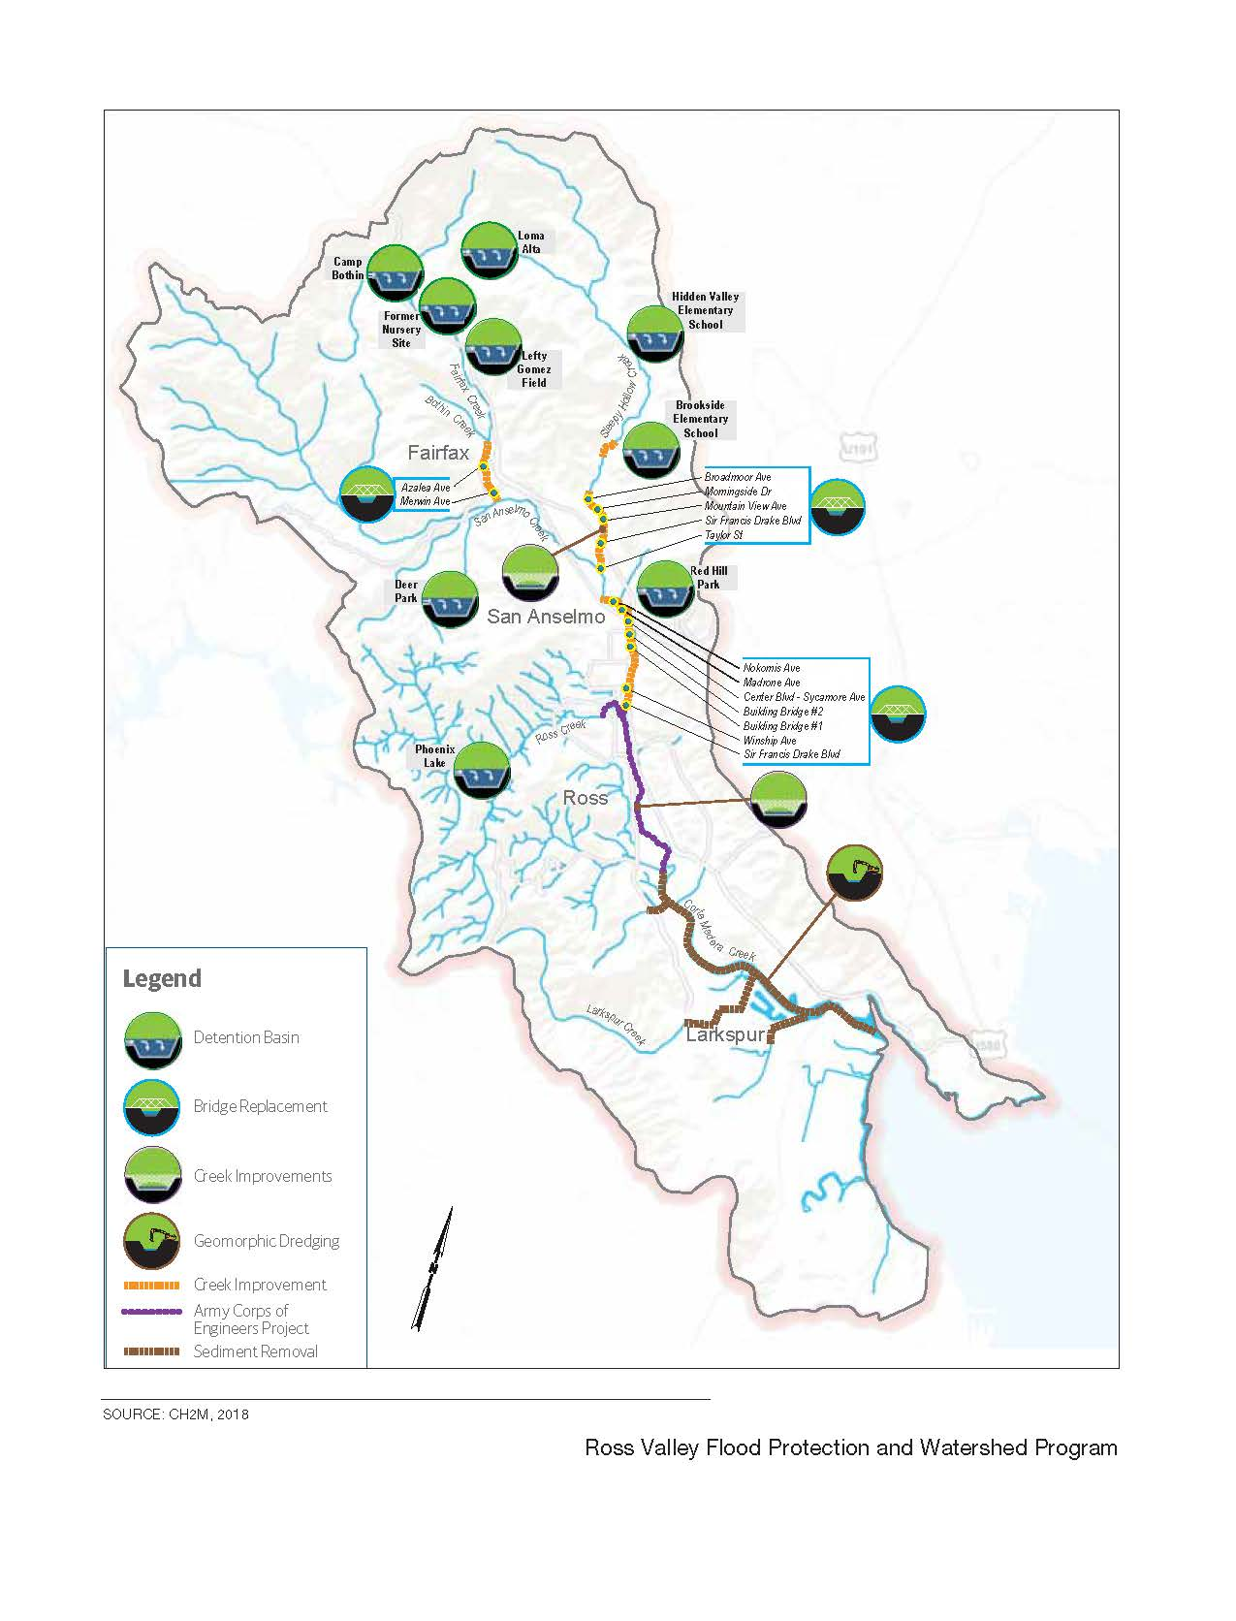
Figure 3-8. Location of Most Likely Future-Foreseeable Projects
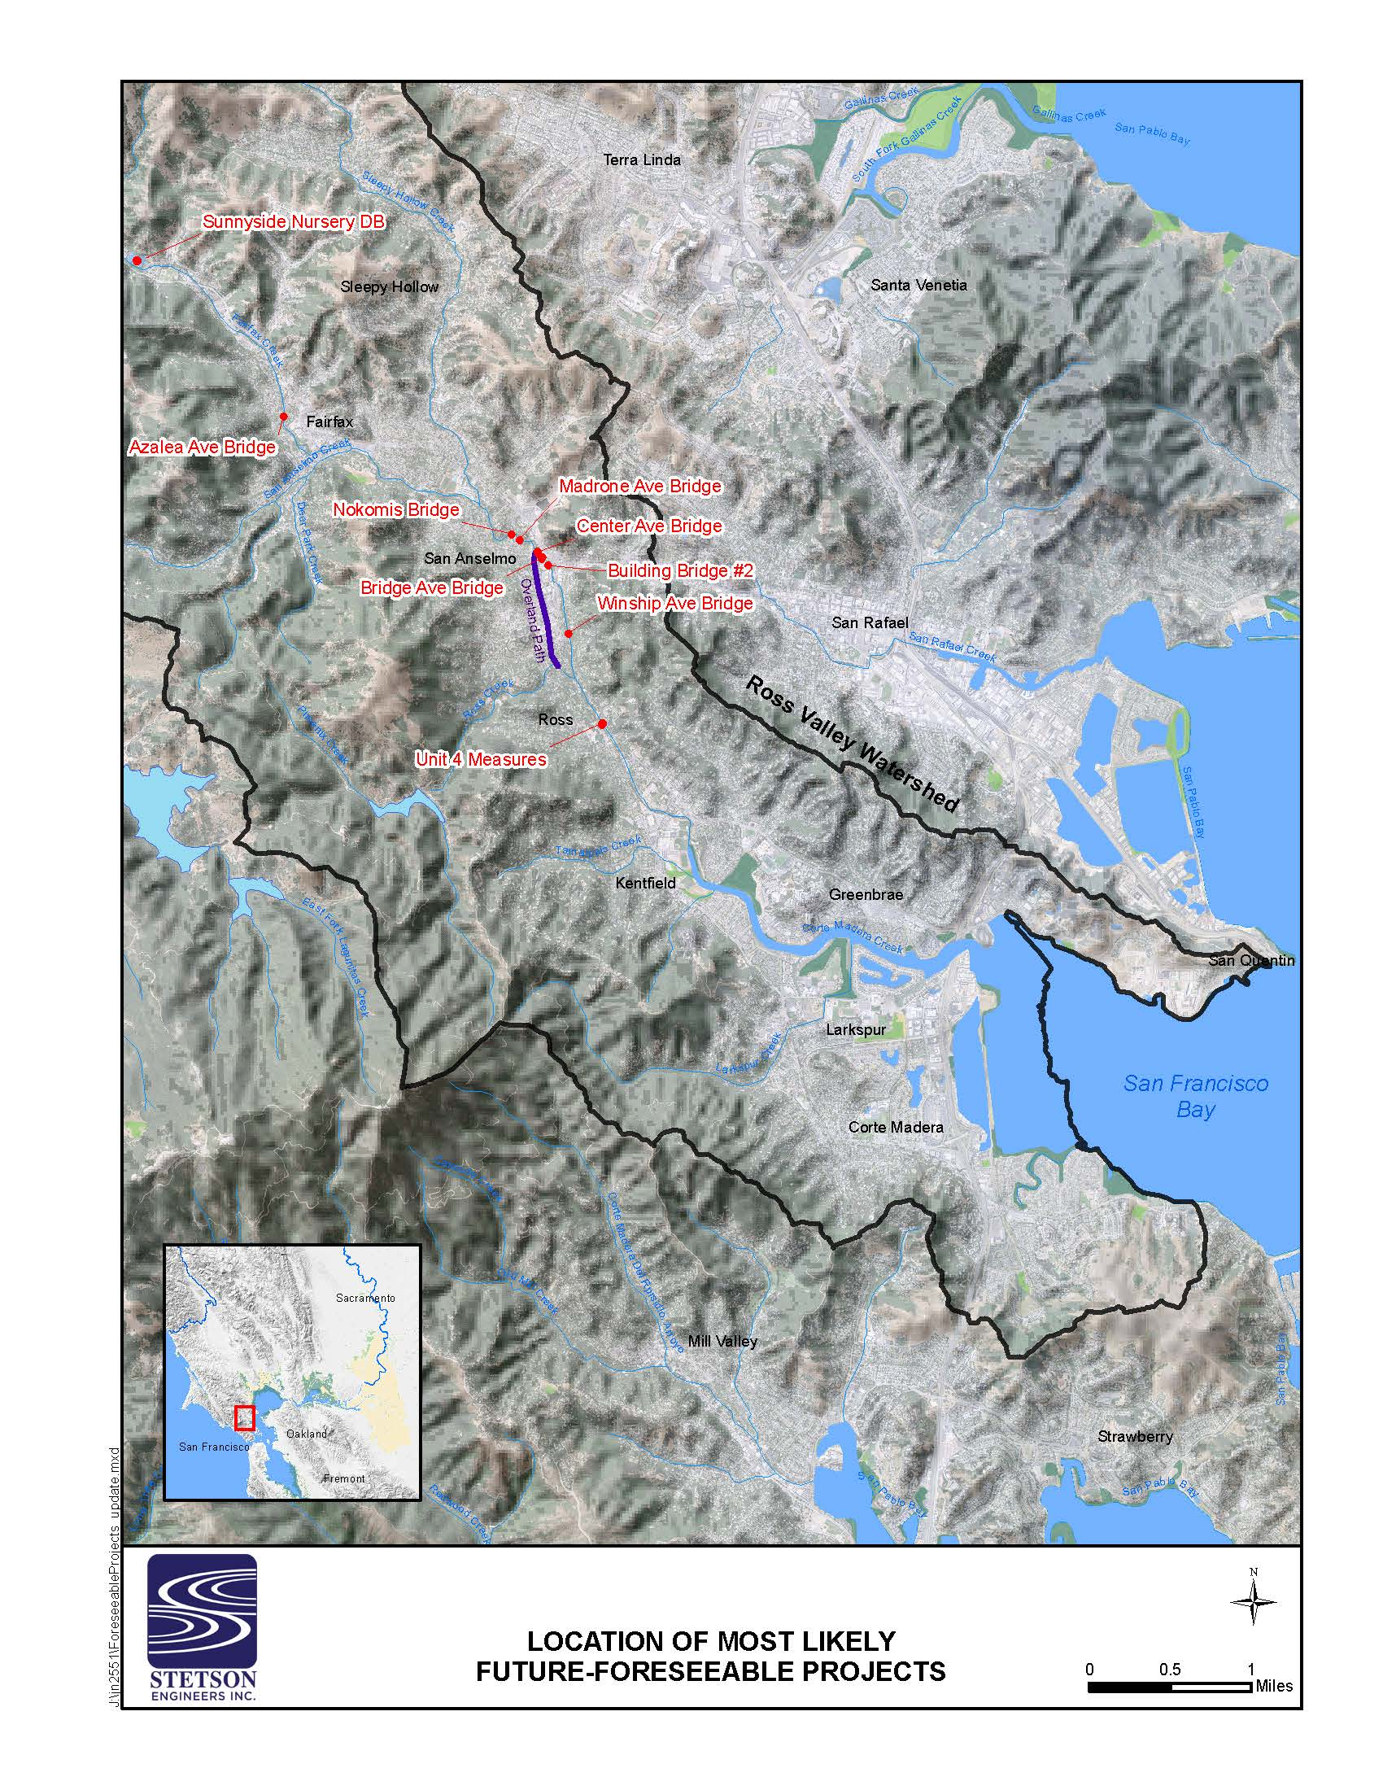
c) Would the project have environmental effects that will cause substantial adverse effects on human beings, either directly or indirectly?
As discussed throughout this IS, construction and operation of the proposed project would not cause substantial adverse effects on human beings, either directly or indirectly. The proposed project is being implemented for the specific purpose of restoring circulation and public safety. Furthermore, mitigation measures are provided as necessary to reduce the proposed project’s potentially significant effects on air quality, biological resources, cultural resources, geology and soils, hazards, hydrology and water quality, and tribal cultural resources to less-than-significant levels. Thus, construction and operation of the proposed project would not cause substantial adverse effects on human beings, either directly or indirectly and would improve the quality of life for humans by improving recreational opportunities and access to surrounding recreational areas. There would be no impact.

Figure 3-9. Map Showing Change in Water Surface Extent and Depth Between Existing Condition and Project Completion. Flood Event: 100-Year Flood (Upper)
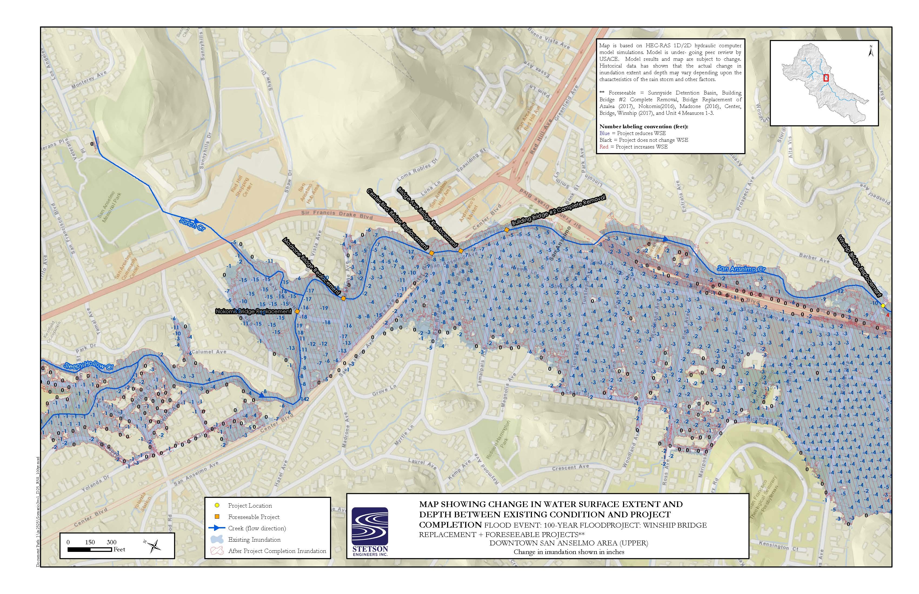
Figure 3-10. Map Showing Change in Water Surface Extent and Depth Between Existing Condition and Project Completion. Flood Event: 100-Year Flood (Upper)
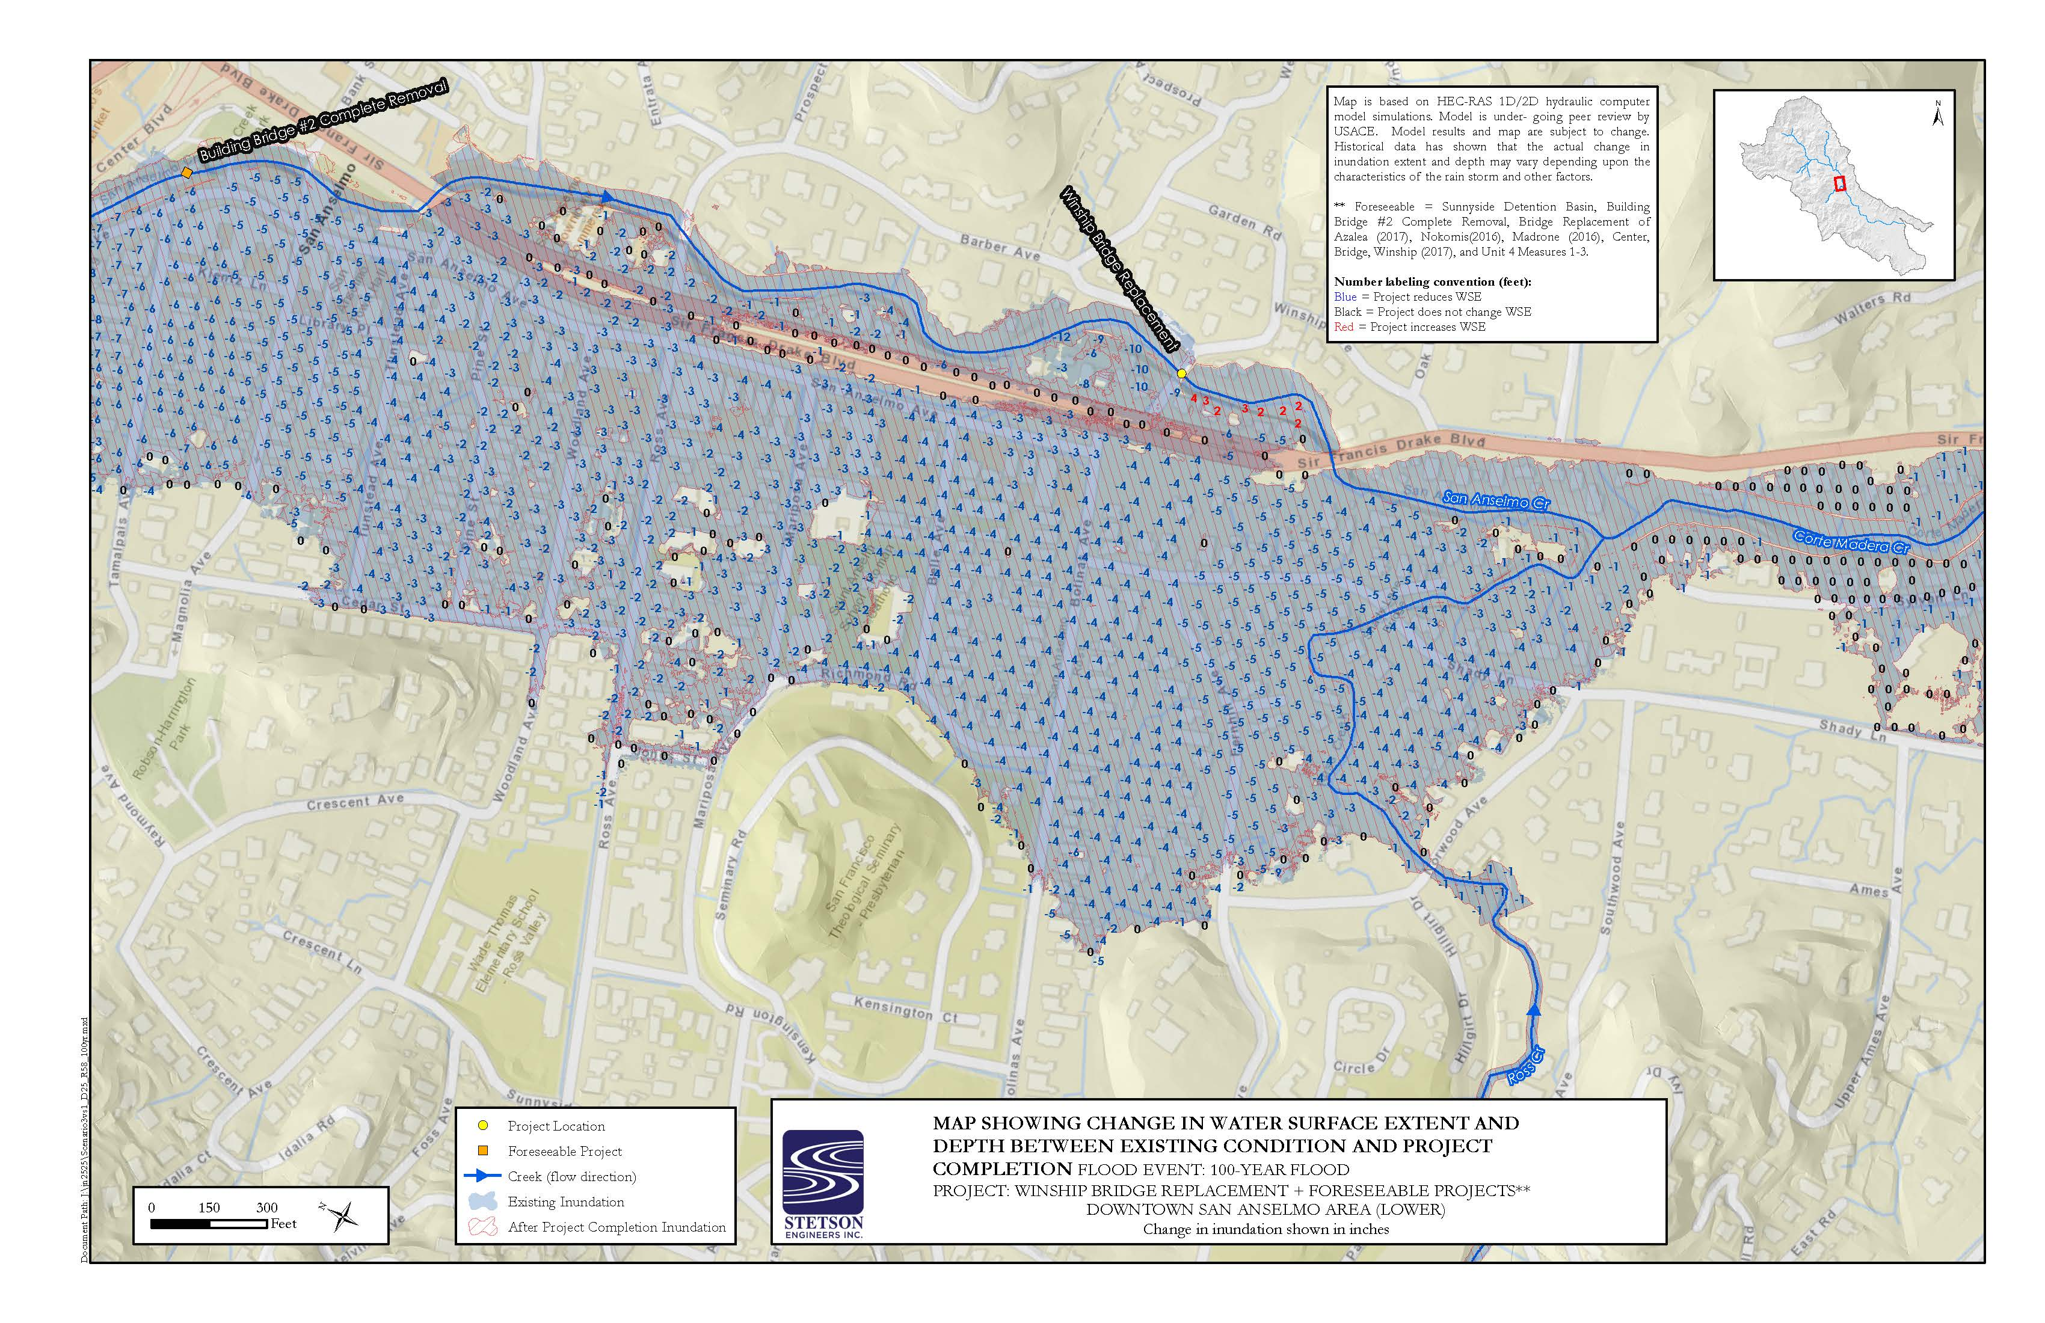

This page intentionally left blank.

References Cited

Chapter 2. Project Description
Garcia and Associates. 2019a. Winship Avenue Bridge Replacement Project Natural Environment Study. San Francisco, CA. Prepared for: Town of Ross and California Department of Transportation, District 4.

Aesthetics
California Department of Transportation. 2019. Caltrans List of Designated Scenic Routes. Available: https://dot.ca.gov/programs/design/lap-landscape-architecture-and-community-livability/lap-liv-i-scenic-highways. Accessed August 2019.
Environmental Science Associates. 2018. San Anselmo Flood Risk Reduction Project, Final Environmental Impact Report, Volume 1 – Revisions to the Draft Environmental Impact Report State Clearinghouse No. 2017042041. Prepared for Marin County Flood Control and Water Conservation District. San Francisco, CA
Kittelson and Associates Inc. 2018. Daily Traffic Volumes Technical Memo. Prepared for the Town of San Anselmo Public Works Department. Oakland, CA
Macdonald Architects. 2017. Winship Avenue Bridge Illumination Study. Prepared for the Town of Ross Public Works Department. San Francisco, CA

Air Quality
California Air Resource Board, 2019. iADAM: Air Quality Data Statistics, 2014-2018. Available: https://www.arb.ca.gov/adam/. Accessed September 2019.
Bay Area Air Quality Management District, 2017. California Environmental Quality Act Air Quality Guidelines, May 2017. Available at http://www.baaqmd.gov/~/media/files/planning-andresearch/ceqa/ceqa_guidelines_may2017-pdf.pdf?la=en. Accessed August 2019.
Bay Area Air Quality Management District, 2011. California Environmental Quality Act Air Quality Guidelines, Updated May 2011. Available: \http://www.baaqmd.gov/~/media/Files/Planning%20and%20Research/CEQA/BAAQMD%20CEQA%20Guidelines%20May%202011.ashx?la=en. Accessed August 2019.
Office of Environmental Health Hazard Assessment (OEHHA), 2015. Air Toxics Hot Spots Program Risk Assessment Guidelines: The Air Toxics Hot Spots Program Guidance Manual for Preparation of Health Risk Assessments, February, 2015.

Biological Resources
A.A. Rich and Associates. 2000. Fishery Resources Conditions of the Corte Madera Creek Watershed, Marin County, California. Prepared for Friends of Corte Madera Creek Watershed. November 2000. Available at: http://friendsofcortemaderacreek.org/rep/AARich.pdf.
California Department of Fish and Wildlife. 2019. California Natural Diversity Database, ver. 5.2.14. Wildlife and Habitat Data Analysis Branch, Sacramento, California. Original search updated.
California Department of Fish and Wildlife. 2013. California Department of Fish and Wildlife, East Marin County San Francisco Bay Watersheds Stream Habitat Assessment Reports - San Anselmo Creek, Surveyed 2009, Report Completed in 2013. Sacramento, California. Available at: https://nrm.dfg.ca.gov/FileHandler.ashx?DocumentID=94533.
California Department of Fish and Wildlife. 2010. California Salmonid Stream Habitat Restoration Manual. Inland Fisheries Division. Available at: http://www.dfg.ca.gov/fish/Resources/HabitatManual.asp.
California Department of Transportation. 2017. Construction Site Best Management Practices (BMP) Manual. CTSW-RT-17-314.18.1. May 2017. California Department of Transportation, Division of Environmental Analysis, Stormwater Program. Sacramento, California. Available at: http://www.dot.ca.gov/hq/construc/stormwater/CSBMP-May-2017-Final.pdf.
Friends of Corte Madera Creek Watershed. 2017. Accessed September 8, 2017. Available at: http://friendsofcortemaderacreek.org/new_site/watershed/.
Friends of Corte Madera Creek Watershed. 2004. Fish and Wildlife in the Corte Madera Creek Watershed. Prepared by Friends of Corte Madera Creek Watershed. May 2004. Available at: http://friendsofcortemaderacreek.org/ws/FishWildlife.pdf.
Friends of Corte Madera Creek Watershed. 1996. A Survey of the Creeks of San Anselmo: A survey of vegetation and creek conditions along the lengths of all the creeks within San Anselmo by Charles Kennard and John Walters. Available at: http://friendsofcortemaderacreek.org/rep/SanAnselmoCreeksSurvey.pdf.
Garcia and Associates. 2019a. Winship Avenue Bridge Replacement Project Natural Environment Study. San Francisco, CA. Prepared for: Town of Ross and California Department of Transportation, District 4.
Garcia and Associates. 2019c. Marin Open Space District Foothill yellow-legged frog survey summary for April 17, 2019 and April 30, 2019 for San Anselmo, Cascade, and Carey Camp. Personal communications via two emails between Karla Marlow of GANDA and Lisa Michl of Marin County on April 19, 2019 and May 1, 2019, respectively.
Garcia and Associates. 2018. Foothill yellow-legged frog monitoring at Little Carson Creek and Big Carson Creek, Mt. Tamalpais Watershed, 2016-2017. Marin Municipal Water District. Corte Madera, CA.
H.T. Harvey and Associates. 2004. California Bat Mitigation Techniques, Solutions, and Effectiveness. Prepared by Dave Johnston (H.T. Harvey and Associates) with Greg Tatarian (Wildlife Research Associates), and Elizabeth Pierson. Prepared for Caltrans and California State University Sacramento Foundation. Project Number 2394-01. December 29, 2004. Available at: https://nrm.dfg.ca.gov/FileHandler.ashx?DocumentID=10334.
Leidy, R. A. 2007. Ecology, Assemblage Structure, Distribution, and Status of Fishes in Streams Tributary to the San Francisco Estuary, California. Contribution No. 530, U.S. Environmental Protection Agency and San Francisco Estuary Institute. Oakland, California. Available at: http://www.sfei.org/sites/default/files/general_content/No530_Leidy_FullReport_revised_0.pdf.
Leidy R.A., G.S. Becker, B.N. Harvey. 2005a. Historical Status of Coho Salmon in Streams of the Urbanized San Francisco Estuary, California. California Fish and Game 91(4):219-254. California Department of Fish and Wildlife, California. Available at: https://knowledge.sonomacreek.net/files/Leidy_coho_2005.pdf.
Leidy R., G. Becker, B. Harvey. 2005b. Historical distribution and current status of steelhead/rainbow trout (Oncorhynchus mykiss) in streams of the San Francisco Estuary, California. Center of Ecosystem Management and Restoration, Oakland, California. Available at: http://www.cemar.org/pdf/wholedoc2.pdf.
Marin County Watershed Program (MCWP). 2017. Ross Valley Watershed. Available at: http://www.marinwatersheds.org/ross_valley.html.
National Marine Fisheries Service. 2014a. Fisheries Off West Coast States; West Coast Salmon Fisheries; Amendment 18 to the Salmon Fishery Management Plan; Final Rule. Federal Register 79(243): 75449-75454. Available at: http://www.westcoast.fisheries.noaa.gov/publications/habitat/essential_fish_habitat/frn_79_vol_79_no_243_efh_final_rule_december_2014.pdf.
National Marine Fisheries Service. 2014b. Endangered Species Act Section 7(a)(2) Biological Opinion for Sleepy Hollow Creek Bank Stabilization Project at 48 Broadmoor Avenue (Corps file #2013-00238N). July 16, 2014. Arcata, California.
National Marine Fisheries Service. 2008. Anadromous Salmonid Passage Facility Design. NMFS, Northwest Region, Portland, OR. Available at: http://www.habitat.noaa.gov/pdf/salmon_passage_facility_design.pdf.
National Marine Fisheries Service. 2000. NMFS Guidelines for Electrofishing Waters Containing Salmonids Listed under the Endangered Species Act. June 2000. Portland, Oregon and Santa Rosa, California. Available at: http://www.westcoast.fisheries.noaa.gov/publications/reference_documents/esa_refs/section4d/electro2000.pdf.
Pacific Fishery Management Council. 2014. Appendix A to the Pacific Coast Salmon Fishery Management Plan, as Modified by Amendment 18 to the Pacific Coast Salmon Plan: Identification and Description of Essential Fish Habitat, Adverse Impacts, and Recommended Conservation Measures for Salmon. September 2014. Portland, Oregon. Available at: http://www.westcoast.fisheries.noaa.gov/publications/habitat/essential_fish_habitat/salmon_efh_appendix_a_final_september-25_2014__2_.pdf.
Peek, R.A., S.M. Yarnell, and A.J. Lind. 2017. Visual encounter survey protocol for Rana boylii in lotic environments. Center for Watershed Sciences, University of California, Davis. June 2017. Available at: https://watershed.ucdavis.edu/files/CWS%20FYLF%20VES%20Survey%20Protocol-Final.pdf
Ross Taylor and Associates. 2006. Corte Madera Stream Crossing Inventory and Fish Passage Evaluation. Prepared for the Friends of Corte Madera Creek Watershed with funding from the National Fish and Wildlife Foundation. February 2006. Available at: http://friendsofcortemaderacreek.org/new_site/wp-content/uploads/BarriersReportandAppendices.pdf.
Sawyer, J., T. Keeler-Wolf, and J. Evens. 2009. A Manual of California Vegetation, 2nd Edition. California Native Plant Society, Sacramento.
Stadler, J.H., K.F. Griffin, E.J. Chavez, B.C. Spence, P. Roni, C.A. Gavette, B.A. Seekins, and A.K. Obaza. 2011. Pacific Coast Salmon 5-Year Review of Essential Fish Habitat Final Report to the Pacific Fishery Management Council. Revised May 2, 2011. Available at: http://www.westcoast.fisheries.noaa.gov/publications/protected_species/salmon_steelhead/efh/info_sup_rpt3_att1_efh_jun2011bb.pdf.
U.S. Army Corps of Engineers. 2005. December 7, 2005. Regulatory Guidance Letter: Ordinary High Water Mark Identification. Washington, D.C. Available at: http://www.usace.army.mil/Portals/2/docs/civilworks/RGLS/rgl05-05.pdf.
United States Fish and Wildlife Service (USFWS). 2019a. Critical Habitat Portal for Threatened & Endangered Species. Website accessed on August 9, 2017 and August 28, 2019. Available at: http://criticalhabitat.fws.gov/crithab/.
United States Fish and Wildlife Service. 2019b. Official Species List Generator. Pacific Southwest Region, Sacramento. Website accessed on September 7, 2017 and updated November 27, 2018 and August 28, 2019. Available at: https://ecos.fws.gov/ipac/.
United States Fish and Wildlife Service. 2017. National Wetlands Inventory. Website accessed on August 16 and August 20, 2017. Available at: http://www.fws.gov/wetlands/Data/Mapper.html.
United States Fish and Wildlife Service. 2010. Best Management Practices to Minimize Adverse Effects to Pacific Lamprey (Entosphenus tridentatus). USFWS April 2010. Available at: https://www.fws.gov/pacificlamprey/Documents/Best%20Management%20Practices%20for%20Pacific%20Lamprey%20April%202010%20Version.pdf.
United States Fish and Wildlife Service. 2005. Endangered and Threatened Species; Designation of Critical Habitat for the Seven Evolutionarily Significant Units of Pacific Salmon and Steelhead in California; Final Rule. Federal Register 70(170): 52488-52627. Available at: http://www.westcoast.fisheries.noaa.gov/publications/frn/2005/70fr52488.pdf.
United States Geological Survey. 2017. National Water Information System. USGS 11460000 Corte Madera C A Ross California. Available at: https://waterdata.usgs.gov/nwis/inventory?agency_code=USGS&site_no=11460000.
Cultural Resources
Garcia and Associates. 2019b. Winship Avenue Bridge Replacement Project Historic Properties Survey Report/Archaeological Survey Report. San Francisco, CA. Prepared for: Town of Ross and California Department of Transportation, District 4.
McMorris, C. 2004. Caltrans Historic Bridge Inventory Update: Concrete Arch Bridges. Prepared for the State of California Department of Transportation Environmental Program. JRP Historical Consulting. On file at the Northwest Information Center, Rohnert Park, California.
Kandler, E.1978. Cultural Resource Reconnaissance of the Corte Madera Creek, Unit 4 Flood Control Project, Township of Ross, Marin County, California. U. S. Army Corps of Engineers, San Francisco District. On file at the Northwest Information Center, Rohnert Park, California.

Geology and Soils
California Geologic Survey. 2002. Note 36, California Geomorphic Provinces, December 2002.
Miller Pacific Engineering Group. 2016. Preliminary Foundation Report for Winship Avenue Bridge Replacement, Federal Project No. 5176 (008), State Bridge No. 27C-0074, Caltrans District 4 and Town of Ross, California.
Natural Resources Conservation Service (NRCS). 2017. Web Soil Survey. United States Department of Agriculture. Website accessed on August 18, August 20, and September 20, 2017. Available at: https://websoilsurvey.nrcs.usda.gov/app/WebSoilSurvey.aspx.
Greenhouse gas emissions
California Air Resources Board. 2017. The 2017 Climate Change Scoping Plan Update: The Proposed Strategy For Achieving California’s 2030 Greenhouse Gas Target, January 20 2017.
Hydrology and Water Quality
CalEMA, CGS, and USC. 2009. Tsunami Inundation Map for Emergency Planning, San Rafael Quadrangle, San Quentin Quadrangle, July 1, 2009.
Environmental Science Associates. 2018. San Anselmo Flood Risk Reduction Project, Final Environmental Impact Report, Volume 1 – Revisions to the Draft Environmental Impact Report State Clearinghouse No. 2017042041. Prepared for Marin County Flood Control and Water Conservation District. San Francisco, CA
Federal Emergency Management Agency. 2016. Flood Insurance Study Volume 1 of 3 Marin County, California, and Incorporated Areas, Flood Insurance Study Number 06041CV001C, March 16, 2016.
PBS&J. 2010. Corte Madera Creek Flood Control Study Baseline Report. Prepared for UACE –San Francisco District, December 2010. Available online at http://www.marinwatersheds.org/ sites/default/files/2017-11/CorteMaderaCreekFinalBaselineReport-2010-12-08.pdf
Stetson Engineers Inc. 2019a. Winship Avenue Bridge Replacement Project Bridge Design Hydraulic Study Report. San Rafael, CA. Prepared for: Town of Ross and California Department of Transportation, District 4.
Stetson Engineers Inc. 2019b. Winship Avenue Bridge Replacement Project Location Hydraulic Study Report. San Rafael, CA. Prepared for: Town of Ross and California Department of Transportation, District 4.
Stetson Engineers, Inc. 2011. Capital Improvement Plan Study for Flood Damage Reduction and Creek Management in Flood Zone 9 / Ross Valley. Prepared for Marin County Flood Control and Water Conservation District, Flood Zone 9, May 2011.
United States Geological Survey. 2017. National Water Information System. USGS 11460000 Corte Madera C A Ross California. Available at: https://waterdata.usgs.gov/nwis/inventory?agency_code=USGS&site_no=11460000.
Noise
California Department of Transportation, Transportation and Construction Vibration Guidance Manual, September 2013
Environmental Science Associates. 2019. Winship Avenue Bridge Replacement Project Construction Noise Technical Report. San Francisco, CA. Prepared for: Town of Ross and California Department of Transportation, District 4.
Environmental Science Associates. 2018. San Anselmo Flood Risk Reduction Project, Final Environmental Impact Report, Volume 1 – Revisions to the Draft Environmental Impact Report State Clearinghouse No. 2017042041. Prepared for Marin County Flood Control and Water Conservation District. San Francisco, CAFederal Transit Administration. 2006. Transit Noise and Vibration Impact Assessment (Guidance Manual, Chapter 12), May 2006. Prepared for the Federal Transit Administration Office of Planning and Environment Washington DC 20590

