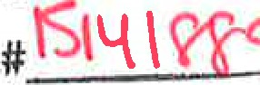
RECEIVED WITH FEE RECEIPT
KERN COUNTY
COPY NOV 26 2019

MARY B. EDARD
R.COUNTYCLERK EPUTY
To: | Office of Planning and Research | From: Kern County Water Agency
 | P.O. Box 3044 | P.O. Box 58
 | Sacramento, CA 95812-3044 | Bakersfield, CA 93302-0058
Kern County Clerk
1 1 15 Truxtun Avenue
Bakersfield, CA 93301
Project Title: Agreement between the Kern County Water Agency (Agency), Antelope ValleyEast Kern Water Agency (AVEK) and California Department of Water Resources (DWR) for Delivery of 2019 State Water Project (SWP) water to Rosedale-Rio Bravo Water Storage District (Rosedale).
Location Specific: The Agency is a State Water Project (SWP) contractor located in Kern County in the southern San Joaquin Valley. Rosedale contracts for S WP water through the Agency and is in Kern County in the southern San Joaquin Valley. The SWP includes facilities located throughout the State of California.
Location County: Kern County.
Description of Activity: In 2019, AVEK will transfer up to 7,000 acre-feet (af) of its 2019 S WP water to the Agency for delivery to Rosedale from California Aqueduct turnouts located in the Agency's service area. In exchange, the Agency will return to AVEK, based on an unbalanced exchange ratio of 2 to l , up to 3,500 af of Rosedale's Table I water less applicable losses.
Name of Public Agency Approving or Carrying Out Activity: Agency (Lead Agency).
Exempt Status:
Ministerial
Declared Emergency
Emergency Project
Ø Categorical Exemption. State type and section number: See CEQA Guideline 15301 (b). Statutory Exemption. State code number: See CEQA Guidelines Section 15061 (b)3.
CEQA Guideline Section 15301 (b) provides that a lead agency may determine an activity to be exempt from CEQA in that it utilizes only existing facilities. This transfer involves delivery of water entirely within the Agency's service area, and exclusively utilizes existing facilities. Additionally, CEQA Guideline Section 15061(b)3 provides that a Lead Agency may determine an activity to be exempt based on a general rule that CEQA applies only to projects that have a potential for causing a significant effect on the environment. Where it can be seen with certainty that there is no possibility that the activity in question may have a significant effect on the environment, the activity is not subject to CEQA. The Agency finds that approval of the proposed water transfer has no possibility of significant effect on the environment for the following reasons: Notice of Environmental
Docu |  | ent
Posted by County Clerk on
- The proposed action consists of a one-time water Pursuant to
Section 21152(C), Public Resources Code
facilities and would not require any construction or grading.
- The proposed action does not constitute a new permanent source of water supply and will not result in any growth inducing or cumulative environmental impacts.
- There will be no change in land use.
Telephone: (661,) 634-1400
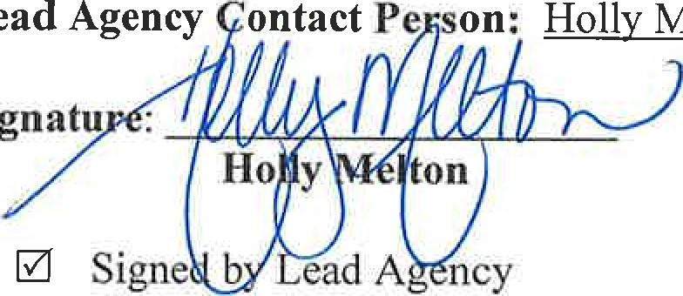
Title: Water Resources Manager Date: 11/20/2019
Lead
Melton
Signatu
Date received for filing by County Clerk:
Signed by Applicant

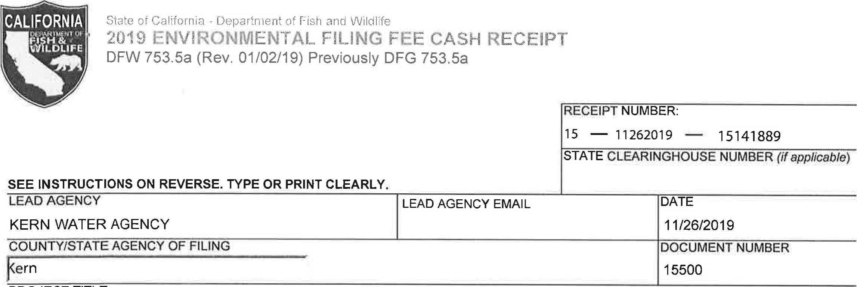
PROJECT TITLE

AGREEMENT BETWEEN THE KERN COUNTY WATER AGENCY, ANTELOPE VALLEY-EAST KERN WATER AGENCY AND CAB
PROJECT APPLICANT NAME  KERN COUNTY WATER AGENCY | PROJECT APPLICANT EMAIL |  | PHONE NUMBER  ( 661 ) 634-1400
PROJECT APPLICANT ADDRESS  3200 RIO MIRADA DR | ITY  BAKERSFIELD | STATE  CA | ZIP DE  93308

PROJECT APPLICANT (check appropriate box)
Local Public Agency School District Other Special District [2 State Agency C] Private Entity
CHECK APPLICABLE FEES:
C] Environmental Impact Report (EIR) $3,271 .00
Mitigated/Negative Declaration (MND)(ND) $2,354.75 0.00

Certified Regulatory Program document (CRP) $1 ,1 12.00 0.00

Exempt from fee
Notice of Exemption (attach)
[3 CDFW No Effect Determination (attach)
Fee previously paid (attach previously issued cash receipt copy)

Water Right Application or Petition Fee (State Water Resources Control Board only) $850.00
County documentary handling fee 50.00
PAYMENT METHOD:
Cash D Credit | [S] Check | Other | TOTAL RECEIVED | 250.00
Other
SIGNATURE x | AGENCY OF FILING PRINTED NAME AND TITLE  E. DEL VILLAR, KERN COUNTY CLERK, ACCOUNTANT 2
ORIGINAL - PROJECT APPLICANT COPY - CDFW/ASB COPY - LEAD AGENCY COPY - COUNTY CLERK DFW753.5a (Rev. 20151215)

