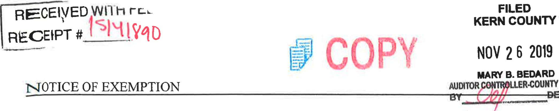PUTY
H
CLERK
To: Office of Planning and Research From: Kern County Water Agency
P.O. Box 3044 P.O. Box 58
Sacramento, CA 95812-3044 Bakersfield, CA 93302-0058
Kern County Clerk
1 115 Truxtun Avenue
Bakersfield, CA 93301
Project Title: 2019 Water Transfer from Kern-Tulare Water District (Kern-Tulare) to Semitropic Water Storage District (Semitropic).
Location -- Specific: The Kern County Water Agency (Agency) is a State Water Project (SWP) contractor located in Kern County in the southern San Joaquin Valley. Semitropic contracts for S WP water through the Agency and is in Kern County in the southern San Joaquin Valley. The S WP includes facilities located throughout the State of California. Kern-Tulare is a public water agency that contracts for Central Valley Project (CVP) water in Kern County in the southern San Joaquin Valley.
Location -- County: Kern County.
Description of Activity: In 2019, Kern-Tulare will transfer up to 26,500 acre-feet (af) of its acquired CVP water to the Agency for delivery to Semitropic from California Aqueduct turnouts located in the Agency's service area.
Name of Public Agency Approving or Carrying Out Activity: Agency (Lead Agency).
Exempt Status:
Ministerial
Declared Emergency
Emergency Project
Categorical Exemption. State type and section number: See CEQA Guideline 15301 (b). Statutory Exemption. State code number: See CEQA Guidelines Section 15061 (b)3.
CEQA Guideline Section 15301 (b) provides that a lead agency may determine an activity to be exempt from CEQA in that it utilizes only existing facilities. This transfer involves delivery of water entirely within the Agency's service area, and exclusively utilizes existing facilities. Additionally, CEQA Guideline Section 15061 (b)3 provides that a Lead Agency may determine an activity to be exempt based on a general rule that CEQA applies only to projects that have a potential for causing a significant effect on the environment. Where it can be seen with certainty that there is no possibility that the activity in question may have a significant effect on the environment, the activity is not subject to CEQA. The Agency finds that approval of the proposed water transfer has no possibility of significant effect on the environment for the following reasons:
Environmental Document
- The proposed action consists of a one-time water transfer -that will use existing facilities and would not require any construction or grading.
- The proposed action does not constitute a new permanents source of water supply and
will not result in any growth inducing or cumulative environmental impacts.
- There will be no change in land use.
Lead Agency Contact Person: Holly Melton Telephone: (661) 634-1400
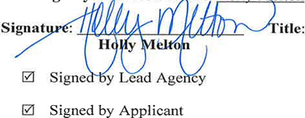
Title: Water Resources Manager Date: 11/20/2019
Date received for filing by County Clerk:

CEQA
Transmittal Memorandum
Attach one transmittal memorandum to the front of the original CEQA document. Clip copies in back.
- If notice requires F&W receipt, you must provide a minimum of 3 copies of the document.
- If notice does not require F&W receipt, you must provide a minimum of 2 copies of the document.

TYPE OR PRINT CLEARLY
LEAD AGENCY Kern County Water Agency

PROJECT TITLE 2019 Water Transfer from Kern-Tulare Water District to Semitropic Water Storage District

PROJECT APPLICANT Kern Count Water Agencv

PHONE NUMBER( 661 ) 634-1400

PROJECT APPLICANT ADDRESS 3200 Rio Mirada Dr.

CITY Bakersfield STATE CA ZIP CODE 93308
WORK ORDER # 30-Day Posting [3 35-Day Posting 45-Day Posting C] Other
CONTACT PERSON Monica TennantPHONE NUMBER ( 661 )634-1419
CHECK DOCUMENT BEING FILED:
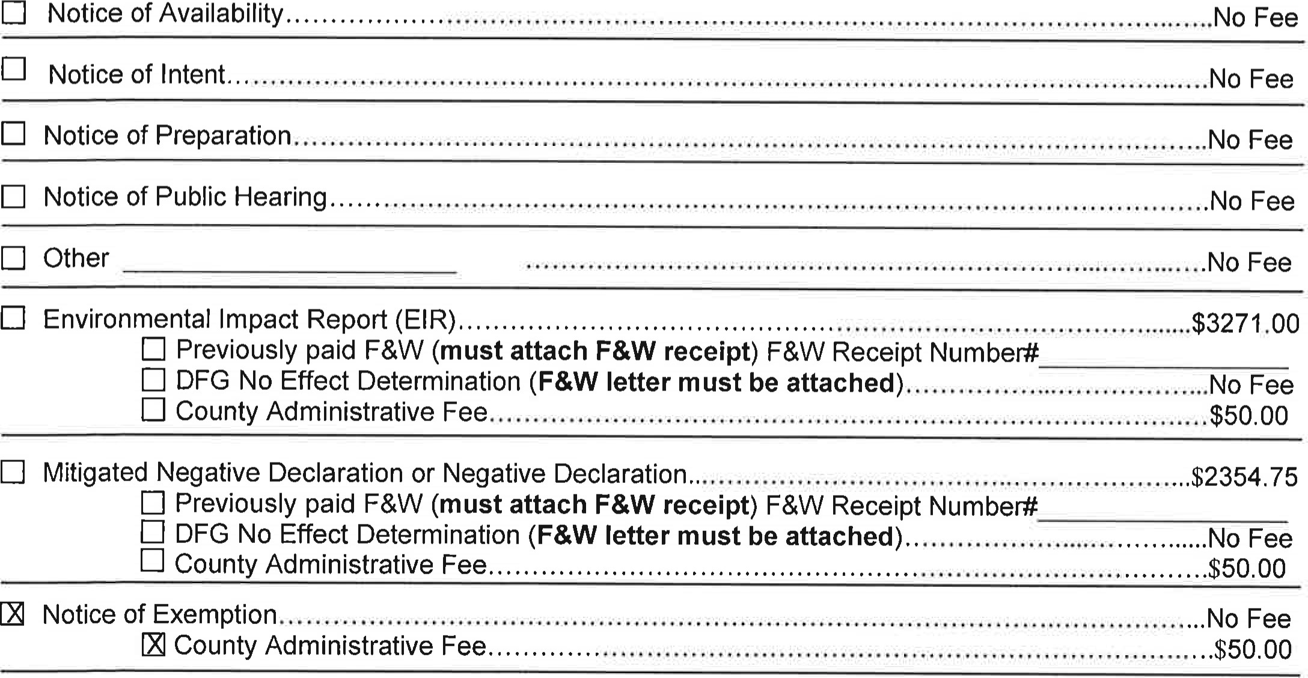

TOTAL $
*Additional copies to be returned to: Kern County Water Agency
*Method of return: [i] Hold for pick-up/CalI # 661-634-1419 Interoffice Mail

PAYMENT METHOD: ALL APPLICABLE FEES MUST BE PAID AT THE TIME OF FILING
JV - Trans Code Dept Fund Expense Key
Money Order
Check
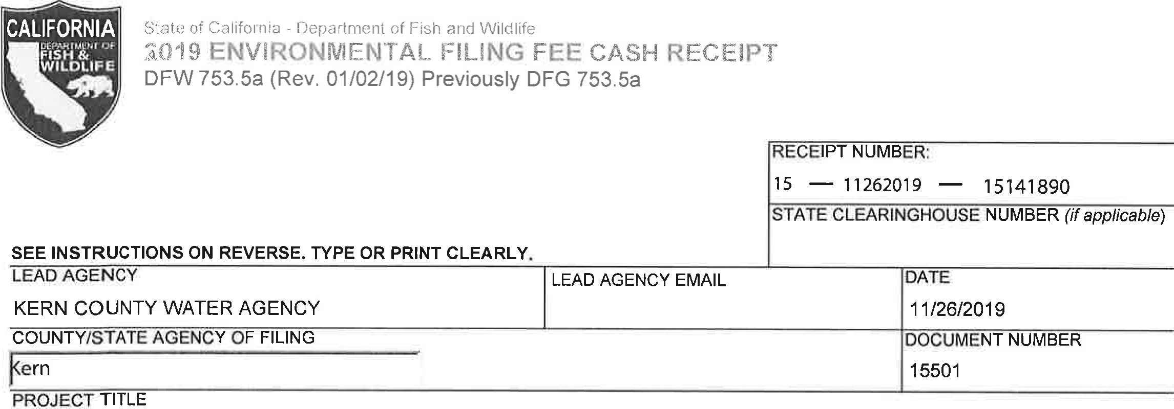
2019 WATER TRANSFER FROM KERN TULARE WATER DISTRICT TO SEMITROPIC WATER STORAGE DISTRICT
PROJECT APPLICANT NAME KERN CUNTY WATER AGENCY | PROJECT APPLICANT EMAIL |  | PHONE NUMBER  661 ) 634-1400
PROJECT APPLICANT ADDRESS  3200 RIO MIRADA DR | CITY  BAKERSFIELD | STATE  CA | ZIP CODE 93308
PROJECT APPLICANT (check appropriate box)
C]
CHECK APPLICABLE FEES:
Exempt from fee
Notice of Exemption (attach)
[3 CDFW No Effect Determination (attach)
[3 Fee previously paid (attach previously issued cash receipt copy)

Water Right Application or Petition Fee (State Water Resources Control Board only) | $850.00
County documentary handling fee |  | 50.00

Other
 | PAYMENT METHOD:
 | ^{Cash} Credit | Check | Other |  | TOTAL RECEIVED | 250.00
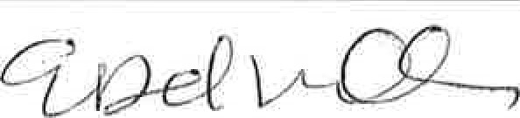  SIGNATURE  x |  |  |  | AGENCY OF FILING PRINTED NAME AND TITLE  E. DEL VILLAR, KERN COUNTY CLERK, ACCOUNTANT 2
ORIGINAL - PROJECT APPLICANT COPY - CDFW/ASB COPY - LEAD AGENCY COPY - COUNTY CLERK DEW 753.5a (Rev. 20151215)

