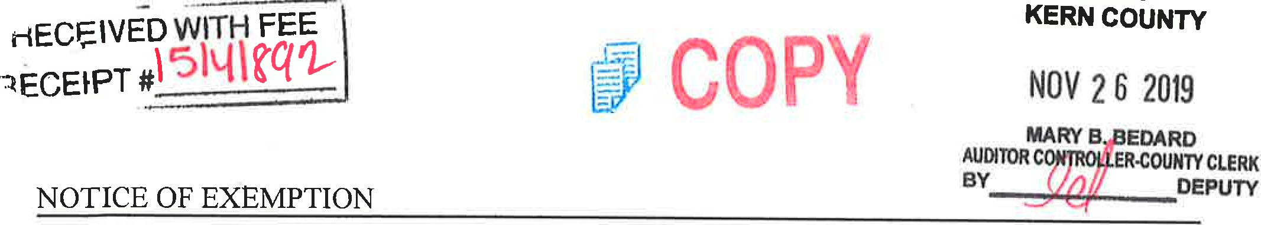
To:
Office
of
Planning
and
Research
From:
Kern
County
Water
Agency
P.O. Box 3044 P.O. Box 58
Sacramento, CA 95812-3044 Bakersfield, CA 93302-0058
Kern County Clerk
1 1 15 Truxtun Avenue
Bakersfield, CA 93301
Project Title: Agreement between the Kern County Water Agency (Agency), Santa Clarita
Valley Water District (Santa Clarita) and California Department of Water Resources (DWR) for Delivery of 2019 State Water Project (SWP) water to Rosedale-Rio Bravo Water Storage District (Rosedale).
Location -- Specific: The Agency is a State Water Project (SWP) contractor located in Kern
County in the southern San Joaquin Valley. Rosedale contracts for SWP water through the Agency and is in Kern County in the southern San Joaquin Valley. The S WP includes facilities located throughout the State of California.
Location County: Kern County.
Description of Activity: In 2019, Santa Clarita will transfer up to 25,000 acre-feet (af) of its 2019 SWP water to the Agency for delivery to Rosedale from California Aqueduct turnouts located in the Agency's service area. In exchange, the Agency will return to Santa Clarita, based on an unbalanced exchange ratio of 2 to 1, up to 12,500 af of Rosedale's Table 1 water less applicable losses.
Name of Public Agency Approving or Carrying Out Activity: Agency (Lead Agency).
Exempt Status:
Ministerial
Declared Emergency
Emergency Project
- Categorical Exemption. State type and section number: See CEQA Guideline 15301 (b).
- Statutory Exemption. State code number: See CEQA Guidelines Section 15061 (b)3.

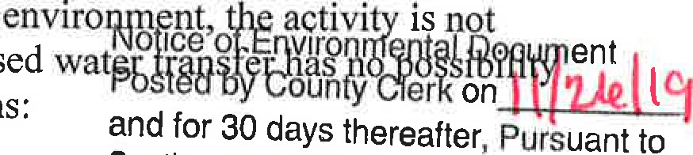
CEQA Guideline Section 15301 (b) provides that a lead agency may determine an activity to be exempt from CEQA in that it utilizes only existing facilities. This transfer involves delivery of water entirely within the Agency's service area, and exclusively utilizes existing facilities. Additionally CEQA Guideline Section 15061 (b)3 provides that a Lead Agency may determine an activity to be exempt based on a general rule that CEQA applies only to projects that have a potential for causing a significant effect on the environment. Where it can be seen with certainty that there is no possibility that the activity in question may have a significant effect on the subject to CEQA. The Agency finds that approval of the proposed of significant effect on the environment for the following reasons:
Section
days thereafter pursuant
21152(C), Public Resources Code
l. The proposed action consists of a one-time water transfer that will use existing
facilities and would not require any construction or grading.
- The proposed action does not constitute a new permanent source of water supply and will not result in any growth inducing or cumulative environmental impacts.
- There will be no change in land use.
Lead Agency Contact Person: Hollv Melton Telephone: (661) 634-1400
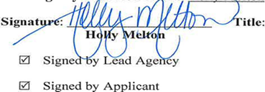Title: Water Resources Manager Date: 11/22/2019
Date received for filing by County Clerk:

CEQA
Transmittal Memorandum
Attach one transmittal memorandum to the front of the original CEQA document. Clip copies in back.
- If notice requires F&W receipt, you must provide a minimum of 3 copies of the document.
- If notice does not require F&W receipt, you must provide a minimum of 2 copies of the document.

TYPE OR PRINT CLEARLY
LEAD AGENCY Kern County Water Agency
PROJECT TITLE Agreement between the Kern County Water Agency, Santa Clarita Valley Water District and CA Department of Water Resources for Delivery of 2019 SWP water to Rosedale-Rio Bravo Water Storage District.
PROJECT APPLICANT Kern county Water
PHONE NUMBER ( 661 ) 634-1400
PROJECT APPLICANT ADDRESS 3200 Rio Mirada Dr.
CITY Bakersfield STATE CA ZIP CODE 93308
WORK ORDER # X 30-Day Posting _ 35-Day Posting _ 45-Day Posting Other
CONTACT PERSON Monica Tennant PHONE NUMBER ( 661 )634-1419

CHECK DOCUMENT BEING FILED:

_ Notice of Availability .......................................................................................................... No Fee
_ Notice of Intent. ................................................................................................................... No Fee
_ Notice of Preparation ........................................................................................................... No Fee
_ Notice of Public Hearing ..................................................................................................... No Fee
_ Other _________________ ………………………………………………………………. No Fee
_ Environmental Impact Report (EIR)
_ Previously paid F&W (must attach F&W receipt) F&W Receipt Number # _______________
_ DFC No Effect Determination (F&W letter must be attached) …………………….. No Fee
_ County Administrative Fee………………………………………………………. $50.00
_ Mitigated Negative Declaration or Negative Declaration………………………………. $2354.75
_ Previously paid F&W (must attach F&W receipt) F&W Receipt Number # _______________

_ DFG No Effect Determination (F&W letter must be attached) ………………… No Fee
_ County Administrative Fee …………………………...................................................$50.00
X Notice of Exemption ……………………………………………………………………… No Fee
X County Administrative Fee ………………………….................................................. $50.00

TOTAL $ 50.00
*Additional copies to be returned to: Kern County Water Agency
*Method of return: X Hold for pick-up/Call # 661-634-1419 _ Interoffice Mail

PAYMENT METHOD: ALL APPLICABLE FEES MUST BE PAID AT THE TIME OF FILING
JV - Trans Code___ Dept____ Fund____ Expense Key____
Money Order
Check

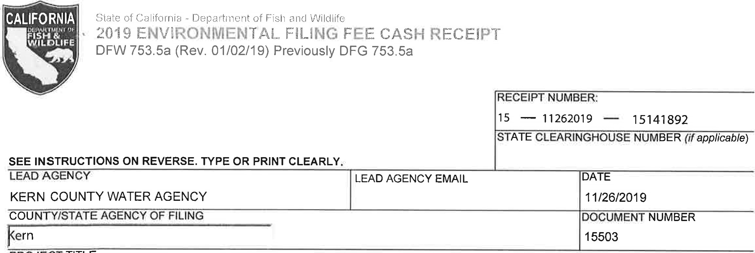
PROJECT TITLE
AGREEMENT BETWEEN THE KERN COUNTY WATER AGENCY, SANTA CLARITA VALLEY WATER DISTRICT AND CA DEPAR
PROJECT APPLICANT NAME  KERN COUNTY WATER AGENCY | PROJECT APPLICANT EMAIL |  | PHONE NUMBER  (661 ) 634-1400
PROJECT APPLICANT ADDRESS  3200 RIO MIRADA DR | CITY  BAKERSFIELD | STATE  CA | ZIP CODE  93308
PROJECT APPLICANT (check appropriate box)
[3
CHECK APPLICABLE FEES:
Exempt from fee
Notice of Exemption (attach)
CDFW No Effect Determination (attach)
Water Right Application or Petition Fee (State Water Resources Control Board only) | $850.00
8] County documentary handling fee |  | 50.00
Fee previously paid (attach previously issued cash receipt copy)

Other
PAYMENT METHOD:
Cash Credit Check Other TOTAL RECEIVED
250.00
SIGNATURE x | AGENCY OF FILING PRINTED NAME AND TITLE  E, DEL VILLAR, KERN COUNTY CLERK, ACCOUNTANT 2
ORIGINAL - PROJECT APPLICANT COPY - CDFW/ASB COPY - LEAD AGENCY COPY - COUNTY CLERK DFW 753.5a (Rev. 20151215)

