RECEIVED WITH FEE RECEIPT #15141891
COPY
NOV 26 2019
MARY B.
EpUT'
P.O. Box 3044 P.O. Box 58
Sacramento, CA 95812-3044 Bakersfield, CA 93302-0058
Kern County Clerk
1 1 15 Truxtun Avenue
Bakersfield, CA 93301
Project Title: Agreement between the Kern County Water Agency (Agency), Littlerock Creek
Irrigation District (Littlerock) and California Department of Water Resources (DWR) for Delivery of 2019 State Water Project (SWP) water to Semitropic Water Storage District (Semitropic).
Location Specific: The Agency is a State Water Project (SWP) contractor located in Kern
County in the southern San Joaquin Valley. Semitropic contracts for S WP water through the Agency and is in Kern County in the southern San Joaquin Valley. The S WP includes facilities located throughout the State of California.

Location County: Kern County
Description of Activity: In 2019, Littlerock will transfer up to 1,208 acre-feet (af) of its 2019 S WP water to the Agency for delivery to Semitropic from California Aqueduct turnouts located in the Agency's service area. In exchange, the Agency will return to Littlerock, based on an unbalanced exchange ratio of 2 to 1, up to 604 afof Semitropic's Table I water less applicable losses.
Name of Public Agency Approving or Carrying Out Activity: Agency (Lead Agency).
Exempt Status:
C] Ministerial
Declared Emergency
C] Emergency Project
Categorical Exemption. State type and section number: See CEQA Guideline 15301 (b). Statutory Exemption. State code number: See CEQA Guidelines Section 15061(b)3.
CEQA Guideline Section 15301 (b) provides that a lead agency may determine an activity to be exempt from CEQA in that it utilizes only existing facilities. This transfer involves delivery of water entirely within the Agency's service area, and exclusively utilizes existing facilities. Additionally, CEQA Guideline Section 15061 (b)3 provides that a Lead Agency may determine an activity to be exempt based on a general rule that CEQA applies only to projects that have a potential for causing a significant effect on the environment. Where it can be seen with certainty that there is no possibility that the activity in question may have a significant effect on the environment, the activity is not subject to CEQA. The Agency finds that approval of the proposed water transfer has no possibility of significant effect on the environment for the following reasons:

facilities and would not require any construction or grading.
2. The proposed action does not constitute a new permanent source of water supply and will not result in any growth inducing or cumulative environmental impacts.
3. There will be no change in land use.

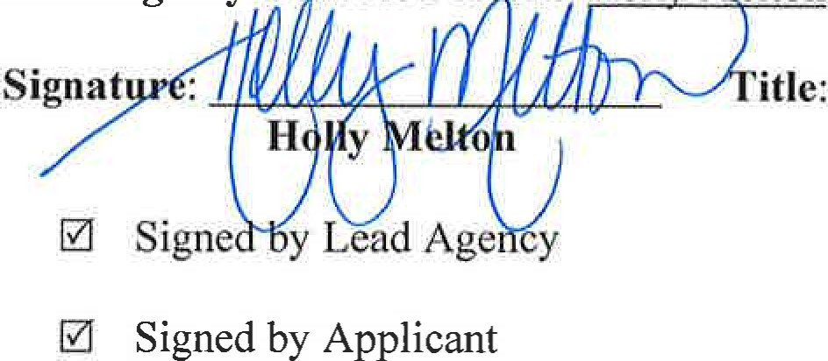
Lead Agency Contact Person : Holly Melton Telephone: (661) 634-1400
Water Resources Manager Date: 11/22/2019
Date received for filing by County Clerk:

CEQA
Transmittal Memorandum
Attach one transmittal memorandum to the front of the original CEQA document. Clip copies in back.
- If notice requires F&W receipt, you must provide a minimum of 3 copies of the document.
- If notice does not require F&W receipt, you must provide a minimum of 2 copies of the document.

TYPE OR PRINT CLEARLY
LEAD AGENCY Kern County Water Agency
PROJECT TITLE Agreement between the Kern County Water Agency, Littlerock Creek Irrigation District and CA Department of Water Resources for Delivery of 2019 SWP water to Semitropic Water Storage District.
PROJECT APPLICANT Kern County Water Agencv

PHONE NUMBER: ( 661 ) 634-1400
PROJECT APPLICANT ADDRESS 3200 Rio Mirada Dr.
CITY Bakersfield STATE CA ZIP CODE 93308
WORK ORDER # X 30-Day Posting _35-Day Posting _45-Day Posting _Other

CONTACT PERSON Monica Tennant PHONE NUMBER ( 661 ) 634-1419
CHECK DOCUMENT BEING FILED:
CHECK DOCUMENT BEING FILED:

_ Notice of Availability .......................................................................................................... No Fee
_ Notice of Intent. ................................................................................................................... No Fee
_ Notice of Preparation ........................................................................................................... No Fee
_ Notice of Public Hearing ..................................................................................................... No Fee
_ Other _________________ ………………………………………………………………. No Fee
_ Environmental Impact Report (EIR)
_ Previously paid F&W (must attach F&W receipt) F&W Receipt Number # _______________
_ DFC No Effect Determination (F&W letter must be attached) …………………….. No Fee
_ County Administrative Fee………………………………………………………. $50.00
_ Mitigated Negative Declaration or Negative Declaration………………………………. $2354.75
_ Previously paid F&W (must attach F&W receipt) F&W Receipt Number # _______________

_ DFG No Effect Determination (F&W letter must be attached) ………………… No Fee
_ County Administrative Fee …………………………...................................................$50.00
X Notice of Exemption ……………………………………………………………………… No Fee
X County Administrative Fee ………………………….................................................. $50.00

TOTAL $ 50.00

Additional copies to be returned to: Kern County Water Agency
*Method of return: X Hold for pick-up/Call # 661-634-1419 _ Interoffice Mail

PAYMENT METHOD: ALL APPLICABLE FEES MUST BE PAID AT THE TIME OF FILING
JV - Trans Code___ Dept____ Fund____ Expense Key____
Money Order
Check

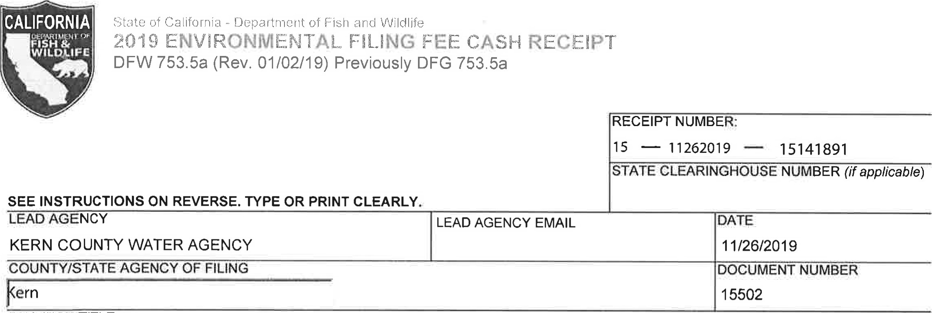
PROJECT TITLE
AGREEMENT BETWEEN THE KERN COUNTY WATER AGENCY, LITTLEROCK CREEK IRRIGATION DISTRICT AND CA DEPAE
PROJECT PP ICANT NAME  KERN COUNTY WATER AGENCY | PROJECT APPLICANT EMAIL |  | PHONE NUMBER  (661 ) 634-1400
PROJECT APPLICANT ADDRESS  3200 RIO MIRADA DR | CITY  BAKERSFIELD | STATE  CA | ZIPC DE 93308
PROJECT APPLICANT (check appropriate box)
CHECK APPLICABLE FEES:
Environmental Impact Report (EIR)
Exempt from fee
Notice of Exemption (attach)
CDFW No Effect Determination (attach)
Fee previously paid (attach previously issued cash receipt copy)

Water Right Application or Petition Fee (State Water Resources Control Board only) | $850.00
County documentary handling fee |  | 50.00

Other
PAYMENT METHOD:
^{Cash} Credit [X] Check Other TOTAL RECEIVED 250.00

SIGNATURE x 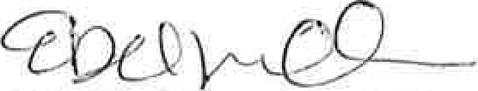 | AGENCY OF FILING PRINTED NAME AND TITLE  E. DEL VILLAR, KERN COUNTY CLERK, ACCOUNTANT 2

ORIGINAL - PROJECT APPLICANT COPY - CDFW/ASB COPY - LEAD AGENCY COPY - COUNTY CLERK DFW 753.5a (Rev. 20151215)

