NOTICE OF EXEMPTION
To: Office of Planning and Research
P.O. Box 3044
Sacramento, CA 95812-3044
Kern County Clerk
1 115 Truxtun Avenue Bakersfield, CA 93301

COPY FILED
KERN COUNTY

NOV 26 2019
MARY B BEDARD
From: Kern County W -COUNTYCLERK
P.O. Box 58 DEPUTY
Bakersfield, CA 93302-0058

Project Title: Agreement between the Kern County Water Agency (Agency), Palmdale Water District (Palmdale) and California Department of Water Resources (DWR) for Delivery of 2019 State Water Project (SWP) water to Semitropic Water Storage District (Semitropic) and Berrenda Mesa Water District (Berrenda Mesa).
Location -- Specific: The Agency is a State Water Project (SWP) contractor located in Kern County in the southern San Joaquin Valley. Semitropic and Berrenda Mesa contract for SWP water through the Agency and are in Kern County in the southern San Joaquin Valley. The S WP includes facilities located throughout the State of California.
Location -- County: Kern County.
Description of Activity: In 2019, Palmdale will transfer up to 15,000 acre-feet (af) of its 2019 SWP water to the Agency for delivery to Semitropic and Berrenda Mesa from California
Aqueduct turnouts located in the Agency's service area. In exchange, the Agency will return to Palmdale, based on an unbalanced exchange ratio of 2 to 1, up to 7,500 af of Semitropic and Berrenda Mesa's combined Table 1 water less applicable losses.
Name of Public Agency Approving or Carrying Out Activity: Agency (Lead Agency).
Exempt Status:
Ministerial
Declared Emergency
Emergency Project
Ø Categorical Exemption. State type and section number: See CEQA Guideline 15301 (b). Ø Statutory Exemption. State code number: See CEQA Guidelines Section 15061 (b)3.
CEQA Guideline Section 15301 (b) provides that a lead agency may determine an activity to be exempt from CEQA in that it utilizes only existing facilities. This transfer involves delivery of water entirely within the Agency's service area, and exclusively utilizes existing facilities. Additionally, CEQA Guideline Section 15061(b)3 provides that a Lead Agency may determine an activity to be exempt based on a general rule that CEQA applies only to projects that have a potential for causing a significant effect on the environment. Where it can be seen with certainty that there is no possibility that the activity in question may have a significant effect on the environment, the activity is not subject to CEQA. The Agency finds that approval of the proposed water transfer has no possibility of significant effect on the environment for the following reasons:
Posted by County Clerk on julL9I Notice of Environmental Docu nt
and for 30 days thereafter, Pursuant to
- The proposed action consists of a one-time water transfer that will use existing facilities and would not require any construction or grading.
- The proposed action does not constitute a new permanent source of water supply and will not result in any growth inducing or cumulative environmental impacts.
- There will be no change in land use.

Telephone: (661,) 634-1400
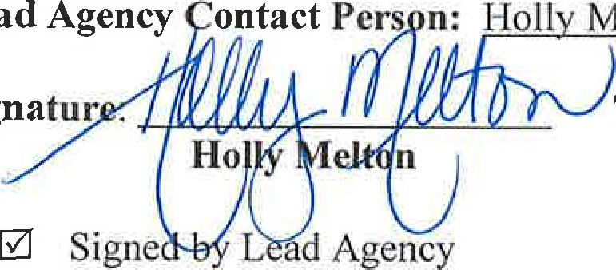
Title: Water Resources Manager Date: 1 1/22/2019
Lead
Melton
Signatur
Date received for filing by County Clerk:
Ø Signed by Applicant

2

CEQA
Transmittal Memorandum
Attach one transmittal memorandum to the front of the original CEQA document. Clip copies in back 1) If notice requires F&W receipt, you must provide a minimum of 3 copies of the document.
2) If notice does not require F&W receipt, you must provide a minimum of 2 copies of the document.

TYPE OR PRINT CLEARLY
LEAD AGENCY Kern County Water Agency

PROJECT TITLE Agreement between the Kern County Water Agency: Palmdale Water District and California Department of Water
Resources for Delivery of 2019 State Water project water to Senitropic Water Storage District and Berrenda Mesa Water District

PROJECT APPLICANT Kern Water Agency

PHONE NUMBER( 661 )

PROJECT APPLICANT ADDRESS
CITY Bakersfield STATE CA ZIP CODE 93308
WORK ORDER # X 30-Day Posting 35-Day Posting 45-Day Posting Other

CONTACT PERSON Monica Tennant PHONE NUMBER ( 661 ) 634-1419

CHECK DOCUMENT BEING FILED:

_ Notice of Availability .......................................................................................................... No Fee
_ Notice of Intent. ................................................................................................................... No Fee
_ Notice of Preparation ........................................................................................................... No Fee
_ Notice of Public Hearing ..................................................................................................... No Fee
_ Other _________________ ………………………………………………………………. No Fee
_ Environmental Impact Report (EIR)
_ Previously paid F&W (must attach F&W receipt) F&W Receipt Number # _______________
_ DFC No Effect Determination (F&W letter must be attached) …………………….. No Fee
_ County Administrative Fee………………………………………………………. $50.00
_ Mitigated Negative Declaration or Negative Declaration………………………………. $2354.75
_ Previously paid F&W (must attach F&W receipt) F&W Receipt Number # _______________

_ DFG No Effect Determination (F&W letter must be attached) ………………… No Fee
_ County Administrative Fee …………………………...................................................$50.00
X Notice of Exemption ……………………………………………………………………… No Fee
X County Administrative Fee ………………………….................................................. $50.00

TOTAL $ 50.00
*Additional copies to be returned to: Kern County Water Agency
*Method of return: X Hold for pick-up/Call # 661-634-1419 _ Interoffice Mail

PAYMENT METHOD: ALL APPLICABLE FEES MUST BE PAID AT THE TIME OF FILING
JV - Trans Code___ Dept____ Fund____ Expense Key____
Money Order
Check
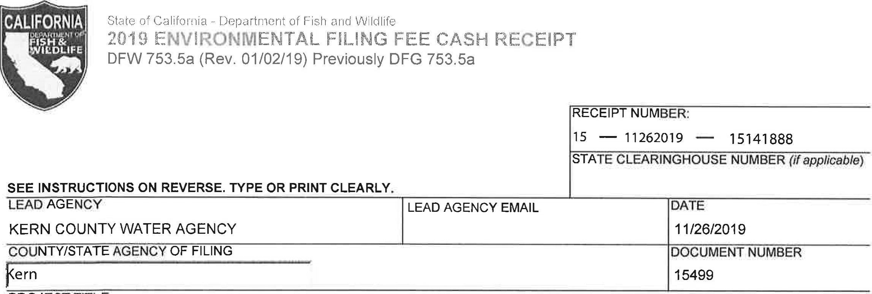
PROJECT TITLE
AGREEMENT BETWEEN THE KERN COUNTY WATER AGENCY, PALMDALE WATER DISTRICT AND CALIFORNIA DEPARTVEI
PROJECT APPLICANT NAME  KERN COUNTY WATER AGENCY | PROJECT APPLICANT EMAIL |  |  | PHONE NUMBER  661 ) 634-1400
PROJECT APPLICANT ADDRESS  3200 RIO MIRADA DR | CITY  BAKERSFIELD | STATE  CA |  | ZIP DE  93308
PROJECT APPLICANT (check appropriate box)
Local Public Agency School District [2 Other Special District [X] State Agency Private Entity
CHECK APPLICABLE FEES:
Environmental Impact Report (EIR)
- Exempt from fee
@ Notice of Exemption (attach)
- CDFW No Effect Determination (attach)
[3 Water Right Application or Petition Fee (State Water Resources Control Board only) | $850.00
County documentary handling fee |  | 50.00
[3 Fee previously paid (attach previously issued cash receipt copy)

Other
PAYMENT METHOD:

TOTAL RECEIVED
250.00
ORIGINAL - PROJECT APPLICANT- CDFW/ASB COPY - LEAD AGENCY COPY - COUNTY CLERK DFW 753Sa (Rev, 20151215)

