Biological Analysis of a Proposed Lime Plant in Trona, California

Prepared for and Submitted to:

Panamint Valley Limestone, Inc.
82532 2nd Street
Trona, CA 93562
(760) 384-8172

Prepared by:

Gilbert Goodlett and Linda Honey
EnviroPlus Consulting, Inc.
1660 West Franklin Avenue
Ridgecrest, CA 93555
(760) 371-3592 voice
(928) 395-9015 fax
e-mail:
Gilbert.Goodlett@EnviroPlusConsulting.com
Linda.Honey@EnviroPlusConsulting.com

June 2, 2018

TABLE OF CONTENTS

Page
1.0 EXECUTIVE SUMMARY 1
2.0 INTRODUCTION 1
2.1 Project Description 1
2.2 Site Description 2
3.0 METHODS 4
3.1 Purpose 4
3.2 Records Search 4
3.3 Biological Survey 5
4.0 RESULTS 5
4.1 Previous Biological Surveys 5
4.2 Biological Survey 5
4.3 Plants 6
4.4 Birds 6
4.5 Mammals 6
4.6 Reptiles 7
5.0 CONCLUSIONS 8
5.1 Site 8
5.2 Natural Gas Pipeline 8
5.3 Electrical Distribution Line 8
6.0 LITERATURE CITED 8
TABLES 10
Table 1. Special status plant and animal species potentially occurring on or near the proposed PVL Lime Plant project. 10
FIGURES 13
Figure 1. PVL Lime Plant project vicinity map 13
Figure 2. PVL Lime Plant Project and Land Ownership 14
Figure 3. PVL Lime Plant Project – Results of CNDDB Search 15
PHOTOGRAPHS 16
Photograph 1. PVL Lime Plant Project site showing very low succesional vegetation density. 16
Photograph 2. PVL Lime Plant Project – view of open Cell #5 showing disposed ash 17
Photograph 3. PVL Lime Plant Project – comparison of vegetation density inside (foreground) and outside (background across fence) of proposed site 18
Photograph 4. PVL Lime Plant Project – view north from the origin of the natural gas pipeline along First Street 19
Photograph 5. PVL Lime Plant Project – view south along 1,500 foot, moderately impacted native habitat section of natural gas pipeline 20
Photograph 6. PVL Lime Plant Project – view north along 3,500 foot section of natural gas pipeline that will lie on an existing dirt road immediately adjacent to Searles Valley Minerals ash disposal landfill (seen on the right side of the frame) 21
Photograph 7. PVL Lime Plant Project – view northeast along 800 foot section of pipeline route between an existing Searles Valley Minerals ash landfill on the right and a moderated used dirt road at the top of a flood control channel on the left 22
Photograph 8. PVL Lime Plant Project – view east along proposed electrical distribution line adjacent to paved Athol Street 23

1.0 EXECUTIVE SUMMARY
Panamint Valley Limestone, Inc (PVL) proposes to construct and operate a lime production plant on a site near Trona, California. The project will be constructed on a 61.65 acre abandoned ash landfill. Two new utilities will be constructed to serve the project, a 1.1 mile long natural gas pipeline and a 0.8 mile electrical distribution line.
This biological analysis combines the results of a multi-agency database review, a field survey conducted in May of 2018 and prior biological studies within and adjacent to the project area reported in 1988, 2012, and 2013.
The 61.65 acre former ash landfill is a heavily impacted industrial waste site and the probability of encountering any sensitive species is very low.
Approximately, 2,200 feet of the natural gas pipeline route lies in moderately disturbed native Allscale Shrubland Alliance. Within this area there is the potential to encounter Borrego milk-vetch (Astragalus lentiginosus var. borreganus). This species is of limited distribution in California and is not very endangered according to the California Native Plant Society. It is not a state or federally listed species.
One bird species, Le Conte’s thrasher (Toxostoma lecontei) has a moderate probability of occurrence. It is a species of special concern in California.
Potential habitat also exists for the California threatened Mohave ground squirrel (Xerospermophilus mohavensis; MGS). However, no suitable burrows for MGS were observed in the current survey and MGS were not detected during protocol trapping surveys conducted about 1,000 feet east of the gas pipeline route in 2013. This suggests that the probability of occurrence for MGS is low.
No evidence of sensitive species was observed along the route of the electrical distribution line. It will be located immediately adjacent to an existing paved road and the potential for sensitive species occurrence is considered very low.

2.0 INTRODUCTION

2.1 Project Description
Panamint Valley Limestone, Inc (PVL) proposes to construct and operate a lime production plant near Trona, California (Figure 1). Lime is produced by heating limestone in a gas-fired kiln. The resulting product is called quick lime. Water can be introduced to quick lime to produce hydrated lime. Both forms of lime are valuable commercial commodities.
The proposed lime production plant will be located on San Bernardino County Accessor’s Parcel Number (APN) 0485-031-12 and will occupy about thirty acres of the 61.65 acre site. Additional utilities for the site will include a 1.1 mile long natural gas pipeline and a 0.8 mile electrical distribution line. Plastic pipe eight inches or less in diameter will be used for construction of the gas pipeline. These features are shown on Figure 2.
Approximately 550 tons per day of limestone will be delivered to a stockpile at the site by truck from the Panamint Valley limestone quarry owned by PVL. Mechanized equipment and conveyors will size and deliver the limestone from the stockpile into a lime kiln which will discharge lime. The quick lime will then be conveyed to the tops of vertical silos which will discharge through the bottoms into delivery trucks. A variable portion of the lime will be conveyed to the hydration plant for conversion to hydrated lime which also will be siloed and then delivered by trucks to customers.
The proposed lime plant site will be sited on top of a former closed boiler ash landfill. The advantages offered by this site are a very favorable soil structure created by the solidified boiler ash which was deposited as a wet slurry and a beneficial reuse of a highly disturbed site. The site, which is zoned as regional industrial (San Bernardino County zoning code IR), is adjacent to the Searles Valley Minerals chemical manufacturing complex and is consistent in appearance and process with current activities in the area.
The PVL lime plant will operate 24 hours per day to produce approximately 120,000 tons per year of combined lime products. This lime will be sold in the California market. There are no lime from limestone production plants in California. Lime is transported to California by truck from distant producers, some as far away as the Midwest. Lime from limestone is a widely used commodity for agriculture, soil conditioning for construction and infrastructure projects, water treatment and myriad other uses. The California market exceeds 200,000 tons per year.
The PVL lime plant will employ approximately thirty management level, skilled operators and laborers in a locally depressed economy. It will add to the County tax base at least partially offsetting the impact recently experienced from shutdown of the adjacent ACE (Argus Cogeneration Expansion) power plant.
The lime plant will require a natural gas supply for the kiln. A 1.1 mile natural gas pipeline will be constructed to the facility. Electricity will be provided to the site via a newly constructed electrical distribution line approximately 0.8 mile in length. Both of these utilities are shown on Figure 2.

2.2 Site Description
The project site (Site) is located in the unincorporated community of Trona within San Bernardino County, California (Figure 1). Cadastrally, the 61.65 acre site is located in the southeast corner of Section 7 (Township 25S, Range 43E) and is identified as APN 0485-031-12. The natural gas pipeline extends into adjacent Section 18 of the same township to the south while the electrical distribution line extends into adjacent Section 8 of the same township to the east.
The Site and its utility features are located in the Searles Valley on a narrow bajada between the Argus Range to the west and Searles Lake to the east with the Slate Range further to the east. The area naturally drains to the southeast at a grade ranging from 2 to 6% into Searles Lake approximately a mile southeast of the Site. Natural flow patterns have been diverted by the San Bernardino County Flood Control District to protect the town of Trona and no drainages are found on the Site or on the electrical distribution line. The natural gas pipeline route crosses approximately four blue line drainages.
The Site is a heavily impacted former ash landfill that supported the ACE 108 megawatt coal-fired power plant. Ash or coal ash is a byproduct of the combustion of coal. Utilization of the site as an ash landfill began in January of 1991 and continued until the ACE plant ceased operations in October of 2014. The only material disposed in the landfill was fly and bottom ash produced by the power plant and refractory lining from the boiler. When slurried into the landfill during disposal, the ash became a concrete-like material. The site is surrounded by an approximately eight foot high chain link fence.
The ash landfill is segregated into five individual cells (Figure 2). When ACE ceased operations, all ash remaining at the boiler was disposed in the landfill and ash disposal operations terminated. Cells #1 to #4 had previously been closed, capped, and allowed to naturally revegetate. Cell #5 was approximately 80% full with solidified ash sloping gently from the two ash disposal locations on the north and south of the cell toward the west. A portion of cell #5 was left open to allow for disposal of boiler refractory lining during demolition of the plant facilities. This activity is no-longer planned.
Twenty-three years of deposition at the Site has resulted in a landfill that that is about 15 feet higher than the surrounding terrain and lies at an elevation of about 1,800 feet. Limited revegetation (Photo 1) has occurred on the landfill in the four years since operations ceased with the exception of Cell #5 which is currently open and denuded (Photo 2). The successional vegetation on the site is characteristic of the vegetation surrounding the site only at a much lower vegetation density (Photo 3). The vegetation is an Allscale Shrubland Alliance (Sawyer, Keeler-Wolf and Evens 2009) dominated by allscale (Atriplex polycarpa), desert holly (Atriplex hymenelytra), and shadscale (Atriplex confertifolia).
The natural gas pipeline originates near the northern terminus of residential housing along paved First Street in Trona where it will tie-in to an existing pipeline (Figure 2) and traverse along the road right-of-way (Photo 4). The paved road turns abruptly about 1,200 feet north of the pipeline origin while the pipeline continues northward. The pipeline route then traverses generally along a dirt road for about 1,500 feet. There are numerous dirt roads and off-road vehicle trails and tracks in this area indicating a moderate level of human impacts. This area and the more northerly segment of the pipeline route is relatively sparsely vegetated Allscale Shrubland Alliance (Sawyer, Keeler-Wolf and Evens 2009) dominated by allscale and desert holly. A few creosote bushes (Larrea tridentata) are found in the area (Photo 5). The pipeline route continues northward for about 3,500 feet immediately adjacent to another ash landfill surrounded by a chain link fence, this one operated by Searles Valley Minerals. In this stretch, the pipeline would be on located under an existing dirt road (Photo 6). Finally, the gas pipeline turns to the northeast and will be sited between the Searles Valley Minerals ash landfill chain link fence and a moderate use dirt road that parallels a San Bernardino County Flood Control District channel (Photo 7). The gas pipeline would enter the site along its northern boundary.
The electrical distribution line originates at the Trona substation near the Trona High School. From there it traverses westward following paved Athol Street which curves to the south as it enters the Site (Figure 2). The entirety of the electrical distribution line is along the paved road which is heavily impacted by utilization of the roadway (Photo 8). Vegetation along the electrical distribution line differs from other project areas in that it is a near monoculture of allscale.
Surface soils on the Site are generally dominated by fine gravel (4-8 mm diameter) interspersed with numerous boulders. On the natural gas pipeline and the electrical distribution line, soils tend to be slightly finer with very course sand (1-2 mm diameter) dominating the substrate.
Surrounding land uses are primarily industrial with the non-operational ACE Cogeneration plant and a Searles Valley Minerals facility immediately to the south-southeast. The Site is privately owned. The gas pipeline route traverses a mix of property ownership including County right-of-way and public lands managed by the Bureau of Land Management while the electrical distribution line will be located within a County road easement or on private land (Figure 2).

3.0 METHODS

3.1 Purpose
EnviroPlus Consulting, Inc. has prepared this Biological Analysis of the proposed project to document the biological conditions present on the Site and its utilities. This analysis is based on the existing site conditions, and the potential for sensitive biological resources to occur both on and in the vicinity of the project site.

3.2 Records Search
Searches of current records, including relevant wildlife and plant databases, were conducted in support of this Biological Analysis. The California Natural Diversity Data Base (CNDDB) (CDFW 2018), California Native Plant Society (CNPS) database (CNPS 2018), and United States Fish & Wildlife Service (USFWS) Threatened & Endangered Animals List (USFWS 2018) were all reviewed to obtain a list of special-status species known to occur within the project vicinity. The CNDDB search was conducted to a radius of five miles from the Site (Figure 3) while the CNPS searched encompassed the USGS 7.5 minute topographic quadrangle in which the project area is located (Trona West).
The CNDDB provides element-specific spatial information on individual documented occurrences of special-status species and sensitive natural vegetation communities. The CNPS database provides similar information on sensitive plant species, but at a much lower spatial resolution. The USFWS query generates a list of federally-protected species known to potentially occur within individual USGS quadrangles. Any wildlife species designated as “Fully Protected” by California Fish and Game Code Sections 5050 (Fully Protected reptiles & amphibians), 3511 (Fully Protected birds), and 4700 (Fully Protected mammals) were included in the list.
In addition to Agency resources, there is a substantial body of biological analysis that has been conducted at and in the vicinity of the Site. In January of 1988, the California Energy Commission addressed biological issues in their certification document for the original ACE Project (California Energy Commission 1988). Much later, in 2012 after the facility had shut down, a proposal was put forth to replace the ACE Cogeneration Facility with a combined-cycle and solar energy hybrid facility referred to as the ACE Phoenix Project. Substantial biological analysis occurred in support that project which never materialized (AECOM 2012a, AECOM 2012b, LaBerteaux 2013).

3.3 Biological Survey
On May 15, 2018, EPC biologist Gilbert Goodlett toured the site and natural gas pipeline route with Larry Trowsdale, a PVL representative. Mr. Trowsdale explained the proposed project and familiarized Mr. Goodlett with the project area. On May 17, Mr. Goodlett conducted a pedestrian survey of the Site, the natural gas pipeline, and the electrical distribution line. Because the Site was so heavily disturbed the survey was comprised of a walk around the interior perimeter. The entirety of the natural gas pipeline route and the electrical distribution line were covered in two transects walked at 10 meter intervals.

4.0 RESULTS
Results of the biological analysis include the combination of the Agency records searches, results of previous biological surveys within the project area, and the current biological survey. These data are summarized in Table 1.

4.1 Previous Biological Surveys
In the 1988 certification document from the California Energy Commission prior to the construction of the ACE facility (California Energy Commission 1988) it was stated that “no sensitive species have been detected at the site” referring to the ACE site which is immediately adjacent to the ash landfill. The document also indicates that no Mohave ground squirrels (Xerospermophilus mohavensis; MGS) were captured during trapping surveys in support of the project.
Including a 500 ft survey buffer, the much later proposed ACE Phoenix project footprint covered the entirety of the Site for the proposed project, 80% of the area of the proposed natural gas pipeline and 20% of the electrical distribution line. In a 2012 initial biological assessment for the project (AECOM, 2012a), AECOM concluded that “only the MGS is thought to have a moderate possibility of occurrence…” Other species were characterized to have a “low to very low” probability of occurrence. Nevertheless, a presence/absence survey was conducted for desert tortoise, western burrowing owl, desert kit fox and American badger (AECOM 2012b). Three desert kit fox dens with fresh scat were observed. No definitive sign of the other species was detected leading to the conclusion that that desert tortoise, western burrowing owl, and American badger were absent from their project area and that desert kit fox was potentially present.
In 2013, a California Department of Fish and Wildlife (CDFW) protocol trapping survey (CDFG 2003) was conducted for a proposed gas pipeline in support of the Phoenix project that is parallel to and about 1,000 feet east of the proposed gas pipeline (LaBerteaux 2013). No MGS were captured or detected during the trapping survey.

4.2 Biological Survey
No sensitive species or sign thereof was detected during the May 17, 2018 survey. The survey was begun at 1430 and completed at 1900. Temperatures were in the low 80’s °F with light winds from the southwest. Species observed on or in the vicinity of the project area included common raven (Corvus corax), coyote (Canis latrans), black-tailed jackrabbit (Lepus californicus), and zebra-tailed lizard (Callisaurus draconoides).

4.3 Plants
Six species of plants were identified as potentially occurring in the project area based on CNDDB and CNPS database searches (Table 1). One of these species were characterized as “not present” on the site because it is a large perennial shrub that would have been easy to detect but was not seen in current or prior surveys. Four species where characterized as “not expected” because suitable habitat for the species does not occur on site.
One species, Borrego milk-vetch (Astragalus lentiginosus var. borreganus) is considered to have a moderate probability of occurring in the project area. The species has a CNPS Rank of 4.3 meaning that it is a plant of limited distribution in California and is not very endangered. Borrego milk-vetch has no state or federal ranking. It occurs in sandy habitat in Mojavean and Sonoran desert scrub and the blooming period is between February and May.
One plant species that is common in the area, desert holly, does not appear in the CNDDB or CNPS search. However, the harvesting of this species is regulated under the California Desert Native Plants Act which protects certain species of California desert native plants from unlawful harvesting on both public and privately owned lands. A permit for removal of regulated species can be obtained through the San Bernardino County Agricultural Commission.

4.4 Birds
Seven species of birds were identified as potentially occurring in the project area based on CNDDB database searches (Table 1). Four of the species were characterized as “not expected” in the project area because suitable habitat does not exist and/or the species were not detected during the current or 2012 surveys (AECOM 2012b). Golden eagle (Aquila chrysaetos) and prairie falcon (Falco mexicanus) were identified as having a “low” probability of occurrence. Both of these raptors nest in cliffs and trees, features which do not exist within the project area. Their “low” probability ranking only occurs because it is possible that the species could utilize the project area for foraging.
One bird species, Le Conte’s thrasher (Toxostoma lecontei) has a moderate probability of occurrence. This highly terrestrial bird is a non-migratory omnivore that feeds on arthropods, seeds, and berries. It is a species of special concern in California.

4.5 Mammals
Six species of mammals were identified as potentially occurring in the project area based on CNDDB database searches (Table 1). Three of these species were characterized as “not expected” to occur in the project area owing to lack of habitat in the area and/or lack of sign detected in the current and/or 2012 survey (AECOM 2012b).
The remaining three species were considered to have a “low” probability of occurrence. One of these three is desert kit fox (Vulpes macrotis arsipus). In the 2012 survey, a potentially active kit fox den was observed along the currently proposed route of the natural gas pipeline. However, this den was not observed in the current survey. It is not unusual that desert kit fox may have moved from one location to another during the six years between surveys. Desert kit fox are protected by the California Code of Regulations (14 CCR § 460) which states that “Fisher, marten, river otter, desert kit fox and red fox may not be taken at any time”.
Another low probability species is American badger, a CDFW species of special concern. This relatively widespread fossorial carnivore is primarily nocturnal and inhabits a wide variety of habitats including Mojavean desert scrub. Even though they are not often seen during the day, they are relatively large and their dens and scat are relatively easy to recognize. No badger sign was observed during the current survey or the 2012 survey (AECOM 2012b).
Mohave ground squirrel has been identified as a species with a low probability of occurrence. MGS is listed as a state threatened species. This characterization of a low probability of occurrence would appear to be counter to a CNDDB observation shown in Figure 3 that reports an MGS observation that overlaps the Site. However, this observation was made in 1989 prior to the utilization of the Site as an ash landfill. The habitat that existed on the Site in 1989 no longer exists today. Currently the site is elevated approximately 15 feet higher than the surrounding terrain and is sparsely vegetated. The surface of Cell #5 which is still open is denuded and composed of compacted fly ash. In 2012, Dr. Phillip Leitner, a recognized MGS expert, reviewed the area that is the current Site and concluded “This area has been used for ash disposal and does not support natural desert habitat. It is not suitable for occupancy by the MGS.”
In addition to the Site itself, the project also includes a natural gas pipeline route and an electrical distribution line. In 2013, a MGS protocol trapping survey (CDFG 2003) was conducted along a proposed natural gas pipeline route for the ACE Phoenix project (LaBerteaux 2013). This proposed pipeline route is generally parallel to the current proposed pipeline route and about 1,000 feet to the east. No MGS were detected.
About 20% of the route of the electrical distribution line was part of the ACE Phoenix project analysis. No sensitive species were detected. Additionally, the route is along the existing paved Athol Street and is not considered suitable MGS habitat.

4.6 Reptiles
Even though the CNDDB search did not reveal any reptile species, desert tortoise (Gopherus agassizii) is considered because the species is state and federally threatened and for consistency with prior studies. The project area lies outside of critical habitat for the species (USFWS 2011). The nearest critical habitat is the Superior-Cronese Area of Critical Environmental Concern that lies 25 miles to the south-southeast.
In the current survey no desert tortoise sign was observed. Sign includes burrows, scat, live tortoises, carcasses, tracks, eggs or fragments thereof, or drinking depressions. In the California Energy Commission certification document (California Energy Commission 1988) it was stated that the “no sensitive species have been detected at the site” for the adjacent ACE facility. In 2012 a desert tortoise survey was conducted for the ACE Phoenix project (AECOM 2012b) that exceeded U.S. Fish and Wildlife Service (USFWS) protocols (USFWS 2010). The part of the survey that exceeded USFWS protocols was the inclusion of a 500 foot wide buffer around the proposed project footprint. With the inclusion of this buffer, the 2012 survey included the entire Site, about 80% of the proposed natural gas pipeline, and 20% of the electrical distribution line. No definitive desert tortoise sign was located during the survey. Three Class 4 burrows were identified but these are not considered definitive because Class 4 burrows are in deteriorated condition and only of a size that could be used by a tortoise. There is insufficient evidence to confirm that a tortoise created or has used such a burrow.

5.0 CONCLUSIONS
This analysis combines the results of database records searches, a May, 2018 field biological survey, and numerous biological surveys conducted in the area dating to 1988 that were conducted in support of other projects. From these data the following conclusions are drawn.

5.1 Site
The Site is a former ash landfill. As such it is heavily impacted and the probability of locating any sensitive species is very low based on the results of current and prior surveys (California Energy Commission 1988, AECOM 2012b).

5.2 Natural Gas Pipeline
Portions of the natural gas pipeline lie along paved and dirt roads. However, approximately 2,200 feet of the line (a 1,500 foot section and an 800 foot section) lies in native habitat that has been moderately disturbed by the presence of dirt roads and trails. In this area the potential exists for Borrego milk-vetch to be found. This plant is of limited distribution in California and is not very endangered (CNPS 2018). It is not a state or federally listed species.
Throughout the natural gas pipeline route the potential exists for LeConte’s thrasher. This is a California species of special concern.
One bird species, Le Conte’s thrasher (Toxostoma lecontei) has a moderate probability of occurrence. This highly terrestrial bird is a non-migratory omnivore that feeds on arthropods, seeds, and berries. It is a species of special concern in California.
Within the approximately 2,200 foot sections of native habitat, the potential exists for habitation by MGS. However, the current survey did not reveal any suitable MGS burrows. Also, MGS were not detected in 2012 (AECOM 2012b) and a protocol trapping survey in 2013 (LaBerteaux 2013) suggesting the probability of occurrence for MGS is very low.

5.3 Electrical Distribution Line
No evidence of sensitive species was observed along the route of the electrical distribution line. It will be located immediately adjacent to an existing paved road and the potential for sensitive species occurrence is considered very low.

6.0 LITERATURE CITED
AECOM. 2012a. Preliminary Site Characterization for Biological Resources for the ACE Phoenix Project, San Bernardino County, California. 46 pgs.
AECOM. 2012b. Desert Tortoise, Western Burrowing Owl, Desert Kit Fox, and American Badger Presence/Absence Survey for the ACE Phoenix Project, San Bernardino County, California. 79 pgs.
California Department of Fish and Game. 2003 (revised 2010). Mohave ground squirrel survey guidelines. Unpublished guidelines produced by CDFG. Sacramento, California. 5 pp.
California Department of Fish & Wildlife. 2018. California Natural Diversity Database Rare Find, Version 5. California Department of Fish & Wildlife, Sacramento, CA.
California Energy Commission. 1988. Application for Certification for Kerr McGee Chemical Corporation’s Argus Cogeneration Expansion Project. Docket No. 86-AFC-1. California Energy Commission, Sacramento, CA.
California Native Plant Society, Rare Plant Program. 2018. Inventory of Rare and Endangered Plants of California (online edition, v8-03 0.39). Website http://www.rareplants.cnps.org [accessed 16 May 2018]
LaBerteaux, Denise. 2013. Mohave Ground Squirrel Survey at the Proposes Phoenix Combined Heat and Power Project Site, Trona, Sand Bernardino County, California. Prepared for AECOM. 24 pgs.
Sawyer, J.O., T. Keeler-Wolf and J.M. Evens. 2009. A manual of California vegetation. Second edition. California native Plant Society Press. Sacramento, CA. 1300 pp.
U.S. Fish and Wildlife Service (USFWS). 2010. Preparing for Any Action that May Occur Within the Range of the Mojave Desert Tortoise (Gopherus agassizii). January.
U.S. Fish and Wildlife Service (USFWS). 2011. Revised Recovery Plan for the Mojave Population of the Desert Tortoise (Gopherus agassizii). U.S. Fish and Wildlife Service, California and Nevada Region, Sacramento, California. 222 pp.
United States Fish & Wildlife Service, Environmental Conservation Online System (ECOS) 2018. All Threatened and Endangered Animals. Website https://ecos.fws.gov/ecp/ [accessed 16 May 2018]

TABLES

Table 1. Special status plant and animal species potentially occurring on or near the proposed PVL Lime Plant project.
Common Name | Scientific Name | Status | Habitat | Potential for Occurrence
PLANTS
Emory's crucifixion thorn | Castela emoryi | CNPS List 2.3 | Mojavean desert scrub and playas | Not present. This species is a large perennial shrub and would have been detected if present during the survey.
Wine-colored tufa moss | Plagiobryoides vinosula | CNPS List 4.2 | Cismontane woodland, Mojavean desert scrub, Meadows and seeps, Pinyon and juniper woodland, Riparian woodland | Not present. Requires wet areas such as seeps or streams which do not occur on project area
Panamint Mountains bedstraw | Galium hilendiae ssp. carneum | CNPS List 1B.3 | Mojavean desert scrub, Pinyon and juniper woodland | Not present. Only known from Panamint Mtns at higher elevations than the project area
Ripley’s aliciella | Aliciella ripleyi | CNPS List 2.3 | Mojavean desert scrub, carbonate soils | Not expected. No suitable habitat is present within the project area.
Booth's evening-primrose | Eremothera boothii ssp. boothii | CNPS List 2B.3 | Joshua tree woodland, Pinyon and juniper woodland | Not expected. Habitat not present on site and the species occurs a higher elevations than the project area
Borrego milk-vetch | Astragalus lentiginosus var. borreganus | CNPS List 4.3 | Mojavean desert scrub, Sonoran desert scrub | Moderate
BIRDS
Western snowy plover | Charadrius alexandrinus nivosus | CDFW SSC | A wader that breeds on sandy coasts and brackish inland lakes | Not expected. No suitable habitat present.
Burrowing owl | Athene cunicularia | BLM Sensitive, CDFW SSC | Areas with low shrub cover, suitable burrows, and a prey base | Not expected. No sign was detected during current or 2012 surveys of the site.

Common Name | Scientific Name | Status | Habitat | Potential for Occurrence
Long-eared owl | Asio otus | CDFW SSC | Nests in trees often using abandoned stick nests of other species, forages in open habitat. | Not expected. No nesting habitat present. Very little foraging habitat present.
Inyo California towhee | Pipilo crissalis eremophilus | FT, SE, BLM Sensitive | Nests near riparian vegetation and forages in mixed Mojave desert scrub. Ranges from 2,680 feet to 5,630 feet in  elevation | Not expected. No nesting habitat present. Project area is at lower elevation than typical occurrence of species
Golden eagle | Aquila chrysaetos | BGEPA, CDFW FP | Nesting on cliffs and trees; foraging in open country | Low. No nesting habitat present. Very little foraging habitat present.
Prairie falcon | Falco mexicanus | CDFW SSC | Nests are located on cliffs in rugged mountain ranges, often within 1/2 mile of water. Forages in open country | Low. No nesting habitat present. Very little foraging habitat present.
LeConte's thrasher | Toxostoma lecontei | CDFW SSC | Dunes, alluvial fans, and flat to gently rolling hills with shallow washes with sparse vegetation | Moderate
MAMMALS
Desert bighorn sheep | Ovis canadensis nelsonii | BLM Sensitive | Mountain slopes with sparse growth of trees above the desert floor in California | Not expected. Unsuitable habitat and unlikely pathway for dispersal.
Townsend's big-eared bat | Corynorhinus townsendii | BLM Sensitive, CDFW SSC | Requires large cavities for roosting such as abandoned buildings, mines, caves and basal cavities of trees | Not expected. No suitable roosting habitat in project area.
Western small-footed myotis | Myotis ciliolabrum | BLM Sensitive | Roosts may be in crevices and cracks in canyon walls, caves, mine tunnels, behind loose tree bark, or in abandoned structures. | Not expected. No suitable roosting habitat in project area.

Common Name | Scientific Name | Status | Habitat | Potential for Occurrence
Desert kit fox | Vulpes macrotis arsipus | CCR - Protected Furbearing Mammal | Wide variety of habitats in the western U.S. | Low. No suitable dens or other sign located during survey. Suitable dens and scat were located during 2012 survey.
American badger | Taxidea taxus | CDFW SSC | Fossorial species with typically open areas and small mammal prey base | Low. No suitable dens or other sign located during survey. No sign located during 2012 survey.
Mohave ground squirrel | Xerospermophilus mohavensis | ST, BLM Sensitive | High-quality habitat includes a diversity of shrub species, native herbaceous plants, and sandy loamy soils that provide substrate for burrow construction. | Low. No small mammal burrows observed during survey. Presence not detected during prior trapping surveys.
Reptiles
Desert tortoise | Gopherus agassizii | FT, ST | Fossorial species that lives in a variety of habitats including creosote bush scrub and saltbush scrub | Not expected. No sign was detected during current or prior surveys of the site.
Abbreviations:
CNPS California Native Plant Society Lists:
1B: Considered rare, threatened, or endangered in California and elsewhere
2: Plants rare, threatened, or endangered in California, but more common elsewhere
3: Plants for which we need more information – review list
4: Plants of limited distribution a watch list
Decimal notations: .1 - Seriously endangered in California, .2 – Fairly endangered in California, .3 – Not very endangered in California
FT = Federally Threatened
SE = California State Endangered
ST = California State Threatened
BLM = Bureau of Land Management
BGEPA = Bald and Golden Eagle Protection Act
CCR = California Code of Regulations
CDFW SSC = California Department of Fish and Wildlife Species of Special Concern
CDFW FP = California Department of Fish and Wildlife Fully Protected

FIGURES

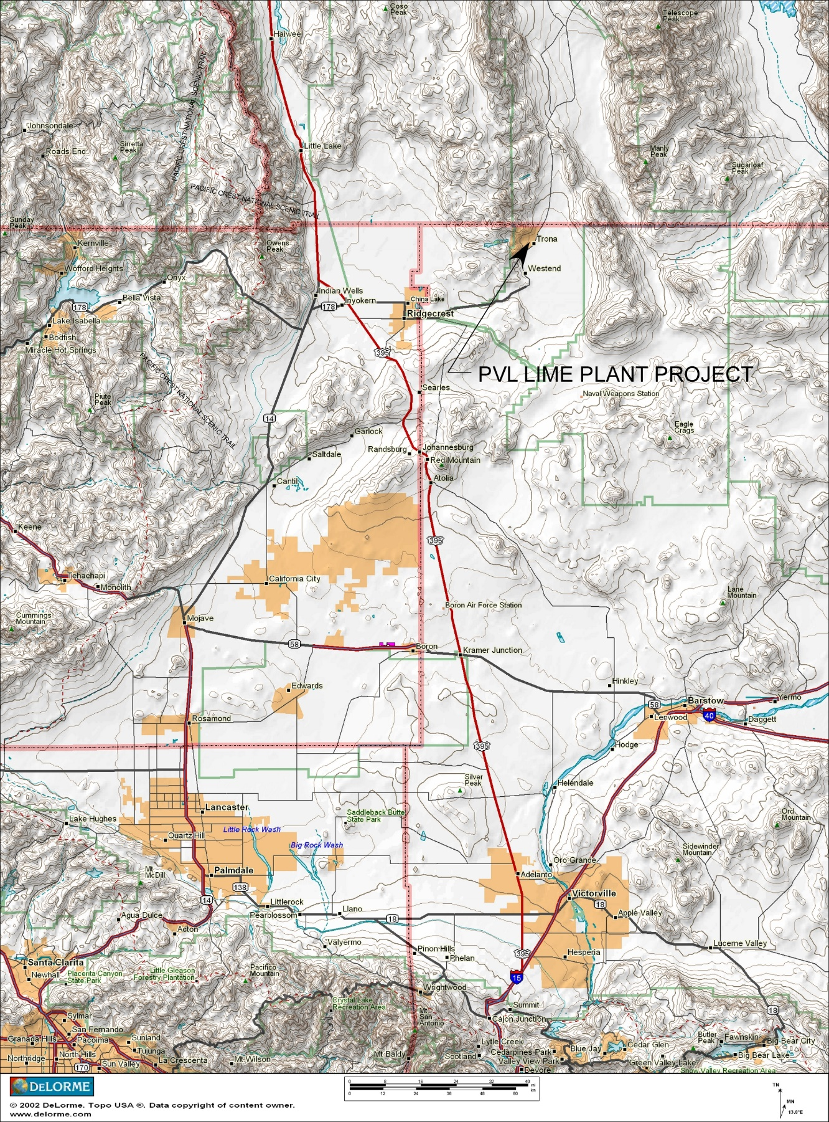

Figure 1. PVL Lime Plant project vicinity map
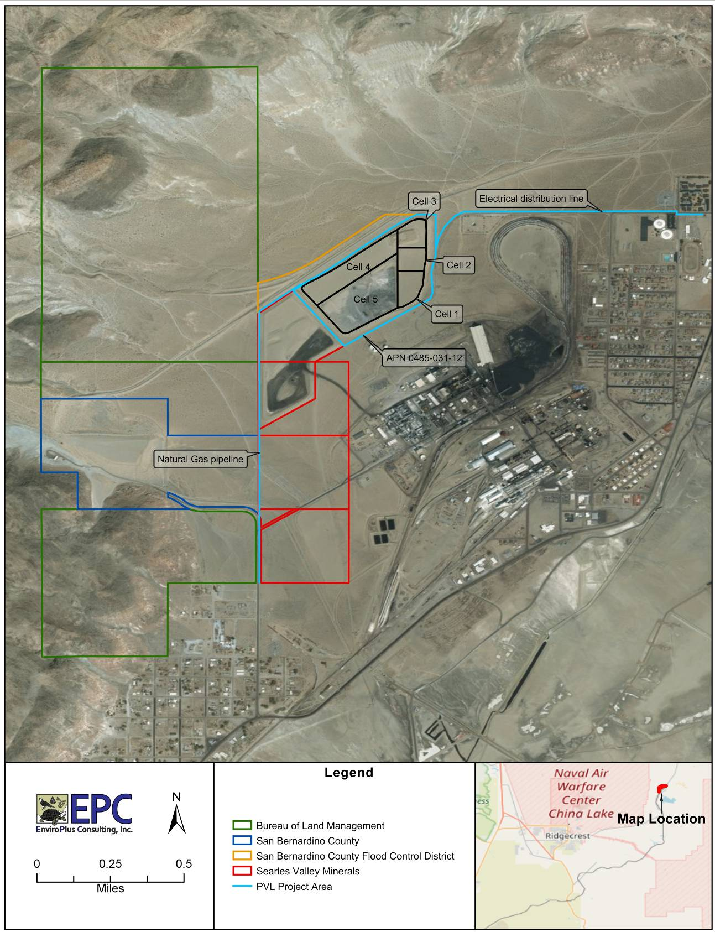

Figure 2. PVL Lime Plant Project and Land Ownership

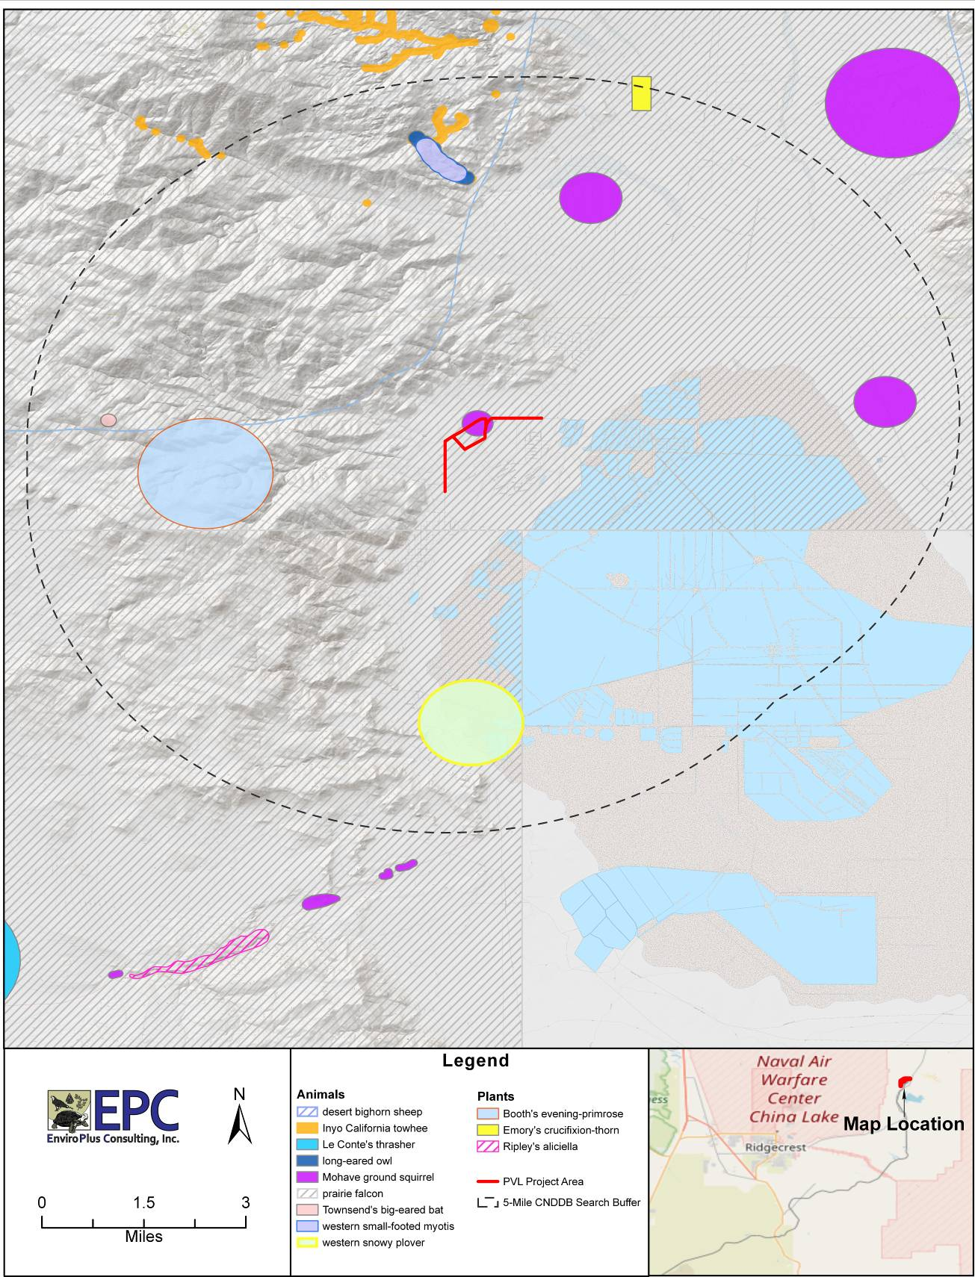

Figure 3. PVL Lime Plant Project – Results of CNDDB Search

PHOTOGRAPHS

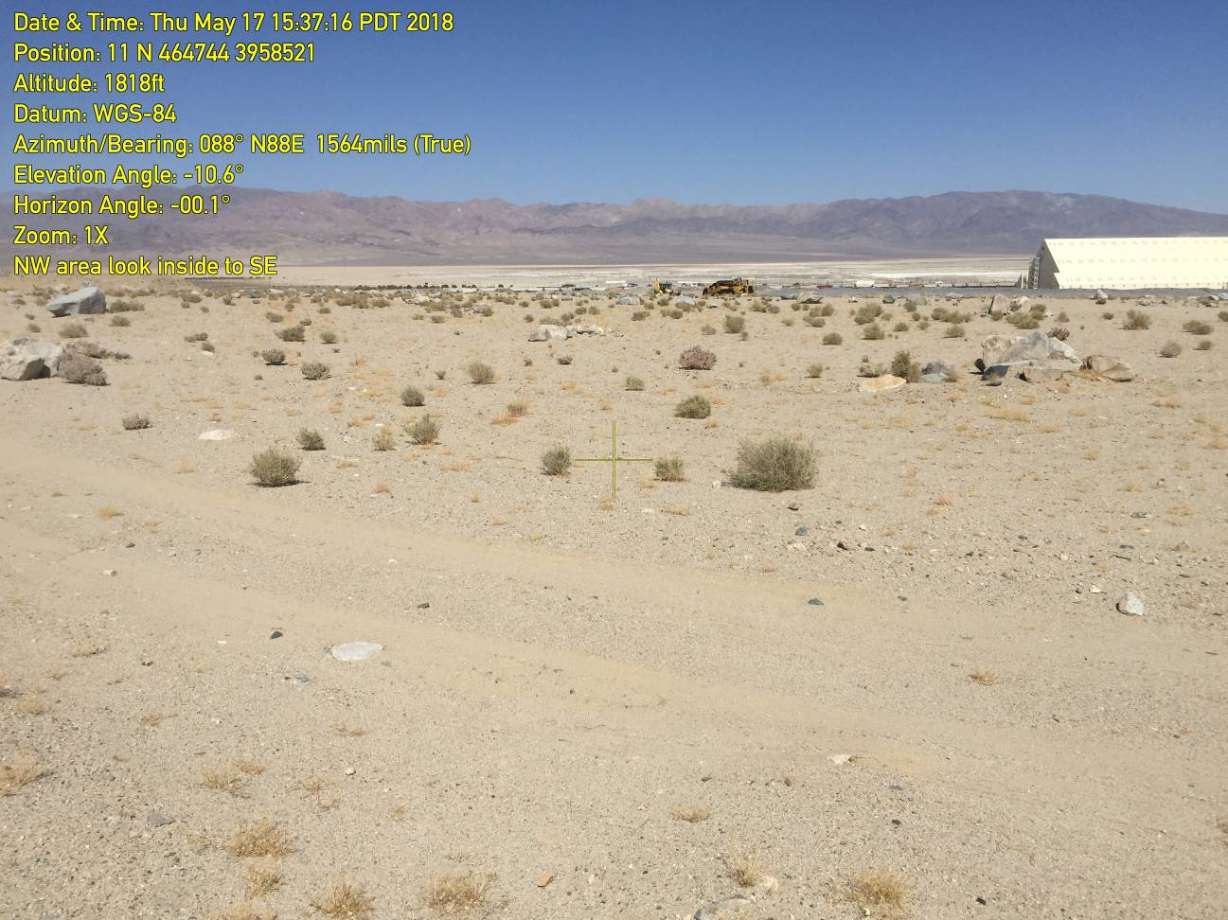
Photograph 1. PVL Lime Plant Project site showing very low succesional vegetation density.

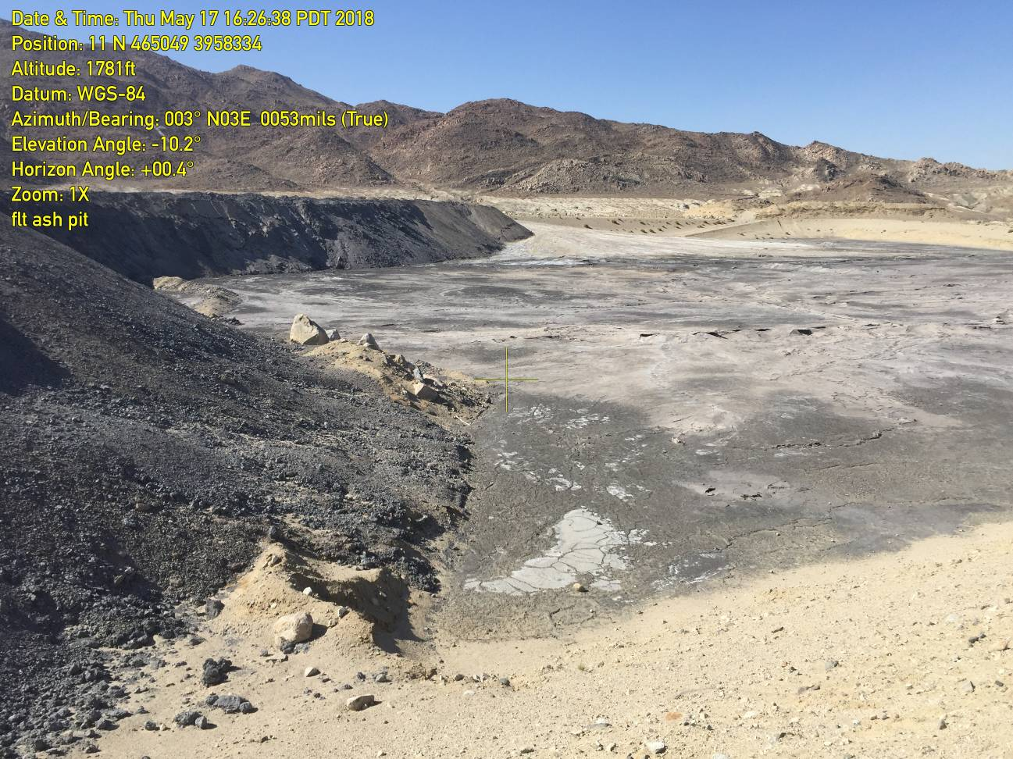
Photograph 2. PVL Lime Plant Project – view of open Cell #5 showing disposed ash

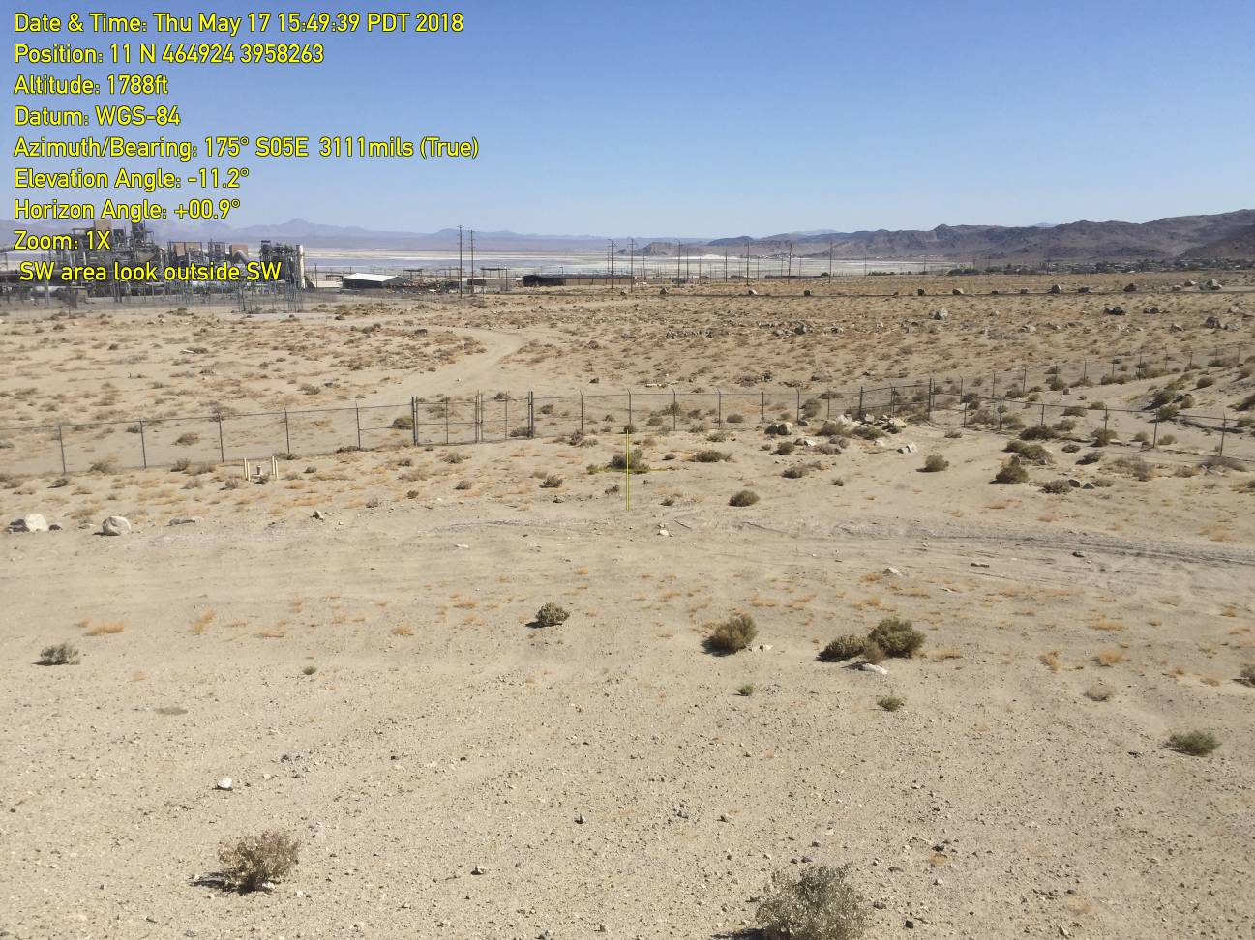

Photograph 3. PVL Lime Plant Project – comparison of vegetation density inside (foreground) and outside (background across fence) of proposed site

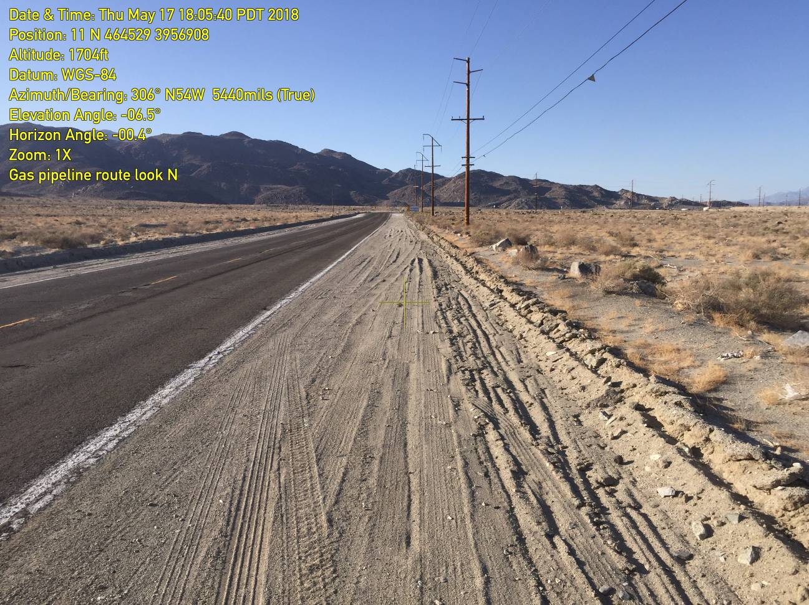

Photograph 4. PVL Lime Plant Project – view north from the origin of the natural gas pipeline along First Street

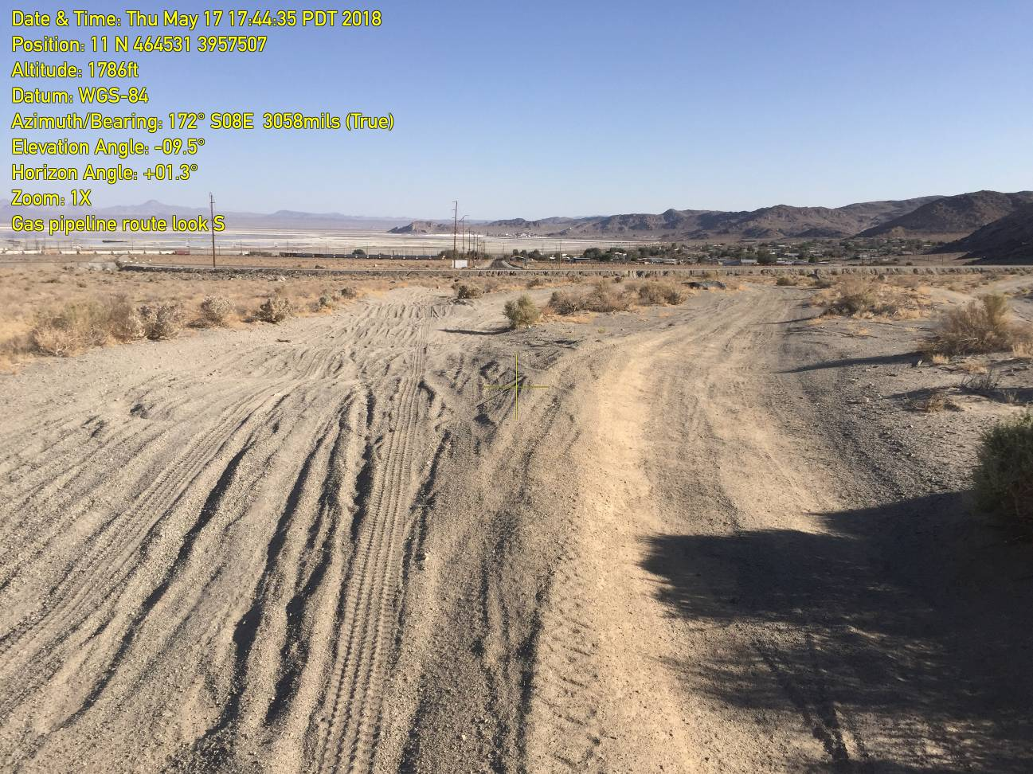

Photograph 5. PVL Lime Plant Project – view south along 1,500 foot, moderately impacted native habitat section of natural gas pipeline

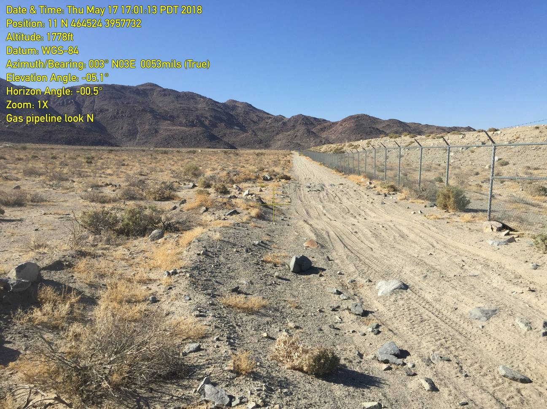

Photograph 6. PVL Lime Plant Project – view north along 3,500 foot section of natural gas pipeline that will lie on an existing dirt road immediately adjacent to Searles Valley Minerals ash disposal landfill (seen on the right side of the frame)

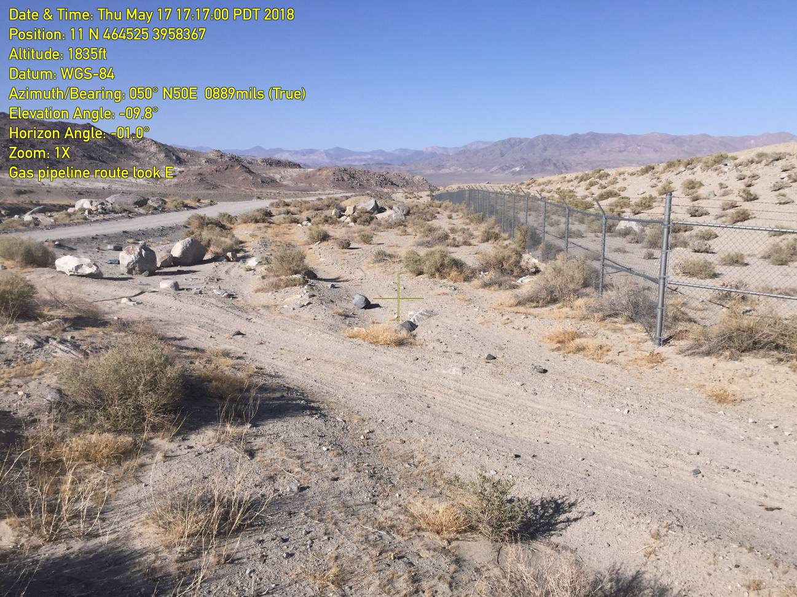

Photograph 7. PVL Lime Plant Project – view northeast along 800 foot section of pipeline route between an existing Searles Valley Minerals ash landfill on the right and a moderated used dirt road at the top of a flood control channel on the left

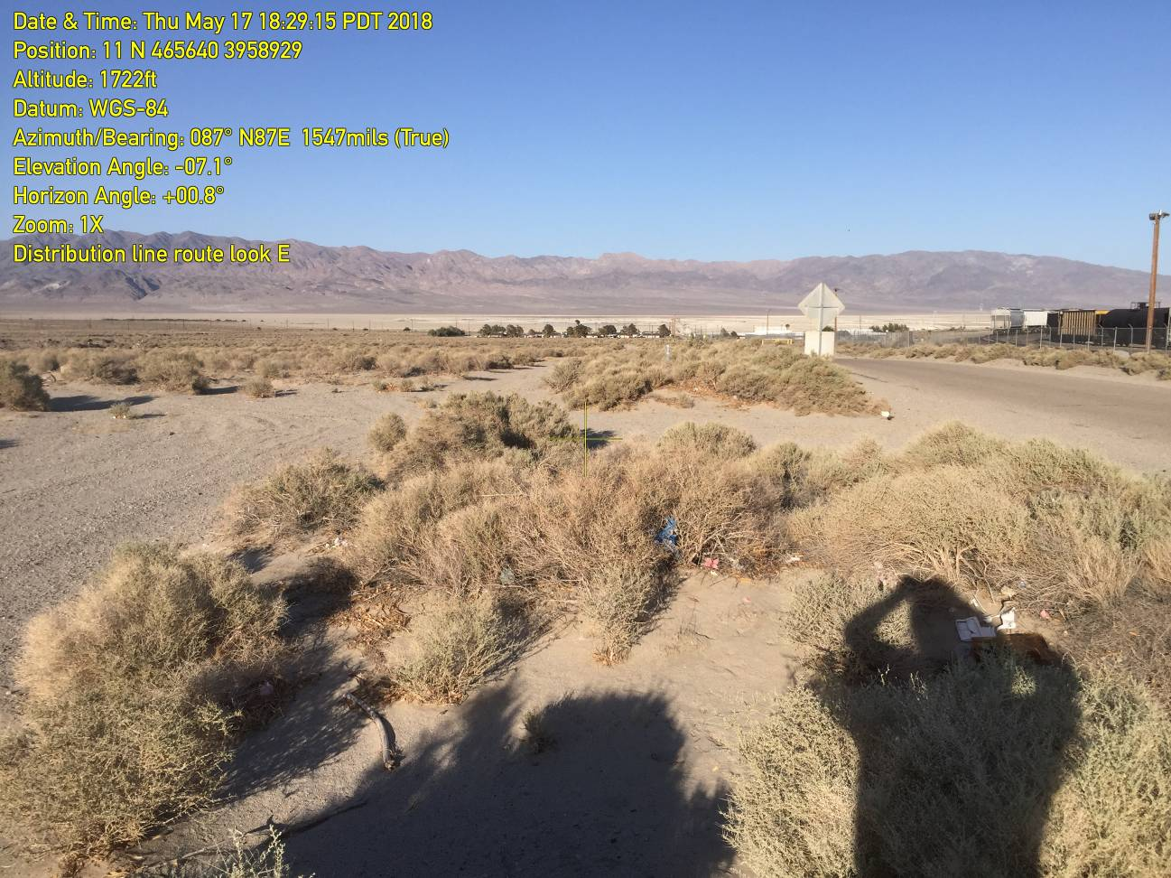

Photograph 8. PVL Lime Plant Project – view east along proposed electrical distribution line adjacent to paved Athol Street

