North Round Valley Road Bridge over Pine Creek Bridge Replacement Project
(Bridge No. 48C0044)
CEQA - Initial Study/MND
Prepared by:
Consulting
Engineers and
Scientists

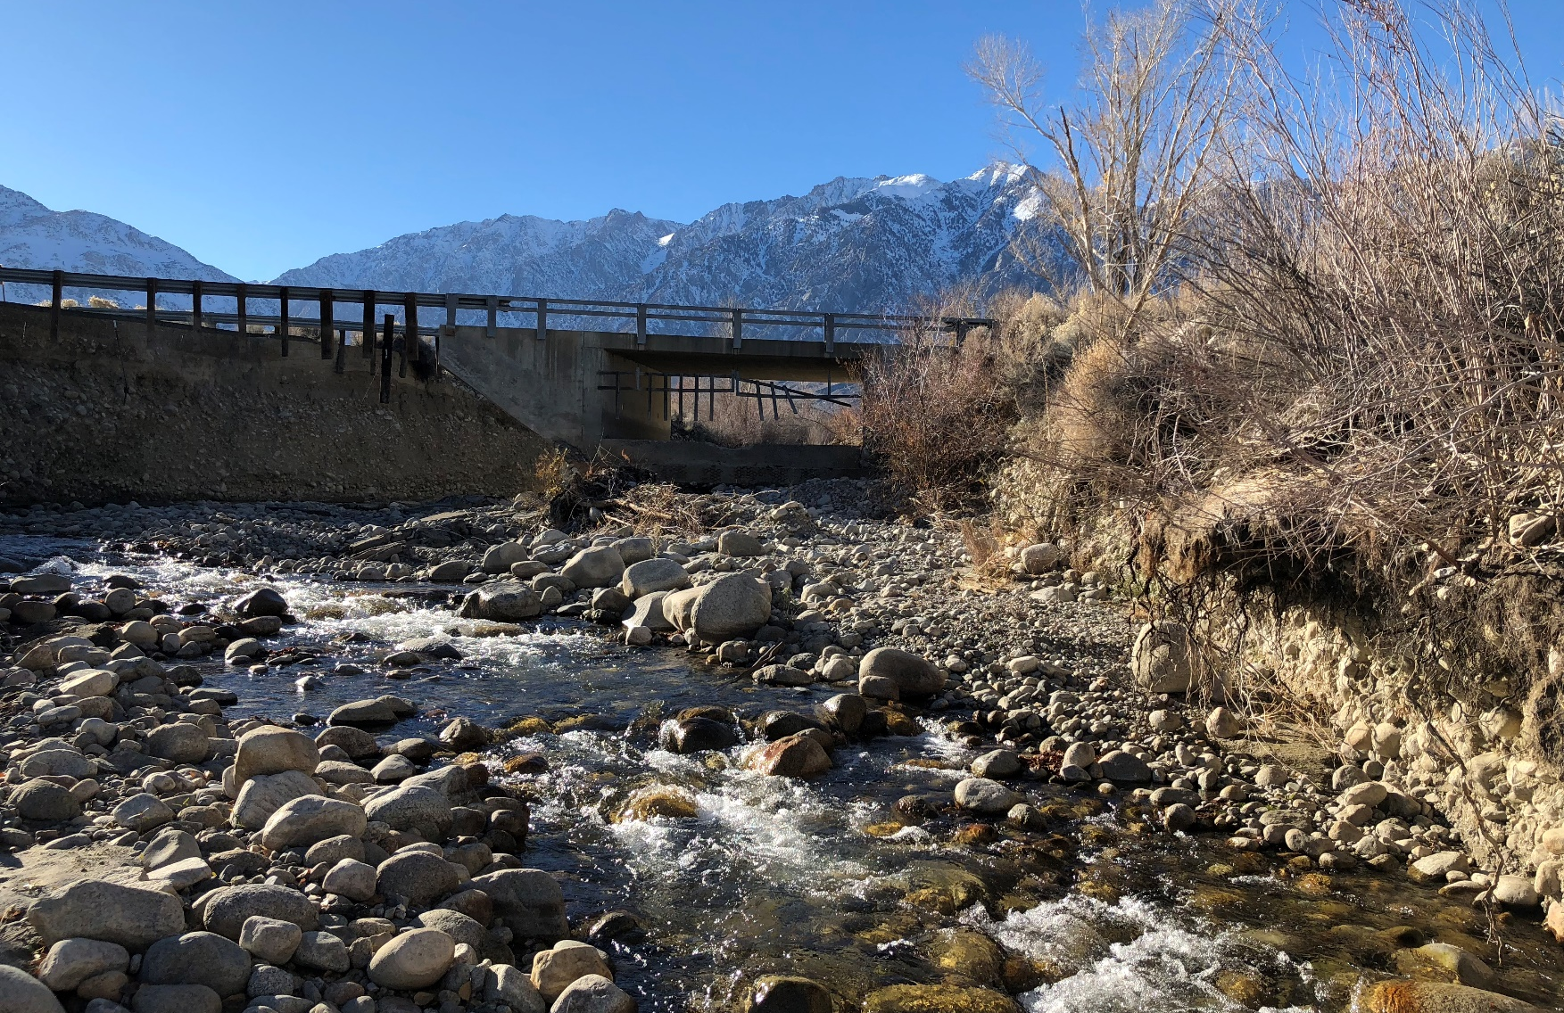
Prepared for:
Inyo County Public Works Department
November 2019
North Round Valley Road Bridge over Pine Creek Bridge Replacement Project
(Bridge No. 48C0044)
Initial Study/Proposed Mitigated Negative Declaration
Prepared for:
CEQA Lead Agency:
Inyo County Public Works Department
168 N. Edwards
P.O. Drawer Q
Independence, CA 93526
Contact:
Ashley Helms
Associate Engineer
(760) 878.0200
Prepared by:
GEI Consultants, Inc.
2868 Prospect Park Drive, Suite 400
Sacramento, CA 95670
Contact:
Ray Weiss
Project Manager
(916) 361-4500
November 2019

Table of Contents
Abbreviations and Acronyms iii
Chapter 1. Mitigated Negative Declaration 1-1
1.1 Introduction 1-1
1.2 Purpose of the Initial Study 1-1
1.3 Project Information 1-2
1.4 Environmental Determination 1-3
Chapter 2. Project Description 2-5
2.1 Project Location and Site 2-5
2.2 Project Background 2-5
2.3 Existing Bridge and Roadway 2-8
2.4 Purpose and Need 2-8
2.5 Environmental Setting 2-8
2.6 Proposed Project 2-9
2.7 Regulatory Requirements, Permits, and Approvals 2-11
Chapter 3. Initial Study Checklist 3-1
3.1 Introduction 3-1
3.2 Evaluation of Environmental Impacts 3-1
3.3 Aesthetics 3-3
3.4 Agriculture and Forestry Resources 3-5
3.5 Air Quality 3-7
3.6 Biological Resources 3-9
3.7 Cultural Resources 3-18
3.8 Energy 3-20
3.9 Geology and Soils 3-21
3.10 Greenhouse Gas Emissions 3-24
3.11 Hazards and Hazardous Materials 3-26
3.12 Hydrology and Water Quality 3-29
3.13 Land Use and Planning 3-32
3.14 Mineral Resources 3-33
3.15 Noise 3-34
3.16 Population and Housing 3-36
3.17 Public Services 3-37
3.18 Recreation 3-38
3.19 Transportation 3-39
3.20 Tribal Cultural Resources 3-40
3.21 Utilities and Service Systems 3-46
3.22 Wildfire 3-48
3.23 Mandatory Findings of Significance 3-50

Tables
Table 2-1. Proposed Construction Work Order and Schedule 2-10
Table 3-1. Summary Inyo County AB 52 Consultation 3-41

Figures
Figure 2-1. Regional Location Map 2-6
Figure 2-2. Project Location Map 2-7
Figure 2-3. Cross Section and Design Details for the Proposed Project 2-13
Figure 2-4. Proposed Project Site Plan (and Area of Potential Effect) 2-14

Appendices
Appendix A. Biological Survey Letter

Abbreviations and Acronyms
AASHTO | American Association of State Highway and Transportation Officials
ADT | Average Daily Traffic
APE | Area of Potential Effect
BMPs | Best Management Practices
CalOES | California Governor’s Office of Emergency Services
CARB | California Air Resources Board
CCR | California Code of Regulations
CDFW | California Department of Fish and Wildlife
CEQA | California Environmental Quality Act
CH4 | Methane
CNDDB | California Natural Diversity Database
CNPS | California Native Plant Society
County | County of Inyo
CO2 | carbon dioxide
CRHR | California Register of Historical Resources
CRS | California Road System
EIC | Eastern Information Center
EIR | Environmental Impact Report
GHGs | Greenhouse gases
IS/MND | Initial Study/proposed Mitigated Negative Declaration
IPAC | Information, Planning, and Conservation System
MLD | Most Likely Descendant
MPH | Miles per Hour
N2O | nitrous dioxide
NAHC | Native American Heritage Commission
NO_{X} | nitrogen oxides
NPDES | National Pollution Discharge Elimination System
NRHP | National Register of Historic Places
OHWM | Ordinary High Water Mark
PM₁₀ | PM equal to or less than 10 micrometers in diameter
PRC | Public Resources Code
ROG | reactive organic gases
RSP | Rock Slope Protection
RWQCB | Regional Water Quality Control Board
SCAQMD | South Coast Air Quality Management District
SPCP | Spill Prevention and Control Plan
SWPPP | Stormwater Pollution Prevention Plan
USACE | U.S. Army Corps of Engineers
USFWS | U.S. Fish and Wildlife Service
USGS | U.S. Geologic Survey
WPCP | Water Pollution Control Plan

Mitigated Negative Declaration

Introduction
The Inyo County Public Works Department (County) has prepared this Initial Study/proposed Mitigated Negative Declaration (IS/MND) in compliance with the California Environmental Quality Act (CEQA) and the State CEQA Guidelines to address the potentially significant environmental impacts of the proposed North Round Valley Road Bridge over Pine Creek Bridge Replacement Project (proposed project) located within the Rovana, California, U.S. Geological Survey (USGS) 7.5 Minute topographic quadrangle map. The County is the lead agency under CEQA.
To satisfy specific CEQA requirements for the proposed project, this document includes:
a proposed MND and the environmental determination (see Chapter 1),
location and description of the proposed project (see Chapter 2),
initial study checklist (see chapter 3).

Purpose of the Initial Study
This document is an IS/MND prepared in accordance with CEQA (California Public Resources Code, Section 21000 et seq.) and the State CEQA Guidelines (Title 14, Section 15000 et seq. of the California Code of Regulations [CCR]). The purpose of this IS is to (1) determine whether proposed project implementation would result in potentially significant or significant impacts on the physical environment; and (2) incorporate mitigation measures into the proposed project design, as necessary, to eliminate the proposed project’s potentially significant or significant project impacts or reduce them to a less-than-significant level. An MND is prepared if the IS identified potentially significant impacts, but: (1) revisions in the proposed project plans or proposals mitigate the impacts to a point where clearly no significant impacts would occur; and (2) there is no substantial evidence, considering the whole record before the agency, that the proposed project as revised may have a potentially significant or significant impact on the physical environment.
An IS presents environmental analysis and substantial evidence in support of its conclusions regarding the significance of environmental impacts. Substantial evidence may include expert opinion based on facts, technical studies, or reasonable assumptions based on facts. An IS is neither intended nor required to include the level of detail provided in an environmental impact report (EIR).
CEQA requires that all State and local government agencies consider the potentially significant and significant environmental impacts of projects they propose to carry out or over which they have discretionary authority, before implementing or approving those projects. The public agency that has the principal responsibility for carrying out or approving a proposed project is the lead agency for CEQA compliance (State CEQA Guidelines, CCR Section 15367). The County has principal responsibility for carrying out the proposed project and is therefore the CEQA lead agency for this IS/MND.
If there is substantial evidence (such as the findings of an IS) that a proposed project, either individually or cumulatively, may have a significant or potentially significant impact on the physical environment, the lead agency must prepare an EIR (State CEQA Guidelines, CCR Section 15064[a]). If the IS concludes that impacts would be less than significant, or that mitigation measures committed to by the County would clearly reduce impacts to a less-than-significant level, a Negative Declaration or MND can be prepared.
After the required public review of this document is complete, the County will consider all comments received on the IS/MND, the entirety of the administrative record for the project, and whether to adopt the proposed MND and a Mitigation Monitoring and Reporting Program and approve the proposed project.

Project Information
1. Project title: | North Round Valley Road Bridge over Pine Creek Bridge Replacement Project (Bridge No. 48C0044)
2. Lead agency name and address: | Inyo County Public Works Department  168 N. Edwards  P.O. Drawer Q  Independence, CA 93526
3. Contact person and phone number: | Ashley Helms, Associate Engineer, (760) 878.0200
4. Project location: | The proposed project site is in northwestern Inyo County, in Section 17 of the USGS 7.5-minute Rovana Quadrangle, Township 6 South, Range 31 East. The project site is accessible from North Round Valley Road, via Pine Creek Road or Birchim Lane.
5. Project sponsor's name and address: | Inyo County Public Works Department
6. General plan designation: | Natural Resource
7. Zoning: | Unclassified
8. Description of project:  (Describe the whole action involved, including but not limited to later phases of the project, and any secondary, support, or off-site features necessary for its implementation. Attach additional sheets if necessary.) | Inyo County Department of Public Works (County) proposes to replace the existing North Round Valley Road Bridge over Pine Creek (Bridge No. 48C0044), which was damaged from high-velocity flows in Pine Creek.  The County proposes to replace the structure with a single-span, precast/prestressed wide flange girder superstructure supported on high cantilever abutments founded on cast-in-drilled-hole concrete piles, approximately 85 feet in length. The existing horizontal and vertical alignments of North Round Valley Road will be maintained. No falsework (temporary form-work used to support the concrete until it develops strength) within locations of the creek channel will be required
9. Surrounding land uses and setting: Briefly describe the project's surroundings: | The project setting is rural in nature and the project site is composed of sagebrush scrubland, developed areas (roadway), and a perennial stream (Pine Creek). No residential land uses are located within the immediate vicinity of the project site.
10. Other public agencies whose approval is required (e.g., permits, financing approval, or participation agreement.) | California Department of Fish and Wildlife, Central Valley Regional Water Quality Control Board, State Water Resources Control Board, and U.S. Army Corps of Engineers.
11. Have California Native American tribes traditionally and culturally affiliated with the project area requested consultation pursuant to Public Resources Code (PRC) Section 21080.3.1? If so, is there a plan for consultation that includes, for example, the determination of significance of impacts to tribal cultural resources, procedures regarding confidentiality, etc.?  Note: Conducting consultation early in the CEQA process allows tribal governments, lead agencies, and project proponents to discuss the level of environmental review, identify and address potential adverse impacts to tribal cultural resources, and reduce the potential for delay and conflict in the environmental review process. (See PRC Section 21080.3.2.) Information may also be available from the California Native American Heritage Commission’s Sacred Lands File per PRC Section 5097.96 and the California Historical Resources Information System administered by the California Office of Historic Preservation. Please also note that PRC Section 21082.3(c) contains provisions specific to confidentiality. | The County has sent letters requesting AB 52 consultation to fourteen (14) representatives of several federally recognized tribes and California tribes. No responses have been received to date.

Environmental Determination

Summary
The County has prepared an IS to assess the potential effects of the proposed project on the environment in the project area. The analysis of potential environmental impacts from the proposed project is based on data gathered for this project and other projects within the project vicinity. Chapter 3 of this document contains the analysis and discussion of potential environmental impacts of the proposed project. Based on the issues evaluated in that chapter, it was determined that:
The proposed project would result in no impacts on the following issue areas:
- Agriculture and Forestry Resources
- Energy
- Land Use and Planning
- Mineral Resources
- Noise
- Population and Housing
- Recreation
- Public Services/Utilities and Service Systems
Transportation
The proposed project would result in less-than-significant impacts on the following issue areas:
Aesthetics
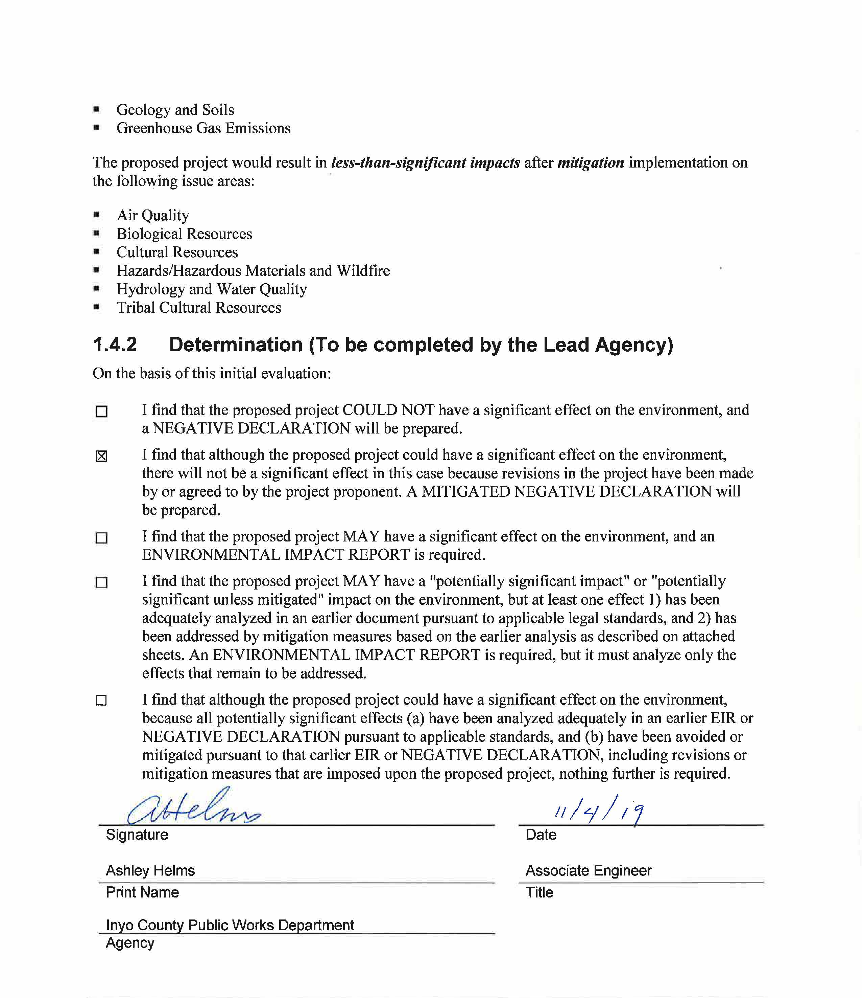
Geology and Soils
Greenhouse Gas Emissions
The proposed project would result in less-than-significant impacts after mitigation implementation on the following issue areas:
Air Quality
Biological Resources
Cultural Resources
Hazards/Hazardous Materials and Wildfire
Hydrology and Water Quality
Tribal Cultural Resources

Determination (To be completed by the Lead Agency)
On the basis of this initial evaluation:
☐ |  | I find that the proposed project COULD NOT have a significant effect on the environment, and a NEGATIVE DECLARATION will be prepared.
☒ |  | I find that although the proposed project could have a significant effect on the environment, there will not be a significant effect in this case because revisions in the project have been made by or agreed to by the project proponent. A MITIGATED NEGATIVE DECLARATION will be prepared.
☐ |  | I find that the proposed project MAY have a significant effect on the environment, and an ENVIRONMENTAL IMPACT REPORT is required.
☐ |  | I find that the proposed project MAY have a "potentially significant impact" or "potentially significant unless mitigated" impact on the environment, but at least one effect 1) has been adequately analyzed in an earlier document pursuant to applicable legal standards, and 2) has been addressed by mitigation measures based on the earlier analysis as described on attached sheets. An ENVIRONMENTAL IMPACT REPORT is required, but it must analyze only the effects that remain to be addressed.
☐ |  | I find that although the proposed project could have a significant effect on the environment, because all potentially significant effects (a) have been analyzed adequately in an earlier EIR or NEGATIVE DECLARATION pursuant to applicable standards, and (b) have been avoided or mitigated pursuant to that earlier EIR or NEGATIVE DECLARATION, including revisions or mitigation measures that are imposed upon the proposed project, nothing further is required.
 | Signature |  |  | Date
 | Ashley Helms |  |  | Associate Engineer
 | Print Name |  |  | Title
 | Inyo County Public Works Department
 | Agency

Project Description
This chapter provides additional details on the proposed project, including the project location, background, project objectives, proposed construction activities, and a summary of discretionary actions and approvals that may be required to implement the project.

Project Location and Site
The project site is located in Inyo County and accessible from North Round Valley Road, via Pine Creek Road or Birchim Lane. The site is west of U.S. Route 395, which provides regional access (see Figures 2-1 and 2-2). Bishop is the nearest incorporated city, located approximately 10 miles to the southeast. The project site encompasses 2.85 acres and is in Section 17 of the USGS 7.5-minute Rovana Quadrangle, Township 6 South, Range 31 East. Natural features include Pine Creek, which the proposed project crosses.

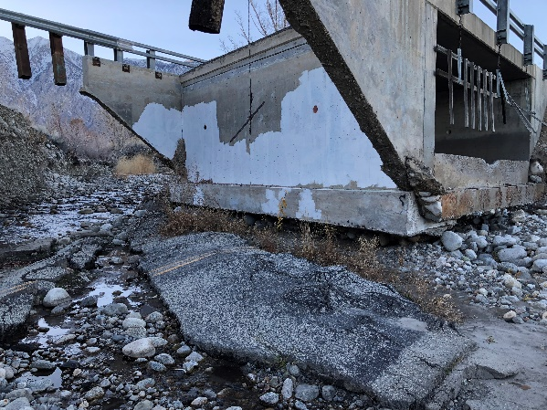
Project Background
The Pine Creek drainage basin delineated at Round Valley Road discharges approximately 37 square miles. The creek is primarily fed by snow melt and is also subject to high flows during high intensity precipitation events. On October 27, 2017, a state of emergency was declared in Inyo and Mono Counties, as a result of severe winter storms and exceptional snowfall, leading to snowmelt that damaged critical infrastructure. These runoff conditions and high-velocity flows in Pine Creek also resulted in failure of the North Round Valley Road Bridge.
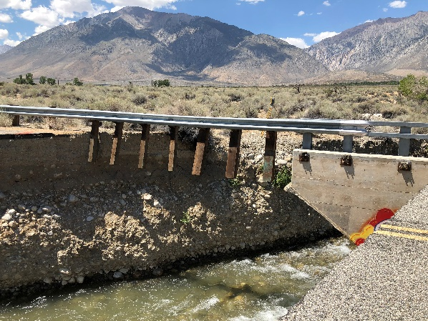
On October 27, 2017, the Governor of the State of California signed a Proclamation of a State of Emergency for both Inyo and Mono Counties, due to these severe winter storms and the resultant damage to critical roadway and bridge infrastructure. In anticipation of this emergency proclamation, the Inyo County Board of Supervisors adopted Resolution #2017-15 (dated March 28, 2017 and amended June 27, 2017) which also proclaimed the threatened existence of a local emergency resulting from the run-off potential of near-record snowpack in the Eastern Sierra. While the proposed project is consistent with the intent of this County resolution and meets the Statutory Exemption (Article 18) requirements consistent with CEQA Guidelines 15269 for Emergency Projects, the County has determined that preparation of this IS/MND is still necessary to disclose the environmental impacts of the proposed project, consistent with CEQA Guidelines. The proposed project will also comply with all other state, local or federal laws that may be applicable to the project (see “Required Regulatory Permits” below).
Figure 2-1. Regional Location Map
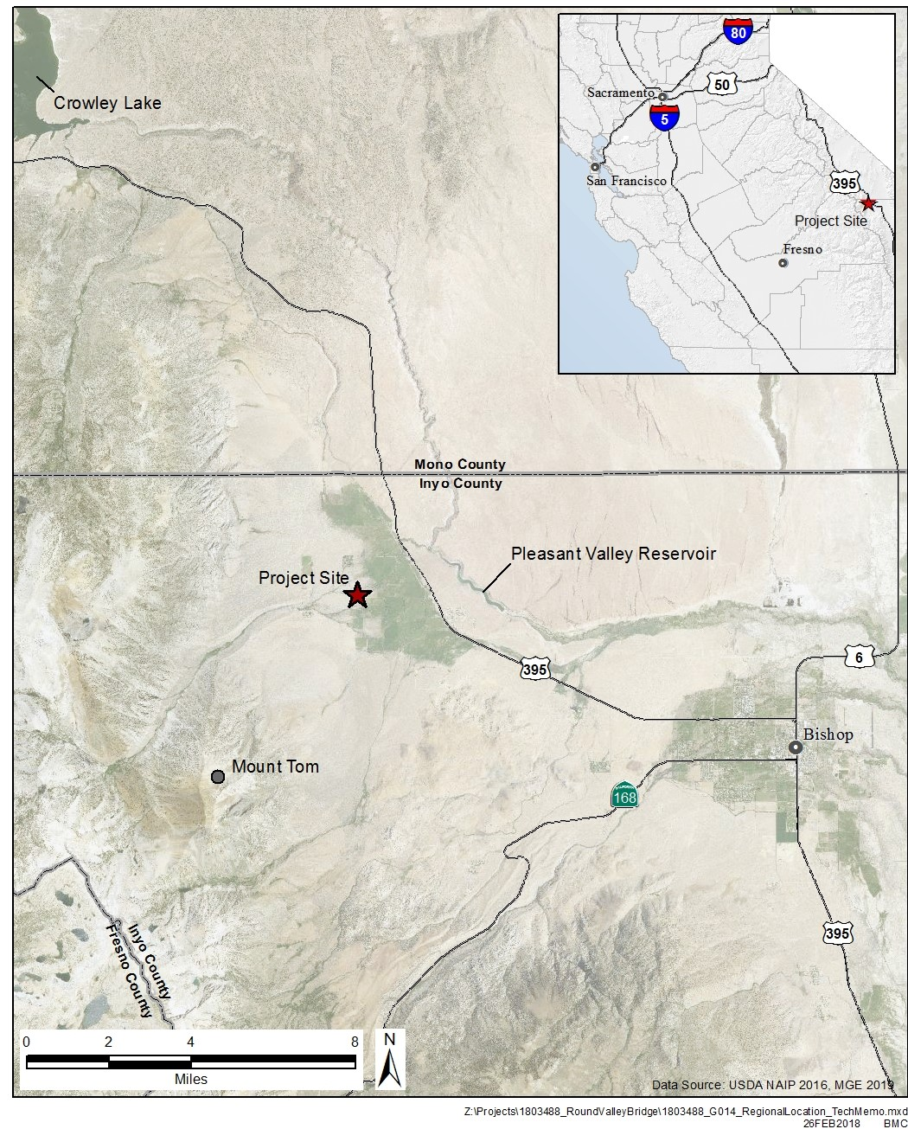
Figure 2-2. Project Location Map
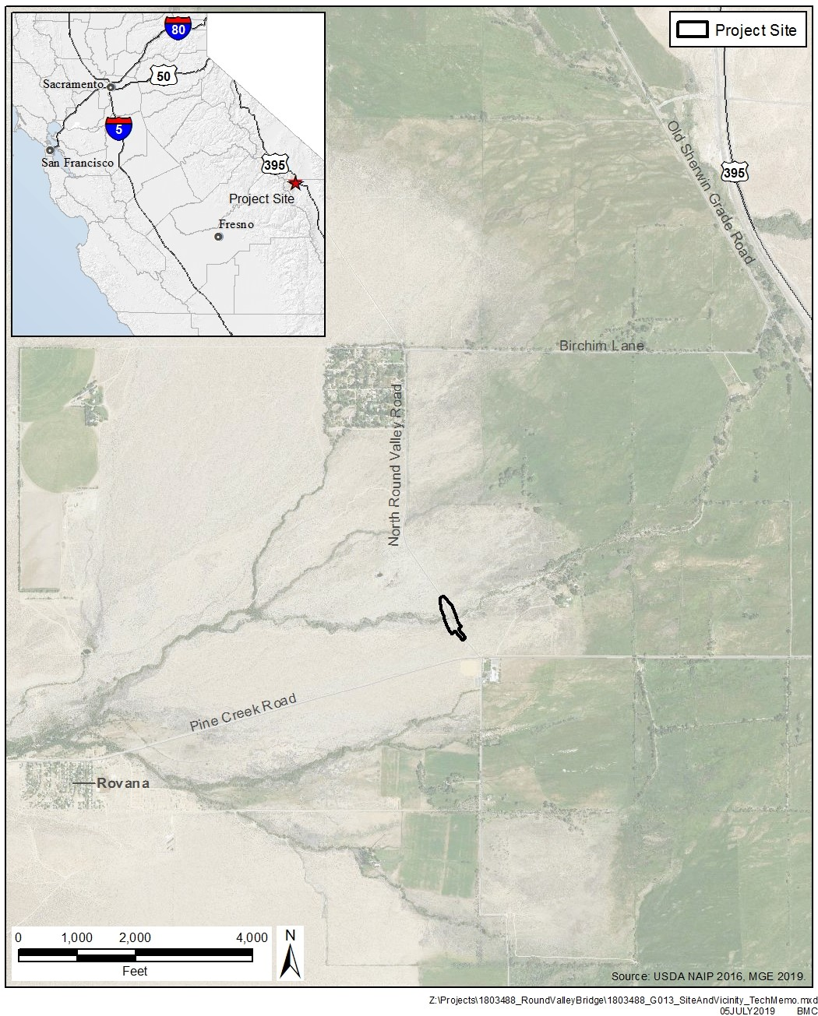

Existing Bridge and Roadway
The existing North Round Valley Road Bridge (Bridge Number 48C0044), built in 1987, is a single-span, cast-in-place, reinforced concrete slab superstructure supported on cantilever abutments and spread footings. The bridge provides a clear hydraulic opening of approximately 21’-5”. The structure has a total length of 25’-6 3/4” and a clear roadway width of 32-feet between metal tube bridge railings.
The bridge is currently closed due to high velocity flows that occurred in June and July of 2017 that eroded approximately 50-feet of the south approach roadway behind the abutment. In addition to the eroded south approach, both existing abutment foundations were undermined due to scour, as native soil at this location is highly erodible. Pine Creek now flows behind the south abutment where the approach roadway was washed out. To reduce the future risk of the embankments eroding from high velocity flows, the replacement bridge will need to be significantly longer than the existing bridge. In addition, rock slope protection (RSP) will be used to armor both abutment embankments. The replacement of the existing bridge is being funding through the State of California Governor’s Office of Emergency Services (CalOES).
North Round Valley Road is a paved road and according to the California Road System (CRS) Maps, it is designated as a Minor Collector Road. Prior to the roadway closure, average daily traffic (ADT) was likely less than 500 vehicles.

Purpose and Need
Specific objectives of the proposed project are to replace the existing flood-damaged North Round Valley Road Bridge with a new structure that:
- Accommodates safe vehicular travel and pedestrian access;
- Provides a slightly longer structure to accommodate the widened creek conditions and to protect the replacement structure against future instability; and
- Minimizes environmental impacts to local resources.

Environmental Setting
Topography on the project site slopes gently toward the east. Elevation at the project site is approximately 4,670 feet above mean sea level. Natural features include Pine Creek, which the proposed project crosses. Pine Creek headwaters are located high in the Sierra Nevada, east of Royce Peak and southwest of the project site. Pine Creek confluences with Pleasant Valley Reservoir, an impoundment of the Owens River, east of U.S. Route 395.

Surrounding Land Uses
Land uses surrounding the project site are comprised of open space uses (comprised primarily of sagebrush scrubland), developed areas (i.e., Round Valley Road and Bridge), and a perennial stream (Pine Creek). No residential land uses are located adjacent or near the project site.

Land Use Designations and Zoning
The project site is designated as Natural Resource and zoned as unclassified under the Inyo County General Plan. No lands in the study area are designated or zoned for Agriculture Preserve, Timber Lands, or are associated with an executed Williamson Act contract.

Proposed Project

Bridge Design
The replacement structure will be a single-span, precast/prestressed wide flange girder superstructure on high cantilever abutments founded on cast-in-drilled-hole concrete piles, approximately 85 feet in length (see Figure 2-3). The existing horizontal and vertical alignments of North Round Valley Road will be maintained. Bridge barriers proposed consist of California Department of Transportation standard California ST-75 open bridge railing. No falsework (temporary form-work used to support the concrete until it develops strength) will be required within locations of the creek channel.

Bridge Abutments
Construction of the new bridge abutments will require two relatively deep excavations. Excavations may need to be stabilized with temporary shoring and will likely need to be de-watered for footing concrete placement. Abutment footing areas are estimated to be approximately 40 feet long by 12 feet wide by 3 feet thick.

Vertical Profile
Water surface elevations are low enough that the existing profile grade of the bridge will not need to be raised. The California Department of Transportation’s Highway Design Manual requires the fifty-year (Q50) event to pass under the soffit with a minimum 2-feet of freeboard and pass the 100-year (Q100) event. The proposed bridge exceeds the freeboard requirements for both the 50-year and 100-year events.

Roadway Approaches, Railing, and Bridge Width
The existing approach roadway widths vary from approximately 22 to 24-feet. Approach roadways will be tapered down from the 32-foot clear bridge width to match existing roadway widths on each side of the bridge (see Figure 2-3). As the proposed project maintains the existing profile grades, the approach roadway work will be limited to reconstructing portions of both approach roadways (roughly 120 feet in each direction) from the bridge. All four corners of the bridge will require California Department of Transportation standard transition railings and terminal systems as the bridge clear width is less than 40-feet. Road improvements will be designed to at least meet the American Association of State Highway and Transportation Officials (AASHTO)’s Policy on Geometric Design of Highways and Streets (Greenbook) as well as AASHTO’s Guidelines for Geometric Design of Very Low-Volume Local Roads (ADT<400).

Utilities
Overhead telephone and power lines are located approximately 150 to 170-feet east of the existing roadway centerline, and thus will not interfere with the proposed construction, as they are located outside the project’s area of direct impact. No utilities are required to be carried on the proposed project.

Right of Way
Existing information indicates that north of the bridge the right-of-way is 60-feet wide versus a 40-foot wide right-of-way south of the bridge. Some permanent right-of-way acquisition will be required on the east and west side of the bridge due to the placement of rock slope protection materials. Temporary construction easements will be needed to allow contractor access into the channel.

Construction Approach, Staging Areas, and Traffic Diversion
Overall, project construction activities are anticipated to occur during the summer and fall months when water levels are at their lowest levels. Table 2-1 (see below) identifies the anticipated timing and duration of the primary construction activities anticipated with this project. Construction staging areas will be located on the bridge approaches (see Figure 2-4). Traffic will continue to be detoured around the bridge site on North Round Valley Road during construction. Existing detour signs will be maintained for the duration of construction.
It is anticipated that excavators, dozers, cranes, pavers, dump trucks, concrete trucks, and concrete pumps may be required to demolish and construct the proposed project.
Table 2-1. Proposed Construction Work Order and Schedule
Activity | Approximate Duration | Estimated Dates
Clearing and grubbing | 1 week | May
Install environmental fencing | 1 week | June
Water diversion (if necessary) | 1 week | June
Remove bridge | 1 week | June
Construct bridge |  | Mid to Late Summer
Footing construction at abutments | 2 weeks
Abutment construction | 4 weeks
Place precast/prestressed CA wide flange girder superstructure | 1 weeks
Finish bridge deck and complete barriers | 8 weeks
Install erosion control/scour countermeasures | 2 weeks | Early Fall
Reconstruct approaches | 3 weeks | Late Summer/Early Fall

In Channel Work and Temporary Creek Diversion
Implementation of the proposed project will not involve permanent modifications to the Pine Creek channel. However, bridge demolition and new bridge construction will require temporary access to the creek channel to remove the existing bridge pier/abutments, installation of new bridge abutments, and for the placement of new rock slope protection at the abutments. Creek access will be limited to 80 feet in each direction from the roadway centerline. Depending on creek flows, a temporary creek diversion system may be necessary during both demolition of the existing bridge and the construction of the new bridge. The water diversion system may include sump pumps to remove water from the abutment excavations and a temporary pipe or culvert (plastic or metal covered with gravel) network through the site (50 to 60 feet in length) to route flow through and around the immediate work area, maintain dewatered conditions, and return flow to the downstream channel network without causing harm to biological resources or affecting water quality. Sand bags and plastic sheeting would be used to direct creek water to the culvert network. Impacted waters located in the work area would either be treated per Stormwater Pollution Prevention Plan (SWPPP)/Water Pollution Control Plan (WPCP) requirements or disposed of per Regional Water Quality Control Board (RWQCB) requirements.

Scour Counter Measures
The geotechnical investigation prepared for the proposed project indicates that soils within the study area are highly susceptible to scour, with high channel velocities at the bridge crossing expected to result in bank and abutment scour in exceedance of 5 feet. Revetment (such as rock slope protection) will be installed around both sides of the bridge abutments (see Figure 2-3), extending approximately 30 feet upstream and 40 feet downstream of the edges of the bridge, to prevent loss of bank material.

Erosion Control
The contractor would be required to install temporary BMPs to control any runoff or erosion from the project site into the surrounding waterways. These temporary BMPs would be installed prior to any construction operations and would remain in place for the duration of the construction period. The removal of these BMPs would be the final operation, along with project site cleanup and restoration.

Regulatory Requirements, Permits, and Approvals
As the lead agency under CEQA, the County has the principal responsibility for approving and carrying out the proposed project and for ensuring that CEQA requirements and all other applicable regulations are met. Other agencies that may have permitting approval or review authority over portions of the proposed project are listed below:
- California Department of Fish and Wildlife—Section 1602 streambed alteration agreement; California Endangered Species Act compliance
- Central Valley Regional Water Quality Control Board—Clean Water Act Section 401 Certification; and Clean Water Act Section 402 National Pollutant Discharge Elimination System storm water permit for general construction
- U.S. Army Corps of Engineers—Department of the Army, Clean Water Act Section 404 Permit for discharge of fill to Waters of the U.S.

This page intentionally left blank.

Figure 2-3. Cross Section and Design Details for the Proposed Project
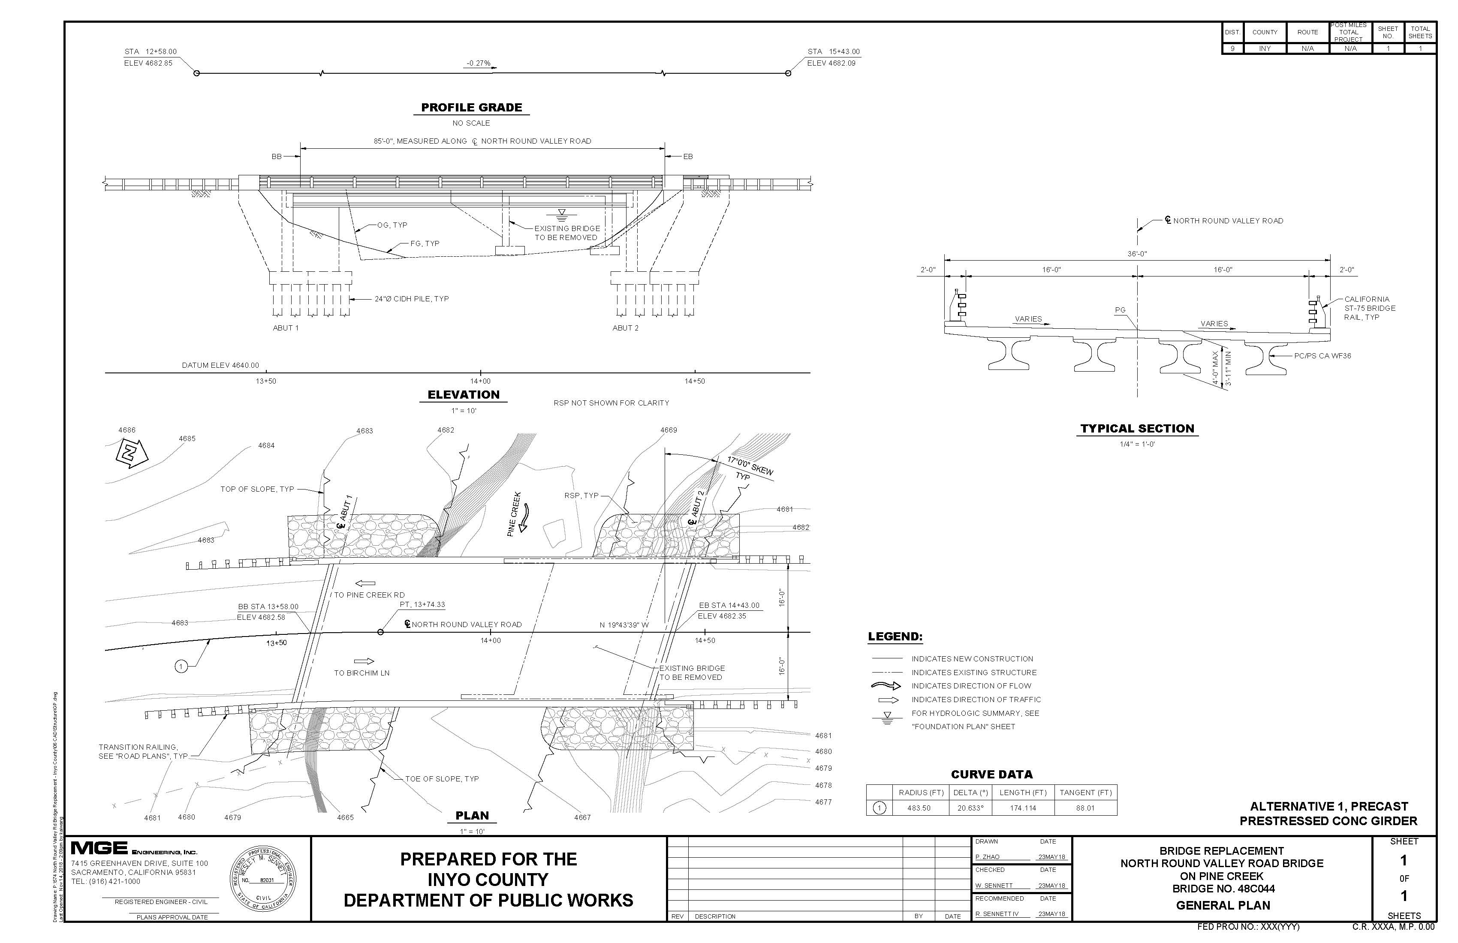
Source: Prepared by MGE Engineering, Inc., 2019
Figure 2-4. Proposed Project Site Plan (and Area of Potential Effect)
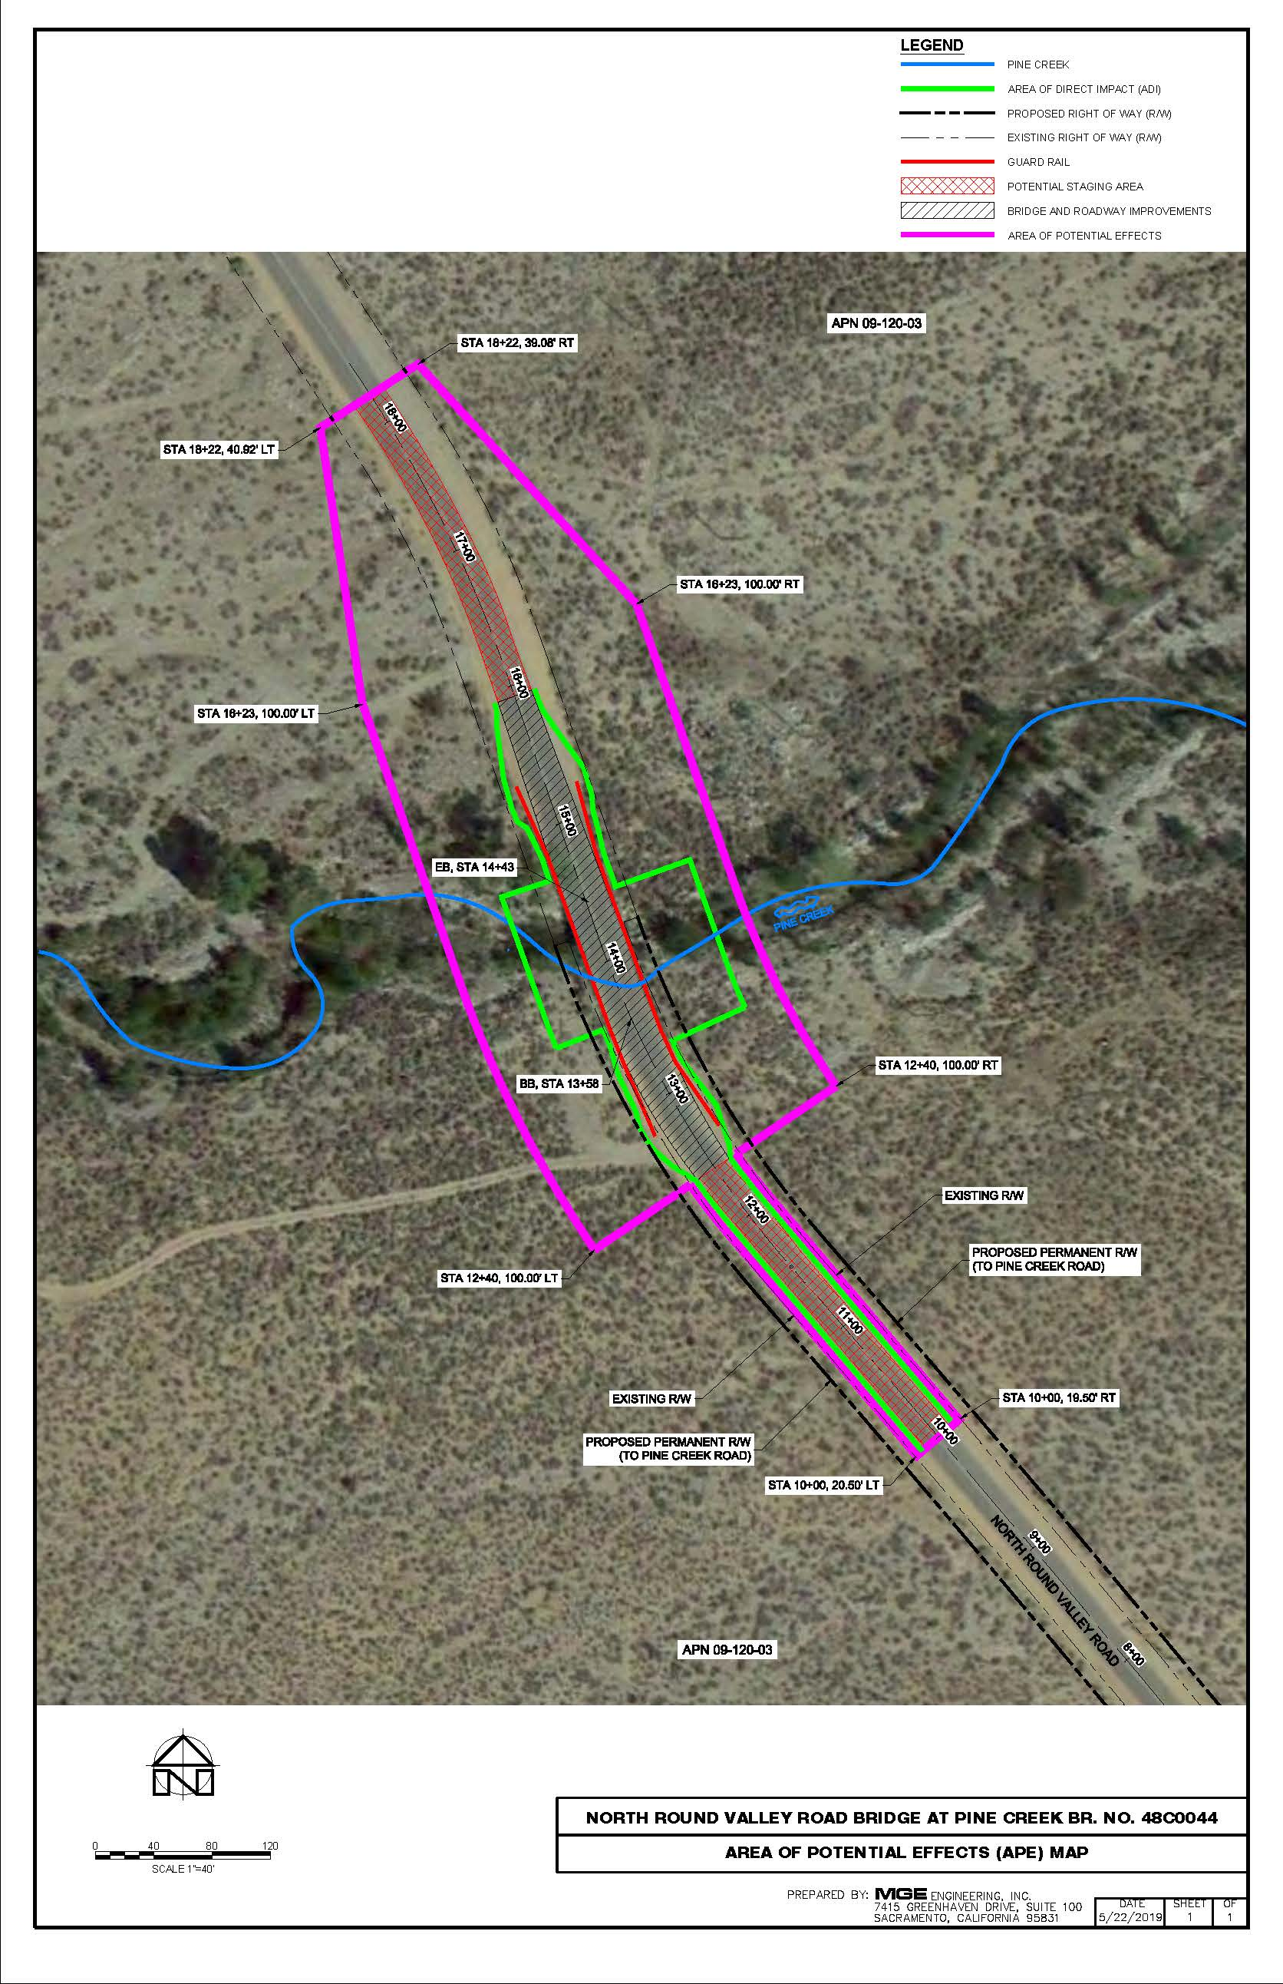
Source: Prepared by MGE Engineering, Inc., 2019

Initial Study Checklist

Introduction
In compliance with the CEQA Guidelines, the County has prepared the following initial study checklist to analyze the environmental impacts of the proposed project. This checklist uses Appendix G of the CEQA Guidelines to provide a basis for the analysis of the resource areas addressed. An evaluation of potential impacts and mitigation measures to reduce potentially significant impacts is presented in the analysis.
The environmental factors checked below would be potentially affected by this project, involving at least one impact that is a "Potentially Significant Impact" as indicated by the checklist on the following pages. However, all impacts would be mitigated to a less than significant level as indicated on the following pages.
☐ | Aesthetics | ☐ | Agriculture and Forestry Resources | ☒ | Air Quality
☒ | Biological Resources | ☒ | Cultural Resources | ☐ | Energy
☐ | Geology/Soils | ☐ | Greenhouse Gas Emissions | ☒ | Hazards and Hazardous Materials
☒ | Hydrology/Water Quality | ☐ | Land Use/Planning | ☐ | Mineral Resources
☐ | Noise | ☐ | Population/Housing | ☐ | Public Services
☐ | Recreation | ☐ | Transportation | ☒ | Tribal Cultural Resources
☐ | Utilities/Service Systems | ☒ | Wildfire | ☐ | Mandatory Findings of Significance

Evaluation of Environmental Impacts
1) A brief explanation is required for all answers except "No Impact" answers that are adequately supported by the information sources a lead agency cites in the parentheses following each question. A "No Impact" answer is adequately supported if the referenced information sources show that the impact simply does not apply to projects like the one involved (e.g., the project falls outside a fault rupture zone). A "No Impact" answer should be explained where it is based on project-specific factors as well as general standards (e.g., the project will not expose sensitive receptors to pollutants, based on a project-specific screening analysis).
2) All answers must take account of the whole action involved, including off-site as well as on-site, cumulative as well as project-level, indirect as well as direct, and construction as well as operational impacts. Operations and maintenance impacts of the proposed project are routine, minimal, and essentially the same as current operations and maintenance of the existing facilities. There is no potential for a significant impact to any resource category from project operations and maintenance of the existing and proposed facilities.
3) Once the lead agency has determined that a particular physical impact may occur, then the checklist answers must indicate whether the impact is potentially significant, less than significant with mitigation, or less than significant. "Potentially Significant Impact" is appropriate if there is substantial evidence that an effect may be significant. If there are one or more "Potentially Significant Impact" entries when the determination is made, an EIR is required. “Beneficial impact” is also identified where appropriate to provide full disclosure of any benefits from implementing the proposed project.
4) "Less-than-Significant Impact with Mitigation Incorporated" applies where the incorporation of mitigation measures has reduced an effect from "Potentially Significant Impact" to a "Less-than-Significant Impact." The lead agency must describe the mitigation measures, and briefly explain how they reduce the effect to a less-than-significant level (mitigation measures from "Earlier Analyses," as described in (5) below, may be cross-referenced).
5) Earlier analyses may be used where, pursuant to the tiering, program EIR, or other CEQA process, an effect has been adequately analyzed in an earlier EIR or negative declaration (Section 15063[c][3][D]). In this case, a brief discussion should identify the following:
a) Earlier Analysis Used. Identify and state where they are available for review.
b) Impacts Adequately Addressed. Identify which effects from the above checklist were within the scope of and adequately analyzed in an earlier document pursuant to applicable legal standards, and state whether such effects were addressed by mitigation measures based on the earlier analysis.
c) Mitigation Measures. For effects that are a "Less-than-Significant Impact with Mitigation Measures Incorporated," describe the mitigation measures which were incorporated or refined from the earlier document and the extent to which they address site-specific conditions for the project.
6) Lead agencies are encouraged to incorporate into the checklist references to information sources for potential impacts (e.g., general plans, zoning ordinances). Reference to a previously prepared or outside document should, where appropriate, include a reference to the page or pages where the statement is substantiated.
7) Supporting Information Sources: A source list should be attached, and other sources used or individuals contacted should be cited in the discussion.
8) This is only a suggested form, and lead agencies are free to use different formats; however, lead agencies should normally address the questions from this checklist that are relevant to a project's environmental effects in whatever format is selected.
9) The explanation of each issue should identify:
a) the significance criteria or threshold, if any, used to evaluate each question; and
b) the mitigation measure identified, if any, to reduce the impact to less than significance.
Significance thresholds are identified for certain resources, but others are not explicitly identified because there is clearly no impact or the checklist question itself serves as the significance threshold.

Aesthetics
Environmental Issue | Potentially  Significant  Impact | Less-than-Significant Impact with  Mitigation  Incorporated | Less-than-Significant  Impact | No  Impact | Beneficial Impact
- AESTHETICS.
Except as provided in PRC Section 21099, would the project:
- Have a substantial adverse effect on a scenic vista? | ☐ | ☐ | ☒ | ☐ | ☐
- Substantially damage scenic resources, including, but not limited to, trees, rock outcroppings, and historic buildings within a State scenic highway? | ☐ | ☐ | ☐ | ☒ | ☐
- In non-urbanized areas, substantially degrade the existing visual character or quality of public views of the site and its surroundings? (Public views are those that are experienced from a publicly accessible vantage point.) If the project is in an urbanized area, would the project conflict with applicable zoning and other regulations governing scenic quality? | ☐ | ☐ | ☒ | ☐ | ☐
- Create a new source of substantial light or glare which would adversely affect day or nighttime views in the area? | ☐ | ☐ | ☐ | ☒ | ☐

Discussion
- Have a substantial adverse effect on a scenic vista?
Implementation of the proposed project will require the removal of some vegetation along Pine Creek; however, replanting (using native vegetation) and erosion control measures (see Section 3.6 “Biological Resources”) would be completed as part of the project to restore the construction site to pre-project conditions. While the project will result in short-term, construction-related visual impacts (i.e., dust, equipment, construction vehicles), no vertical features (such as cellular towers, storage tanks, or utility lines) or new sources of lighting are included with the project that would result in permanent negative effects to existing open space views in the study area. Therefore, the project will not result in a negative adverse impact to a scenic vista or the visual character of the site. Consequently, this impact is less-than-significant, with no additional mitigation measures required.
b) Substantially damage scenic resources, including, but not limited to, trees, rock outcroppings, and historic buildings within a State scenic highway?
The project site is not located on or near a state designated scenic highway and will not result in damage to scenic resources within a state scenic highway. Consequently, no impact would occur.
c) In non-urbanized areas, substantially degrade the existing visual character or quality of public views of the site and its surroundings? (Public views are those that are experienced from publicly accessible vantage point.) If the project is in an urbanized area, would the project conflict with applicable zoning and other regulations governing scenic quality?
See checklist Item “a” above.
d) Create a new source of substantial light or glare which would adversely affect day or nighttime views in the area?
See checklist Item “a” above. Consequently, no impact would occur.

Agriculture and Forestry Resources
Environmental Issue | Potentially  Significant  Impact | Less-than-Significant Impact with  Mitigation  Incorporated | Less-than-Significant  Impact | No  Impact | Beneficial Impact
- AGRICULTURE AND FORESTRY RESOURCES.
In determining whether impacts to agricultural resources are significant environmental effects, lead agencies may refer to the California Agricultural Land Evaluation and Site Assessment Model (1997, as updated) prepared by the California Department of Conservation as an optional model to use in assessing impacts on agriculture and farmland. In determining whether impacts to forest resources, including timberland, are significant environmental effects, lead agencies may refer to information compiled by the California Department of Forestry and Fire Protection regarding the State’s inventory of forest land, including the Forest and Range Assessment Project and the Forest Legacy Assessment project; and forest carbon measurement methodology provided in Forest Protocols adopted by the California Air Resources Board. Would the project:
- Convert Prime Farmland, Unique Farmland, or Farmland of Statewide Importance (Farmland), as shown on the maps prepared pursuant to the Farmland Mapping and Monitoring Program of the California Resources Agency, to non-agricultural use? | ☐ | ☐ | ☐ | ☒ | ☐
- Conflict with existing zoning for agricultural use, or a Williamson Act contract? | ☐ | ☐ | ☐ | ☒ | ☐
- Conflict with existing zoning for, or cause rezoning of, forest land (as defined in PRC Section 12220(g)), timberland (as defined by PRC Section 4526), or timberland zoned Timberland Production (as defined by Government Code Section 51104(g))? | ☐ | ☐ | ☐ | ☒ | ☐
- Result in the loss of forest land or conversion of forest land to non-forest use? | ☐ | ☐ | ☐ | ☒ | ☐
- Involve other changes in the existing environment which, due to their location or nature, could result in conversion of Farmland, to non-agricultural use or conversion of forest land to non-forest use? | ☐ | ☐ | ☐ | ☒ | ☐

Discussion
a) Convert Prime Farmland, Unique Farmland, or Farmland of Statewide Importance (Farmland), as shown on the maps prepared pursuant to the Farmland Mapping and Monitoring Program of the California Resources Agency, to non-agricultural use?
The project site does not contain any Important Farmlands as identified by the California Department of Conservation’s Farmland Mapping and Monitoring Program, parcels with an active Williamson Act contract, or lands designated as Forest or Timberlands. Additionally, the project would replace an existing bridge, with construction activities concentrated within and directly adjacent to the existing roadway, thus remaining consistent with existing development and current zoning and land use designations. Therefore, the project will not result in the conversion of Important Farmland, Timberland/Forest resources or is expected to encourage the non-renewal or cancellation of Williamson Act contracted lands. Consequently, no impact would occur.
b) Conflict with existing zoning for agricultural use, or a Williamson Act contract?
See checklist Item “a” above.
c) Conflict with existing zoning for, or cause rezoning of, forest land (as defined in Public Resources Code Section 12220(g)), timberland (as defined by PRC Section 4526), or timberland zoned Timberland Production (as defined by Government Code Section 51104(g))?
See checklist Item “a” above.
d) Result in the loss of forest land or conversion of forest land to non-forest use?
See checklist Item “a” above.
e) Involve other changes in the existing environment which, due to their location or nature, could result in conversion of Farmland, to non-agricultural use or conversion of forest land to non-forest use?
See checklist Item “a” above.

Air Quality
Environmental Issue | Potentially  Significant  Impact | Less-than-Significant Impact with  Mitigation  Incorporated | Less-than-Significant  Impact | No  Impact | Beneficial Impact
- AIR QUALITY.
Where available, the significance criteria established by the applicable air quality management district or air pollution control district may be relied on to make the following determinations. Would the project:
- Conflict with or obstruct implementation of the applicable air quality plan? | ☐ | ☐ | ☒ | ☐ | ☐
- Result in a cumulatively considerable net increase of any criteria pollutant for which the project region is non-attainment under an applicable Federal or State ambient air quality standard? | ☐ | ☒ | ☐ | ☐ | ☐
- Expose sensitive receptors to substantial pollutant concentrations? | ☐ | ☐ | ☐ | ☒ | ☐
- Result in other emissions (such as those leading to odors) adversely affecting a substantial number of people? | ☐ | ☐ | ☐ | ☒ | ☐

Discussion
a) Conflict with or obstruct implementation of the applicable air quality plan?
This impact is determined based on whether the proposed project would conflict with or obstruct implementation of the applicable air quality plan and/or applicable portions of the State Implementation Plan, which would lead to increases in the frequency or severity of existing air quality violations. As a bridge replacement project (with the primary objective of maintaining public safety, the proposed project would not increase roadway capacity or service capabilities that would induce unplanned growth, remove an existing obstacle to growth, or lead to permanent increases in vehicle miles travelled by existing motorists. Therefore, the proposed project would not conflict with or obstruct implementation of the applicable air quality plan. Consequently, this impact is less-than-significant, with no mitigation measures required.
b) Result in a cumulatively considerable net increase of any criteria pollutant for which the project region is non-attainment under an applicable Federal or State ambient air quality standard?
The project site is in a region designated as nonattainment for ozone and particulate matter equal to or less than 10 micrometers in diameter (PM10) under state standards and nonattainment for PM10 under federal standards. While air quality estimates or modelling were not generated for this project, it is assumed that combustion-related emissions, some of which are precursors to ozone, would be well below South Coast Air Quality Management District (SCAQMD) significance thresholds and would have minimal impact on ambient air quality at the project site or in the region, based on a review of similar bridge replacement projects in the County. However, the proposed project may generate construction-related diesel exhaust and dust that could impact air quality in the region. Fugitive dust would also be generated from use of vehicles and equipment as well as during earth-moving activities. Impacts to air quality from emissions generated during construction would be relatively short and limited to the 5/6-month construction period; however, the proposed project’s contribution of fugitive dust and ozone precursors to the region, which is in nonattainment may be potentially significant. Implementation of Mitigation Measure AIR-1 requires implementation of dust and engine emissions control measures, which would reduce the impact to less than significant. Therefore, the proposed project would have a less-than-significant impact with mitigation incorporated.
Mitigation Measure AIR-1: Dust and Engine Emissions Control Measures
Inyo County shall ensure that the construction contractor will comply with District Rule 401 regulations. In addition to reasonable precautions outlined in Rule 401, the following measures shall be incorporated during the demolition and installation of the bridge and realigned roadway approaches:
- Water or dust palliatives shall be applied on dirt roads, material stockpiles, and other surfaces that could give rise to airborne dust and are subject to disturbance.
- Water or dust palliatives shall be applied to prevent particulate matter from becoming airborne during the transportation or stockpiling of dusty materials.
- Trucks hauling material shall be covered during transit.
- Roadways shall be maintained in a clean condition.
- Vehicles shall be limited to 15 miles per hour (mph) on unpaved roads, to the extent feasible.
- Idling times shall be minimized either by shutting equipment off when not in use or reducing the maximum idling time to 5 minutes (as required by the California airborne toxics control measure Title 13, Section 2485 of California Code of Regulations [CCR]).
- All construction equipment shall be maintained and properly tuned in accordance with manufacturer ‘s specifications. All equipment shall be checked by a certified visible emissions evaluator.
Responsibility: County of Inyo / Construction Contractor
Timing: Before and During Construction Activities
c) Expose sensitive receptors to substantial pollutant concentrations?
No sensitive receptors are located near the project site or would be exposed to substantial pollutant concentrations. Consequently, no impact would occur.
d) Result in other emissions (such as those leading to odors) adversely affecting a substantial number of people?
No objectionable odors would be generated from project construction activities or from use of the proposed bridge. Consequently, no impact would occur.

Biological Resources
Environmental Issue | Potentially  Significant  Impact | Less-than-Significant Impact with  Mitigation  Incorporated | Less-than-Significant  Impact | No  Impact | Beneficial Impact
- BIOLOGICAL RESOURCES.
Would the project:
- Have a substantial adverse effect, either directly or through habitat modifications, on any species identified as a candidate, sensitive, or special status species in local or regional plans, policies, or regulations, or by the California Department of Fish and Wildlife or U.S. Fish and Wildlife Service? | ☐ | ☒ | ☐ | ☐ | ☐
- Have a substantial adverse effect on any riparian habitat or other sensitive natural community identified in local or regional plans, policies, or regulations or by the California Department of Fish and Wildlife or U.S. Fish and Wildlife Service? | ☐ | ☒ | ☐ | ☐ | ☐
- Have a substantial adverse effect on State or Federally protected wetlands (including, but not limited to, marsh, vernal pool, coastal, etc.) through direct removal, filling, hydrological interruption, or other means? | ☐ | ☒ | ☐ | ☐ | ☐
- Interfere substantially with the movement of any native resident or migratory fish or wildlife species or with established native resident or migratory wildlife corridors, or impede the use of native wildlife nursery sites? | ☐ | ☒ | ☐ | ☐ | ☐
- Conflict with any local policies or ordinances protecting biological resources, such as a tree preservation policy or ordinance? | ☐ | ☐ | ☐ | ☒ | ☐
- Conflict with the provisions of an adopted Habitat Conservation Plan, Natural Community Conservation Plan, or other approved local, regional, or State habitat conservation plan? | ☐ | ☐ | ☐ | ☒ | ☐

Discussion
a) Have a substantial adverse effect, either directly or through habitat modifications, on any species identified as a candidate, sensitive, or special-status species in local or regional plans, policies, or regulations, or by the California Department of Fish and Wildlife or the U.S. Fish and Wildlife Service?
A Biological Resources Technical Report (GEI, 2019a) and a Preliminary Delineation of Waters of the United States, Including Wetlands Report (GEI, 2019b) were prepared for the County to evaluate site conditions and potential impacts to sensitive habitats, biological, and botanical species from project activities. Other primary references consulted include species lists and information gathered using United States Fish and Wildlife Service’s (USFWS), Information, Planning, and Conservation System (IPAC), California Department of Fish and Wildlife’s (CDFW) Natural Diversity Database (CNDDB), the California Native Plant Society’s (CNPS) list of rare and endangered plants, and literature review. The conclusions of the reports are the result of field survey findings and research to determine the potential of special-status species to occur within the study area, and/or if these species could be impacted by project activities. The following information is summarized from the Biological Resources Technical Report and the report is included as Appendix A.
Implementing the proposed project would not result in tree removal or permanent conversion of sagebrush habitat. Developed road shoulders and adjacent sagebrush scrubland are areas where equipment and materials may be temporarily staged. Impacts of the proposed project on biological resources could result from vegetation removal and grading during construction. In-water work could result in temporary disturbance to aquatic biological resources. In general, terrestrial impacts are anticipated to be relatively minor, because project implementation would be restricted to the developed surfaces along North Round Valley Road and sagebrush scrub habitat located adjacent to the road.
In-water construction would be restricted to periods of low-flow, most likely beginning in June. In-water construction activities include removing the existing failed bridge and constructing new abutments in the Pine Creek channel. Because Pine Creek is a perennial channel, dewatering is required to complete project construction.
Special-status Species – Birds
Four special-status bird species––golden eagle, bald eagle, Swainson’s hawk, and bank swallow––have low or moderate potential to occur on or adjacent to the project site (see Table 2, Biological Resources Technical Report, Appendix A). All of these species are known or likely to occur in the general region, but potential for most of them to occur onsite is likely limited to foraging and/or roosting. The project site and immediately adjacent areas provide limited potential nesting habitat for large raptors; only two large-diameter Cottonwood trees are present along the north bank of Pine Creek, and few large trees are present along other nearby portions of the creek. Stick nests were not observed in trees on or near the project site during the December field survey, when trees were devoid of leaves and nests would have been readily observable. In the unlikely event an active Swainson’s hawk nest is present on or adjacent to the project site during demolition and construction activities, nesting birds could be disturbed to an extent that results in nest failure. The CNDDB contains few records for the species nesting in Inyo County, indicating that the population is small, and the loss of a single nest would result in a substantial adverse effect on the species. Implementation of Mitigation Measure BIO-1 requires implementation of preconstruction and species avoidance measures, which would reduce the impact to less than significant. Therefore, the proposed project would have a less-than-significant impact with mitigation incorporated.
Mitigation Measure BIO-1: Avoid and Minimize Effects to Nesting Swainson’s Hawk.
Inyo County shall ensure the construction contractor implement the following measures to avoid and minimize potential adverse effects on nesting Swainson’s hawk during project construction.
- Preconstruction surveys for active Swainson’s hawk nests shall be conducted by a qualified biologist in all areas of suitable nesting habitat within 0.25-mile of project disturbance. A minimum of one survey shall be conducted no more than 14 days before project activities commence.
- Appropriate buffers shall be established and maintained around active nest sites to avoid nest failure from project activities. The appropriate size and shape of the buffers shall be determined by a qualified biologist and may vary depending on the nest location, nest stage, and construction activity. The buffers may be adjusted if a qualified biologist determines it would not be likely to adversely affect the nest. Monitoring shall be conducted to confirm that project activities are not resulting in detectable adverse effects on nesting birds or their young. No project activities shall commence within the buffer areas until a qualified biologist determines that the young have fledged, or the nest site is otherwise no longer in use.
Responsibility: County of Inyo / Construction Contractor
Timing: Before and During Construction Activities
The project site and vicinity lack suitable nesting habitat for bank swallow. Implementation of the proposed project would result in the loss of a very small amount of temporal foraging habitat loss for one season but would not substantially reduce the overall populations or distribution of any special-status bird species. However, it is recommended that Mitigation Measure BIO-2 be implemented to avoid and minimize destruction of active bird nests and potential violation of FGC Section 3503 during project construction. Implementation of the construction worker awareness training practices, revegetation measures, and invasive plant avoidance measures identified in Mitigation Measures BIO-3, BIO-4, and BIO-5 are also recommended to minimize related species and habitat impacts.
Mitigation Measure BIO-2: Pre-Construction Bird Surveys
Inyo County shall ensure the construction contractor implement the following measures to avoid and minimize destruction of active bird nests and potential violation of FGC Section 3503 during project construction:
- If vegetation removal must occur during the migratory bird nesting season (March 15 through July 31), surveys for active bird nests shall be conducted by a qualified biologist in areas of suitable nesting vegetation designated for removal. If active nests are found, removal of vegetation in which the nests are located will be delayed until a qualified biologist determines that the young have fledged, or the nest site is otherwise no longer in use.
- Preconstruction surveys for active nests of common raptor species shall be conducted by a qualified biologist. Surveys for raptor nests shall include suitable habitat within up to 300 feet of areas subject to project disturbance, depending on the potential extent of indirect impact. Surveys shall be conducted within 14 days before commencement of any construction activities that occur during the raptor nesting season (March 15 to July 31) in a given area.
- If any active nests, or behaviors indicating active nests are present, are observed, appropriate buffers around the nest sites shall be determined by a qualified biologist to avoid nest failure resulting from project activities. Buffer size shall depend on the species, nest location, nest stage, and specific construction activities to be performed while the nest is active. The buffers may be adjusted if a qualified biologist determines it would not be likely to adversely affect the nest. If buffers are adjusted, monitoring shall be conducted to confirm that project activity is not resulting in detectable adverse effects on nesting birds or their young. No project activity shall commence within the buffer areas until a qualified biologist determines that the young have fledged, or the nest site is otherwise no longer in use.
Responsibility: County of Inyo / Construction Contractor
Timing: Before and During Construction Activities
Mitigation Measure BIO-3: Conduct Environmental Awareness Training Regarding Special-status Species and Sensitive Habitats prior to Construction
Inyo County shall ensure the construction contractor will implement the following actions before and during construction activities:
Before any work occurs in the proposed project footprint, including grading and equipment staging, all construction personnel shall participate in an environmental awareness training regarding special-status species and sensitive habitats present in the project limits. The training shall describe sensitive resources (i.e., waters of the U.S. and state, riparian habitat, special-status species and habitat, nesting birds/raptors) to be avoided during project construction and applicable permit conditions identified by state and federal agencies to protect these resources. If new construction personnel are added to the project, they must receive the mandatory training before starting work. After being trained, each construction person shall sign-in to document they received the training.
Responsibility: County of Inyo / Construction Contractor
Timing: Before and During Construction Activities
Mitigation Measure BIO-4: Return Temporarily Disturbed Areas to Pre-Project Conditions
The County shall ensure the construction contractor will implement the following actions before and during construction activities:
All temporarily disturbed areas shall be returned to pre-project conditions within one year following completion of construction/maintenance. These areas shall be properly protected from washout and erosion using appropriate erosion control devices including coir netting, hydroseeding, and revegetation.
Responsibility: County of Inyo / Construction Contractor
Timing: During and After Construction Activities
Mitigation Measure BIO-5: Avoid the Spread of Invasive Plant Species
The County shall ensure the following mitigation measures shall be implemented, as appropriate, to avoid the spreading of invasive plant species throughout the project site during construction and maintenance activities, particularly in riparian areas:
- All hay, straw, hay bales, straw bales, seed, mulch, or other material used for erosion control or landscaping on the project site, and all material brought to the site, including rock, gravel, road base, sand, and top soil, shall be free of noxious weed seeds and propagules. Noxious weeds are defined in Title 3, Division 4, Chapter 6, Section 4500 of the California Code of Regulations and the California Quarantine Policy – Weeds. (Food and Agriculture Code, Sections 6305, 6341 and 6461)
- All equipment brought to the project site for construction shall be thoroughly cleaned of all dirt and vegetation prior to entering the site to prevent importing noxious weeds. (Food and Agriculture Code, Section 5401)
Responsibility: County of Inyo / Construction Contractor
Timing: Before and During Construction Activities
Special-status Species – Mammals
Three special-status bat species––pallid bat, Townsend big-eared bat, and spotted bat have the potential to forage over the project site, but roosting habitat is absent from the project site and immediate vicinity. Foraging activities are unlikely to be disturbed by construction activities. Areas of rock outcrops near the toe slope of Wheeler Mountain may support colonial bat roost sites, but project activities are unlikely to create enough disturbance to disrupt bats that may roost in such areas, located over 3 miles away. The existing failed bridge structure is concrete slab and lacks cracks or openings on the underside of the bridge deck that could serve as bat rooting habitat. Existing mature trees on the project site are unlikely to provide habitat for roosting colonies due to the limited amount of habitat present, but they could be used as temporary roost sites for small numbers of individuals. Potential disturbance of small numbers of roosting bats that may be present onsite would not result in a substantial adverse effect to local or regional populations of either species. Therefore, the proposed project would have a less-than-significant impact on special-status bats.
Western white-tailed jackrabbit and Sierra Nevada bighorn sheep utilize high elevations in the summer months and migrate down the eastern slope of the Sierra Nevada during winter months. These species are not likely to be present on the project site or vicinity when the project is implemented during summer and fall months. The proposed project would not result in a permanent loss of sagebrush scrubland habitat and therefore would not result in the loss of foraging habitat for these species. The proposed project would have no impact on western white-tailed jackrabbit and Sierra Nevada bighorn sheep.
Sierra Nevada red fox are typically found at elevations above 7,000 feet and have been extirpated from much of the Sierra Nevada. One potential occurrence of this subspecies has been reported from several miles upstream along Pine Creek, but the identification cannot be confirmed. The project site includes a narrow band of sagebrush scrub habitat adjacent to North Round Valley Road, which could provide suitable dispersal and foraging habitat for Sierra Nevada red fox. The proposed project would not result in a permanent loss of sagebrush scrubland habitat and therefore would not result in the loss of dispersal/foraging habitat for this species. Project implementation would not impede the movement of this species, if an individual were present at the time of construction. The proposed project would have no impact on Sierra Nevada red fox.
Special-status Species – Fish
Owens sucker and Owens speckled dace were determined to have moderate potential to occur in the waters of Pine Creek. The proposed project would result in temporary dewatering of Pine Creek in the construction footprint (approximately 50 to 60 linear feet) to complete in-channel construction activities including the removal of the existing failed bridge structure and the construction of two new bridge abutments. Channel dewatering would result in a temporary loss of foraging habitat for fish species. The construction of new bridge abutments would require excavation in the creek bed to construct the cast-in-drilled-hole piles and modification of the channel bank in the immediate vicinity of the abutment. Each new abutment would measure approximately 40 feet long by 12 feet wide by 3 feet deep. Temporary shoring may be required to stabilize the abutment excavation and localized dewatering may be required to ensure that the area surrounding the footing concrete remains dry. Uncured cement has a high pH and can rapidly change stream chemistry if the area is not isolated. Degradation of downstream water quality could result in mortality of aquatic species downstream of construction and could result in mortality of individuals of special-status fish downstream, if present. This would be a potentially significant impact on special-status fisheries. Implementation of Mitigation Measure BIO-6 and BIO-7 requires implementation of dewatering and water quality measures, which would reduce the impact to less than significant. Therefore, the proposed project would have a less-than-significant impact with mitigation incorporated.
Scour counter measures are required because the soils within the project site are highly susceptible to erosion and therefore it is anticipated that rip rap would be placed 30 feet upstream and 40 downstream of abutments. Placement of rip rap would result in the permanent modification of channel slopes in the immediate vicinity of the bridge resulting in the loss of a fraction of a percent of available spawning habitat within Pine Creek, since most scour counter measures would be placed along the streambank. Up to 70 linear feet of spawning habitat represents a minor loss of the overall amount of spawning habitat present in Pine Creek and therefore this impact would be less-than-significant.
Mitigation Measure BIO-6: Avoid and Minimize Effects to Special-status Fish.
Inyo County shall ensure the construction contractor implement the following measures to avoid and minimize adverse impact on special-status fish species.
- The construction contractor shall prepare a dewatering plan, which shall be reviewed by a qualified fisheries biologist retained by Inyo County.
- A qualified biologist shall be present during dewatering activities and shall relocate fish downstream to flowing waters outside the project site, if necessary.
- No refueling, storage, servicing, or maintenance of equipment shall take place on the shore within 100 feet of the Ordinary High-Water Mark (OHWM) of Pine Creek.
- All machinery used during project construction shall be properly maintained and cleaned to prevent spills and leaks that could contaminate soil or water. Secondary containment for stationary machinery used to dewater, such as pumps or generators, shall be used.
- All pumps used to conduct dewatering activities shall be screened to prevent fish entrainment.
- The area surrounding concrete abutment footings shall remain dry until cement is fully cured. Any waters that make contact with wet cement shall be disposed of outside of the active channel of Pine Creek.
Responsibility: County of Inyo / Construction Contractor
Timing: Before and During Construction Activities
Mitigation Measure BIO-7: Avoid and Minimize Effects to waters of the United States/waters of the State.
Inyo County shall ensure the construction contractor implement the following measures to avoid and minimize direct fill of waters of the United States in Pine Creek. Pine Creek is also a water of the state, regulated under Section 401 of the CWA, and subject to regulation by CDFW under Section 1600 of the California Fish and Game Code.
- Ground disturbance shall be limited to construction areas, including necessary access routes and staging areas. The total area of the project activity shall be limited to the minimum necessary. When possible, existing access routes and points shall be used. All roads, staging areas, and other facilities shall be placed to avoid and limit disturbance to Pine Creek when feasible.
- A Storm Water Pollution Prevention Plan (SWPPP) or a Water Pollution Control Plan (for disturbance areas less than an acre) that identifies specific best management practices (BMPs) to avoid and minimize impacts on water quality during construction activities shall be prepared and implemented. BMPs may include:
- Erosion control measures that minimize soil or sediment from entering waterways and wetlands shall be installed, monitored for effectiveness, and maintained throughout construction activities.
- Precautions to minimize turbidity/siltation shall be implemented during construction. This may require placing barriers (e.g., silt curtains) to prevent silt and/or other deleterious materials from entering downstream reaches.
- Petroleum products, chemicals, fresh cement, and construction by-products containing, or water contaminated by, any such materials shall not be allowed to enter flowing waters and shall be collected and transported to an authorized upland disposal area.
- A written spill prevention and control plan (SPCP) shall be prepared and implemented. The SPCP and all material necessary for its implementation shall be accessible on-site prior to initiation of project construction and throughout the construction period. The SPCP shall include a plan for the emergency cleanup of any spills of fuel or other material. Employees/construction workers shall be provided the necessary information from the SPCP to prevent or reduce the discharge of pollutants from construction activities to waters and to use the appropriate measures should a spill occur. In the event of a spill, work shall stop immediately and CDFW, Lahontan Regional Water Quality Control Board (RWQCB), and United States Army Corps of Engineers (USACE) shall be notified within 24 hours.
- Before the commencement of construction activities, high-visibility fencing shall be erected to protect areas of Pine Creek that are located adjacent to construction areas, but can be avoided, from encroachment of personnel and equipment. The fencing shall be inspected before the start of each work day and shall be removed only when the construction within a given area is completed. Limits of waters of the United States shall be incorporated into project bid specifications, along with a requirement for contractors to avoid these areas.
- A qualified biologist shall monitor the start of in-water construction activities to ensure that avoidance and minimization measures are being properly implemented and no unauthorized activities occur.
- Project implementation would result in the need to obtain regulatory permits from USACE, RWQCB, and CDFW for direct impacts to Pine Creek. All measures developed through consultation with the respective regulatory agencies shall be implemented.
- Section 404: Before any ground-disturbing project activities begin in Pine Creek, a qualified biologist shall conduct a formal delineation of waters of the United States for Clean Water Act Section 404 permitting. The findings shall be documented in a detailed report and submitted to USACE for verification as part of the Section 404 wetland delineation process. Authorization for fill of jurisdictional waters of the United States shall be secured from USACE via the Section 404 permitting process before project construction. Any measures determined necessary during the 404 permitting process shall be implemented during project construction.
- Section 401: Water quality certification pursuant to Section 401 of the Clean Water Act shall be obtained from the Lahontan RWQCB before starting project construction in any areas that may contain waters of the State. Any measures required as part of the issuance of water quality certification shall be implemented.
- Section 1602: A CDFW lake and streambed alteration agreement shall be obtained under Section 1602 of the California Fish and Game Code for all work below the top of bank of Pine Creek. Any conditions of issuance of the lake and streambed alteration agreement shall be implemented as part of project implementation.
Responsibility: County of Inyo / Construction Contractor
Timing: Before, During and After Construction Activities
b) Have a substantial adverse effect on any riparian habitat or other sensitive natural community identified in local or regional plans, policies, or regulations or by the California Department of Fish and Wildlife or U.S. Fish and Wildlife Service?
See checklist Item “a” above.
c) Have a substantial adverse effect on State or Federally protected wetlands (including, but not limited to, marsh, vernal pool, coastal, etc.) through direct removal, filling, hydrological interruption, or other means?
See checklist Item “a” above.
d) Interfere substantially with the movement of any native resident or migratory fish or wildlife species or with established native resident or migratory wildlife corridors, or impede the use of native wildlife nursery sites?
See checklist Item “a” above.
e) Conflict with any local policies or ordinances protecting biological resources, such as a tree preservation policy or ordinance?
No local policies or ordinances protecting biological resources, such as a tree preservation policy or ordinance, apply to the project site. Consequently, no impact would occur.
f) Conflict with the provisions of an adopted Habitat Conservation Plan, Natural Community Conservation Plan, or other approved local, regional, or State habitat conservation plan?
No impact would occur.

Cultural Resources
Environmental Issue | Potentially  Significant  Impact | Less-than-Significant Impact with  Mitigation  Incorporated | Less-than-Significant  Impact | No  Impact | Beneficial Impact
- CULTURAL RESOURCES.
Would the project:
- Cause a substantial adverse change in the significance of a historical resource pursuant to California Code of Regulations (CCR) Section 15064.5? | ☐ | ☒ | ☐ | ☐ | ☐
- Cause a substantial adverse change in the significance of an archaeological resource pursuant to CCR Section 15064.5? | ☐ | ☒ | ☐ | ☐ | ☐
- Disturb any human remains, including remains interred outside of dedicated cemeteries? | ☐ | ☒ | ☐ | ☐ | ☐

Discussion
a) Cause a substantial adverse change in the significance of a historical resource pursuant to in California Code of Regulations Section 15064.5?
A Cultural Resources Inventory Report (GEI, 2019c) was prepared for the County to evaluate site conditions and potential impacts to cultural resources. The report (available for review at the Inyo County Public Works office) is summarized below and has been conducted to comply with Section 106 of the National Historic Preservation Act of 1966, as amended (Section 106) and the California Environmental Quality Act and its implementing guidelines (CEQA) as pertaining to cultural resources.
The cultural resources investigation included a records search conducted at the Eastern Information Center (EIC) of the California Historical Information System located at the University of California, Riverside and a pedestrian survey of the Area of Potential Effects (APE). The records search at the EIC did not identify any previously reported cultural resources within the APE. One previously unidentified, prehistoric archaeological resource was found during the archaeological field survey. Given the temporary designation RV-1 until the EIC can assign a resource number and trinomial to the site, it consists of a moderately sized lithic scatter predominantly containing debitage but also some stone tools including bifaces, flake tools, and projectile points; two artifact concentrations were also noted.
There is insufficient data regarding RV-1 to determine if it is eligible for listing in either the National Register of Historic Places (NRHP) or the California Register of Historic Resources (CRHR). While RV-1 is outside of the project’s area of direct impact, a portion of RV-1 is located within the APE. However, project activities would be focused on construction staging and limited to the existing roadway. To ensure no adverse effects to the resource, implementation of resource avoidance measures provided in Mitigation Measure CR-1 and CR-2 would reduce the impact to less than significant. Therefore, the proposed project would have a less-than-significant impact with mitigation incorporated.
Mitigation Measure CR-1: Install Environmentally Sensitive Area Fencing Around Portions of Resource RV-1
To ensure no adverse effects to the resource, Inyo County will ensure that the construction contractor install Environmentally Sensitive Area fencing around portions of the RV-1 resource near the roadway limits to clearly depict the limits of the resource. The fencing would provide a visual reference, so construction personnel can clearly recognize the resource limits on the ground and ensure no adverse effects to RV-1.
Responsibility: County of Inyo / Construction Contractor
Timing: Before and During Construction Activities
Mitigation Measure CR-2: Accidental Finding of Human Remains
- If human remains are found, the California Health and Safety Code requires that excavation be halted in the immediate area and that the Inyo County Coroner be notified to determine the nature of the remains. The Coroner is required to examine all discoveries of human remains within 48 hours of receiving notice of a discovery on private of State lands (California Health and Safety Code, Section 7050.5[b]). If the Coroner determines that the remains are those of a Native American, he or she must contact the Native American Heritage Commission (NAHC) by telephone within 24 hours of making that determination (California Health and Safety Code, Section 7050.5[c]).
- Once notified by the Coroner, the NAHC shall identify the person it believes it the Most Likely Descendant (MLD) of the Native American remains. With permission of the legal landowner(s), the MLD may visit the site and make recommendations regarding the treatment and disposition of the human remains and any associated grave goods. This visit should be conducted with 48 hours of the MLD’s notification by the NAHC (California Public Resources Code [PRC], Section 5097.98[a]). If a satisfactory agreement for treatment of the remains cannot be reached, any of the parties may request mediation by the NAHC (California PRC, Section 5097.94[k]). Should mediation fail, the landowner or landowner’s representative must reinter the remains and associated items with appropriate dignity on the property in a location not subject to further subsurface disturbance (California PRC, Section 5097.98[b]).
Responsibility: County of Inyo / Construction Contractor
Timing: During Construction Activities
b) Cause a substantial adverse change in the significance of an archaeological resource pursuant to California Code of Regulations Section 15064.5?
See checklist Item “a” above.
c) Disturb any human remains, including remains interred outside of dedicated cemeteries?
See checklist Item “a” above.

Energy
Environmental Issue | Potentially  Significant  Impact | Less-than-Significant Impact with  Mitigation  Incorporated | Less-than-Significant  Impact | No  Impact | Beneficial Impact
- ENERGY.
Would the project:
- Result in potentially significant environmental impact due to wasteful, inefficient, or unnecessary consumption of energy resources, during project construction or operation? | ☐ | ☐ | ☐ | ☒ | ☐
- Conflict with or obstruct a State or local plan for renewable energy or energy efficiency? | ☐ | ☐ | ☐ | ☒ | ☐

Discussion
a) Result in potentially significant environmental impact due to wasteful, inefficient, or unnecessary consumption of energy resources, during project construction or operation?
Fuel use would be consistent with typical construction and manufacturing practices and would not require excessive or wasteful use of energy. Construction activities would not reduce or interrupt existing fuel or electricity delivery systems due to insufficient supply. The proposed bridge replacement project would not result in a potentially significant environmental impact due to wasteful, inefficient, or the unnecessary consumption of energy resources. Consequently, no impact would occur.
b) Conflict with or obstruct a State or local plan for renewable energy or energy efficiency?
The proposed bridge replacement project would not conflict with or obstruct a plan for renewable energy or energy efficiency. Consequently, no impact would occur.

Geology and Soils
Environmental Issue | Potentially  Significant  Impact | Less-than-Significant Impact with  Mitigation  Incorporated | Less-than-Significant  Impact | No  Impact | Beneficial Impact
- GEOLOGY AND SOILS.
Would the project:
- Directly or indirectly cause potential substantial adverse effects, including the risk of loss, injury, or death involving: | ☐ | ☐ | ☐ | ☒ | ☐
i) Rupture of a known earthquake fault, as delineated on the most recent Alquist-Priolo Earthquake Fault Zoning Map issued by the State Geologist for the area or based on other substantial evidence of a known fault? (Refer to California Geological Survey Special Publication 42.) | ☐ | ☐ | ☐ | ☒ | ☐
ii) Strong seismic ground shaking? | ☐ | ☐ | ☐ | ☒ | ☐
iii) Seismic-related ground failure, including liquefaction? | ☐ | ☐ | ☐ | ☒ | ☐
iv) Landslides? | ☐ | ☐ | ☐ | ☒ | ☐
- Result in substantial soil erosion or the loss of topsoil? | ☐ | ☐ | ☒ | ☐ | ☐
- Be located on a geologic unit or soil that is unstable, or that would become unstable as a result of the project, and potentially result in on or off-site landslide, lateral spreading, subsidence, liquefaction or collapse? | ☐ | ☐ | ☐ | ☒ | ☐
- Be located on expansive soil, as defined in Table 18-1-B of the Uniform Building Code (1994, as updated),), creating substantial direct or indirect risks to life or property? | ☐ | ☐ | ☐ | ☒ | ☐
- Have soils incapable of adequately supporting the use of septic tanks or alternative waste water disposal systems where sewers are not available for the disposal of waste water? | ☐ | ☐ | ☐ | ☒ | ☐
- Directly or indirectly destroy a unique paleontological resource or site or unique geologic feature? | ☐ | ☐ | ☐ | ☒ | ☐

Discussion
a) Directly or indirectly cause potential substantial adverse effects, including the risk of loss, injury, or death involving:
i) Rupture of a known earthquake fault, as delineated on the most recent Alquist-Priolo Earthquake Fault Zoning Map issued by the State Geologist for the area or based on other substantial evidence of a known fault? (Refer to California Geological Survey Special Publication 42.)
Implementation of the proposed project would adhere to construction recommendations in the California Department of Transportation’s Design Manual and the current design parameters of the Structural Engineers of California Uniform Building Code. Therefore, the project would not expose people or structures to potential substantial adverse effects involving the rupture of a known earthquake fault, and no impact would occur. Furthermore, the proposed project would be designed to withstand seismic loading. Consequently, no impact would occur.
ii) Strong seismic ground shaking?
See checklist Item “ai” above.
iii) Seismic-related ground failure, including liquefaction?
See checklist Item “ai” above.
iv) Landslides?
The project site and surrounding area is flat and has a low potential for landslides. Construction and operation of the proposed project would result in no additional exposure of people to landslides. Therefore, there would be no increased hazard from landslides and no impact.
b) Result in substantial soil erosion or the loss of topsoil?
Construction activities associated with the project would involve grading and excavation activities within the project site. These activities could expose barren soils to sources of wind or water, resulting in the potential for erosion and sedimentation on and off the project site. The County plans to complete construction in the dry season, such that any surfaces disturbed during construction would be paved or re-vegetated before the raining season, keeping the potential for erosion low. Furthermore, the County would employ appropriate sediment and erosion control BMPs to minimize the potential for erosion and sedimentation as part of a SWPPP (or as part of a WPCP in accordance with the construction specifications and prepared by a QSP) in accordance with contract specification and with NPDES General Permit for Storm Water Discharges associated with construction activity. Additionally, the implementation of the erosion prevention measures/water quality best management practices provided under Mitigation Measure BIO-7 (more fully described above under Section 3.6 “Biological Resources”), would serve to further minimize the project’s impacts to soil loss and substantial soil erosion. Consequently, this impact is less-than-significant.
c) Be located on a geologic unit or soil that is unstable, or that would become unstable as a result of the project, and potentially result in on or off-site landslide, lateral spreading, subsidence, liquefaction or collapse?
See checklist Item “ai” above.

d) Be located on expansive soil, as defined in Table 18-1-B of the Uniform Building Code (1994, as updated), creating substantial direct or indirect risks to life or property?
See checklist Item “ai” above.
e) Have soils incapable of adequately supporting the use of septic tanks or alternative waste water disposal systems where sewers are not available for the disposal of waste water?
Portable toilets would be used for construction workers. The proposed project would not require or include the construction of wastewater disposal systems of any kind. Thus, there would be no impact related to the ability of project site soils to support the use of septic systems.
f) Directly or indirectly destroy a unique paleontological resource or site or unique geologic feature?
The proposed bridge replacement project would not destroy a unique geologic feature. Consequently, no impact would occur.

Greenhouse Gas Emissions
Environmental Issue | Potentially  Significant  Impact | Less-than-Significant Impact with  Mitigation  Incorporated | Less-than-Significant  Impact | No  Impact | Beneficial Impact
- GREENHOUSE GAS EMISSIONS.
Would the project:
- Generate greenhouse gas emissions, either directly or indirectly, that may have a significant impact on the environment? | ☐ | ☐ | ☒ | ☐ | ☐
- Conflict with an applicable plan, policy or regulation adopted for the purpose of reducing the emissions of greenhouse gases? | ☐ | ☐ | ☒ | ☐ | ☐

Discussion
a) Generate greenhouse gas emissions, either directly or indirectly, that may have a significant impact on the environment?
Project construction-related activities would generate a variety of greenhouse gases, such as carbon dioxide (CO2), methane (CH4), and nitrous dioxide (N2O) from the exhaust of equipment and the exhaust of vehicles for employees, visitors, and construction hauling trips. The project would also result in the short-term generation of aerosols from diesel particulate matter exhaust. Aerosols are short-lived greenhouse gases, as they remain in the atmosphere for approximately one week. The project would emit nitrogen oxides (NOx) and reactive organic gases (ROG), which are ozone precursors. Ozone is a greenhouse gas. However, unlike the other greenhouse gases, ozone in the troposphere is relatively short-lived and is being reduced in the troposphere daily. Overall, these emissions are considered temporary or short-term.
As previously described above in Section 3.5 “Air Quality”, the proposed project would not increase roadway capacity or service capabilities that would induce unplanned growth or remove an existing obstacle to growth that would contribute additional long-term sources of ROG or NOx. The proposed project would generate temporary and short-term construction-related emissions of ROG or NOX; however, Mitigation Measure AIR-1 (more fully described above in Section 3.5 “Air Quality”) requires implementation of engine emissions control measures which would further minimize the project’s greenhouse gas emission impacts. Therefore, the proposed project would have a less-than-significant impact.
b) Conflict with an applicable plan, policy or regulation adopted for the purpose of reducing the emissions of greenhouse gases?
The California Air Resources Board (CARB) Scoping Plan provides an outline of actions to reduce California’s GHG emissions. The Scoping Plan requires CARB and other state agencies to adopt regulations and other initiatives to reduce Greenhouse Gases (GHGs). At this time, there are no applicable local plans, mandatory GHG regulations, or finalized agency guidelines that would apply to this project. As such, the proposed project does not conflict with any local plans. Additionally, the proposed project would generate very minimal GHG emissions compared to GHG thresholds that have been developed by SCAQMD to meet compliance with AB32 requirements. Consequently, this impact is less-than-significant, with no mitigation measures required.

Hazards and Hazardous Materials
Environmental Issue | Potentially  Significant  Impact | Less-than-Significant Impact with  Mitigation  Incorporated | Less-than-Significant  Impact | No  Impact | Beneficial Impact
- HAZARDS AND HAZARDOUS MATERIALS.
Would the project:
- Create a significant hazard to the public or the environment through the routine transport, use, or disposal of hazardous materials? | ☐ | ☐ | ☒ | ☐ | ☐
- Create a significant hazard to the public or the environment through reasonably foreseeable upset and accident conditions involving the release of hazardous materials into the environment? | ☐ | ☐ | ☒ | ☐ | ☐
- Emit hazardous emissions or handle hazardous or acutely hazardous materials, substances, or waste within one-quarter mile of an existing or proposed school? | ☐ | ☐ | ☐ | ☒ | ☐
- Be located on a site which is included on a list of hazardous materials sites compiled pursuant to Government Code Section 65962.5 and, as a result, would it create a significant hazard to the public or the environment? | ☐ | ☐ | ☐ | ☒ | ☐
- For a project located within an airport land use plan or, where such a plan has not been adopted, within two miles of a public airport or public use airport, would the project result in a safety hazard or excessive noise for people residing or working in the project area? | ☐ | ☐ | ☐ | ☒ | ☐
- Impair implementation of or physically interfere with an adopted emergency response plan or emergency evacuation plan? | ☐ | ☐ | ☐ | ☒ | ☐
- Expose people or structures, either directly or indirectly, to a significant risk of loss, injury or death involving wildland fires? | ☐ | ☒ | ☐ | ☐ | ☐

Discussion
a) Create a significant hazard to the public or the environment through the routine transport, use, or disposal of hazardous materials?
Hazardous materials present during project construction may include gasoline, diesel fuel, hydraulic oils, equipment coolants, and any generated wastes that may include these materials. Fueling of equipment and vehicle would be performed on-site. Construction equipment and vehicles would use a minimal amount of hazardous materials. Gasoline and diesel fuel would be stored in small quantities at the staging yards during construction. Although very few individuals live and work in the area, a hazard to the public or the environment could occur through the transport and use of gasoline and diesel fuel on the project site. Spill response and control would be addressed in the project-specific SWPPP or WPCP (more fully described above under Section 3.6 “Biological Resources”). Compliance with the spill control and response measures in the SWPPP or WPCP would reduce the risk to the public and environment from transport and use of hazardous materials. The impact to the public or the environment from use, disposal, or transport of hazardous materials during construction would be less-than-significant.
b) Create a significant hazard to the public or the environment through reasonably foreseeable upset and accident conditions involving the release of hazardous materials into the environment?
See checklist Item “a” above.
c) Emit hazardous emissions or handle hazardous or acutely hazardous materials, substances, or waste within one-quarter mile of an existing or proposed school?
The Round Valley Joint Elementary School is located near the project site. However, construction related activities would occur during the summer months to minimize impacts to the school. Consequently, no impact would occur.
d) Be located on a site which is included on a list of hazardous materials sites compiled pursuant to Government Code Section 65962.5 and, as a result, would it create a significant hazard to the public or the environment?
The project site is not located on a site included on a list of hazardous materials sites. The project would result in no impacts associated with emissions from hazardous materials sites. Consequently, no impact would occur.
e) For a project located within an airport land use plan or, where such a plan has not been adopted, within two miles of a public airport or public use airport, would the project result in a safety hazard or excessive noise for people residing or working in the project area?
The project site is not located within an airport use plan or within 2 miles of a public airport or public use airport. The project would have no impacts associated with airport hazards. Consequently, no impact would occur.
f) Impair implementation of or physically interfere with an adopted emergency response plan or emergency evacuation plan?
The existing bridge is currently not in use, with no through vehicle traffic on this portion of North Round Valley Road. Use of the new bridge would allow for safer passage of larger emergency response vehicles and easier evacuation, if needed. The project would have no impact on emergency response. Consequently, no impact would occur.
g) Expose people or structures, either directly or indirectly, to a significant risk of loss, injury or death involving wildland fires?
Heavy equipment used during project construction has the potential to start a fire on surrounding open space areas near the project site. Vegetation removal activities resulting from the project will help to reduce the potential of wildland fires by providing a clearing, reducing fire fuels and removing fire sustaining litter. In addition, during construction, spark arrestors or turbo chargers (which eliminate sparks in exhaust) and fire extinguishers would be required for all heavy equipment pursuant to Mitigation Measure HAZ-1 that would serve to further minimize wild land fire impacts. Consequently, this impact is less-than-significant with mitigation incorporated.
Mitigation Measure HAZ-1: Implement BMPs for Wildland Fire Prevention.
Inyo County shall ensure that the construction contractor will clear dried vegetation or other materials that could serve as fuel for combustion from construction or building areas. To the extent feasible, the contractor shall keep these areas clear of combustible materials to maintain a firebreak. Construction contractors shall ensure that any construction equipment that normally includes a spark arrester shall be equipped with an arrester in good working order. This includes, but is not limited to, vehicles, heavy equipment, and chainsaws.
Responsibility: County of Inyo / Construction Contractor
Timing: Before and During Construction Activities

Hydrology and Water Quality
Environmental Issue | Potentially  Significant  Impact | Less-than-Significant Impact with  Mitigation  Incorporated | Less-than-Significant  Impact | No  Impact | Beneficial Impact
- HYDROLOGY AND WATER QUALITY.
Would the project:
- Violate any water quality standards or waste discharge requirements or otherwise substantially degrade surface or ground water quality? | ☐ | ☒ | ☐ | ☐ | ☐
- Substantially decrease groundwater supplies or interfere substantially with groundwater recharge such that the project may impede sustainable groundwater management of the basin? | ☐ | ☐ | ☒ | ☐ | ☐
- Substantially alter the existing drainage pattern of the site or area, including through the alteration of the course of a stream or river or through the addition of impervious surfaces, in a manner which would: | ☐ | ☐ | ☒ | ☐ | ☐
i) result in substantial erosion or siltation on- or off-site; | ☐ | ☐ | ☒ | ☐ | ☐
ii) substantially increase the rate or amount of surface runoff in a manner which would result in flooding on- or offsite; | ☐ | ☐ | ☒ | ☐ | ☐
iii) create or contribute runoff water which would exceed the capacity of existing or planned stormwater drainage systems or provide substantial additional sources of polluted runoff; or | ☐ | ☐ | ☒ | ☐ | ☐
iv) impede or redirect flood flows? | ☐ | ☐ | ☒ | ☐ | ☐
- In flood hazard, tsunami, or seiche zones, risk release of pollutants due to project inundation? | ☐ | ☐ | ☐ | ☒ | ☐
- Conflict with or obstruct implementation of a water quality control plan or sustainable groundwater management plan? | ☐ | ☐ | ☒ | ☐ | ☐

Discussion
a) Violate any water quality standards or waste discharge requirements or otherwise substantially degrade surface or ground water quality?
Construction-related activities resulting from the proposed project would require ground- disturbing work within and adjacent to Pine Creek. Construction and staging areas would be disturbed by vehicles and various work activities (e.g., grading) that would make these areas susceptible to erosion by stormwater runoff. Sediment-laden stormwater runoff could increase turbidity in Pine Creek within the immediate project area, resulting in a temporary adverse effect on water quality. However, the County plans to complete construction in the dry season, such that any surfaces disturbed during construction would be paved or re-vegetated before the rainy season, keeping the potential for erosion low. Additionally, impacts to runoff water quality could potentially result from leaks or spills of fuel or hydraulic fluid used in construction equipment; outdoor storage of construction materials; or spills of paints, solvents, or other potentially hazardous materials commonly used in construction.
As previously described above in Sections 3.6 “Biological Resources” and 3.9 “Geology and Soils”, a SWPPP (or WPCP prepared in accordance with the contract specifications and by a QSP), in accordance with contract specifications and with California National Pollution Discharge Elimination System (NPDES) General Permit for Storm Water Discharges (associated with construction activity) would be implemented as part of the project. The SWPPP (or WPCP) would require the implementation of appropriate construction BMPs and would ensure no water quality standards or waste discharge requirements would be violated. In addition, the project is subject to the water quality and erosion prevention provisions outlined under the Clean Water Act Sections 401 and 404 and a CDFW Streambed Alteration Agreement.
Prior to in-channel construction activities, the County will complete the Section 404 Clean Water Act Nationwide Permitting Process, complete RWQCB certification, and obtain a Streambed Alteration Agreement with California Department of Fish and Wildlife. Conditions of Approval outlined in the respective permits would help to alleviate any potential water quality impacts resulting from bridge replacement activities occurring within Pine Creek. Additionally, the implementation of the erosion prevention measures/water quality best management practices provided under Mitigation Measure BIO-7 (more fully described above under Section 3.6 “Biological Resources”), would serve to further minimize the project’s impacts to soil and substantial soil erosion. Consequently, this impact is less-than-significant, with no further mitigation required.
b) Substantially decrease groundwater supplies or interfere substantially with groundwater recharge such that the project may impede sustainable groundwater management of the basin?
The proposed project would not require the use of groundwater or substantially interfere with groundwater recharge. The proposed project is located within an area where groundwater levels vary seasonally and are highly influenced by precipitation, drainage, soil texture, and profile. Replacement of the bridge would not result in new amounts of impervious surfaces that would affect local groundwater levels or the production rates of nearby water wells. Therefore, the project would not substantially deplete groundwater supplies and would not affect groundwater recharge such that a net deficit would occur. Consequently, this impact is less-than-significant, with no mitigation required.
c) Substantially alter the existing drainage pattern of the site or area, including through the alteration of the course of a stream or river or through the addition of impervious surfaces, in a manner which would:
i) Result in substantial erosion or siltation on- or off-site;
ii) Substantially increase the rate or amount of surface runoff in a manner which would result in flooding on- or offsite;
iii) Create or contribute runoff water which would exceed the capacity of existing or planned stormwater drainage systems or provide substantial additional sources of polluted runoff; or
iv) Impede or redirect flood flows?
The project site naturally drains into Pine Creek. The proposed bridge and road widening would not add a significant amount of new impervious surfaces and would not substantially alter the existing topography or drainage pattern of the creek channel. While there may be a temporary alteration of flow during installation of the proposed bridge, any water diversion structures utilized would be in place over a short-term period and are not anticipated to significantly alter the existing drainage pattern of the site in a way that would result in substantial erosion or siltation on- or offsite. In addition, standard construction erosion control measures, permit Conditions of Approval, as well as the SWPPP (or WPCP) would be implemented as a part of the project and would ensure that potential construction erosion and siltation would not affect drainages. Consequently, this impact is less-than-significant, with no mitigation required.
d) In flood hazard, tsunami, or seiche zones, risk release of pollutants due to project inundation?
There are no large water bodies in the vicinity of the project site and the surrounding area is in a flat valley area, not subject to mudflow risks. Consequently, no impact would occur.
e) Conflict with or obstruct implementation of a water quality control plan or sustainable groundwater management plan?
See checklist Item “b” above.

Land Use and Planning
Environmental Issue | Potentially  Significant  Impact | Less-than-Significant Impact with  Mitigation  Incorporated | Less-than-Significant  Impact | No  Impact | Beneficial Impact
- LAND USE AND PLANNING.
Would the project:
- Physically divide an established community? | ☐ | ☐ | ☐ | ☐ | ☒
- Cause a significant environmental impact due to a conflict with any land use plan, policy, or regulation adopted for the purpose of avoiding or mitigating an environmental effect? | ☐ | ☐ | ☐ | ☒ | ☐

Discussion
a) Physically divide an established community?
The proposed project would replace an existing storm damaged bridge and would not result in a physical division or barrier to an established community. Land uses in the immediate project vicinity consist of open space with scattered rural residential uses. The project is designed to improve public safety, connectivity, and circulation for residents in the project vicinity and any short term-construction-related impacts to local vehicle travel would be minimal. Consequently, implementation of the proposed project would not physically divide an established community and improve public safety by replacing the existing storm damaged bridge, resulting in a beneficial impact.
b) Cause a significant environmental impact due to a conflict with any land use plan, policy, or regulation adopted for the purpose of avoiding or mitigating an environmental effect?
The proposed replacement of an existing bridge would occur within the County’s existing right-of-way and the proposed project would remain consistent with the existing site land use and surrounding land use designations, requiring no further change or amendment to the General Plan land use designation or zoning assigned by the County. Therefore, the project would not conflict with any applicable land use plan, policy, or regulation of an agency with jurisdiction over the project. Consequently, No impact would occur.

Mineral Resources
Environmental Issue | Potentially  Significant  Impact | Less-than-Significant Impact with  Mitigation  Incorporated | Less-than-Significant  Impact | No  Impact | Beneficial Impact
- MINERAL RESOURCES.
Would the project:
- Result in the loss of availability of a known mineral resource that would be of value to the region and the residents of the State? | ☐ | ☐ | ☐ | ☒ | ☐
- Result in the loss of availability of a locally important mineral resource recovery site delineated on a local general plan, specific plan or other land use plan? | ☐ | ☐ | ☐ | ☒ | ☐

Discussion
a) Result in the loss of availability of a known mineral resource that would be of value to the region and the residents of the State?
No mineral extraction activities exist on the project site and mineral extraction is not included as a part of the project. Consequently, no impact would occur.
b) Result in the loss of availability of a locally important mineral resource recovery site delineated on a local general plan, specific plan or other land use plan?
See checklist Item “a” above.

Noise
Environmental Issue | Potentially  Significant  Impact | Less-than-Significant Impact with  Mitigation  Incorporated | Less-than-Significant  Impact | No  Impact | Beneficial Impact
- NOISE.
Would the project:
- Generation of a substantial temporary or permanent increase in ambient noise levels in the vicinity of the project in excess of standards established in the local general plan or noise ordinance, or in other applicable standards of other agencies? | ☐ | ☐ | ☐ | ☒ | ☐
- Generation of excessive groundborne vibration or groundborne noise levels? | ☐ | ☐ | ☐ | ☒ | ☐
- For a project located within the vicinity of a private airstrip or an airport land use plan or, where such a plan has not been adopted, within 2 miles of a public airport or public use airport, would the project expose people residing or working in the project area to excessive noise levels? | ☐ | ☐ | ☐ | ☒ | ☐

Discussion
a) Generation of a substantial temporary or permanent increase in ambient noise levels in the vicinity of the project in excess of standards established in the local general plan or noise ordinance, or in other applicable standards of other agencies?
Implementation of the proposed project would result in potential noise impacts from short-term construction activities. Regarding long-term or operational noise impacts, implementation of the proposed project would not result in added travel lanes along the project alignment, nor would it move travel lanes substantially closer to any sensitive receptor in the project vicinity. In addition, implementation of the proposed project would not result in any increase in traffic volumes along the project alignment. As such, the project would not result in any new long-term operational noise sources, nor would it move existing operational noise sources (i.e., traffic) closer to existing sensitive land uses. No long-term or operational noise impacts are associated with the project and this topic is not addressed further.
Construction activities necessary to complete the bridge replacement would generate a considerable amount of noise in the immediate project vicinity. Noise from vehicles, earth-moving operations, and heavy equipment would result in elevated ambient and intermittent noise levels. Noise impacts from construction depend on the noise generated by various pieces of equipment, timing and duration of noise-generating activities, and the distance between construction noise sources and noise-sensitive receptors, and the noise environment in which the proposed project would be constructed. Noise generated during the construction period would vary on a day-to-day basis, depending on the specific activities being
undertaken at any given time. Construction traffic and equipment resulting from the proposed project is not anticipated beyond the limits of the project site. Consequently, construction noise would not exceed County noise standards. No residential land uses are located near the project site and construction-related activities would occur during the summer months to minimize construction noise to the Round Valley Joint Elementary School. Consequently, no impact would occur.
b) Generation of excessive groundborne vibration or groundborne noise levels?
See checklist Item “a” above.
c) For a project located within-the vicinity of a private airstrip or-an airport land use plan or, where such a plan has not been adopted, within 2 miles of a public airport or public use airport, would the project expose people residing or working in the project area to excessive noise levels?
The project site is not located within 2 miles of an airport or within an existing or projected airport land use plan. Consequently, no impact would occur.

Population and Housing
Environmental Issue | Potentially  Significant  Impact | Less-than-Significant Impact with  Mitigation  Incorporated | Less-than-Significant  Impact | No  Impact | Beneficial Impact
- POPULATION AND HOUSING.
Would the project:
- Induce substantial unplanned population growth in an area, either directly (for example, by proposing new homes and businesses) or indirectly (for example, through extension of roads or other infrastructure)? | ☐ | ☐ | ☐ | ☒ | ☐
- Displace substantial numbers of existing people or housing, necessitating the construction of replacement housing elsewhere? | ☐ | ☐ | ☐ | ☒ | ☐

Discussion
a) Induce substantial unplanned population growth in an area, either directly (for example, by proposing new homes and businesses) or indirectly (for example, through extension of roads or other infrastructure)?
The proposed project would not directly or indirectly induce growth in the area. The new bridge would restore connectivity and safely accommodate existing traffic volumes by replacing the existing storm damaged bridge. The new bridge and roadway would not provide an extension to new destinations beyond the current extent of the existing road. Construction is expected to last up to 20 weeks utilizing a construction crew of 12 workers. Adequate temporary housing (including local hotels or campgrounds) is available for construction workers and implementation of the proposed project would not require new or additional housing. Consequently, no impact would occur.
b) Displace substantial numbers of existing people or housing, necessitating the construction of replacement housing elsewhere?
Replacing the storm damaged bridge with a similar structure does not involve the construction, displacement, or demolition of any existing housing structures. Consequently, no impact would occur.

Public Services
Environmental Issue | Potentially  Significant  Impact | Less-than-Significant Impact with  Mitigation  Incorporated | Less-than-Significant  Impact | No  Impact | Beneficial Impact
- PUBLIC SERVICES.
Would the project:
- Result in substantial adverse physical impacts associated with the provision of new or physically altered governmental facilities, or the need for new or physically altered governmental facilities, the construction of which could cause significant environmental impacts, in order to maintain acceptable service ratios, response times, or other performance objectives for any of the public services:
Fire protection? | ☐ | ☐ | ☐ | ☐ | ☒
Police protection? | ☐ | ☐ | ☐ | ☐ | ☒
Schools? | ☐ | ☐ | ☐ | ☐ | ☒
Parks? | ☐ | ☐ | ☐ | ☐ | ☒
Other public facilities? | ☐ | ☐ | ☐ | ☐ | ☒

Discussion
a) Result in substantial adverse physical impacts associated with the provision of new or physically altered governmental facilities, or the need for new or physically altered governmental facilities, the construction of which could cause significant environmental impacts, in order to maintain acceptable service ratios, response times, or other performance objectives for any of the public services:
Fire protection?
Police protection?
Schools?
Parks?
Other public facilities?
Implementing the proposed project would not create new housing or other structures and, therefore, would not require additional public services (including fire or police protection facilities, schools, or parks). Furthermore, replacement of the existing storm damaged bridge would improve circulation patterns and benefit emergency response within the local area. Consequently, implementation of the proposed project would result in a beneficial impact.

Recreation
Environmental Issue | Potentially  Significant  Impact | Less-than-Significant Impact with  Mitigation  Incorporated | Less-than-Significant  Impact | No  Impact | Beneficial Impact
- RECREATION.
Would the project:
- Increase the use of existing neighborhood and regional parks or other recreational facilities such that substantial physical deterioration of the facility would occur or be accelerated? | ☐ | ☐ | ☐ | ☒ | ☐
- Include recreational facilities or require the construction or expansion of recreational facilities that might have an adverse physical effect on the environment? | ☐ | ☐ | ☐ | ☒ | ☐

Discussion
a) Increase the use of existing neighborhood and regional parks or other recreational facilities such that substantial physical deterioration of the facility would occur or be accelerated?
As previously described, the proposed project does not include the development of any new residential uses or include other land development that would directly induce additional population growth affecting existing recreation facilities or opportunities. Employment opportunities from the construction phase of the project would not induce any additional population growth in Inyo County. Therefore, the project would not cause physical deterioration of existing recreational facilities from increased usage or result in the need for new or expanded recreational facilities. Consequently, no impact would occur.
b) Include recreational facilities or require the construction or expansion of recreational facilities that might have an adverse physical effect on the environment?
See checklist Item “a” above.

Transportation
Environmental Issue | Potentially  Significant  Impact | Less-than-Significant Impact with  Mitigation  Incorporated | Less-than-Significant  Impact | No  Impact | Beneficial Impact
- TRANSPORTATION.
Would the project:
- Conflict with a program plan, ordinance or policy addressing the circulation system, including transit, roadway, bicycle and pedestrian facilities? | ☐ | ☐ | ☐ | ☐ | ☒
- Conflict or be inconsistent with CEQA Guidelines Section 15064.3, subdivision (b)? | ☐ | ☐ | ☐ | ☒ | ☐
- Substantially increase hazards due to a geometric design feature (e.g., sharp curves or dangerous intersections) or incompatible uses (e.g., farm equipment)? | ☐ | ☐ | ☐ | ☒ | ☐
- Result in inadequate emergency access? | ☐ | ☐ | ☐ | ☐ | ☒

Discussion
a) Conflict with a program plan, ordinance or policy addressing the circulation system, including transit, roadway, bicycle and pedestrian facilities?
The proposed project complies with multiple circulation system improvement plans and initiatives, and replacement of the existing storm damaged bridge would improve circulation patterns and benefit emergency response within the local area. Consequently, implementation of the proposed project would result in a beneficial impact.
b) Conflict or be inconsistent with CEQA Guidelines Section 15064.3, subdivision (b)?
See checklist Item “a” above.
c) Substantially increase hazards due to a geometric design feature (e.g., sharp curves or dangerous intersections) or incompatible uses (e.g., farm equipment)?
No hazards due to design features would occur through implementation of the proposed project, as the replacement bridge structure and associated roadway approaches would conform to County standards. In addition, replacement of the storm damaged bridge will be designed to increase safety. Therefore, the project would not substantially increase hazards due to a design feature or incompatible use. Consequently, no impact would occur.
d) Result in inadequate emergency access?
See checklist Item “a” above.

Tribal Cultural Resources
Environmental Issue | Potentially  Significant  Impact | Less-than-Significant Impact with  Mitigation  Incorporated | Less-than-Significant  Impact | No  Impact | Beneficial Impact
- TRIBAL CULTURAL RESOURCES.
Would the project cause a substantial adverse change in the significance of a tribal cultural resource, defined in PRC Section 21074 as either a site, feature, place, cultural landscape that is geographically defined in terms of the size and scope of the landscape, sacred place, or object with cultural value to a California Native American tribe, and that is:
- Listed or eligible for listing in the California Register of Historical Resources, or in a local register of historical resources as defined in PRC Section 5020.1(k), or | ☐ | ☒ | ☐ | ☐ | ☐
- A resource determined by the lead agency, in its discretion and supported by substantial evidence, to be significant pursuant to criteria set forth in subdivision (c) of PRC Section 5024.1. In applying the criteria set forth in subdivision (c) of PRC Section 5024.1, the lead agency shall consider the significance of the resource to a California Native American tribe. | ☐ | ☒ | ☐ | ☐ | ☐

Discussion
a) Would the project cause a substantial adverse change in the significance of a tribal cultural resource, defined in PRC Section 21074 as either a site, feature, place, cultural landscape that is geographically defined in terms of the size and scope of the landscape, sacred place, or object with cultural value to a California Native American tribe, and that is listed or eligible for listing in the California Register of Historical Resources, or in a local register of historical resources as defined in PRC Section 5020.1(k)?
Under PRC section 21080.3.1 and 21082.3, the County must consult with tribes traditionally and culturally affiliated with the project area that have requested formal notification and responded with a request for consultation. The parties must consult in good faith. Consultation is deemed concluded when the parties agree to measures to mitigate or avoid a significant effect on a tribal cultural resource when one is present or when a party concludes that mutual agreement cannot be reached. Mitigation measures agreed on during the consultation process must be recommended for inclusion in the environmental document.
Inyo County sent letters requesting AB 52 consultation to representatives of several federally recognized tribes and California tribes, as shown in Table 3-1, below. The letters provided a brief description of the project, the project location, and an invitation to engage in consultation regarding the project. The letters were sent in the first week of March 2019 with return receipts dated between three and six days after being sent. Responses were due back from the tribes during the second week of April 2019; due dates for the responses were based on the CEQA requirement that tribes be given 30 days to respond from receipt of requests for consultation. As shown in Table 3-1, none of the tribal contacts has responded back to the information request.
Table 3-1. Summary Inyo County AB 52 Consultation
Contact | Tribe | Date Sent | Return Receipt | Received By | Response Due | Response
Mary Wuester, Chairperson | Lone Pine Paiute-Shoshone Tribe | 3/6/2019 | 3/12/2019 | Jennifer Naylor | 4/11/2019 | None
Carl Dahlberg, Chairperson | Fort Independence Indian Community of Paiutes | 3/6/2019 | 3/12/2019 | Brianne Bent | 4/11/2019 | None
George Gholson, Chairperson | Timbisha Shoshone Tribe | 3/6/2019 | 3/11/2019 | Margaret C. | 4/10/2019 | None
Danelle Guiterrez, Tribal Historic Preservation Officer | Big Pine Paiute Tribe of the Owens Valley | 3/6/2019 | 3/11/2019 | G. Lewis | 4/10/2019 | None
Genevieve Jones, Chairperson | Big Pine Paiute Tribe of the Owens Valley | 3/7/2019 | 3/11/2019 | G. Lewis | 4/10/2019 | None
Jill Paydon, Tribal Administrator | Big Pine Paiute Tribe of the Owens Valley | 3/6/2019 | 3/11/2019 | G. Lewis | 4/10/2019 | None
Allen Summers Sr, Chairperson | Bishop Paiute Tribe | 3/6/2019 | 3/11/2019 | Teresa Martinez | 4/10/2019 | None
Gloriana Bailey, Tribal Administrator | Bishop Paiute Tribe | 3/6/2019 | 3/11/2019 | Teresa Martinez | 4/10/2019 | None
Monty Bengochia, Tribal Historic Preservation Officer | Bishop Paiute Tribe | 3/6/2019 | 3/11/2019 | Teresa Martinez | 4/10/2019 | None
Michael Mirelez, Cultural Resource Coordinator | Torres Martinez Desert Cahuilla Indians | 3/6/2019 | 3/11/2019 | Jones | 4/10/2019 | None
Darrell Mike, Tribal Chairperson | Twenty-Nine Palms Band of Mission Indians | 3/6/2019 | 3/9/2019 | E. Reyes | 4/8/2019 | None
Anthony Madrigal, Jr., Tribal Grants Administrator | Twenty-Nine Palms Band of Mission Indians | 3/6/2019 | 3/9/2019 | E. Reyes | 4/8/209 | None
Doug Todd Welmas | Cabazon Band of the Mission Indians | 3/6/2019 | 3/9/2019 | Frank Quincnez | 4/8/2019 | None
Jacquelyn Barnum, Environmental Director | Cabazon Band of the Mission Indians | 3/6/2019 | 3/9/2019 | Frank Quincnez | 4/8/2019 | None

While no responses have been received to date, portions of the proposed project area may be sensitive for the presence of tribal cultural resources. However, no tribal cultural resources as defined in Public Resources Code 21074 have been identified in or adjacent to the proposed project area. Consequently, the proposed project is not anticipated to result in an adverse change in the significance of a tribal cultural resource pursuant to Public Resources Code 21074. While unlikely, construction of the proposed project could result in the inadvertent discovery of undocumented tribal cultural resources such as Native American archaeological sites, Native American human remains and associated objects and materials, features, sacred places or objects with value to a Tribe that is culturally or traditionally affiliated with the proposed project, and the disturbance or destruction of these resources. Therefore, the proposed project could result in potentially significant impact on tribal cultural resources. To ensure no adverse effects to the resource, implementation of resource avoidance measures provided in Mitigation Measure CR-2 and CR-3 would reduce the impact to less than significant. Therefore, the proposed project would have a less-than-significant impact with mitigation incorporated.
Mitigation Measure CR-2: Accidental Finding of Human Remains
- If human remains are found, the California Health and Safety Code requires that excavation be halted in the immediate area and that the Inyo County Coroner be notified to determine the nature of the remains. The Coroner is required to examine all discoveries of human remains within 48 hours of receiving notice of a discovery on private of State lands (California Health and Safety Code, Section 7050.5[b]). If the Coroner determines that the remains are those of a Native American, he or she must contact the Native American Heritage Commission (NAHC) by telephone within 24 hours of making that determination (California Health and Safety Code, Section 7050.5[c]).
- Once notified by the Coroner, the NAHC shall identify the person it believes it the Most Likely Descendant (MLD) of the Native American remains. With permission of the legal landowner(s), the MLD may visit the site and make recommendations regarding the treatment and disposition of the human remains and any associated grave goods. This visit should be conducted with 48 hours of the MLD’s notification by the NAHC (California Public Resources Code [PRC], Section 5097.98[a]). If a satisfactory agreement for treatment of the remains cannot be reached, any of the parties may request mediation by the NAHC (California PRC, Section 5097.94[k]). Should mediation fail, the landowner or landowner’s representative must reinter the remains and associated items with appropriate dignity on the property in a location not subject to further subsurface disturbance (California PRC, Section 5097.98[b]).
Responsibility: County of Inyo / Construction Contractor
Timing: During Construction Activities
Mitigation Measure CR-3: In the Event that Tribal Cultural Resources or Cultural Resources Are Discovered During Construction, Implement Avoidance and Minimization Measures and Procedures to Evaluate Resources.
If cultural resources or tribal cultural resources (such as Native American archaeological materials, sacred objects, unusual amounts of bone or shell, artifacts, or human remains and associated objects and materials) are encountered at the project site during construction, work shall be suspended within 100 feet of the find (based on the apparent distribution of cultural materials), and the construction contractor shall immediately notify the project’s County representative. Avoidance and preservation in place is the preferred manner of mitigating impacts to cultural resources or tribal cultural resources. This will be accomplished, if feasible, by several alternative means, including:
- Recommendations for avoidance of cultural resources or tribal cultural resources will be reviewed by the County representative, interested culturally affiliated Native American tribes and other appropriate agencies, considering factors such as costs, logistics, feasibility, design, technology and social, cultural and environmental considerations, and the extent to which avoidance is consistent with project objectives. Avoidance and design alternatives may include realignment within the project site to avoid cultural resources or tribal cultural resources, modification of the design to eliminate or reduce impacts to tribal cultural resources or modification or realignment to avoid highly significant features within a cultural resource or tribal cultural resource.
- Native American representatives from interested culturally affiliated Native American tribes will be invited to review and comment on these analyses and shall have the opportunity to meet with the County representative and its representatives who have technical expertise to identify and recommend feasible avoidance and design alternatives, so that appropriate and feasible avoidance and design alternatives can be identified.
- If the discovered cultural resource or tribal cultural resource can be avoided, the construction contractor(s), will install protective fencing outside the site boundary, including a 100-foot buffer area, before construction restarts. The boundary of a tribal cultural resource will be determined in consultation with interested culturally affiliated Native American tribes and tribes will be invited to monitor the installation of fencing. Use of temporary and permanent forms of protective fencing will be determined in consultation with Native American representatives from interested culturally affiliated Native American tribes.
- The construction contractor(s) will maintain the protective fencing throughout construction to avoid the site during all remaining phases of construction. The area will be demarcated as an “Environmentally Sensitive Area”.
If a cultural resource or tribal cultural resource cannot be avoided, the following performance standard shall be met prior to continuance of construction and associated activities that may result in damage to or destruction of tribal cultural resources:
- Each resource will be evaluated for California Register of Historical Resources- (CRHR) eligibility through application of established eligibility criteria (California Code of Regulations 15064.636), in consultation with consulting Native American Tribes, as applicable.
If a cultural resource or tribal cultural resource is determined to be eligible for listing in the CRHR, the County will avoid damaging effects to the resource in accordance with California PRC Section 21084.3, if feasible. The County shall coordinate the investigation of the find with a qualified archaeologist (meeting the Secretary of the Interior’s Professional Qualifications Standards for Archeology) approved by the County and with interested culturally affiliated Native American tribes that respond to the County’s invitation. As part of the site investigation and resource assessment, the County and the archaeologist shall consult with interested culturally affiliated Native American tribes to assess the significance of the find, make recommendations for further evaluation and treatment as necessary and provide proper management recommendations should potential impacts to the resources be determined by the County to be significant. A written report detailing the site assessment, coordination activities, and management recommendations shall be provided to the County representative by the qualified archaeologist. These recommendations will be documented in the project record. For any recommendations made by interested culturally affiliated Native American tribes that are not implemented, a justification for why the recommendation was not followed will be provided in the project record.
Native American representatives from interested culturally affiliated Native American Tribes and the County representative will also consult to develop measures for long-term management of any discovered Native American cultural resources or tribal cultural resources. Consultation will be limited to actions consistent with the jurisdiction of the County and considering ownership of the subject property. To the extent that the County has jurisdiction, routine operation and maintenance within tribal cultural resources retaining tribal cultural integrity shall be consistent with the avoidance and minimization standards identified in this mitigation measure.
If the County determines that the project may cause a significant impact to a cultural resource or tribal cultural resource, and measures are not otherwise identified in the consultation process, the following are examples of mitigation capable of avoiding or substantially lessening potential significant impacts to a tribal cultural resource or alternatives that would avoid significant impacts to the resource. These measures may be considered to avoid or minimize significant adverse impacts and constitute the standard by which an impact conclusion of less-than significant may be reached:
- Avoid and preserve resources in place, including, but not limited to, planning construction to avoid the resources and protect the cultural and natural context, or planning greenspace, parks, or other open space, to incorporate the resources with culturally appropriate protection and management criteria.
- Treat the resource with culturally appropriate dignity considering Tribal cultural values and meaning of the resource, including, but not limited to, the following:
- Protect the cultural character and integrity of the resource.
- Protect the traditional use of the resource.
- Protect the confidentiality of the resource.
- Establish permanent conservation easements or other interests in real property, with culturally appropriate management criteria for the purposes of preserving or using the resources or places.
- Protect the resource.
Responsibility: County of Inyo / Construction Contractor
Timing: Before and During Construction Activities
b) Would the project cause a substantial adverse change in the significance of a tribal cultural resource, defined in PRC Section 21074 as either a site, feature, place, cultural landscape that is geographically defined in terms of the size and scope of the landscape, sacred place, or object with cultural value to a California Native American tribe, and that is a resource determined by the lead agency, in its discretion and supported by substantial evidence, to be significant pursuant to criteria set forth in subdivision (c) of PRC Section 5024.1.
See checklist Item “a” above.

Utilities and Service Systems
Environmental Issue | Potentially  Significant  Impact | Less-than-Significant Impact with  Mitigation  Incorporated | Less-than-Significant  Impact | No  Impact | Beneficial Impact
- UTILITIES AND SERVICE SYSTEMS.
Would the project:
- Require or result in the relocation or construction of new or expanded water, wastewater treatment or storm water drainage, electric power, natural gas, or telecommunications facilities, the construction or relocation of which could cause significant environmental effects? | ☐ | ☐ | ☐ | ☒ | ☐
- Have sufficient water supplies available to serve the project and reasonably foreseeable future development during normal, dry, and multiple dry years? | ☐ | ☐ | ☐ | ☒ | ☐
- Result in a determination by the wastewater treatment provider that serves or may serve the project that it has adequate capacity to serve the project’s projected demand in addition to the provider’s existing commitments? | ☐ | ☐ | ☐ | ☒ | ☐
- Generate solid waste in excess of State or local standards, or in excess of the capacity of local infrastructure, or otherwise impair the attainment of solid waste reduction goals? | ☐ | ☐ | ☐ | ☒ | ☐
- Comply with Federal, State, and local management and reduction statutes and regulations related to solid waste? | ☐ | ☐ | ☐ | ☒ | ☐

Discussion
a) Require or result in the relocation or construction of new or expanded water, wastewater treatment or storm water drainage, electric power, natural gas, or telecommunications facilities, the construction or relocation of which could cause significant environmental effects?
Replacement of the existing storm damaged bridge would not generate any new housing, businesses, or other changes that would increase the demand for utilities or related service systems beyond their current capacity. Therefore, the proposed project would not require or result in the construction of new or upgraded utility systems. Consequently, no impact would occur.
b) Have sufficient water supplies available to serve the project and reasonably foreseeable future development during normal, dry, and multiple dry years?
See checklist Item “a” above.
c) Result in a determination by the wastewater treatment provider that serves or may serve the project that it has adequate capacity to serve the project’s projected demand in addition to the provider’s existing commitments?
See checklist Item “a” above.
d) Generate solid waste in excess of State or local standards, or in excess of the capacity of local infrastructure, or otherwise impair the attainment of solid waste reduction goals?
See checklist Item “a” above.
e) Comply with Federal, State, and local management and reduction statutes and regulations related to solid waste?
See checklist Item “a” above.

Wildfire
Environmental Issue | Potentially  Significant  Impact | Less-than-Significant Impact with  Mitigation  Incorporated | Less-than-Significant  Impact | No  Impact | Beneficial Impact
- WILDFIRE.
If located in or near State responsibility areas or lands classified as very high fire hazard severity zones, would the project:
- Substantially impair an adopted emergency response plan or emergency evacuation plan? | ☐ | ☐ | ☐ | ☐ | ☒
- Due to slope, prevailing winds, and other factors, exacerbate wildfire risks, and thereby expose project occupants to, pollutant concentrations from a wildfire or the uncontrolled spread of a wildfire? | ☐ | ☒ | ☐ | ☐ | ☐
- Require the installation or maintenance of associated infrastructure (such as roads, fuel breaks, emergency water sources, power lines, or other utilities) that may exacerbate fire risk or that may result in temporary or ongoing impacts to the environment? | ☐ | ☐ | ☒ | ☐ | ☐
- Expose people or structures to significant risks, including downslope or downstream flooding or landslides, as a result of runoff, post-fire slope instability, or drainage changes? | ☐ | ☐ | ☐ | ☒ | ☐

Discussion
a) Substantially impair an adopted emergency response plan or emergency evacuation plan?
Replacement of the existing storm damaged bridge would improve local circulation patterns by restoring connectivity to North Round Valley Road, resulting in a benefit to emergency response within the local area. No short or long-term impacts are anticipated to local emergency response plans. Consequently, implementation of the proposed project would result in a beneficial impact.
b) Due to slope, prevailing winds, and other factors, exacerbate wildfire risks, and thereby expose project occupants to, pollutant concentrations from a wildfire or the uncontrolled spread of a wildfire?
Heavy equipment used during project construction has the potential to start a fire on surrounding open space areas near the project site. However, implementation of Mitigation Measure HAZ-1 (more fully described above in Section 3.11 “Hazards and Hazardous Materials”) would reduce the potential for construction-related wildland fires by providing a clearing, reducing fire fuels and removing fire sustaining litter. In addition, during construction, spark arrestors or turbo chargers (which eliminate sparks in exhaust) and fire extinguishers would be required for all heavy equipment. Consequently, this impact is less-than-significant with mitigation incorporated.
c) Require the installation or maintenance of associated infrastructure (such as roads, fuel breaks, emergency water sources, power lines, or other utilities) that may exacerbate fire risk or that may result in temporary or ongoing impacts to the environment?
See checklist Item “a” above.
d) Expose people or structures to significant risks, including downslope or downstream flooding or landslides, as a result of runoff, post-fire slope instability, or drainage changes?
Replacement of the existing storm damaged bridge does not include any project features that would expose people or structures to significant wildlife, flooding, or landslide risks, as the replacement bridge would be similar in size and occur within the same project footprint. Consequently, no impact would occur.

Mandatory Findings of Significance
Environmental Issue | Potentially  Significant  Impact | Less-than-Significant Impact with  Mitigation  Incorporated | Less-than-Significant  Impact | No  Impact | Beneficial Impact
- MANDATORY FINDINGS OF SIGNIFICANCE.
Would the project:
- Have the potential to substantially degrade the quality of the environment, substantially reduce the habitat of a fish or wildlife species, cause a fish or wildlife population to drop below self-sustaining levels, threaten to eliminate a plant or animal community, substantially reduce the number or restrict the range of an endangered, rare, or threatened species, or eliminate important examples of the major periods of California history or prehistory? | ☐ | ☐ | ☒ | ☐ | ☐
- Have impacts that are individually limited, but cumulatively considerable? ("Cumulatively considerable" means that the incremental effects of a project are considerable when viewed in connection with the effects of past projects, the effects of other current projects, and the effects of probable future projects)? | ☐ | ☐ | ☐ | ☒ | ☐
- Have environmental effects which will cause substantial adverse effects on human beings, either directly or indirectly? | ☐ | ☐ | ☐ | ☒ | ☐

Discussion
a) Would the project have the potential to substantially degrade the quality of the environment, substantially reduce the habitat of a fish or wildlife species, cause a fish or wildlife population to drop below self-sustaining levels, threaten to eliminate a plant or animal community, substantially reduce the number or restrict the range of an endangered, rare, or threatened species, or eliminate important examples of the major periods of California history or prehistory?
As discussed in the Air Quality, Biological Resources, Cultural Resources, Geology and Soils, Hazards, Hydrology and Water Quality, and Tribal Cultural Resources sections, any potentially significant impacts related to the quality of the environment, plant, fish, or wildlife habitat or populations, special-status species, and important historical or cultural resources would be reduced to a less-than-significant level through implementation of avoidance and minimization measures and by incorporating mitigation measures. No known cultural resources would be affected by the proposed project and if unidentified resources are encountered during construction, mitigation measures are in place to ensure that impacts would be less than significant.
b) Would the project have impacts that are individually limited, but cumulatively considerable? (“Cumulatively considerable” means that the incremental effects of a project are considerable when viewed in connection with the effects of past projects, the effects of other current projects, and the effects of probable future projects.)
There are no past, present, or probably future projects in the vicinity of the proposed project. No cumulative impact would occur.
c) Would the project have environmental effects that will cause substantial adverse effects on human beings, either directly or indirectly?
As discussed throughout this IS, construction and operation of the proposed project would not cause substantial adverse effects on human beings, either directly or indirectly. The proposed project is being implemented for the specific purpose of restoring circulation and public safety. Furthermore, mitigation measures are provided as necessary to reduce the proposed project’s potentially significant effects on air quality, biological resources, cultural resources, geology and soils, hazards, hydrology and water quality, and tribal cultural resources to less-than-significant levels. Thus, construction and operation of the proposed project would not cause substantial adverse effects on human beings, either directly or indirectly. Replacement of the existing storm damaged bridge would actually improve local circulation patterns by restoring connectivity to North Round Valley Road, resulting in a benefit to emergency response within the local area. There would be no cumulative impact.

This page intentionally left blank.

- Biological Survey Letter

