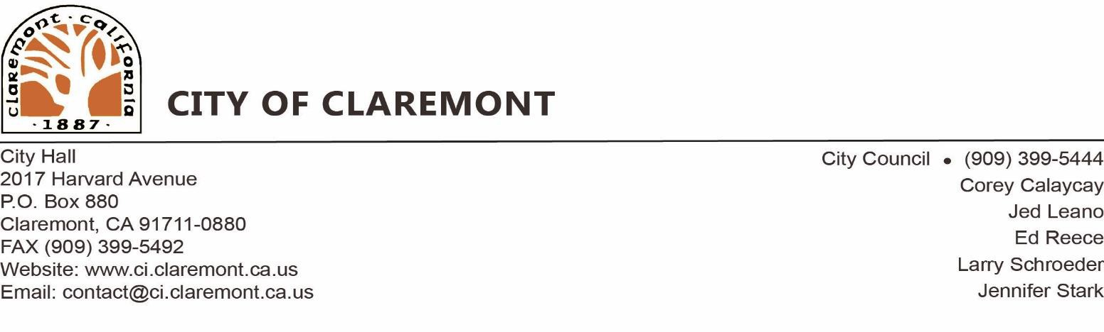

**Notice of Preparation of an Environmental Impact Report**

**DATE:** October 22, 2019

**TO:** All Interested Parties

**FROM:** City of Claremont

**SUBJECT:** Notice of Preparation (NOP) of an Environmental Impact Report for The Commons

**NOP REVIEW PERIOD:** November 19, 2019 – December 19, 2019

The City of Claremont (City) will be the Lead Agency pursuant to the California Environmental Quality Act (CEQA) and will prepare an Environmental Impact Report (EIR) addressing The Commons project with consists of a Specific Plan (in Claremont), development plans, a tentative tract map, and amendments to the General Plan and Zoning Maps. This Notice of Preparation (NOP) has been prepared and distributed by the City to solicit written comments from responsible and trustee agencies, from the state agencies, and interested organizations and individuals. The City is requesting input regarding the scope and content of the environmental information to be addressed in the Draft EIR.

**PROJECT LOCATION:** The Commons is proposed on approximately 9.5 acres located at the northwest corner of Foothill Boulevard and Monte Vista Avenue in the Cities of Claremont and Upland. The City of Claremont is located in Los Angeles County and the City of Upland is located in San Bernardino County. The City of Claremont portion of the project site is 6.5 acres of the 9.5 acres. The City of Upland portion of the project site is 3.0 of the 9.5 acres.

**PROJECT DESCRIPTION:** The Commons would establish land use regulations, development standards, and design guidelines for development within the Specific Plan planning area in the City of Claremont only. The intent is to provide specificity with regard to permitted uses and expectations for the design and construction of new buildings and parking facilities, development and use of open spaces, internal roadway and other circulation improvements, lighting, and landscaping. Future development within The Commons would provide a high quality planned development that provides a diverse mix of housing opportunities with a small area of retail.

The Commons would include a total of 62 dwelling units (27 single-family detached homes, 20 townhomes with 15 flats above the retail spaces) and 5,000 square feet of retail and associated parking in Claremont and 48 townhomes in the Upland portion of the project. The development will have a wide easement, which will be used as active and passive open space for the project. There are three types of plans that will be built on site: single-family detached units, 2, 3, and 4 bedroom townhomes, and single-story flats. The household expected size is between 2 and 5 occupants.

# 

# Conceptual Site Plan

# Probable Environmental Effects

The City has prepared an Initial Study for the proposed project and determined the project may have a potentially significant impact on the environment and that preparation of an EIR is the appropriate level of documentation pursuant to CEQA. The maximum development capacity allowed by the Specific Plan will be analyzed in the EIR to provide a conservative estimate of potential environmental impacts of the project. The EIR will evaluate the potential of the project to impact the following environmental topics: Air Quality, Biological Resources, Cultural Resources, Energy, Greenhouse Gas Emissions, Hazards, Hydrology & Water Quality, Land Use & Planning, Noise, Transportation, Tribal Cultural Resources, and Wildfires.

**Availability of the NOP and Initial Study:** A copy of the NOP and Initial Study are available on the City’s website at <https://www.ci.claremont.ca.us/government/departments-divisions/planning-division/ceqa-documents>.

# NOP Review and Comment Period

The NOP review and comment period is from **Tuesday, November 19** through **Thursday, December 19, 2019**. Due to the time limits mandated by State law, please send your written response at the earliest possible date but not later than 30 days after receipt of this NOP. In your response, please include the name of a contact person in your agency. Please direct your written comments to:

**Mail:** City of Claremont 207 Harvard Avenue

Claremont, CA 91711

Attn: Jennifer Davis, Contract Planner

**Email:** [jdavis@romoplanninggroup.com](mailto:bjohnson@ci.claremont.ca.us)

The City will consider all written comments regarding the scope of issues to be addressed in the EIR. **Written comments must be submitted by 4:00 PM, Thursday, December 19, 2019.**