North Vicinity Map

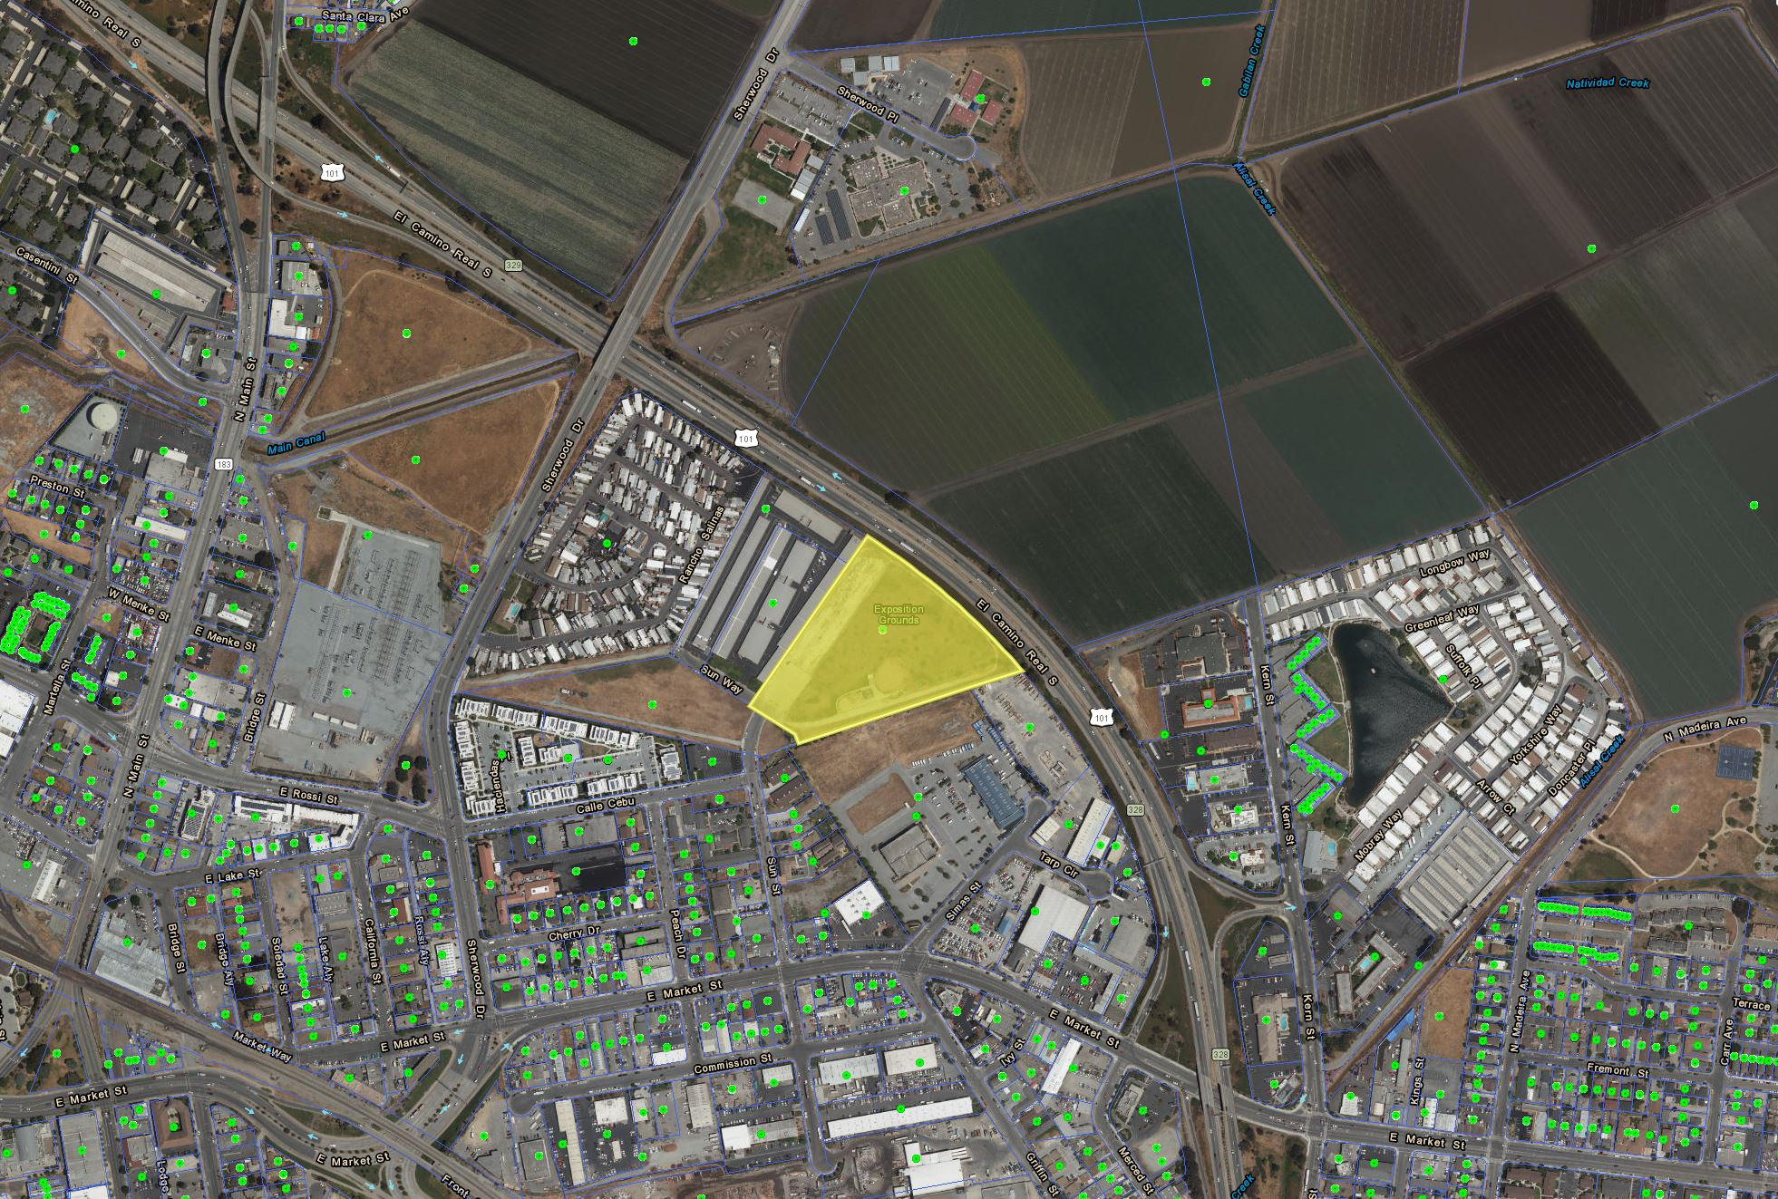

GPA 2017-001 and RZ 2017-002

295 Sun Way

Exhibit A
\\SalSvr44\DeptPvt\ComDev\robertl\Documents\295 Sun Way\ER 2017-002\IS & MND\GPA 2017-001 & RZ 2017-002 Vicinity Map.docx

